Assessment 1
Blogging to communicate

Programme: BA Business Management
Module: Marketing Fundamentals
Module code: LCBB4004

Contribution to Overall Module Assessment (%): 30%
Module Coordinator / Lecturer: Tushara Balendran
Internal Verifier: Dr Anupam Mazumdar

Word count (or equivalent): 1500-2000

Student name: RAZVAN STELIAN BADU

Contents

Introduction 2
Amazon Segmentation, Targeting and Positioning 3
The Positioning Strategy of Amazon 5
Amazon Marketing Mix 6
Amazon Marketing Strategy 7
Conclusion 10
Bibliography 11

Introduction

Everyone on the world is aware that Amazon is a major participant in the e-commerce business. It's no surprise that they've segregated their massive viewership. The criteria and the Amazon target segment are listed under each segmentation category. (Blackwood, 2021)
The first stage for each new firm is to consider how to occupy the space in the minds of potential customers, a process known as 'Brand Positioning.' It's also known as a consumer's view of a brand in comparison to competitors. (Mohammed, 2019)
Product targeting can help you get your adverts in front of users on Amazon who are looking for items that are comparable or complementary to yours. Product targeting, which is available when utilising Sponsored Display and Sponsored Products to create ad campaigns, allows you to target specific goods or product categories to assist boost attention and sales. Each of these solutions has its own set of features and characteristics that can help you achieve your company objectives. (Vyas, 2020)

Amazon Segmentation, Targeting and Positioning

Amazon segmentation, targeting, and positioning refers to a series of efforts aimed at identifying and producing products and services that appeal to distinct categories of consumers.
Segmentation is the process of separating a population into groups based on traits, whereas targeting is the process of selling items to specific groups found because of segmentation. The term "positioning" refers to the process of selecting the marketing mix that is most suited to the target client group.

Amazon mostly employs two types of positioning:
- Multi-segment positioning. Amazon has a diverse selection of products and services, allowing it to profit from many market segments at the same time. Specifically, the online retail behemoth sells about 120 million items, catering to a diverse spectrum of client demographics. (Scraphero, 2019)
- Adaptive positioning. The online retail behemoth keeps a close eye on developments in the external marketplace and responds to rising customer expectations by repositioning products and services on a regular basis in response to market shifts.
- Anticipatory positioning. This refers to targeting a market sector with low turnover with the expectation of increased turnover in the future. A good example of anticipatory positioning is Amazon Web Services (AWS). "No one asked for AWS," says Jeff Bezos, the company's founder, and CEO. Nobody. It turns out that the world was ready and eager for something like AWS but didn't realise it." Amazon Sage Maker, Amazon Comprehend, and Amazon Recognition are some of the company's other anticipatory positioning applications. (Dudovskiy, 2020)

Amazon segmentation, targeting, and placement are shown in the table below:
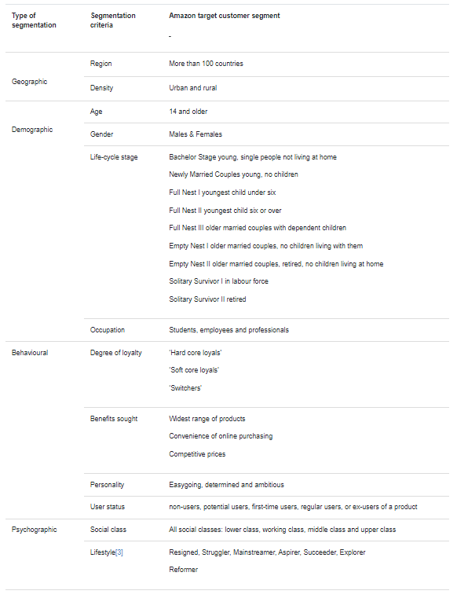

The Positioning Strategy of Amazon

To develop a category, we must first freeze the target consumer segment and understand their needs, as we saw before.
- Finding a Niche Market. The best approach for a company to prosper is to concentrate on a tiny niche market. Concentrate on a specific demand, work on it, differentiate your offering, and dominate the niche market. The smaller the sector, the easier it is for the entire firm to focus on and address the requirements, wants, and wishes of the customers. You might expand into wider areas once you've established yourself as a niche market leader. As a result, the first step is to position your brand towards this specific niche.
- Amazon’s Earlier Niche — After being shaken by the Internet's 2300 percent annual growth rate in 1994, Jeff Bezos began to consider creating an online "everything shop." However, he recognised that, at least in the beginning, such a business would be unfeasible. As a result, he had to focus on a specialisation to place his service in people's minds. How do you pick a niche? He produced a list of twenty probable categories, including computer software, office supplies, clothing, music, and so on... The Books was one of the most intriguing options that came up. (Mohammed, 2019)
The difference in Positioning:
As Amazon began to sell books online, it began to look for methods to establish and maintain the distinction in the minds of customers as the next essential step in establishing a long-term competitive advantage.
Amazon’s Difference — Amazon's main point of differentiation, according to Bezos, would be to provide higher value to customers through a mix of amazing ease, fast access, and broad selection. These distinctions would have been enough to give Jeff a competitive advantage, but he had another idea. He made the decision to include a key differentiator: low prices. Amazon would be a good combination of value and low pricing.
Why are the prices so low? He had his own reasons for believing that Amazon would have an inherent edge in selling low-profit-margin items.
Bezos: “I didn’t want to repeat the mistake of Steve Jobs — pricing the iPhone in a way that was so fantastically profitable that the smartphone market became a magnet for competition”. (Mohammed, 2019)
High profit margins, he believes, justified competitors' efforts in R&D and drew more competition, but low margins attracted more consumers and were more defensible.
As a result, Amazon's positioning strategy was low prices, exceptional convenience, fast access, and a wide range.
“As per Porter’s definition of Strategy, Amazon was offering both value and low price to customers.” (Mohammed, 2019)

Amazon Marketing Mix

The Amazon marketing mix (also known as the Amazon 7Ps of marketing) is made up of product, place, price, promotion, process, people, and physical evidence.
The following are the four categories in which Amazon items may be found:
- Amazon websites that allow Amazon and other parties to sell hundreds of millions of goods across dozens of product categories. In 2018, third-party merchants accounted for almost 58 percent of all products sold on Amazon's platforms. Paid Prime subscribers' number in the hundreds of millions.
- Electronic devices such as Kindle e-readers, Fire tablets, Fire TVs, and Echo. Customers purchased tens of millions of Echo devices, as well as the Echo Dot and Fire TV Stick with Alexa, in 2018. Customers have purchased over 100 million Alexa-enabled devices since the initial iteration of Echo. In 2018, the business increased Alexa's capacity to interpret requests and respond to queries by more than 20%.
- Media content. A wide range of goods and services are available, including cloud-based services for content creation.
- Amazon Web Services (AWS). This business area provides a diverse set of global computation, storage, database, and other services. AWS caters to a wide range of developers and businesses, including start-ups, government organisations, and academic institutions.
In 2017, the e-commerce behemoth finalised the acquisition of Whole Foods Market. (Dudovskiy, 2020)

Amazon Marketing Strategy

Amazon reported net sales of $108.518 billion in the first quarter of 2021, up 43.8 percent from $75.452 billion in the same quarter of 2020. Amazon's net service revenues, which include fulfilment services for merchants on its marketplaces, totaled $51.027 billion, up 51.8 percent from $33.611 billion the previous year. Since the company's inception in 1994, the marketing approach used by Amazon has developed.

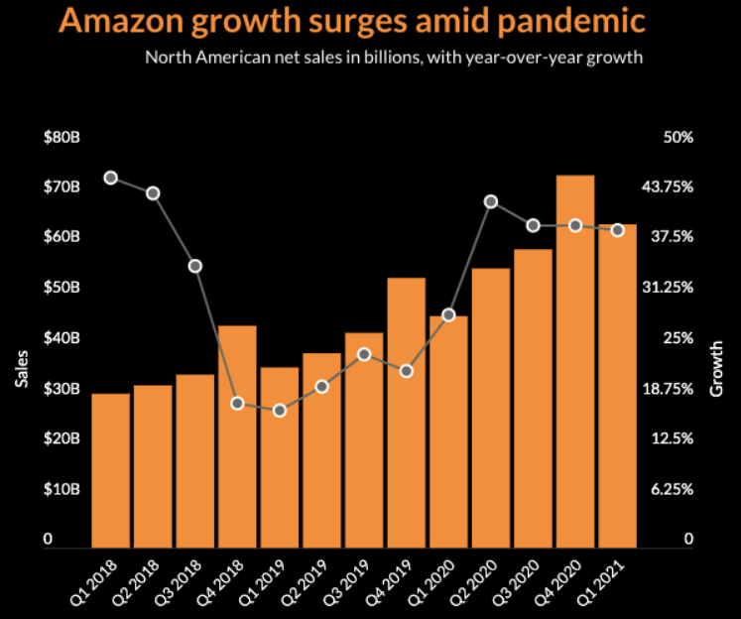
Since I believe that all sorts of businesses can benefit from Amazon's digital business model, I've featured the case study in my books for over 20 years. Their response to the epidemic is outstanding, but not surprising for a company that is "customer obsessive."
We can all benefit from their attention on the customer, particularly at this time of evaluating market potential made available by digital technology, and their concentration on testing and analysis to enhance results, from start-ups and small enterprises to major worldwide businesses. Their commitment to the customer experience, or "Customer Obsession," is demonstrated by the fact that they constantly exceed other retailers in terms of ACSI customer satisfaction.
I want to maintain this case study up to date for book readers and Smart Insights subscribers who might be interested. We look at Amazon's history, revenue strategy, and sources for the most recent financial data in it.
We can also benefit from their digital marketing approach, since they effectively employ it across all consumer communication touchpoints in our RACE Framework:
- Reach: Amazon's first business development was built on a sophisticated SEO and AdWords strategy that targeted millions of keywords.
- Act: Using testing and learning, create clear and easy experiences.
- Convert: Using customization to offer relevant suggestions, as well as a simple checkout procedure that many companies are now copying.
- Engage: Customers are delighted with Amazon's customer-centric culture, which keeps them coming back for more. (Chaffey, 2021)

Amazon's expansion and changing business strategy:
Amazon outperforms the competition when it comes to revenue per visitor, which is one of the most important metrics for any commercial website, whether it's a news site, a search engine, a social network, a transactional store, or one that provides travel or financial services. Of course, due to the substantially lower expenses of other .coms like Facebook and Google, earnings per user would be significantly different.
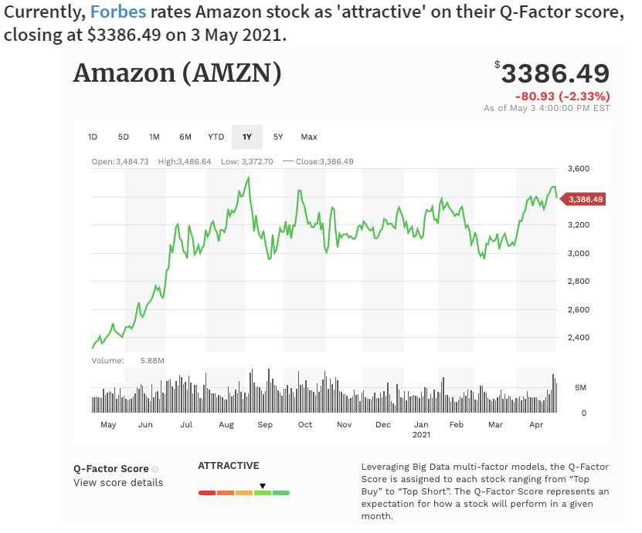
In this way, Forbes explains a "risky" approach to marketing strategy that paid out handsomely for Amazon. So, even if we decide not to imitate all the company's methods and ideas, there is a lot to gain by studying it. (Chaffey, 2021)

Conclusion

The pandemic of the coronavirus is causing a boom in internet buying. While most brick-and-mortar businesses have had a difficult year in 2020, internet merchants such as Amazon have had a fantastic year. As the year draws to a close, Amazon is claiming a 37 percent increase in year-over-year sales. Experts predict that the pandemic's internet buying patterns will persist even after COVID-19 has passed. Amazon vendors may follow in the footsteps of the e-commerce behemoth if they employ digital marketing to promote their wares and establish their brand.

Bibliography

Blackwood, A., 2021. Amazon’s approach to audience segmentation. [Online]
Available at: https://blog.iotechnologies.com/as-amazon/
[Accessed 04 01 2022].
Chaffey, D., 2021. Amazon.com marketing strategy: A business case study. [Online]
Available at: https://www.smartinsights.com/digital-marketing-strategy/online-business-revenue-models/amazon-case-study/
[Accessed 03 01 2022].
Dudovskiy, J., 2020. Amazon Marketing Mix (Amazon 7Ps of Marketing). [Online]
Available at: https://research-methodology.net/amazon-marketing-mix-amazon-7ps-marketing-2/
[Accessed 04 01 2022].
Dudovskiy, J., 2020. Amazon Segmentation, Targeting and Positioning: Widest Range of Target Customer Segment. [Online]
Available at: https://research-methodology.net/amazon-segmentation-targeting-positioning-widest-range-target-customer-segment-2/
[Accessed 04 01 2022].
Mohammed, S., 2019. Brand Positioning Strategy -Amazon, An Example. [Online]
Available at: https://shahmm.medium.com/brand-positioning-strategy-amazon-an-example-452a7397846a
[Accessed 04 01 2022].
Scraphero, 2019. How Many Products Does Amazon Sell? – April 2019. [Online]
Available at: https://research-methodology.net/amazon-segmentation-targeting-positioning-widest-range-target-customer-segment-2/
[Accessed 04 01 2022].
Vyas, M., 2020. Reaching relevant audiences with product targeting. [Online]
Available at: https://advertising.amazon.com/blog/reach-relevant-audiences-with-product-targeting
[Accessed 04 01 2022].

Lifestyle - According to Cross Cultural Consumer Characterization by Young & Rubican.

