

Welcoming diverse workfare: Recommendation for National Grid’s equally recruitment and selection process in the context of globalisation.

Name – Najma Aktar
Student Number - 1905770
Module code - LCDB7002
Assignment Title: Assessment 1
Lecturer- Amare Desta
Module Title- Managing in Complex Environments: Strategies, Insights and Solutions

Summary
The aim of this report is to identify the facts and present the appropriate argument for National Grid’s recruitment and selection teams regarding the significant of employing diverse workforce by implementing diversity strategy. This report draws attention to the member of recruitment board of the fact that National Grid’s less diverse workforce percentage. As a multinational company recruiting diverse employee will help to build greater network towards expending the services, making positive impact on public eye, secure for long term company success, make company innovative and advance with diverse talent, all these direct the company for achieving the company goal.
National Grid has their services on UK and US. As a multinational company, this report seeking attention to the recruitment team for making strategy for attracting diverse workforce according to each country’s organisational context. As both countries have similar index in most of the way despite some acceptations. To understand the variants for both UK and US, PESTEL analysis was applied for identify the external HR strategic business development
The possible recommendation for developing the strategy were stated in this report. Recruiting diverse employee have certain challenges for every organisation, whereas retain the employee also have an issue. Therefore, ethnic and cultural differences, differences in language and communication, generational and age differences, respect other culture and accept the differences of others considered as a challenge. And recommendation part demonstrated, how those challenges can be mitigating and how new strategy can implant for attract diverse workforce.
Giving more priority to female employees were one of the important recommendations for recruitment as well as ethnic minority. Create more space for talented worker from all aspects and every single post were stated as a top priority recommendation.
Finally, in conclusion section recommendation were stated for HR strategy development process to implementation plan.

Table of Contents
Introduction 3
Equal opportunity factor regarding globalisation at National grid 4
Benefits for Recruiting diverse employees equally 5
To add new skills to teams 6
To promotes innovation 6
To open business up to new markets 7
To opens up new talent 7
Challenges for recruiting employees equally 7
Ethnic and Cultural Differences 8
Differences in Language and Communication 10
Generational and Age Differences 12
Respect other culture and Accept the Differences of Others 12
HR Strategy for National Grid in Organizational Context 13
PESTEL analysis 13
Recommendations for national grids equal recruitment and selection 21
Prior to recruit female employees 21
Implement new strategy to employ diverse workforce 22
Create open space for minority workforce 23
Conclusion 24
References 26

Table of Figures
Figure 1: National Grid’s Employees Globally, 2020 5
Figure 2: Ethnicity facts in UK 8
Figure 3: Population of the U.S. by race 2007-2019 10
Figure 4: Number of languages spoken in United States 10
Figure 5: Number of languages spoken in United Kingdom 11
Figure 6: UK GDP growth from 1949 to 2019 14
Figure 7: U.S. GDP growth from 1990 to 2019 15
Figure 8: Hofstede insights, 2020 17
Figure 9: Female employment rate worldwide 21

Introduction
National Grid (former name Transco) is a British multinational gas and electricity utility company based on UK. One of the largest investors owned company who provides gas and electricity to ten million customers worldwide. National Grid have worldwide service through providing energy and connected to diverse stakeholders. As the company is UK based most of the employees are recruited by following ethnocentric approach. Globalisation make the world more attached to worldwide clients which requires diverse workforce to manage the competitive environment. National Grid needs to implement diversity recruitment and equal selection strategy to attract and connect to worldwide clients.
Empirical evidence suggest that National grid give less priority to women when it comes to recruitment. With the specification of equal opportunity in recruitment process at national grid employee, this report seeks to national grid’s recruitment and selection team’s attention to the necessity of recruiting and giving equal opportunity to women employees. According to 2020 National grids annual report female employee percentage are 24.7%, above the whole company (National grid, 2020). With the competitive race of globalisation and equal opportunity scheme, prioritising female employees and recruiting them as equal will bring more interactive customer service and better connection. Further, recruiting female employees equally can facilitate companies core value “Do the right thing” for “Find the better way” to enhance customer service.
As company have UK and US oriented service and wide customer range within these countries, this report aims to draw attention to National grid’s recruitment and selection boards consideration to the important of enforcing equal selection and recruitment strategy in both countries. Therefore, management of National grid should have to understand the particular authoritative settings can extraordinarily influence company’s HR strategies. The macro and micro environmental context of US and UK must consider designing alternative methods for National grid for the purpose of implement effectively recruit equally and retain diverse employees.

Equal opportunity factor regarding globalisation at National grid
National Grid plc was born in 1935, which is one of the first integrated national grid in the world. At present, National Grid provides utility services to UK and US to million customers and also offering renewable energy resources (National Grid, 2020). In 1990, the central electricity generating board transmission activities were transferred to National grid plc which covers the supply in England and Wales. The company began to expand their services to US in 2000, by using their acquisition of Eastern utilities associates and new England electric system. Currently, company have 23,069 employees worldwide.
National Grid expects to convey custom-made and separated administrations to the various clients of the organization. So as to accomplish this objective, National Grid has been putting forth extraordinary attempts to construct a workforce as differing as the client base to improve the comprehension of the clients' necessities and the correspondence with the clients. National grid also has endeavoured to shape a comprehensive culture to regard and worth the uniqueness and worth the ability of every worker to upgrade client support quality. In 2019, National Grid hired 24.3% ethnic minority to improve diversity and inclusion within the company.
Figure 1: National Grid’s Employees Globally, 2020
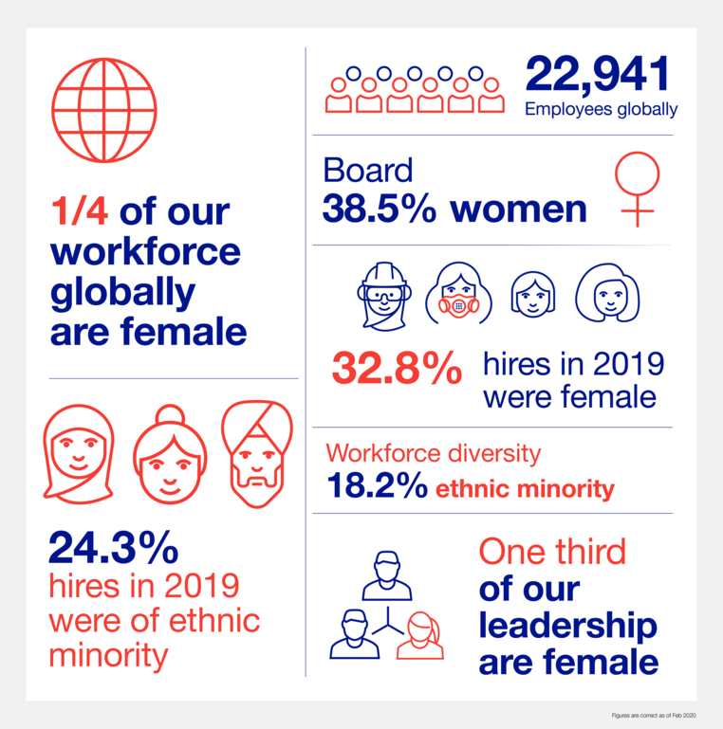
Source: National Grid, 2020

Benefits for Recruiting diverse employees equally
From a business viewpoint, an association's capacity to address future difficulties is contended to be duplicated by more noteworthy workforce diversity, and more importantly explicitly through an expanded variety of aptitudes, encounters, social measurements and qualities (Thornhill et al., 2000). As a utility company, National Grid has wide customer service area where recruiting diverse employees for those customer services will be fit for company betterment. Therefore, only one fourth of employees are women within the company, it can be more efficient if company employ more female. According to Vandekinderen et al. (2012), females are accepted to have expressive aptitudes, and to be enthusiastic, useful to other people, and mindful of other's sentiments. They are additionally accepted to be more kind, accommodating, and understanding than compare to male. Because of these generalizations, females might be seen as more promptly captivating in practices that help others, and that create and continue connections at workplace (Kerpelman & Schvanavedlt, 1999). Enlisting and holding individuals of diverse background who can share a typical technic of qualities and way to deal with business is a need for the at present scenario of (McCormack, 2002). Number of studies have recognized the basic zones of fruitful systems to lead the present diverse workforce (Clark, 2000). With this competitive market, gain and attract customers attention communicating skills are vital (Stovell and Schnack, 2001). Male and female, each other, are frequently confused in light of the fact that they utilize various methods of conveying. The distinction makes them address the issue in an unexpected way (Kluttz, 2002). Male tend to be acceptable speakers, accentuating and reinforcing their status when talking, dissimilar to females do. While females centre around making positive social connections, having a tendency to tune in to other people, and being more enthusiastic. Improving understanding that everybody has an alternate method of talking as far as advancing implications, it is bound to pick up profits by an assortment of likely workers with various correspondence styles (Terjesen et al., 2009).
“European social model” can be used to develop and match the criteria to improve equal requirement process in National Grid. The policy comprised with equal opportunities, anti‐discrimination and labour mobility. European social model concerns for equivalent chances and anti‐discrimination which have brought about sexual orientation mainstreaming so as to advance equivalent open doors in all network strategies. As per the general goals of the EEC Treaty, the consideration paid to females in the European Union has been principally, and only, in their ability as laborers (Ter Haar and Copeland, 2010). Some of the Benefits are given below-

To add new skills to teams
Welcoming more diverse individuals from various backgrounds can include new encounters, ability, and aptitudes into National grids team all of which improve organization execution. A recent survey was conducted by Liao et al. (2020) discovered an immediate connection between diverse team comprehensive decision making and improved business execution. As National Grid have their operations in multicultural countries adding more diverse employee can add more skilled individual. Groups that were geographical different members involve, gender and age diverse settled on better business choices 87% of the time. Esteeming diversity and utilizing individuals from various backgrounds with alternate points of view can hugely improve business yield.

To promotes innovation
National Grid has successful achievement in their sector, thought in this competitive business environment company needs to innovate to be able sustain their success. According to Herstad and Sandven (2020) recent report, when employees realised about their organisation which is committed to them and also supportive for the diverse workers their innovation ability increase by 83% in 2017. With a more prominent spotlight on diversity from that point forward, this percentage is probably going to be considerably extend significantly in 2018. It is obvious that having diverse workplace makes more inventive business outputs. Currently, national grid has 24.3% of minority employees, by exchanging thoughts off one another, a diverse group can produce more inventive, imaginative thoughts. Skilled diversity additionally becomes an integral factor here. Great diversity management is vital to future business achievement.

To open business up to new markets
Introducing and adding more diverse individual into National Grids teams from different social background, geographical verity and cultural verity will open another information base for expected new business sectors. The business economy is getting progressively globalized. Utility services are in high demand worldwide, the opportunity of expending to new areas will make easier by hiring a more diverse team which will give the core skills to the company to push the business forward. National Grid provides services to different backgrounds customers, whereas company can have the benefit of multilingual individuals to serve the customer in their preferable way. Having various ethnicities and social foundations inside the organization can make it more current and relatable to the rest of the world. Workplace diversity means that company’s employee can relate to every one-off companies’ customers. Having the scope of individuals with a scope of feelings then it makes it a lot simpler to focus on a more extensive scope of customers.

To opens up new talent
National Grid is a company that need more strategic ideas to develop for future sustainability. If company can create a strong employer brand which built with diverse teams, talented and skilled candidates will be emerge. Once company shows the compatibility which attracts the customers as well as the market as a progressive organisation, as a result company will get attention from every sector and societies people. When company offers candidates from diverse and different background, there are more opportunity to choose the better candidate as more talented individuals to choose from. Offering diversity not only opens up door for new talent, it also helps the company to retain the best talent for long term company success. Valuing employees by their employers create a reflection to them for retaining to the company.

Challenges for recruiting employees equally
UK and US citizens are from different religions, genders, aged groups, races, ethnicities, political believes and sexual orientations. Each country provides the opportunity to all individual for “life, liberty, and the pursuit of happiness” for all people. In general, in today’s modern society the reflection of different culture and views existed as because of companies and organisation were evolving them. Any organisations success and growth the diverse perspective, their skills and experiences are invaluable. Although creating a diverse environment at workplace is preached, and it’s more difficult to put those into practise. One of the main challenges to recruit minority in company is to reach the minority individual who meets the selection criteria in order to fulfil the position. Therefore, these minority groups use different networks and they are different in every section. One of the other challenges to recruit minority is the individual’s potential to submit the application for the position offered by company. In some cases, many companies are not fully aware of their homogeneity reflect by their certain action, on the other hand some companies take the fact in consideration for the company’s betterment (Panaccio, 2004; Waxin, 2008).

Ethnic and Cultural Differences
UK
Figure 2: Ethnicity facts in UK
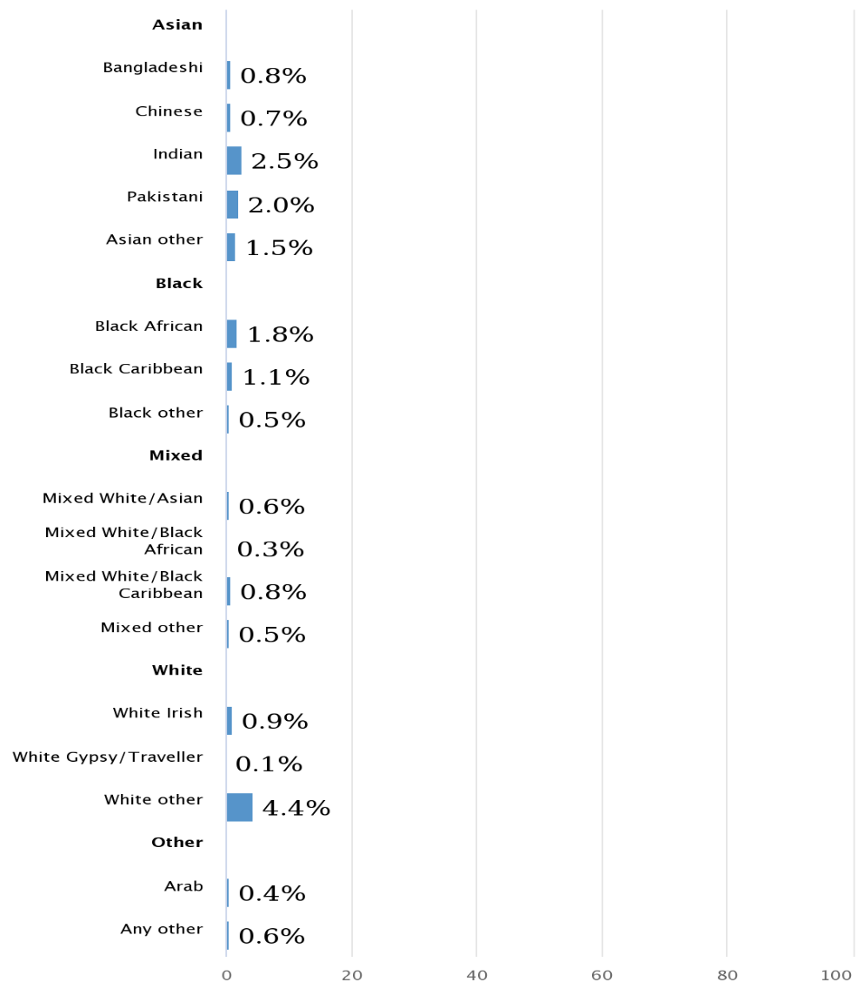Source: Gov. UK, 2011
Although the United Kingdom and United States is predominantly white, but the racial percentages are now changing every year as because a lot of people emigrate to these countries from all over the world. According to the most recent data from ONS (2019) UK population projected 66.65 million and for the US according to Census Bureau data, consisted around 325 million people the racial breakdown of the U.S.’s population. There are still some unfair prejudices against people from different background rather than white, by some individuals who’s not ready to accept the diverse employees at workplace. At a professional work environment that intolerance should not be accepted as the world has changed and company must need to adopt the change according to globalisation.
US
Figure 3: Population of the U.S. by race 2007-2019
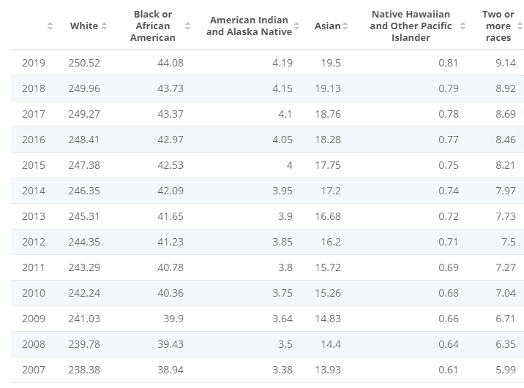
Source: Statista, 2020

Differences in Language and Communication
US
Managing diversity can be an issue at workplace when there are language variances. Despite the fact that in United States the most and generally accepted and communicated language is English although the number of individuals is increasing who speaks different languages. According to American Community Survey in 2016 which published in united states census bureau stated one of every five Americans communicate and speaks different languages. Which in total sum of 65 million of American individuals are communicating with others by speaking different languages rather than English. And the number was increased 1.9 percent from the previous year.
Figure 4: Number of languages spoken in United States
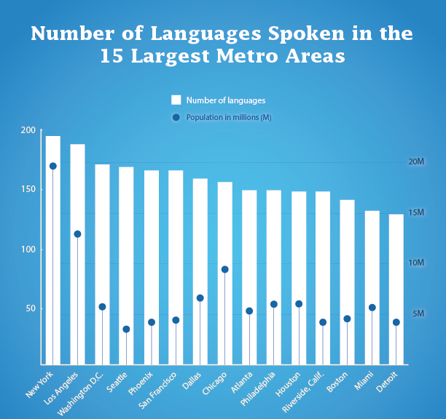
Source: American Community Survey, 2016 (U.S. census bureau)
UK
This measurement shows the circulation of first dialects, other than English or Walsh, spoken in England and Wales in 2011 at the hour of the National Census, by language gathering. European dialects were the most regularly spoken, perhaps because of the vicinity of their nations, yet in addition because of the opportunity of development inside the European Union. 2.4 percent of the complete populace communicated in a South Asian language as their first language. This classification included Indian dialects, for example, Panjabi, Urdu, Bengali, which were the third, fourth and fifth most regular unfamiliar first dialects in England and Wales.
Figure 5: Number of languages spoken in United Kingdom
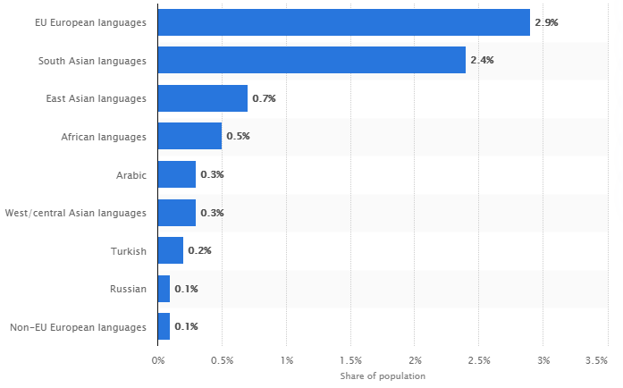
Source: Statista, 2020

Generational and Age Differences
Every year, new diverse workers are recruiting and entering the workforce whereas a large number of employees are retiring. Which makes a huge shift in workforce, more specifically it resulted the main distinctions among the different generations. Differentiations in generation have different perception regarding the workplace. According to the research, millennials are more educated then the silent generation, baby boomer generation and generation X. it is predicted that, at present in UK workforce dominated by millennials (35%) and generation X (35%), with baby boomers only making up 6%. In the present different workforce, pioneers could almost certainly confront four ages of workforces all the while, comprising of older people coming back to the working environment, Baby Boomers, and individuals from Generations X and Y. The shifting ways of life, needs, work styles, objectives, and requests of these age-diverse laborers offer difficulties to building trust and gaming duty (Bear and Bostian, 2002; Kelly, 2001).

Respect other culture and Accept the Differences of Others
A multinational cultural company may face sensitive issues with dealing the culture differences. This problem might stem in organisation as because lack of understanding and not knowing other cultures and respect them. This cases often happen when the manager or employer refuse to give a certain time off during the work as some individuals have their prayers also it happens when some individuals ask for some faith related holidays. Another issue is that common in companies which discrimination a transgender or gay or lesbian by other employees with their lifestyle.

HR Strategy for National Grid in Organizational Context
Considering National grid works its business in particular hierarchical settings, competency model was chosen to implement HR strategies for National grid. The competency model is particularly applied for HR strategies when defining the skill and knowledge requirements of a job in organizational contexts. In this model, HR procedures, which are viewed as firmly identified with associations' upper hand, must be created by various business conditions. A competency model can be defined as “a descriptive tool that identifies the competencies needed to perform a role, effectively in the organization and help the business meet its strategic objectives” (Sampson and Fytros 2008). In addition, in instructive assets, metadata alludes to data about assets utilized with regards to learning, training and education (Vatankhah et. al., 2013).

PESTEL analysis
To demonstrate National grid’s HR strategy, PESTEL analysis chosen to analyse the macro environment for both countries. Ethical context has been considered more effective for the explanation than environmental.
Political context
UK
Britain has an incredible quality of political security in the country; regardless, Brexit has made weaknesses and political conversations in an uncertain way. A few experts accept that Brexit will make an impossible chaos, in spite of the fact that, others trust it will open approaches to enormous open entryways for the country. This might be the cause of weaker starling of pounds, high taxation fee for import and export, shortage of skilled worker, moving companies, increase unemployment rate.
US
America has a solid majority rule arrangement and viable standard of law, with choices that are seen as sensible and clear. The country acknowledges enormous political and money related effect over both open and overall policymaking and is seen as the primary superpower on the world. Nonetheless, the US faces worldwide analysis for its interventionist approaches with regards to the 'War on Terror' which is souring unfamiliar relations, and simultaneously fuelling terrorist group, expanding the danger of psychological oppression. The USA advocates and improved majority rules system worldwide. With a stable world of politics, progressed framework, and innovation, the USA positions itself as an incredible objective for unfamiliar direct venture. Thus, the nation has been the best option for some global organizations for unfamiliar direct venture for quite a while.
Economical context
UK
Figure 6: UK GDP growth from 1949 to 2019
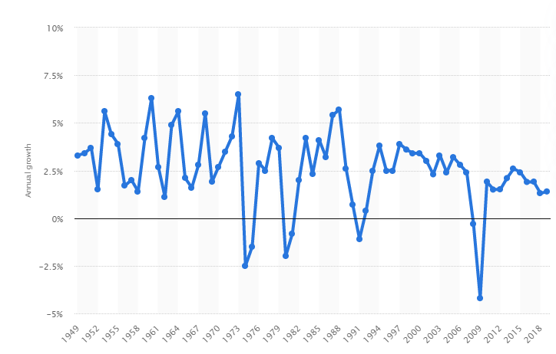
Source: Statista, 2020
United Kingdom’s economic growth raised up by 1.4 percent in 2019, it lastly increased since the unexpected downturn of the GDP in end of 2010, where the economy significantly dropped around 4.2 percent. Before the financial crisis at 2008, the economic growth was steady, in 2000 the GDP growth was recorded 3.7 percent. United Kingdom represent world 5th biggest economy on the total world. The explanation for the achievement of the UK's economy is diversity. UK market is different from other markets that it gives an equal opportunity to all the associations to create and flourish. Nonetheless, it remembers esteems for the lives of customers, and their enthusiasm for the market. Exactly when an overall population has an alternate culture, it infers that it gives outsider a space to live and create. Therefore, UK economy has pulled in the thought of multitudinous over the world. Thusly, various individual budgetary masters and associations have placed their advantages and capital in various fields like land, science, development, food, clothing, staple, redirection, and sports. Presently, the corporate assessment rate for associations is 19 percent. There was a revelation in 2016 that the council would diminish the duty rate to 18 percent before the completing of 2020. If it happens, by then she would pull in more examiners. Starting at now, growing the tax rate in the UK is 1.94 percent. In 2019, it was roaming 1.7 percent. As demonstrated by the rule of the Bank of England, it shouldn't go more than 2 percent. Despite the way that it is a slight addition, and it doesn't mean anything, yet it's a climb. In February 2020, the joblessness pace of the UK's economy was around 3.8 percent. In case we contrast it and the pace of prior years, by then it has fallen roundabout 0.2 percent.
US
Figure 7: U.S. GDP growth from 1990 to 2019
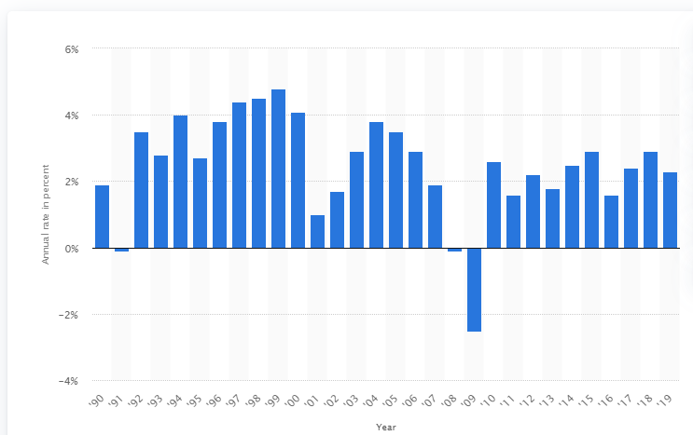
Source: Statista, 2020
US GDP has declined over the past few years although there was a sharp growth in back in 1992 to 2000. The stated reason for declining the GDP in recent years were inflation or deflation and a lot of changes in prices for U.S. dollar. Also, the primary reason was suspected downturns in private investment’s, government spending on federal resources, also, there was an imbalance on import goods which maximise the cost and fixed venture on nonpresidential implications. Despite having some confronting issues at the basic level in instantly changing business of world America have still hold the position of world highest economy and have significant on the planet. More importantly United States economy represent in total of 20 percent of worldwide input and that is the evidence of how strong the economy is no matter how big it is geographically and the number of populations. The U.S. economy includes a profoundly created and mechanically progressed administrations segment, which represents around 80 percent of its total output. Also, it is ruled by administrations situated organizations in regions, for example, innovation, finance, administrations, medical services and retail. U.S. have long list partnership with worldwide corporations where they can access the data and the member of Fortune Global 500 which originated from United States.
Technological context
UK and US both have the similar social media platforms accesses. As both countries citizens are prone to use the four high rated social media platform Facebook, Instagram, YouTube and Twitter. Maximum number of employees use those medias for their personal interest. According to CIPD (2013), in UK more than 90% of millennial workers use social media platform for their personal reason, whereas 40% of social media users are identified that they used it for their work purposes, essentially higher than the normal proportion of all UK workers (26%) and other age groups. The exploration of CIPD (2013) likewise found that 60% of UK representatives utilize phones, for example, PCs, cell phones or tablets, for work. Dominant part of the UK representatives esteemed that online media and cell phone prompted positive effects on their work and could encourage adaptable working.
The innovation has extraordinarily reshaped current UK work environment, teleworking has turning out to be increasingly more mainstream because of its focal points, including better work-life balance, lower worker stress and decreased representative turnover (CIPD, 2018). Penetrating mobile phone stood 131.30 as per 100 individual and in total subscription of mobile phone stood 84.14 million in 2013. However, the number grew up by 9.97 percent by the year 2000 t0 2013. Internet users recorded 56.54 million with a penetration rate of 88.76 percent at the year 2012. Regardless of the nature of instructive and examination foundations inside the UK, there is a lack of workforce in the R&D area. The purpose behind this pattern could be the opening effective opportunities accessible for outside of study inside the UK. In UK technicians in R&D at year 2011 were 970.9 per person whereas Germany, France and Spain were 1363.7, 1855.9 and 1314.3 respectively did far better in this parameter according To the World Bank.

Social context
Hofstede national culture dimension (6-D Model©), were used to differentiate the variance between UK and US.
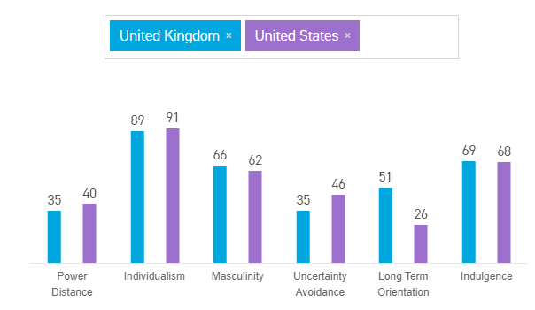
Figure 8: Hofstede insights, 2020
Power Distance
Power Distance is defined as “the extent to which the less powerful members of institutions and organisations within a country expect and accept that power is distributed unequally.”
Power distance dimension scores are more likely similar for both countries. At 35 and 40 sits the lower ranking of power distance. Which indicates that UK and US societies believed inequalities should be minimise among the people. Most importantly power distance index is much higher in working class whereas the index very low in higher class, according to research.
Individualism
This dimension is “the degree of interdependence a society maintains among its members.”
UK has third highest individualist culture in the world. English individuals are exceptionally individualistic and private in the public arena. Children are told since the beginning to have a free intuition and to discover what their brilliant clarification in life is and how they outstandingly can add to society. US has one of the most Individualist societies on the planet, freedom and equity is most reason file to all Americans. This is demonstrated by an unequivocal emphasis on identical rights in all edges. American culture and government accentuation on equivalent rights in all angles.
Inside American affiliations, demand is created for accommodation, supervisors are available, and directors depend upon specific representatives and social occasions for their wellness. The general populace is openly sewing in which the yearning is that individuals manage themselves and their close by families just and ought does not depend upon authorities for help. There is in like way a certifiable level of geological adaptability in the United States. In the business world, workers are expected to act regularly poor and show activity. In like way, inside the trade-based universe of work we see that enrolling, movement and choices depend upon valid ness or proof of what one has done or can do.
Masculinity
“The fundamental issue here is what motivates people, wanting to be the best (Masculine) or liking what you do (Feminine).”
Britain follows Masculine society as it scored 66 which determined highly success oriented and driven. The US score for masculinity is bit higher compare to UK. Which refers to high Masculinity. Specifically, Americans, show their masculinity in their single manner of the way the speak. The British, nevertheless, show the similar context in a slightly different way.
Uncertainty Avoidance
“The extent to which the members of a culture feel threatened by ambiguous or unknown situations and have created beliefs and institutions that try to avoid these is reflected in the score on Uncertainty Avoidance.”
British people are not really concern about uncertainty avoidance; they wake up their day without knowing what the day bring for them. In general, there are not many rules and regulations for live in a society, which may hamper their lifestyle whatever they like to live. The country is a mix of Individualist and inquisitive which is a significant level of imagination and solid requirement for advancement. Also, the country accepts diverse culture. This ascent all through the overall population in its humour, generous commercialization for new and creative things and the brisk significantly innovative endeavours it thrives in advancing, publicizing, monetary designing. However, Americans also have less Uncertainty Avoidance measurement. Both countries citizens have the tendency to sensible amount of affirmation novel acceptance, try creative facts and they also have the capacity to embarking into new things, no matter it is identical with new advancement or not, vital approaches or food. Therefore, Americans will by and large be more permissive toward musings or feelings from anyone and grant the chance of enunciation.
Long Term Orientation
“This dimension describes how every society has to maintain some links with its own past while dealing with the challenges of the present and future, and societies prioritise these two existential goals differently.”
A common tendency in British culture can't be settled, as it shows higher number. For giving long term orientation significant Americans are in 5th position in the whole world. Usual acceptance for new information seems not easy for them, information provided by any source is correct or not they always make sure to check. However, Americans lifestyle does not make them practical in their life, yet this should not be confused with how Americans are even minded. American associations measure their presentation on a transient reason, with advantage and adversity clarifications being given on a quarterly reason. This similarly drives individuals to gain ground toward rapid results inside the workplace.
Indulgence
“The extent to which people try to control their desires and impulses.”
the British culture is one that is appointed Indulgent. People in social requests described by a high score in Indulgence generally show an enthusiasm to comprehend their inspirations and needs as to get a charge out of life and making some incredible memories. They have an elevating mien and have an affinity towards confidence. Also, they place a further degree of criticalness on entertainment time, go about anyway they see fit spend. The United States scores as an Indulgent society on the sixth estimation. This, in blend in with a controlling score, is reflected by the going with clashing mindsets and direct: Work hard and play hard. The States has sought after a war against drugs is still amazingly involved in doing all things considered, yet illegal medication use in the States is higher than in various other well-to-do countries. It is a smug society yet even some notable TV preachers seem, by all accounts, to be indecent.
Ethical Context
The requirement is for a business to adopt ethical business practices in everything that is done throughout the organisation. All the workforce should be included in decision making for any organisation. Business need to maintain cultural norms within the workplace and give space for all equally. Considering ethical factors within the organisation and take responsibility for corporate society are equally important in business context. In UK, November 2015, from UK government the Better Regulation Delivery Office produce key concepts of business ethics in, ‘Law and Corporate Behaviour’ (GOV.UK, 2016). This concept includes the factors of diversity management within the organisation specifically the culture factor. Similarly, U.S. Customs and Border Protection's Privacy and Diversity Office, attempts to guarantee correspondence of chance and the advantage of work choices liberated from unlawful separation for all representatives and candidates for business, and non-discrimination in law authorization exercises and all other managed programs for the exchange and traveling public (CBP, 2019).
Executing business methodology for Diversity and Inclusion Strategic Plan, need to configuration to meet departmental objectives for a comprehensive and drew in workforce. Creating and actualizing business system wide effort program need to instruct workforce on assorted variety and incorporation issues. Inspecting hindrances to business and headway so as to make a domain that is inviting to all people, paying little mind to their ensured status under Federal law, guideline, or strategy. Teaming up with the Office of Human Resources Management and different workplaces to guarantee that keeps up a situation that completely uses and perceives the aptitudes and capacities everything being equal, incorporating people with inabilities.
UK and US both have diverse society which means there both countries organisations need to be more ethical in their HR strategy and most prior to diversity issues in the workforce management. Although, the leading companies in both countries have strong HR policies for the maintenance of diversity issues but still there is some controversial facts remain unchanged. According to CIPD (2019) ethical issues are facing in organisation Unethical Leadership, 60% of workplace misconduct, toxic Workplace Culture, Discrimination and Harassment, equal opportunity program, Unrealistic and Conflicting Goals, Questionable Use of Company Technology, Nondisclosure and Corporate Espionage. Most certainly, in the context of diversity management from HR perspective equal selection and recruitment and equal pay is the top issue in present circumstances.

Legal Factors
Organizations that have their business in the United Kingdom they need to follow the Employment Act 1996. Whether or not it's weakened remuneration, the most reduced compensation allowed by law, event pay, maternity or paternity leave, this exhibit guarantees their benefits. Of course, the Equality exhibit 2010 shields people from being persecuted because of their race, sex, concealing or some different differences. US authentic components considered current and moving toward order that impact the business in districts, for instance, work, competition, and prosperity and security. Progressing years have seen an important rising in the amount of regulatory bodies that have been set up to screen affiliations' acknowledgment of institution relating to all regions of exercises, including purchaser security, specialist government help, trash evacuation, and how their pay and adventures will be troubled. There are likewise the exchanging limitations, shares, and extract obligations to consider.

Recommendations for national grids equal recruitment and selection
In recent years UK and US both has undergoes to the employment scheme. Firstly, UK has to deal with Brexit consequences which led the country conquer with new recruitment process. As the scenario was different before the Brexit, right after the Brexit companies having issue with many areas of workforce. For example, many talented employees had to move as because of new policies has been implemented for other nationalities, rules included for traveling restriction, immigrations laws and healthcare services. In this circumstances UK Govt. has planned to go for point base skilled worker recruitment for the need of companies. According to ONS (2020), women employment rate is 72. 8% in July 2020, which refers that there is still gap for women recruitment as compare to men.
Figure 9: Female employment rate worldwide
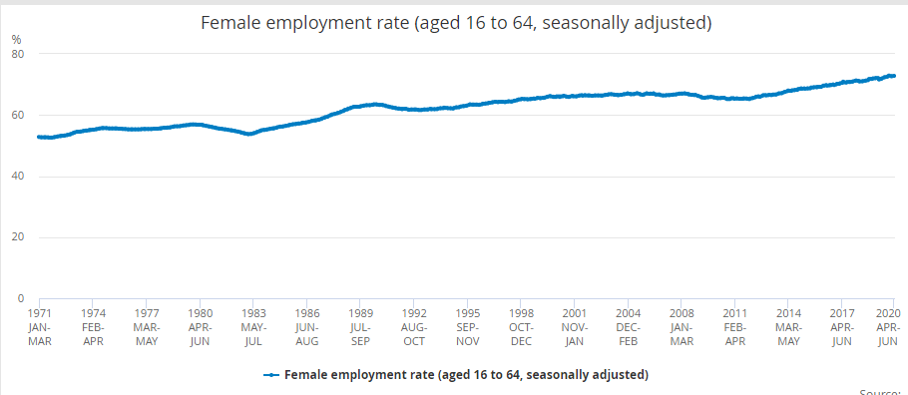
Source: Statista, 2020

Prior to recruit female employees
Females are as of now a huge, and basically undiscovered, pool of possible worker for the UK and US. The financial movement rate for females keeps on expanding and at a higher rate than previous. In territories where a higher extent of occupations is in the division, the extent of financially dynamic females is marginally lower. Notwithstanding, this speaks to an open door as more females might be urged to enter the employment market given the correct motivators. There is an overall view that, individuals' appropriateness for various positions isn't controlled by their sex, and this is fortified by against separation enactment (Thomas, 1992). Nonetheless, the utility enterprises are solidly connected to suppositions of manliness in the open cognizance. This implies young ladies tend not to consider this to be an open door for them, and neither do their guardians or instructors (Wentling and Palma‐Rivas, 1998). This stems from a mix of a poor public comprehension of the business industry and the current sexual orientation uneven characters. Therefore, this poor public comprehension, females tend not to be remembered for conventional courses of enrolment into the utility business. This implies those ladies who are keen on working in the part think that it’s hard to secure data about positions and courses into them. It is likewise the situation that females for the most part despite everything keep up the biggest portion of childrearing duty. Ladies arranging their vocations will in general courtesy business that offers admittance to adaptable working choices. At present, the predominant thought of 'adaptable working' in the utility chain ventures is of employees being adaptable to manager requests. There will not be any changes happen until developed an effective strategy for achieving an inclusion by giving a commitment to all level of workforce diversity. Most significantly at the senior level, which is the topmost important factor and least in evidence (Conklin, 2001). Fitpatrick (19970 supported that argument by stating "Such a strategy should involve a systemic, results-oriented, business-based approach”.

Implement new strategy to employ diverse workforce

To recruit diverse workforce in National grid, company need to Identify present and future states. Which should begin with pointing out present workforce configuration future states at work (Syed and Kramar, 2009). Present implication of HRM policies, processes and practices must need to investigate to determine their fairness and validity for the diverse employees (Turner and Praktanis, 1994). National grid management team need to build a formed and a HR manager should be responsible for diverse workforce where HR manager need to play as a diversity manager. The diversity management team and diversity director should handle and take responsibility to direct and coordinate all the changes and efforts making by company. According to Okoro and Washington (2012), HRM policies and systems need to be modified and reformulate within the collaboration of line employees and managers. Surely, in a setting where the authoritative culture isn't especially ideal for the proposed changes, correspondence, consultation and association of workers and managers are the key point (Panaccio and Waxin, 2010). In this structure and advancement step, the diversity management group ought to likewise choose which pointers will be estimated to assess the usage and viability of the diversity approaches and practices. When the strategies have been created, managers should be prepared just as the workers prior to implementation. All through the change cycle, it will be vital to underline bidirectional, open and straightforward correspondence, with all workers (Almeida et al., 2019). The selected field for implementing and forming the strategy are most importantly recruitment and selection. Therefore, retention, communication, public image, supplier diversity, training and mentoring and assessment should be formed in a strategic way. Finally including them for reward and recognition (McBride and Bostian, 1998; Kluttz, 2002).

Create open space for minority workforce
To encourage the outer recruitment of diverse workforce Panaccio and Waxin (2010), propose four helpful practice for works on, Analysing and improving the picture/notoriety of the organization. The notoriety of the National Grid as an equivalent opportunity recruiter will enable the organization to draw in profoundly qualified applicants. The organization should then promote their arrangement to build minority portrayal among its workers, and outside the association, to change the confusion of homogeneity (Kim, 2006). The execution of this activity would require the arrangement of conversation gatherings to more readily grasp the picture of the organization is presently foreseeing, to fuse people from minority bundles in special reports, to remember these individuals for social gatherings, to plan and send them to enlisting occasions, and to welcome agents of outer minority people to visit the workplaces and meet the organization pioneer (Richard et al., 2007). To gauge the viability of this activity, the organization could quantify the picture it ventures as a minority manager by directing studies among the customers or candidates during prospective employee meetings, follow up normally and think about the yearly outcomes (Roberson and Park, 2007). Arranging external publicizing efforts towards the focused-on networks. Accomplishment of this activity would require a survey of all commercials so as to take out all indications of ethnic or social segregation, to include an announcement affirming that the organization upholds equivalent opportunity in employment (Shen et al., 2009).
To disseminate the business in media available to minority individuals and recall minority people for ads, flyers and films. Possible appraisal measures could be the number and nature of such exercises, the amount of usages got per publicizing exertion, and the amount of workforce employed through the different kinds of media (Beardwell and Claydon, 2007). Making relationship with organizations of minority people. Direct contact with minority networks is a fruitful technique for passing on the action introducing information on them. The execution of this activity would require 1) developing an arrangement of affiliations with diverse members and focused on networks, 2) telecom work openings through these networks, and 3) arranging various activities close by those nearby gatherings (Thomas and Ely, 1996). Possible appraisal measures could be the number and nature of the associations made or kept up each year, the amount of usages got past this framework, and the amount of minority people who were utilized through this framework (Thomas and Wetlaufer, 1997). Creating solid associations with instructive organizations having high proportions of minority student recruitment.

Conclusion
National Grid has been in their business in a long period of time and within the time they have created space for diverse workforce in certain manner. Whereas, company need to focus on employing more diverse workers to be able to stand in strong position in related business. To attract more diverse employee National Grid, need to enforce strategies which reform the company and make more easier to employee and retain diverse workers. To implement the strategy company, need to apply long term perspective, global diversity management design, able to handle diversity challenges and finally implement. The recommendation for strategy implementations is given below-
Longitude perspective
The extended period of time, HR and financial public matrix has committed to the organization over the time is explanation of the hugeness of worldwide employee diversity as a focusing subject (Erinmez et. Al., 2002). Gradual decreases in incorporation endeavours, both purposefully and unexpectedly, under the reason that diversity executives should turn into everybody's commitment, as it were not just that of diversity co-ordinators, HR or line supervisors. National Grid has been implementing policies and plans, but still remain in same way off the ideal imbued practices, handy use of diversity and comprehensiveness standards. From that point of view, where it has been shown that national grid has depart past stability with compatibility authorization towards the stage of esteeming contrasts (Dawes, 1999) and of an ability to gain from diversity (Forte, 2010), it has made relatively littler strides in changing individual perspectives and practices, and culture (Langdon, 1995). This would all things considered appear to infer that National grid ends up engaging ‘access-and-legitimacy’ worldview with conformation to propose that, with extra time, a couple of advances could be made into the perspective of 'learning-and-viability' (Selwyn, 2000). Where the basic diversity plan has intensely accentuated the intercessions of the HR function (Selwyn, 2000), doubtlessly public framework's worldwide diversity executives’ obligations and assignments are not possessed by HR similarly.
Global diversity management design
one of the key problems possessing the considerations of worldwide organizations is the capacity to use the diversity of a worldwide workforce while keeping up association wide consistency (Roberts et. Al., 1998). This was not least apparent in the plan of national grid framework measure where there were clear contrasts in pressures for normalization as indicated by the different degrees of diversity executives’ exercises. Indeed, HRM rehearses are more inclined to social and institutional impacts and subsequently variation than HRM exercises at the policy and theory levels (Tarique et. Al., 2006). National grid’s mix of standardisation and locally adjusted practices would likewise appear to help past SIHRM contentions for conceptualizing the HR work as inside separated whereby single individual practices, for example, diversity management, are pretty much defenceless to worldwide combination (Gamble, 2003).
Global diversity management challenges
Concerning Kostova's (1999) institutional system, administrative difficulties were viably alleviated by National Grid’s express affirmation from the beginning that authoritative irregularities in various host nations will require neighbourhood transformation. Therefore, the obstacles of incorporating worldwide diversity management were construct to dwell in establishing and psychological hindrances rectify with the US context. Therefore, US organisational setting wind up being both open and invulnerable to the principles of diversity and comprehensiveness. Generally, the spellbound idea for the US organisational condition as compare to diversity implied represent that gender equality considered as a non-issue, the psychological and establishing shifts needed to talk about directly the fact of sexual direction and ethnicity were demonstrated to be an average, on occasion and excruciating cycle. This has accordingly prompted the overall analysis that, National grid has illustrated adaption (Andersson, 2002) of diversity through its proficient enforcement of policy and practices, but at current ailing in the disguise (Cantwell, 2010) of diversity may view as a hierarchical specific perceive its worth and use.
Implications
As to how worldwide diversity management is planned and passed on, the request with respect to whether a worldwide or multi-domestic system is additionally appropriate or not which may ought to be answered while conceptualizing around the world diversity management as including isolated activities occurring at various authoritative levels. As underlined by the progressing theoretical defences for worldwide HRM, and generally upheld in this report, the appropriate response may at that point be found in additional worldwide coordination and consistency of diversity theories which override identity, with an inclining towards a multi-domestic way to deal with diversity practices and policies which are all more geographically and institutionally installed and more defenceless to Anglo-Saxon social inclination. Such affirmations, notwithstanding, remain experimentally under upheld and needing further certification.
Moreover, two key reasonable ramifications should be gathered in the organization. To begin with, the scale and modernity of any worldwide diversity management mediation need to have the option to be meant all significant nearby host objections. As featured here, while a multi-domestic methodology is frequently considered generally fitting in managing host-explicit difficulties of workforce diversity, the absence of intercession from the inside should likewise show itself in a more genuine absence of help. From this perspective, both parent and subsidiary should co-work to discover commonly valuable arrangements. Secondly, from a longitudinal viewpoint, organization must stay both steady and patient in the quest for overseeing worldwide workforce diversity.

References
Sippola, A. and Smale, A., 2007. The global integration of diversity management: A longitudinal case study. The International Journal of Human Resource Management, 18(11), pp.1895-1916.

Andersson, U., Forsgren, M. and Holm, U., 2002. The strategic impact of external networks: subsidiary performance and competence development in the multinational corporation. Strategic management journal, 23(11), pp.979-996.
Almeida, S., Waxin, M.F. and Paradies, Y., 2019. Cultural Capital of Recruitment Decision‐Makers and its Influence on their Perception of Person‐Organisation Fit of Skilled Migrants. International Migration, 57(1), pp.318-334.
Beardwell, J. and Claydon, T. eds., 2007. Human resource management: A contemporary approach. Pearson Education.
Cantwell, J., Dunning, J.H. and Lundan, S.M., 2010. An evolutionary approach to understanding international business activity: The co-evolution of MNEs and the institutional environment. Journal of International Business Studies, 41(4), pp.567-586.
CIPD, 2020, Ethical practice and the role of HR, [online] available from<https://www.cipd.co.uk/knowledge/culture/ethics/role-hr-factsheet>[Accessed 25 Aug 2020]
CBP, 2020, Diversity and Inclusion [online] available from <https://www.cbp.gov/about/eeo-diversity>[Accessed 28 Aug 2020]
Dawes, L., 1999. First connections: teachers and the National Grid for Learning. Computers & Education, 33(4), pp.235-252.
Erinmez, I.A., Kappenman, J.G. and Radasky, W.A., 2002. Management of the geomagnetically induced current risks on the national grid company's electric power transmission system. Journal of Atmospheric and Solar-Terrestrial Physics, 64(5-6), pp.743-756.
El Asame, M. and Wakrim, M., 2018. Towards a competency model: A review of the literature and the competency standards. Education and Information Technologies, 23(1), pp.225-236.
Forte, V.J., 2010, January. Smart grid at national grid. In 2010 Innovative Smart Grid Technologies (ISGT) (pp. 1-4). IEEE.
Gamble, J., 2003. Transferring human resource practices from the United Kingdom to China: the limits and potential for convergence. International Journal of Human Resource Management, 14(3), pp.369-387.
GOV.UK., 2020, Population of England and Wales by ethnicity [online] available from <https://www.ethnicity-facts-figures.service.gov.uk/uk-population-by-ethnicity/national-and-regional-populations/population-of-england-and-wales/latest >[Accessed 5 Sep 2020]
Herstad, S.J. and Sandven, T., 2020. A closer look at the relationship between innovation and employment growth at the firm level. Journal of Evolutionary Economics, 30(2), pp.375-399.
JULIE, H.W. and CORDEIRO, B.L., 2003. Who is a Good Organizational Citizen? Social Perception of Male and Female Employees Who Use Family Leave. Sex Roles, 49(5), pp. 233-246.
Kim, B.Y., 2006. Managing workforce diversity: Developing a learning organization. Journal of Human Resources in Hospitality & Tourism, 5(2), pp.69-90.
Kostova, T., 1999. Transnational transfer of strategic organizational practices: A contextual perspective. Academy of management review, 24(2), pp.308-324.

Liao, H., Mi, X. and Xu, Z., 2020. A survey of decision-making methods with probabilistic linguistic information: bibliometrics, preliminaries, methodologies, applications and future directions. Fuzzy Optimization and Decision Making, 19(1), pp.81-134.
Langdon, W.B., 1995, April. Scheduling planned maintenance of the national grid. In AISB Workshop on Evolutionary Computing (pp. 132-153). Springer, Berlin, Heidelberg.
National Grid, 2020, Annual Report and Accounts 2019/20 - National Grid [online] available from<https://investors.nationalgrid.com/~/media/Files/N/National-Grid-IR-V2/reports/2019-20/ng-annual-report-and-accounts-2019-20.pdfin> [Accessed 30 Aug 2020]
https://www.nationalgrid.com/about-us
National Grid, 2020, Inclusion and diversity [online] available from <https://www.nationalgrid.com/careers/inclusion-and-diversity> [Accessed 5 Sep 2020]
Okoro, E.A. and Washington, M.C., 2012. Workforce diversity and organizational communication: Analysis of human capital performance and productivity. Journal of Diversity Management (JDM), 7(1), pp.57-62.
ONS, 2020, Female employment rate, [online] available from <https://www.ons.gov.uk/employmentandlabourmarket/peopleinwork/employmentandemployeetypes/timeseries/lf25/lms> [Accessed 25 Aug 2020]
Panaccio, A.J. and Waxin, M.F., 2010. HRM case study: diversity management: facilitating diversity through the recruitment, selection and integration of diverse employees in a Quebec bank. Journal of the International Academy for Case Studies, 16(4), p.53.
Richard, O.C., Murthi, B.S. and Ismail, K., 2007. The impact of racial diversity on intermediate and long‐term performance: The moderating role of environmental context. Strategic Management Journal, 28(12), pp.1213-1233.
Roberts, K., Kossek, E.E. and Ozeki, C., 1998. Managing the global workforce: Challenges and strategies. Academy of Management Perspectives, 12(4), pp.93-106.
Roberson, Q.M. and Park, H.J., 2007. Examining the link between diversity and firm performance: The effects of diversity reputation and leader racial diversity. Group & Organization Management, 32(5), pp.548-568.
Selwyn, N., 2000. The national grid for learning: Panacea or panopticon? British Journal of Sociology of Education, 21(2), pp.243-255.
Selwyn, N., 2000. The discursive construction of the National Grid for Learning. Oxford Review of Education, 26(1), pp.63-79.
Statista, (2020), Foreign languages spoken within England and Wales in 2011, by language group [online] available from <https://www.statista.com/statistics/329443/census-most-common-language-group-uk/>[Accessed 10 Sep 2020]
Statista, (2020), Resident population of the United States by race from 2000 to 2019, [online] available from <https://www.statista.com/statistics/183489/population-of-the-us-by-ethnicity-since-2000/> [Accessed 25 Aug 2020]

Syed, J. and Kramar, R., 2009. Socially responsible diversity management. Journal of Management and Organization, 15(5), p.639.
Sippola, A. and Smale, A., 2007. The global integration of diversity management: A longitudinal case study. The International Journal of Human Resource Management, 18(11), pp.1895-1916.
Shen, J., Chanda, A., D'netto, B. and Monga, M., 2009. Managing diversity through human resource management: An international perspective and conceptual framework. The International Journal of Human Resource Management, 20(2), pp.235-251

Tarique, I., Schuler, R. and Gong, Y., 2006. A model of multinational enterprise subsidiary staffing composition. The International Journal of Human Resource Management, 17(2), pp.207-224.
Turner, M.E. and Praktanis, A.R., 1994. Affirmative action: Insights from social psychological and organizational research. Basic and Applied Social Psychology, 15(1-2), pp.1-11.
Terjesen, S., Sealy, R. and Singh, V., 2009. Women directors on corporate boards: A review and research agenda. Corporate governance: an international review, 17(3), pp.320-337.
Thomas, D.A. and Wetlaufer, S., 1997. A question of color: A debate on race in the US workplace. Harvard Business Review, 75(5), pp.118-133.
Thomas, D.A., & Ely, R.J. 1996. Making differences matter: A new paradigm for managing diversity. Harvard Business Review, 74(5), 79-90.
Thomas, R., 1992. Beyond race and gender: Unleashing the power of your total workforce by managing diversity. Amacom.
Ter Haar, B.P. and Copeland, P., 2010. What are the future prospects for the European social model? An analysis of EU equal opportunities and employment policy. European Law Journal, 16(3), pp.273-291.
Vandekinderen, C., Roets, G., Vandenbroeck, M., Vanderplasschen, W. and Van Hove, G., 2012. One size fits all? The social construction of dis-employ-abled women. Disability & Society, 27(5), pp.703-716.
Wentling, R.M. and Palma‐Rivas, N., 1998. Current status and future trends of diversity initiatives in the workplace: Diversity experts' perspective. Human Resource Development Quarterly, 9(3), pp.235-253.
https://www.census.gov/newsroom/press-releases/2015/cb15-185.html#:~:text=Census%20Bureau%20Reports%20at%20Least%20350%20Languages%20Spoken%20in%20U.S.%20Homes,-November%2003%2C%202015&text=U.S.%20Census%20Bureau%20released%20a,U.S.%20residents%20speak%20at%20home.

