
Measuring customer satisfaction with SAEVQUAL model dimensions. A Case study of MTN Telecommunication Nigeria.

Name: Charles Chukwudi Okonyia Okeyia
Student No: 2117194
Course Name and Code: Quantitative Research Methods LCDB7011
Word Count: 5520

Table of Contents
Abstract. 2
1. Introduction 3
2. Literature Review 4
2.1 Concept of Quality of Service 5
2.2 The SERVQUAL Model 6
2.3 The Relationship between QoS and Customer Satisfaction. 8
2.4 Attributes of Service Quality in the Telecommunications domain. 9
2.5 Critique of SERVQUAL Model. 10
2.6 The Gaps in the Literature. 10
3. The research Methodology 11
4 Data Analysis Methods 11
5. Results and discussion 12
5.1. Model Summary 12
5.2 The linear regression results 15
6. Discussion 16
7. Conclusions 17
8. Limitation of this paper. 18
9. References 19
10. Appendix. 26

Abstract.

The telecommunications sector over the past decades has grown in terms of subscribers and revenue, which has also increased demand for network services, including delivering a better and sustainable quality of services (QoS). This growth has triggered the relationship between QoS and customer satisfaction to earn significant recognition in the researched context. Given this concern about network services and subscriber growth, this paper aims to determine the effect of QoS on prepaid and postpaid customer satisfaction.
In presenting the employed hypothesis, we performed a literature review on the quality of service dimensions and the relationship with customer satisfaction. Additionally, we used the network performance indicators as the measurement method and a quantitative approach to generalise the results.
The sample population in this paper was hundred (100) individuals based on assumptions, variables and demography. In analysing the collected data from the quantitative research methods and assessing the hypotheses, the paper utilised the statistical package for social sciences (SPSS) version v29, which allowed different statistical computations. The study's results with the descriptive statistical analysis showed that the participant's responses to the QoS variables significantly affected the prepaid and postpaid subscribers' satisfaction variables.
Furthermore, the findings show that customer satisfaction is clearly and substantially related to a prepaid and postpaid contract. However, reliability, empathy and tangibles were predictors across general QoS and customer satisfaction.

Keywords: Customers Satisfaction and Value-added Services, Telecommunication, Quality of Services and Network Availability.

1. Introduction
Telecommunication services have been increasing rapidly because of the various benefits to businesses, technology, the economy, human development and government. The rapid development of telecommunication services offered increased subscribers and challenged the network providers to provide better customer services and value-added services. Customers depend on network availability and QoS to have satisfaction and value-added service. According to Haryadi et al. (2001), the quality of service includes a set of parameters associated with traffic performance on a telecommunication network. This means the collective impact of service performance defines the level of service customer satisfaction ITU-T, (2011).
Additionally, network availability is the prospect of a telecommunications service provided to customers through network assets and infrastructure. Therefore, these definitions show a direct relationship between network availability, QoS rendered, and customer satisfaction (Kothari et al., 2011). Some research has shown that the QoS provided by these network providers still requires to meet the agreed key performance indicators (KPI), thereby impacting customers' needs (NCC, 2020).
The QoS supplied by these network providers is one essential characteristic influencing the customers to select a network provider. Customers with good QoS experiences will remain with the same network provider. The concern in telecommunications QoS study on customer satisfaction has increased the number of studies conducted using related theories and approaches in the telecommunication domain. However, only some studies have focused on the impact of asset and infrastructure performance on QoS when assessing customer satisfaction.
In contrast, customers with bad experiences may only remain with the provider if alternative network services exist. Oodam et al. (2003) supported this view that customer perception is the key criterion by which network providers can assess and measure the value-added service and QoS delivered to customers. For this justification, improving the network services is essential to retain existing subscribers and attract incoming customers. Customers of the researched organisation are classified into prepaid, postpaid and enterprise customers, including businesses, companies, and government subscribers. This paper focuses on prepaid and postpaid subscribers because they are the direct usage categories with more sample populations (Creswell et al. 2019) as the targeted participants.
Despite the increased network capacity to support customers' satisfaction and value-added services, the QoS has remained the same, as they complain about network services. In the researched organisation, customers reported dissatisfaction with the QoS and value-added services. Interactive data from NCC customer consultative meetings shows that forty-five (45) per cent of subscribers were dissatisfied with QoS. At the same time, fifty-five (55) per cent were also dissatisfied with the internet services they received from the researched organisation.
The general objective was to explore the level of QoS, prepaid and postpaid customer satisfaction, and value-added services provided by the researched organisation. Consequently, the specific objective; Is to identify customer satisfaction and the degree of QoS as observed by the prepaid and postpaid customers of the study context.
To achieve the research objective and address the research problem, the research questions are as follows:
- What are the levels of customer satisfaction and QoS perceived by prepaid and postpaid customers in the researched organisation?
- What is the correlation between perceived QoS and customer-expected services?
- How significant are the identified QoS dimensions in predicting customer satisfaction and value-added services?
Furthermore, these hypotheses will give the paper an uncertain answer to the research question that directs the whole research journey.
H1: The QoS dimensions significantly influence the satisfaction experienced by the subscribers on prepaid and postpaid plans.
H2: The QoS dimensions significantly influence the satisfaction with the facilities experienced by subscribers' on prepaid and postpaid plans.
H3: The QoS dimensions significantly influence the satisfaction with network providers' activities that subscribers on prepaid and postpaid plans experience.
H4: The QoS dimensions significantly influence the perceived and expected QoS experienced by subscribers on prepaid and postpaid plans.
This paper is structured in the following direction. First, the literature review is in section 2, followed by section 3, which presents the data and subsequently chosen methodology, where the empirical results and discussion are provided in section 4. Finally, Section 5 concludes with suggestions and further research direction.

2. Literature Review
The literature review for this paper was performed to analyse and synthesise the previous and existing researched work and identify the gaps related to the study topic about the quality of service and customer satisfaction with value-added service in Nigeria's telecommunication environment. The literature review approach of analysing and synthesising assists in determining the present knowledge and understanding of the research topic chronologically. Therefore, the literature review addresses the concepts of quality of service, the instruments for evaluation (SERVQUAL), and the quality of service characteristics.

2.1 Concept of Quality of Service
The concept of quality of service is essential because of its effect on customers and businesses. Service is mainly intangible and is usually experienced concurrently with utilisation and production. Groonroos (1998) argued that service is the interaction between the network provider and the subscriber that delivers the service to customers. However, the service could also be perceived as any performance or activity that groups. Kotler et al. (2019) supported this perspective by defining services as a kind of product that comprises activities, satisfactions and advantages delivered for selling that are intangible and do not cause in possession of something. While services suggest something delivered to the subscribers, service implies the entire organisation's performance in offering subscribers a great experience.
Customers decide their satisfaction level with the service delivered and the result by the network provider, and they make decisions regarding quality. However, QoS and customer satisfaction are linked concepts, though they are different. Sugeng (2016) argued that customer satisfaction is an attitude determined by the experience achieved. This insight explains that satisfaction is an evaluation of the service or product features that offer customer satisfaction with an emphasis on customer expectations. Parasuraman et al. (2015) supported this perspective by describing quality as the gap between customers' expectations of QoS according to the service performance experienced by the subscribers. On the other hand, Marnovita (2020) was indifferent to the gap perspective as quality is the quality of service provided by the organisation, and customer satisfaction will be higher.
Additionally, customer satisfaction is an emotional response to a specific service experience in the short term. This is because the perception of QoS is based on the cognitive evaluation of providers' service delivery. Therefore, the most common literature concerning QoS description viewed it as the customer perception of service excellence.
These authors also argued that the distinction between the assessment of the QoS and that of a good QoS by a customer is not in the procedure but rather in the characteristics that the assessment was conducted (Parasuraman et al. 1988). These characteristics were intangibility, the inseparability of production and consumption, simultaneity, heterogeneity, variability, and expiration (Parasuraman et al. 1988). In addition, there is a distinction between the impact of physical products on QoS Gronroos (1998) and Parasuraman et al. (2015).
This distinction refers to intangible and tangible dimensions of QoS. However, the intangible characteristics are challenging to identify and quantify, making it complicated to determine the exact requirements to standardise their QoS (Stanton et al., 199; Zeithaml et al., 1988; Alauddin et al., 2019; Marsrurul, 2019). In contrast, the objective QoS aims at the technical characteristics (Carman, 1990; Raj et al., 2018) from the provider's viewpoint and the subjective QoS in which customers' needs are underlined, therefore developing the perceived QoS concept.
In the case of the context of this paper, we focus on the concept of QoS from the viewpoint of the product, with effectiveness being the fundamental objective for which standards are used for its control (Gronroos, 1988; Gummesson, 1988; Lehtinen et al. 1982). This QoS model from Gronroons (1994) recognised two dimensions for QoS which interrelate among each other: Technical quality or design of the service, mentioned as what service the customer receives (result), is susceptible to be evaluated by the providers and assessed by the customer; and the available quality or performance of the service, which is a concern with how customer service (process) is delivered. Marsrueul (2019) and Alauddin et al. (2019) supported the positive impact of all QoS dimensions on customer satisfaction. However, Ali et al. (2021) supported Tessera et al. (2016) to disagree with the positive effect and suggested the negative effect of two QoS dimensions of assurance and reliability.
Reflecting on these perspectives as appropriate to this case context requires additional analysis and synthesis of the SERVQUAL model (Parasuraman et al. 1988). These authors describe perceived QoS by the customer as a general evaluation of the customer concerning the dominance of the service resulting from the difference made among the expectations and opinions, and experience about the performance of the received service.

2.2 The SERVQUAL Model
Customer satisfaction is a prominent aspect of organisations' ongoing accomplishment and could be achieved when business delivery exceeds the customer's expectations and value-added service (Asa et al. 2021). Therefore, providers must deliver the best QoS to increase customer satisfaction reports and indexes because satisfied customers are vital business representatives (Fida et a., 2020). Customer satisfaction theory was inspired by several authors (Churchill et al. 1982; Kano et al. 1984; Parasuraman et al. 1985) with their suggestion to measure organisations' service provision actual quality instead of customers' perceived quality.
Gronroos (1984) and Parasuraman et al. (1988) perspective suggested and operationalised service quality as the divergence between customer expectations, wants and experiences what they get. As a result of these ideas with specific components - concept and specifying how the concept will be evaluated by operationalising the variables, the authors suggested a service quality measurement scale known as SERVQUAL.

However, Parasuraman e al. (1988) widened the QoS concept by categorising it into five key processes comprising tangibility, reliability, responsiveness, assurance, and empathy dimensions to develop a SERVQUAL model. The authors described these QoS dimensions as follows:
- Tangible evidence includes the organisation's employees, physical facilities, equipment and communication channels. This also includes the appearance of facilities that are buildings, availability of vehicle packing lots, effectiveness, orderliness and comfort of the reception and the communication equipment and the employee's appearance.
- Reliability – the capability to deliver the pledged or assured QoS and value-added service promptly, correctly and satisfactorily. The network provider delivered services appropriately in the first instance.
- Assurance – the employee's expertise, capacity, civility and honesty, free from risk, threat and fears. Employees show competence and knowledge in their services to customers.
- Empathy – good communication, personal attention, the simplicity of making relationships and understanding customers' requirements.

Figure 1 presents the SERVQUAL model.
Source: Parasuraman et al. (2015) SERVQUAL Model
This SERVQUAL model was initially evaluated by Parasuraman et al. (2005) in the restaurant services sector. However, the model can also be replicated in the research context because the focus is all on products and services involving tangibility and intangibility. Nevertheless, this model has been utilised in several scholarly and practitioner studies of customer satisfaction within their respective fields.
Table 1: The QoS five dimensions.
Source: Zeithaml et al. (1988) and Sanjuq (2014) Five dimension SERVQUAL model.
The SERVQUAL model represented in table 1 by Zeithaml et al. (1988) and Sanjuq (2014) defined the SERVQUAL model as a summarised multiple-scale instrument with an outstanding level of reliability and validity that organisations better apply to understand the customer's expectations and perceptions of QoS. This perspective explains the critical factors of expectations and perception that determine perceived customer QoS (Parasuraman et al. 1988). However, there are divergent interpretations of the literature concerning these dimensions in this perspective. Eight dimensions (performance, characteristics, reliability, attachment, durability, service aspects, aesthetics, and perceived quality) were considered by (Garvin, 1988). While three dimensions (physical, corporate and interactive quality were also considered by (Lehtinen et al. 1982).
Furthermore, Gronroos (58) accounted for the technical or result, the corporate image and the process or functional dimensions. The concept of QoS is a complex variable with various explanations. However, the most deemed multidimensionality QoS model used in this research context is the standard proposed by Parasuraman et al. (2015), as stated in figure 1.

2.3 The Relationship between QoS and Customer Satisfaction.
There is a remarkable similarity between the concepts of QoS and satisfaction (Zeithaml et al. 1988). However, several research works indicate that the concepts are separate constructs, while the QoS is more comprehensive than satisfaction. For example, Parasuraman et al. (2015) refer to the disagreements between concepts than durability. The perceived QoS implies a lasting attitude associated with service superiority (Parasuraman et al. 1988). In contrast, satisfaction is a transitional evaluation of a transaction in which a difference is made with expectation (Aremu et al. 2017). This viewpoint explains the indirect influence of QoS on customer satisfaction.
From another researcher's perspective, Oliver (1997) argued that these distinctions are that when customers evaluate the perceived QoS, the main dimensions are those of a cognitive and rational nature. In this research context or other cases of customer satisfaction, this dimension of that rational nature creates the emotional outcome. This emotional result could be positive or negative, calling for more discussions based on the literature by Kumar (2018) that supported the promotion of value-added services for customers.
Furthermore, the gap characteristics discussed in this paper led Zeithaml et al. (1988) to suggest that the difference between concepts is because of the evidence of satisfaction. This explanation includes an evaluation made by the customer for a particular transaction (Oliver, 2009). It entails earlier experience because this evaluation varies on the customer's former expectation (Brady et al. 2001, Westbrook et al. 1991). This QoS could be perceived without requiring a direct experience with it (Parasuraman et al. 1988). Additionally, some researchers had no consensus concerning the causal relationship between concepts, even though they acknowledge the actuality of a relationship between the concepts (Zeithaml, 1988, Parasuraman et al., 1988, Cronin et al., 1992, Swan et al., 1998).
Contrarily, this position of research supports the notion that satisfaction is a result of perceived QoS (Parasuraman et al. 1988, Cronin et al. 1992, Koelemeijer et al. 1993, Bigne et al. 2003) and the research that supports the inverse relationships, seeing satisfaction as an antecedent of QoS (Carman 1990, Bolton et a. 1991, Bitner (1990), Patterson et al., 1993 and Dabholkar, 1995). Therefore, this paper aligned with the research work by Parasuraman et al. (1988), Zeithaml et al. (1988), Rust et al. (1994) and Martinez-Tur et al. (2001) that has an intermediate position, in which satisfaction is judged as an antecedent and a result of the perceived QoS. Hence, in this research context, the proposed hypotheses.

2.4 Attributes of Service Quality in the Telecommunications domain.
There is excellent attention by researchers and practitioners on service quality in the telecommunication environment. For example, Lehtinen et al. (1982) conceptualised service quality as a three-dimensional concept; physical, interactive and corporate. Parasuraman et al. (1985) extended this viewpoint with an understanding that service quality is the perception that derives from the difference between customer expectations and the performance of service in the actual segment. In their studies in the telecommunication domain, these authors argued that perceptions are established not only on the results of services but also on the service's delivery process.
Therefore, Garvin (1998) argued that service quality comprises performance, features, conformance, reliability, durability, aesthetics, serviceability, and customers' perceived quality. In contrast, several academics worldwide (Cronin et al. 1992) criticised the SERVQUAL model. However, other authors, such as Lai et al. (2007), examined different attributes that help customers measure service quality perceptions.

2.5 Critique of SERVQUAL Model.
Van Dyke et al. (1997) outlined the empirical and theoretical findings associated with critiquing the SEVQUAL model based on various issues. For instance, using gap scores with the problem of a poor choice is a measure of the complex psychological construct. The issue of validity with the perception factor of the perception minus expectation scores that perform better as a predictor of perceived general quality than the difference scores.
Jain et al. (2004) backed the line of reasoning that general service quality is defined by perception only rather than the difference between expectation and perception. Their findings from a verified dominance of the perception-based SERVPERF scale and expectation and perception difference score-based SERVQUAL scale was a more convergent and discriminant valid explanation of the service construct processes greater power to clarify differences in the general service quality score and a more stingy data gathering instrument.

2.6 The Gaps in the Literature.
Generally, several pieces of research work have explored the relationship between QoS and customer satisfaction in a different context. The literature review in this case context indicates that the more significant part of the research was primarily quantitative and presented conclusive results on the effect of QoS on customer satisfaction. This signifies a methodological gap. These results were prepared due to specific QoS dimensions in the SERVQUAL model that uncovered positive or adverse impacts on customer satisfaction based on each context. For example, Alauddin et al. (2019) and Marsrurul (2019) found a positive impact on customer satisfaction in all the dimensions of QoS.
In contrast, the inverse impacts of reliability and assurance on customer satisfaction were established from the results presented by Ali et al. (2021). Furthermore, there are positive results from Mujinga et al. (2020) on the effect of the QoS dimensions on customers and negative findings from the evidence by Fida et al. (2020) on the impact of tangibility, reliability and assurance.
Furthermore, Parasuraman et al. (1988) discovered some likely gaps with the service organisations that could lead to a crucial and final gap. The contrast between expectations before service delivery and experiences or view of customers after service delivery. Thus, the authors identified five service quality gaps from interviews with service companies' management teams. The gaps are customer expectations and management experiences or views; management experiences concerning customer experiences and specifications of service quality; specifications of service quality and service delivery; service delivery and communication to outside customers and customers' anticipated service and perceived service performance.

3. The research Methodology
The attention of this paper is to study customer satisfaction with the quality of service in MTN telecommunication. Therefore, the population for this study includes customers who have experienced their services in Port-Harcourt, Nigeria. The study draws from existing literature to establish the current position of knowledge on the effect of quality service on customer satisfaction. In the context of this paper was the use of a structured questionnaire with closed-ended questions. The paper assessed the answer to the questionnaire with a 5-point Likert scale, where (1) – Very unsatisfied; (2) – Unsatisfied; (3) – Neutral; (4) – Satisfied; (5) – Very satisfied. The survey instrument for the service quality attributes was also developed based on a detailed literature review.
Given the sample representative, reliability and validity checks were conducted to understand the appropriateness of the construct for the research domain. This action reflects the content validity as supported by (Straub et al. 2004). Following the establishment of the correctness of the construct, the paper administered the structured questionnaire to the participants. Only customers on the prepaid and postpaid plans that are active subscribers were included. However, the target population was made of one hundred and twenty-five (125) subscribers, and one hundred and ten (100) subscribers responded to the questionnaire representing a response rate of ninety-two per cent (91%). We excluded incomplete questionnaires from the research.

4 Data Analysis Methods
A statistical package for the social sciences (SPSS v29) was used to analyse the data. Firstly, a descriptive study of the mean and standard deviation samples was conducted. Then, the measurement scales were confirmed by considering the psychometric elements of reliability, validity, and unidimensionality (Anderson et al. 1988). Additionally, the unidimensionality analysis permits this paper to comprehend the structure of the dimensions of the planned scales.
Furthermore, multiple regression analysis was used to contrast the proposed hypotheses. This process enabled the paper to study the relationship between the dependent variable (y) – customer satisfaction and its independent variables (x) – dimensions of perceived QoS through the estimation of the regression R-square and coefficient that determine the effect that the variations of the (x) have on the behaviour of the (y).

5. Results and discussion
The paper analysed the variables from the descriptive statistics and the correlation among variables in table 2. The coefficient of determination analysis is applied to determine the correctness of the analytical model. The value of the coefficient is a means to quantify the impact of the researched independent variables on the variation of the dependent variable of customer satisfaction.
The maximum scale of variance inflation factors (VIFs) was less than the value of 10, indicating no multicollinearity (Pallant, 2010, Hair et al., 2010). Multicollinearity is the condition of very high inter-relationships between the independent variables (x). This means a distribution in the data; if it appears in the data, the statistical assumption made regarding the data might not be reliable.
Table 2: Coefficient matrix of dependent variables
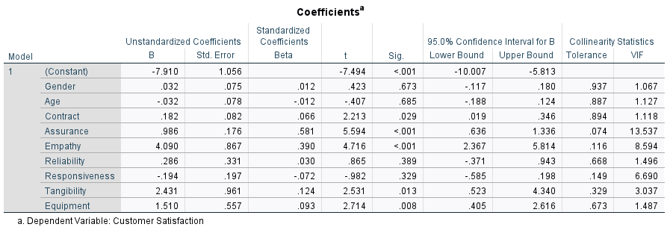
Therefore, multicollinearity is assessed by exploring tolerance and the variance inflation factor (VIF) based on the R square value found by regressing a predictor on all the other predictors in the analysis. Although, from the table, only one independent variable assurance has a full scale of VIF was 13.537, which exceeded the value of 10. Other independent variables do not exceed the value of 10, indicating no multicollinearity based on the scales range of Durbin and Watson, 1971). Therefore, this study has no issue based on the VIF values.

5.1. Model Summary
Table 3 shows the hypothesis testing outcomes, with a good observation of the data point and the R-Square value of 0.928 (92.8%), representing a high significance of the entire variables.

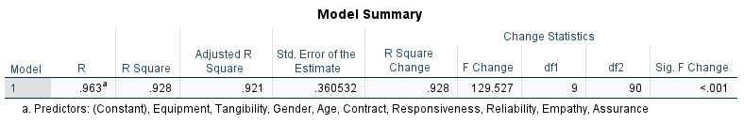
This signifies that the variability observed in the target variable is justified by the regression model. Therefore, the obtained r-square value is 0.928 or 92.8%. Next, the R square is applied to verify the percentage of the impact of the independent variables (QoS dimensions) on changes in the dependent variables (customer satisfaction).

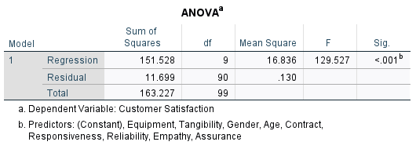

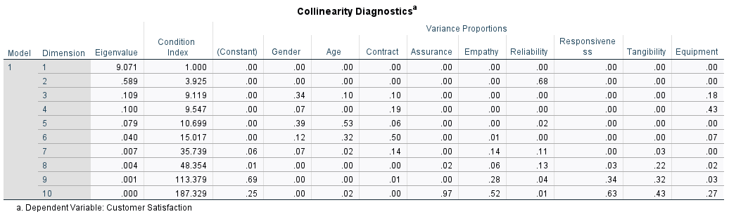
The coefficient correlation affirms that the QoS dimensions have a positive relationship to t values with assurance at 5.594, empathy – at 4.716, and tangibility - at 2.531. In contrast, the control variables of equipment have a t stat value of 2.714 and contract 2.213. These values showed a significant and robust correlation coefficient level.
In addition, the correlation coefficient of each explanatory variable was valued, which implies the specific correlation of the variable with the dependent variable considering that the other independent variables remain steady. The correlation coefficient β sign makes it possible to determine the path of the correlation and the F statistics and the reliability of correctness of the regression., where the p-value (> or < that 1) indicates the significance level with the dependent variable.
We incorporated four control variables, contracts, gender, age and equipment, into the model. The findings were examined among the analysis variables in the correlation matrix. Regarding the control variables, although significant differences were found and the correlation coefficients are strong, it is observed that two of the control variable, equipment and contract, positively influences customer satisfaction. In contrast, age and gender variables do not affect customer satisfaction.

Table 4: Descriptive Statistics and Correlation Matrix
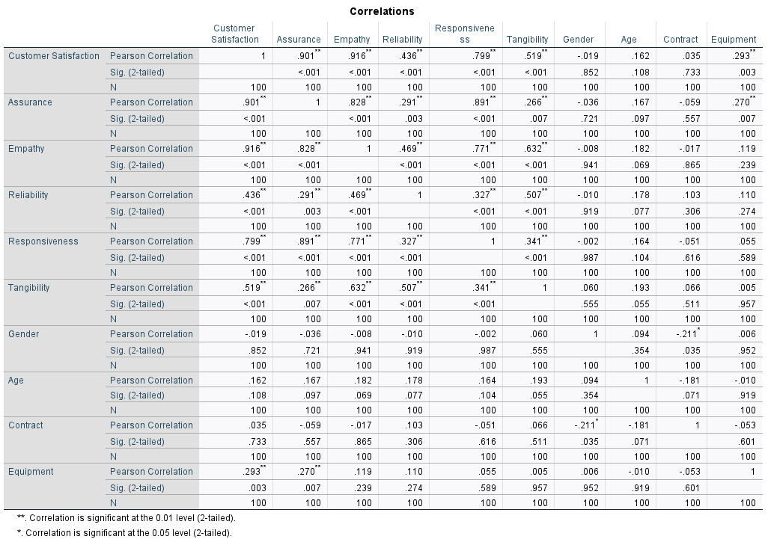

The multiple regression analyses used the five QoS dimensions to substantiate the objective set. The model consists of five independent variables that matched the dimensions contained in the scale, allowing us to measure the perceived QoS – facilities, activities, materials, communication, staff and monitor – with each of the dimensions of customer satisfaction (dependent variable). General customer satisfaction, QoS dimensions of tangibility activities, reliability and responsiveness organisation, assurance of facilities and staff empathy.

5.2 The linear regression results
The multiple linear regression analysis was applied to establish the direction of the linear correlation between the independent variables. The paper examined the relationship between the QoS dimensions, customer contract, gender, age, equipment and customer satisfaction. The hypotheses were evaluated using regression because the dependent variable (y) – customer satisfaction was assumed to be assessed on the scale. Furthermore, using Cohen (1988) determined the criteria for the strength of the relationship among the variables.
The models comprised independent variables (x) that linked to the QoS dimensions in the scale, allowing the paper to evaluate the QoS – assurance, empathy, reliability, responsiveness, and tangibility. We also incorporated customers' contracts, gender, age and equipment into the model as control variables. – with customer satisfaction considered as the dependent variable (y).
Table 5: Linear regression analysis.
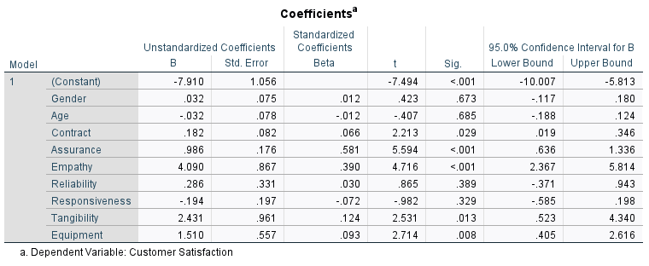
From table 5, the multiple linear regression equation is found as follows: Y = -7.910 + 1.510X. The equation was explained as follows: The constant value (a) is -7.910, implying that if the QoS dimensions and control variables are zero (0), customer satisfaction remains 1.510. The regression coefficient value of the QoS dimensions of equipment variable (b) is 1.510 positive, tangibility variable (b) is 2.431 positive, and empathy variable (b) is 4.090 positive, meaning that for every one unit increase in the equipment, tangibility and empathy variables, customer satisfaction increases by 1.510. From this table 5, we can resolve that the direction of the relationship that equipment, tangibility, and empathy variables have on customer satisfaction has a positive correlation direction which is shown by a positive b value, positive means that there is a positive correlation between equipment, tangibility, empathy and customer satisfaction. These empirical results are consistent with Kaplan et al. (2010) works that allow organisations performing research to participate and directly communicate with customers concerning attitudinal and behavioural reactions toward the relevant offered services and commitment.
From the regression test results in table 5, the calculation results obtained t count > t table 5 (2.714 > 1.500), then H1 is accepted. This means that QoS dimension equipment, tangibility and empathy (X) affect customer satisfaction (Y).
The findings in the regression linked with the correlations let us examine that in the customer satisfaction problem, the QoS dimensions and control variables significantly explain satisfaction with high and significant β values. For this reason, the higher the QoS dimensions, the higher the customer satisfaction experience.
In considering these findings, hypotheses H1, H2, and H3 were confirmed, given that not all QoS dimensions positively and significantly affected customer satisfaction. Therefore, based on these outcomes, it could be assumed that the direction of the relationship that the three QoS dimensions have on the customer satisfaction variable has the direction of a positive relationship.

6. Discussion
The key findings suggest a relationship between expected QoS and customer satisfaction. Additionally, network providers must focus on delivering outstanding QoS that attract new customers and maintain customers using their network. Finally, and more importantly, the dimensions of QoS are more of the soft side of the technical concerns. Therefore, the focus should be on how network providers' telecommunication infrastructures affect QoS.
The QoS in the research context has primarily been at the receiving point of criticisms from subscribers that the network providers have been assumed to be performing poorly. Based on this assumption, the paper sought to explore the QoS of the researched organisation and context. How the QoS dimensions, such as customer expectation and perception, affect prepaid and postpaid customer satisfaction in Nigeria's Telecommunication environment
The discovered results are linked to the dimension structure of the scale that allows the paper to evaluate the QoS dimensions. The Parashurama et al. (1988) SERVQUAL model scale was applied in this paper to explore QoS. The scalable are perceived QoS and expected QoS. These scalable assessed the five dimensions of assurance, empathy, tangibility, reliability and responsiveness. The items in the model scale were based on the 5-point Likert format, as stated.
An excellent QoS would be achieved by deducting the expectation value from the perception value for each item. When perception surpasses expectation, QoS would be suitable, and when perception equates to expectation, QoS is acceptable. However, if the expectation goes above the perception, QoS is unacceptable. Additionally, to strengthen the validity of the hypotheses and research the correlation composition, various regression models were suggested, which consist of the QoS dimensions as independent variables (x). And customer satisfaction as the dependent variable (y) to measure the joint impacts of the independent and control variables on customer satisfaction.
From the results, H1 was confirmed, which considered the positive correlation between the QoS dimension and customer satisfaction. Furthermore, it was established that the correlation in the constant from standardised correlation coefficients is significant at the t stat < 0.001 level. These outcomes align with Murray et al. (2002) and Kyle et al. (2010) assertions that a better QoS level results in better customer satisfaction. The results also indicate that the QoS dimensions are strongly correlated to customer satisfaction, with the most significant variables being assurance (β value 0.986; p-value < 001), empathy (β value 4.09; p-value < 0.001) and equipment (β 1.510; p-value < 0.008). On the other hand, minor significant variables were responsiveness (β - 0.194; p-value < 328) and age (β value - 0.032; p-value < .865). In quantitative research, this reflection corroborates this result. Therefore, Nuviala et al. (2012) argued that the apparent value of 50% satisfaction justified by their model, including the QoS dimensions, is acceptable. Contrarily, the QoS dimensions of tangibility (β value 2.431), reliability (β value .286) and control variables of contract (β value 1.82) are shown in the regression equation. Supporting this result, Manas et al. (2008) discovered that tangible factors are significant predictors of customer satisfaction.

7. Conclusions
Several studies focus on assessing customer satisfaction with the SERVQUAL model scale. However, this paper considered what was discussed by Parashurama et al. (1988) quality dimensions. Therefore, this paper agrees with the assessment and emphasis some conclusions already found from the literature and the collected data.
There needed to be an agreement on the causal correlation between the QoS dimension and customer satisfaction rather than various data perspectives. This is because only some investigations that explored the QoS dimensions are the most valuable form of customer satisfaction. This paper considered the study of QoS in telecommunication in emerging markets as facing more infrastructure challenges that impact QoS.
The finding also has academic implications and is of interest to network providers that deliver QoS in the formation of their customer satisfaction, becoming a critical strategic component for any business. Therefore, network providers must focus on their operational activities towards addressing QoS concerns. This will enable network providers to focus on improved QoS for customer satisfaction, as Suarez et al. (2004) argued that who defines the QoS is the customer through their satisfaction.
Grounded on the multiple regression results, we concluded that the path of the correlation that QoS dimension variables have on the customer satisfaction variable has a positive correlation path indicated by a positive β value; positive signifies that there is a positive correlation between QoS dimension and customer satisfaction. The greater the QoS, the more customer satisfaction will also improve. Therefore, from the hypothesis analysis results, QoS influences customer satisfaction as demonstrated by the calculation results obtained t value counts, then H1 is accepted. This implies that there is an influence of QoS (x) on customer satisfaction (y). The scale of the impact of the independent variables (x) on the dependent variable (y) is positive.

8. Limitation of this paper.
This paper has limitations. Firstly, the critical interactions obtained do not indicate a cause-effect relationship. The reason is based on the design population, the limit to one geographic cluster and coverage, and the purpose of fulfilling my class assignment on quantitative research methods. However, notwithstanding these limitations, the paper has generated substantial results that would make network providers question their deliverable QoS, customer needs and value-added services in the research setting. Therefore, in future research, the paper should focus on all the network providers in Nigeria, as this was only aimed at MTN telecommunications Nigeria.

9. References

Alauddin, Md., Ahsan, S., Md., H., Mowla, M., M., Islam, Md., M. and Hossain M. (2019). Investigating the relationship between service quality, customer satisfaction and customer loyalty in the hotel industry: Bangladesh perspective. Global Journal of Management and Business Research, 1(19), 28-35.

Ali, H., Narulita, E., and Nurmahdi, A. (2018a). Saudi Journal of Business and Management Studies ( SJBMS ) The Influence of Service Quality, Brand Image and Promotion on Purchase Decision at MCU Eka Hospital. Business and Management Studies.https://doi.org/10.21276/sjbms.2018.3.1.12.

Ali, H., Narulita, E., and Nurmahdi, A. (2018b). The Influence of Service Quality, Brand Image and Promotion on Purchase Decision at MCU Eka Hospital. Saudi Journal of Business and Management Studies. https://doi.org/10.21276/sjbms.2018.3.1.12

Ali, B. J., Gardi, B., Othman, B. J., Ahmed, S. A., Ismael, N. B., Hamza, P. A., Aziz, H. M., Sabir, B. Y.,Sorguli, and S., Anwar, G. (2021). Hotel service quality: The impact of service quality on customer satisfaction in hospitality. International Journal of Engineering, 5(3), 14-28.

Ajala, O., and Adesanya, T. A. (2018). Impact of foreign direct investment (FDI) in telecommunications on Nigeria economic growth: a descriptive analysis. Available [Online] from http://www.proceedomgs.academicjournals.org (Accessed: 12 September 2022).
Al Marzooqi, F. A., Hussain, M., and Ahmad, S. Z. (2019). Performance of physical asset management using the analytic hierarchy process. Property Management, 37(3), 327–345. Available [online] from: https://doi.org/ 10.1108/PM-07-2018-0039. (Accessed: 12 October 2022).
Anderson, J.C.; Gerbing, D.W. Structural equation modelling in practice: A review and recommended two-step approach. Psychol. Bull. 1988, 103, 411.

Aremu, M. A., Ademola, O. O., and Aremu, M. A. (2017). Exploring the impact of service quality on customer satisfaction in the Nigerian banking industry. KIU Journal of Humanities, 2(2a), 163-175.

Bigne, E.; Moliner, M.A.; Sánchez, J. Perceived quality and satisfaction in multiservice organisations: The case of Spanish public services. J. Serv. Mark. 2003, 17, 420–442.

Brady, M.K, and Cronin, J.J. (2001) Some new thoughts on conceptualising perceived service quality: a hierarchical approach. J Marketing 65: 34–49.

Burrell, G. and Morgan, G. (2016). Sociological Paradigms and Organisational Analysis: Elements of the Sociology of Corporate Life. Routledge.

Carman, J.M. Consumer Perceptions of Service Quality: An Assessment of T. J. Retail. 1990, 66, 33–55.

Chukalov, K. (2017). Horizontal and vertical integration as a requirement for cyber-physical systems in the context of industry 4.0. Industry 4.0, 2(4), 155–157.

Crotty, M. (1998). The foundations of social research: Meaning and perspective in the research process. 1st ed. London: Sage Publication, Inc.

Cronin, J. and Taylor, S. A. (1992). Measuring service quality: a re-examination and extension. J Marketing 56: pp. 55–68.

Dabholkar, P.A. A contingency framework for predicting causality between customer satisfaction and service quality. Na-Adv. Consum. Res. 1995, 22, 101–108.

Danbatta, K. B. and Zangina, T. (2022). Performance analysis of telecommunications regulations in Nigeria: A quality of service approach. Duse Journal of Pure and Applied Sciences. Available [Online] from: https://doi:10.4314/dujopas.v8i1a.17 (Accessed: 15 October 2022).

Dellermann, D., Ebel, P., Söllner, M. and Leimeister, J. M. (2019). Hybrid intelligence. Business and Information Systems Engineering, 61. 1–7. Available [Online] from https:// doi. Org/ 10. 1007/ s12599- 019- 00595-2. (Accessed: 05 July 2022).

Dubey, R. Rameshwar D., Angappa G. Angappa G. Stephen J C. Thanos P. Samuel F. and Samuel, W. (2017). "World-class sustainable supply chain management: critical review and further research directions." The International Journal of Logistics Management 28 (2):332–62.

Fauska, C. (2022) PRISM Checklist and flowchart – Industry 4.0 solutions for preventive engine maintenance. Figshare. Available [online] from: https://doi.org/10.6084/m9.figshare.20363727.v1 (Accessed: 16 October 2022).

Feng, Y. Qinghua Z. and Kee-Hung L. (2017). "Corporate social responsibility for supply chain management: A literature review and bibliometric analysis." Journal of cleaner production 158:296-307.

Fida, B. A., Ahmed, U., Al-Balushi, Y., and Singh, D. (2020). Impact of service quality on customer loyalty and customer satisfaction in Islamic banks in the Sultanate of Oman. Journals Sage Publication, 3(1), 1-10

Carman, J.M. (1990) Consumer Perceptions of Service Quality: An Assessment of T. J. Retail. 66, 33–55.

Garvin, D.A. (1988). Managing Quality: The Strategic and Competitive Edge; Simon and Schuster: London, UK.

Ghoreishi, M., and Happonen, A. (2020). Key enablers for deploying artificial intelligence for circular economy embracing sustainable product design: Three case studies. AIP Conference Proceedings, 2233(1), 050008.

Grönroos, C. A (1984) Service quality model and its marketing implications. Eur. J. Mark. 18, 36–44. GSMA Green Power for Mobile. (2014). Available online: http://www.gsma.com/mobilefordevelopment/wp-content/uploads/2014/11/Africa-Market Report-GPM-final.pdf (Accessed: 18 July 2022).

Hardt, F. Kotyrba, M. Volna, E. and Jarusek, R. (2021). Innovative Approach to Preventive Maintenance of Production Equipment Based on a Modified TPM Methodology for Industry 4.0. Applied Science. 11, 6953. Available [online] from: https://doi.org/10.3390/app11156953 (Accessed: 16 October 2022).

Hardy, C. William. (2001): QoS Measurement and Evaluation of
Telecommunications Quality of Service. John Wiley & Sons, Ltd.
Baffins Lane, Chichester, West Sussex, PO19 1UD, England. 2001
Hardy, C. W. (2001). QoS Measurement and Evaluation of Telecommunications Quality of Service. John Wiley and Sons, Ltd. Baffins Lane, Chichester, West Susses, England.

Han, Y., Zhen, X.W., Huang, Y., Vinnem, J.E., (2019). Integrated methodology for determination of preventive maintenance interval of safety barriers on offshore installations. Process Saf. Environ. Prot. 132, 313–324.
ITU-T Recommendation E.800: Definitions of terms related to
quality of service
ITU-T Recommendation E.800: Definitions of terms related to
quality of service

ITU-T Recommendation E.800: Definitions of terms related to
quality of service
ITU-T Recommendation E.800: Definitions of terms related to
quality of service
ITU-T (2011) Recommendation E.800: Definitions of terms related to quality of service.

Izuchukwu, O. (2014). Relationship between FDI and Telecommunication growth in Nigeria. Proceeding of the 7th International Conference on Innovation Management.

Kaganova, O., and Amoils, J. M. (2020). Central government property asset management: a review of international changes. Journal of Corporate Real Estate. Available [Online] from: https://doi.org/10.1108/JCRE-09-2019-0038 (Accessed: 12 October 2022).

Kaseke, N., Hosking, S. (2013). Sub-Saharan Africa Electricity Supply Inadequacy: Implications. Eastern Africa Social Science Research Review 29(2), 113-132.

Kamoun, F. (2005). Toward best maintenance practices in communications network management. International Journal of Network Management ·.

Kehinde, A.; Lawan, S.; Adunola, F. and Isaac, A. (2017). GSM Quality of Service Performance In Abuja, Nigeria. International Journal of Computer Science, Engineering and Applications (IJCSEA) Vol. 7, No.3/4.

Koelemeijer, K.; Roest, H.; Verhallen, T. (1993). An integrative framework of perceived service quality and its relations to satisfaction/dissatisfaction, attitude, and repurchase intentions. In Proceedings of the 22nd Annual Conference of the European Marketing Agency, Barcelona, Spain, 25–28; pp. 683–699.

Kotler, P.; Saliba, S.;Wrenn, B. (1991). Marketing Management: Analysis, Planning, and Control: Instructor's Manual; Prentice-Hall: New York, NY, USA.

Kuhn, T. (1996). The Structure of Scientific Revolutions. (3rd ed.). Chicago: University of Chicago.
Kyle, G.T.; Theodorakis, N.D.; Karageorgiou, A.; Lafazani, M. (2010) The effect of service quality on customer
loyalty within the context of ski resorts. J. Park Recreat. Adm. 28, 1–15.
Lee, S. M., Lee, D. H. and Kim, Y. S. (2019). The quality management ecosystem for predictive maintenance in the Industry 4.0 era. International Journal of Innovative, 5(1): 1–11.

Lehtinen, U.; Lehtinen, J.R. (1982). Service Quality: A Study of Quality Dimensions; Service Management Institute: Helsinki, Finland.

Mañas, M.A.; Jiménez, G.; Mayor, J.A.; Martínez-Tur, V.; Moliner, C.P. Los tangibles como predictores de la
satisfacción del usuario en servicios deportivos. Psicothema 2008, 20, 243–248.

Martínez-Tur, V.; Peiró, J.M.; Ramos, J. Calidad de (2001). Servicio y Satisfacción del Cliente: Una Perspectiva Psicosocial; Síntesis Psicología: Madrid, Spain.

Marsrurul, M. M. (2019). Impact of service quality on customer satisfaction in Bangladesh Tourism Industry: An empirical study. Advances in Management, 12(1), 136-140.

Marnovita. (2020). 2020-Service Quality Relationship With Customer Satisfaction. Psychoborneo, Vol 8, No 1, 2020:100-106.

Mclvor, R. (2005). The Outsourcing Process Strategies for Evaluation and Management. United States: Cambridge University.

Mohamed, S. H. (2013). Facilities Management for Construction. Parit Raja : Penerbit UTHM.

Murthy, D. N., Atrens, A. and Eccleston, J. A. (2002). Strategic maintenance management. Journal of Quality in Maintenance Engineering, Col. 8 No. 4, pp. 287–305.

Murray, D.; Howat, G. (2002) The relationships among service quality, value, satisfaction, and future intentions of
customers at an Australian sports and leisure centre. Sport Manag. Rev. 5, 25–43.

National Bureau of Statistics (2022). Foreign direct investment in Nigeria. Telecommunication Sector.

Nuviala, A.N.; Pérez-Ordás, R.; Osuna, M.B.; Grao-Cruces, A.; Nuviala, R.N.; Jurado, J.A.G. Calidad, satisfacción y valor percibido de los usuarios de un servicio deportivo público. Movimento 2012, 18, 11–32.

Oliver, R. (1997). Satisfaction: A Behavioural Perspective on the Consumer; McGraw–Hill: New York, NY, USA.

Oliver, M. (2009). Understanding Disability: From Theory to Practice, 2nd ed.; Macmillan: London, UK.

Oviroh P. O and Jen T. (2018). The energy cost analysis of hybrid systems and diesel generators in powering selected base transceiver station locations in Nigeria. Energies 2018;11:1e20. Available [Online] from: https://doi.org/10.3390/en11030687 (Accessed: 14 July 2022).

Oztemel, E. and Gursev, S. (2020). Literature review of Industry 4.0 and related technologies. Journal of Intelligence Manufacturing. 31(1): 127-182. Available [online] from: https://doi.org/10.1007/s10845-1433-8 (Accessed: 16th October 2022).

Patterson, P.G.; Johnson, L.W. (1993). Disconfirmation of expectations and the gap model of service quality: An integrated paradigm. J. Consumer Satisfaction. Dissatisfaction Complain. Behavioural. 6, 90–99.

Parasuraman A, Zeithaml VA, Berry LL (1988) SERVQUAL: a multiple item scale for measuring consumer perceptions of service quality. J Retailing 64: 12–40.
Parasuraman, A., Zeithaml, V.A. and Malhotra, A., (2005). ES-QUAL: A multiple-item scale for assessing electronic service quality. Journal of service research, 7(3), pp.213-233.

Rahman, E., Management, J., Economics, F., and Gorontalo, U. (2018). The Effect Of The Quality Of Prepaid Electrical Products And Employee Performance On Customer Satisfaction In Pt Pln (Persero) Gorontalo Rayon Telaga Area. Jambura, 1(2).

Raj, M.P.M., A., V. and S., A. (2018). Measurement of Customers' Brand Choice and Brand Loyalty Expectancy Value and Colombo – Morrison Model Approach. Journal of International Business Research and Marketing, 4(1), 24-29.

Paul, G. (2014). The Importance of Cleanliness. Avmor, 1(1), pp. 1–5.

Roberts R. D., Zeidner M., Matthews G. (2001). Does emotional intelligence meet traditional standards for an intelligence? Some new data and conclusions. Emotion 1:196. 10.1037/1528-3542.1.3.196

Sang-Guk, Y. Kim, J. and Son, K. (2020). Natural hazard influence model of maintenance and repair cost for sustainable accommodation facilitates. Sustainability 12(12), 4994. Available [Online] from: http://doi:10.3390/su12124994 (Accessed: 12 October 2022).

Sanjaya, K. E., and Utama, M. S. (2020). Asset management performance in the government of Jembrana Bali Regency. International Research Journal of Management, I.T. and Social Sciences, 7(4), 24–35.

Saunders M, Lewis P and Thornhill A. (2019). Research methods for business students. Eighth edition. London: Pearson.

Schutte N. S., Malouff J. M., Hall L. E., Haggerty D. J., Cooper J. T., Golden C. J., et al. (1998). Development and validation of a measure of emotional intelligence. Personal. Indivi. Diff. 25, 167–177. 10.1016/S0191-8869(98)00001-4

Stanton, W.J.; Etzel, M.J.; Walker, B.J. (1996). Fundamentos de Marketing; Méjico, Ed.; Mc. Graw-Hill: New York, NY,
USA.

Stephens, V. L., Gareth R. W., and Rachel M. (2016). "Problematising the concept of 'sustainability 'in the supply chain through systematic literature review."

Straub, D. Boudreau, M and Gefen, D. (2004). Validation guidelines for I.S. positivist research. Communication of Association for Information Systems, 13, 380-427.

Stoy, C., and Johrendt, R. (2008). Cleaning management of owner-operated real estate. Journal of Facilities, 26(3–4), pp. 131–143.

Smith, C. K. and Anderson, N.J. (2017). Work-related injuries among commercial janitors in Washington State, comparisons by gender. Journal of Safety Research. 62:199-207. Available [Online] from: https://Ini.wa.gov/safety-health/safety-research/ongoing-projects/janitorial-workload-study#publications (Accessed: 12 October 2022).

Suárez, A.D.; Guerrero, L.G. La satisfacción del consumidor deportivo en los servicios públicos. Investig. Mark.
2004, 83, 26–30.

Sudjianto, A. Aditya, C. Halim, A. and Fachrudin, F. (2021). The comparison study of the monopole tower foundation using CPT and laboratory data In Gresik District, East Java, Indonesia. EUREKA: Physics and Engineering, Number 3(3), 127-139. Available [Online] from: https://doi.org/10.21303/2461-4262.2021.001869 (Accessed: 16 October 2022).

Sugeng. (2016). Understanding and Indicators of Customer Satisfaction According to Experts. Https://Etalasepustaka.Blogspot.Com.

Swan, J.E.; Bowers, M.R. (1998) Services quality and satisfaction. J. Serv. Mark. 12, 59–72.

Teran, S. and vanDommelen-Gonzalez, E. (2017). Excessive Workload in the Janitorial Industry. Berkeley: Labour Occupational Health Program: University of California, Berkeley. Available [Online] from: https://Ini.wa.gov/safety-health/safety-research/ongoing-projects/janitorial-workload-study#publications (Accessed: 12 October 2022).

Tessera, F. A., Hussain, I. A., Ahmad N. (2016). Service quality and hotel's customer satisfaction: An empirical evidence from Ethiopia. Electronic Journal of Management, 1(1), 24-32.

The Nigerian Communications Commission. Subscriber Data. (2021). Available online: https://www.ncc.gov.ng/statisticsreports/subscriber-data (Accessed: 18 July 2022).

Tian, L. Zhang, X. and Fu, X. (2020). Collapse simulations of communication tower subjected to wind loads using dynamic explicit method. Journal of Performance of Constructed Facilities, 34(3), 4020024. Available [Online] from: https://doi.org/10.1061/(ASCE) C.F.1943-5509.0001434 (Accessed: 16 October 2020).

United Nations Statistics Division (2022). Ninety-two million Nigerians Lack access to electricity, worst globally. Available [Online] from: https://punchng.com (Accessed: 10 October 2022).

Westbrook, R.A.; Oliver, R.L. (1991). The dimensionality of consumption emotion patterns and consumer satisfaction. J. Consum. Res. 18, 84–91.

Yawar, S. A. and Stefan, S. (2017). "Management of social issues in supply chains: a literature review exploring social issues, actions and performance outcomes." Journal of Business Ethics 141 (3):621.

Zeithaml, V.A. (1991). How Consumer Evaluation Processes Dier Between Goods and Services. In Marketing of Services; Donnelly, J.H., George, W.R., Eds.; American Marketing Association: Chicago, IL, USA. pp. 186–190.

Zhang, C., Chen, R.T., Wang, S.P., Dui, H.Y., Zhang, Y.D., (2022). Resilience efficiency importance measure for the selection of a component maintenance strategy to improve system performance recovery. Reliab. Eng. Syst. Saf. 217, 108070.

Zhong, R. Y. Xun, X. Kloz, and Newman, S. T. (2017). Intelligent Manufacturing in the Context of Industry 4.): A Review. Available [online] from: https://doi.org/10.1016/J.ENG.2017.05.015. (Accessed: 16 October 2022).

Zimmerman, R., Restrepo, C.E., and Simonoff, J.S. (2008) "Infrastructure Disruptions and Recovery Rates in Disasters," ASCE Metropolitan Section Infrastructure Group Technical Seminar "New York City Infrastructure Critical Needs," Brooklyn, NY: Polytechnic University of New York, March 24-25, pp. 28-35.

10. Appendix.



