

Nike Pulse: A Holistic Wellness Strategy
Student Name: Urjefaben Usmanbhai Patel
Student ID: 2504917
Professor Name: Gladius Kulothungan
Module Name: Marketing Management
Module Code: LCMB7024
Term 1

Table of Contents
Element 1 – STDP 3
1. Company Background & New Brand Rationale 3
2. Segmentation 4
3. Targeting 5
4. Differentiation 5
5. Positioning 6
Element 2 – Marketing Mix (7Ps) 6
1. Product 6
2. Price 7
3. Place / Distribution 8
4. Promotion 9
Element 3 – Marketing Strategy Pitch + Poster 10
Poster 11
Element 4 – Reflection 12
References List 14

Element 1 – STDP

1. Company Background & New Brand Rationale
Nike is among the largest brands of sports and lifestyle in the world. It operates in over 190 countries and is reputed to have strong relations with athletes, new thoughts and designs that are performance oriented. Nike has gained a reputation worldwide in the shoes, clothing and sports technology, and it continues to invest in digital applications such as the Nike Run Club and Nike Training Club apps. Such applications demonstrate that Nike is aware that its athletes and ordinary people are interested in digital assistance in training (Jaworek, Karaszewski and Kuczmarska, 2021).
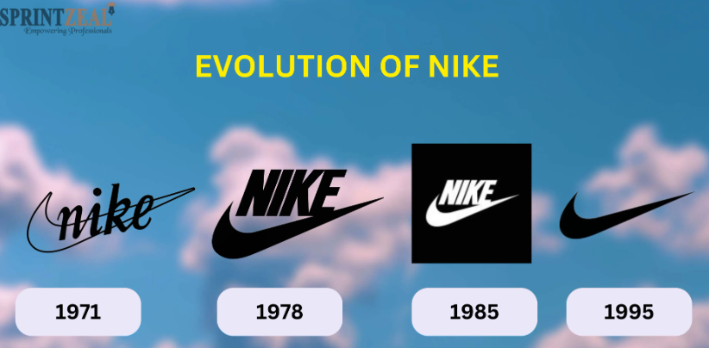
Nike Pulse is another new Nike brand that belongs to the rising market of smart wellness and recovery technologies. It assists individuals to comprehend their body cues, handle pressure, aid in muscle recuperation and enhance general health. Having become health-conscious, monitoring themselves, and using digital fitness after the pandemic, people become more demanding and require personalized knowledge rather than overall guidance. Nike Pulse presents Nike with an opportunity to go beyond performance training to the daily health and wellness.

2. Segmentation
Smart wellness and performance technology can have numerous diverse users that require various things in the market. This market can be made sense of by classifying the users according to their identity, likes, behaviors, and their places (Fabbrizio et al., 2023).
The demographics indicate that the largest users are aged 18-45. They are mostly students, employees and dynamic adults that can spend money. They tend to be of medium to high education level and are well adjusted to purchase of digital products. Psychographic information indicates that these customers are concerned with health, self-improvement, and balance. Most of them wish to be aware of their progress, prevent burnout and remain mentally and physically robust. Their motivation is based on such goals as becoming more fit, less stressed, and learning to understand their bodies.
Behavioural data considers the frequency in which they consume technology products, desired benefits, and their approaches to their fitness. Most users already know their steps, heart rate, or sleep, but they desire something more detailed like how they are ready to recover, the amount of stress they experience, and individual advice. They also prefer apps that do not consume much time and are easy to use and integrate into their routine (Pawełoszek, 2021).
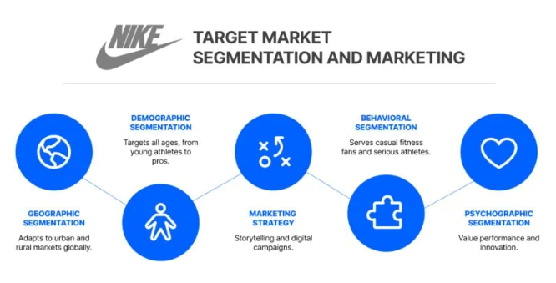

3. Targeting
Nike Pulse targets young professionals, age 20- 35. These individuals are physically active in an exercise but work hard and do not have too much free time. They prefer to be healthy, rest after physical activities, and get things that are convenient. They will use funds to purchase intelligent devices that will enable them to manage their physical fitness as well as their stress. They are familiar with the products of Nike since they already have health or workout apps. Nike Pulse would work well with their lifestyles as it provides them with quick personalized information that will allow them to achieve better and feel better (Bolmgren, 2024).

4. Differentiation
Compared to other devices such as Fitbit, WHOOP, and Garmin, Nike Pulse is the one that is closely associated with the brand Nike. Majority of health gadgets are simply trackers. Nike Pulse puts that data into helpful recommendations that are linked to the workouts and the recovery of the user. The device monitors data on recovery in the body, stress, and provides personalized coaching, which varies depending on the performance of the user on a daily basis. Since it is compatible with the Nike Run Club and Nike Training Club, the device provides recommendations based on the previous training, fitness, and goals of the user (George, Shahul and George, 2023).

5. Positioning
Nike Pulse is an intelligent fitness device that monitors health, recovery, and performance of the day. It is similar in terms of such basic capabilities as heart-rate tracking, sleep monitoring, and sensor insights. These assist Nike Pulse in this competition (George, Shahul and George, 2023).
The brand is meant to be perceived as a quality yet affordable product that can make users feel stronger, healthier and more balanced. Nike Pulse is to be a smart wellness companion that transforms ordinary individuals into motivated performers who are confident enough to take risks by combining technology, restoration, and the Nike spirit in one experience.

Element 2 – Marketing Mix (7Ps)

1. Product
Nike pulse is the new product that allows everyone to get a comprehensive wellness and restoring solution to advance their daily performance and understand the body better. The main advantage of the product is that it will enable individuals to feel healthier, smarter, and balance their physical and mental health. It is also aimed at supporting users with busy schedules and yet would like to remain active and take care of them. Nike Pulse is oriented on performance insights, stress tracking, and customised recovery (Dhesi, 2021).
The product is a light and comfortable wearable, which they can wear on a daily basis. It is made of a soft recycled material flexible band and has a simplistic touch interface. The device has superior sensors that are capable of monitoring the heart rate, stress, muscle fatigue, sleep quality and movement. Nike Pulse is an app that is powered by machine learning to provide they with daily advice depending on what they have done in the past and the habits.
Nike Pulse app is also available on the product and is connected to Nike Run Club and Nike Training Club. Through the app, they are able to do guided breathing exercises, receive customized training suggestions, and perform recovery routines. There is also an option of paying on a monthly basis when they would require more in-depth information about coaching. The design is also sustainable, as it is recycled plastics, uses energy-efficient sensors, and has a low-power design to reduce the environmental impact (Sawhney and Goodman, 2022).
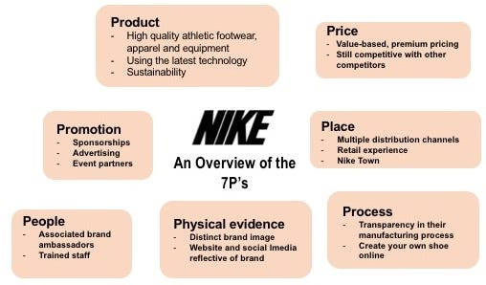

2. Price
One of the reasons why Nike Pulse is sold at a high price is considered a high-quality wellness and recovery tool that offers greater returns than the mere fitness trackers. Its high prices indicate its superior sensors, integration into the Nike system, and customizable coaching capabilities. With a value-based strategy, the customers are paying to get the benefits as well as experience what the product promises instead of the actual device (Gupta et al., 2024).
Similar to Fitbit, Nike Pulse is slightly more expensive, as the device is superior in terms of performance and it also provides additional coaching. It is approximately of the same price as WHOOP or Garmin wellness devices, which are also expensive. This allows Nike Pulse to compete in the high-end wellness segment and remain easy to wear. Pricing gimmick might be applied as well such as adjusting the product to prices of £249 rather than 250 to make the product feel less expensive (Hillen, 2021).
Nike Pulse has also provided a subscription service to users that would receive additional guidance of the users. The subscription is affordable every month in order to continue receiving value without incurring high expenses at a single time. The price will assist the brand to appear high-end, trendy, and relate to the long-term health process of the user.

3. Place / Distribution
The sale of Nike Pulse will be made via selected distribution channels, which would suit its premium appearance. It will be stocked in key Nike outlets where they can test it, test the app, and receive the assistance of trained employees. It will also be sold on the official site of Nike that already has the digital shopping experience with videos and detailed product pages and customer reviews. The primary channel is the online store since the target market prefers purchasing technology products online (Li, 2023).
In addition to the Nike stores, Nike Pulse will be available in some sports shops that specialize on high-performance equipment. These stores already attract a client who is interested in technology and fitness. Nike can also partner with Apple Stores or any other luxury stores to capture people who enjoy purchasing the best technology in trendy locations.
Nike desires to manage the point of sale of the product in order to maintain its premium. It does not prefer the product in discount stores or supermarkets as this would be a blow to its brand. Rather, it will only sell in locations where customers desire good tips and strong brand experience (Chen, 2024).

4. Promotion
Nike Pulse will sell a message that is easy to understand; recover smarter. Perform better.” The idea is to demonstrate to the users how Nike Pulse can assist them in learning about their bodies, enhance their routine, and feel balanced daily. It targets the feelings of power, identity and sense of belonging. Nike has a tendency to inspire its human resources. The reasons why Nike Pulse retains it are that it makes its users take charge of their wellbeing and belong to a positive, active community (Zhavoronkova, 2021).
The prominent component of the promotion will be digital campaigns. Instagram, Tik Tok, and YouTube will be used by Nike to publish real stories of individuals using Nike pulse in their daily lives. In the form of short videos, the main features of the device, such as stress tracking, sleep data, and individual recovery tips, will be displayed. These campaigns will target young professionals and active adults that already browse through wellness, fitness, and lifestyle posts online.
It is also highly dependent on influencer marketing. Nike will collaborate with wellness coaches, lifestyle influencers, and fitness trainers that already use Nike apps or products. They will develop credibility by telling the truth about Nike Pulse and demonstrate how the device will help to integrate into daily life. Athlete endorsements will be more of motivation and brand image rather than of technicality. Athletes with star status could discuss recovery, psychological balance, and training, which proves that wellness is important at all levels (Pekkanen, 2022).
The launch will be done online and physically. They shall give live video demonstrations online and make demos in Nike flagship stores. Partnerships with wellness brands, countdowns, and teaser videos will help to create excitement before the launch. The target group fits in this promotion. They prefer online material, touching narratives, and connections.

Element 3 – Marketing Strategy Pitch + Poster
Nike Pulse is an emerging wellness brand, which assists individuals to enhance balance, create a more akin way of life and enhance everyday performance. The objective of Nike Pulse is to unite personal training, recovery advice, and psychological support into a single integrated technology. It gathers biometric data on smart watches, smart phones, and Nike technology to provide users with explicit advice on stress, rest and overall wellness. This also allows Nike to look beyond physical performance to a more holistic perspective of human performance (Chafic and Dissertation, 2025).
The age of Nike Pulse focuses on individuals between 18-35 years. They could be young professionals or students. They are active individuals, who prefer technology to keep fit, and are concerned with mental well-being and balance. They desire a support that will make use of the data to suit their needs. Nike Pulse would fit very well in their daily digital consumption.
The major advantage of Nike Pulse lies in the fact that it provides a convenient means of maintaining both mind and body. It provides personal training, monitors mood, and customizes workouts based on an individual. The AI wellness platform, the highest-quality guided workouts, collaboration with small-scale influencers and sports psychologists, and short videos on Tik Tok and Instagram that inspire and retain the attention of the youth are the main components of marketing (Mäki, Niina Johanna, 2024).

Poster

Element 4 – Reflection
The Nike Pulse project helped me learn a great deal about the process of marketing. My prior understanding of marketing focused on advertisement and selling. Having done all these, I have now understood that having a good marketing plan begins in learning about people, their needs, and problems they desire to achieve. STDP helped me to understand that it is essential to choose the right target segment and create a product that fits their way of life. I got to know that market segmentation and target selection are not a mere concept that is taught but are involved in all marketing mix decisions (McDougal et al., 2021).
One could not decide what group to concentrate on. It had a lot of options, such as athletes, older adults, students, and busy workers. There were various needs and habits of each group. I also found it difficult to select only one group as I feared that I would miss potential customers. There was also an issue with data that I experienced, particularly, when I attempted to observe wellness, mental health, and digital fitness trends. There were not many facts that could be chosen as the most significant.
I was surprised that branding can influence a complete project. Having worked on Nike Pulse, I was able to understand that a brand is not just a name or a logo, but a promise, a feeling, and an identity. As I was composing the message, product features, and positioning, I noticed that all of that had to be in line with the overall Nike brand personality. It has altered my perception of branding as I was to consider feelings, identity, and what the user’s desire. I also understood that wellness is currently high on the agenda of people, and thus bridging the gap between physical and mental health made the brand even more substantial (Soren and Ryff, 2023).
The development of the pitch helped me know how to express ideas in a concise and clear manner. I was forced to choose the most significant details and outline them in simple words. It encouraged me to consider the target audience, young professionals and people interested in wellness, and how to communicate with them in a manner that will count. The creation of the poster also taught me that pictures and brief phrases make a plan easier to understand and remember.
There are various skills that I developed in the course of this project. I improved my analytical skills by studying the trends in the market as well as analyzing the behavior of various customers. I was able to communicate better by writing and preparing the pitch. I also gained more knowledge on good judgment by selecting good ideas and denying those that did not align with the strategy. Their skills can be applied in various ways in school and work situations as well as not in marketing (McDougal et al., 2021).
In case I were to do this project again, I would dedicate more time to learning customer behavior and examining actual cases in the wellness technology sector. I would also consider more innovative brand concepts prior to making a choice. Lastly, I would rehearse my pitch before being more comfortable and presenting it more effectively. On the whole, this project made me develop both at school and in life.

References List
Bolmgren, N. (2024). Gender in The Age of the Strongman. [online] Lub.lu.se. Available at: https://lup.lub.lu.se/student-papers/search/publication/9152297[Accessed 2 Dec. 2025].
Chafic, N. and Dissertation, K. (2025). Health & Wellness Trends and Business Implications. [online] Available at: https://uniselinus.education/sites/default/files/2025-04/Nadim%20Khattar.pdf.
Chen, T. (2024). A study on nike’s digital marketing strategy based on the 4ps theory and analysis of competitiveness maintenance methods. SHS Web of Conferences, [online] 207(01007). doi:https://doi.org/10.1051/shsconf/202420701007.
Dhesi, A.S. (2021). Sustaining Digital Transformation in the Post-COVID Era: Nike Case Study. [online] dspace.mit.edu. Available at: https://dspace.mit.edu/handle/1721.1/139396.
Fabbrizio, A., Fucarino, A., Cantoia, M., De Giorgio, A., Garrido, N.D., Iuliano, E., Reis, V.M., Sausa, M., Vilaça-Alves, J., Zimatore, G., Baldari, C. and Macaluso, F. (2023). Smart Devices for Health and Wellness Applied to Tele-Exercise: An Overview of New Trends and Technologies Such as IoT and AI. Healthcare, [online] 11(12), p.1805. doi:https://doi.org/10.3390/healthcare11121805.
George, A.S.H., Shahul, A. and George, D.A.S. (2023). Wearable Sensors: A New Way to Track Health and Wellness. Partners Universal International Innovation Journal, [online] 1(4), pp.15–34. doi:https://doi.org/10.5281/zenodo.8260879.
Gupta, U., Somani, P., Behare, N., Mahajan, R., Singh, M. and Iyer, C.A.V. (2024). Revolutionizing Retail. Auerbach Publications eBooks, pp.60–80. doi:https://doi.org/10.1201/9781003458401-5.
Hillen, J. (2021). Psychological pricing in online food retail. British Food Journal, ahead-of-print(ahead-of-print). doi:https://doi.org/10.1108/bfj-09-2020-0847.
Jaworek, M., Karaszewski, W. and Kuczmarska, M. (2021). Source of success of the most valuable sportswear brands in the world. Journal of Physical Education and Sport ®(JPES), [online] 21(2), pp.1050–1056. doi:https://doi.org/10.7752/jpes.2021.s2131.
Li, D. (2023). Investigation and Analysis of Nike Product Marketing Strategy. [online] Available at: https://www.theseus.fi/bitstream/handle/10024/811920/Li%20Dequan.pdf?sequence=2.
Mäki, Niina Johanna (2024). Value proposition for FunWellness. Theseus.fi. [online] doi:http://www.theseus.fi/handle/10024/875539.
McDougal, E.R., Syrdal, H.A., Gravois, R. and Kemp, A. (2021). Telling the tale: applying a strategic brand storytelling process for STP planning. Journal of Strategic Marketing, [online] 31(7), pp.1–21. doi:https://doi.org/10.1080/0965254x.2021.1892803.
Pawełoszek, I. (2021). Customer segmentation based on activity monitoring applications for the recommendation system. Procedia Computer Science, 192, pp.4751–4761. doi:https://doi.org/10.1016/j.procs.2021.09.253.
Pekkanen, E. (2022). Influencer Marketing and Its Impact on Consumer Behavior - Instagram Influencers in the Context of Fitness Industry. aaltodoc.aalto.fi. [online] Available at: https://aaltodoc.aalto.fi/items/1b9dbad2-9cb5-4795-a084-370db553e231.
Sawhney, M. and Goodman, P. (2022). Nike: Tiptoeing into the Metaverse. Kellogg School of Management Cases, pp.1–21. doi:https://doi.org/10.1108/case.kellogg.2025.000036.
Soren, A. and Ryff, C.D. (2023). Meaningful Work, Well-Being, and Health: Enacting a Eudaimonic Vision. International Journal of Environmental Research and Public Health, [online] 20(16), p.6570. doi:https://doi.org/10.3390/ijerph20166570.
Zhavoronkova, A. (2021). SPORT MARKETING AND ITS SOCIAL IMPLICATIONS. REALIZE NIKE SOCIAL MEDIA MARKETING STRATEGY USING IN-DEPTH ANALYSIS ON FOUR SOCIAL MEDIA PLATFORMS. [online] Available at: https://is.vsfs.cz/th/ef1qx/Zhavoronkova_Anna_35543_Sport_marketing_and_its_social_media_implications.pdf.

