Vincenzo Venora
Student ID 2511132

Module number LCLM4005_LON

Lecturer: Dr. Inderjit Grewal
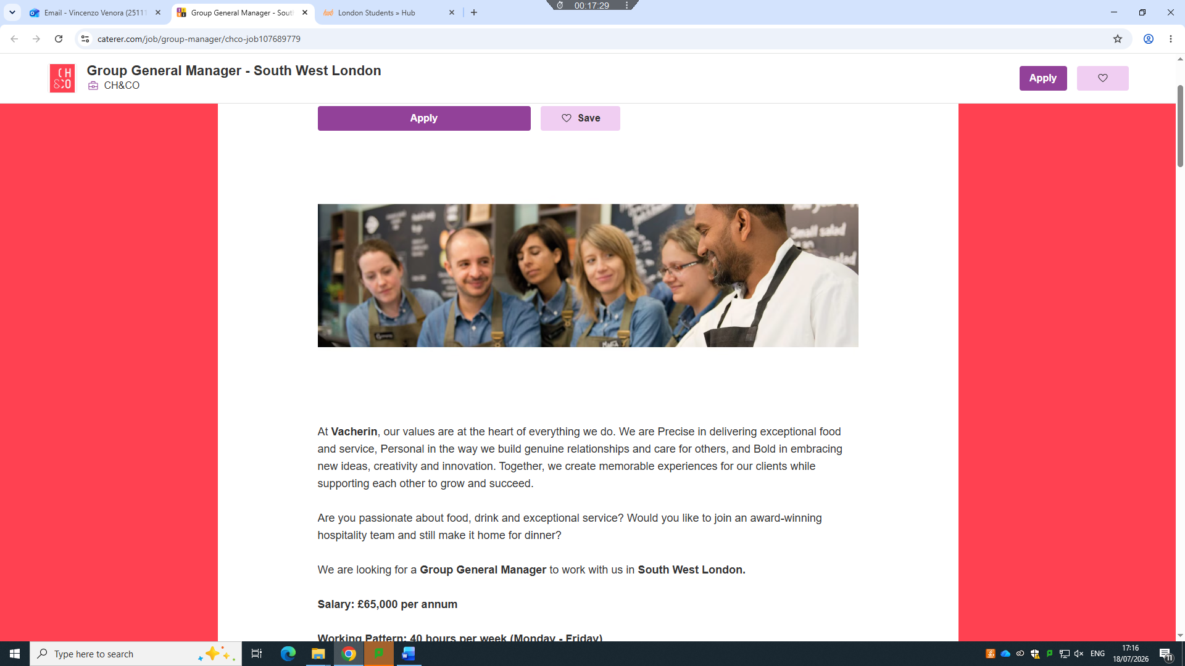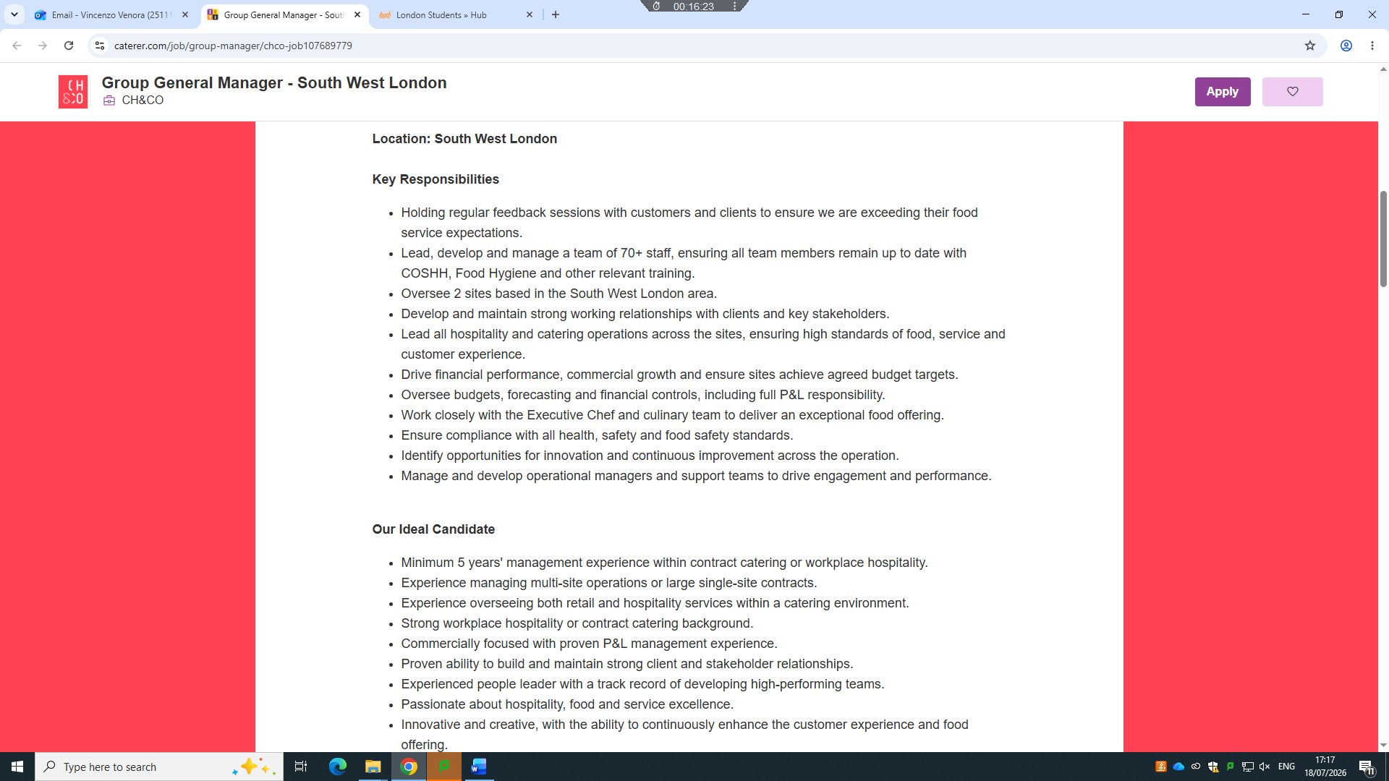

CH&Co Catering LTD Vincenzo Venora
2nd floor, Lydon House, 7 - 12 Tavistock Square, London WC1H 9LT London (UK)
Date 18/07/2026
Dear Hiring Manager,
I am writing to express my interest in the Group Manager position with CH&CO. With over 25 years of experience in hospitality and catering, including the past 10 years in management roles within corporate hospitality, I have developed a strong track record of leading high-performing teams, delivering exceptional client experiences, and driving operational excellence. My current role as Catering Manager at Vacherin, working within the prestigious Moët Hennessy account, has provided me with extensive experience managing corporate hospitality operations, client events, financial performance, compliance, and team development.
I oversee the day-to-day operation of corporate hospitality services and the employee restaurant, leading a team to deliver consistently high standards of service. I manage hospitality events, supplier relationships, stock control, budgeting, recruitment, and staff development while ensuring full compliance with Health & Safety, Food Safety, HACCP, and allergen legislation. Building strong relationships with clients and responding proactively to their needs has been fundamental to maintaining excellent service standards and identifying opportunities to enhance the customer experience.
Throughout my career, I have successfully managed teams of varying sizes across corporate catering, luxury hotels, restaurants, and bars. I am passionate about developing people, creating positive working environments, and leading by example. I believe that investing in people is the key to delivering outstanding hospitality and achieving long-term business success.
I am particularly attracted to CH&CO because of your reputation for delivering exceptional hospitality through innovation, quality, and strong client partnerships. I share these values and would welcome the opportunity to contribute my operational expertise, commercial awareness, and leadership skills to your business. I am confident in managing multiple priorities, maintaining high standards across operations, and ensuring both client and customer expectations are consistently exceeded.
I would welcome the opportunity to discuss how my experience and enthusiasm align with the Group Manager role and how I can contribute to the continued success of CH&CO. Thank you for taking the time to consider my application. I look forward to hearing from you.
Yours faithfully,
Vincenzo Venora

VINCENZO VENORA  Contact  LONDON, UK  2511132@student.uwtsd.ac.uk  Skills  • Team Leadership & Development  • Hospitality & Event Management  • Stock & Cost Control  • Multi-site Operations  • Client Relationship Management  • Budget & P&L Management  • Health & Safety & Food Safety Compliance  •Staff Recruitment & Training  • Customer Service Excellence  Languages  • Italian Native  • English Fluent  • Spanish Intermediate  Licenses  • Full Uk Driving License  Qualification and Training  • Business Skills for the Workplace L4 9/2026-Prersent  • Food Hygiene L3  5/2025  • Health & Safety Level3 6/2025  • Diploma Level 2 in Team Leading 9/2018  • WSET Level 2 Award in Wines & Spirits 6/2016  • High School Diploma 6/1995 (Italy) | PROFESSIONAL SUMMARY  Highly accomplished Hospitality and Catering Manager with over 25 years' experience leading operations across corporate catering, hospitality, luxury hotels, restaurants, and bars. Proven track record of managing high-performing teams, delivering exceptional client experiences, and driving operational excellence within fast-paced environments. Experienced in overseeing hospitality operations, event management, financial performance, stock control, budgeting, and supplier relationships while ensuring full compliance with Health & Safety, Food Safety, HACCP, and company standards. A confident and approachable leader who excels at developing teams, building strong client relationships, and consistently delivering high-quality service and commercial results.  EMPLOYMENT HISTORY  Vacherin (Moët Hennessy Catering Manager),  London | 10/2021– Present  • Manage the day-to-day operation of corporate hospitality services and the employee restaurant.  • Lead and develop a team, ensuring consistently high standards of service and operational excellence.  • Plan and deliver weekly hospitality events and client functions.  • Manage food purchasing, supplier relationships, stock control, and monthly stock takes to achieve budget targets.  • Recruit, train, schedule, and supervise agency and permanent staff.  • Ensure full compliance with Health & Safety, Food Safety, HACCP, allergen legislation, and company policies through regular audits and staff training.  • Produce monthly hospitality reports, client billing, and financial reconciliations.  • Build strong relationships with clients, responding proactively to requests and identifying opportunities to enhance service delivery.  Vacherin (CBRE Hospitality Manager),  London | 06/2016–11/2021  • Supervised hospitality operations and events for up to 300 guests.  • Managed a team of 8, including recruitment, training, and weekly rotas.  • Managed stock control, monthly stock takes, and supplier ordering.  • Delivered staff training to maintain exceptional service standards.  • Ensured compliance with Health & Safety and Food Safety procedures.  The Exhibitionist hotel (Bar Manager),  London | 10/2014–05/2016  • Managed the day-to-day operation of the hotel bar and restaurant.  • Led a team of 4, including scheduling, training, and performance management.  • Managed stock control, ordering, and monthly stock takes.  • Designed seasonal cocktail menus and pricing strategies.  • Delivered staff training to improve service standards  Clubino Within Hotel Baglioni (Assistant Bar Manger), London|12/2012–10/2014  • Assisted the Bar Manager with the day-to-day operation of a luxury hotel bar.  • Delivered VIP bottle service to high-profile guests.  • Assisted with stock control, ordering, and monthly stock takes.  • Prepared cocktails and delivered cocktail masterclasses  • Managed and trained a team of 10 staff.  Travel And Bar Tendering| 10/2011–12/2012  • Supported the opening of a new nightclub in Ibiza  • Worked as a bartender in Dubai, including at the Abu Dhabi Grand Prix.  • Assisted with the launch of new hospitality venues in London, including Double Frank and The Boadicea.  Brompton quarter caffè (Bartender) London| 05/2009–10/2011  • Prepared and served a wide range of hot and cold beverages, including classic and signature cocktails.  • Operated cash tills and processed customer transactions accurately.  • Provided table and bar service while delivering excellent customer care.  •Maintained cleanliness and presentation of the bar area.  Häagen-Dazs (Kitchen Team Leader) London|12/ 2003–05/2009  • Managed, trained, and motivated a team of 15 staff.  • Ensured compliance with Food Safety, HACCP, and Health & Safety legislation.  • Carried out daily opening and closing procedures, including equipment checks and stock replenishment.  • Prepared and served a wide range of hot and cold beverages, including classic and signature ice cream sundaes  Ata hotels Naxos Beach (Bartender)Sicily| 04/1997–10/2003  • Prepared and served a wide range of hot and cold beverages, including classic and signature cocktails.  • Prepared and served light meals and bar snacks while maintaining high food quality and presentation standards.  • Assisted with the planning, setup, and delivery of events, banqueting functions, and private hospitality.  • Delivered exceptional customer service in a fast-paced hotel environment.  • Maintained high standards of cleanliness, hygiene, and food safety throughout the bar and service areas.  • Carried out daily opening and closing procedures, including equipment checks and stock replenishment.  • Assisted with the preparation and delivery of weddings, conferences, and banqueting events.  References available upon request

