Smart Energy Solutions – Smart Temperature Monitoring System
Jasitharan Kugathasan, P151435, Computer Networks and Cybersecurity; Module: Smart and connected device 2, Lecturer: Prof John Rees
Table of Contents
I. INTRODUCTION 1
II. ENERGY SOURCES 2
A. Renewable 2
1) Solar Energy 2
2) Wind Energy 2
3) Hydro Energy 2
4) Tidal Energy 2
5) Geothermal Energy 2
6) Biomass Energy 2
B. Non – Renewable 2
1) Fossil Fuel 2
2) Nuclear Fuel 2
III. SMART ENERGY SOLUTION 2
A. Transportation 3
B. Environment 3
C. Health Care 3
D. Hospitality 3
E. Energy and Utilities 3
F. Retail 3
IV. DESIGN AND IMPLEMENTATION 3
A. Sensor Client 4
B. End Client 4
C. Server 5
V. CONCLUSION 5
VI. Bibliography 5

Figure 1: Smart Energy Systems [7] 3
Figure 2: Smart Temperature Monitoring System 4
Figure 3: Sensor Client 4
Figure 4: End Client 4
Figure 5: Server 5

Abstract—The Smart Energy solution helps cities around the world overcome the difficulties of increasing demands of energy resources. The most cities all over the world under pressure due to increase in population. Due to increase in population, a lot of energy resource needed to utilize the technology and innovations. Automation of things could reduce consumption energy according to its needs and reduce human work load. [1] This report consists of research on “ How digitalization could relieve the stress on overstrained services and resources” The report also consists of design and implementation of Smart Temperature Monitoring System. The Smart Temperature monitoring system, which reduce human workload by automation of its control accordingly to it temperature level and by reducing energy consumption. This smart temperature monitoring system which check the temperature level of the building and accordingly adjust the heat settings, this smart temperature monitoring systems work with the help of time management. Once time scheduled the system begins its automation. The Smart temperature monitoring system which can be used by universities, schools, house and office etc. Individual implementation of this smart temperature monitoring systems could save overall energy consumed by the world. Automation in every sector could fully relieve overloaded service and resources.

INTRODUCTION

The world today facing challenges with energy recourses as the demand increases. The energy production can be categorized in to two, which is renewable and non-renewable source of energy. The energy produced by renewable source are less impact to environment, humans and other lives compared to non-renewable source. [2] This report consists discussion about types of energy sources and its impact, and research on smart energy solution. The smart energy solution is relief, which could reduce the usage of energy and automate things, which also reduce the human workloads. Automation of things are achieved using Internet of Things with sensors. The Internet of things are used in many sectors such as construction, transportation, manufacturing, health care and consumer electronic. [3] This report also contains Smart Temperature Monitoring System design and implementation of its working prototype, this prototype automate the heating system and light system to turn on or off. The Smart Temperature Monitoring System is designed for universities, schools and offices. Smart Temperature Monitoring System consists of hardware implementation and software implementation. The hardware implementation using computer, Gateway, Wi-Fi enabled nodeMCU ESP8266 microcontroller, DHT11 temperature sensor, photoresistor sensor, PIR motion sensor, RGB LED module and relay module. The software implementation is using C programming language and JAVA programming language. The microcontrollers are programmed with C and server is programmed using JAVA. The working structure is implemented with two NodeMCU ESP8266 which act as client. client 1 nodeMCU is connected with temperature sensor, PIR motion sensor and photoresistor sensor and client 2 nodeMCU connected with RGB LED and relay module. The client 1 sends the sensor data to the server. The server receives the data and processes, then server sends turn on or turn off instructions to client 2 to turn on or turn off the RGB LED and relay.

ENERGY SOURCES

The energy is produced by many sources, these sources are classified in to two, renewable and non-renewable source of energy. Advantage of renewable source of energy, it doesn’t pollute the environment. These renewable sources of energy could be obtained by naturally. Disadvantages of renewable source of energy, which require high maintenance of its equipment’s used for energy consumption. The renewable source of energy produces low energy compared to non-renewable source of energy; weather may impact the energy production of energy. The non-renewable source of energy is produced in high compared to renewable source. Non-renewable energy affects the environment when producing energy. Fossil fuel are used mostly to produce energy, due to usage of fossil fuel climate of earth is changing constantly. Fossil fuel are non-renewable source of energy. [4]

Renewable
Renewable energy is obtained from natural source. These natural sources of energy can be obtained from Biomass energy, Geothermal energy, Tidal energy, Hydro energy, wind energy and solar energy.

Solar Energy

Solar energy is obtained from sunlight. These solar energies available in large amount that could power the planet but due to weather conditions and geographical location, energy could differ.

Wind Energy

Wind energy are obtained from wind using wind turbines, these wind turbines rotate to wind direction and speed. Wind turbines are connected to generator to generate electricity.

Hydro Energy

Hydro energy is developed commercially by building barrier or dam to control water flow. Hydro energy is generated rotating turbine when water flows.

Tidal Energy

Tidal Energy uses the concept of Hydro energy, instead of water flow, it uses tidal current to rotate the turbine.

Geothermal Energy

Geothermal energy is obtained from below the surface of earth. Heat from the earth surface produces dry steam, these dry steams are used to rotate electric generator to generate electricity.

Biomass Energy

The plant materials are used in making solid fuel, solid fuel then converted into electricity. Biomass energy can be generated in lower economic and environmental cost. Conversion of domestic waste, industrial waste and agriculture waste into gas fuel, liquid and solid. [5]

Non – Renewable

Non-renewable energies can’ be renewed, the way energy produced using non-renewable source are harmful to environment and to lives of earth.

Fossil Fuel

Fossil fuel are primarily coal, hydrocarbon, fuel oil or natural gas. These fossil fuels are burned to generate steam to rotate turbine that produce electricity. Burning the carbon fuel, it produces carbon dioxide which lead to climate change. Burning of fossil fuels also causes acid rain.

Nuclear Fuel

Nuclear fuel generates electricity by producing steam by the process of heat generated by nuclear fission. These hot steams produced by nuclear fission rotate the turbine to produce electricity. [6]

SMART ENERGY SOLUTION

In section “Energy Source”, discussed about source of energy produced and way it affects the environment and lives on earth. The usage of energy is high in demand now a days, the demand of energy will be increasing in future due to technology and innovation. How could this energy needs can be satisfied? These energies can be satisfied by finding new ways of producing more energy without any harm to environment and lives. Utilizing the energy wisely according to the need. It is important to minimize the usage of energy. minimizing the usage of energy could save energy from getting wasted unwantedly. This minimizing usage of energy can be achieved with smart energy solution.

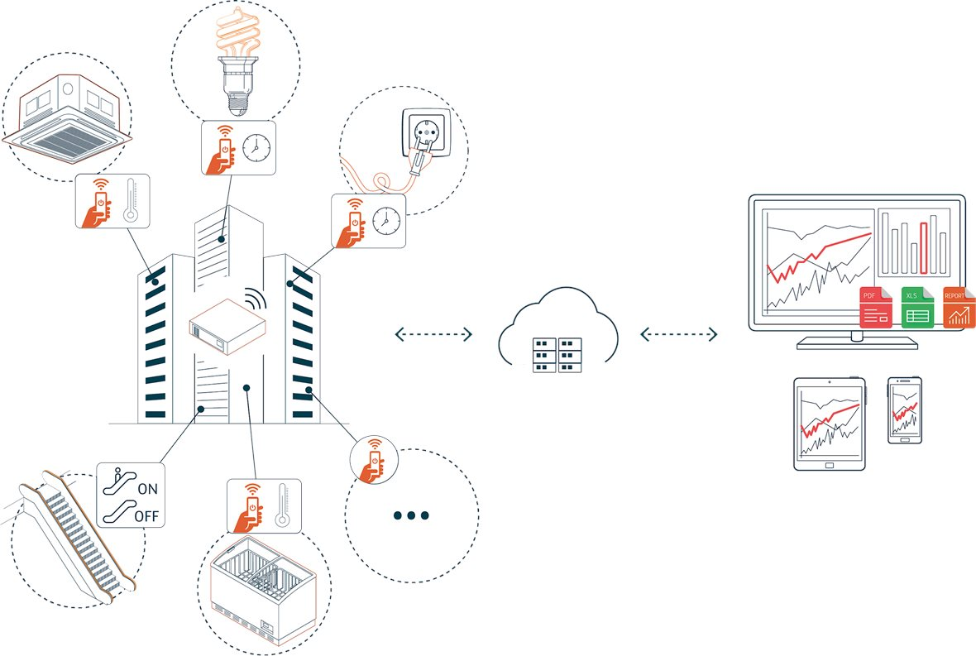
Figure 1: Smart Energy Systems [7]

With the help of automation using Internet of Things. For example, if a light is turned on unwantedly, this burns the energy. This light could be monitored using Internet of Things device which can turn on the light when it needs or when it is dark. These smart energy solutions can be used in many sectors, for example Transportation, Environment, Health care, Hospitality, Energy and utilities and retail.

Transportation

Internet of Things are used in transportation to monitor the real time of transport vehicles using GPS tracking device. This can be used in buses to monitor the waiting time information’s. Internet of things helps in monitoring real time traffic and analyze the data to do traffic control smarter to prevent congestion.

Environment

Internet of Things can be used in environment sector to monitor the pollution and reduce CO2 emission. This can also be used to check any water leakages in pipes running around the cities. Agriculture is advanced with the help of IoT. It helps in irrigation and soil managements. [8]

Health Care
IoT device are used in health care to monitor patient’s safety and health. IoT device are designed as wearable fitness band, wireless monitor of patient’s their glucometer, heart rate and blood pressure etc. wireless.

Hospitality

IoT device is not only used in monitoring patient’s in hospital. It is used even in tracking real time location tracking of medical equipment’s such as defibrillator, wheelchair, nebulizers, oxygen pumps etc. IoT device can also monitor hygiene which help’s prevention from patients getting infected. Drones are used to delivery medical kits which save human workload and lots of energy. management of medical equipment’s and drugs are bigger challenges to health industry, these are managed well by IoT device and utilized efficiently. [9]

Energy and Utilities

Internet of things help connect power production elements and consumption, it helps in real time monitor and control. IoT technology helps renewable source of energy if efficient way. Wind turbines produce energy using rotating the turbines, the turbine rotate to wind direction. Wind are not always in same direction. IoT sensor can be used to detect the wind direction and turn the wind turbines. Household can use green power energy by implementing solar and wind energy solution, reducing the conventional power supplies. This green power implementation requires good IoT energy and infrastructure. IoT device can be used to monitor the usage pattern of energy in household or in building etc. to find out the wastage of energy, which could be unused appliances or unnecessary heating system, cooling system and lighting system. [10]

Retail

IoT takes retail to the next level by saving cost, time and energy. IoT are used in retails to monitor track assets, food safety, customer satisfaction and supply chain. [11]

DESIGN AND IMPLEMENTATION

The Smart Temperature Monitoring System is designed with temperature sensor, Light Sensor and Motion sensor. When temperature drop to minimum it turns on the heater. Light sensor is used to turn on the light when it is dark and motion sensor also implemented with light sensor to turn on the lights when there is motion. It turns the light only when it is dark and when there is motion. This can be used in university, office, school and house etc. This is a scheduled system which works only when time are scheduled. When a time is scheduled, it turns on the system until the scheduled task is end.

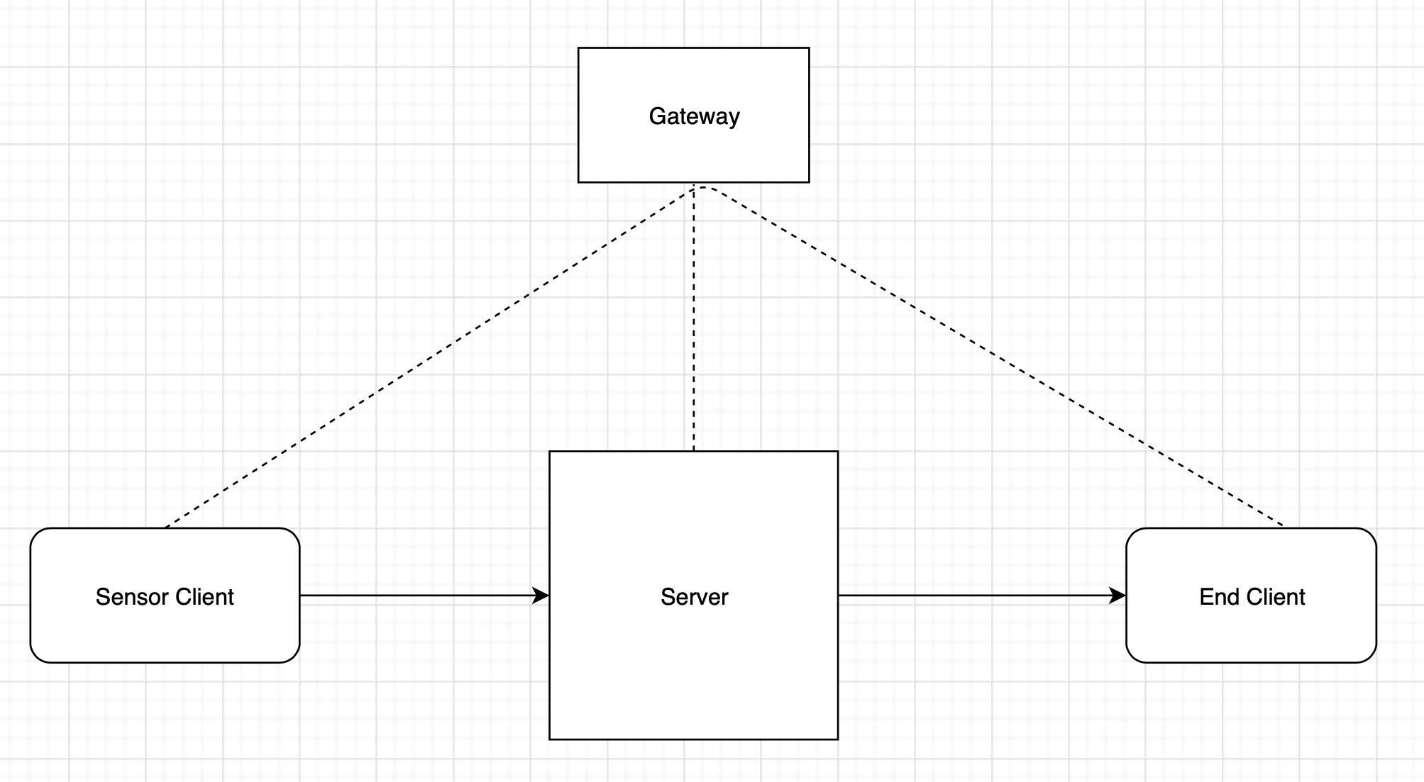

Figure 2: Smart Temperature Monitoring System
The figure 2 shows Sensor Client, which sends all the sensor data to Server, Server process the data and send an integer value to End Client. According to the integer value received, the End client turns on or off the particular device connected with End Client.

Sensor Client

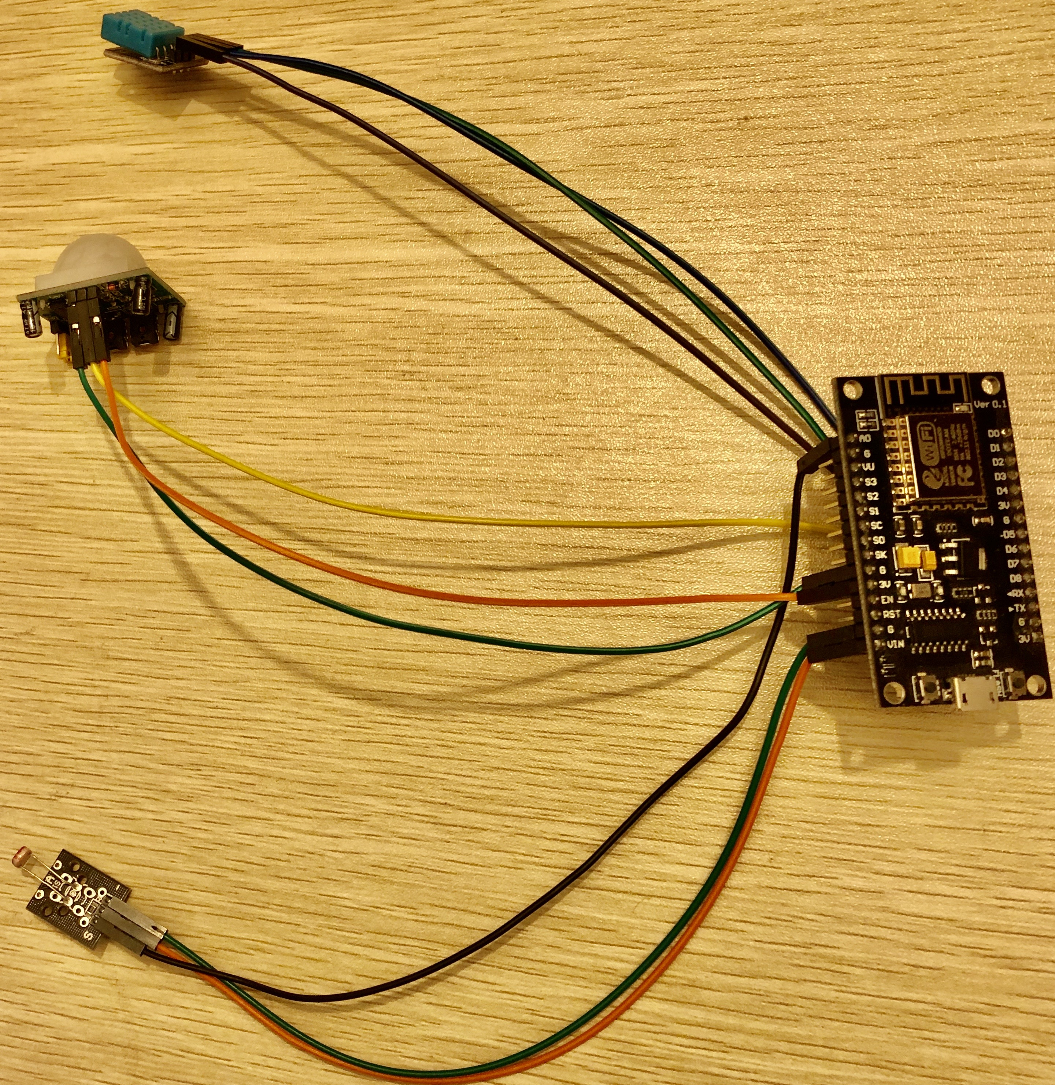
Figure 3: Sensor Client

The figure 3, show’s Sensor client which is programmed with C language. NodeMCU ESP8266 Version 1 Wi-Fi enabled. NodeMCU ESP8266 act as Sensor Client connecting the DHT11 Temperature sensor, Photo-Resistor and HC-SR501 PIR Motion Sensor. The exact reading from each sensor are send to the Server.

Pin Map

DHT11 Temperature Sensor:
DHT11 VCC Pin connected to ESP8266 3V Pin
DHT11 GND Pin connected to ESP8266 GND Pin
DHT11 DATA Pin connected to ESP8266 D5 Pin

Photo-Resistor:

Photo-Resistor VCC Pin connected to ESP8266 VIN Pin
Photo-Resistor GND Pin connected to ESP8266 GND Pin
Photo-Resistor DATA Pin connected to ESP8266 A0 Pin

HC-SR501 PIR Motion Sensor:

PIR VCC Pin connected to ESP8266 3V Pin
PIR GND Pin connected to ESP8266 GND Pin
PIR DATA Pin connected to ESP8266 D7 Pin

End Client

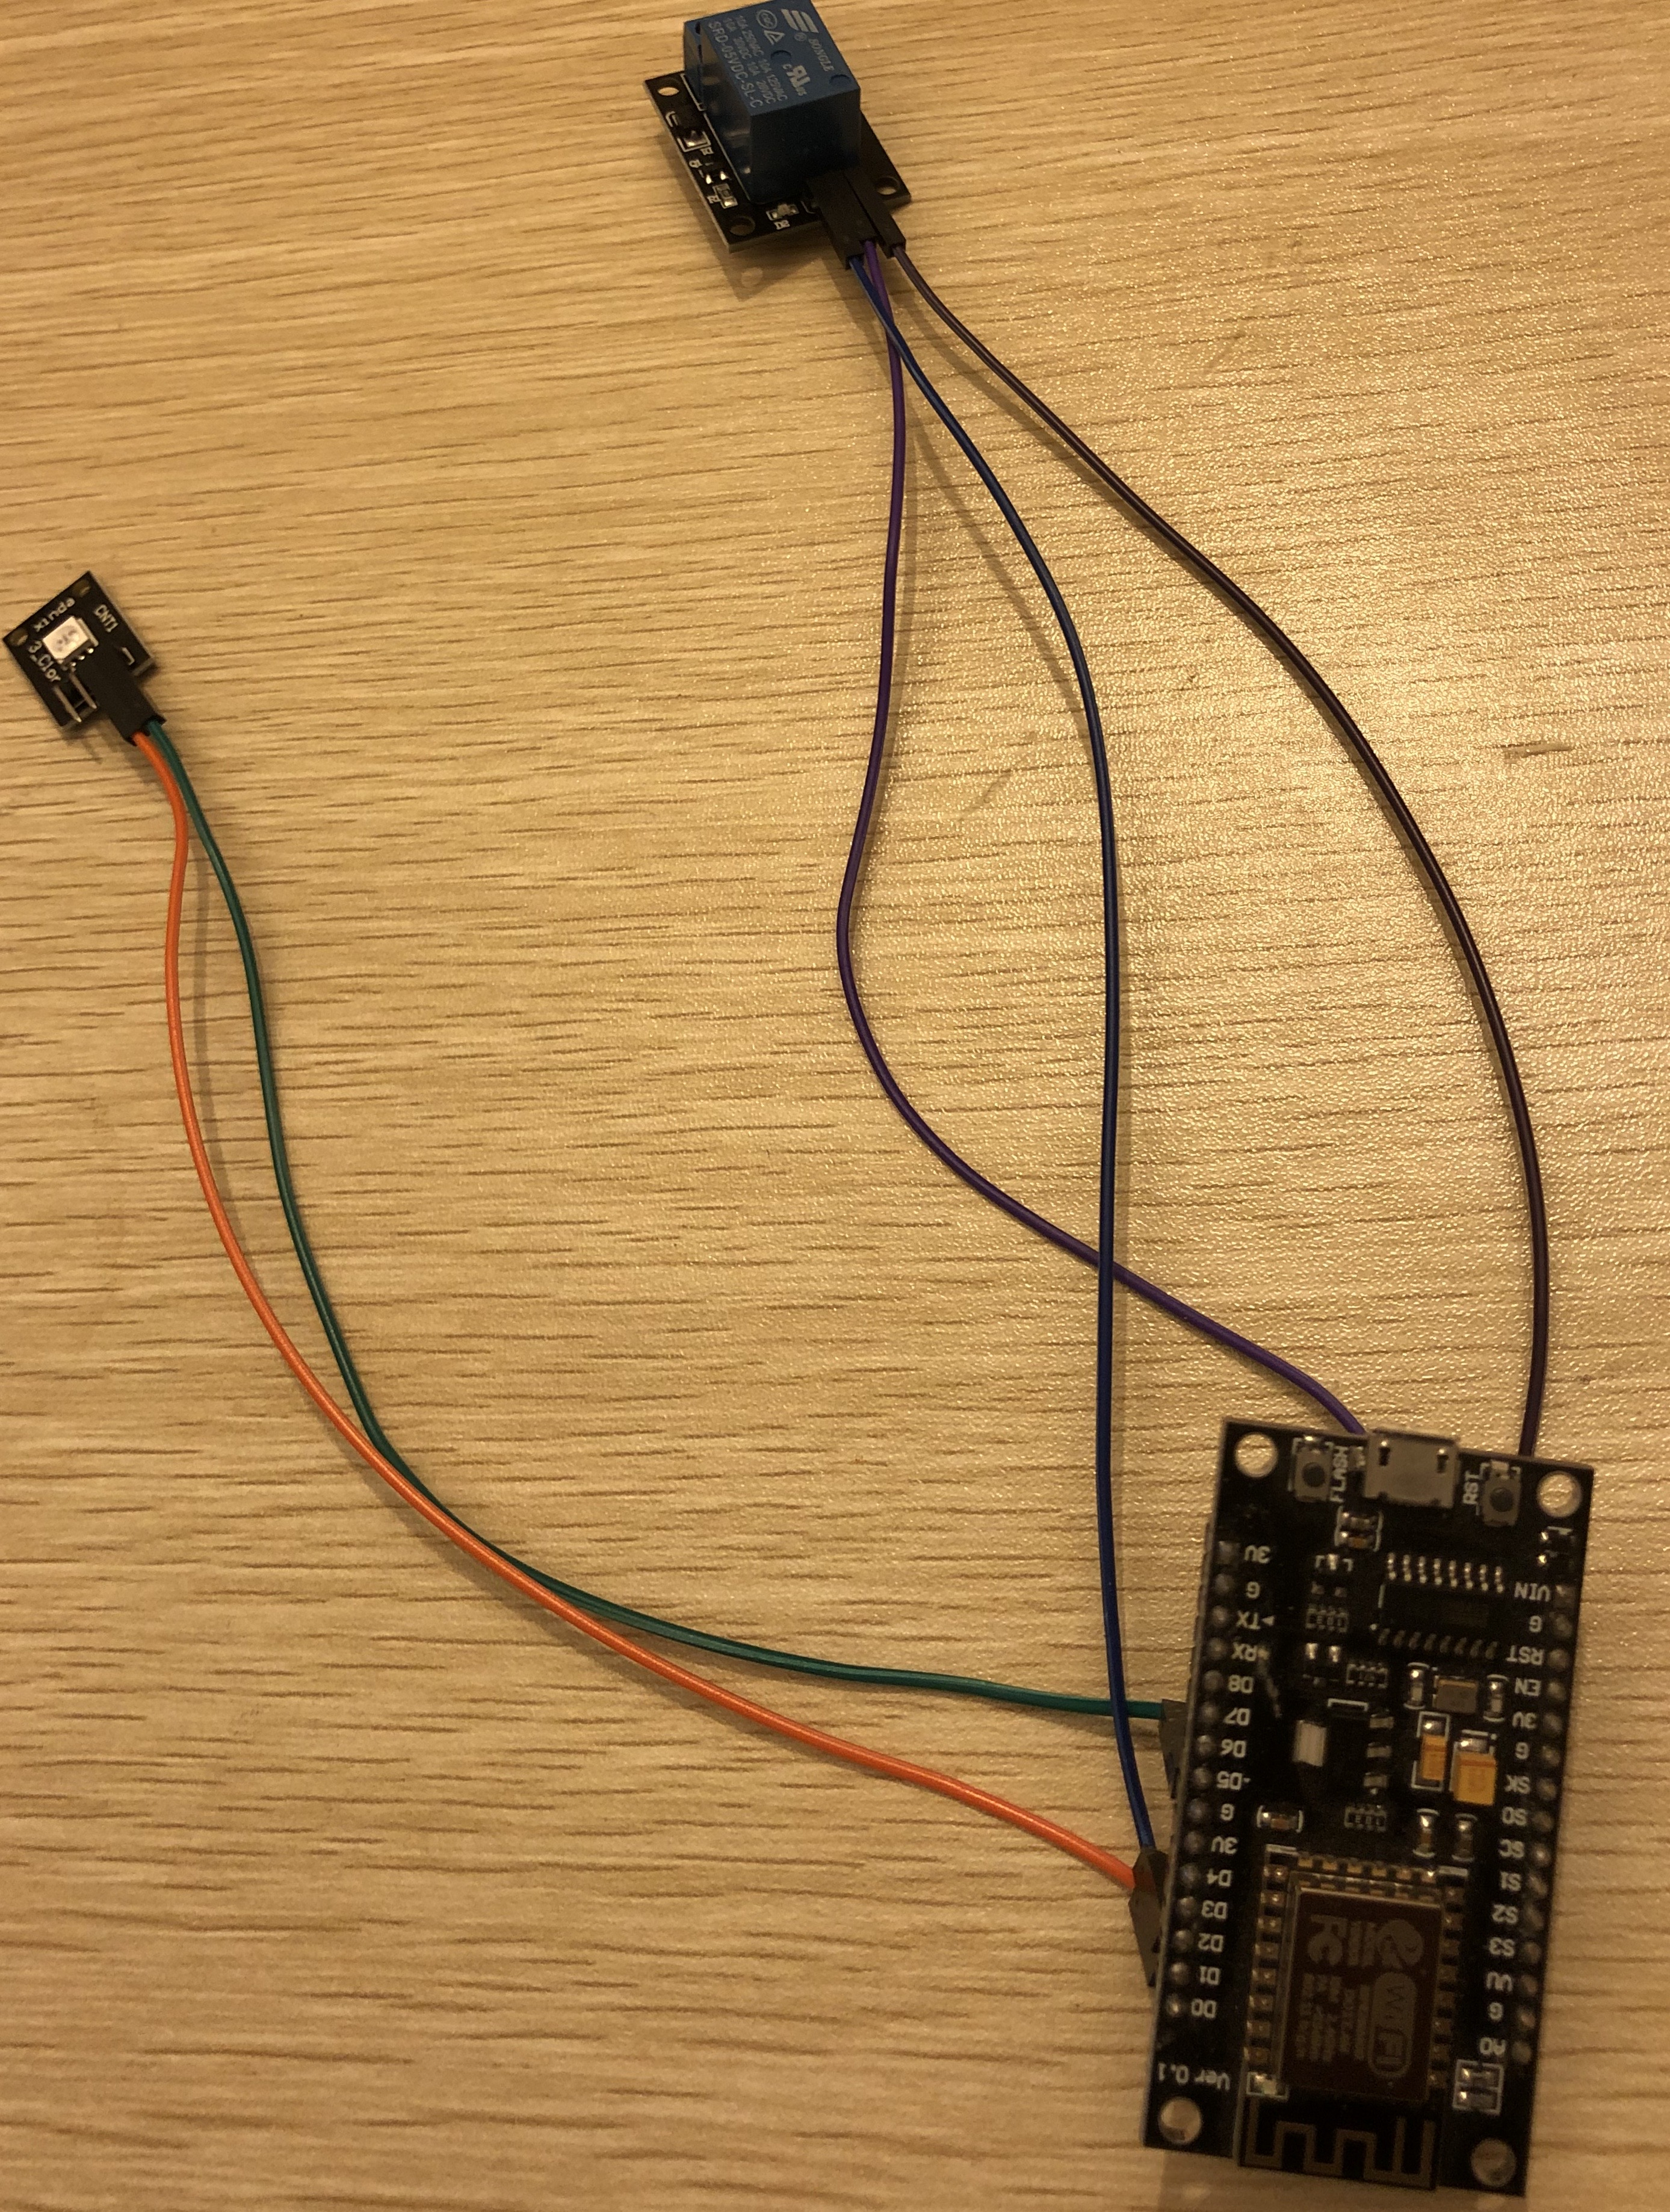
Figure 4: End Client
The figure 4 shows End Client which is programmed with C language. NodeMCU ESP8266 Version 1 Wi-Fi enabled. NodeMCU ESP8266 act as End client which receives assigned integer value from the server to turn ON or OFF the particular device. End Client is connected with relay module which represent the heater and RGB LED Module is connected representing the light. Assigned integer values that turns ON and OFF each module.

Integer Value “1000” turns ON the Relay Module.
Integer Value “2000” turns ON the RGB LED Module.
Integer Value “3000” turns ON the Relay and RGB LED Module together.
Integer Value “0” turns OFF the Relay and RGB LED Module.

Pin Map

Relay Module:

Relay VCC Pin connected to ESP8266 3V Pin.
Relay GND pin connected to ESP8266 GND Pin.
Relay DATA pin connected to ESP8266 D1 Pin.

RGB LED Module:

RGB GND Pin connected to ESP8266 GND Pin.
RGB DATA Pin connected to ESP8266 D0 Pin.

Server

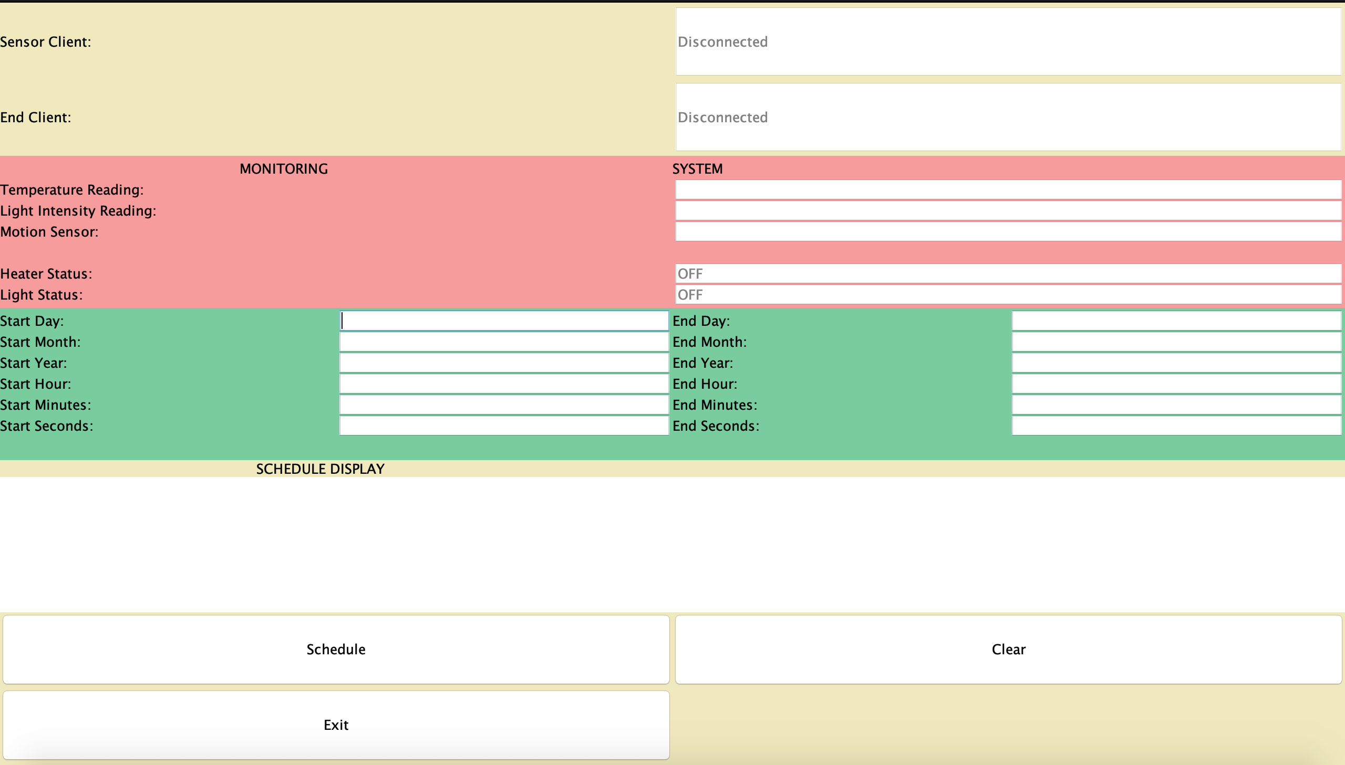
Figure 5: Server
The figure 5 shows the Server. Server is programmed with JAVA programming language. The value received from Sensor Client processed in server. If the temperature falls under 25-degree, the Server assign an integer value of “1000” and send it to End Client to turn ON the Relay Module. If the light intensity is more than 10 and PIR Sensor Value is 1, then the Server assign an integer value of “2000” and send it to End Client to turn ON the RGB LED Module. If the temperature falls under 25-degree, light intensity is more than 10 and PIR Sensor value is 1, the Server assign an integer value of ”3000” and send it to End Client to turn on the Relay Module and RGB LED Module together. If Server sends an integer value of “0” then End Client turns OFF the Relay Module and RGB LED module.

The graphical Interface, it contains Sensor Client and End client status. Monitoring System Temperature Reading, Light Intensity Reading and Motion Sensor reading. It shows the status of heater and light.

The schedule system consists of start date to end date and start time to end time. This schedule system performs only a single task, it can only be scheduled once. When ending the scheduled task, it shuts the server down. The server needs to be run again to reschedule or re-monitor. The Start Month and End Month input field accept only integer value. For example
January input value 0, February input value is 1, March input value is 2, April input value is 3, May input value is 4, June input value is 5, July input value is 6, August input value is 7, September input value is 8, October input value is 9, November input value is 10 and December input value is 11. The schedule display show if any task is scheduled.

CONCLUSION

The report consists of analysis of energy source and to save energy with smart energy solutions. Considering smart energy solution, design and implementation of Smart Temperature monitoring System included with this report. Smart Temperature Monitoring System hardware implementation using NodeMCU ESP8266 version 1, DHT11 Temperature sensor, Photo-Resistor sensor, HC-SR501 PIR Motion Sensor, Relay Module and RGB LED Module used in this implementation is not high-quality electronics, it does give false reading sometimes. These electronics used in this implementation is for the purpose of demo. The Software implementation with C programming language and java programming language. Two clients are programmed with C and Server is programmed with Java. The server implementation only supports single schedule task and no validation implemented for user input text fields. The server could be developed with supporting multi schedule task system. This implementation just contains two clients communicating with the server. Due to less clients communicating, multithreaded server not implemented. Multithreaded server could be implemented if more clients need to access the sever at the same time. This prototype could be developed by adding these implementations.

Bibliography

[1] | "Digital Cities Challenge," 21 05 2019. [Online]. Available: https://www.digitallytransformyourregion.eu/how-cities-can-leverage-digitalisation-relieve-stress-resources.
[2] | J. Chen, "Energy Sector," 15 11 2019. [Online]. Available: https://www.investopedia.com/terms/e/energy_sector.asp. [Accessed 5 12 2019].
[3] | K. Matthews, "5 Industries That Are Winning with IoT," 9 5 2018. [Online]. Available: https://www.dmnews.com/data/article/13034551/5-industries-that-are-winning-with-iot. [Accessed 5 12 2019].
[4] | "Renewable vs nonrenewable energy resources," [Online]. Available: https://sciencing.com/renewable-vs-nonrenewable-energy-resources-12071170.html. [Accessed 5 12 2019].
[5] | L. Davies, "Energy News," 21 12 2017. [Online]. Available: https://www.edfenergy.com/for-home/energywise/renewable-energy-sources. [Accessed 7 12 2019].
[6] | W. N. Association, "Nuclear Basics," [Online]. Available: https://www.world-nuclear.org/nuclear-basics/electricity-generation-what-are-the-options.aspx. [Accessed 7 12 2019].
[7] | T. S.A, " Optimise Energy," [Online]. Available: https://iot.telefonica.com/en/solutions/optimise/energy-optimise/. [Accessed 6 12 2019].
[8] | R. V. Elst, "public sector," [Online]. Available: https://www2.deloitte.com/content/dam/Deloitte/lu/Documents/public-sector/lu_en_how-will-iot-improve-public-sector-services_122015.pdf. [Accessed 06 12 2019].
[9] | M. J. Dr. Rajashekhar Karjagi, "IoT health care," 11 2018. [Online]. Available: https://www.wipro.com/business-process/what-can-iot-do-for-healthcare-/. [Accessed 6 12 2019].
[10] | G. Team, "IoT and Green Energy," Digiteum, 12 4 2019. [Online]. Available: https://www.digiteum.com/iot-green-energy. [Accessed 6 12 2019].
[11] | K. Rawlings, "How IoT Technology is Revolutionizing the Retail Industry," [Online]. Available: https://www.mytotalretail.com/article/how-iot-technology-is-revolutionizing-the-retail-industry/. [Accessed 6 12 2019].

