University of Wales Trinity Saint David

Wales Institute of Science & Art

BEng Manufacturing Systems Engineering

Module: Stress Analysis & Dynamic (ACMA5010)

Assignment Title:
Analyse and simulate a mechanical energy recovery system

Name: Mathew Soroka
Student ID: 2406846
Date: November 2025
Word count: Task A – 1740 / Task B – 1006. Total Word count = 2746 words

Executive Summary

This assignment explores flywheel technology, its history, fundamental principles, and modern applications, culminating in a practical analysis of a mechanical Kinetic Energy Recovery System (KERS) in a hybrid vehicle. Theoretical investigation traces the flywheel from the ancient potter’s wheel to contemporary energy storage, emphasizing its ability to store rotational energy and deliver controlled power. Key concepts such as moment of inertia, rotational kinetic energy, and design improvements including vacuum enclosures, magnetic bearings, rim weighted rotors, and high strength materials are examined to explain efficient energy management.
The practical component analyses a hybrid vehicle with a flywheel based KERS integrated with a Continuously Variable Transmission (CVT). Calculations determine vehicle kinetic energy before braking, energy captured in the flywheel, its rotational speed, and the vehicles re acceleration using stored energy. The effects of varying braking speeds, flywheel mass, and diameter on performance are assessed, highlighting trade-offs between energy storage, rotational speed, and mechanical stress. Simplifying assumptions including an 80 percent combined efficiency, negligible frictional and aerodynamic losses, and a thin ring flywheel model allow theoretical evaluation while acknowledging real world limitations.
The study demonstrates how flywheels have evolved to meet modern energy and vehicle performance needs, bridging historical principles with advanced technological applications. By combining theoretical understanding with practical analysis, this assignment highlights the versatility of flywheels in supporting both efficient energy storage and high power output in contemporary engineering systems.

Table of Contents
1 Executive Summary 1
Table of Contents 2
Table of Figures 4
Table of Tables 5
2 Flywheels: From Ancient to Modern Applications 6
2.1 Introduction 6
2.2 Fundamentals of Rotational Energy Storage 6
2.3 Flywheel application in the Potters Wheel 7
2.4 Evolution of Flywheels 8
2.5 Kinetic Energy Recovery Systems (KERS) 9
2.6 Mechanical Batteries 11
2.7 Conclusion 13
3 Analysis of a Mechanical KERS System 14
3.1 Kinetic Energy of the Vehicle 14
3.2 Energy Stored in the Flywheel 14
3.3 Rotational Speed of the Flywheel 15
3.4 Vehicle Re-acceleration Using KERS Energy 15
3.5 Effect of Braking Speed on Re-acceleration 15
3.6 Re-acceleration from 60 mph Braking in 6.5 Seconds 17
3.7 Effect of Flywheel Dimensions on Rotational Speed 17
Appendix A – Mathematical Derivations 20
Equation A1 - Kinetic energy of vehicle before braking ($EVehicle)$ 20
Equation A1.1 - Conversion of mph to m/s 20
Equation A2 – Stored Energy in Flywheel ($EReturn)$ 20
Equation A3 – Flywheel Inertia ($I)$ 21
Equation A3.1 - Rotational kinetic energy ($Ef)$ and Angular speed $(ω)$ 21
Equation A3.2 - Conversion of rad/s to rpm 22
Equation A4 – Flywheel velocity $(Vf)$ 22
Equation A4.1 – Conversion of m/s to mph 23
Equation A5 – Graph plotting: Conversion of braking speed (mph) to m/s 23
Equation A5.1 – Graph plotting: Conversion of braking speed (m/s) to Energy before breaking (j) with 0.8 round-trip efficiency 24
Equation A5.2 – Graph plotting: Final speed at re-acceleration (m/s) 24
Equation A5.3 – Graph plotting: Conversion of final Re-acceleration speed to final speed (mph) 24
Equation A6 – Vehicle kinetic before breaking $(EVehicle)$ 25
Equation A6.1 – Energy recovery (80% Efficiency) $(EReturn$) 25
Equation A7 – Flywheel velocity $(Vf)$ 25
Equation A7.1 – Acceleration ($a$) 26
Equation A8 – Vehicle Kinetic Energy before braking $(EVehicle)$ 26
Equation A8.1 – Graph plotting: Energy recovery (80% Efficiency) $(EReturn$) 27
Equation A8.2 – Graph plotting: Flywheel Inertia (I) 27
Equation A8.3 – Graph plotting: Angular speed $(ω)$ 27
Equation A8.4 – Graph plotting: Conversion of rad/s to rpm 28
10.Bibliography 29

Table of Figures
Figure 1 - Typical Potters Wheel (Woodford, 2012) 8
Figure 2 - Water Wheel Anastasi (2023) 8
Figure 3 - Steam Engine Flywheel (Alami, 2019) 9
Figure 4 - KERS Flywheel System (Volvo, 2023) 10
Figure 5 - Different applications of FESS (Olabi et al., 2021) 11
Figure 6 - Flywheel energy storage system illustration (Porter, 2017) 12
Figure 7 - Aircraft carrier FESS System (Doyle et al., 1995) 12
Figure 8 – Braking vs Final Speed graph 15
Figure 9 - KERS Flywheel RPM vs Diameter graph 17

Table of Tables
Table 1 - Final Vehicle Speeds After Braking and KERS Energy Recovery 16
Table 2 - Flywheel Diameter vs Rotational Speed 18

Flywheels: From Ancient to Modern Applications

Introduction
A flywheel is a mechanical device that stores energy by rotating a mass at high speed, accumulating kinetic energy for later use. The concept dates back over 5,000 years to the potter’s wheel, where a heavy spinning disc provided smooth, continuous motion for shaping clay (Davy, 2024). In principle, a flywheel acts as an energy reservoir, absorbing excess energy when supply exceeds demand and releasing it when demand exceeds supply, enabling continuous operation and short, high-power bursts (Kumar et al., 2016).
Modern flywheel systems enclose the rotor in a vacuum chamber to reduce air resistance and use precision bearings for efficient rotation. Energy is stored when an electric machine accelerates the rotor in motor mode and released when operating in generator mode. Power electronics regulate energy flow, control speed, and stabilise output, while stored energy depends on the rotor’s mass distribution and the square of its rotational speed (Bolund et al., 2007).

Fundamentals of Rotational Energy Storage
Understanding flywheel operation requires an appreciation of the physics of rotational motion. Central to this is the mass moment of inertia, which measures an object’s resistance to changes in its rotational speed. This principle comes from Newton’s first law, which states that objects resist changes in their motion. In rotation, just as in linear motion, greater resistance requires greater effort to overcome, meaning that higher torque is needed to change the angular velocity of objects with larger inertia (Tipler and Mosca, 2008).
For a circular disc, a common flywheel geometry, the moment of inertia is particularly important. A thin uniform disc has the same inertia as a solid cylinder of any length, and using the perpendicular axes theorem, its inertia about a central perpendicular axis is:
$$I=\frac{1}{2}MR^{2}$$
where M is the mass and R is the radius. This shows the strong influence of radius, since inertia increases with the square of R.
The rotational energy stored in a flywheel is given by:
$$E_{k}=\frac{1}{2}Iω^{2}$$
where ω is the angular velocity in radians per second (Halliday et al., 2013). Because energy increases linearly with inertia but more strongly with the square of speed, raising rotational speed is often the most effective way to increase energy storage. Modern flywheels use rim weighted designs and high strength carbon fibre materials to withstand very high speeds. To reduce friction and air drag, advanced systems run in vacuum chambers and use magnetic bearings, improving efficiency and energy retention (Bolund et al., 2007).

Flywheel application in the Potters Wheel

The potter’s wheel is one of the earliest and most practical applications of flywheel technology. Early versions were made from heavy materials such as stone or solid wood, giving them a high moment of inertia that allowed the wheel to keep spinning once set in motion (Gingras and Sneed, 2018). This steady rotation was essential for shaping clay accurately and made pottery production far less physically demanding than earlier hand-coiling methods.
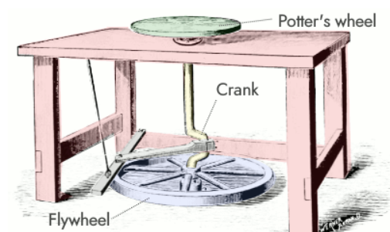
In a traditional kick wheel, the flywheel is the large disc positioned near the floor. When the potter applies force through a crank or kicking motion, torque is transferred to the flywheel, which then drives the turntable above. Because the flywheel’s mass stores rotational energy, it stabilises the speed of the wheel, allowing the potter to maintain consistent rotation even when the applied force varies. This simple mechanism illustrates the fundamental purpose of flywheels: to store kinetic energy and deliver smooth, continuous motion (Figure 1).

Figure 1 - Typical Potters Wheel (Woodford, 2012)
The potter’s wheel also highlights key mechanical principles. Its high moment of inertia reduces the need for constant input, improves efficiency, and increases precision. As an early demonstration of rotational energy storage, it laid important groundwork for the development of modern mechanical and energy-storage systems (Gandon et al., 2021).

Evolution of Flywheels


After the potter’s wheel, the flywheel principle was steadily adapted and refined across many machines. During the medieval and Renaissance periods, flywheels were incorporated into water lifting mechanisms (Figure 2), milling equipment, and early clockwork devices to regulate motion and store rotational energy. These early uses improved mechanical smoothness and consistency, supporting more predictable operation (Bender, 2016).

Figure 2 - Water Wheel Anastasi (2023)

In medieval communities, waterwheels fitted with simple flywheel mechanisms became shared resources that increased local productivity and reduced manual labour. Centralised milling at these mechanically efficient sites provided more reliable grain processing, with the flywheel helping regulate speed and maintain steady performance.
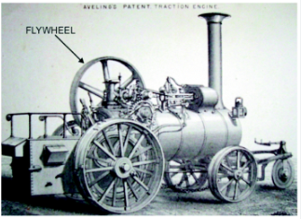
The Industrial Revolution marked a major advance in flywheel technology, particularly through their vital role in steam engines (Figure 3). In these systems, the flywheel ensured smooth and continuous rotation by moderating the uneven power produced during each piston stroke. The piston delivered force in bursts, and the flywheel absorbed surplus energy during the power stroke and released it during the return stroke, maintaining consistent crankshaft speed. This stability allowed steam engines to drive textile machinery, pumps, and industrial tools effectively. Improvements in metal casting and machining enabled the construction of larger, better-balanced flywheels, greatly enhancing reliability in early industrial power systems (Genta, 2014).

Figure 3 - Steam Engine Flywheel (Alami, 2019)

Advances in materials, manufacturing, and bearings eventually led to high speed, high strength flywheels for modern applications. Carbon fibre composites, vacuum enclosures, and magnetic bearings now allow flywheels to store significant energy with minimal losses, continuing the principles first demonstrated by the potter’s wheel.

Kinetic Energy Recovery Systems (KERS)

Kinetic Energy Recovery Systems (KERS) are designed to capture energy that would otherwise be lost during vehicle deceleration and return it to the drivetrain to improve efficiency and performance. In road-going vehicles, KERS allows braking or natural deceleration energy to be stored temporarily and used to assist propulsion, reducing fuel consumption and improving acceleration (Armenta-Déu and Cortés, 2023). While regenerative braking in electric vehicles converts kinetic energy into electrical energy stored in batteries, mechanical KERS achieves the same goal physically through a high-speed flywheel.
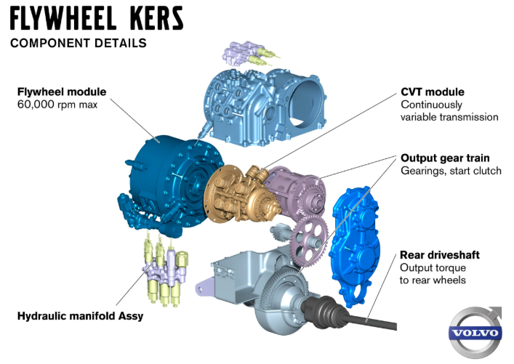
In a typical mechanical system, a lightweight carbon-fibre flywheel is mounted on the rear axle and coupled to a specially designed transmission (Figure 4). During braking, the vehicle’s kinetic energy spins the flywheel at high rotational speeds, often exceeding 60,000 rpm, converting linear motion into rotational kinetic energy. When the driver accelerates, energy is transferred back to the wheels via the transmission, providing additional torque, boosting horsepower, and reducing engine load. Volvo reports that such a system can reduce fuel consumption by approximately 25% while improving acceleration performance (Volvo, 2023).

Figure 4 - KERS Flywheel System (Volvo, 2023)

Design considerations are critical for safe and efficient operation in road vehicles. Precision balancing ensures smooth rotation at extremely high speeds, reducing vibrations and wear. Containment systems prevent hazards in the event of rotor failure. Material selection, including high-strength carbon-fibre rotors, allows for lightweight construction while resisting mechanical stress. Additionally, magnetic bearings and vacuum housings reduce friction and air resistance, improving energy retention and component longevity (Azarm et al., 2015).
By integrating these design features, mechanical KERS provides a reliable method for energy recovery in road vehicles. It allows manufacturers to reclaim otherwise wasted kinetic energy, improve fuel efficiency, and deliver rapid power assistance, demonstrating how a technology developed for racing has been adapted for practical, high-performance road use.

Mechanical Batteries

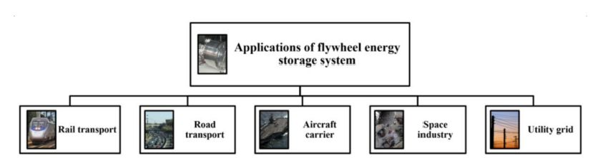
Flywheels provide fast, efficient energy storage and release, making them valuable across a wide range of applications (Figure 5).
Figure 5 - Different applications of FESS (Olabi et al., 2021)

Mechanical batteries store energy by accelerating a rotor, retaining kinetic energy physically rather than chemically. This allows millions of charge–discharge cycles without significant degradation, rapid energy transfer, and minimal maintenance. They are also less sensitive to temperature and chemical aging, making them highly reliable for long-term operation. Vacuum enclosures and magnetic bearings reduce friction, while power electronics stabilise voltage and manage energy flow.
FESS (Flywheel Energy Storage System) stores energy physically in a high-speed rotor rather than chemically, enabling rapid charge and discharge, long operational life, and exceptional efficiency (Takarli et al., 2023). Unlike chemical batteries, which degrade over time and respond more slowly, FESS delivers consistent performance over millions of cycles, making it ideal for grid stabilisation, frequency regulation, renewable energy smoothing, and backup power. In modern systems, the rotor is coupled to a motor/generator, seamlessly converting electrical energy into rotational kinetic energy during charging and back into electricity during discharging. Power converters intelligently manage energy flow between the flywheels, batteries, and the grid, ensuring stable voltage and frequency.
Advanced FESS units use vacuum enclosures and magnetic bearings to minimise friction, allowing the rotor to spin at extremely high speeds and achieve maximum energy efficiency, demonstrating the precision and engineering of modern mechanical energy storage systems (Figure 6).
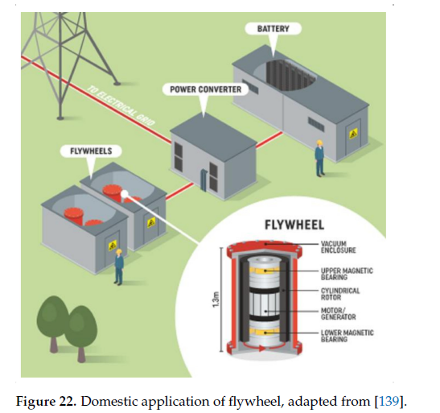

Figure 6 - Flywheel energy storage system illustration (Porter, 2017)
Flywheels also support high-power applications. On the U.S. aircraft carrier Gerald R. Ford, flywheels in the Electromagnetic Aircraft Launch System spin at very high speeds to store kinetic energy from the ship’s engines, releasing it in rapid bursts to launch aircraft. This allows power surges far exceeding the engines’ instantaneous output, after which the flywheels quickly recharge (Figure 7).
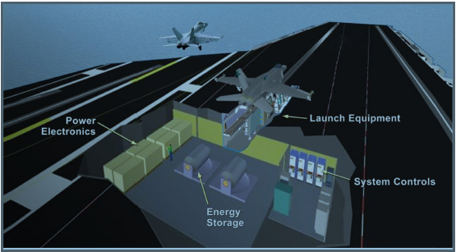

Figure 7 - Aircraft carrier FESS System (Doyle et al., 1995)

Conclusion

Flywheel technology has evolved from simple ancient tools to advanced modern energy storage systems, yet its core principle has remained constant: storing energy through rotational motion. Early uses such as the potter’s wheel and medieval milling machinery demonstrated how a rotating mass could provide smooth, continuous motion with minimal input, forming the basis for later mechanical developments. During the Industrial Revolution, flywheels became essential in steam engines, regulating uneven power delivery and enabling stable operation in factories and mechanical workshops.
Advances in materials and engineering have since transformed flywheels into highly efficient energy storage devices. Modern systems use lightweight carbon fibre rotors, magnetic bearings, and vacuum enclosures to minimise friction and achieve extremely high rotational speeds. These innovations allow flywheels to store more energy with greater efficiency and reliability than traditional designs.
Mechanical Kinetic Energy Recovery Systems (KERS) apply these principles to road vehicles by capturing braking energy and returning it during acceleration, improving performance and reducing fuel consumption. Flywheel Energy Storage Systems (FESS) also support grid stability, renewable energy integration, and high-power industrial applications by offering rapid charge and discharge cycles and long operational lifetimes.
Overall, the development of flywheel technology highlights its enduring value, providing an effective and durable solution for both transportation and modern energy systems.

Analysis of a Mechanical KERS System
This analysis evaluates a mechanical KERS in a high-performance hybrid vehicle, focusing on energy recovery, flywheel storage, rotational speed, and vehicle re-acceleration. Detailed calculations are in Appendix A.

Kinetic Energy of the Vehicle
The kinetic energy of the vehicle prior to braking represents the total mechanical energy available for recovery by the KERS system. Using Equation A1 (Appendix A), the kinetic energy is calculated as:
$$kE=\frac{1}{2}mv^{2}$$
where $m$ is the vehicle mass (2,080 kg) and $v$ is the velocity. The vehicle speed of 55 mph is converted to meters per second using Equation A1.1 (Appendix A), resulting in 24.5872 m/s. Substituting these values gives:
$E_{Vehicle}=\frac{1}{2}\left(2080\right){\left(24⋅5872\right)}^{2}$ = $628,711.62 J$ = $628.71 KJ$
This represents the total energy available for the flywheel during braking.

Energy Stored in the Flywheel

Flywheel energy is limited by system round-trip efficiency, accounting for braking and re-acceleration losses (Equation A2, Appendix A).
$$E_{Return}=η_{Round}×E_{Vehicle}$$

With $(η_{Round})$ = 0, the stored energy is:
$$E_{Return}=0.8 ×628,711.62 =502,969.30 J=503.0 KJ$$
This reflects the practical energy available for re-acceleration and highlights the impact of energy conversion losses in the KERS system.

Rotational Speed of the Flywheel
The flywheel is of a thin ring design, with moment of inertia calculated using Equation A3 (Appendix A):
$$I=m⋅r^{2}$$
With a mass of 6.5 kg and radius of 0.15 m, the moment of inertia is 0.14625 kg·m². The angular speed required to store the recovered energy is then calculated using Equation A3.1 (Appendix A):
$$ω=\sqrt{\frac{2E_{f}}{I}}=\sqrt{\frac{2 X 502,969.3 }{0.14625}}=2,622.63 rad/s$$
Converting to rpm (Equation A3.2, Appendix A) gives 25,044 rpm, which is below the maximum rated speed of 50,000 rpm, confirming safe operation.

Vehicle Re-acceleration Using KERS Energy
The energy stored in the flywheel is returned to the vehicle to achieve re-acceleration. Using Equation A4 (Appendix A):
$$\frac{1}{2}m_{v}V_{f}^{2} =E_{flywheel}$$
The vehicle’s final velocity is calculated as:
$v_{f}=\sqrt{\frac{2E_{flywheel}}{m_{v}}}=\sqrt{\frac{2 X 502,969.30 }{2080}}=21.99\frac{m}{s}≈49.19 mph$ (Equation A4.1, Appendix A)
This shows that the KERS system recovers a substantial portion of the vehicle’s initial speed.

Effect of Braking Speed on Re-acceleration

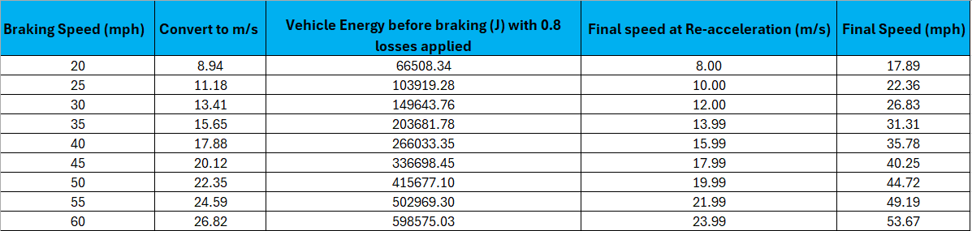
To analyse how braking speed influences vehicle re-acceleration using KERS, kinetic energy and final speed were calculated for braking speeds from 20–60 mph in 5 mph increments. Appendix A (Equations A5–A5.3) outlines the full method, including speed conversion to SI units, application of an 80% energy-recovery efficiency, and determination of final velocity. The resulting post-recovery speeds are summarised in Table 1.
Table 1 - Final Vehicle Speeds After Braking and KERS Energy Recovery

These results are shown graphically, illustrating how braking speed affects final speed after KERS recovery (Figure 8).
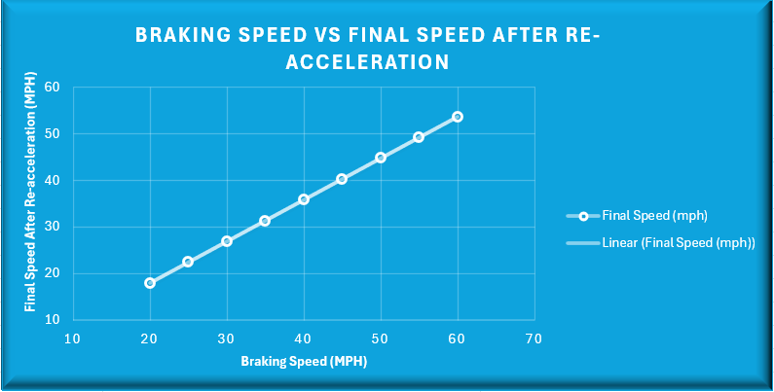
Figure 8 – Braking vs Final Speed graph

The graph shows a clear positive correlation: as braking speed increases, the vehicle’s kinetic energy before braking rises, allowing more energy to be stored in the flywheel. As a result, the vehicle achieves a higher final speed when this stored energy is returned. However, all final speeds remain slightly lower than the corresponding braking speeds due to the system’s combined efficiency of 80%, which accounts for energy losses during both braking and re-acceleration. Overall, the chart and graph provide a clear visual representation of how higher initial braking speeds enhance KERS performance, emphasizing the importance of braking conditions in maximizing energy recovery while also illustrating the limitations imposed by system efficiency.

Re-acceleration from 60 mph Braking in 6.5 Seconds
For a braking speed of 60 mph, the stored energy is 598,467.92 J (Equations A6–A6.1, Appendix A). Using Equation A7, the final vehicle speed is 23.99 m/s. The average acceleration is calculated from Equation A7.1 (Appendix A):
$$a=\frac{v_{f}-v_{i}}{t}=\frac{23.99-0}{6.5}=3.69 m/s²$$
This demonstrates that the KERS system alone can provide substantial re-acceleration.

Effect of Flywheel Dimensions on Rotational Speed

For a 1,510 kg vehicle with a 4.5 kg flywheel, the angular velocity required to store a specific energy depends on flywheel diameter. Calculations of inertia, angular speed, and rpm conversion are in Appendix A (Equations A8.2–A8.4). Table 2 summarises rotational speeds for 120–240 mm diameters in 20 mm increments.
Table 2 - Flywheel Diameter vs Rotational Speed
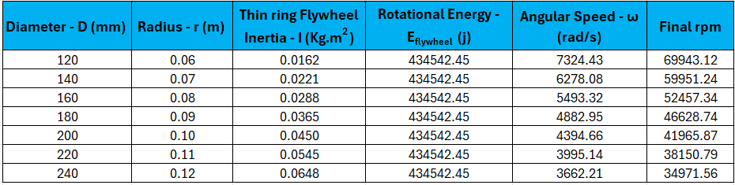
These results are shown graphically, illustrating braking speed’s effect on final vehicle speed after KERS recovery (Figure 9).
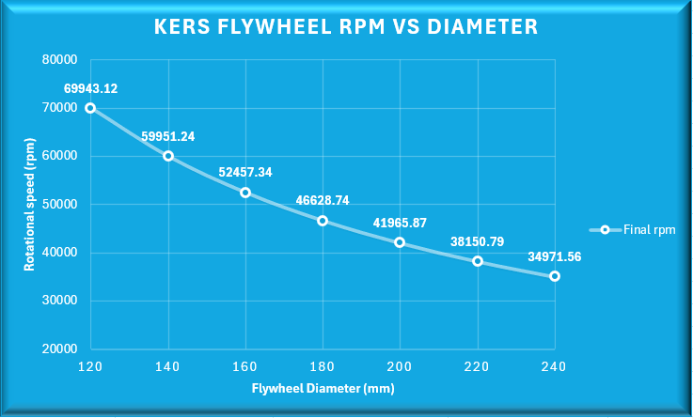

Figure 9 - KERS Flywheel RPM vs Diameter graph

The results show a clear inverse relationship between flywheel diameter and the rotational speed required to store a given amount of energy. As diameter increases, the radius becomes larger, raising the moment of inertia according to I = m·r². With greater inertia, the flywheel can store the same energy at a lower angular velocity. This is reflected in the results, where the 120 mm flywheel must rotate at approximately 69,900 rpm, while the 240 mm flywheel requires only around 35,000 rpm. From a design standpoint, larger flywheels benefit from lower operating speeds, reduced mechanical stress, and improved stability, but they occupy more space and add mass. In contrast, smaller flywheels are compact and easier to package but must run at extremely high speeds, increasing material demands, cost, and safety considerations. The table and graph therefore illustrate the inherent trade-off between flywheel size, rotational speed, and system integration when designing a compact KERS unit.
The analyses presented across Sections 1–7 rely on several simplifying assumptions that enable theoretical calculations to remain focused and manageable. Energy transfer is treated as largely lossless aside from an overall efficiency factor of 80% applied to the full braking–re-acceleration cycle. Losses from friction, aerodynamics, bearings, tyre slip, and drivetrain components are neglected. The flywheel is assumed to operate in a vacuum enclosure, eliminating air drag, and is idealised as a thin ring, simplifying inertia calculations by ignoring hub mass and structural thickness. Energy exchange through the CVT is treated as instantaneous and perfectly efficient, with no consideration of transient effects or mechanical lag. Vehicle mass, braking conditions, and flywheel properties are assumed constant, and external environmental factors such as road friction, temperature, and gradient are excluded. While these assumptions clarify the core energy interactions, a more realistic model would require incorporating mechanical losses, safety limits, dynamic behaviour, and practical system constraints.

Appendix A – Mathematical Derivations

Equation A1 - Kinetic energy of vehicle before braking ($E_{Vehicle})$

$$kE=\frac{1}{2}mv^{2}$$

($kE)$Kinetic Energy; J
Known Values
($m)$ Mass = 2080kg
($v$ ) Velocity = 55 mph converts to 24.5872 m/s (Appendix A1.1)
$$E_{Vehicle}=\frac{1}{2}\left(2080\right){\left(24⋅5872\right)}^{2}$$
$$E_{Vehicle}=1040×604.53$$
$$E_{Vehicle}=628,711.62 J$$
$$E_{Vehicle} =628.7 KJ$$

Equation A1.1 - Conversion of mph to m/s

- mph → m/s: multiply by 0.44704

Velocity = 55 x 0.44704
Velocity = 24.5872 m/s

Equation A2 – Stored Energy in Flywheel ($E_{Return})$

$$E_{Return}=η_{Round}×E_{Vehicle}$$

($E_{Return})$ Energy available for return; J
Known Values
$(η_{Round})$ Efficiency of round trip (braking and acceleration) = 0.8
${(E}_{Vehicle})$ Energy stored in Vehicle (Flywheel) = 628,711.62 (Equation A1)

$$E_{Return}=0.8 ×628,711.62$$
$$E_{Return}=502,969.30 J$$
$$E_{Return}=503.0 KJ$$

Equation A3 – Flywheel Inertia ($I)$

$$I=m⋅r^{2}$$

($I)$Flywheel Inertia (Thin ring); kg.m²
Known Values
($m)$ Flywheel Mass = 6.5 kg
($r)$ Flywheel radius = 300mm diameter therefore = 0.15 m
($E_{Vehicle})$Kinetic Energy before braking = 628,711.62 J (Equation A1)
${(E}_{Return})$ Stored energy in the Flywheel = 502,969.30 J (Equation A2)

$$I=6.5×{0.15}^{2}$$
$I=$0.14625 Kg.m²

Equation A3.1 - Rotational kinetic energy ($E_{f})$ and Angular speed $(ω)$

$$E_{f}=\frac{1}{2}Iω^{2}$$
Re-arranged for Angular speed ($ω)$
$$ω=\sqrt{\frac{2E_{f}}{I}}$$

$(ω)$ Angular speed; rad / s
Known Values
${(E}_{Return})$/$(E_{f})$ Stored energy in Flywheel = 502,969.30 J (Equation A2)
($I)$Flywheel Inertia (Thin ring) = 0.14625 kg.m² (Equation A3)
$$ω=\sqrt{\frac{2 X 502,969.3 }{0.14625}}$$
$$ω=\sqrt{\frac{ 1,005,938.6 }{0.14625}}$$

$$ω=\sqrt{6878212.65}$$
$$ω=2,622.63 rad/s$$

Equation A3.2 - Conversion of rad/s to rpm

$$rρm=ω×\frac{60}{2π}$$

$$rρm=2622.67 X 9.5493$$
$$rρm=25,044.32 rpm$$

Equation A4 – Flywheel velocity $(V_{f})$

When the flywheel releases its stored energy into the vehicle (assuming no further losses):
$$E_{flywheel}=Kinetic Energy of Vehicle$$
$E_{flywheel}=\frac{1}{2}m_{v}V_{f}^{2}$
Re-arranged for Final velocity $(V_{f})$
$$\frac{1}{2}m_{v}V_{f}^{2} =E_{flywheel}$$
$\left(V_{f}\right)$ Flywheel Velocity; m/s
Known Values
${(E}_{Return})$ Stored energy in Flywheel with combined losses accounted for = 502,969.30 J (Equation A2)
($m)$ Mass = 2080kg
$$v_{f}=\sqrt{\frac{2E_{flywheel}}{m_{v}}}$$
$$v_{f}=\sqrt{\frac{2 X 502,969.30 }{2080}}$$
$$v_{f}=\sqrt{\frac{1,005,938.6}{2080}}$$
$$v_{f}=\sqrt{483.62}$$
$$v_{f}=21.99 m/s$$

Equation A4.1 – Conversion of m/s to mph

- m/s → mph: multiply by 2.23694
Final Speed = 21.99 x 2.23694
Final Speed = 49.19 mph

Equation A5 – Graph plotting: Conversion of braking speed (mph) to m/s

Using 20 mph as a constant in the following examples:
Braking speed 20 (mph) x 0. 44704 = 8.94 m/s

Equation A5.1 – Graph plotting: Conversion of braking speed (m/s) to Energy before breaking (j) with 0.8 round-trip efficiency

Using equation A1
$$kE=\frac{1}{2}mv^{2}$$
$kE=$ $\frac{1}{2}\left(2080\right){\left(8.94\right)}^{2}$*0.8
$kE=$ 66508.34 J

Equation A5.2 – Graph plotting: Final speed at re-acceleration (m/s)

Using equation A4
$$v_{f}=\sqrt{\frac{2E_{flywheel}}{m_{v}}}$$
$$v_{f}=\sqrt{\frac{2 X 66508.34}{2080}}$$
$$v_{f}=\sqrt{\frac{2 X 66508.34}{2080}}$$
$$v_{f}=\sqrt{\frac{133016}{2080}}$$
$$v_{f}=\sqrt{63.95}$$
$$v_{f}=7.99 m/s$$

Equation A5.3 – Graph plotting: Conversion of final Re-acceleration speed to final speed (mph)

Final re-acceleration speed 8 (m/s) x 2.23694= 17.89 mph

Equation A6 – Vehicle kinetic before breaking $(E_{Vehicle})$

$$kE=\frac{1}{2}mv^{2}$$
($kE)$ Kinetic Energy; J
Known Values
$\left(v_{f}\right)$Velocity = 60 mph X 0.44704 converts to 26.82 m/s.
($m)$ Mass = 2080kg
$$E_{vehicle }=\frac{1}{2}\left(2080\right){\left(26.82\right)}^{2}$$
$$E_{vehicle }=1040 X 719.31$$
$$E_{vehicle }=748084.90 J$$

Equation A6.1 – Energy recovery (80% Efficiency) ${(E}_{Return}$)

$$E_{Return}=η_{Round}×E_{Vehicle}$$
$$E_{Return}=0.8 ×748084.90$$
$$E_{Return}=598,467.92 J$$

Equation A7 – Flywheel velocity $(V_{f})$

Using equation A4
$$v_{f}=\sqrt{\frac{2E_{flywheel}}{m_{v}}}$$

$$v_{f}=\sqrt{\frac{2 X 598,467.92 }{2080}}$$
$$v_{F}=\sqrt{\frac{2 X 1183572}{2080}}$$
$$v_{F}=\sqrt{575.45}$$
$$v_{F}=23.99 m/s$$

Equation A7.1 – Acceleration ($a$)
$$a=\frac{v_{f}-v_{i}}{t}$$
$(a$) Acceleration; m/s
Known Values
$\left(v_{f}\right)$Final Velocity = 23.99 m/s (Equation A7)
$\left(v_{i}\right)$ Initial Velocity = 0 m/s from rest
$(t$) Time = 6.5 seconds

$$a=\frac{23.99-0}{6.5}$$
$$a=3.69 m/s²$$

Equation A8 – Vehicle Kinetic Energy before braking $(E_{Vehicle})$

$$kE=\frac{1}{2}mv^{2}$$
($kE)$ Kinetic Energy; J
Known Values
$\left(v_{f}\right)$Velocity = 60 mph X 0.44704 converts to 26.82 m/s.
($m)$ Mass = 1510kg
$$E_{vehicle }=\frac{1}{2}\left(1510\right){\left(26.82\right)}^{2}$$
$$E_{vehicle }=755 X 719.31$$
$$E_{vehicle }=543,178.06 J$$

Equation A8.1 – Graph plotting: Energy recovery (80% Efficiency) ${(E}_{Return}$)

$$E_{Return}=η_{Round}×E_{Vehicle}$$
$$E_{Return}=0.8 ×543,178.06$$
$$E_{Return}=434,542.45 J$$

Equation A8.2 – Graph plotting: Flywheel Inertia (I)

$$I=m⋅r^{2}$$

($I)$Flywheel Inertia (Thin ring); kg.m²
Known Values
($m)$ Flywheel Mass = 4.5 kg
($r)$ Flywheel radius = 120mm diameter therefore = 0.06 m

$$I=4.5×{0.06}^{2}$$
$I=$0.0162 Kg.m²

Equation A8.3 – Graph plotting: Angular speed $(ω)$

$$E_{f}=\frac{1}{2}Iω^{2}$$
Re-arranged for Angular speed ($ω)$
$$ω=\sqrt{\frac{2E_{f}}{I}}$$

$(ω)$ Angular speed; rad / s
Known Values
${(E}_{Return})$Stored energy in Flywheel = 434,542.45 J (Equation A8.1)
($I)$Flywheel Inertia (Thin ring) = 0.0162 kg.m² (Equation A8.2)
$$ω=\sqrt{\frac{2 X 434,542.45 }{0.0162}}$$
$$ω=\sqrt{\frac{ 869084.9 }{0.0162}}$$

$$ω=\sqrt{53,647,216.05}$$
$$ω=7,324.26 rad/s$$

Equation A8.4 – Graph plotting: Conversion of rad/s to rpm

$$rρm=ω×\frac{60}{2π}$$

$$rρm=7,324.26 X 9.5493$$
$$rρm=69,943.14 rpm$$

10.Bibliography

Alami, A.H. ed. (2019). Flywheel Storage Systems. Advances in Science, Technology & Innovation, pp. 35–49. doi:10.1007/978-3-030-33788-9_5. Available at: https://link.springer.com/book/10.1007/978-3-030-33788-9 [Accessed 8 Nov. 2025].
Anastasi, L. (2023). Medieval History – Watermills: A Key Tech of the Middle Ages. Medieval History. Available at: https://historymedieval.com/watermills-a-key-tech-of-the-middle-ages/ [Accessed 19 Oct. 2025].
Armenta-Déu, C. and Cortés, H. (2023). Analysis of Kinetic Energy Recovery Systems in Electric Vehicles. Vehicles, 5(2), pp. 387–403. doi:10.3390/vehicles5020022. Available at: https://www.mdpi.com/2624-8921/5/2/22 [Accessed 10 Nov. 2025].
Azarm, A., Esfahanian, M. and Hamidi Rad, H. (2015). Development of an Innovative Flywheel-Based Brake Energy Recovery System for Enhanced Urban Fuel Efficiency in Passenger Cars. Automotive Science and Engineering, 53(03), pp. 53–1072. doi:10.5860/choice.191861. Available at: https://ijae.iust.ac.ir/article-1-671-en.pdf [Accessed 6 Nov. 2025].
Bender, D. (2016). Flywheels. In: Storing Energy, pp. 183–201. doi:10.1016/B978-0-12-803440-8.00010-5. Available at: https://www.sciencedirect.com/science/chapter/edited-volume/abs/pii/B9780128034408000105 [Accessed 2 Nov. 2025].
Bolund, B., Bernhoff, H. and Leijon, M. (2007). Flywheel Energy and Power Storage Systems. Renewable and Sustainable Energy Reviews, 11(2), pp. 235–258. doi:10.1016/j.rser.2005.01.004. Available at: https://www.sciencedirect.com/science/article/pii/S1364032105000224 [Accessed 3 Nov. 2025].
Davy, M. (2024). The Fascinating History of the Pottery Wheel. Kiln Crafts. Available at: https://www.kilncrafts.co.uk/blogs/news/the-fascinating-history-of-the-pottery-wheel?srsltid=AfmBOorqLtsrNdefV1--O1_D2CRpLgf6rCsM8jHfNZeia0cdyJP7oBP8 [Accessed 11 Oct. 2025].
Doyle, M.R., Samuel, D.J., Conway, T. and Klimowski, R.R. (1995). Electromagnetic Aircraft Launch System-EMALS. IEEE Transactions on Magnetics, 31(1), pp. 528–533. doi:10.1109/20.364638. Available at: https://ieeexplore.ieee.org/document/364638 [Accessed 02 Nov. 2025].
Gandon, E., Coyle, T., Pous, F., Buloup, F. and Bootsma, R.J. (2021). A Preliminary Study of Rotation Velocity Regulation in Pottery Wheel-Throwing: Fieldwork with Indian Potters Using the Low-Inertia Kick-Wheel. Journal of Archaeological Science: Reports, 37, p. 102987. doi:10.1016/j.jasrep.2021.102987 Available at: https://www.sciencedirect.com/science/article/pii/S2352409X21001991 [Accessed 03 Nov. 2025].
Genta, G. (2014). Kinetic Energy Storage. Butterworth-Heinemann.
Gingras, J. and Sneed, D. (2018). Potter’s Wheel. Department of Classics. Available at: https://www.colorado.edu/classics/2018/06/15/potters-wheel [Accessed 13 Oct. 2025].
Halliday, D., Resnick, R. and Walker, J. (2013). Fundamentals of Physics. John Wiley & Sons. Available at: https://books.google.co.uk/books/about/Fundamentals_of_Physics.html?id=HybkAwAAQBAJ&redir_esc=y [Accessed 16 Oct. 2025].
Kumar, T.R.S., Koppula, S.B., Prakash, Cr. and Srikanth, D.V. (2016). Design and Dynamic Analysis of Flywheel. IOSR Journal of Mechanical and Civil Engineering, 16(053), pp. 51–56. doi:10.9790/1684-16053045156. Available at: https://www.iosrjournals.org/iosr-jmce/papers/i-%20CAM2K16-2016/Mech/Volume%204/9.%2051-56.pdf [Accessed 18 Oct. 2025].
Olabi, A.G., Wilberforce, T., Abdelkareem, M.A. and Ramadan, M. (2021). Critical Review of Flywheel Energy Storage System. Energies, 14(8), p. 2159. doi:10.3390/en14082159. Available at: https://www.mdpi.com/1996-1073/14/8/2159 [Accessed 16 Nov. 2025].
Porter, K. (2017). Electricity Storage on the Fly. Watt-Logic. Available at: https://watt-logic.com/2017/06/07/flywheel-energy-storage/ [Accessed 2 Nov. 2025].
Takarli, R., Amini, A., Khajueezadeh, M., Zarbil, M.S., Vahedi, A., Kiyoumarsi, A., Tarzamni, H. and Kyyra, J. (2023). A Comprehensive Review on Flywheel Energy Storage Systems: Survey on Electrical Machines, Power Electronics Converters, and Control Systems. IEEE Access, 11, pp. 81224–81255. doi:10.1109/ACCESS.2023.3301148. Available at: https://ieeexplore.ieee.org/abstract/document/10203021/ [Accessed 4 Nov. 2025].
Tipler, P.A. and Mosca, G. (2008). Physics for Scientists and Engineers. Freeman. Available at: https://faculty.kfupm.edu.sa/PHYS/aanaqvi/%5BPaul_AP-Tipler-Physics_for_Scientist(BookFi.org).pdf [Accessed 14 Nov. 2025].
Volvo (2023). Flywheel KERS, Component Details. Volvo Car Corporation. Available at: https://www.volvocars.com/uk/media/images/f3691391a58746019615b33e0048b69f/ [Accessed 1 Nov. 2025].
Woodford, C. (2012). How Do Flywheels Store Energy? Explain That Stuff. Available at: https://www.explainthatstuff.com/flywheels.html [Accessed 12 Oct. 2025].

