Module Code & Title: LCHS4009 Professional Development within Health and Social Care
Assignment Title: Personal Development Portfolio

Student’s Name: Mansur Alam
Student’s ID: 2441879
Name of the Tutor: Soban Sadiq

Acknowledgement of AI use
I confirm that I have not used AI to complete my work.

Table of Contents
Acknowledgement of AI use 2
Introduction 4
Task 1: Professional CV 5
Task 2: Personal Statement 7
Task 3: SWOT Analysis and Personal Development Plan (PDP) 8
SWOT Analysis 8
Personal Development Plan 9
Task 4: Reflecting Using Gibbs Reflective Cycle 9
References 12

Introduction
This portfolio contains a professional resume and personal statement with more than ten years of transferable experience in customer facing jobs. In addition, the portfolio also contains a SWOT analysis and Personal Development Plan aimed at clinical growth, and finally, there is also a critical reflection that is done using the Gibbs Reflective Cycle.

Task 1: Professional CV
MANSUR ALAM
London, W14 | 00000000000 | mansur@myyahoo.com
CAREER OBJECTIVE
Empathic and trustworthy person who is pursuing a BSc in Health Care and who has more than 10 years’ experience in customer facing positions. Capable of communicating, working in a team and ensuring high levels of hygiene and safety in busy settings. Driven by motivation to provide person-centred care, aiding people with dignity and respect, and benefiting healthcare teams. Applying to work as a “Healthcare Assistant” to acquire practical care skills and be able to assist patients with high-quality services.
KEY SKILLS
- Good interpersonal skills and communication skills.
- Good teamwork and cooperation.
- Awareness of health, hygiene and infection control.
- Safeguarding awareness (basic understanding)
- Time management and ability to work under pressure
- Observation and attention to detail
- Dependable, time-conscious and flexible.
- Multilingualism (English, Bengali, Hindi, Urdu).
PROFESSIONAL EXPERIENCE
Steak and Chicken - Chef & Customer Service - Feb 2021 – Present
- Provided quality service with high pace and worked with patience and professionalism.
- Maintained high hygiene and safety standards, which can be transferred to infection prevention in healthcare.
- Effectively communicated with a wide variety of customers, establishing trust and rapport.
- Provided teammates with support in times of need, making sure that operations run smoothly.
Naked Chicken & Takeaway - Chef & Barista Assistant - Nov 2020 – Jan 2021
- Certain hygiene and adhering to food safety measures were in line with health standards.
- Being attentive and careful when dealing with customers.
- Behaved effectively under stress, showing strength and flexibility.
Retail & News Agent - Sales & Service Assistant - May 2013 – Oct 2020
- Delivered dependable, cordial service to a multicultural community.
- Learned to listen and be responsive to customer needs.
- Household clean working conditions.
McDonald’s - Customer Service Assistant - Apr 2011 – Apr 2013
- Worked as a team member in a stressful situation.
- Acquired good communication and multi-skilling skills.
- Standards of hygiene and cleanliness were always observed
EDUCATION
BSc in Health Care (In Progress)
University of Wales Trinity Saint David – London Campus
Expected Graduation: 2029
Additional Information
- Willing to undertake training such as the Care Certificate and First Aid.
- Strong interest in developing a career in health and social care.
- Dedicated to life-long learning.
LANGUAGES
- English (Fluent)
- Bengali (Fluent)
- Hindi (Fluent)
- Urdu (Fluent)

Task 2: Personal Statement
I am applying to be a “Healthcare Assistant” because I am strongly excited to build a valuable career in the health and social care field. At the moment, I am pursuing BSc in Health Care at the University of Wales Trinity Saint David which is helping develop my knowledge in the areas of patient-centred care, professional values, and the significance of effective communication in a healthcare environment. I enjoy helping people with dignity, respect and compassion and I am ready to use my academic knowledge and practical skills in the real-life caring setting.
My career objective in the long term is to further develop in the healthcare industry, which may lead to senior care or nursing career. Healthcare assistant position is a needed phase towards practice, clinical awareness, and knowledge of the day-to-day duties of providing quality care (Fee et al. 2020). I would like to specifically work in multidisciplinary teams and provide patients with their physical and emotional needs, so that they feel well and comfortable all the time.
Despite my main experience in the hospitality and retail sectors, I have acquired a plethora of transferable skills that directly align with the position of Healthcare Assistant. I have been operating in fast-paced, customer-oriented areas over the last ten years, and communication, collaboration, and flexibility are all crucial in my work. My interpersonal skills have been quite good as I have been able to engage with different people and this has helped me to build trust, respond to the needs well and deal with difficult situations calmly and professionally. Such experiences have equipped me with the skills to be sensitive when talking to patients and to offer a sense of security when they are at their weakest moments.
Moreover, my practice of ensuring a high level of hygiene and safety is quite relevant to the practices of infection prevention and control in healthcare facilities. I am used to strict procedures, cleanliness and always prioritizing safety. I am also very reliable, timely and able to work under pressure, which are key qualities to provide unswerving and efficient care. My multilingual skills also contribute to my ability to effectively communicate with people of different cultural backgrounds, enhancing inclusivity and patient-centred care.
In my opinion, my personal characteristics are very representative of the main values which are needed in health and social care. I am also empathetic, patient, and attentive by nature and I have a real interest in assisting others. I know the value of protecting, keeping secrets and respecting and treating people with dignity and integrity and I will ensure that I practice this in my work in every part. I also have interest in taking more training e.g. the Care Certificate and First Aid to ensure that I become more competent and confident in providing care.
To sum up, I am eager about the chance to make a positive contribution as a Healthcare Assistant. I believe that my transferable skills, academic experience, and dedication to compassionate care will enable me to bring a significant change to your organisation as I still grow professionally in the healthcare field.

Task 3: SWOT Analysis and Personal Development Plan (PDP)

SWOT Analysis
The SWOT analysis is a useful tool to consider personal preparedness to work as a Healthcare Assistant because it helps to determine both internal and external aspects that affect career development.
Strengths | Weaknesses
My most important strength is that I have excellent communication and interpersonal skills, which have been gained in an extensive experience dealing with customers. These are the skills that can be necessary in healthcare to establish trust with patients and collaborate with multidisciplinary teams. Moreover, my stress tolerance, hygiene, and the quality of quick adaptation to any changing situation fit the requirements of the healthcare environment. Another strength is my multilingualism, which allows me to interact with people with different cultural backgrounds and foster inclusive care. | My major weakness is that I have no firsthand experience in healthcare and, therefore, my confidence and understanding of clinical contexts might be restricted. I also do not have formal qualifications like the Care Certificate or the First Aid training, which are usually required in the industry.
Opportunities | Threats
Potential opportunities are great with the high demand of Healthcare Assistants in UK and availability of structured training programmes (Conyard et al. 2020). These offer a career advancement route. | Competitive forces and preference of candidates who have previous experience in care are threats and can pose barriers to entry (Aeschbacher and Addor, 2021).
Table1: Personal SWOT Analysis

Personal Development Plan
To prepare to be a Healthcare Assistant, a Personal Development Plan (PDP) is necessary to establish disciplined objectives and to be constantly improved.
First Objectives
My initial objective is to acquire hands-on healthcare experience in the 6-12 months. I will do this by volunteering in nursing homes or neighbourhood care facilities. This will enable me to gain practical skills, as well as confidence in my interaction with patients, and learn care routines in actual settings. Feedback on the progress will be done by supervisors and reflective practice.
Second Objectives
The second objective is to achieve pertinent professional qualifications in a year. I would like to complete the Care Certificate and have some basic training in First Aid. Professional qualifications will help to improve understanding of patient care, safeguarding and health and safety practices (Patrick et al. 2020). Successful certification and the use of acquired skills in practice will be the measures to assess achievement.
Third Objectives
My third objective is to enhance my skills in communication and clinical awareness within two years. I will also be a lifelong learner by studying, using the internet and reflecting on myself. Enhancing skills in communication and clinical awareness are important in providing person-centred care and effectively addressing the needs of patients (Wolderslund et al. 2021). I will monitor my improvement by watching my academic performance and getting the opinions of tutors and professionals.
Monitoring and Evaluation of Progress
In order to track and assess my general progress, I will periodically check my goals, keep a reflective journal, and revise my plan in accordance with the feedback and progress. This step-by-step strategy will make me better prepared to a successful career in health and social care.

Task 4: Reflecting Using Gibbs Reflective Cycle
This is in reflection of my Component 1 presentation, in which I spoke about the significance of communication in health and social care. Gibbs Reflective Cycle allows to critically assess individuals’ performance by facilitating a systematic reflection and professional growth (Adeani et al. 2020).
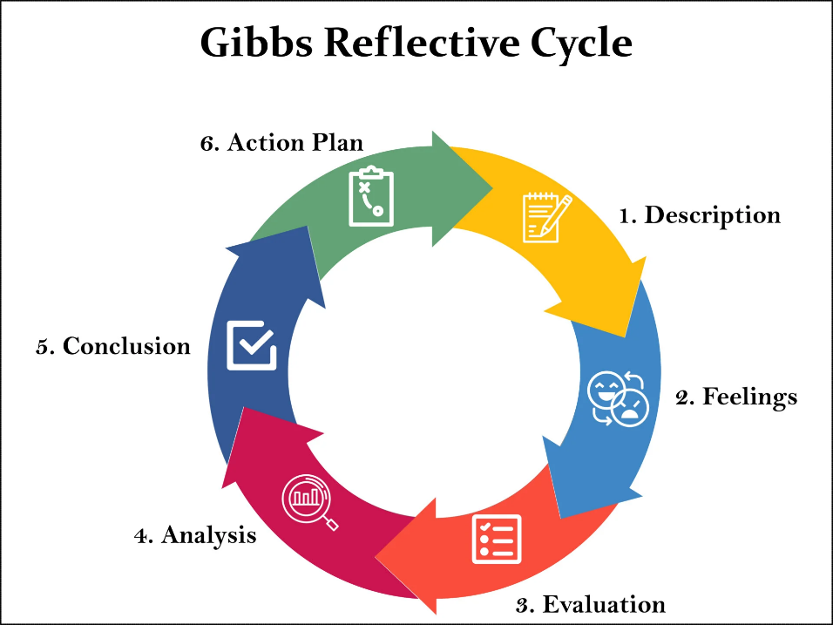
Figure1: Gibbs Reflective Cycle (McLeod, 2025)
Description
The presentation was dedicated to the communication as an essential professional competence in health and social care. I defined it, clarified its significance in clinical practice, and the way it promotes patient safety and person-centred care. I also used communication in a situation in real life where a care assistant is assisting an elderly resident. Additionally, I discussed how communication contributes to my future career development. The presentation was well organized in logical sections, such as theory, application and reflection.
Feelings
I was a little nervous before the presentation, especially regarding my ability to speak confidently before an audience. But I was also ready because of my knowledge on the subject matter. My confidence also increased during the presentation as I went through the slides. I was relaxed in clarifying significant aspects particularly when speaking about real-life examples. My overall performance was satisfactory after doing the presentation but I identified the areas where I need to work on.
Evaluation
The coherent flow of information and well-structured presentation was one of the primary strengths of my presentation. I was able to explain the significance of communication and relate it to actual healthcare practice, which showed that I was aware of the subject. The practical example makes the content relevant and interesting (Broman et al. 2022). Also, in my description of the Reflective Cycle by Gibbs, I was conscious of professional development tools.
Nevertheless, it had certain flaws. In some cases, I overused my slides and this minimized eye contact with the listeners. There are aspects that I could have performed more confidently and engagingly, especially in ensuring a steady tone and pace. Additionally, I might have incorporated more critical analysis as opposed to describing concepts mostly. These restrictions had an overall influence on the effect of my presentation.
Analysis
I prepared well and knew the topic; this played a significant role in the strengths of my presentation. Academic studies have enabled me to learn important concepts like communication and person-centred care that I was able to expound on. Practical application was also encouraged by inclusion of a real-life scenario, and is critical in health and social care.
Conversely, my weaknesses were more associated with presentation skills instead of knowledge. The fact that I depended on the slides indicates that I lack confidence and I do not practice speaking to the audience. This could have decreased viewer participation. Moreover, the fact that the depth of critical analysis is only average means that I still have to enhance my abilities to think on a higher level, i.e. to evaluate and justify ideas, but not merely describe them. Feedback indicated that better performance would be achieved by increasing confidence and interaction (Gnepp et al. 2020).
Conclusion
To sum up, the presentation was efficient to show that I have learned about the importance of communication as an essential skill in health and social care. Nevertheless, to reach a better performance level, I have to work on my confidence and minimized use of notes, as well as critical analysis. These will be positive changes in my academic as well as work abilities.
Action Plan
I will follow a few steps in order to enhance my future presentations. Firstly, I will speak more often, instilling confidence and enhancing fluency. Second, I will decrease relying on slides and use short notes and concentrate more on communication with the audience. Third, I will be able to work on my critical thinking skills through practice as I will be analysing and evaluating my written work. Lastly, I will also use the assistance of tutors and peers to gauge my progress. Through these measures, I hope to be a better and more assured communicator, which will be crucial in my future professional life in health and social care.

References
Adeani, I.S., Febriani, R.B. and Syafryadin, S., (2020). Using GIBBS’reflective cycle in making reflections of literary analysis. Indonesian EFL Journal, 6(2), pp.139-148.
Aeschbacher, R. and Addor, V., (2021). Competitive employer positioning through career path analysis: the case of the Swiss nursing sector. Human resources for health, 19(1), p.47.
Broman, K., Bernholt, S. and Christensson, C., (2022). Relevant or interesting according to upper secondary students? Affective aspects of context-based chemistry problems. Research in Science & Technological Education, 40(4), pp.478-498.
Conyard, K.F., Codd, M., Metcalfe, A., Corish, S., Flannery, J., Hannon, P., Rusk, B. and Yeates, S., (2020). Healthcare Assistants and Qualified Carers, A Trained, but Untapped Underutilised Resource: A population-based study in Ireland of skillset, career satisfaction, wellbeing and change across all sectors and care settings. UCD CSTAR & HCA & Carers Ireland.
Fee, A., Muldrew, D., Slater, P., Payne, S., McIlfatrick, S., McConnell, T., Finlay, D.A. and Hasson, F., (2020). The roles, responsibilities and practices of healthcare assistants in out-of-hours community palliative care: A systematic scoping review. Palliative Medicine, 34(8), pp.976-988.
Gnepp, J., Klayman, J., Williamson, I.O. and Barlas, S., (2020). The future of feedback: Motivating performance improvement through future-focused feedback. PloS one, 15(6), p.e0234444.
McLeod, S. (2025). Gibbs Reflective Cycle. [online] Simply Psychology. Available at: https://www.simplypsychology.org/gibbs-reflective-cycle.html.
Patrick, A., Kandiah, T. and Welbury, R., (2020). Can child safeguarding training be improved?: findings of a multidisciplinary audit. European Archives of Paediatric Dentistry, 21(6), pp.679-685.
Wolderslund, M., Kofoed, P.E. and Ammentorp, J., (2021). The effectiveness of a person-centred communication skills training programme for the health care professionals of a large hospital in Denmark. Patient education and counseling, 104(6), pp.1423-1430.

