Caitlin Llewelyn
1904121
ECGE4002P: Academic Study Skills for Students
A portfolio of tasks reflecting the skills, knowledge and dispositions needed for higher education study

Table of Contents
Portfolio Task 1 – Developing your skills: vision of success as a student-teacher 1
Digital mind-map of all the resources available to me as a university student 1
Current Skills Audit showing the skills and qualities that I have developed. 2
What Success Looks like for Me as a Student Teacher 3
Portfolio Task 2 – Developing Critical Thinking 4
Portfolio Task 3 – Developing Critical Writing 6
What I think about Education in Wales 6
References: 8
Appendix 1: Stella Cottrell (2005) Self-evaluation and Priorities 9

Portfolio Task 1 – Developing your skills: vision of success as a student-teacher

Digital mind-map of all the resources available to me as a university student

Current Skills Audit showing the skills and qualities that I have developed.

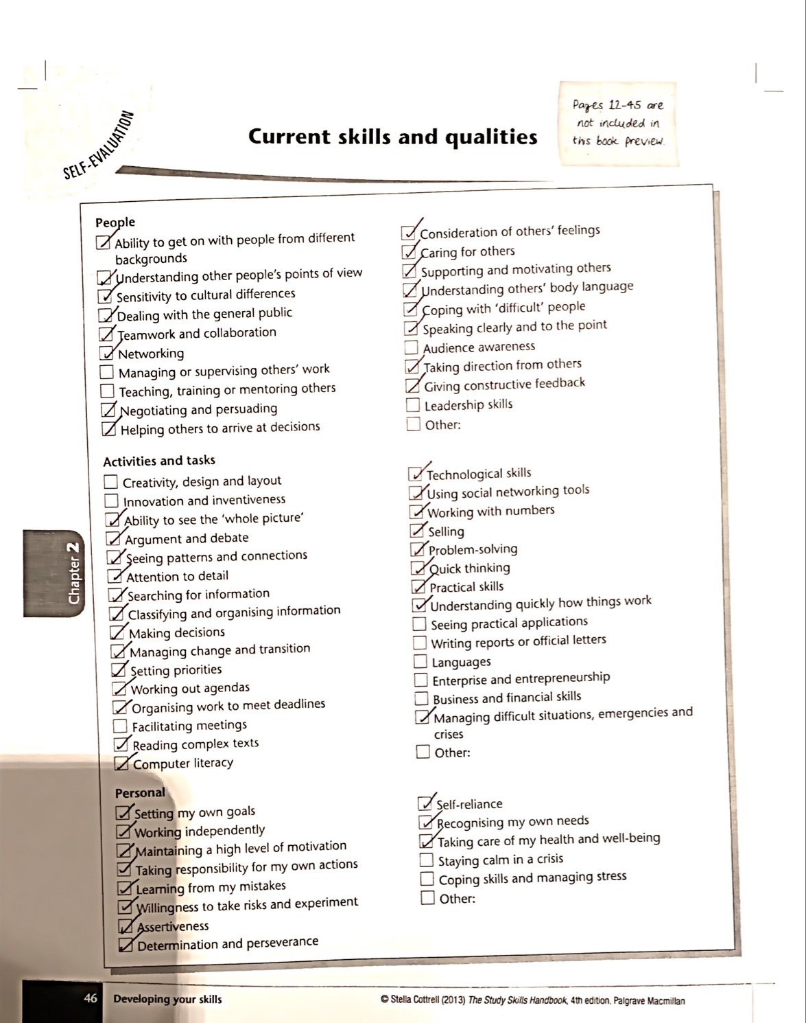

(Cottrell, 2013)

What Success Looks like for Me as a Student Teacher

Success is “the accomplishment of an aim or purpose” (Dictionary, 2019). The purpose of my study at university is to be a qualified teacher. Career and qualification success for me would be to complete the BA Primary Education with QTS course with the best degree classification that I can achieve and to be able to obtain a teaching position within Wales.

Personal success would be improving my creativity skills, increasing my confidence and obtaining a good vocabulary in the Welsh language. Success would also mean obtaining coping strategies to manage stressful situations and completing the school-based experiences to the best of my ability.

Such an achievement would be gained through a transformational experience by obtaining confidence. This confidence would be gained through teaching placements and obtaining teaching skills to enable me to control and educate a class. Success will also be gained by making use of all the resources available to me such as the library, lectures, and Moodle. The ultimate success would be to provide children with the foundations on which they can develop their future education.

Portfolio Task 2 – Developing Critical Thinking

Stella Cottrell (2005) provides us with an understanding of what critical thinking is as well as different activities to help improve and develop our critical thinking skills. When completing a degree course, students need to analyse many sources of information to make evidence-based informed decisions. Stella Cottrell (2005) suggests that critical thinking is a way of analysing and evaluating information so you can identify whether it is true.

Stella Cottrell (2005) recommends ‘using reasons’ when critically analysing a text so we can answer problems and make conclusions which can then be supported by evidence. There are lots of benefits associated with good critical thinking skills for example, an increase in an individual’s ability to locate the important information within a text. As you improve critical thinking skills, you will save time because you will get better at finding the key points quickly and precisely (Cottrell, 2005).

There are some underlying skills and attitudes that you need to have good critical thinking skills; these include ‘underlying thinking skills’, ‘emotional self-management’ and ‘knowledge and research’ (Cottrell, 2005). Stella Cottrell (2005) suggests that you need to be dedicated, to ensure that your critical thinking skills are accurate.

Stella Cottrell (2005) implies that accurate critical thinking requires us to know the factors that may impact it, such as an individual’s beliefs. We can deal with this by questioning the opinion and establishing if there is supporting evidence. It can be difficult to challenge someone else’s opinion, although we can deal with this by ensuring that there is evidence to back up your point of view (Cottrell, 2005).

A good critical analysis involves questioning the positive and negative points within a piece of research. This ensures that the evidence is valid and supports the aim of the research. When critically analysing and evaluating other people’s work, it is important to give constructive criticism in a way they accept so they can improve. As the internet is readily available to many, we tend to find answers to questions very quickly, however, in university it may take years to find an answer (Cottrell, 2005).

There are many barriers to critical thinking skills, for example, ‘lack of strategies, lack of practice, insufficient focus and attention to detail’ (Cottrell, 2005). These are the barriers that affect my critical thinking skills; I could manage these by trying not to become distracted by irrelevant information and practising more so I become more confident. By completing the activities within the book, it has helped me understand what aspects I need to develop to improve my critical thinking skills.

After interpreting my score on the self-evaluation activity, it has made me aware that I need to develop my critical thinking skills as my score was below 75 (Appendix 1). I have identified three aspects from the priorities table which will help develop my critical thinking skills these include knowing how to structure an argument, finding out what tautology means and what is meant by triangulation (Cottrell, 2005).

Portfolio Task 3 – Developing Critical Writing

What I think about Education in Wales

In September 2022, Wales will be introducing the new curriculum which is currently being developed as a result of the low performance shown in the Programme for International Student Assessment (PISA) tests in Wales (Donaldson, 2017). Professor Graham Donaldson (2015) reviewed the current curriculum in Wales and from gathering evidence, he came up with suggestions for the Welsh Government to change the current curriculum so that children have a successful future.

In my opinion, the new curriculum will be beneficial to education in Wales because it will be up to date with the way children learn. The curriculum will allow schools to be more flexible and creative in the way they teach. This means lessons will be more engaging for children helping them to develop a better understanding when learning which will, therefore, improve pupil’s performance.

Professor Graham Donaldson states that:
The purpose of the new curriculum is that all children and young people will be
- ambitious, capable learners, ready to learn throughout their lives;
- enterprising, creative contributors, ready to play a full part in life and work;
- ethical, informed citizens of Wales and the world;
- healthy, confident individuals, ready to lead fulfilling lives as valued members of society.
(Donaldson, 2015, pp. 29-30).

According to the Curriculum for Wales 2022 Feedback Analysis (Welsh Government, 2019), most people agreed that the four purposes would be achieved through the new curriculum. I agree with this as the new curriculum will improve children’s skills and confidence; helping them to achieve the four purposes.

The curriculum will have six new areas of learning including:
- Languages, Literacy and Communication;
- Mathematics and Numeracy;
- Science and Technology;
- Humanities;
- Health and Well-being;
- Expressive Arts.
(Government, 2019, p. 7).

The feedback analysis for the new curriculum suggests that many respondents were supportive of the six areas of learning however some thought that combining subjects could ‘dilute teaching and learning’ (Welsh Government, 2019, p. iii). I think combining subjects would help children to understand the links between topics and will help them develop the four purposes of the curriculum, however, I think it could also confuse some children.

According to the Successful Futures report (Donaldson, 2015), the priority for teachers should be to ensure that children improve their literacy, numeracy and digital competence. This is important as they are essential for children to become independent and gain the skills needed to work, enabling them to have a successful future. Digital technology is frequently used in today’s society, which means children must develop digital competency so they can be successful in the future.

Many people are concerned that schools and teachers will not have sufficient training and funding so they can deliver the new curriculum (Wightwick, 2019). Schools are worried that they will not be ready. The Education Workforce Council carried out a survey and found that 38.6% of teachers were ‘not very or not at all familiar’ with the changes to the curriculum (Wightwick, 2019). It is very important that teachers are given appropriate training so they are prepared to implement the curriculum.

I think the curriculum reform will have a positive impact on the education system in Wales. It is an opportunity to embrace digital technology and move forward with the way children live and learn.

References:

Cottrell, S., 2005. Critical Thinking Skills. Basingstoke: Palgrave Macmillan.

Cottrell, S., 2013. The Study Skills Handbook. 4th ed. Basingstoke, Hampshire: Palgrave Macmillan.

Dictionary, O., 2019. Lexico powered by Oxford. [Online]
Available at: https://www.lexico.com/en/definition/success
[Accessed 8 October 2019].

Donaldson, G., 2015. Successful Futures: Independent Review of Curriculum and Assessment Arrangements in Wales, Cardiff: Welsh Government.

Donaldson, G., 2017. A Systematic Approach to Curriculum Reform in Wales. Wales Journal of Education , 19(1), pp. 7-20.

Government, W., 2019. A guide to Curriculum for Wales 2022. [Online]
Available at: https://hwb.gov.wales/draft-curriculum-for-wales-2022/a-guide-to-curriculum-for-wales-2022/
[Accessed 26 October 2019].

Welsh Government, 2019. Curriculum for Wales 2022 Feedback Analysis, (Accessed: 30 October): Available at: https://gov.wales/sites/default/files/consultations/2019-10/curriculum-wales-2022-feedback-analysis.pdf.

Wightwick, A., 2019. Wales' new curriculum 'does not have enough of what actually matters', say school leaders. [Online]
Available at: https://www.walesonline.co.uk/news/education/wales-new-curriculum-does-not-15650862
[Accessed 30 October 2019].

Appendix 1: Stella Cottrell (2005) Self-evaluation and Priorities


