Academic and Employability skills
Task 2
Student Name : Andrei Viorel Ilie Minof
Student ID : 2132997
Module code : BMSW4001
Lecture’s name : Joanna Walsh

Table of content
Introduction 3
Overview of the Gibbs model 3
Time Management using Gibbs model 4
Paraphrasing using the Gibbs model 4
Summarising using the Gibbs model 6
Public speaking and giving a presentation using the Gibbs model 7
Conclusion 8
References 9
Appendix 10

Introduction
The purpose of this report here is to provide all the necessary information regarding the strategies and the planning that must be undertaken to develop as per the requirements of a job profile as a hotel manager. With the help of the Gibbs model here, the report provides insight into the skills that are needed to be developed and the overall benefits of the skills. Gibbs model is an analytical model structure that very seamlessly elaborates all the skills about their various stages. This helps in better understanding the necessary skills and what are the areas that are needed to be worked on. Therefore, this report hereby reflects the overall abilities and their benefits.

Overview of the Gibbs model
Gibbs model was developed in the year 1998 by Graham Gibbs. This model is recognised as one of the most famous cyclical models of reflection. Here in this reflection model, six stages are prominent. These six stages very deeply analyse the areas where the skills have been beneficial and explain the areas where there are fields to be worked on (Ed, 2022). The framework here provides experiences and then offers the plans by which one can learn things from the past experiences for their own betterment. These six stages are- Description (description of the experience), Feeling (thoughts about the experience), Evaluation (experiences regarding both good and bad), Analysis (in making sense of the experiences), Conclusion (what one has learned and the areas to be worked on) and Action plan (how one will deal with a similar situation in further). Each of these stages of the Gibbs model, very well described the overall strategies and planning.
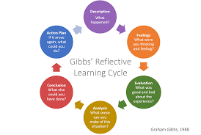
Figure 1: Gibbs' Reflective Cycle
Source: (Ed, 2022)
Time Management using Gibbs model
Description
I can effectively use my time on my work which helps me to become a good hotel manager. So that, I will effectively manage my time and do my work properly. Also, I can take several benefits while I manage my time properly. As a hotel manager, I can prepare a checklist, use a timer, eliminate distractions, time for planning, and many more things that help me to be a good manager.
Feelings-
Our good time management skill helps us to grow our work. I am quite confident about my time management skill as I will be able to make a proper schedule and then work accordingly. This trait will also help me manage my time in an effective manner. Also, I can smartly divide my work depending on the given schedule.
Evaluation
Time management is the most essential thing everywhere, so I decided to focus on my time effectively and properly (Khiat, 2022). The contribution of positive and proper time work is essential. I shall be highly motivated and then can be able to perform at my best level.
Analysis-
I would effectively manage my time and it is the type of lesson that helps me to become a good hotel manager. I think that time management and work division help us to do our work in a better way and a good outcome of the work is expected.
Conclusion
Here, I learned that time management and division of work are essential things to become a better manager. It helps me to focus more on work with a proper schedule. Besides, I must develop the skill of operating both my personal and professional life.
Action plan-
Here I must give importance to working hours. While I can manage my time properly and effectively it will eventually become my strength. I must operate my timings in a more decorated way and pay attention to the other fields too.

Paraphrasing using the Gibbs model
Description
Paraphrasing here simply means presenting several ideas and information in one’s own words by acknowledging the root from where they came. This term here is considered as delivering the same message as the original one. While paraphrasing, one must keep in mind that demonstrating the ideas should convey the same information as the original content retains.
Feeling
I am quite confident that this skill will benefit me in several ways. With the help of this paraphrasing skill, I can develop my overall personality. I will be more agile and confident in any situation. With the help of paraphrasing skills, I can make the guests understand the various situations of the hotel offerings and the environment in short.
Evaluation
Paraphrasing will help me better understand the overall situation of the guest and the ambiance around them (Rossi, 2022). I can be more agile and flexible during my working hours. I can gain the ability to make the guest understand the whole situation in short. Only the important things here will be discussed, and because of that, both I and the hotel will benefit.
Analysis
Paraphrasing will help me in making the overall sense of the experience. This experience will also benefit me in gaining a lot of important little traits. With the help of paraphrasing, I will be able to discover the weak areas where I must work and acknowledge the staff’s effort toward the hotel. As a hotel manager, I will be highly benefited from this trait.
Conclusion
This stage here will make me learn about the areas where I am weak, or I must work a bit more on the areas. Paraphrasing means simplifying the original context and here, as a hotel manager, I will have to make it proper and keep it simple and short for better understanding.
Action plan
This stage here will make me know about the plans that did not go well and the strategies that are undertaken were not impactful enough. I must here keep in mind that while paraphrasing I deliver the proper information and maintain the shortness of the original content here. These are the areas where I must give importance and also must prepare myself as I may have to face similar situations in the future.
Summarising using the Gibbs model
Description
Here the term summarising or to summarise means simply bringing out the most necessary and important aspects or information from a text. Every day we as human beings summarise without thinking about it. This summarised version is always shorter than the original text. Overall summarising means re-purposing information from the sources and then making it a shorter version of it.
Feeling
While thinking about summarising skills, I can relate this particular skill to my job profile. As I will be applying for the post of hotel manager, this skill can benefit me in many ways.
While having conversations with the guests, I can be more defined and can analyse them shortly about the facilities and the other offerings of the hotel.
Evaluation
I can find both good and bad vibes regarding this stage. Here, I will get benefits from these skills, and also, I may have to suffer too (Carnerud, and Bäckström, 2021). As I will be elaborating everything, in short, the guests may not make out their queries and therefore, I may have to face difficulties too. However, explaining everything, in short, will be beneficial for both the guests and me.
Analysis
I can be more agile and will be performing in my level best position as I will develop this skill here. As a hotel manager, it is my duty to observe everything and then work accordingly. Making decisions, organising every situation, etc. here will help me as I will be more confident about making and delivering statements in short. This will also help the staff as well.
Conclusion
Overall, this trait will be very beneficial for me. I, as a hotel manager, will get several benefits from this particular skill. This skill will help me to grow more and will make me agile and confident about several things and opportunities. I will be more flexible in my duty and make can help the staff in organising everything with the summarised version of my thinking.
Action plan
There will be many areas where I have to work on. As a manager of a hotel, several responsibilities will be on my shoulder. I have to make them look very easy. I have to work on my skill of summarising things as sometimes they may get a bit complicated for the guests to be understood. Also, I must prepare and re-arrange the thought before delivering it in front of the guests or the staff.
Public speaking and giving a presentation using the Gibbs model
Description
Public speaking and giving a presentation are regarded as one of the most dominant and impactful skills that one can develop. Public speaking is considered as giving a speech for a longer period or maybe for a shorter time in front of people, and giving a presentation means to deliver slideshows in an office meeting or in front of a group. These two traits are highly valuable and important both for businesses and their personal growth.
Feeling
As I will be applying for the job post of a hotel manager, I must develop the skill of presenting something and also the trait of public speaking. In front of the guests I have to be more sober and confident, that is why the demand for public speaking is necessary. I feel I will be highly benefited from this particular trait.
Evaluation
I can be more agile, and more confident as I will develop this skill. This skill will benefit me a lot. I will be more confident about my personality and KI don does not have to worry about presenting something or giving information regarding the hotel offerings (Ebrahimi, et al.,2019). Therefore, this trait is necessary in my opinion, and everyone must develop thesis skills to prosper in life.
Analysis
These two skills will help both me and the hotel as I will be more comfortable in front of the guests and will not hesitate to present something in front of them. With every task that will be thrown at me, I will be able to handle it smoothly. Public speaking and giving presentations here will benefit me as a hotel manager in organising and making the guests comfortable.
Conclusion
Here in this concluding part, I will have to work on the areas where I struggle a bit. As I will handle the staff, the guests, and the other department too, it is my duty to perform everything smoothly. When giving presentations related to the hotel or delivering speeches in front of guests, I have to be very gentle and kind towards them, so that they can easily understand me.
Action plan
I have to be ready to face any critical situation there. The areas where I must work are, handling the guests, organising the overall situation, and also having to look after the staff. Therefore, I must develop a better version of myself while performing all these important tasks. Besides, politeness and showing vulnerability are the other aspects that I must develop.
Conclusion
This report here provides the overall skills that are needed to be a hotel manager. With the help of the Gibbs model here, the areas are very deeply understood. The six stages of analysis help us to better gain an overall insight into the skills. Besides, the elaborative six stages help us to identify the areas that are needed to be worked on and the proper procedure that one must undertake to develop these skills. This cyclic analytical model structure here delivers all the aspects of the skills and their importance to an individual in a very elaborative way.

References
Carnerud, D. and Bäckström, I., 2021. Four decades of research on quality: summarising, Trendspotting and looking ahead. Total Quality Management & Business Excellence, 32(9-10), pp.1023-1045.
Ebrahimi, O.V., Pallesen, S., Kenter, R.M. and Nordgreen, T., 2019. Psychological interventions for the fear of public speaking: A meta-analysis. Frontiers in psychology, 10, p.488.
Ed. (2022). Gibbs'Reflective Cycle. Available at. https://www.ed.ac.uk/reflection/reflectors-toolkit/reflecting-on-experience/gibbs-reflective-cycle (Accessed 20 January 2022).
Khiat, H., 2022. Using automated time management enablers to improve self-regulated learning. Active Learning in Higher Education, 23(1), pp.3-15.
Rossi, S.L., 2022. Revisioning paraphrasing instruction. In Academic Integrity in Canada (pp. 411-429). Springer, Cham.
Appendix
Slide 1
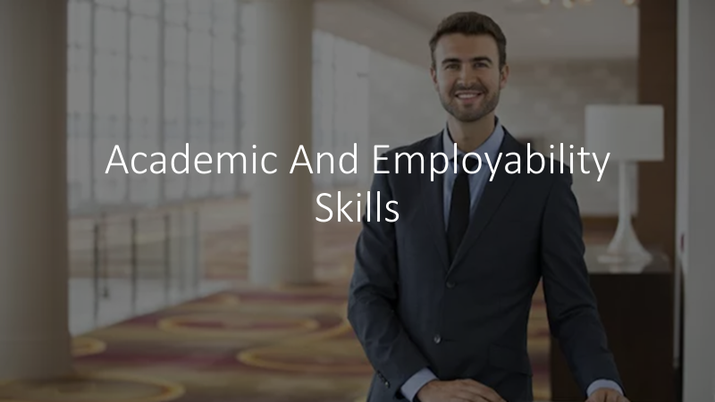
Slide 2

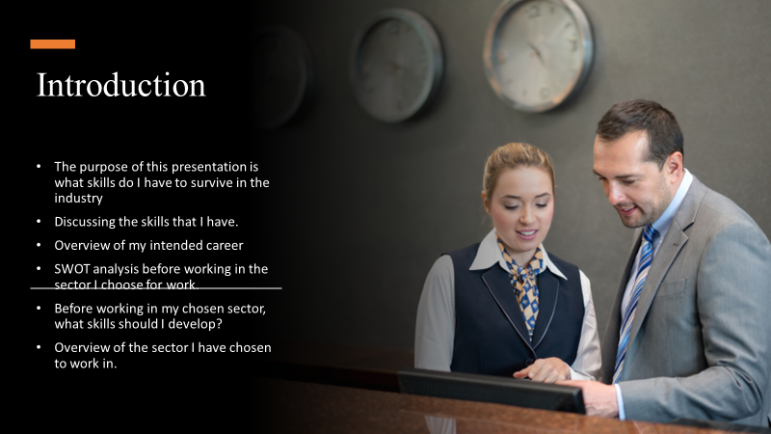
Slide 3
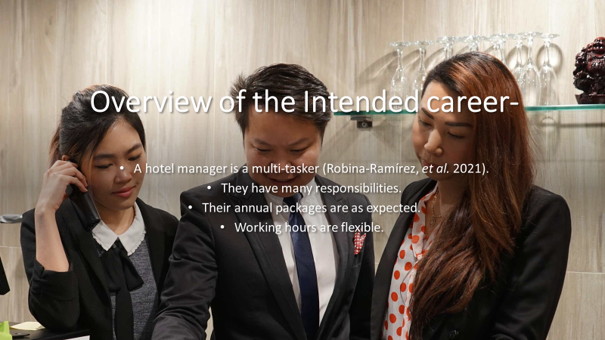
Student 4
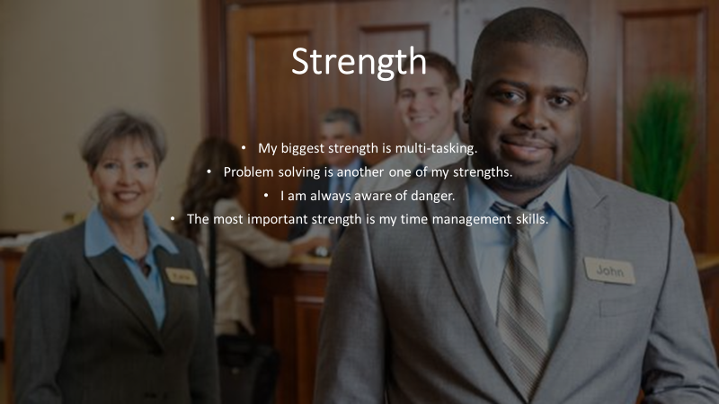
Slide 5
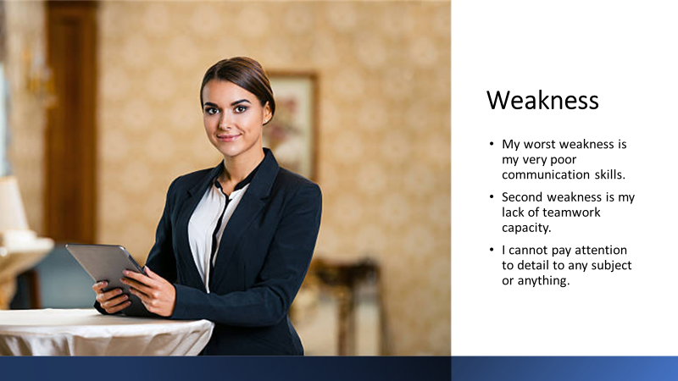
Slide 6

Slide 7
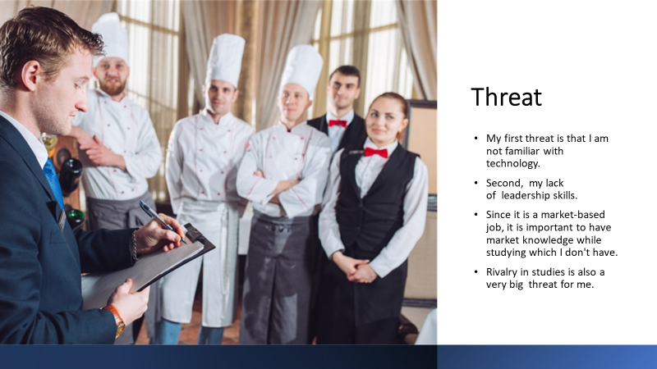
Slide 8
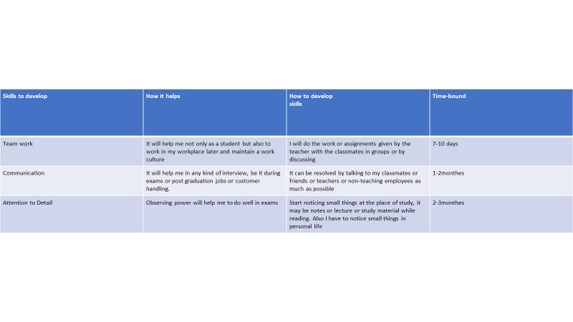
Slide 9
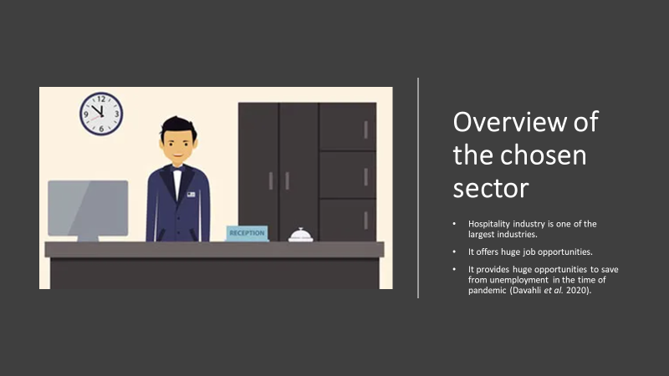
Slide 10
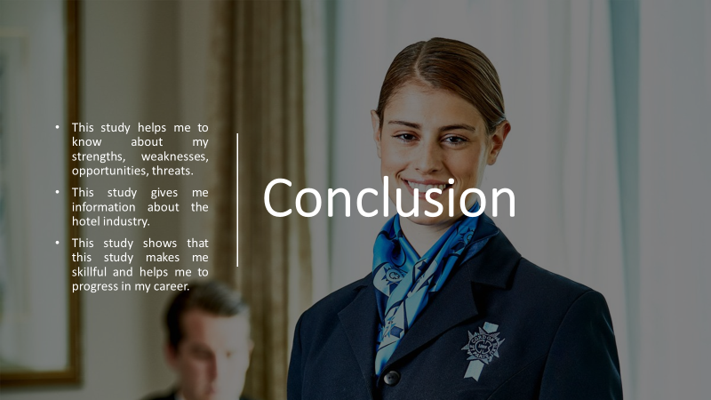
Slide 11
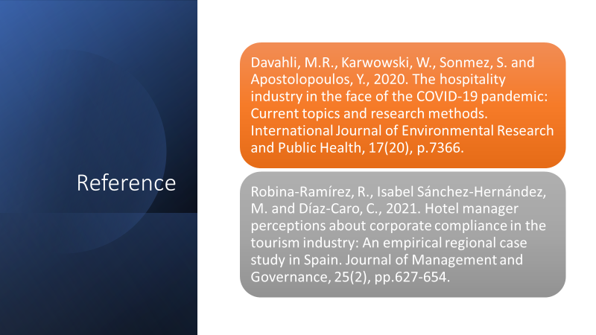
Slide 12


