Module: Research in Context (ADAD5003)
Name: Isobel Bridgland
Student Number: 2004215
Lecturer : Delyth Lloyd-Evans
Program of Study: Illustration Ba(Hons)
Word count: 2541

“If we insist on telling children that everything in the garden is lovely, we’re
doing them a disservice” (Browne quoted in Crown, 2009, p. 12). Analyse the work of
illustrators and, particularly, author illustrators who tackle difficult, sensitive and sometimes
shocking themes.

Within today’s society, children are often sheltered from topics that the adults around them deem as too sensitive. To some parents it seems easier to allow their child blissful naivety when it comes to topics such as loss and grief. Benjamin Beit-Hallahmi speaks of ‘the wish to protect versus the duty to educate’ (Biet-Halahmi, 2011, p. 46) when it comes to how we behave when a chid has questions about death.

Browne suggests that “If we insist on telling children that everything in the garden is lovely, we are doing them a disservice” (Browne quoted in Crown, 2009, p. 12). He is referring to the way that many adults believe it would be cruel to allow their children to lean of the harsher aspects of life. This will have no effect but to hinder the child’s emotional response when they come face to face with someone close to them dying.

Children’s picture books can be a useful tool in combatting this problem. They can explain big concepts in a way that’s digestible for a developing mind. They serve to educate, but also to entertain- finding a balance that allows the child to feel safe to think about such themes.

In this essay I will be analysing how the subject of death is handled in children’s picture books. I will be looking at three different books that each take a different approach to tackling loss. I will further analyse how effective their handling of the subject is when compared to various studies on how children think and develop when it comes to the concept of death.
It was said that ‘for the past fifty years, death has been a taboo subject in children's books’ (Swenson, 1972). I want to use these children’s picture books to show how we as adults can provide education of death to young people, so that they can see death as a natural part of life.
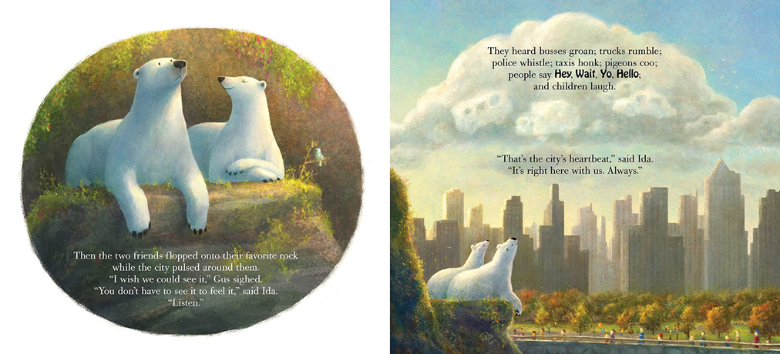
Ida, always, Caron Levis, 2016

Ida, Always tackles the topic of grief. It shows the protagonist, Gus, lose his best friend, Ida, to an unspecified illness.

Levis shows the whole process of having an unwell loved one. The story begins with Gus and Ida enjoying their time together in the zoo that they inhabit. Showing them before Ida becomes ill helps show children the unpredictability of terminal illness and how it can happen to a loved one unexpectedly. The audience can build a connection to these characters and appreciate the authenticity of the friendship between them and mirror it to the close relationships in their own lives.

The zookeeper tells Gus that Ida was ‘very sick’ and that ‘one day, when her body stopped working, Ida would die’. This falls in line with advice given to adults who need to explain to a child that one of their loved ones is terminally ill. You should use ‘simple terms’ (anon, 2015) as the child may feel confused or lied to if they aren’t aware of everything that is happening to the ill individual. The dialog from Zookeeper Sonya will come as a surprise to some children. It is common to use phrases such as ‘she's passed on or we lost her’ or ‘gone to sleep’ (Longbottom, Slaughter, 2018) when trying to explain someone’s passing to a younger audience. These phrases only add ambiguity and will confuse the child into thinking that the deceased person may come back. Adults naturally view children as delicate so will feel the need to use sweetened vocabulary that allude to resting rather than the truth of a person’s body ceasing to function anymore. Browne referring to a ‘disservice’ (Browne quoted in Crown, 2009, p. 12) towards our children is applicable to the way in which we try and shelter them from the facts of life. Ida, Always will help to start a dialog between the child and adult about what it actually means to die.

The illustrations are painted with watercolour making them look wistful and dreamlike. Having a light wash of paint is effective when dealing with a darker theme as it works as a contrast within the iconotext. A book with a sensitive topic needs to still be engaging and visually appealing to capture the attention of children. There is a whimsy within this story that is matched with the images. Gus and Ida spend their time looking up at the clouds and using their imaginations, as seen in fig 1. Despite the upsetting subject matter, these moments of the characters appreciating the world around them despite their troubles gives the story a feeling of hope. S foster believes that ‘just as books on the psychology of sex are seldom pornographic, investigations into death and bereavement are not of necessity doleful’ (Foster, 1981 p. 540). Ida, Always is far from doleful thanks to the style of illustration.

After receiving the news of Ida’s sickness, both characters react in ways that mimic the ‘anticipatory grief’ that people feel ‘prior to a loss’ (Mallon, 2018). they are seen showing anger, sadness and even moments of happiness. They have both ‘growling days’ and ‘laughing days’, illustrating that anticipatory grief is more than just feeling down and there will still be nice moments with the unwell person. Levis includes all the different ways a child may feel when trying to cope with this type of situation and shows that these feelings are okay, a child seeing a character in a book expressing their emotions may be more likely to do so themselves. It will also show children who may have a loved one who is recently diagnosed that although it will be hard, there will still be good days amongst the bad. This story would be validating to read for a young person struggling with the impending death of a loved one.

When children have a loved one who is terminally ill, they may want to ‘help out with their care’ (anon, 2020 p. 21). Gus does things for Ida such as bringing her ‘her favourite toys and fishy treats’. In real life this behaviour is healthy as it makes the child feel more in control of the situation. By doing small tasks to help the sick person they are able to stay busy and show their love.

By the end of the book, Ida has passed, and Gus is left to continue his life without his friend. He reflects on their time together and while he is heartbroken, can remember the good times. He concludes that although Ida is gone, through his memories of her she will be with him ‘always’.

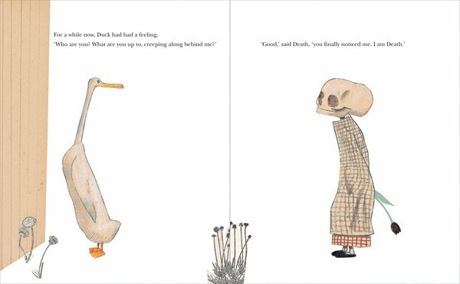
Death, Duck and the Tulip, Wolf Erlbruch , 2007

Death, Duck and the Tulip takes a more existential look into death. In the story, Duck notices that she is being followed by the character of Death. Uniquely, this story features the protagonist dying, rather than a side character. Another noteworthy element of this narrative is how Erlbruch personifies death.

Personifying death is not a unique concept, in various pieces of media and even within religious tales we may see the grim reaper. However, he is usually seen as a foreboding character and one to invoke terror. Erlbruch characterises him differently. he is there to take duck’s life; however, he is not malicious. Duck describes him as ‘nice (if you forgot for a moment who he was)’. By making the character of death friendly, you are in turn making the idea of dying less anxiety inducing.

Dying is a difficult idea to conceptualise for children. By having it symbolised in this way, it is easier for them to digest. Instead of an open ended concept that has no real answers, it is somebody who comes to you at the end of your life. This is fanciful and not an accurate representation of what happens as you die, however a visual aid may be helpful for young people.

Death’s character design makes him seem friendly, particularly because he is almost always shown with a smile on his face. He is wearing a night gown and slippers, making him look childlike. There is a juxtaposition between the innocence of his representation and the melancholy nature of what is taking place in the narrative.

While the idea of explaining their own mortality to a child may seem too mature, Death, Duck and the Tulip brings the idea to light in an easily digestible way. Death tells duck ‘I’ve been close by all your life- just in case’, showcasing the unpredictability of death. A child may not realise that they are guaranteed to pass away one day, so concepts such as these are important to include in ways a child will understand, such as picture books. In the article Death Understanding and Fear of Death in Young Children it is suggested that ‘children typically consider that death is something that happens only to some’ (Griffiths, Slaughter, 2007 p. 525), or similarly, that children believe there are people ‘who are protected from death, like teachers, parents, and themselves’ (Hughes, 2013). This further verifies Browne’s theories, the lack of education of death is only hindering a child’s understanding of the finality of dying.

Questions of the afterlife are brought up by duck to which death meets her theories by saying ‘quite possibly’. Death, by nature should be the person who could answer these questions, however, he answers with ambiguity. Nobody knows what happens after death, it one of life’s most pondered questions. Not giving an answer within the story will allow the child reading to come up with their own theories without being force fed one answer.

The illustrations are small on the page and surrounded by white space. There are no backgrounds meaning the focal point is on the titular characters throughout. In the book Children Reading Pictures the idea that children are ‘sophisticated readers of visual texts’ (Arizpe, et al, 2003) is presented. If we consider this, we can begin to imagine how semiotics will affect a child’s perception of this story. The colour white represents innocence and peace. If the background were painted dark the tone of the story would change completely. White, however, makes the tale less macabre and replaces it with a feeling of serenity. This is mirrored by the way that duck’s body is sent along the river at the end of the story., there is an overarching feeling of tranquillity within the story.

Although the character of death is introduced from the first page, within the paratext we see illustrations of duck before she meets him. These establishing illustrations set up the story’s theme of how death sneaks up on you.

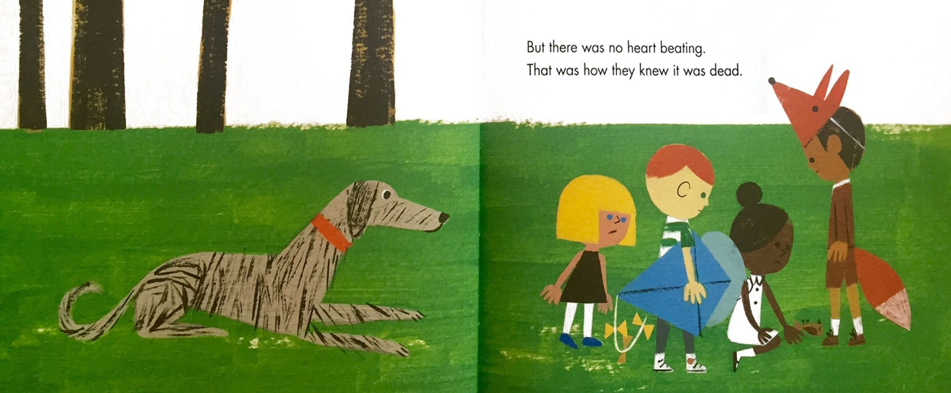
The Dead Bird, Margaret Wise Brown, 2016

The Dead Bird by Margaret Wise Brown portrays death in a scientific way. It focuses more on the biology of death rather than the death of a loved one. It was written in 1938 and re illustrated in 2016, yet the story remains timeless in it’s message.

This narrative gives a literal answer to the question of what happens after you die- you are buried. There is no talk of an ambiguous afterlife, the children recognise this by saying ‘oh bird you’re dead, you’ll never fly again’. These lyrics, while bleak, are truthful.

It is a rarity to see death approached in such an informative way within children’s literature. When the group of children find the deceased bird, they checked it’s pulse but ‘there was no heart beating’. Learning the signs of death will help a child if they are in a similar circumstance to the characters, for example if they were to find an injured animal.

The children decide to have a ‘funeral and sing to it the way grown-up people did when someone died’. A child reading about the ways we honour life will help them feel less anxious when they have to attend a funeral. If we consider that ‘rituals around death are some of the most meaningful ways we have of recognizing someone’s life’ (Marks, 2007), letting young people know that they are nothing to be afraid of will be beneficial. The characters trying to behave like a ‘grown-up’ will help the audience reflect on what to do if they are put in a similar situation. Children will look to the adults in their life for comfort in their decisions. Brown showing her characters acting in a realistic way will further show the audience that these are expected actions.

Much like the plot of the story, a study done in a preschool found that when a group of children came across a small dead animal, they too wanted to mimic what the adults in their lives would do in a situation relating to death. The children suggested that they should arrange ‘a funeral’ and that they ‘should bury it’ (Porter, Schonfeld, 2019, p. 68). People tend to have funerals for the people they love, however a child will feel a connection to a dead animal and want to show them the same amount of care and respect as a human. Brown captured this level of care and innocence in her characters. Some adults may think of The Dead Bird as unnecessarily forward in it’s description of death, however, the same study found that ‘the children were also able to consider and talk about death in a way that was both science based and emotion based’ (Porter, Schonfeld, 2019 p.68). The children were able to theorise on the cause of death and wanted to touch the dead animal. Brown’s story will help to encourage the curiosity children have for death. This is vital, a child learning to not be afraid of a dead animal will in turn be less afraid of death as a concept.

Narratives that show the death of a character that the audience already has an emotional connection to will lead to an emotional response when reading them. This will show children what emotions they would feel when grieving, albeit on a small scale. By writing of a random dead animal that the audience, nor the characters of the book have any prior connection to, Brown is giving children the space to ponder death as a concept rather than putting it into perspective of their own lives.

The children mourn the loss of the bird and visit it’s grave until one day ‘they forgot’. Throughout the story the dead bird seems so important to the characters, but they eventually forget bout it and go on with their lives. This lets us know that grief can feel all encompassing but will ease with time.

I believe that all of these books will allow children to think about death and ponder what it means to be alive. If we can make sure that children read these books, and in turn more are produced we may no longer be doing them a ‘disservice’ (Browne quoted in Crown, 2009, p. 12). In the future I hope to see more children’s books being written by authors who have read similar resources to do with child psychology as I have. I hope authors will be able to start a dialog between children and the adults in their lives so that they won’t be falsely promised that ‘everything in the garden is lovely’ (Browne quoted in Crown, 2009, p. 12) anymore.

Bibliography
Biet-Hallahmi, B., 2011. Children's Understanding of Death From Biological to Religious Conceptions. pp.41-60.
Browne, A. and Crown, S., 2009. A life in books. The Guardian.
Swenson, E., 2021. The Treatment of Death In Children’s Literature. Elementary English, 49(3), pp.401-404.
2015. Supporting Children When Someone They Love Has a Serious Illness. [ebook] Available at: <https://elunanetwork.org/assets/files/HSCC.SupportingChildren.handbook4.pdf> [Accessed 1 December 2021].
Longbottom, S. and Slaughter, V., 2018. Sources of children's knowledge about death and dying. Philosophical transactions of the Royal Society of London., 373,1754.
Foster, S., 1981. Explaining death to children. British Medical Journal (Clinical research ed.), pp.pp. 540–542.
Mallon, B., 2018. Building continuing bonds for grieving and bereaved children : a guide for counsellors and practitioners. London: Jessica Kingsley Publishers.
2020. Supporting children and young people when someone has a terminal illness. [ebook] p.21. Available at: <https://www.mariecurie.org.uk/globalassets/media/documents/how-we-can-help/booklets-pdfs-only/supporting-children-young-people-when-someone-has-a-terminal-illness.pdf> [Accessed 1 December 2021].
Slaughter, V. and Griffiths, M., 2007. Death Understanding and Fear of Death in Young Children. Clin Child Psychol Psychiatry, 12(4), pp.525-535.
Hughes, V., 2013. When Do Kids Understand Death?. National Geographic, [online] Available at: <https://www.nationalgeographic.com/science/article/when-do-kids-understand-death> [Accessed 2 December 2021].
Arizpe, E. and Styles, M., 2006. Children reading pictures. London: RoutledgeFalmer.
Fraga, J. and Marks, D., 2017. When a Pet Dies, Helping Children Through the ‘Worst Day of Their Lives’. The New York Times.
Porter, D. and Schonfeld, D., 2019. Life and Death in Nature: Outdoor Discoveries Bring the Topic of Death into a Preschool Classroom. YC Young Children, 74(2), pp.68-77.

List of Figures
Levis, C. and Santoso, C., 2016. Ida, always. New York, NY: Simon & Schuster.
Erlbruch, W. and Chidgey, C., 2007. Duck, death and the tulip.
Wise Brown, M. and Robinson, C., 2016. The Dead Bird.

