Study Skills
Contents page
- Study time table………………………………………. Page 2-3
- Using Ai ………………………………………………...Page 3-7
- Library search………………………………………….. Page 8
- Reflection………………………………………………..Page 8
- Poster……………………………………………………Page 9
- Reference list……………………………………………Page 9

I acknowledge the use of AI Microsoft 365 Copilot(https://copilot.microsoft.com) on( 08/09/26)
Part 1- study time table
Amser /Time | Llun  Monday | Mawrth  Tuesday | Mercher  Wednesday | Iau  Thursday | Gwener  Friday | Sadwrn  Saturday | Sul  Sunday
00:00 - 00:59 | Sleep | Sleep | Sleep | Sleep | Sleep | Sleep | Sleep
01:00 - 01:59 | Sleep | Sleep | Sleep | Sleep | Sleep | Sleep | Sleep
02:00 - 02:59 | Sleep | Sleep | Sleep | Sleep | Sleep | Sleep | Sleep
03:00 - 03:59 | Sleep | Sleep | Sleep | Sleep | Sleep | Sleep | Sleep
04:00 - 04:59 | Sleep | Sleep | Sleep | Sleep | Sleep | Sleep | Sleep
05:00 - 05:59 | Sleep | Sleep | Sleep | Sleep | Sleep | Sleep | Sleep
06:00 - 06:59 | Sleep | Sleep | Sleep | Sleep | Sleep | Sleep | Sleep
07:00 - 07:59 | Wake up/get ready for the day | Wake up/get ready for the day | Wake up/ get ready for the day | Wake up/ get ready for the day | Wake up/ get ready for the day | Sleep | Sleep
08:00 - 08:59 | Work | Work | Work | Work | Work | Sleep | Sleep
09:00 - 09:59 | Work | Work | Work | Work | Work | Wake up/ chill | Wake up/ chill
10:00 - 10:59 | Work | Work | Work | Work | Work | Get ready for the gym | Get ready for the gym
11:00 - 11:59 | Work | Work | Work | Work | Work | Gym | Gym
12:00 - 12:59 | Work | Work | Work | Work | Work | Gym | Gym
13:00 - 13:59 | Work | Work | Work | Work | Work | Shower/ get dressed for the day | Shower/ get ready for the day
14:00 - 14:59 | Work | Work | Work | Work | Work | See friends | Spend time with family
15:00 - 15:59 | Work | Work | Work | Work | Work | See friends | Spend time with family
16:00 - 16:59 | Get ready for University/ travel there | Have dinner and get ready for the gym | Have dinner | Have dinner | Have dinner | See friends | Do University work
17:00 - 17:59 | University | Gym | Gym | Gym | Gym | Do University work | Do University work
18:00 - 18:59 | University | Gym | gym | Gym | Gym | Do University work | Spend time with family
19:00 - 19:59 | University | Shower | Shower | Shower | Shower | Have dinner | Have dinner
20:00 - 20:59 | Have dinner | Do University work | Do University work | Do University work | Do University work | Shower/ get ready for bed | Shower/ get ready for bed
21:00 - 21:59 | Shower | Pack work bag ready for next day/ make lunch | Pack work bag ready for next day/ make lunch | Pack work bag ready for next day/ make lunch | Pack work bag ready for next day/ make lunch | Spend time with family | Spend time with family
22:00 - 22:59 | Pack work bag ready for next day/ make lunch | Get ready for bed | Get ready for bed | Get ready for bed | Get ready for bed | sleep | sleep
23:00 - 23:59 | Get ready for bed | sleep | sleep | sleep | sleep | sleep | sleep

Part 2 using Ai
Prompt asked –
I am a student studying primary education at level 4 in a university in the UK and have a fulltime job in a school how can I manage my time correctly in order to make the most out of each day and make sure I can fit everything in that I need to do?
AI response –
⭐ Core takeaway
You’ll manage your time best by building a predictable weekly structure, batching tasks, and protecting small pockets of focused study time, rather than trying to “fit everything in” reactively.
🧠 Why this is hard (and normal)
As a Level 4 student working full-time, your challenge isn’t motivation — it’s cognitive load. You switch between:
- Teaching responsibilities
- Academic reading and assignments
- Placement expectations
- Personal life
Your brain needs structure to avoid burnout. So let’s build it.
📅 1. Create a weekly template (not a timetable)
A timetable is rigid. A template gives structure without pressure.
Your weekly template might look like:
- Mon–Fri (after work):
  - 30–45 mins max of light study (reading, note-making, watching lectures)
  - Dinner + rest
  - No heavy assignment writing
- Saturday:
  - 2–3 hour deep-focus block for assignments
  - Break
  - 1 hour admin (emails, planning, organising notes)
- Sunday:
  - 1–2 hours of study
  - 1 hour of school prep
  - Early finish to reset for the week
This structure prevents burnout and keeps you progressing steadily.
⏳ 2. Use the “3-block day” method
Instead of thinking in hours, think in blocks:
- Work block – your school day
- Personal block – meals, commute, downtime
- Study block – short or long depending on the day
This stops you feeling like you must study every spare minute.
🧩 3. Batch your tasks
Batching reduces mental switching.
Examples:
- Batch reading: 2–3 readings in one sitting
- Batch assignment writing: one long block each week
- Batch school prep: Sunday afternoon
- Batch admin: Saturday morning
Your brain works better when tasks are grouped.
📚 4. Use micro-study sessions during the week
You don’t need long sessions — you need consistent ones.
20–30 minute micro-sessions:
- Read one journal article
- Watch one lecture segment
- Write 150–200 words of an assignment
- Summarise notes
- Plan your next study block
These keep you moving forward without draining you after work.
🧘 5. Protect your energy, not your time
Your best study time is probably Saturday morning or Sunday late morning.
Your worst time is after a long school day.
So don’t force heavy work when your brain is tired. Use evenings for:
- Light reading
- Planning
- Watching course videos
- Organising notes
Save the “big brain” tasks for weekends.
📦 6. Use the “Must / Should / Could” system
Each week, list tasks under:
- Must – deadlines, essential reading, school responsibilities
- Should – recommended reading, early assignment drafting
- Could – optional extras
This stops you feeling guilty for not doing everything.
🧭 7. Build a realistic assignment workflow
For each assignment:
- Week 1: Read, highlight, gather sources
- Week 2: Write a rough plan + 300–500 words
- Week 3: Write the main body
- Week 4: Edit + reference
This spreads the load across weeks instead of cramming.
🧱 8. Set boundaries at work
You’re full-time, but you’re also a university student. Protect your time by:
- Not taking on extra responsibilities
- Saying no to unnecessary tasks
- Avoiding staying late unless essential
- Keeping your lunch break for yourself
Your degree is part of your professional development — it deserves protected time.
🌿 9. Build in recovery
You need at least:
- One evening a week with no study
- One half-day each weekend with no work or uni
- Sleep as a non-negotiable priority
Burnout will cost you more time than rest ever will.
📌 10. A sample weekly plan (tailored to you)
Monday
- Light reading (20 mins)
- Relax + early night
Tuesday
- Watch a lecture (30 mins)
- Quick note summary
Wednesday
- No study
- Personal time
Thursday
- Read one article (20–30 mins)
- Plan weekend study
Friday
- No study
- Rest
Saturday
- Deep study block (2–3 hours)
- Assignment writing
- Admin hour
Sunday
- 1–2 hours study
- School prep
- Early finish
Refined answer-
• Prioritise tasks using a realistic weekly plan — break your university work, job responsibilities, and personal commitments into manageable chunks, identifying what is urgent and what can be scheduled later. This helps you stay organised and ensures essential tasks are completed without last-minute stress.
• Use structured routines to maximise productivity — set aside dedicated study periods around your work hours, use tools like calendars or to-do lists, and create consistent habits (e.g., studying for one hour after work or using weekends for assignment progress) so your time is used intentionally rather than reactively.
• Maintain balance by setting boundaries and allowing rest — communicate clearly with your workplace and university when needed, avoid overcommitting, and include breaks and self-care in your schedule. This prevents burnout and ensures you can sustain both full-time work and academic study effectively.
AI suggested references-
• Prospects.ac.uk (2026) Time management tips for students: 7 ways to stay organised. Available at: https://www.prospects.ac.uk/careers-advice/study-and-training/time-management-tips-for-students (prospects.ac.uk in Bing) (Accessed: 24 September 2026).
• University of Salford (2025) Our top tips for managing your time. Available at: https://www.salford.ac.uk/news/time-management-tips (salford.ac.uk in Bing) (Accessed: 24 September 2026).
• University of Portsmouth (n.d.) Time management and productivity. Available at: https://library.port.ac.uk/time-management (library.port.ac.uk in Bing) (Accessed: 24 September 2026).

Library search-
Cottrell, S. (2019) The study skills handbook. 5th edn. London: Red Globe Press.
Glading, B., & CandidCareer.com, production company. (2014). Time management [Video studied.recording]. uConnect.
Time management can be hard to navigate, Cottrell (2024) suggested that effective time management can enable students to avoid procrastination. Knowing this students should make effort to plan and prepare their time efficiently in order to reach dead lines and complete their assignments. It is important that students set aside time each day for themselves this way completing work doesn’t take over their day and they know how much time each day should be spent on what activity.
If students struggle to get work done as they are always worried about other things this is called procrastination. According to the University of St Andrews (2024), students can reduce procrastination by breaking tasks into smaller steps. This allows them time to think ahead and not get overwhelmed by the job at hand instead they can break it down and do bit by bit so stop it becoming to challenging and a lot to think about.
Reflection
For the first part of the assignment Microsoft Copilot was asked a prompt on how to manage time effectivity, using the response it was then asked to refine it into 3 clear bullet points as the first answer gave large amounts of information rather than clear instructions. Then a search in the library was carried out to find books to back up the information given my CoPilot and support the answer. This gave a more relevant answer that was related more to the course that was being

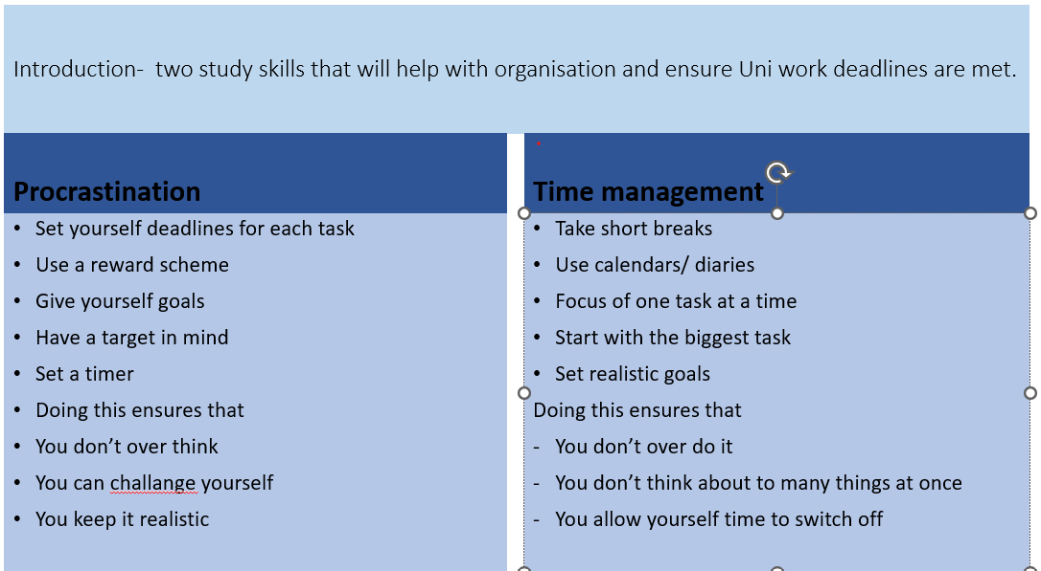
Reference list

Cottrell, S. (2019) The study skills handbook. 5th edn. London: Red Globe Press.(Accessed on: 24 September 2026)
• Prospects.ac.uk (2026) Time management tips for students: 7 ways to stay organised. Available at: https://www.prospects.ac.uk/careers-advice/study-and-training/time-management-tips-for-students (prospects.ac.uk in Bing) (Accessed: 24 September 2026).
• University of Salford (2025) Our top tips for managing your time. Available at: https://www.salford.ac.uk/news/time-management-tips (salford.ac.uk in Bing) (Accessed: 24 September 2026).
• University of Portsmouth (n.d.) Time management and productivity. Available at: https://library.port.ac.uk/time-management (library.port.ac.uk in Bing) (Accessed: 24 September 2026).
Glading, B., & CandidCareer.com, production company. (2014). Time management [Video studied.recording]. uConnect.( accessed: 24 September 2026)
University of St Andrews (2024) Recognise and manage procrastination. Available at: https://www.st-andrews.ac.uk/students/advise.recognise-and-manage-procrastination/(st-andrews.ac.uk in bing) ( accessed on: 24 September 2026)

