THE GLOBAL BUSINESS ENVIRONMENT
Rexon Nting
LCBB4005

LYUBEN EFTIMOV
(1913402)
Assessment 1
Ba Business management

Table of Contents
A 3
External and Internal Forces 3
Change in the Automobile Industry 4
B 5
PESTEL Analysis of Automobile Industry 5
Political Consequences 6
Economic Consequences 6
Social Consequences 6
Technological Consequences 6
Environmental Consequences 6
Legal Consequences 7
Analysis of Michael Porter Forces 7
The threat of New Entrants 7
Bargaining Power of Suppliers 8
Bargaining Power of Buyers 8
The threat of a Substitute 8
Competitive Rivalry 8
References 9

A
Due to the increasing problems and profit loss over time, the automobile industries have a potential influence. The automobile industry is one of the top industries worldwide. The automobile industry also gave employment. The vehicle industry gave charity to the needy people. They also gave effective rewards to its workers. The automobile industry delivers its vehicles to supplier in order to gain productivity and profit. The automobile industry also has a strong influence on demographic factors. This industry is ancient. The automobile industry started its operation in Europe and then in the United States of America. At initial stages, the automobile industry earned a lot of profit. The industry remained recognize in the eyes of the consumers. In Europe countries, the automobile industry gained maximum productivity (Law, 2017).
The vehicle industry is going to be a worldwide business. The industry enlarged in many countries. This industry is progressing in this digital world by the ongoing demands of the consumers. Nowadays, consumers have specific wants according to the changing trends of the world. Now the automobile industry spread its businesses in numerous regions of the world. In Middle East and central Asia, the automobile unit obtained maximum productivity and constant growth. With the passage of time it spreader with the neighbour countries with respect to growing trends in vehicle industry sector. But in today’s pandemic situation, the industry suffered from huge losses (Law, 2017).

External and Internal Forces
External and internal forces have a great influence on the automobile industry. Internal and external forces include workers of the automobile industry, government policies and procedures, technology consequences, and the capital of the automobile industry. There is a high level of competition in the automobile industry that drives serious innovation. These days’ new sources and ideas of innovation make the automobile industry very tremendous. Now there is an influence of the unique design and features of a vehicle. Now the use of the digital medium is widely used in the auto industry. Now the cars are fully loaded with entertainment and much technological advancement. Now the latest technology trends make the vehicle more innovative and user-friendly (Hoffman, 2019).
With the advancement of technology, now the vehicles are fully loaded with parking and backup sensors gadgets. The use of Google maps in vehicles influences the automobile industry. The worker of the automobile industry has a direct influence on the car industry. The automobile industry must give training to its workers concerning perfect skills in the automobile industry. Capital is also the main consequence because it is the pillar of the automobile industry to pay its expenditure. Latest Technology trends also open new horizons in the automobile industry. Now we can easily navigate the positions of the regions. Now, there is an emerging trend of electrical vehicles in the automobile industry (Hoffman, 2019).
Electric vehicles are fuel-efficient and can save a lot of money for the consumers. This trend is also growing rapidly. The use of the software is increasing day by day. By using the software and different kind of IT gadgets, we can easily measure the tire pressure. With software, we can now easily find errors in our vehicle if it misbehaves or does not start. Big organizations like Apple, Microsoft, and Google make specific software for the automobile industry. These technologies are used nowadays to gain a competitive advantage. With the increased use of these technological trends, our vehicles now become more innovative (Hoffman, 2019).

Change in the Automobile Industry
This industry obtains much popularity and changed itself for the last few years. There are a lot of aspects behind its success. The industry offer opportunities to individuals in the world. The vehicle industry have consistent a roles and core values in the growing economy. In Europe and America, it gave employment to a million people for the last few years. Now, the time is come to make constant and competent techniques in order to gain productivity. It is more important to maintain in the market. The industry seriously needs to make its market value around the digital world. If they make its market value, then they will obtain efficiency in the future. So the industry demands a lot of struggle. A productive and maintain portfolio should be the life line of this industry. Contrary to it, there is a lot of improvement in the R&D department. Similarly it is better to design those products that are best in the image of the consumers (Rawlinson, & Wells 2016).
With respect to digital trends and gain in productivity, the vehicle industry now shifted to AI technology to make vehicles more productive and safe. With the help of this technology, consumers can easily find their required places and fields. With the help of this technology, the top managers of the car industry give safety and precautionary measures to its consumers concerning the digital software. The use of technology aspect already played a realistic role in the industry with the help of artificial intelligence system, now it generated more value in the last few years (Rawlinson, & Wells 2016).

B

PESTEL Analysis of Automobile Industry
In PESTEL analysis, many consequences can be faced by the automobile industry. It is used to examine and evaluate the external consequences of the market. Some other legal consequences are used to examine the condition of the marketplace in the world. Most organization uses this technique to gain maximum productivity and output. Now the automobile industry also used this technique to observe the opportunities and threats in order to survive in the market. PESTEL analysis could be used to determine the growth level of any organization in the world where it stands. This technique likewise is more similar to SWOT analysis. It is very quick, reliable, and utilized in many consequences. Despite this technique, the Automobile industry will able to drive out very consistent and useful results. Besides this, the PESTEL analysis draws very competitive results as compared to the SWOT technique (Kalliokuusi, 2013).
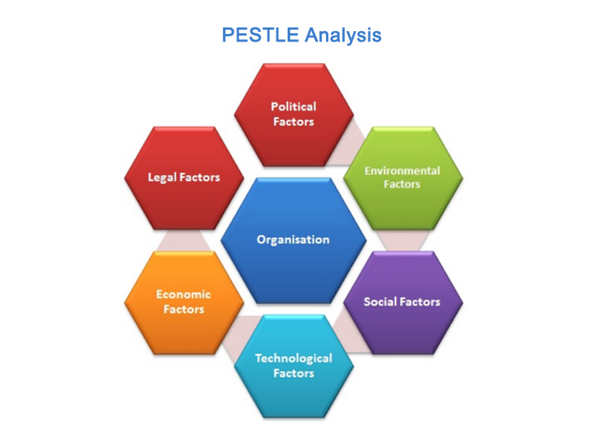
There are legal procedures that are potentially encouraged. Demographic consequences is another aspect and consisting of many social issues. Summarizing the general viewpoint and affect, moral issues consists of community and biased issues. The economic condition would perfectly comparable with the industrial evaluation. In the PESTEL model, these consequences are given below as you can see (Kalliokuusi, 2013).

Political Consequences
These consequences tell us how the government gets involved in the automobile industry in terms of their new launching vehicles. It covers all the major consequences like trade and tax standards, environmental legal procedures, and international market legal procedures. With the above consequences, it is much clear that these consequences have a strong influence on launching newly branded vehicles in the automobile industry. The automobile industry will have to obey all these legal standards in order to survive in the marketplace (Kalliokuusi, 2013).

Economic Consequences
Economic consequences have much influence in the automobile industry in order to generate maximum profit in terms of new brands of vehicles and how they do business. These consequences include mark-up rates, economic standards, other market rates, and how the income from the consumers will generate in the future from their new brand clothing. These consequences are further broken down into various consequences such as how tax from the consumers will generate, their expenditure policies, and their management demands in order to launch its new brands of vehicles in the automobile industry (Kalliokuusi, 2013).

Social Consequences
Social consequences include the behaviours and attitudes of consumers. This means how consumers react in a new product launch in terms of new vehicles of brands and what are their beliefs about having this new vehicle brand launch. In this factor, we handle the modes and behaviours of the consumers. It also includes age factors of the consumers (Lucky and Takim 2015).

Technological Consequences
In technological consequences, we all very familiar with how the automobile industry launch with which technology. Technology is more competent and plays a vital role in terms of many factors in the automobile industry. Technological factors encourage new ways to us "how we deliver our products and in which way we communicate with our consumers" so technological factors are more fundamental in every aspect (Lucky and Takim 2015).

Environmental Consequences
These days' environmental consequences have a tremendous influence. In the past, these factors are mainly ignored by most of the organizations. But the demand for the products in this modern era, this consequence is stronger in evaluating any product. This tells us how ethical and moral the company or organization is. How often they take care of the consumer's reactions to satisfy the needs and wants (Lucky, & Takim 2015).

Legal Consequences
Legal consequences include safety and health measures, opportunities, promotion procedures, consumer’s equality, product packaging, and product safety health measures. An organization needs that they recognize what is according to standard and what is not. If they do business worldwide, then it becomes more attentive to the automobile industry to take these issues seriously in order to gain maximum productivity (Lucky, & Takim 2015).

Analysis of Michael Porter Forces
The forces of Michael Porter are very fundamental to get competitive forces in an organization. The automobile industry must understand these forces. These forces find out the failure and success within the organization (Dobbs, 2014).

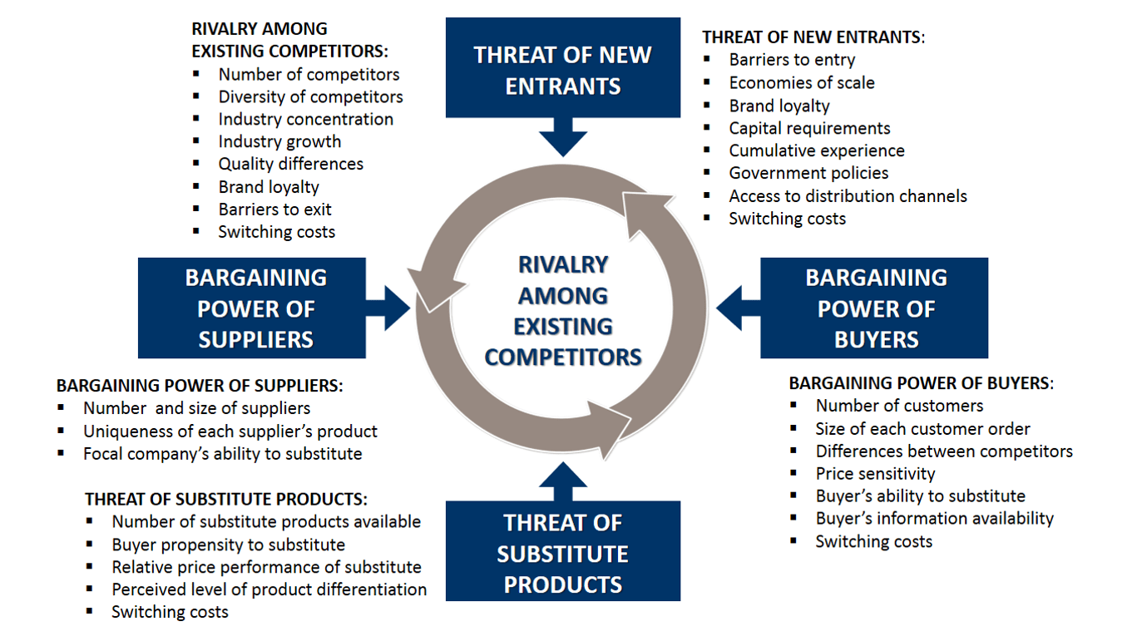

The threat of New Entrants
This consequence is very rare because of its higher capital. On the other hand, making an automobile company requires huge capital. So chances are very low (Dobbs, 2014).

Bargaining Power of Suppliers
This consequence is also very rare because most of the suppliers have small businesses concerning the automobile industry. The auto parts of most of the cars come from different parts of the world. So it is found that this consequence has also very low chances in the automobile industry (Dobbs, 2014).

Bargaining Power of Buyers
In the automobile industry, this consequence has a tremendous result and the rate of buying is comparatively much higher because the prices in the automobile industry are very competitive. Most of the consumers make a comparison through the digital medium in judging the price comparison of the cars (Dobbs, 2014).

The threat of a Substitute
In this consequence, there are minimum chances of substitutes because nowadays cars are the most simplest and convenient medium of transport concerning geographical factors. Cars are used by many people concerning going to offices or recreational purposes. These days, the only substitute for cars is bicycles. With a bicycle, a person can only cover the distance of a maximum of 15 to 20 kilometres (Dobbs, 2014).

Competitive Rivalry
The automobile industry is now becoming the top industry in the world. Now it is a more competitive sector as compared to other sectors. The technique of production depends on knowledge in the automobile industry (Dobbs, 2014).

References

- Dobbs, M. E. (2014). “Guidelines for applying Porter's five forces framework: a set of industry analysis templates”. Competitiveness Review.
- Hoffman, K. (2019). “Driving force: the global restructuring of technology, labour, and investment in the automobile and components industry”. Routledge.
- Kalliokuusi, M. (2013). “Renewing marketing strategy in Kenyan automobile industry”.
- Law, C. M. (2017). “Restructuring the global automobile industry” (Vol. 4). Taylor & Francis.
- Lucky, B. O., & Takim, S. (2015). “Manufacturing defects in the automobile industry, a case study of the remote causes and effects of Toyotas transmission malfunctions in cars”. International Journal of Engineering and Applied Sciences, 2(8).
- Rawlinson, M., & Wells, P. (2016). “The new European automobile industry”. Springer.

