“I will not live my life dictated by the issues you have with my sexuality.
You be you, and let me be me”
- Kim Kardashian

COURSE: photojournalism and documentary photography third year student
AT: University of Wales Trinity Saint David Swansea, wales.
United Kingdom.
13.12.2018
by Sara Assebab
word count without in text reference and quotes: 5,011

Table of contents

Title page: 1 page

Abstract page: 1 page

Chapter one: 9 pages

Chapter two: 7 pages

Chapter three: 5 pages

Conclusion: 2 pages

Bibliography: 3 pages

Abstract

This paper will discuss and offer the reader insight on the difference of idea(s) existing within the feminism movement. The feminist movement is diverse and open to a difference of interpretation, how you perceive feminism depends on the reader, context, time and place. This paper will reflect on two very different Ideas existing within the feminism movement. The idea of being “extremely modest” and the contrary promoting a sexual image. Subjectively famous / infamous celebrity named Kim Kardashian is constantly all over social media and is currently shaping and impacting the younger generations’ ideals of female beauty based on sexualized take on feminism. Whilst analyzing and discussing the impact Kim has on the younger generation globally because of social media a discussion of the notions of feminism will also be incorporated in this paper. The discussion will try to unpack and understand how / where Kim’s Ideas of how feminism defines the way that she presents herself. As Kim is recognized for saying, “I am a feminist, because I believe that I empower women to flaunt and love their body shapes” (closer, body shaming, accessed 2018). Although this can be perceived to be a very powerful interpretation of feminism, there is a contrast of opinion that challenges this notion of being overly sexualized, both coexisting in the west.

Chapter one
Waves of feminism

It is believed that feminism has empowered many women to become activists and fight for women’s rights. This movement is believed to have kicked off during the 1848 period (history art archives, women’s rights, accessed 2018)
Feminism initially developed to give women the right to own property, vote and the freedom to make the choices for their lives. However, today feminism is becoming a more of a political stance against patriarchy, particularly in western societies. Because of this current technological age, Feminism has reached platform and therefore is giving coverage to many activists. This movement has become more powerful and recognized because of the internet and the role social media plays, now people are connected more than ever. It is no misconception that a new wave of feminism has emerged because of the #MeToo movement. This new wave of feminism is recognised as the fourth wave of feminism, often it is described as, “passionate, social influencing power, deconstructing social constructs and demanding change” (progressive women’s leadership, the four waves of feminism, accessed 2018)
The first wave of feminism is noted to have began in the 1830s and started to flourish in the 1900s. This first wave of feminism started to bring about political and social change for women. The aim was to recognise women as first class citizens. To allow them rights to vote, own property, equal pay and other legal issues. First wave of feminism focused primarily on giving the women rights to vote so that they can bring about social and political change.

Chapter one
Waves of feminism
This wave of feminism was often recognised as “militant”, women and men members who belonged to this club were referred to as the suffragettes. The suffragettes were a group of women and some (men) who recognised the unequal, misogynistic and patriarchal society of their time and wanted to bring about equal change for women.
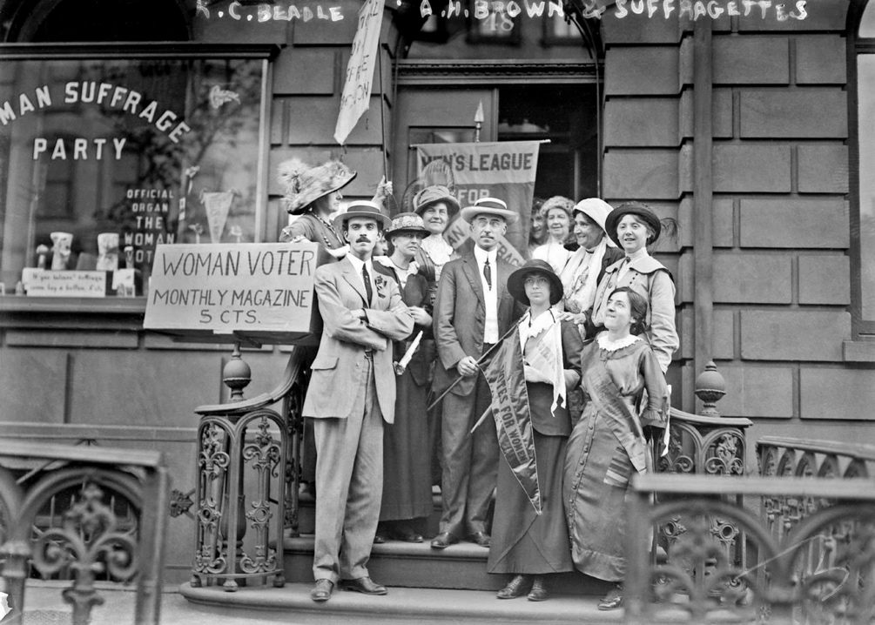FIG 1
The suffragette’s movement also tackled subject matters such as sexual behaviour, the biology of the reproductive system and economic matters. First wave of feminism has given the opportunity for other waves of feminism to develop and make further political and social change of their time.
The second wave of feminism is believed to have began during the 1960s until the 1980s, this wave of feminism differs from the first wave of feminism in many ways, as it focuses on the workplace, the family structure, sexuality and the women’s reproductive rights.
Chapter one
Waves of feminism
Second wave of feminism focused on giving women the opportunity to work, rights and protection regarding domestic violence in the home and educational rights. The second wave’s main intention was to bring about a debate, one that would convince the populace that women are also capable of working and achieving equally what men had achieved throughout history and also that they could bring new achievements given the chance. An interesting quote that will illustrate this point would be, “it is not women’s inferiority that has determined their historical insignificance: it is their historical insignificance that has doomed them to inferiority”. The sayings of, Rosa Luxemburg and Marie Curie.
Although this statement is somewhat true, it is not the entire picture of history, as Jordan Preston illustrates a difference of opinion in his debates regarding this subject matter. Preston mentions that historically, “both men and women suffered, women suffered greatly because of their biological anatomy, after all tampons as they exist today are fairly a new invention”. (feminism debate, YouTube, accessed 2018) It is only fair to consider this aspect as women have been held back in the past not because of the patriarchy alone, but there are other elements to consider. It is believed that disposable pads have only come about in the 1970s. before the invention of tampons women from all walks of life, had to use and invent methods that had a negative impact on their health and as one can imagine left them emotionally incapable of focusing on anything else but their current menstrual state. Because of this essential biological factor, it was another element that could have deemed their historical insignificance.
Chapter one
Waves of feminism
The third wave feminism movement is recognised to have started during the 1990s and began to flourish and develop followers (particularly in western societies) during the early 2000s. Third wave feminism main focus and aims involved re-shaping what people think about sexuality regardless of your gender. The notion was to accept people without judgement pertaining to their gender, colour and whether they self identify as male or female. It attempted to revolutionise the idea of the two rigidly defined genders, the belief was that these aspects like femininity or masculinity are social construct ideas that needed to be de-constructed and redefined. In a way this movement recognised and accepted gender fluidity.
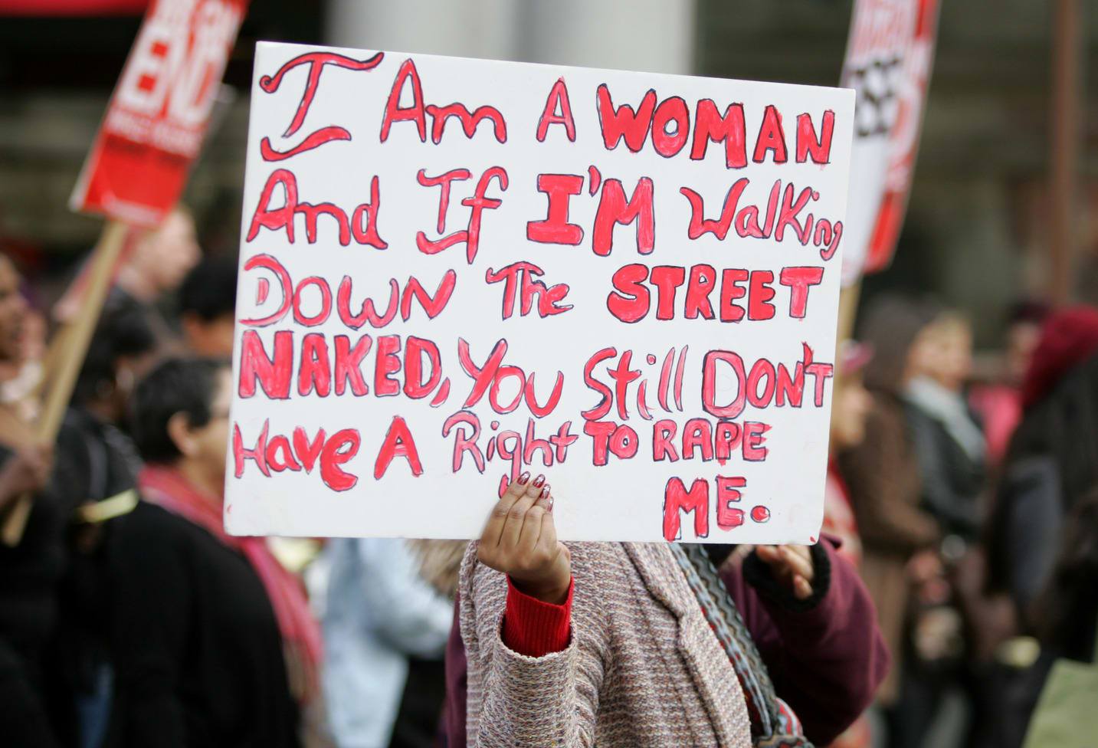FIG 2
Third wave of feminism is different to the first wave and second wave of feminism because this new wave, states that if by default (some) men can act a certain way because of their biological instinct, then women can act how they please regardless of how men/women feel about how one is presenting one self in the public domain.
Chapter one
Waves of feminism
Although this is a powerful statement as clothes are social constructs, and this is evident as in some civilisations (even today) tribes do not wear clothes, or appear as covered as we in western societies are today. Although it is very difficult to measure whether men instinctually sexually objectify women or whether they have been socially conditioned to do so, one can argue from an objective perspective that this idea of men sexualising women exists and if one makes the conscious decision to dress a certain way then they are doing so at their own risk as we can not account for how people behave in the public domain.
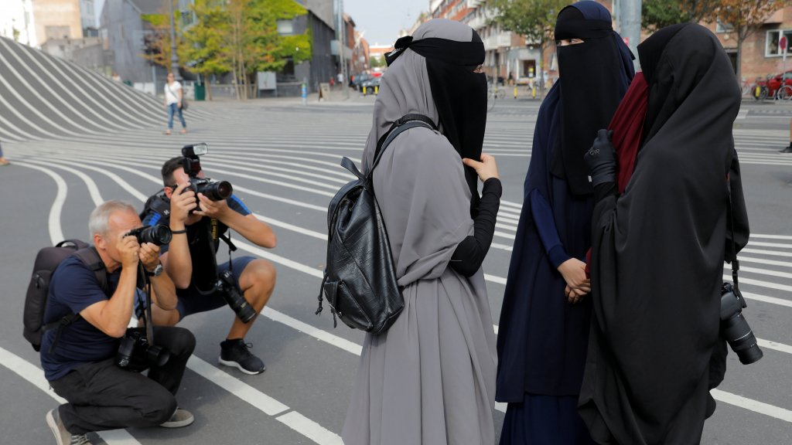FIG 3
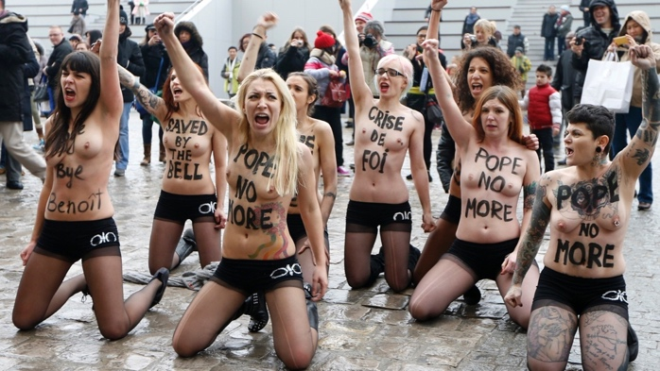FIG 4

Chapter one
Waves of feminism
Fourth wave feminism can be described as post-modern feminism, although this wave of feminism is not fully recognised as ‘real feminism’, it can be referred to as post-feminism and descried by some influencers like Jordan Preston, Ben Shapiro and Milo Yiannopoulos as anti-feminist, however this is all down to their personal interpretation of what feminism should constitute.
Fourth wave feminism is a relatively new concept that is believed to have started during 2012. This wave follows the same school of thought as third wave feminism. This movement preaches equal rights for every human, it has a very liberal approach towards all humans. It is in no doubt a secular way of viewing the world. Although it may not be practical or objective, it is seen as ideal, because it accommodates individual perspectives which can be hard to attain in a secular democratic society, because democracy constitutes majority choice, which is not absolute equality.
An analogy to illustrate this point would be, if XYZ (the majority) votes for Donald Trump to be president of the USA, but another group votes otherwise the majority wins. Which means the minority vote cannot be met and therefore must live with the majority choice, this is anti-equality. Perhaps there is no absolute perfect system as our choices tend to be broad and subjective.
The fourth wave feminism has become recognised as this “call out culture” (vox atl, culture all, accessed 2018) it promotes this idea of challenging the patriarchy in the west. The call out culture means that

Chapter one
Waves of feminism
whenever patriarchy is evident, feminists must challenge this notion by starting a debate and raising awareness to it. Overall this ‘new wave of feminism’ promotes a louder voice, as unlike the first wave and second wave, its main intention is to focus on topics like the #MeToo movement, which gives voices to those who have been dominated or sexually assaulted by men. Not only that but this notion of feminism also opens up a further debate on what could be perceived as sexual assault etc.
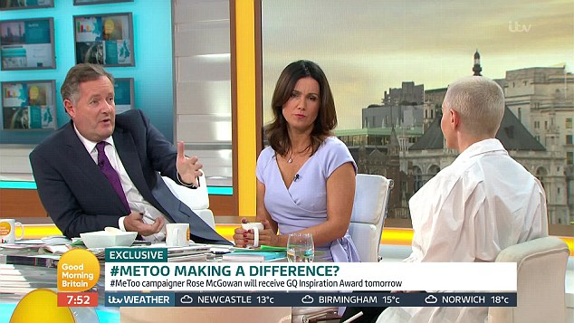FIG 5
Although the first wave of feminism is what started the debate regarding women’s rights, it did not end there. The first wave of feminism has essentially given rise to the second, third and fourth wave. Feminism be it first wave or third/fourth is essentially looking out for the interest of the women. How do these different waves of feminism differ from each other depends on context, time and place. First wave of feminism is believed to have been shaped by well known feminists like Susan B Anthony, Marie Stopes and Simone de Beauvoir. First wave focused on giving

Chapter one
Waves of feminism
women their basic rights like voting, right to work and hold employment and have domestic rights.
The second wave’s main focus (recognised as “women’s liberation” (khan academy, second wave feminism, accessed 2018) was to truly liberate women, it recognised that women had more rights than before the first wave feminism period, but wanted to further expand this freedom to women. This second wave challenged “the traditional wife and mother roles” (BBC, second wave feminism, accessed 2018)
second wave feminism also focused on the women’s rights over her own body, which involved the choice to abortion and safe contraception etc.
Third wave feminism main motives involved challenging the patriarchy, de-constructing social constructs, challenging female/male roles and generally raise awareness regarding women issues. Fourth wave feminism unlike the above did not have a particular motive or focused attention on one main subject matter, but rather it is to encourage an on-going debate about gender fluidity, women in the work place (and how there is still inequality in regards to pay) and starting this notion of allowing women to express their individuality, meaning in this context if one wants to appear dressed like Kim Kardashian whose dress style tends to provoke and draw sexual attention to her body then one should be free to express that choice, regardless of how men might feel or behave, contrast to this would be those who are in minority groups and self identify as Jew, Christian or a Muslim and choose to wear the face veil or dress in a modest manner, these particular groups of communities tend to be either marginalised or given a one-
Chapter one
Waves of feminism
way narrative about how freedom of choice should appear in western context. However, if freedom of choice is subjective then we as liberal
society cannot enforce a one idea of how freedom of choice should appear. It is no misconception that in western societies most women choose to appear in what is often referred to as ‘western attire’ because they have been influenced by the western life style, which is derived from movies, art, literature etc. Other groups of communities have also been conditioned by other ideas that constitute their ‘truths’. This narrative can easily be identified when one analyses and
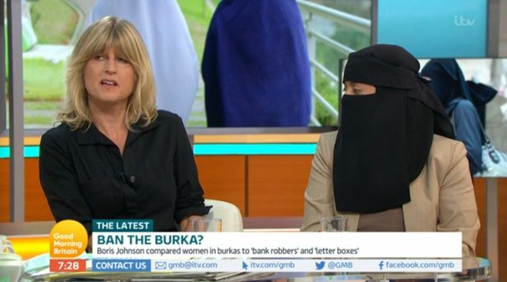FIG 6
compares these debates that occur in mainstream media. Ensue a trial, where the minority are forced to justify their choice based from the framework of somebody else’s freedom of choice. This approach is damaging as the populace are being shown freedom of choice has boundaries surrounding deviation from ‘western attire’, when in reality it is far more complex than that.
Chapter two
Kim K
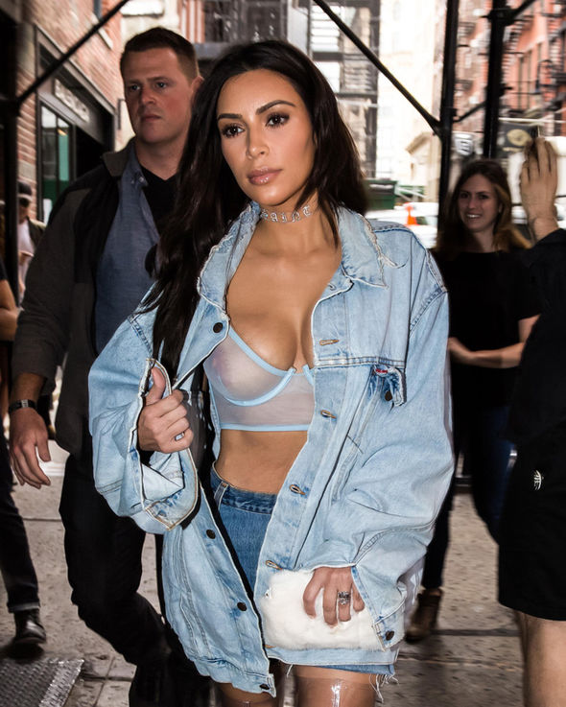
Taking Kim’s dress style into consideration it is hard to measure or know if she is impacting women in today’s society in a positive or negative manner. Kim has become this new face of beauty, meaning that before she gained wider recognition which was in 2007, due to her sex tape scandal. Pre Kim’s fame there was this one-way idea of beauty often painted as being painfully thin women, who were
FIG 7
often glorified for being under weight, it was the time of twiggy and such. The mainstream media often focused on giving platform to women who look very thin, and because of the narrative the media created, “that if you are thin, you too can look this beautiful” (live science, thin always will be in, accessed 2018).

Chapter two
Kim K

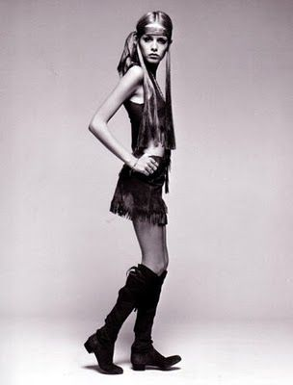FIG 8
It is evident that Kim enjoys the recognition she receives for being famous for her curvy body. However, the question still remains whether she is a good role model for the younger generation or if she is in fact an anti-feminist who is impacting the younger generation in negative manner, because of the Kardashian’s family we now see epidemic of plastic surgery, buttock implants, lip fillers, cheek fillers etc.
Before the fame of the Kardashian family there was this notion that fake hair or nails were seen as taboo as it did not meet the standards of natural beauty, however since the coming of the Kardashian family this notion has been challenged and now we see that the fake / plastic look is normalised, this is because of the narrative the Kardashian family have created since their show aired. “keeping up

Chapter two
Kim K
with the Kardashians” has been a new way of viewing beauty, this notion that if you do not have big lips, long nails, long hair then you can attain this by buying it, perhaps a post-modernist idea. The Kardashian family are in no doubt a materialistic family who enjoy the life of capitalism and what it has to offer them.
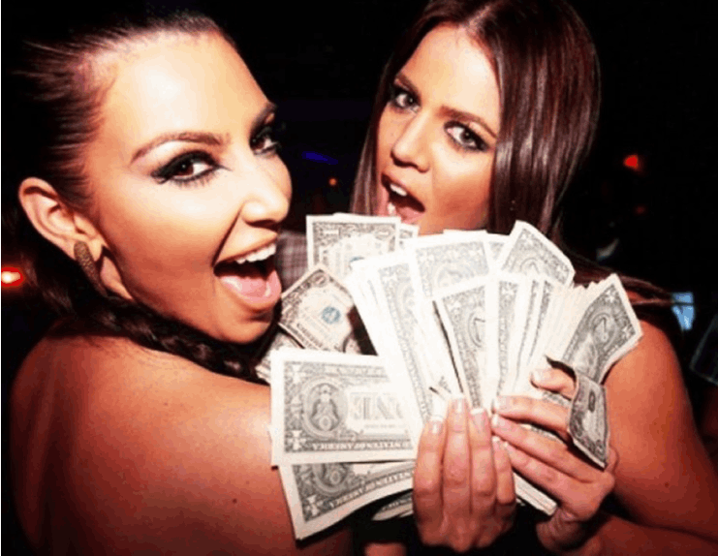FIG 9
from a post-feminist perspective Kim can be seen as a feminist who is empowering women of her time, what makes this particular celebrity flaunt it all and be proud of her body, could be down to her Americanised life style. As Kim grew up in California and therefore her lifestyle and the way she views the world will be impacted by the environment she has been raised in. So it should not come to be a shock that she is a product of her upbringing. A quote to illustrate this point would be, “give me a child and ill shape him into anything” the saying of, B.F Skinner.

Chapter two
Kim K
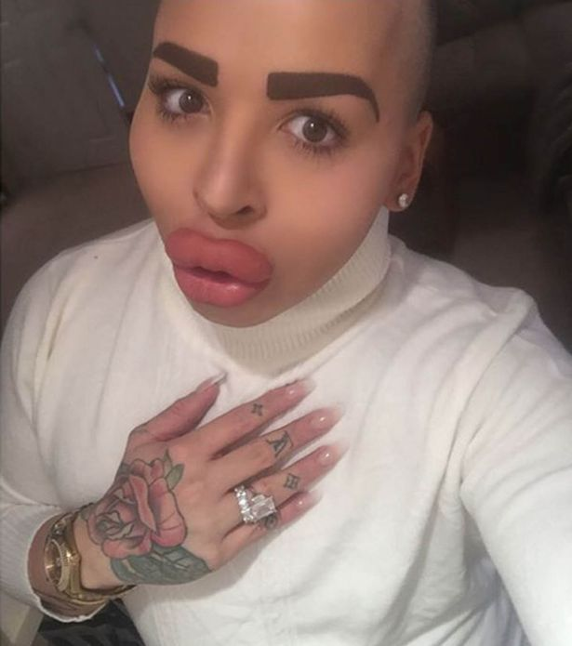
But with fame and international recognition comes responsibility, and that is the impact one has on the viewers/audience they are attracting. This factor dose not seem to faze the K family, as they are brutally honest about the plastic surgeries they receive and promote certain plastic procedures they are going to receive. This opens the possibility for their audience to consider receiving these treatments even if the results could be tragic or even fatal. The difference between the Kardashian(s) and your average viewer whose keeping up with these celebrities is that Kim can afford to receive the best surgeon who will operate on her, whereas someone who cannot afford to receive the highest quality of surgical producers could end up with tragic results and we have seen this growth of “ botched-up results” due to dishonest and unqualified surgeons who take advantage off these women and men, because they feed off their insecurities as they sell them a fake idea.
FIG 10
Chapter two
Kim K
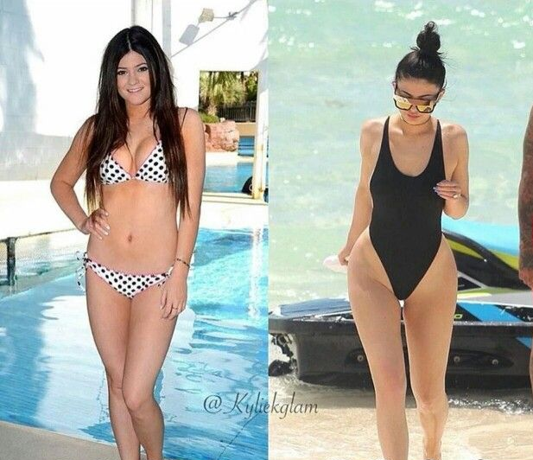
The Kardashian family are known for many scandals, one of them was the underage kylie Jenner whose had surgical procedures when she was only 16 years old. This became a very controversial topic for the family, as they tried to deny it at first. It is believed that kylie who has a following of one hundred and twenty million followers on Instagram has had her lips filled, nose job, cheek fillers, boob job, buttock implant and her hips widen. Although it is not possible to know for certainty if she had all the above procedures done photographs give a clear
FIG 11
indication that Kylie’s face and body went through evolution. At first Kylie denied having her lips filled and has repeatedly said, “I outline my lips with lip liner” convenient for her as she produced a lip liner kit for her audience, undoubtedly her lip liners were sold out in minutes. It is only until much of criticism that she

Chapter two
Kim K
admitted to having her lips filled, the way this was publicised was to get the audience to connect with her on an emotional level. This was constructed to create a narrative about how this celebrity was bullied by her ex boyfriend for having thin lips. This can send the wrong image to young girls as it promotes the idea of beauty only consisting of one set of attributes when beauty is subjective. So why give younger girls an image that is so hard to attain and going through constant change.
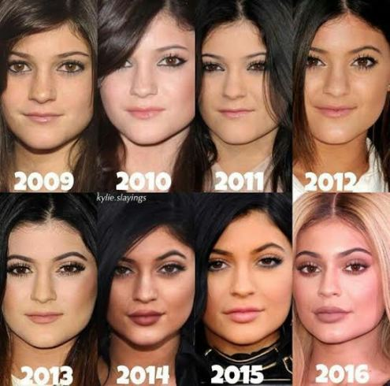FIG 12

Chapter two
Kim K
All one has to do is compare and contrast the pre-Kardashian period and one will come to the conclusion after much analytical research that in the west today these celebrities are shaping the future generation ideas of beauty and what should be desirable, although this can be seen as problematic it is inevitable because one can argue that before Kim or Marilyn Monroe there was this unhealthy obsession with being thin, women in the west were conditioned to be very thin and attain this unhealthy life style by inventing unhealthy habits to attain this look. So one can argue that the populace will follow what is being sold to them, regardless of negative connotations attached to these lifestyles. People will follow what they have been conditioned to follow because it is seen as the norm and this effects both genders as men are also under pressure to attain a certain ‘masculine look’.
One of Kim’s famous quotes, “we are celebrating the beauty of the feminine” illustrates her ideas of beauty and how she perceives herself, in contrast to this are those who choose a completely different path.
It has become a baffling subject in western context regarding why some western women choose to leave their ‘modern’ values behind and commit themselves to a different way of viewing the world. This idea has sparked some heated debates, as many westerners cannot grasp why western women or eastern women who settle in the west still make the choice to wear headscarf’s, face veil or wear traditional loose garments. It is no misconception that imperialism is deeply rooted in western cultures so often we see a narrative about how women in the
Chapter three
Modesty
west should appear. This is a very flawed way of viewing freedom, as liberal values consist freedom of choice. What makes these particular women abandon western values and become influenced by literal interpretations of religious texts is a very complex question as there are many factors that could possibly impact these women. Although there is a growing number of western women who are choosing to face veil, or cover their hair, equally there are women who are choosing to remove themselves from self identifying as Muslim, traditional Christian, Jew etc.
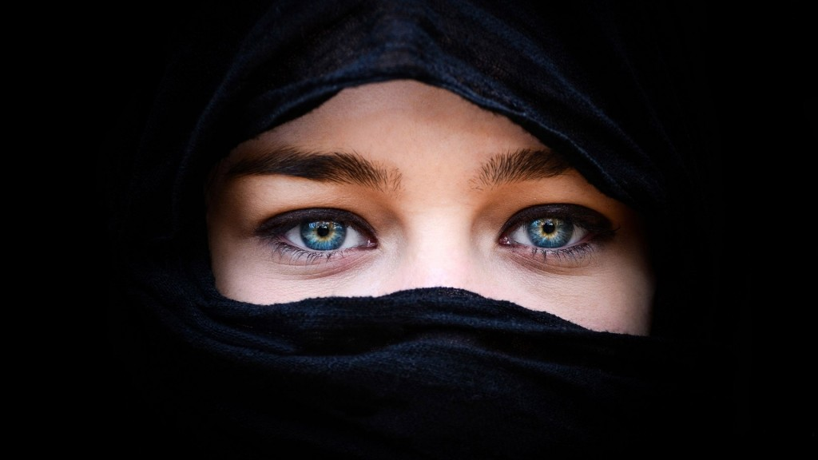 FIG 13
In cosmopolitan cities such as London, New York, Paris and such there is a growth of western women who are converting to religion(s) that have an impact on how they view the world, therefore they often adapt their style and change their behaviour to suit that ideology. As that individual has adapted their identity to that ideology, they want others to treat them a way that respects this choice.

Chapter three
Modesty
It is no misconception that women who choose to face veil are creating a barrier between other(s) particularly men. Without saying verbally “you cannot sexually objectify me” (the telegraph, feminism/fashion/religion, accessed 2018) they are saying this silently by the manner of their dress style and behaviour. This idea could also be linked to feminism, and some women who are considered to be prominent advocators for minority women’s rights in the west regard themselves as feminists and see the way they are dressed as a feministic stance against the post-modernist idea of sexualising women. Speakers like, Sahar Al Faifi, Shalina Litt and Hoda Katebi. Choosing to self identify as a religious person has many complex factors and reasons for each individual, for example two Jewish women might both choose to wear the face veil but the reasoning behind why they wear it could differ, however they will connect with each other on one commonality and that is they are both Jewish. The same goes for western women who adhere to liberal values, they might both choose to wear what is considered provocative and sexual attire, but their reasoning on why they do this might differ, but nevertheless they have both been impacted by secular values.
The question still remains what makes these western women choose a completely different lifestyle, as mentioned previously there are many variables and factors that impact their identity. One can argue that in a place like London, speakers corner where free speech is encouraged, people attend this park on Sunday’s to debate religion, politics and such are impacted by some speakers at the park.

Chapter three
Modesty
Some people even end up converting to a new way of life and others abandon the ideologies they were given. Although this is just one factor, some people choose to read books, watch debates and attend talks. Although some people are impacted by their friends, family or partner moral values they often will adapt their behaviour to there’s. one can argue there is a strong sense of social conditioning that impacts these individuals, but the same argument can also be made about western women. For example, some western women choose to wear high heels even though they can be difficult to walk in and effect their posture, but nevertheless they still wear heels because they have been socialised into doing so. This topic has recently sparked a debate on Good Morning Britain. The debate was about a woman who was fired for wearing flat shoes, a receptionist who was put under pressure to wear high heels. This debate sparked discussions about gender roles, sexism and misogyny.
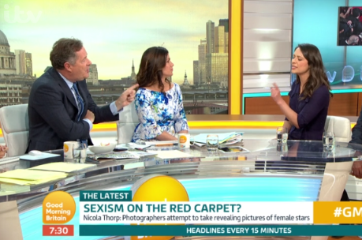FIG 14

Chapter three
Modesty
Although these very different women coexist in the west because liberal values allow room for difference of opinions, freedom of expression and choice and freedom of speech (with limits), it does not stop the mainstream media from constantly attempting to push this narrative about how women in the west should appear. Often we see this debates regarding banning the face veil or headscarves and the narrative of how these women do not fit in western societies, these minority groups are constantly being challenged about their ethics and identity politics, we do not see the other class of women who choose to wear provocative clothing being challenged or have their freedom of choice threatened or taken even taken away. This is because these women are seen as the norm in western societies.
In western societies today, it is no longer the time of Christianity, Christian values no longer constitute western ideals, now is the time of liberalism, secularism and such. But if we are truly taking these secular values into consideration then there needs to be room for every individual to express their truth(s). we can no longer force people to appear a certain way, but rather encourage people to learn and educate one’s self about western values and what they constitute.
In the west the mainstream media tends to focus on dehumanizing, marginalising and generally speak in a negative manner about those minority women who choose to cover up, it is evident that the mainstream media has a current/on going obsession over how women dress, particularly those who choose to appear modest, maybe too modest for the west? In fact, some western societies are facing a

Chapter three
Modesty
backlash against banning the face veil. Places like France, Denmark, Belgium, Spain, Italy and many other European countries (the telegraph, burka bans, accessed 2018). However, this is inconsistent of liberal values, because secular values allow and give freedom to others to practice their religions. Currently in mainstream media there is this constant rhetoric about whether in Britain “we should tolerate the intolerant”. It is widely accepted that Britain is one of the most tolerant countries in Europe, and this is what makes the ‘British’ culture appear as more accepting and welcoming, this however is in contrast to other European countries. However, we can also see more tolerance (perhaps more than Britain) regarding how women choose to dress is a place like Dubai where these women who choose to face veil and others who choose to wear westernised clothes both are respected and coexist in that society (world nomads, clothing and dress codes, accessed 2018).
In a truly liberal, secular and consistent society there is room for tolerance and difference of opinions to coexist peacefully and have an acceptance and understanding towards difference of opinions, as there are many different ways of perceiving the world around us. Although Britain is currently a tolerant country there is no absolute certainty for what the future holds and which direction this country will take. The question still remains will Britain continue to be tolerant and allow these women their freedom of choice or will it follow the steps of European allies who have chosen an anti liberal approach and have banned the face veil.

Conclusion

Throughout this paper three main discussions took place. These topics regarded feminism in western context, the impact Kim Kardashian has on the younger generations and how she is currently shaping their ideas of beauty and the contrast between women who are considered westernised compare to those women who choose to dress modestly, or what is often referred to in debates that have been mentioned “too modest for western culture” (BBC news, Boris Johnson/jilab, accessed 2018). This paper has looked at and compared the current narrative in mainstream media that is shaping mainstream culture. This paper looks at why some women choose to cover and others to choose otherwise. Throughout this paper there has been an argument put forward to the thinker and that is about what constitutes liberal values, often these western values can be shadowed with the current rhetoric about how these minority groups of women are not integrated into western societies which can have a negative impact on the economy and such. The main aspects to these discussions is to allow the thinker to consider, analyse and come to their own conclusion. One cannot simply impose their values on other(s) and expect thee to take as objective truths, when morals and ethics are believed to be subjective, particularly in western culture. The main principle that constitute liberalism is the notion known as “the harm principle” (study.com, john Stuart mill, accessed 2018) this was well illustrated by John Stuart Mill, a British philosopher and politician, who believed that as long as one does not harm anyone else, one can live freely in a liberal society. This means that we might not agree with how XYZ choose to appear or agree with her/his opinion we must respect their freedom to exist as long as they do not harm us. Another quote that illustrates western values is “I disapprove of what you say, but I will defend to the death your rights to say it”, is believed to be said by Voltaire. This paper aims to begin a discussion regarding recent events that are relevant in the media today and are constantly being debated. The question imposed throughout this paper has compared the difference of opinions regarding how women should dress. Feminism will play a role in understanding these women’s positions/stance etc. Feminism is an ideology that is open for interpretations, that is why we see two conflicting ideas both claiming to belong to the same movement. This paper looks into why some people could interpret freedom of choice to appear like Kim Kardashian’s expression and why other women choose to face veil, what is impacting these groups of women to behave the way they do? Indeed, it is a complex matter that will not have a simple answer or an
outcome that will fully determine the reasons behind these women’s choices, nevertheless it is an eye opening discussion to allow the thinkers to have an open perspective about why some women behave the way they do.
For the purpose of this essay, the works of Simone De Beauvoir (the second sex book), Jordan Preston debates, Caroline Dorey-Stein (essays regarding waves of feminism), Diane Atkinson (rise up women book), Rosa Luxemburg (theory of accumulation and imperialism book), Christopher Herndon (documentary photographer who documents the lives of the Amazonian tribes), Milton Friedman book capitalism and freedom, John Gray book, the two faces of liberalism PDF format, Good Morning Britain debates. Also in order to fully analyse the Kardashians family a study of their “reality TV show”, titled keeping up with the Kardashians has been studied and documented notes to critically analyse the impact they have on current mainstream media. For the third chapter (modesty) the reader will find the interpretations of Sahar Al Faifi, Shalina Litt and Hoda Katebi works so that their perspectives can be taken into consideration and critically analysed.

Bibliography
INTERNET REFERNCES:
https://www.progressivewomensleadership.com/a-brief-history-the-four-waves-of-feminism/
https://history.house.gov/Exhibitions-and-Publications/WIC/Historical-Essays/No-Lady/Womens-Rights/
https://voxatl.org/calling-positive-force-call-culture/
http://www.bbc.co.uk/archive/70sfeminism/
https://www.telegraph.co.uk/women/womens-life/11120588/Muslim-women-reveal-why-they-wear-the-veil-burqa-school-debate.html

https://www.telegraph.co.uk/women/life/burka-bans-the-countries-where-muslim-women-cant-wear-veils/
https://www.worldnomads.com/travel-safety/middle-east/united-arab-emirates/what-can-i-wear-uae
https://www.bbc.co.uk/news/uk-45112792
https://study.com/academy/lesson/john-stuart-mills-harm-principle-definition-examples-quiz.html

BOOKS:
Simone De Beauvoir (the second sex book, page 42/46/47)
Caroline Dorey-Stein (essays regarding waves of feminism)
Diane Atkinson (rise up women book)
Rosa Luxemburg (theory of accumulation and imperialism book)
Christopher Herndon (documentary photographer who documents the lives of the Amazonian tribes)
Milton Friedman book capitalism and freedom
John Gray book, the two faces of liberalism PDF

IN TEXT ILUSTRATIONS:
Figure 1. (accessed 2018)
Figure 2. (accessed 2018)
Figure 3. (accessed 2018)
Figure 4. (accessed 2018)
Figure 5. (accessed 2018)
Figure 6. (accessed 2018)
Figure 7. (accessed 2018)
Figure 8. (accessed 2018)
Figure 9. (accessed 2018)
Figure10. (accessed 2018)
Figure 11. (accessed 2018)
Figure 12. (accessed 2018)
Figure 13. (accessed 2018)
Figure 14. (accessed 2018)

