Hannah Frankcombe
Student number - 1921212

Essay one title:
Analyse the role of independent bodies (i.e., IOPC/HMICFRS) in holding the police accountable to those they serve. (1000 words)
Police forces can be held accountable in many ways and are generally based on public satisfaction and confidence in the work that they do. They are held accountable by the Independent Office of Police Complaints (IPOC) for complaints including honesty and integrity concerns. The Her Majesty’s Inspectorate of Constabularies and Fire and Rescue Service (HMICFRS) holds forces accountable for their performance and the quality of service being provided to the public. There are two conflicting opinions regarding investigations conducted by independent bodies such as the IPOC and HMICFRS. There are pessimistic and optimistic opinions regarding the structure and scope of these police investigations.
The Policing and Crime Act 2017 was enacted to promote integrity within police forces through a complaints and discipline process (Torrible, 2020). Such complaints can be investigated via an internal Professional Standards Department within each force which is made up of both detectives and civilian staff. However, many people believe that to achieve a more transparent and honest investigation it is far better for it to be conducted by independent bodies such as IPOC (Seneviratne, 2004). It is crucial for an independent body such as the IPOC to investigate police conduct as this will serve to increase the trust and confidence of the public (Fenwick, 2002). However there has been huge concern regarding the increased involvement of these bodies and their ever-expanding scope as this can undermine an officers’ independent authority and disciplined command structure of forces (Hudson, 1971)
There will always be those members of society who are naturally pessimistic, leaning towards a more negative view and are suspicious when things are going well (Is It Safer to Be a Pessimist? 2021). Likewise there will always be the optimists who think positively about situations and tend to have a higher personal resilience. When reviewing the effectiveness of independent bodies who hold police forces to account there will always be those who are negative and pessimistic (probably through a negative experience) and those who are supportive and can see the benefit. There has to be some level of change with the governance of police forces and that every member, even the Chief Constable, is held accountable for their actions.
In recent years there have been changes made regarding police accountability to reassert the ownership of the complaints process. Many people have expressed their opinions that police complaints should be managed internally, and forces should not be totally excluded from the complaint’s arena. However, there are concerns regarding this and feelings that members of the public might not be getting an honest service thus widening the gap between the public and the police.
Police forces have become more transparent in the way in which they deal with internal complaints for example by hearing misconduct proceedings in public. This has encouraged the public to have confidence in reporting complaints to their local police force. However, there is still the need to have certain complaints to be referred to independent bodies to maintain this level of transparency and demonstrating openness and honesty by the police force. Both of which are core principles in the Code of Ethics. This will encourage those from vulnerable groups to come forward and log complaints in the future. In the past these groups may have felt that their complaints haven’t been heard. By the police building trust with these groups they will have faith in the complaints system, both internally and externally.
It is not without it challenges and there are those who still hold the view that the increasing involvement of independent bodies threatens the internal command structure, which has been held by police forces for hundreds of years. There are concerns that this increased accountability from these independent bodies could diminish the confidence of police officers in their own decision making and feeling supported by their organisation. For example, the use of core police powers such as stop and search or the use of force against an individual. This would have a huge impact on the level of service they are able to provide to the public for fear of complaints being made against them, which invariably leads to time consuming and stressful investigations. This will also have a massive impact on the police officer’s wellbeing. In recent years there have been many changes in rules and regulations for police officers. Alongside this, officers are living now in a society where complaining is become normality and the public expect the service to be able to offer more.
It is one the of the most difficult and complex in the democratic theory and question whether there will ever be compromise where both the public and police force is satisfied with the level of scrutiny. We live in world of multiple different communities, cultures and religions which lead to so many different beliefs. There are those who have had a bad experience of the police which has impacted on generations below them. These things are very difficult to overcome.
Both opinions have valid points and to eventually agree and work together would be a positive thing for all involved. The scrutiny that the HMICFRS provides can only seek to better the force and improve performance in key high-risk areas. It can only be right that you receive the same level of service wherever you live in the country whether you are a victim of crime or anti-social behaviour. Ultimately the HMICFRS are trying to achieve this. It is only right that each police service is held accountable for decisions and actions taken. This is a far cry away from service provided by the police over 50 years ago. As for public satisfaction, it comes down to a lot more than just independent bodies investigating complaints and reviewing policies. Police officers learning about communities and working more closely with them will be a huge factor into building public trust in the police force and the wellbeing of officers will have a huge impact on that.
Total words (989)
Essay two title:
Examine the ethical dimension of ‘real time’ operational decisions. (1000 words)
In this piece I will examine ethical dimension in relation to operational decisions. I will talk about the NDM (National Decision-making Model) (Aepli, 2011) and how its used to ensure ethical decision making. I will also talk about risk, what it is and how it can affect outcomes of incidents and safety of all involved. I will also talk about how a person’s unconscious bias can affect the decisions made about how they will deal with a situation.
The National Decision-Making Model (NDM) is five step structured process to which officers are taught to utilise when making any operational decisions. Central to the NDM and underpinning all decisions made is the Code of Ethics. (Aepli, 2011). The NDM is very adaptable and can be used in spontaneous incidents or planned operations. In a fast paced incident the main priority for the decision maker (Commanding Officer) is to keep at the forefront of their mind the principles and standards within the Code of Ethics.
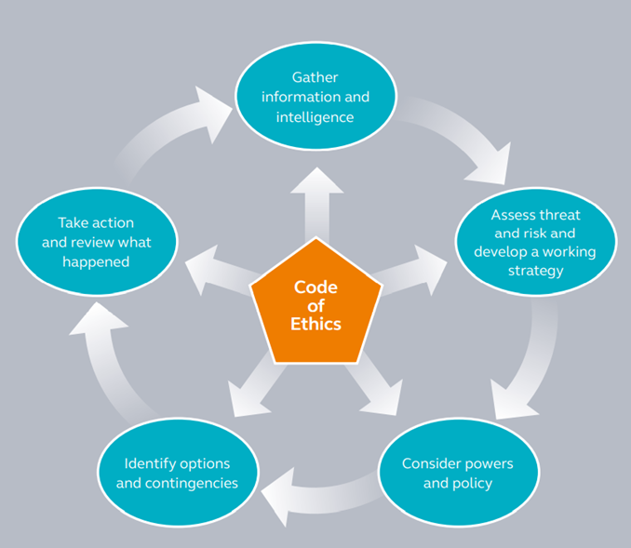

The Code of Ethics (Rogers and Smith, 2021) was produced by the College of Policing in 2014 in its role as the professional body for policing. It sets and defines the exemplary standards of behaviour for everyone who works within policing. It is intended to encourage personal responsibly and personal professional judgment. The Code of Ethics really maintains the values and standards of the police force whilst also setting the standards for the expected behaviour of police officers. The Code of Ethics contains 10 standards of professional behaviour including,
• Honesty and Integrity
• Authority, respect, and courtesy
• Equality and diversity
• Use of force
• Orders and instructions
• Duties and responsibilities
• Confidentiality
• Fitness for work
• Conduct
• Challenging and reporting improper behaviour
The first element of the NDM is to Gather information and intelligence. An example of this is the information received by an officer when dispatched to a call. This can be from a range of sources and can include information that an officer has from previous experience.
The next step is to assess the threat, risk and develop a working strategy. This can be done prior to arrival or when at a scene before entering a situation. It is about taking the information gathered and deciding what your next steps should be. For example, do we need more units for support? Do we need specialist units such as firearms or dogs? Do we know if there is any injuries or chance of injury if so, is an ambulance required? When this is in place a decision can be made on the available options.
The next step is the consideration of powers and policies that are applicable to the situation. Depending on whether a crime has been identified will then help to assess what options are available. For example, is there a power of arrest under PACE? Is there ground for a possible Section 18 search? And so on.
The next step is to identify options and contingencies. Once the possible options have been identified and reviewed, there may be options which can be discounted. Contingency plans also need to be created if things go wrong. For example, an offender is in an address and from all the information gathered he has violence and firearms markers. The offender has committed an offence that he needs to be arrested. The plan would be to use the least intrusive force to enter and detain the individual.
The final step to the National Decision-making Model is to act and then review what has happened. This is possibly the most important step. During this step, this is when individual and organisational learning takes place. Officers can then evaluate what worked well and what requires improvement for next time. After this final step, the cycle can be completed again if the situation has not concluded. The cycle can be completed as many times as required with the Code of Ethics always being at the centre of any decision made.
The NDM is a vital tool when trying to mitigate any threat/risk or harm to officers or members of the public. People always assume risk means violence in relation to the police force, but it is a much wider range of risk we are exposed to daily. For example, weapons such as knives, guns, fire, smoke inhalation and insecure/dangerous buildings.
A risk to using the National Decision-making Model ethically, is that a person’s decision making can be altered by their unconscious bias. Unconscious biases are social stereotypes about certain groups of people that individuals form outside their own conscious awareness. Everyone holds unconscious beliefs about various social and identity groups, and these biases stem from one’s tendency to organise social worlds by categorising (Unconscious Bias | diversity.ucsf.edu, 2021). Unconscious bias has been a real issue regarding race recently in communities. Police have been accused of treating all people of colour unfairly whilst abusing their power and authority. It is not ethical to base decisions on a bias, towards or against a particular group or any preconceived ideas about their lifestyle. This must be challenged both by the individual officer and by their colleagues.
Taking all of this into consideration it shows how important it is for utilise tools such as the NDM and the Code of Ethics to ensure that ethical operational decisions are not only being made but will also stand-up to external scrutiny. To be able to make a real difference, ethical decision making needs to be embedded in every department of the organisation, for both staff in public facing and non-public facing roles.
(921 words)

Essay three title:
Assess the impact of organisational justice on police agency. (1000 words)
The term ‘organisational justice’ refers to the extent to which employees perceive workplace procedures, interactions and outcomes to be fair. These perceptions can influence the attitudes and behaviour, in turn having a positive or negative impact on employee performance and the organisations success. The concept of organisational justice extends the traditional models of work behaviour that include job demands, job control and social supports as the main factors in determining individual well-being and productivity. ‘Fairness’ is largely subjective as what may be fair to one might not be seen to be fair in the eyes of another. Often the notion of organisational justice will only become relevant and tangible when a violation of it occurs (Organisational identification, 2021).
The police do not escape the impact of organisational justice, if anything it is more real, due to the roles performed within the organisation. Every member of a team wants to feel fairly treated by their supervisor and they want to know that this fairness is extended to other members. It is key for supervisors to be able to demonstrate this fairness to secure the support of their team, which ultimately will improve the wellbeing of the individuals, their performance and the team's performance. This then continues up the chain until Chief Officers can demonstrate that they treat all members of their organisation fairly.
The figure below is a process set out by Gwent police showing the structure of organisational justice and each component which if followed should have a positive outcome on the relation with the public.
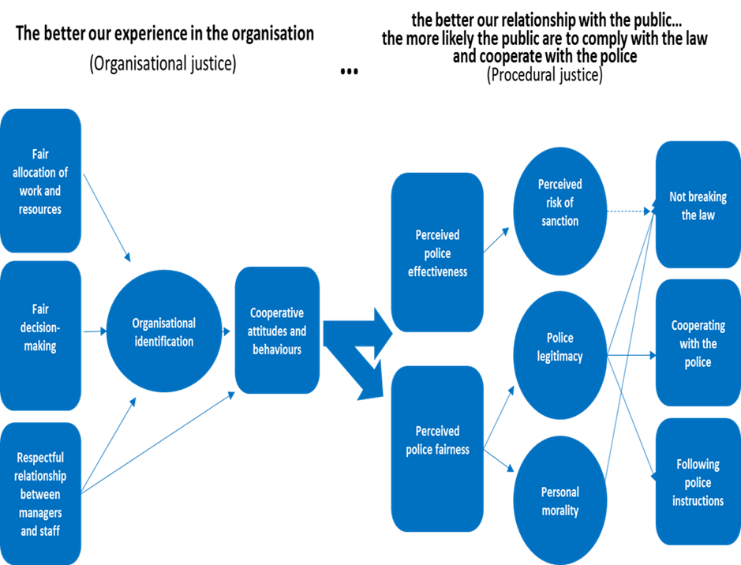

The first of the first three components is fair allocation of work and resources. This can be related to frontline staff and the allocation of work to different departments and organisation resources being fairly and legitimately allocated. The second component is fair decision making. The organisation should demonstrate that the decision making is fair and appropriate from the very top down to the operational staff. The third and final component of the first stages of the process are respectful relationships between managers and staff. All three lead on to the next stage being organisational identification. Organisational identification is a key concept in organisational psychology and refers to the degree to which employees define themselves as a member of the organisation and to what extent they experience a sense of oneness with it, it’s values, brand, methods etc (Organisational identification, 2021). Research has shown organisations across the globe the importance of organisational identification for their employees and the organisation. The research has shown that if employees can identify with their organisation, they will have a higher work performance and are more likely to engage in organisational behaviours. This could include helping colleagues or coming up with constructive suggestions. Most importantly employees will be more likely to enjoy their job and less likely to quit (Blader and Tyler, 2009). This then leads to the final step being Cooperative attitudes and behaviour of the employees and organisation. It is important that all members of an organisation move together, otherwise if individuals or departments pull in opposite directions which reduces the overall effectiveness of the organisation. This is even more important in the police due to the high levels of threat, risk and harm involved in the day-to-day work.
Good organisation justice leads on to procedural justice set out in the figure above. Procedural justice focuses on the way police and other legal authorities interact with the public, and how the characteristics of those interactions shape the public’s views of the police, their willingness to obey the law, and actual crime rates. Mounting evidence shows that community perceptions of procedural justice can have a significant impact on public safety. (Procedural Justice, 2021)
Procedural justice is based on four key principles,
- Treating people with respect and dignity
- Giving people a voice
- Being fair in decision making
- Showing trustworthy motives
Looking at these four principles they are similar to the Code of Ethics standards of professional behaviour. There is a strong link between organisational justice and procedural justice, if organisational justice is positive then it follows that procedural justice will also be a lot more positive. This will lead to several positive outcomes for the relationship between the police and the community. Research shows that some of these are
1. the community has trust and confidence in the police as being honest, unbiased and lawful.
2. the community are more likely to follow the law and rules
3. the community feels they share a common set of interests with the police.
It is vital for policing to look at all avenues to increase public confidence and satisfaction.
Organisation justice doesn’t just come from being inclusive but also being able to challenge those who fall below the required standard. Staff need to see that unprofessional behaviour is challenged within the workplace and they also need reassurance that their internal complaints are dealt with swiftly and appropriately. Staff need to have confidence in the systems in place to raise a grievance or report on a colleague. The police advocate this in a number of ways least of all an anonymous phone line called Safe call. There are robust procedures in place for staff to report concerns and clear guidance on what to expect when a report is made. The organisation is open and transparent, with policies being accessible to all members.
Organisational justice is an important consideration for any successful company and even more important for the police service as it helps to improve not only performance, but also the relationships with the local communities.
(943 words)

Essay four title:
Analyse potential links between serious and organised crime and public protection issues (1000 words)
Serious and organised crime covers several different offences, including child sexual exploitation, human trafficking, drug trafficking and many more (Serious Crime Act, 2015). The groups of people that commit these offences are called organised crime groups (OCG). These groups have a hierarchy of offenders often with individual specialist skills working together to ultimately make money. These groups can operate across the country and are often sophisticated in their development. There are many organised crime groups within our communities. They often target and exploit those who are most vulnerable, whether that be through age, disability, or illness.
One such method is called Cuckooing. This is a practice where organised crime groups take over a vulnerable person’s home and use the property to facilitate their criminality. It takes the name from cuckoos who take over the nests of other birds.
There are different types of cuckooing:
• Using the property to deal
• Using the property to store drugs
• Using the property to take drugs
• Using the property to sex work
• Taking over the property as a place for them to live
• Taking over the property to financially abuse the tenant
The most common form of cuckooing is where drug dealers take over a person’s home and use it to store or distribute drugs (Council, 2021). Usually the home taken over is that of a vulnerable person, they are brainwashed in to believing these people are their friends and slowly they are groomed, and the cuckooing begins to take place. The people who groom these vulnerable victims can be deemed a ‘professionals’ and because of this causes huge issues for public protection services. This is because the vulnerable people and groomed so well they refuse to speak out about what is happening and often truly believe that what is happening is ok, making it difficult for authorities to prove criminal activity and safeguard the person.
Intelligence and information researched shows that’s cuckooing is often connected to county lines. County Lines is where illegal drugs are transported from one area to another, often across police and local authority boundaries (although not exclusively), usually by children or vulnerable people who are coerced into it by gangs. The ‘County Line’ is the mobile phone line used to take the orders of drugs. Importing areas (areas where the drugs are taken to) are reporting increased levels of violence and weapons-related crimes as a result of this trend” (National Crime Agency, 2016). County lines often exploit the younger members of society and in particular children who are in care or come from a chaotic home. It will often go hand in hand with missing episodes and concerning changed in the young person’s behaviour. Their enticement into the group is often due to the need to belong and the recruiter will spend money on the young person or buy them gifts, so they feel indebted to that person. This can sometimes involve an element of romance, for example doing a favour for an older boyfriend.
County lines is now used across the United Kingdom to assist is large scale drug dealing. Vulnerable people are not only used to transport large scale amounts of drugs across the United Kingdom but also to distribute the drugs in local areas to customers by manning the line phone. There properties are then used to store these drugs often implicating them criminally and due to the grooming process will often not give information to exactly who is responsible for the crime. Both county lines and cuckooing are displaying the same issues regarding effective policing and public protection. For both crimes they target children and vulnerable adults.
Vulnerability is defined as “A person is vulnerable if, as a result of their situation or circumstances, they are unable to take care of or protect themselves or others from harm or exploitation”. (2021). This could include a variety of different characteristics such as, financial difficulties, children, children with lack of home stability and parenting, learning difficulties, victims of honour-based abuse and victims of sexual exploitation making a lot of them susceptible to bribery and easier targets to groom. Organised crime groups will always choose a vulnerable person and not somebody who is independent, strong minded and able to safeguard themselves from such criminal activity.
To prevent such crimes and exploitation early intervention is key. Positive multi agency meetings and sharing of information is an important start. This is especially important as many vulnerable people will share information openly with their support worker than they will with a police officer. If police can identify a member of the community as vulnerable early support can be put in place which could potentially protect them from potential cuckooing. There needs to be a holistic approach to solving this problem. However, this is not something the police service alone can do, and the expertise help of other agency’s such as social services are paramount to identifying and prioritising the people who need the help and support and offer enough levels of safeguarding.
Publicising how these groups operate and who they target encourages communities to be more alert to the signs and report behaviours which appear suspicious. Communities need to feel confident to approach the police with their concerns so action can be taken. There needs to be a co-ordinated approach so that the intervention is successful, and the vulnerable person is safeguarded.
These groups will not cease in their activities however organisations can mitigate some of the risk to the public by providing appropriate safeguarding of vulnerable persons making it harder for the groups to successfully operate in this way.
(928 words)

Bibliography

Aepli, P., 2011. Decision making in policing. Lausanne: EPFL-Press.

Blader, S. and Tyler, T., 2009. Testing and extending the group engagement model: Linkages between social identity, procedural justice, economic outcomes, and extrarole behavior. Journal of Applied Psychology, 94(2), pp.445-464.

Council, O., 2021. What is cuckooing | Cuckooing | Oxford City Council. [online] Oxford.gov.uk. Available at: <https://www.oxford.gov.uk/info/20101/community_safety/1308/cuckooing> [Accessed 2 August 2021].

Diversity.ucsf.edu. 2021. Unconscious Bias | diversity.ucsf.edu. [online] Available at: <https://diversity.ucsf.edu/resources/unconscious-bias> [Accessed 2 August 2021].

Employment-studies.co.uk. 2021. [online] Available at: <https://www.employment-studies.co.uk/system/files/resources/files/mp73.pdf> [Accessed 2 August 2021].

Fenwick, H., 2002. Civilian Oversight of Policing: Governance, Democracy and Human Rights, edited by A. Goldsmith and C. Lewis. King's Law Journal, 13(1), pp.131-138.

Hudson, J., 1971. Police Review Boards and Police Accountability. Law and Contemporary Problems, 36(4), p.515.

National Initiative. 2021. Procedural Justice. [online] Available at: <https://trustandjustice.org/resources/intervention/procedural-justice> [Accessed 2 August 2021].

National Crime Agency. (2016) County Lines Accessed at: https://www.nationalcrimeagency.gov.uk/what-we-do/crime-threats/drug-trafficking/county-lines (Accessed: 2nd August 2021)

Paas-s3-broker-prod-lon-6453d964-1d1a-432a-9260-5e0ba7d2fc51.s3.eu-west-2.amazonaws.com. 2021. [online] Available at: <https://paas-s3-broker-prod-lon-6453d964-1d1a-432a-9260-5e0ba7d2fc51.s3.eu-west-2.amazonaws.com/s3fs-public/Recognising-responding-vulnerability-related-risks-guidelines.pdf> [Accessed 2 August 2021].
Rogers, C. and Smith, B., 2021. The College of Policing: Police Education and Research in England and Wales.

Seneviratne, M., 2004. Policing the police in the United Kingdom. Policing and Society, 14(4), pp.329-347.

The Oxford Review. 2021. Organisational identification. [online] Available at: <https://www.oxford-review.com/oxford-review-encyclopaedia-terms/organisational-identification/> [Accessed 2 August 2021].

Torrible, C., 2020. Police complaints and discipline: integrity, lesson learning, independence and accountability: some implications of the reforms under the Policing and Crime Act 2017. Policing and Society, pp.1-16.

Verywell Mind. 2021. Is It Safer to Be a Pessimist?. [online] Available at: <https://www.verywellmind.com/is-it-safer-to-be-a-pessimist-3144874> [Accessed 9 June 2021].

