“STRATEGIC DEVELOPMENT AND IMPLEMENTATION FOR SMEs”
CHOSEN ORGANISATION HAWTHORNE
BMSW6104

STUDENT NAME: Aleksandar Mihaylov
STUDENT ID: 2029754
LECTURER NAME: FAIZU EDU

Executive Summary
Marketing analysis is one of the major strategies that help an organisation evaluate its market position. Hawthorne is a British Small and Medium enterprise clothing manufacturing organisation located in central London. The present research aims to assess the marketing analysis for this SME to analyse its position and competitive advantage in the UK apparel market. The internal analysis reveals that "customisable garments" is the major strength for this company and poor "HRM strategies" are the major weakness for Hawthorne. From the external environment analysis based on the PESTEL framework, it has been identified that the technological, social, political, and environmental factors are providing opportunities for Hawthorn. In addition, economic and legal factors have been identified as threats. Moreover, from the analysis of "Porter's Five Factors," it has been identified that the "power of suppliers", and "threats of substitute products" is quite low for the SMEs. However, the "threats of new entrants" and "competitive rivalry" has been identified as a high threat for the company. Therefore, Hawthrone must earn a competitive advantage in the UK market. In this report, SAFe analysis has been done to weigh two strategic options and then recommend one. To obtain one final strategy Porter’s generic strategy framework, BCG matrix, and stakeholder matrix have been used. Then a timeline has become attached to it and a conclusion has been drawn.

Table of Contents
Introduction 5
● Purpose 5
● Company name and justification 5
● Theoretical Models/Tolls/Techniques 5
● Structure of Report 5
● Expected outcome 5
Main Body 5
Strategic Development Process 5
1. Strategic Analysis (SWOT) 5
1.1. “An Internal Analysis of the Company by Applying Porter's Value Chain Model" 5
1.2 “An external analysis by applying PESTLE” 9
1.3 “An Industry Analysis by Applying Porter’s Five Forces” 12
1.4 Summarisation of Findings 13
2. Strategic growth choices/options/action points 14
2.1 Conduct strategic options analysis by applying the Ansoff Matrix model/ Porter’s Generic Strategies/ BCG Matrix to identify different strategic directions or choices for your chosen company 14
Porter’s Generic Strategies 16
BCG Matrix 18
2.2 You can apply the SFA framework to check the suitability, feasibility, and acceptability of the strategic direction/option 400_dipanwita 20
2.3 Conduct Stakeholder analysis by applying Mandelow’s Stakeholder Matrix to assess the acceptability of option 21
Conclusions and Recommendations- Strategic Implementation, monitoring, and evaluation 23
Conclude with your summary findings 23
Propose the recommended strategic direction based on section 2 in the main body 23
Give a timeline of the strategic implementation process (suggest how and by when the proposed strategic option can be implemented- step-by-step process 24
How your proposed strategic direction can be of help/benefit to the selected company 25
What may be potential consequences if the proposed strategic directions are not followed 26
References 27

Introduction

Purpose
Marketing analysis is essential for understanding the strengths and weaknesses of a firm. This helps in understanding the marketing position of a firm. The purpose of this report is to analyse the marketing position of a British Clothing Manufacturing company Hawthorn.

Company name and justification
Hawthorn is a British Clothing manufacturing SME that offers “high-quality garments” and is one of the major leading clothing manufacturers of the United Kingdom (Hawthornintl, 2023a). The company has approximately 216 employees which indicate that the company is a “Small and Medium Sized” organisation (Zoominfo, 2023a). Hawthorn has been selected for this report as this SME has placed a major impact on the UK clothing manufacturing market with the help of its strong brand quality and high-quality products.

Theoretical Models/Tolls/Techniques
Theoretical models are essential for critically analysing a firm’s strategic position in the market. In the present report, a “SWOT” analysis would be done for analysing the strength and weaknesses of the company. In addition, a “Porter’s value chain analysis” and an “RBV- VRIO Analysis” would be done in this report for proper internal market analysis of the company. A PESTEL analysis would be conducted in this report for analysing the external market position of the company. A “Porter’s Five Forces Model” analysis will be done for conducting an industry analysis. “SFA framework” and “Mandelow’s Stakeholder Matrix” analysis would also be done in this report to analyse the strategic growth choices for the company.

Structure of the report
The report would be done in two major sections where in the first section a strategic analysis of the company would be covered. This includes the internal, external, and industry market analysis for the company. In the second major section of the report, the strategic growth choices of Hawthorn would be assessed.

Expected outcome
The report would help in strategically analysing the internal and external marketing position of the organisation through the help of suitable theories and model analysis.

Main Body

Strategic Development Process

1. Strategic Analysis (SWOT)

1.1. “An Internal Analysis of the Company by Applying Porter's Value Chain Model"
Porter’s value chain Analysis
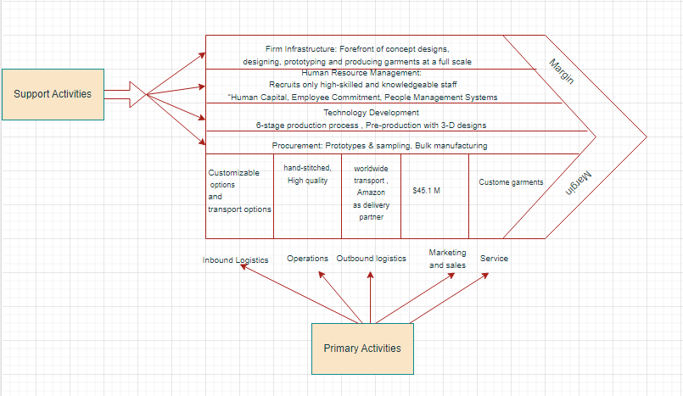
Figure 1: Porter’s Value chain analysis for Hawthorne
(Source: Created by the author)
Support Activities
- Firm infrastructure
Hawthorn is known for its “Forefront of concept designs” which allows the company in proper designing, prototyping, and producing garments at a full scale. The firm infrastructure analysis of Hawthorn reveals that the company manufactures and effectively delivers high-quality clothes that are fully customised to different “Established fashion brands”, “SMEs” and different “Start-up companies”. The company offers expert advice and guidance to other SMEs and startups which helps the company in improving their market position (Hawthornintl, 2023b).
- Human Resource Management
The company mostly recruits high-skilled and knowledgeable staff who can offer expert advice, guidance, and support to other SMEs and Start-up companies. No such evidence has been found which indicates that Hawthorne maintains equality and diversity in its Human resource management policies. According to Adam (2018), clothing brands maintain different HRM strategies including “Human Capital” (skills, experience, and the education of employees), a high level of “Employee Commitment”, and the presence of “People Management Systems”. Hawthorne also needs to properly maintain these HRM strategies for improving its market competitiveness.

- Technology Development
Hawthorne offers customisable clothes which are developed with high technological implementation and with a 6-stage production process that helps to ensure high-standard products. These are “Pre-production” with three-dimensional designing technology, “Pattern development” with “Fit replication”, “pattern cutting” and “grading” technology, “Fabric sourcing”, “Prototypes & sampling”, “Bulk manufacturing” and “Quality check” (Hawthornintl, 2023a)
- Procurement
The procurement process of Hawthorne includes the “Prototypes & sampling”, and “Bulk manufacturing” stages of the 6 stage production process (Hawthornintl, 2023a). In the “Prototypes & sampling” process, the company offers a “free sample of each design” for prior approval from the customers. The bulk manufacturing process is done with handmade and customisable options for maintaining quality (Hawthornintl, 2023b)
Primary Activities
- Inbound Logistics
The company receives orders on its official website and stores all the orders in its factory located in “central London, United Kingdom”. On its official website, the company offers customisable options and transport options with free samples of the order for maintaining supply and demand. In addition, the incoming supplies are managed by maintaining the minimum order quantity (MOQ) at 50 pieces (Hawthornintl, 2023b).
- Operations
The company offers “hand-stiched” clothing items with four quality control stages. This helps the company in maintaining the high clothes standard. Their operational process includes the production of “made to order” garments which helps the customers in getting their customisable products.
- Outbound Logistics
The company offers worldwide transport of its products with minimal shipping charges. The company offers pre-order customisable clothes that can be shipped worldwide as per customer demands with the help of transport partners. Their biggest delivery and retail partner is Amazon which allows the company to worldwide shipment of products.
- Marketing and Sales
Recent data shows that the company has an annual revenue of “$45.1 M” in 2022 which indicates that the company has a strong market position in the United Kingdom (Zoominfo, 2023b).

- Service
The company offers “Custom garments” with high clothing standards and high-quality maintenance. The company offers a “made on order” and hand-stitched service of clothes that helps customers in improving their purchase experience.
RBV- VRIO Analysis
Resource-Based View Analysis
Tangible | “Land”, “Equipment”, “Supplies”, “Facilities”
Intangible | “Brand reputation”, “Goodwill”, “Customer experience”
Heterogenous | "human resource activities", "support and guidance for other SMEs and start-ups"
Immobile | “Customisable clothes”
Table 1: RBV-Analysis for Hawthorne
(Source: Developed by the author)
Resource | Valuable | Rare | Immutable | Organised | Competitive advantage
Land | YES | YES | YES | YES | “Sustainable competitive advantage”
“Equipment” | YES | NO | YES | YES | “Competitive Parity”
“Supplies” | YES | NO | NO | NO | “Competitive Parity”
“Facilities” | YES | NO | YES | YES | “Competitive Parity”
“Brand reputation” | YES | NO | NO | NO | “Competitive Parity”
“Customer experience” | YES | NO | YES | YES | “Competitive Parity”
“Human resource activities”, | YES | NO | YES | NO | “Competitive Parity”
“Customisable clothes” | YES | YES | YES | YES | “Sustainable competitive advantage”
Table 2: VRIO-Analysis for Hawthorne
(Source: Developed by the author)
“Strength and Weakness Analysis in terms of resource and capabilities”
Strength: It can be stated by analysing the resources and capabilities of Hawthorne through "Porter's value chain Analysis", and "RBV-VRIO" analysis that customisable clothes are the major strength of this company. "Porter's value chain Analysis" has shown that customisable clothes are the primary service activity of the company which is supported by the proper "6-stage production process", "4-staged quality control process", "3-D designs of prototype" and "free samples". The VRIO analysis also reveals that "Customisable clothes" are the major resources that offer a "Sustainable competitive advantage" to the SME.
Weakness: The major weakness of the company is the poor "Human Resource Management". "Porter's value chain Analysis" indicates that the company needs to follow "Human Capital", "Employee Commitment", and "People Management Systems" like other clothing brands in a proper way. However, the VRIO analysis indicates that the HRM strategies offer only a "Competitive Parity” for the company.

1.2 “An external analysis by applying PESTLE”
According to Pan et al. (2019), PESTEL analysis is a significant strategic framework that is considered for the evaluation of the external business environment based on factors namely “political”, “economic”, “social”, “technological”, “environmental and “legal”.
Factors | Analysis | Impact (Opportunity/Threat)
Political | The UK is one of the most politically stable countries in the world. The latest value fetched by the UK in the "political stability index" is 0.54 (The Global Economy, 2021). The world average score for the 194 countries in this index is -0.07 points. Therefore, it can be stated that the UK is one of the leading politically stable countries. | After analysing this political factor it can be expressed that operating in such a politically stable country like the UK is beneficial for Hawthorn. It can be assumed that the SME is not facing any politically unstable scenario like violence or terrorism while operating in the business environment of the UK. Thus, the political factor can be identified as beneficial or “opportunistic” for Hawthorn.
Economic | The real GDP percentage in the UK in quarter 1 of 2023 was reported 0.5 lower (UK Parliament, 2023). The decrease in the GDP of the UK indicates that the economy is shrinking. In addition, the current inflation rate of the UK is 7.9% which is very high (ONS, 2023). | After analysing the economic factors it can be identified as a "threat” for Hawthorn. The preferences of the consumers for the products of Hawthorn might decrease due to the negative impact of economic factors. As a consequence of the high inflation rate the SME may be forced to increase the price of the products and it would impact the profitability of the organisation.
Social | In a report, it has been identified that in the UK the demand for personalised or customised clothing increased significantly. As per the result of the survey, 50% of the respondents aged between 25-39 years have a likeness or preference for personalised clothing items (Statista, 2015). In addition, spending of the UK consumers in 2022 reached 62.2 billion GBP (Smith, 2023). | It can be expressed that the total domestic expenditure in the UK for clothing items is an opportunity for Hawthorn. The increased demand for personalised clothing items is a favourable business condition for the SME to increase its production rate.
Technological | The fashion industry is going through technological innovations like excessive use of augmented reality, and virtual reality dressing rooms. In that scenario, it has been identified that for millennials and Gen Zs, the application of VR and AR technologies in the dressing is one of the driving forces for buying for the 6% of consumers (Sabanoglu, 2023). | The application of VR and AR technologies for clothing shopping is an opportunity for Hawthorn. The consideration for the new age technology by Hawthorn increases the competitive advantage for the company.
Environmental | The UK government adopted the best and most suitable practices or policies to improve the environmental performance of organisations and to reduce emissions from business operations (Russell, 2022). The names of such policies are “Best Available Technique” (BAT), "Sustainable Clothing Action Plan (SCAP)", and "New Green Deal" (Russell, 2022; UK Parliament, 2019; Nguyen, 2022). | From the analysis of this factor, it can be expressed that the impact of this factor on Hawthorn is positive and it is an opportunity for the company. The company needs to create a sustainable business policy so that it can adhere to the policies set by the UK government.
Legal | The UK's Parliamentary "Environmental Audit Committee" started a "national clothing recycling" programme to reduce waste and increase the practice of clothing recycling in the UK (Laursen, 2019). | Hawthorn must adhere to the regulations of the program while operating business in the UK. Avoidance of this might appear as a threat to the company's long-term sustainability.
Table 3: PESTEL Factors Analysis
(Source: Self-Developed)
From the above PESTEL analysis, political, social, technological, and environmental factors have been identified as opportunities for Hawthorn. In addition, legal and economic factors have been identified as threats.

1.3 “An Industry Analysis by Applying Porter’s Five Forces”
As identified by Raymundo-Delmonte (2023), Porter's Five Forces is a strategic framework to identify the level of competition in a particular industry based on the five parameters. The parameters are "Threats of New Entrants", "Threats of Substitute Products", "Power of Suppliers", "Power of Consumers" and competitive rivalry.
“Threats of New Entrants” (High): It has been identified that by 2026, the UK apparel market would reach a valuation of 65 billion GBP (Smith, 2022). Therefore, from the data, it can be assumed that in the upcoming years, more small business clothing companies will enroll themselves in this industry. As a small and medium enterprise, Hawthorn might face significant threats from the new business entities due to the identical business segment. Therefore, the threats of new entrants for Hawthorn would be moderate to high.
“Threats of Substitute Products” (Low): In the competitive market there are no such substitute products for clothing items. In addition, currently, people are more preferring for "custom-made tailored pieces" (Manz, 2019). Since Hawthorn provides customised clothing items, therefore, it can be stated that the "threats for the substitute products" for the SME are low.
"Power of Suppliers" (Moderate): The total number of suppliers in the UK for clothing companies is 21,434 (Euro Pages, 2023). The number of suppliers in this case is quite high. Therefore, the switching option for Hawthorn is high as there are many suppliers available in the UK. From the analysis, it can be stated that, in this case, the power of the suppliers is moderate.
“Power of Consumers” (High): The UK clothing industry is the “third largest” footwear and apparel industry across the world economy (Fashion United, 2022). The market size of this industry is around 70.7 billion USD (Fashion United, 2022). This information expresses that the presence of small and large entities in the clothing industry is quite impressive or high. Consumers have many options to switch their buying choices towards other companies. Hence, the power of the consumers in this case is high.
"Competitive Rivalry" (High): In the UK there are several clothing manufacturers and startups who are operating in the apparel industry of the UK. These companies are the potential competitors for Hawthorn. Alanic Clothing, the SJ garment manufacturer, fashionworks London, and White2label manufacturing is some prominent startup fashion companies operating in the UK (White2label manufacturing, 2023; Alanic, 2023; Fashionworks London, 2023). Due to the presence of several clothing SME brands in the UK apparel industry, the competitive rivalry is high for Hawthorn.

1.4 Summarisation of findings
SWOT Analysis
This SWOT analysis is based on the findings from the above internal and external business environment analysis.
Strengths | Weaknesses
- Hawthorn is using prototyping and proper designing and it is ensuring the full-scale production to the company.  - The company offers customisable clothes with the implication of high technological advancements such as “pattern cutting”, “fit application” “Fabric scoring” and many more (Hawthornintl, 2023a).  - VRIO analysis has shown that “Customisable garments” is the major strength for Hawthorne that gives a “Sustainable competitive advantage” to the firm [Refer to Table 2: VRIO analysis]. | - As a small and medium enterprise, the company is unable to increase its market presence in the UK apparel industry.  - "Porter's value chain analysis and RBV-VRIO analysis" indicates that poor HRM strategies have been the primary weakness of this company.  - The VRIO analysis has shown that the weak HRM management of “Human Capital”, “Employee Commitment”, and “People Management Systems” offers a “Competitive Parity” for Hawthorne [Refer to Table 2: VRIO analysis]
Opportunities | Threats
- Since it has been identified from the PESTLE analysis that the apparel industry is evolving with the application of VR and AR, more investment in the technological budget will provide an opportunity for Hawthorn to grow and outperform other competitors.  - Recent evidence has shown that there has been a growing market trend for customisable t-shirts and printed shirts in the United Kingdom (Printnasium, 2023). This can act as a selective advantage for Hawthorne as the social factor of “PESTLE” analysis reveals that the demand for personalised (customisable) clothing has enhanced rapidly in the UK apparel market [Refer to Table 3: PESTEL Factors Analysis] | - From the “competitive rivalry” factor of the “five forces analysis model” it has been identified that the competition across the UK clothing industry is quite high due to the presence of many competitors and it is a potential threat to Hawthorn.  - In addition, the high inflation rate of the UK is another threat to the SMEs as it would impact the profit and revenue of the company.  - Porter's five force analysis reveals that a "high Power of Consumers" exists in the UK Apparel market due to increased market competition [Refer to section 1.3 Industry Analysis]. This can act as a major threat to the market advantage of Hawthorne.
Table 4: SWOT Analysis of Hawthorn
(Source: Self-Developed)

2. Strategic growth choices/options/action points

2.1 Conduct strategic options analysis by applying the Ansoff Matrix model/ Porter’s Generic Strategies/ BCG Matrix to identify different strategic directions or choices for your chosen company
Ansoff Matrix
According to Khajezadeh et al. (2019), the Ansoff matrix is a decision-making matrix that is used in cases of growth determination for organisations. The Ansoff matrix is segmented into four growth strategies which are named, Market penetration, Market Development, Product Development, and Diversification. The implementation of the Ansoff matrix for Hawthorn is as follows:
- Market Development
Market development refers to the growth of the business through the expansion of offerings in the other market (Indeed, 2023). In strategy, a new market has to be identified and chosen as an area of entry. In the case of Hawthorn, it can be understood that it will be required to be expanding its operations in regions outside the UK. This mode of growth can be expensive and complex due to the involvement of different trade regulations in different markets. Due to this reason, this option cannot be considered suitable for the concerned SME.
- Market penetration
In this growth strategy, the organisation seeks to increase in sales and customers by finding new customers in the same market. This growth strategy requires the company to invest hugely in its marketing and distribution process. Hawthorn will be required to enter a new market in a new country with this strategy. Considering Ireland as an example, the fashion industry is expected to grow by 10.4% CAGR and is expected to reach 2.64 billion US dollars by 2027 (Statista, 2022). Hawthorn can enter the market of Ireland and try to establish itself and adhere to opportunities for growth in the market reflected by a high annual CAGR.
- Product Development
While in the product development market growth strategy, the new product is developed by the SME in the same market to attract customers. In the case of Hawthorn, a product development strategy will help the company to develop new products like sustainable footwear. The footwear market in the UK is expected to grow by 4.15% CAGR (Statista, 2023a). There are many benefits of sustainable footwear which the company can get like fulfilling high demands for their customers, reducing water consumption, and reducing plastic waste (‌Greensole, 2023). This depicts that Hawthorn has scope for growth if the company starts developing footwear as its new product.

- Diversification
The diversification strategy is the riskiest of all the four strategies in the Ansoff matrix. In this strategy, the organisation is required to develop a new product and use it to enter a new market (Indeed, 2023). In this case, Hawthorn can adhere to the use of sustainable fashion products in the market of Sweden (example). There is an increase in demand for sustainable fashion products by 7%-8% every year in Sweden (Forestindustries, 2019). Hawthorn can enter the Sweden market with a sustainable product category and fulfil the increasing demand of the market which can help the business of the organisation grow.
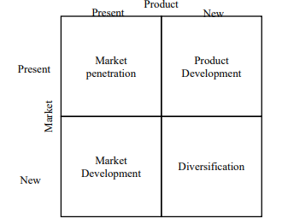
Figure 2: Ansoff Matrix
(Source: Khajezadeh et al. 2019)

Porter’s Generic Strategies
According to Subrahmanyam and Azad (2019), Porter’s generic strategies are a framework of strategies that can be used by businesses to develop a competitive advantage. These three strategies are two well-defined measurements namely, scope and source of strategy. Porter's generic strategies are cost strategy, focus strategy, and differentiation strategy as depicted in the figure below.
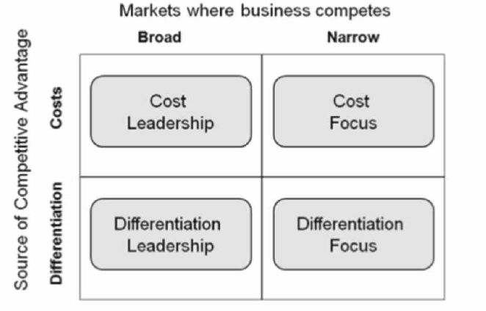
Figure 3: Porter’s Generic Strategies
(Source: Subrahmanyam and Azad, 2019)
- Cost-leadership: Based on the previous findings, the company can implement footwear manufacturing strategies to capture more significant values in the market. In such a manner, the company can follow a cost-leadership strategy to generate better competition in the existing market and catch the lens of the customers widely to achieve growth in the new footwear products development. According to the discussion of ‌Ramazan et al. (2020), the cost-leadership concept signifies the mere reduction of costs to reduce competitive power while not compromising on quality. Therefore, based on the cost leadership strategy, the company will focus on reducing the cost of footwear while not reducing the quality and will be able to engage more customers and generate huge sales in the market. Therefore, besides the cost focus and differentiation focus, the cost leadership strategies will be able to accelerate the growth of the company in the market significantly.
- Cost-focus: From the database of Hawthorn, it can be observed that the company “offers the lowest minimum order quantity (MOQ)” in the UK so that the dealers can “custom clothing” from “50 pcs per design” (Hawthorn, 2022). The clothes have several ranges of pricing, however, those have moderate to high price ranges. The cost-focus function has been followed by the company since the company offers prices on a middle to high-end basis focusing on the quantity purchased by the clients.
- Differentiation leadership: The company will not be required to follow differentiation leadership since footwear manufacturing is not unique in the market, however, the quality and the cost leadership will be able to engage the customers for the company significantly.
- Differentiation focus: On the other hand, observing the quality of the materials offered by the company, it can be understood that the clothes are high-quality adhering to specific garments details, Four stages of the quality control process have been maintained to ensure higher standards and others (Hawthorn, 2022). It signifies the differentiation focus also imposed through the maintenance of high quality with four quality control standards which is a prime focus for the business run by Hawthorn.

BCG Matrix
Boston Consulting Group or BCG matrix refers to a planning tool that highlights the term “represents the company’s products and services” (Maha et al. 2020). The elements of the BCG matrix are stars, question marks, dogs, and cash cows. The marketing analysis of Hawthorn is going to be discussed with the help of the BCG matrix.
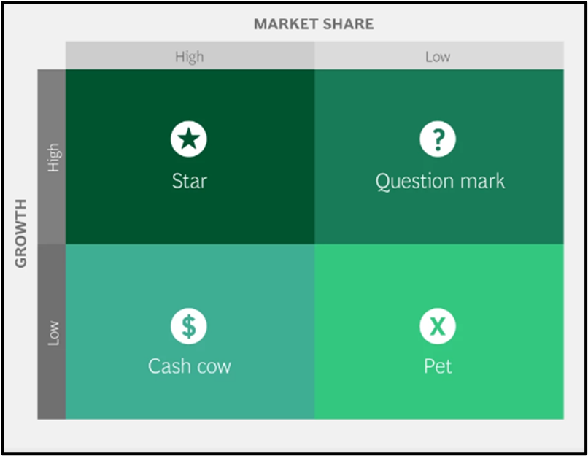
Figure 4: BCG Matrix
(Source: BCG, 2022)
Question marks: The question mark part of this matrix describes the service and product of an organisation that considers “low market share but higher market growth”. The men's clothing accessories of Hawthorn are T-shirts and tops and jeans delivering higher market growth to Hawthorn. The organisation can achieve its annual revenue by
$45.1M (ZoomInfo, 2023a). However, the presence of competitors such as Ettinger Co, Gem-Dandy, and Bosca is responsible for generating marketing obstacles to generate higher competition in the existing market in the UK due to having a lower market share in the market.
Stars: In this quadrant, the products are mentioned as having the potential to develop organisational revenue. After identifying the star product, it would support Hawthorn to support to establish its market position which helps them to meet its target goal opportunity related to market growth. The primary support of Hawthorn products involves its unique products such as its custom products including badges, custom fabric, patches, and embroidery products which would drive their potentiality on higher revenue. From the report, it is observed that the market size of custom apparel is USD 48573.49 million in 2022 (MarketWatch, 2023). The custom products on men's garments have high market demand which improves their market demand and would support higher market growth for Hawthorn.
Dogs: Dog quadrants refer to particular underperforming products which have lower or zero contribution to organisational profitability and growth. Based on analysis of dog quadrants will be effective for the organisation as it supports the organisational stakeholder in determining the areas where the organisation would focus for reinvestment. The prime products in the dg quadrants of Hawthorn are Tracksuits & twinsets, Shirts, and Caps. based on the present market competition, Hawthorn is unable to create sufficient profit which could influence their investors to invest in this section. As it is observed that shirts and trousers have lower demand in the UK men's apparel market (Statista, 2023b). However, Hawthorn does not require to focus on this quadrant and needs to discontinue their operational transaction as it would support organisational reputation and market stability.
Cash cows: Denim and casualwear are the popular products offered by Hawthorn and influence the organisation to achieve higher market growth (Fibre2fashion, 2023). The primary cash cow product of Hawthorn is these products which support to the improvement of their revenue along with providing stability in consideration of target market share. With the help of the cash cow products of Hawthorn, it would be able to achieve its target goal and market position despite higher market competition with Ettinger Co, Gem-Dandy, and Bosca.

2.2 You can apply the SFA framework to check the suitability, feasibility, and acceptability of the strategic direction/option 400_dipanwita
The SAF framework strategy ensures the entire application of the strategy is effective for the company (Almora, 2020). The framework is quite suitable for weighing strategic options to determine which strategy will be beneficial for the company to earn a competitive advantage.
Elements of the SFA matrix | Strategic option 1: Introducing footwear ranges | Strategic option 2: Entering the market of Ireland to optimise sales numbers
Suitability | Hawthrone can make marketing decisions by introducing its footwear ranges by reviewing product considerations and reviewing female customers’ preferences like wearing new funky style footwear, so it can be launched in the market to provide a wider range of products to its existing customers; mainly the female customers. This strategy will be suitable for this company as they can successfully implement it with less budget. | Irish corporation tax receipts soared by more than around 70% in the year's first quarter (O’Dwyer, 2023). As it is mentioned that Hawthorne is an SME, so if they expand in Ireland and somehow their products fail, they will not be able to take the financial shock. Therefore, the strategy will not be suitable for them.
Feasibility | Right now, Hawthorne’s total funding is around $22.3 million (Tracxn, 2023). It means that they have enough budget to produce sustainable footwear as this is quite affordable to make and also it will not cause any negative impact on the environment. | Market development for the SME will be hectic because the funding Hawthrone has right now will not be invested for multi purposes like research and development, promotion, and investing in new technologies. Hence, it can be stated that this particular strategy will not be suitable for this grooming care company.
Acceptability | In case the company enjoys success after implementing this recommendation, the SME can extend their footwear ranges for males and children besides females as well. This product will be quite acceptable in the market as it will be produced with sustainable materials like non-toxic chemicals and leather substitutes. As per research, around 300 million shoes are thrown away that contain “crude oil-derived plastics” (‌Greensole, 2023). So, there is extensive opportunity for the company so they can introduce footwear in the market. | It is a huge risk to introduce new grooming care products in the Ireland market and the company may not e able to earn profits in the initial stage. Therefore, it will be considered that entering into the market of Ireland might not be able to take the market.
Table 5: SAF Framework Analysis
(Source: Self-developed)
Elements of the SFA matrix | Strategic option 1: Introducing new footwear ranges (1-5) | Strategic option 2: Entering the market of Ireland to optimise sales numbers (1-5)
Suitability | 5 | 2
Feasibility | 5 | 3
Acceptability | 4 | 2
Total | 14 | 7
Table 6: SAF Framework Analysis marking
(Source: Self-developed)
By reviewing the scores and analysis, it can be stated that strategic option one will be selected to grab the attention of the market. With that, the company will be able to make further investments.

2.3 Conduct Stakeholder analysis by applying Mandelow’s Stakeholder Matrix to assess the acceptability of the option
Stakeholder analysis can be described as the process of identifying, prioritising, and assessing people as well as project stakeholders that can be impacted by the project. This analysis assists in determining the major people that can impart influence the operations of the organisation. “Mendelow's Stakeholder Matrix” is the framework that assists in determining the expectations and attitudes of the stakeholders in terms of their potential influence on the decisions of the business. The analysis has been further performed considering the two variables namely “power and interest”. The major stakeholders of Hawthorn involve “shareholders, board of directors, employees, suppliers, investors, government, local authorities, customers and community”.
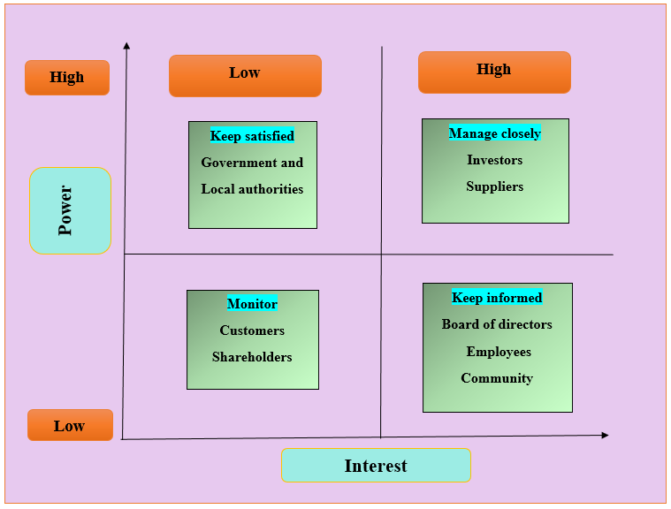
Figure 5: Mendelow’s Stakeholder Matrix for Hawthorn
(Source: Self-developed)
Based on the power-interest matrix the analysis of stakeholders for Hawthorn can be divided into four parts:
High power, low interest: Stakeholders having high power but low interest can be stated as the stakeholders who do not have a direct role within the organisation (Indeed, 2022). In the context of the present company, government, and local authorities fall under this category.
High power, high interest: The stakeholders with high power and high interest play an important role within the organisation and it is crucial to managing them closely. In terms of Hawthorn, the investors, and suppliers can be considered in this category.
Low power, high interest: The high involvement of this group of stakeholders is required within the organisation (Indeed, 2022). Considering the case of Hawthorn, it is necessary to keep informed the board of directors, employees, and community about the working and operations of the organisation.
Low power, low interest: These groups of stakeholders need to be monitored adequately by the organisation. For Hawthorn, it is necessary to monitor customers and shareholders of the organisation.
From the analysis of stakeholders and the SAFe analysis performed above, the most suitable option among the two can be the introduction of a new footwear range. It has been identified that the adoption of this option would help the company to attract the attention of existing and potential customers towards the company. Moreover, the fruitful footwear market would allure the organisational stakeholders to accept this option (Statista, 2023a). This is because the fruitful market of footwear would help in increasing the customer base of the organisation and it would also assist in increasing the sales of the company's product. This in turn would benefit in increasing the revenue generation of the organisation and thus, it would be easily accepted by the stakeholders.

Conclusions and Recommendations- Strategic implementation, monitoring, and evaluation

Conclude with your summary findings
Based on the above discussions, it can be concluded that the marketing analysis of Hawthorn, a clothing manufacturer in the UK. internal analysis using a value chain framework outlines the primary and supporting activities within the company. Moreover, VRIO analysis, strengths and weaknesses, external analysis applying PESTLE, and industry analysis using Porter’s Five Forces have been conducted within the study. In addition, Ansoff's matrix suggests new product development based on footwear for the company while cost-leadership has been suggested through generic analysis. BCG matrix, SFA matrix, and stakeholders’ analysis also outlined comprehensive business analysis for Hawthorn efficiently.

Propose the recommended strategic direction based on section 2 in the main body
- Recommendation 1: Footwear product development can be recommended to Hawthorn for increasing business growth in new market segments alongside its existing clothing manufacturing business. In the UK, the footwear market is estimated to generate revenue of US$16.19bn by 2023 with an anticipated compound annual growth rate of 4.15% (CAGR rate) (Statista, 2023). Therefore, it can be recommended to the company that using the footwear business, Hawthorn might be able to trigger better profits in the market as recognised in Ansoff’s matrix in section 2.
- Recommendation 2: Sustainable product development is one of the hot topics in the market currently. Therefore, the company is recommended to follow sustainable footwear product development so that environmental protection factors can be relied on. The footwear will be able to engage athletes and non-athletes in a better manner.

Give a timeline of the strategic implementation process (suggest how and by when the proposed strategic option can be implemented- step-by-step process
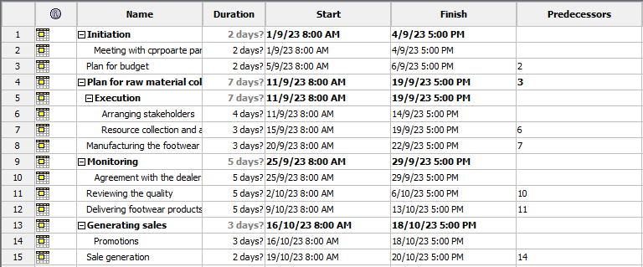
Figure 6: Timeline
(Source: Created by author)
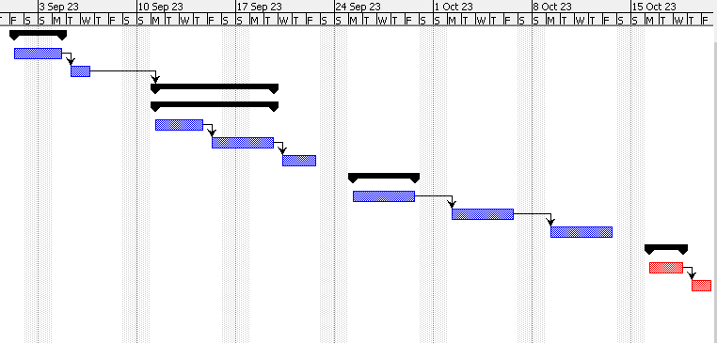
Figure 7: Gantt chart
(Source: Created by author)
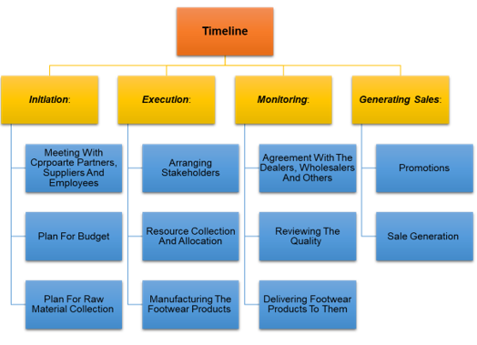
Figure 8: Step-by-step work break structure for the timeline
(Source: Created by author)

How your proposed strategic direction can be of help/benefit to the selected company
The proposed strategic direction of new product development in the form of footwear would benefit Hawthorn vastly. It can be observed that the volume of the UK footwear market is expected to facilitate growth by 0.6% in 2024 (Statista, 2023). In addition to this, the market is further expected to touch the scale of 338.30 million pairs by the year 2028 (Statista, 2023). This reflects that the company has high possibilities to expand its range and improvise itself in terms of revenue generation. The high inclination of customers toward the footwear market would support the proposed strategic decision with alluring customers in a better manner. The high expected volume and attraction of customers would impart to increasing the sales of the organisation. This in turn provides an opportunity to the company in terms of accelerating profit generation and improving its position in the market.

What may be potential consequences if the proposed strategic directions are not followed
- In case the company does not follow the proposed strategic directions, there will be chances of experiencing financial loss.
- Right now, companies in the UK market have become competitive.
- In this market scenario, if Hawthrone does not introduce its new products, it will be out of competition and will not be able to run in the long race.
- In case, if the organisation has delivered conflicting priorities and unclear values, they would be unable to follow the proposed strategic directions.
- Having poor and ineffective team members also affects and creates a barrier to following the strategic direction.

References
Adam, M., 2018. The role of human resource management (HRM) for the implementation of sustainable product-service systems (PSS)—an analysis of fashion retailers. Sustainability, 10(7), p.2518.
Alanic, 2023. We are the biggest clothing wholesaler and manufacturer since 2004. Available at: https://www.alanic.com/wholesale/ (Accessed: 22 July 2023)
Almora, C. 2020. What is the SAF framework strategy? Example & Guide - Marketinggenerators. Available at: https://marketinggenerators.com/marketing-models/saf-framework-strategy/ (Accessed: 3 July, 2023)
Euro Pages, 2023. Clothing - Import export. Available at: https://www.europages.co.uk/companies/clothing.html (Accessed: 20 July, 2023)
Fashion United, 2022. UK fashion industry statistics. Available at: https://fashionunited.uk/uk-fashion-industry-statistics (Accessed: 20 July, 2023)
Fashionworks london, 2023, Pattern cutting, fabric sourcing and sampling. Garment Manufacturing for startups. Available at: https://fashionworkslondon.com/ (Accessed: 23 July, 2023)
Fibre2fashion, 2023, Tom Lovelace | Founder & Chief Creative Officer | Hawthorn International. Available at: https://www.fibre2fashion.com/interviews/face2face/hawthorn-international/tom-lovelace/12450-1 (Accessed 1 Aug. 2023).
Forestindustries, 2019. Sustainability is becoming increasingly important in the fashion industry. Available at: https://www.forestindustries.se/bioeconomylife/what-we-wear/sustainability-is-becoming-increasingly-important-in-the-fashion-industry/ (Accessed: 25 July 2023)
‌Greensole, 2023. Sustainable Shoes: 6 Reasons Why You Should Choose Them. GreenSole. Available at: https://www.greensole.com/sustainable-shoes-6-reasons-why-you-should-choose-them/#:~:text=Sustainable%20footwear%20uses%20sustainable%20materials,humane%20methods%20to%20produce%20footwear. (Accessed: 25 July, 2023)
Hawthorn, 2022. Clothing Manufacturers UK - Low Order Quantity | Hawthorn. Available at: https://www.hawthornintl.com/ (Accessed: 25 July 2023).
Hawthornintl, 2023a, Starting a clothing brand? We can help!, Available at: https://www.hawthornintl.com/ (Accessed: 29 July, 2023)
Hawthornintl, 2023b, Grow your clothing brand with Hawthorn, Available at: https://www.hawthornintl.com/about-hawthorn(Accessed: 27 July, 2023)
Indeed 2022. What is the Mendelow stakeholder matrix? Plus how to use it. Available at: https://uk.indeed.com/career-advice/career-development/mendelow-stakeholder-matrix (Accessed: 31 July 2023).
Indeed, 2023. Ansoff Matrix: Definition, Strategies and How To Use. Available at: https://www.indeed.com/career-advice/career-development/ansoff-matrix (Accessed: 25 July 2023)
Khajezadeh, M., Niasar, M.S.F., Asli, S.A., Davari, D.D., Godarzi, M. and Asgari, Y., 2019. Application of neural network in portfolio product companies: Integration of Boston Consulting Group Matrix and Ansoff Matrix. International Journal of Economics and Management Engineering, 13(6), pp.821-825.
Laursen, 2019. A ‘Fast Fashion’ Tax? Britain Has a Radical New Plan to Spur Clothing Recycling and Reduce Waste. Available at: https://fortune.com/2019/02/19/uk-fashion-tax-recycling/ (Accessed: 23 July, 2023)
Maha, K.A., Cahyandito, M.F. and Purnomo, D., 2020, February. Mapping of business potentials of Maha orange plantation using the Business Model Canvas and BCG matrix. In IOP Conference Series: Earth and Environmental Science (Vol. 443, No. 1, p. 012045). IOP Publishing.
Manz, 2019. Rising Demand for Customised Clothing. Available at: https://www.fibre2fashion.com/industry-article/8350/rising-demand-for-customised-clothing (Accessed: 11 July, 2023)
MarketWatch, 2023, Custom Apparel Market Research Report on Regional Size and Status 2023-2030. Available at: https://www.marketwatch.com/press-release/custom-apparel-market-research-report-on-regional-size-and-status-2023-2030-2023-06-15#:~:text=Custom%20Apparel%20market%20size%20was,USD%2070990.8%20million%20by%202028. (Accessed 1 Aug. 2023).
Nguyen, 2022. What the EU Textile Strategy means for the UK fashion industry. Available at: https://www.raconteur.net/global-business/what-the-eu-textile-strategy-means-for-the-uk-fashion-industry (Accessed: 15 July, 2023)
‌O’Dwyer, P. 2023. Ireland Sees Further Corporation Tax Boost as Receipts Jump 70%. Bloomberg.com. Available at: https://www.bloomberg.com/news/articles/2023-04-04/ireland-sees-further-corporation-tax-boost-as-receipts-jump-70 (Accessed: 17 July, 2023)
ONS, 2023. Inflation and price indices. Available at: https://www.ons.gov.uk/economy/inflationandpriceindices (Accessed: 16 July, 2023)
Pan, W., Chen, L. and Zhan, W., 2019. PESTEL analysis of construction productivity enhancement strategies: A case study of three economies. Journal of Management in Engineering, 35(1), p.05018013.
Printnasium, 2023, Fashion Forward: Exploring the Latest Trends in T-Shirt Printing in the UK, Available at: https://medium.com/@printnasium/fashion-forward-exploring-the-latest-trends-in-t-shirt-printing-in-the-uk-be0ff7e4e9bf(Accessed: 20 July, 2023)
‌Ramazan, K.A.Y.A., Öncü, M.A. and Mesci, M., 2020. The mediating effect of organizational learning on the relationship between the cost leadership strategy and business performance: A study on travel agencies. Journal of Economy Culture and Society, (62), pp.323-343.
Raymundo-Delmonte, N., 2023. Frameworks and Tools in Developing Marketing Strategies for Transnational Education (TNE) Providers: A Literature Review. European Journal of Theoretical and Applied Sciences, 1(4), pp.333-346.
Russell, 2022. UK textile sector subject to new government emissions regulations. Available at: https://www.just-style.com/news/industry-news/uk-textile-sector-subject-to-new-government-emissions-regulations/ (Accessed: 17 July, 2023)
Sabanoglu, 2023. Impact of AR/VR dressing rooms on online luxury sales in the United Kingdom (UK) in 2021, by generation. Available at: https://www.statista.com/statistics/1288521/ar-vr-dressing-room-effect-on-online-luxury-sales-uk/ (Accessed: 30 July, 2023)
Smith, 2022. Apparel market in the United Kingdom (UK) - statistics & facts. Available at:https://www.statista.com/topics/3348/apparel-market-in-the-uk/#topicOverview (Accessed: 25 July, 2023)
Smith, 2023. Consumer spending on clothing in the United Kingdom (UK) from 2005 to 2022. Available at: https://www.statista.com/statistics/289999/consumer-spending-on-clothing-in-the-united-kingdom-uk/ (Accessed: 18 July, 2023)
Statista, 2015. hare of consumers interested in personalized clothing products in Great Britain as of June 2015, by age group. Available at: https://www.statista.com/statistics/466041/level-of-interest-for-online-personalized-clothing-great-britain-uk/ (Accessed: 11 July, 2023)
Statista, 2022. Fashion - Ireland. Available at: https://www.statista.com/outlook/dmo/ecommerce/fashion/ireland (Accessed: 25 July 2023)
Statista, 2023a. Footwear - United Kingdom | Statista Market Forecast. Statista. Available at: https://www.statista.com/outlook/cmo/footwear/united-kingdom (Accessed: 22 July 2023).
Statista, 2023b, Men’s Apparel - United Kingdom Available at: https://www.statista.com/outlook/cmo/apparel/men-s-apparel/united-kingdom (Accessed 1 Aug. 2023).
Subrahmanyam, S. and Azad, S., 2019. Carrefour’s Competitive Strategy–Cost Leadership and Differentiation: A Case Study. Pacific Business Review International, 11(8), pp.137-145.
The Global Economy, 2021. United Kingdom: Political stability. Available at: https://www.theglobaleconomy.com/United-Kingdom/wb_political_stability/ (Accessed: 12 July, 2023)
Tracxn, 2023. Hawthorne. Tracxn.com. Available at: https://tracxn.com/d/companies/hawthorne/___jVNftyvcp_o76kiNT2EY9LQyvoH-U2JRh7iQv0jpjQ (Accessed: 17 July, 2023)
UK Parliament, 2019. Fixing fashion: clothing consumption and sustainability: Government Response to the Committee’s Sixteenth Report. Available at: https://publications.parliament.uk/pa/cm201719/cmselect/cmenvaud/2311/2311.pdf (Accessed: 15 July, 2023)
UK Parliament, 2023. GDP – International Comparisons: Key Economic Indicators. Available at: https://commonslibrary.parliament.uk/research-briefings/sn02784/#:~:text=In%20Q1%202023%2C%20the%20UK,0.5%25%20fall%20in%20Q4%202022. (Accessed: 18 July, 2023)
White2label manufacturing, 2023. A Strategy Driven Clothing Manufacturer Who Puts Your Brand First.. Available at: https://www.white2labelmanufacturing.com/ (Accessed: 21 July, 2023)
Zoominfo, 2023a, Hawthorn - Overview, News & Competitors | ZoomInfo.com, Available at: https://www.zoominfo.com/c/hawthorn/374583548#:~:text=Hawthorn%20has%20216%20employees%20What%20industry%20does%20Hawthorn%20belong%20to%3F (Accessed: 29 July, 2023)
Zoominfo, 2023b, Hawthorn - Business Information, Available at: https://www.zoominfo.com/c/hawthorn/374583548 (Accessed: 27 July, 2023)

