Appendix ECAD6003

Appendix 1
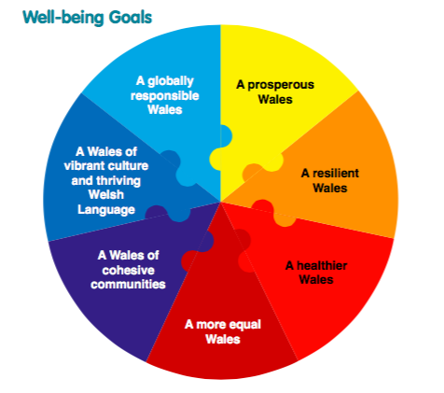
Wales’ well being goals - taken from Welsh Government (2015).

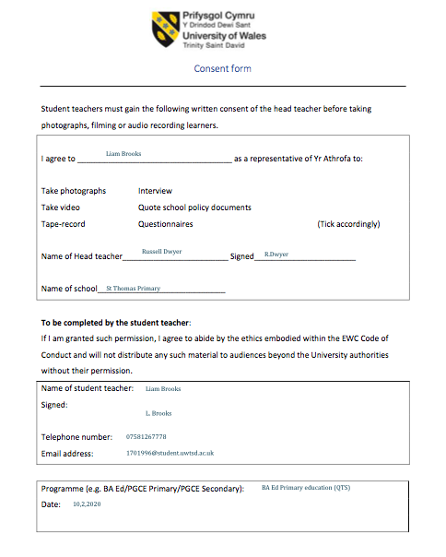
Appendix 2
Letter of consent signed by headteacher.
Appendix 3
APPLICATION FOR ETHICAL APPROVAL

In order for research to result in benefit and minimise risk of harm, it must be conducted ethically. A researcher may not be covered by the University’s insurance if ethical approval has not been obtained prior to commencement.

SECTION A: About You (Principal Researcher)
Full Name: |  | Liam Brooks
Tick all boxes which apply: |  | Member of staff: | ☐ | Honorary research fellow: | ☐
Undergraduate Student | X | Taught Postgraduate Student | ☐ | Postgraduate Research Student | ☐

Faculty/School/Centre: | ITE: Yr ATHROFA, UWTSD.
Campus: | Carmarthen
E-mail address: | 1701996@student.uwtsd.ac.uk
Contact Telephone Number: | 07581267778
For students:
Student Number: | 1701996
Programme of Study: | BA Primary Education (QTS).
Director of Studies/Supervisor: | Dr Sioned V Hughes

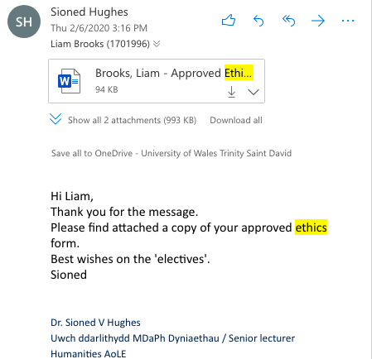

Ethics form application and Email confirmation of Ethics approval.

Appendix 4
 | Rhif Adnabod Cyfranogwr:  Participant Identification Number: | 1701996
FFURFLEN GANIATÂD CYFRANOGIAD | PARTICIPATION CONSENT FORM
Teitl Y Prosiect: / Project Title: A study of attitudes and perceptions of the role, of physical education and activity, relating to what affect it has on well being in one educational setting?
Enw'r Ymchwilydd / Name of Researcher: Liam Brooks

1 | Cadarnhaf fy mod wedi deall y wybodaeth a roddwyd gan ......................... (enw’r ymchwilydd) ar gyfer ei chynnig ymchwil. Rwyf wedi cael y cyfle i ystyried y wybodaeth, gofyn cwestiynau, ac rwyf wedi cael ateb boddhaol i’r rhain. |  | I confirm that I understand the information given by Liam Brooks for his research proposal. I have had the opportunity to consider the information, ask questions and have had these answered satisfactorily.
2 | Deallaf fy mod yn cymryd rhan o’m gwirfodd a bod croeso i mi dynnu’n ôl ar unrhyw adeg, heb roi rheswm. |  | I understand that my participation is voluntary and that I am free to withdraw at any time, without giving any reason.
3 | Deallaf y gellir defnyddio unrhyw wybodaeth a roddir gennyf mewn adroddiadau, erthyglau neu gyflwyniadau gan y tîm ymchwil. |  | I understand that any information given by me may be used in future reports, articles or presentations by the research team.
4 | Deallaf na fydd fy enw’n ymddangos mewn unrhyw adroddiadau, erthyglau neu gyflwyniadau. |  | I understand that my name will not appear in any reports, articles or presentations.
5 | Cytunaf i gymryd rhan yn yr astudiaeth uchod. |  | I agree to take part in the above study.
Enw’r Cyfranogwr Name of Participant |  | Mr Tom Goss |  | Llofnodwyd  Signature  T.G
Ymchwilydd  Researcher |  | Liam Brooks |  | Llofnodwyd  Signature  LB

Cewch wrthod cymryd rhan yn yr astudiaeth hon. Cewch ddod â’ch cyfranogiad yn yr astudiaeth hon i ben unrhyw bryd. Os penderfynwch barhau’n ddienw, bydd sicrhau hynny’n flaenoriaeth a chymerir pob cam ymarferol i guddio pwy ydych. Os yw’n well gennych fod yn anhysbys, ni fydd unrhyw wybodaeth yn eich enwi ar dapiau sain na thrawsgrifiadau o’r cyfweliad hwn nac o unrhyw un arall. Ni fydd neb yn clywed unrhyw dapiau sain nac yn gweld unrhyw drawsgrifiadau heb eich cydsyniad o flaen llaw. Bydd deunyddiau a grëir yn sgil y cyfweliad hwn neu unrhyw gyfweliad arall yn aros yn gyfrinachol. | You may decline to participate in this study. You may end your participation in this study at any time. If you decide to remain anonymous, maintaining your anonymity will be a priority and every practical precaution will be taken to disguise your identity. If you prefer anonymity, there will not be any identifying information on audiotapes or transcripts of this or any interview. No-one will hear any audiotapes or see any transcripts without your prior consent. All materials generated from this or any interview will remain confidential.

Appendix 5
Interview Questions
Senior leadership

- How much of an impact do you feel PE in schools has on the physical health of pupils?
- Do you think PE has an impact on pupil’s mental well being? How?
- Do you think PE has an impact on pupil’s social well being? How?
- Are there opportunities for pupil’s to develop their well being tailored towards the community in St Thomas?
- What opportunities do the school provide for pupils to take part in physical education/sporting opportunities?
- What do you feel are the biggest barriers to teaching PE in primary schools? Do other schools face similar circumstances?
- How do you see physical education fitting into the new health and well being AOLE?
- Do you think the importance of well-being will be exposed further to staff due to it becoming a key part of an area of learning and experience?

Interview questions (staff)
All questions can be adapted dependent on the role of the staff member.

- How much of an impact do you feel PE in schools has on the physical health of pupils?
- Do you think PE has an impact on pupils mental well being? How?
- Do you think PE has an impact on pupil’s social well being? How?
- Are there opportunities for pupil’s to develop their well being tailored towards the community in St Thomas?
- What is your personal opinion on PE in general? Why/how?
- What are your feelings on teaching the subject of physical education?
- How do you think the children feel during PE lessons? What can be done to overcome any issues?
- What opportunities do the school provide for pupils to take part in physical education/sporting opportunities?
- What do you feel are the biggest barriers to teaching PE in primary schools? Do other schools face similar circumstances?
- Are there any interventions/strategies that take place within the school to improve the well being of pupils?
- Do you feel PE increases the standard of engagement from pupils? Why/How?
- Do you feel PE has a positive or negative effect on pupil’s behavior? Why/How?
- What is your opinion on pupils not bringing sports kit with them? Is there a strategy you follow as a teacher? Is there any reason for the pupils not brining their kit?
- How do you see physical education fitting into the new health and well being AOLE?
Interview Questions (Pupils)
All questions can be adapted dependent on the participants in the interview.

- Do you enjoy PE lessons in school?
- What do you like/dislike most about PE in school?
- Do you feel PE in school is safe?
- Do you get the chance to take part in school sports teams?
- Do you have any school sports after school clubs?
- If something is bothering you during a PE session, would you feel confident to tell a teacher?
- Would this be the case if you had a teacher who isn’t your usual class teacher?
- What do you wish was different about PE lessons in school?
- Do you take part in any sports out of school? Would you know where/when sports teams run?
- If there was anything you could do more in PE what would it be?
- Do you ever feel sad during PE? Why?
- Do staff members ask how you are feeling during PE lessons?

All interview questions for different groups who were interviewed.

Appendix 6

St Thomas Primary School electives report
School information
Number of pupils: 420
Age range: 3-11 (Additional flying start unit)
Number of staff: 50
Attendance: 94.3%
Pupils eligible for FSM: 35%*
Ethnic minority background: 18%*
EAL: 16%*
ALN: 16%*
* These figures have been taken form the school’s most recent Estyn report from 2014 and may have changed.
School overview
As a school, St Thomas promoted the use of physical activity throughout the curriculum as a vehicle to engage and improve pupil’s well-being and school experience. The school aims to overcome barriers to physical education (PE) by offering as many inclusive opportunities as possible for pupils. The school uses external local companies such as street dance to ensure maximum engagement levels between pupils and the expressive arts as well as providing opportunities for pupils to visit the National Pool, Swansea for swimming lessons. Furthermore, in partnership with the local comprehensive school, members of the PE department visit the school and lead lessons to enhance the experience of the pupils and aid transition. St Thomas run enrichment sessions for pupils on a Friday afternoon, where by, pupils are grouped with a range of different pupils at both different attainment levels and ages and complete an activity of their choice. Activities include hockey, basketball, circuit training and other team sports such as football, rugby and cricket.
Context and background to sector leading practice
In recent years the school has recognised the importance of well being for pupils and staff members and use physical activity embedded throughout the curriculum to enhance this. The school development plan discusses a need for pupils to “be aware of the importance of a healthy lifestyle and positive emotional well being”. The school uses different strategies to achieve this such as implementing physical education with pupils controlling their own learning and whole school activities such as the “Feel good Friday” initiative. The school vision discusses the need to “nurture curiosity, confidence, initiative and resilience in pupils” and this is done through well-planned physical activities.
Description of best practice
Staff members plan a variety of imaginative and stimulating learning experiences and provide pupils with opportunities to access a range of sports. This is further enhanced by the excellent facilities that the school can provide to pupils including a sports hall, a yard and a field complimented further by top of the range sports equipment. Different games are adapted to allow all pupils to have an opportunity to access the learning experience. The majority of pupils enjoy their experience during PE lessons in school and all pupils feel safe within the learning environment. Some pupils state they are not as confident in PE due to a number of factors including fear of getting hurt and not being as good as other pupils.
There is a range of extra-curricular activities in place at St Thomas and pupils discussed how much they enjoy these clubs. Pupils felt you can try things in these clubs with no pressure of having to be good at the activity. To ensure staff well-being is maintained the head is trialing a scheme where staff members can earn a day off by completing a certain amount of extra curricular activity with pupils. The school also take part in the happen project which is a national initiative looking at each individual pupils health and well being and results are fed back by the Government to the school where they can compare their results against national results. Staff members intend to use the results of these projects to assist planning for the new health and well being area of learning and experience in the New Curriculum for Wales. Furthermore, the results from the project have been used to implement appropriate interventions required by pupils.
Outside of PE lessons, there is evidence that there is a general enjoyment of physical activity as many pupils partake in games on the yard during break and lunch times. The school recently introduced a climbing frame area, to further allow pupils to access physical opportunity, and is currently going through the process of having new yard markings put in place. The school council is leading this regeneration of the yard. It is felt this will allow pupils to create an environment they are comfortable in.
Staff are aware of barriers that may affect the learning of pupils. They recognize the importance of having a variety of activities and making sure activities don’t become tedious. Staff members recognise the importance of maintaining a pupils well being as feeling anxious about PE can have a further effect on their whole school day. Further barriers such as pupils becoming anxious about not having the most recent clothing due to financial restraints can also cause issues for pupils. The school aims to overcome this by providing spare kit for those who have not brought their own.
Recommendations
R1: To continue to promote pupils well being during PE sessions by utilising strategies, such as emotional check in’s used throughout the school day in a classroom environment.
R2: Build on partnerships with local sports clubs that can engage with parents and make pupils more aware of opportunities outside of school.
R3: Offer continuous professional development opportunities to members of support staff to be able to deliver games/activities confidently, during playtime/lunchtime and through out the school day.
How the experience has enhanced my personal knowledge and understanding
I have thoroughly enjoyed my elective experience and have found it to has helped me to develop professionally, especially in the physical education area of the curriculum. Something that has become evident to me is the importance individual positive well-being can have on the entire school and this is something I feel I will definitely begin to introduce into pedagogical strategies that I apply. Observing and interviewing pupils has allowed me to gain a deeper knowledge of how the child feels in different environments and what makes them engage more with their learning. Interviews and informal chat with members of staff have allowed me to build upon previous knowledge I have on the subject area and have give me some new ideas of ways I can create a positive environment for inclusive physical activity. I especially liked the idea of pupils having the opportunity to control their learning by deciding on a topic, this allowed pupils to understand the need to be fair and offer equal opportunities for every body in the class. From analysing and taking part in memorable first hand learning experiences I have been allowed to, make connections with wider research and pedagogical theories I have applied in the past. The electives experience has given me the opportunity to recognise ways to improve these further.

Recommendations
R1: To continue to promote pupils well being during PE sessions by utilising strategies, such as emotional check in’s used throughout the school day in a classroom environment.
R2: Build on partnerships with local sports clubs that can engage with parents and make pupils more aware of opportunities outside of school.
R3: Offer continuous professional development opportunities to members of support staff to be able to deliver games/activities confidently, during playtime/lunchtime and through out the school day.

One Page report that was fed back to senior management and head of health and well being along with reccomendations made to the school by writer.

