Accessing IEEE
https://www.uwtsd.ac.uk/quick-links/

select library and learning resources above:

to get the following screen –scroll down and select Find OUT More under Library Resources tab


Select DATABASES tab:


Select DATABASES:

Select Explore Databases:

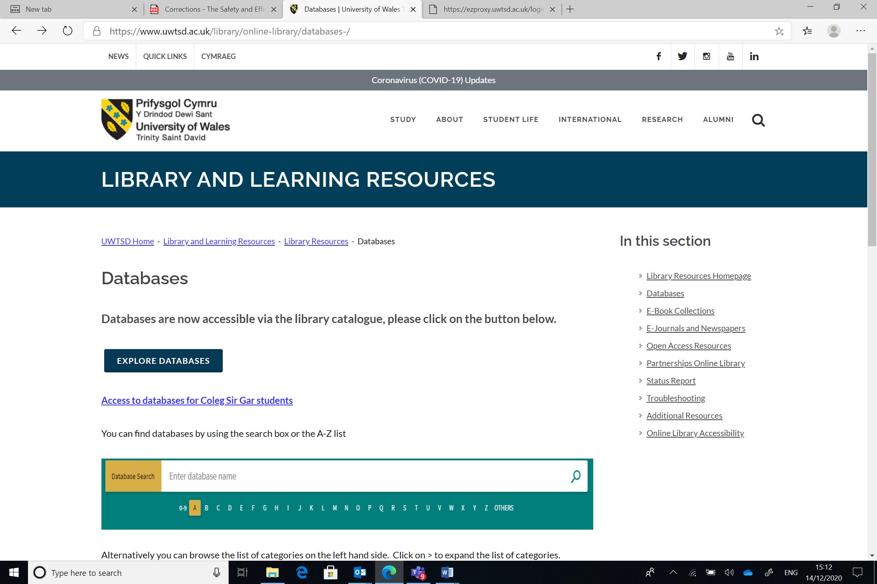

Enter IEEE in the Search:
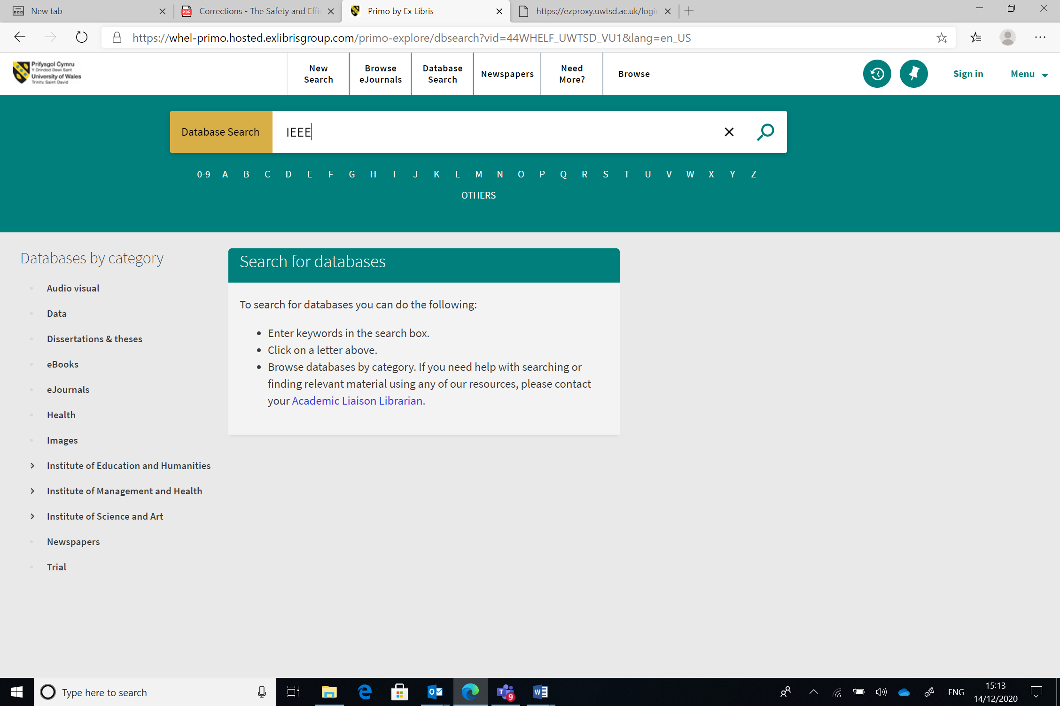

Select ONLINE Access:
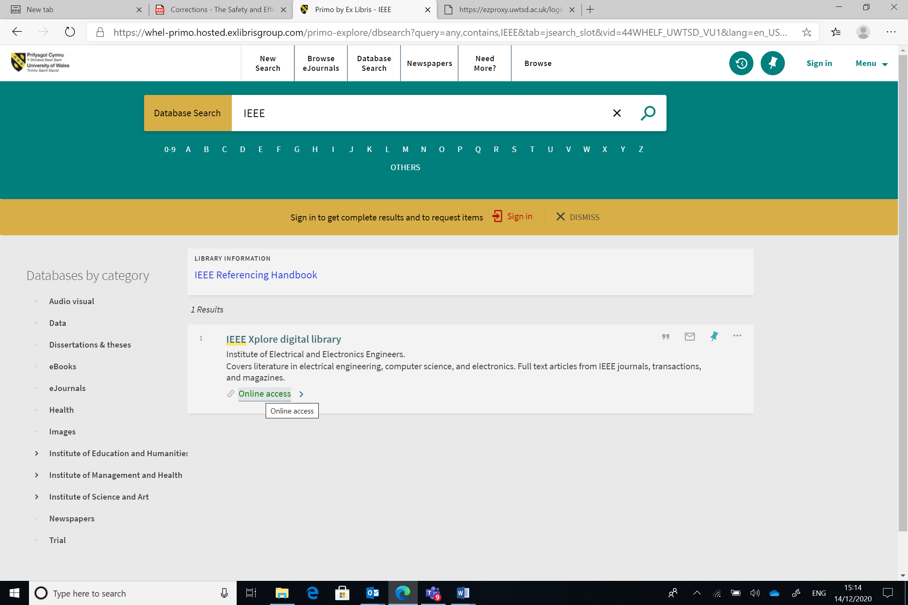

Select IEEE Xplore Digital Library:
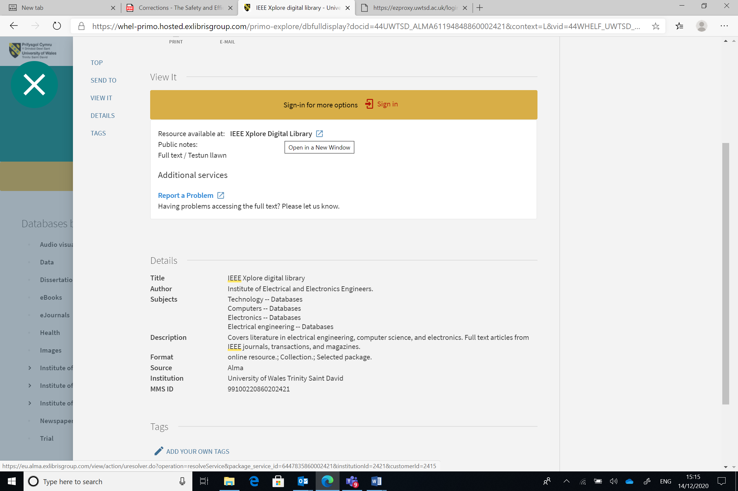

This now gives you the UWTSD login screen so that you can get access to IEEE through UWTSD:
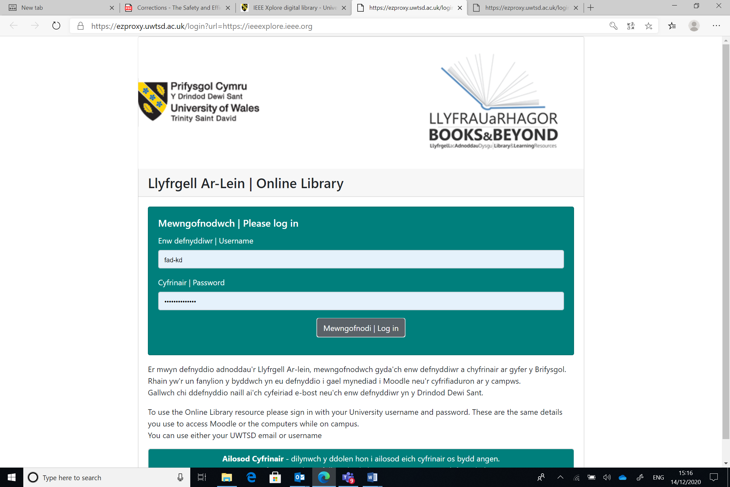

And then you are in!:


