STUDENT NAME: Gabriela Pravalici
STUDENT CODE: 1905719
MODULE TITLE: Business skills for the International Hospitality industry
EMPLOYABILITY SKILLS

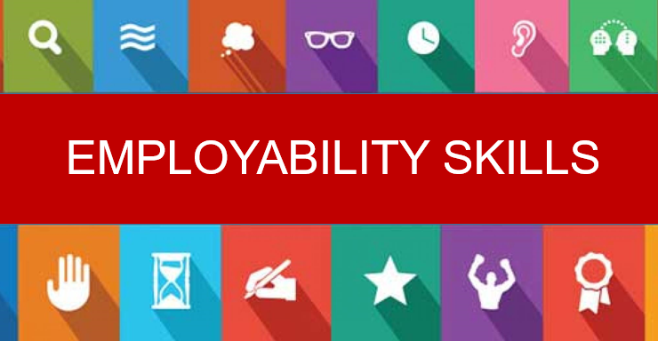

TABLE OF CONTENTS
- Introduction…………………………………………………………….page 3
- Employability Skills…………………………………………………page 3
- SWOT analysis……………………………………………………….page 4/5
- PDP……………………………………………………………………….page 5/6
- CONCLUSION…………………………………………………………...page 6
- REFERENCES……………………………………………………………….page 7

INTRODUCTION
The purpose of this assignment is to outline a clear representation of my personal employability skills describing then what are the useful ones for the hotel industry and this because the career path I am following is into the hotel industry. After describing my employability skills I am required to design a SWOT analysis which will then be followed by a Personal Development Plan (PDP), which will clearly describe the steps and the procedures I will follow to touch my goals.
My main goal is to have a good progress while undertaking the course at the university and as well while being in the placements at the Marriott International Hotel. My progression as well as my abilities, my knowledge and my skills will the support me to build experience and to start working as a manager in the hotel industry.
- Employability Skills
The employability skills are transferable skills that are needed by an individual to make them suitable for such positions in companies (STEMNET 2017). There are some most important skills that you need in all environments. Skills such as communication skills; time management; presentation skills are skills that are required everywhere. However, the employability skills are spread in three sections of employability skills that the employers are looking after (SkillsYouNeed 2018). These are:
- Getting well along with other people
- Being Reliable and Dependable
- A willingness to learn

GETTING WELL WITH OTHER PEOPLE
These are also known as being the interpersonal skills, so the skills that are categorized here are: ¬Communication skills ¬Emotional intelligence ¬Team-working ¬Problem solving ¬Decision making
BEING RELIABLE AND DEPENDABLE
This contains skills that are describing motivated people and people that are ready to work hard for the best:
¬Self-management skills ¬Time management skills ¬Organisational skills
A WILLINGNESS TO LEARN
-Personal development skills ¬Resilience skills ¬Flexibility/adaptability ¬Quick learning ¬Hard-working
Having into consideration the skills listed about and myself at the same time, I can say that I have most of the skills and this because of the variety of jobs I had before, each place was requiring different things so I needed to develop myself in the vest way possible. The skills that I have will highly support me in my personal development for the career in the hospitality industry and in the management industry, however, I still need to improve such abilities to enable myself to go further with my career.
SWOT analysis
SWOT is the abbreviation that stands for STRENGHTS, WEAKNESSES, OPPORTUNITIES and THREATS (MindTools 2019). SWOT as an analysis, is used as a key strategy to analyse the Strengths, weaknesses, opportunities and threats to check the current stability of the company/ individual.
One of the advantages of using SWOT analysis is that at the end of it you can build a clear strategic plan to develop your academic achievement (Prachi J 2015). Therefore my personal SWOT analysis looks as it follows:
STENGTHS
My main strength is that I am very communicative, and I can easily work in a team does not matter what. The fact that I can work in a team is very helpful especially in the hotel industry and this because, in a hotel everyone is cooperating one with another with the aim of delivering the best possible services to the coming guests.
Another strength that I have is that I have the ability to learn quick so if there are changes occurring I am able to change the way I am working ensuring that the rules are being followed, this meaning that I have the adaptability skills, which again are more than necessary in a hotel where there are changes in such things like services/ products every day.
In addition to the previous strengths I can also say that I am an ambitious person always aiming as high, this pushing me towards trying new things every time to get better and better. Therefore, because I am ambitious, I am trying to take up to myself all opportunities that are coming.

WEAKNESSES
The main weakness that I have is that I am not as confident as I should be, even if I know I am right I am struggling to point out my ideas and the main thing that stops me is the fact that before outlining my ideas there is something telling me that I should keep them for me only.
Another weakness that I have has to do with my English language and this because my first language is Romanian and at the moment, I cannot confidently say that my English is perfect. I might struggle to understand everything some people are saying to me, especially if they have a strong accent or an accent different to what I previously heard.
OPPORTUNITIES
Since I came in UK, I had many opportunities that enabled me to develop myself from both aspects characteristically and professionally because of the variety jobs that I had. Currently I am working for Dominos (Delivery Services) and I have to interact with people a lot, I consider this is a opportunity for me to develop my English speaking and understanding.
Another opportunity that I did take up to myself massively was the opportunity of undertaking the course that I am doing not at UWTSD. I consider that this university and the course in hospitality and tourism as well as the placement that is going to take place will highly develop my practical abilities and skills of working in the hotel industry. In addition to that the fact that I will have a work experience placement in all departments of Marriott International Hotel will also help me build confidence of working in a hotel.
THREATHS
The threat that I am dealing with every day is the miss of motivation as sometimes I do not find motivation to do things with ease. However, I consider that once I will be in the position where I have to learn things I will obviously to everything at the right time.
Another threat is the time management as I have a job and most of the time I am working late and especially in the days I am going to University as well it is hard for me to maintain my brain fresh for learning English language, for example.
PERSONAL DEVELOPMENT PLAN
It is the process of “establishing aims and objective that you want to achieve within a period of time” (CMI 2017). The personal development plan, therefore, has a specific cycle that must be followed in order to have the best results when finishing the plan. The cycle is based on:
- Establish the aim that you need to achieve
- Identify the area of development
- Outline the opportunities for development
- Design an action plan
- Go through the development
- Record the progress
- Review and evaluate
All the steps above are steps that are highly helping during the PDP and this because it supports the person that is looking for improvement to have a clear plan that will be undertake carefully and strictly.
Therefore, my PDP is based von:
- My aim is to develop new skills and abilities to push myself toward a career in the hotel industry.
- The are of development when it comes about me is to develop my confidence, my English-speaking skills and my abilities of working in busy environments with people coming from a variety of cultures
- The main opportunity that will highly support me to develop myself is based on the placement at Marriott International Hotel, which will enable me to get to know all the different department in which I will be required to work as well as the original employees
- The action plan is based on doing my best to get involved in everything I have to do to successfully accumulate all the needed procedures in all departments.
- While I am going through the development, I will constantly ask for feedback to check I am doing right and what not.
- When recording the progress I will evaluate what I was doing for each week outlining the abilities that I succeed developing
- After finishing my placement I will clearly evaluate if I am capable to do in the position as a manager.
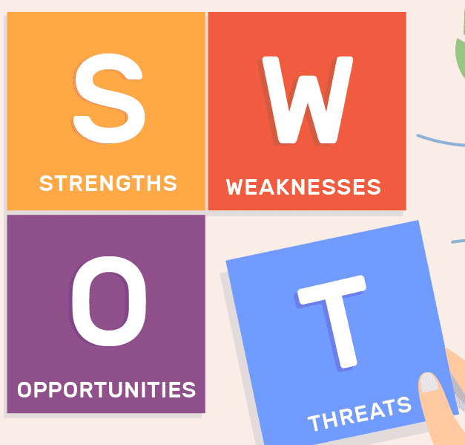

CONCLUSION
As a conclusion the main thing to mention is that the employability skills are more than just important in all environments if someone needs a job. SWOT analysis is as well very important and effective because it allowed me to analyse my current abilities.

REFERENCE PAGE
Chartered Management Institute (CMI 2017), “Personal Development Planning”, [available on: https://www.managers.org.uk/knowledge-bank/personal-development-planning accessed on: 22/03/2020]
MindTools (2019), “SWOT analysis” [available on: https://www.mindtools.com/pages/article/newTMC_05.htm, accessed on: 22/03/2020]
Prachi J. (2015), “SWOT analysis- Definition, Advantages and Limitations”, [accessed on
SkillsYouNeed (2018), “Employability skills: skills you need to get a job”, [available on: https://www.skillsyouneed.com/general/employability-skills.html, accessed on: 22/03/2020]
STEMNET (2018), “Employability Skills”, [available on: https://www.exeter.ac.uk/ambassadors/HESTEM/resources/General/STEMNET%20Employability%20skills%20guide.pdf, accessed on: 20/03/2020]

