Smart and Connected Devices 1

Neil O’Mahoney 0351709

Cyber Security Part-Time Student

Table of Contents
Landing Page 3
Check login 4
Conn Info 5
Trim quotes function 6
Secret page 7
Search page 8
Transfer of Data 10
Close session 11
Conclusion 11
References 12

Landing Page
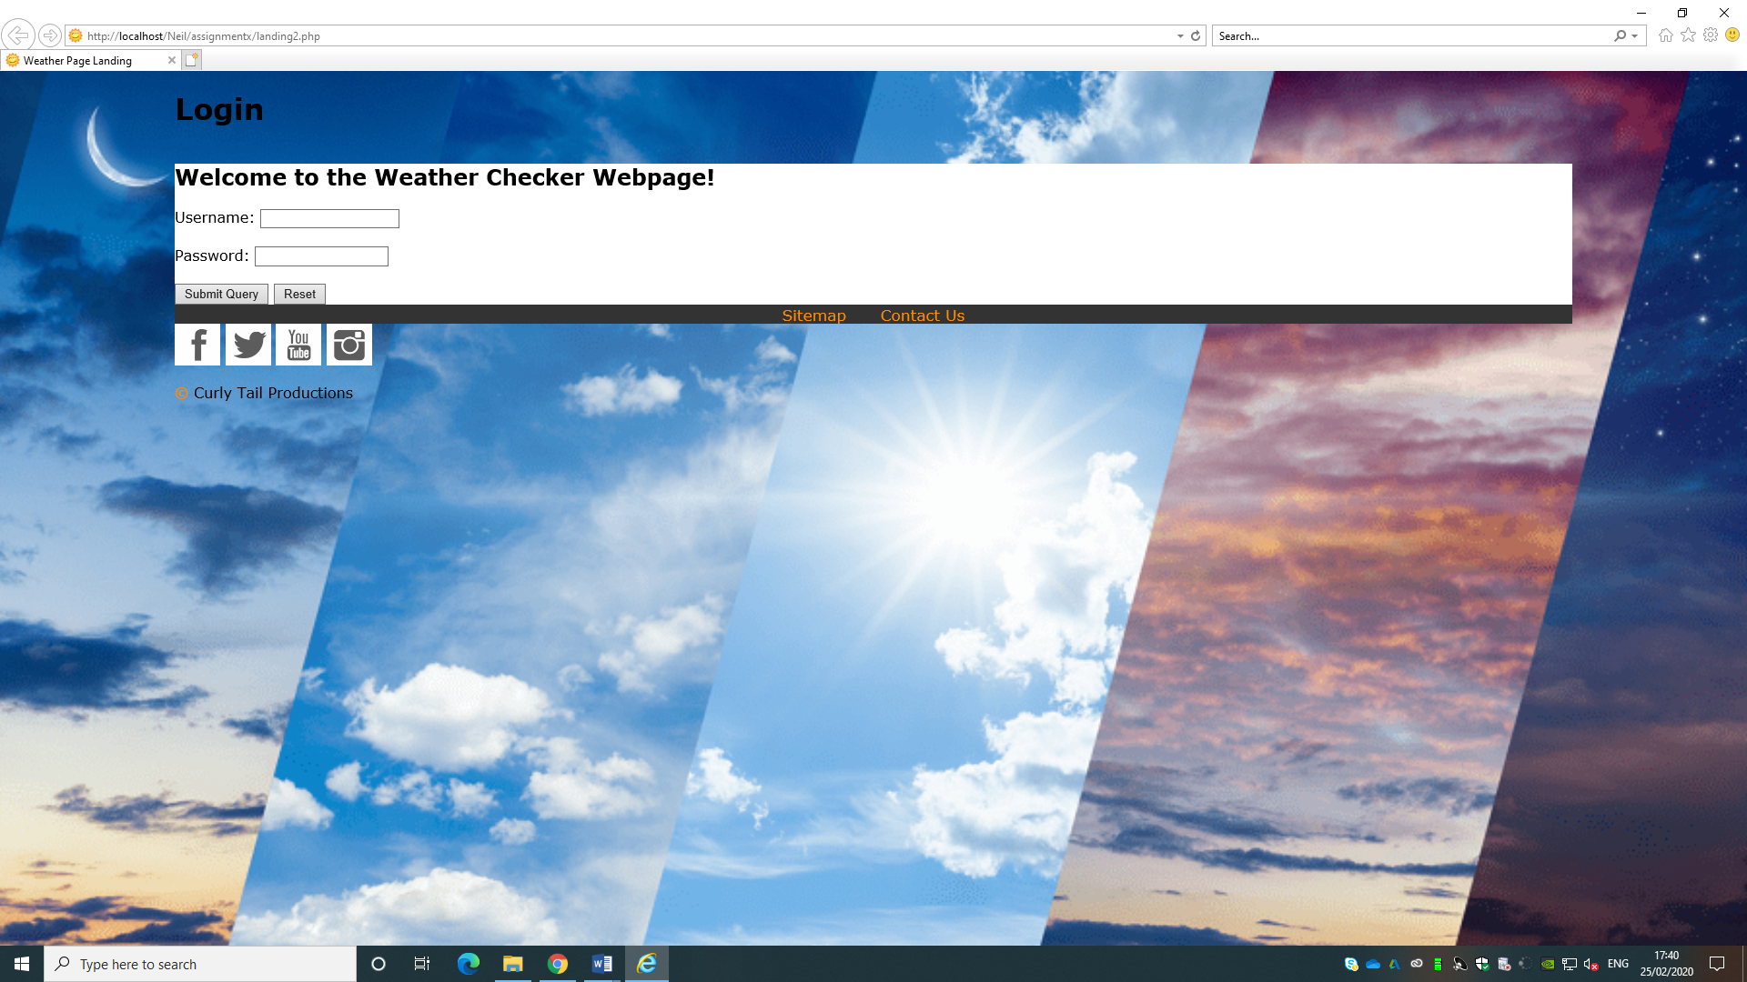
Above is the landing page. It features a username and password logon box.
The webpage has been designed in Cascading Style Sheets (CSS) and is HTML 5 compliant. Ideally the author should have used bootstrap to configure this element of the website. CSS was used as it supports multiple browsers and environments ‘CSS supports various profiles in consideration of different device environments.’ [1]
The username and logon box are linked to a MySQL database table called ‘users’.
Initially at the top of the page a PHP script checks that the user isn’t already logged in. The ‘<?’ brackets are there to allow PHP to be typed in a HTML document. The logic of the statement reads that if the ‘uname’ is ‘NOT EQUAL TO’ (!=) “”then the user must be logged in and the session is still live, the ELSE statement s there for the possibility that the user might not be logged in and posts the form below. The IF ELSE statement is useful in that it can be used until a statement matches the condition ‘..You provide a sequence of conditions, the program can check each until it finds one that is true.’ [2]
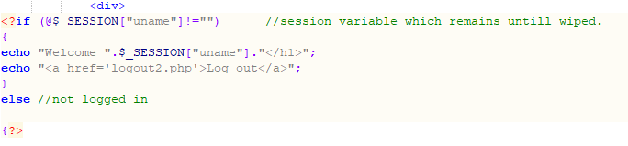
The format of the questions presented to the user is put into a form. This is a standardised format which presents to the user where to input their information.
There is a submit button which pushes what data has been inputted into it to a page called checklogin2.php.
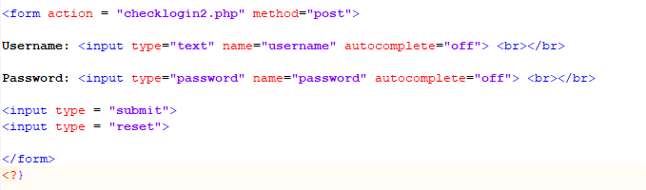
The password field is hidden by changing a field type to “password” in the HTML form. Autocomplete has also been switched off in the same way.
The method of sending the data is the ‘POST’ method. According to W3 schools this more secure than the Get method as the ‘…Parameters are not stored in browser history or in web server logs’. [3]

Check login
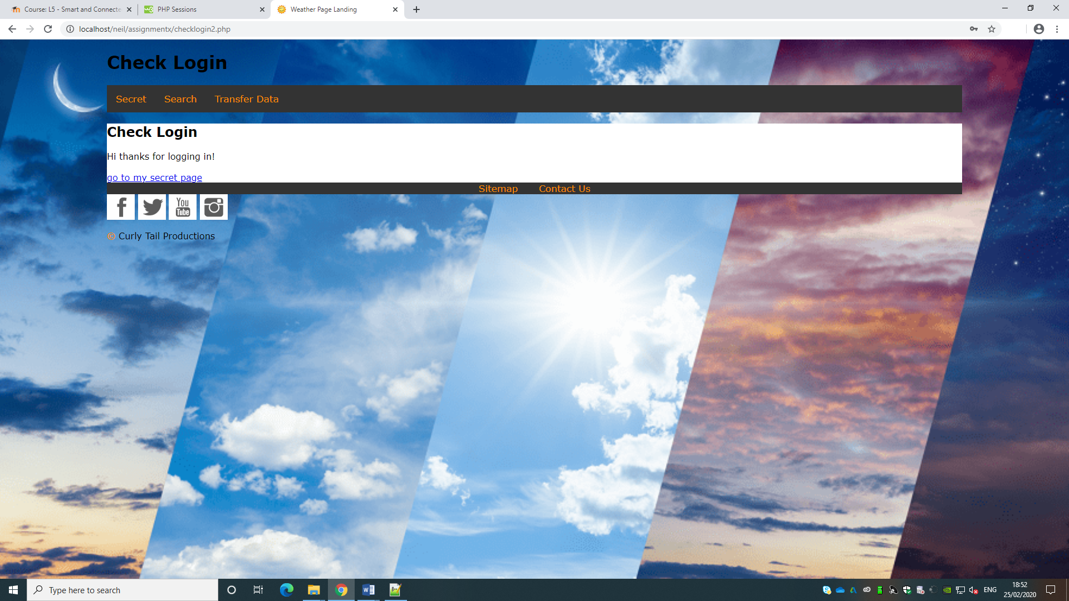
SQL statement checks that the user is a valid member of the website against the database
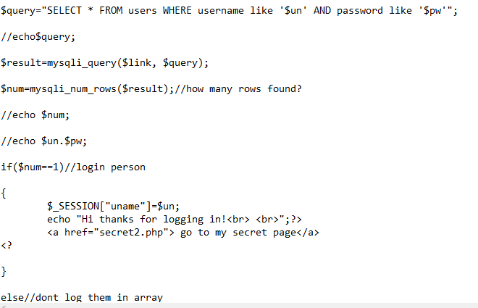
UN & PW are variables that the user has to type in. the ‘IF’ statement is a logical check of the above SQl statement that adds the user to a session if the account is found, containing the username of the person logged in. IF statements ‘..Condition is true, the following block of code will be executed.’ [2]
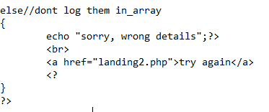
Image above depicts the unsuccessful login of the user and demonstrates validation on the website.

Conn Info
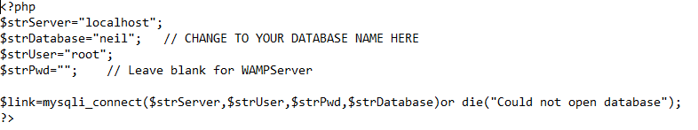
The ‘Conn info’ file is referred to throughout the website to access the SQL database. This is a single file and any information that is changed here will change for all access pages. ‘MySqli_connect’ opens a new connection with the server, database, user and password credentials.

Trim quotes function
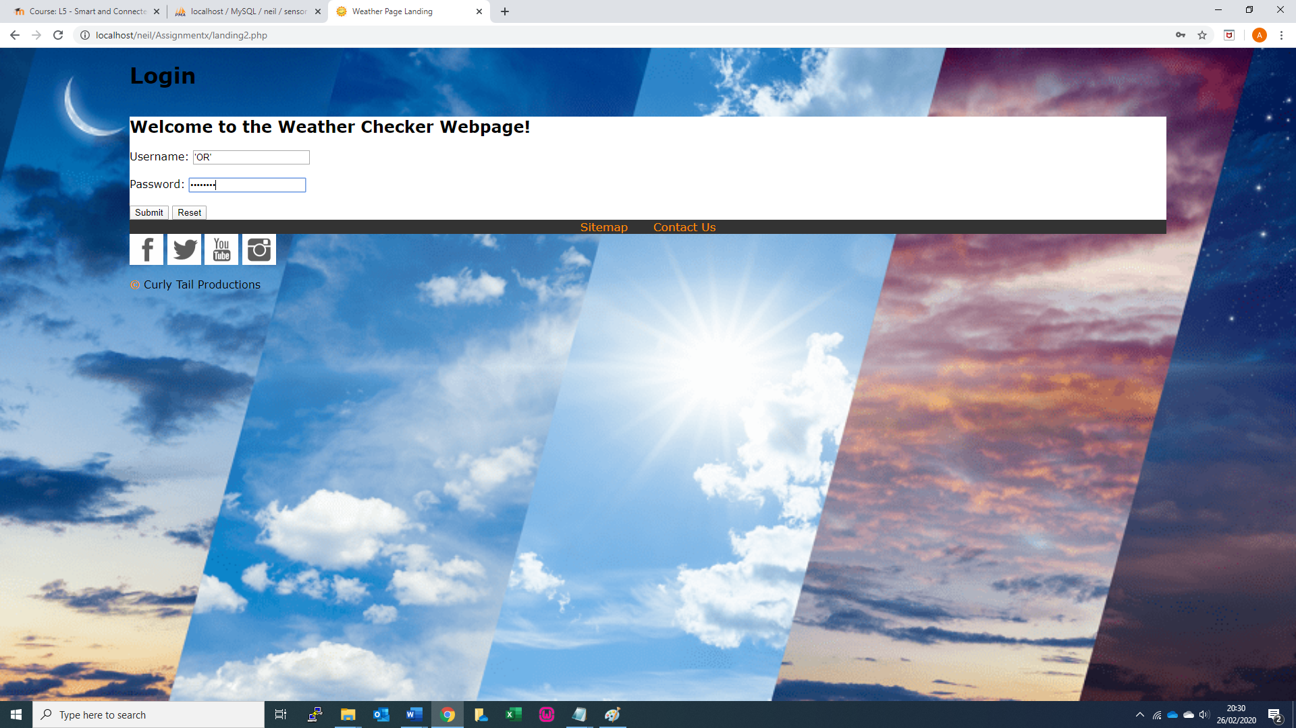
The above shows the user intentionally logging in with the ‘OR’ quotes function. This should cause the database to crash and allows the insertion of code. The password typed in is a correct one and had the trim quotes function not been used, would have allowed unrestricted access to the site.
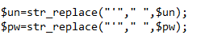
Above shows the trim quotes against the username and password. This statement unquotes a quoted string, the left in the brackets is what is quoted, the right is what it becomes.

Secret page
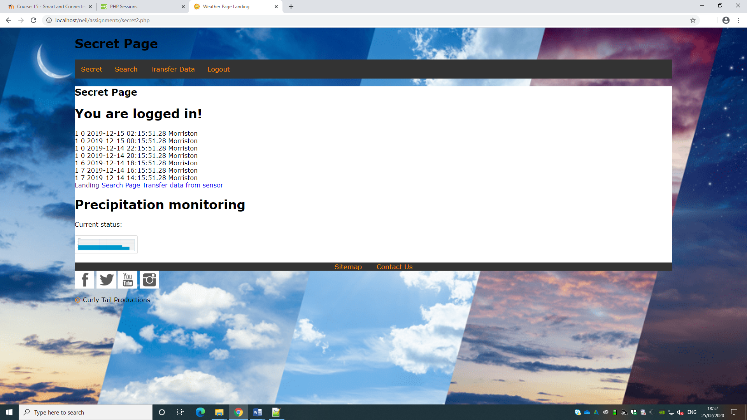
The above shows the now logged in webpage, known as the secret page. So called because the only way to access this webpage is via a login. The data on the page is pulled from the database and displays information back to the client. Ideally this would be removed, however for testing purposes and to demonstrate that it worked, the author thought it prudent to display his database.
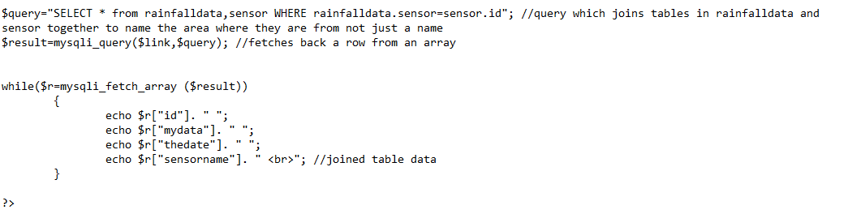
Shown on the page is a join between two SQL databases the sensor name, rainfall, timestamp and the location are show. The location is joined from the sensor table to data pulled from the text files. As we can see, the author has stated the two separate tables in the first part of the query then references the column names ‘sensor’ and ‘id’ later on. There needs to be data common to both (in the case of our table the sensor from the rainfalldata table and the id number from the sensor table [4] ‘…We can use this column to tie the two tables together into a single query.’
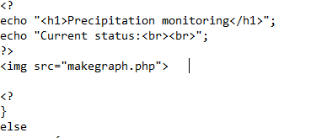
The author displayed the graph in a small pictorial format to show that there had been data connecting and creating a graph, it is referenced as an image file, pulled from ‘makegraph.php’. The author should have changed the size on the graph at the time to display its full size 640 x 640 by using the width=”640” height=”640”. The graph can be further shown on the ‘Search’ page.

Search page
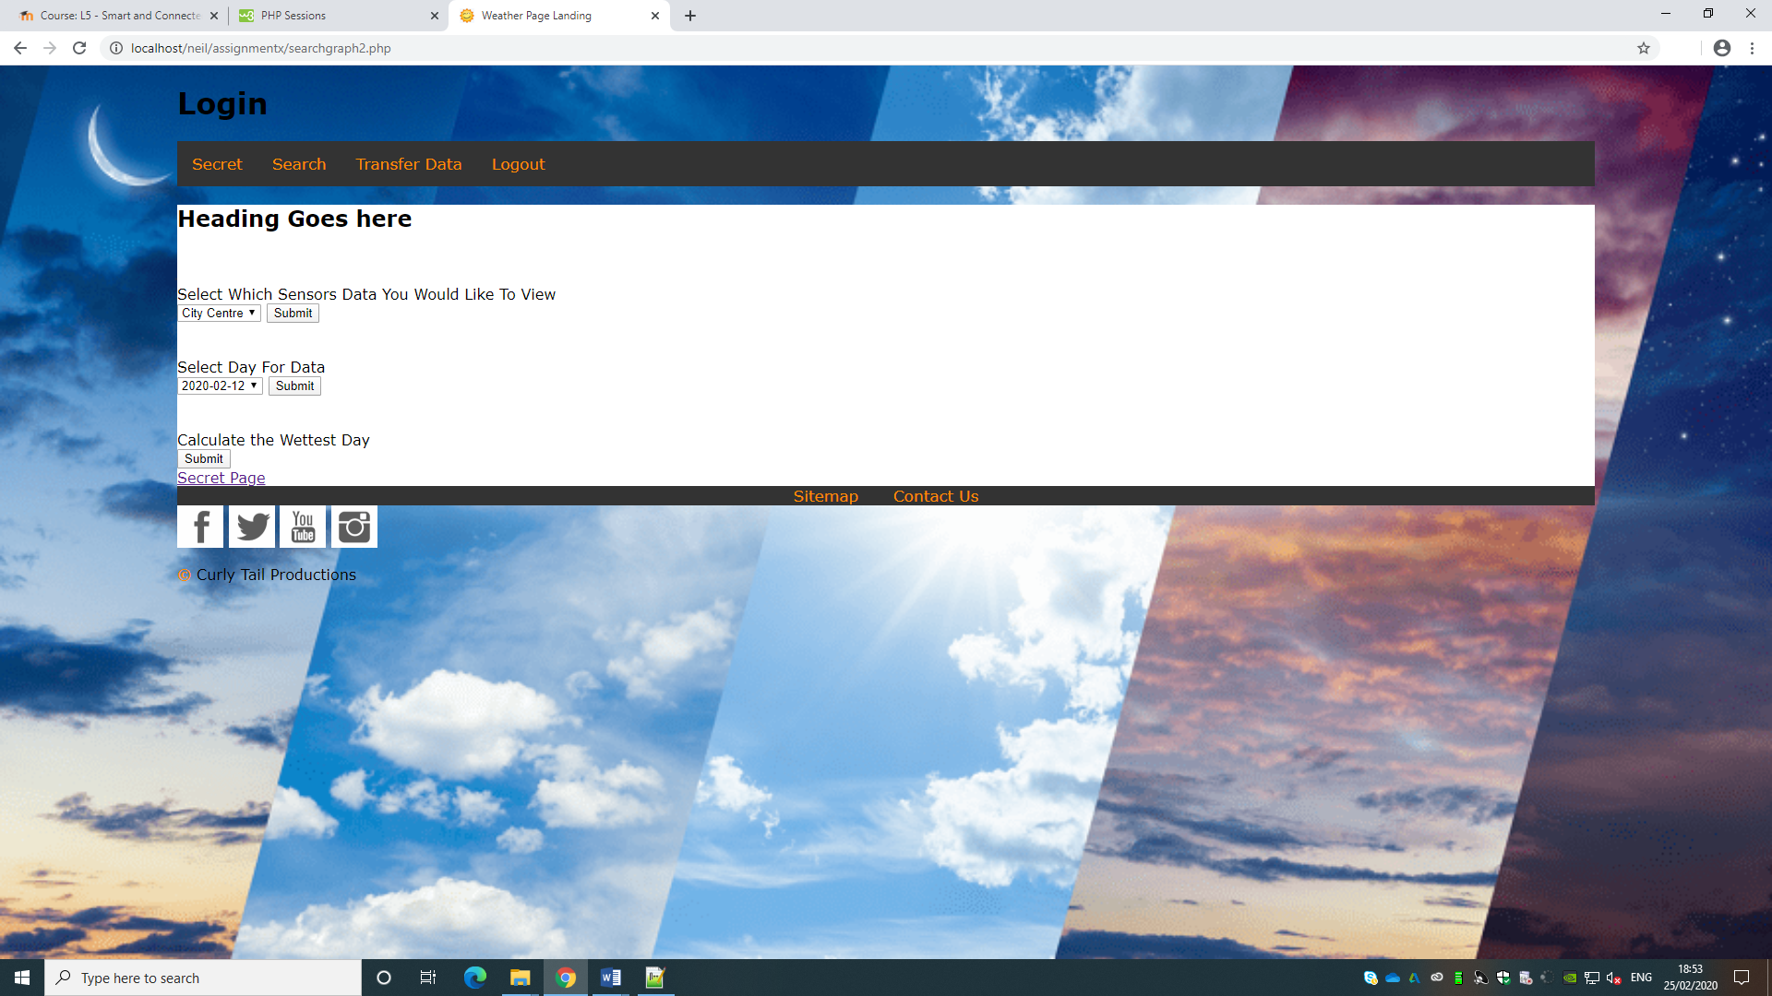
Containing multiple SQL queries, the ‘Search Page’ allows the user to change variables to manipulate the data that is found within the webpage.
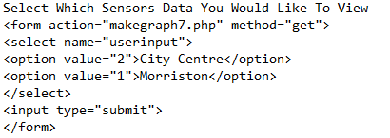
The first query allows the user to search the different sensors, ‘Morriston’, ‘City Centre’ and ‘Sketty’. These all relate to 1,2 and 3 ‘rainfalldata’ text files. When the user selects the drop down and clicks search button, this relates to a number of the sensor and using the ‘Get’ command sends this number (pre-programmed into the HTML) to some SQL in ‘makegraph7.php’ seen below as the array variable ‘$ui’:
In retrospect it would have been a better idea to populate the dropdown list from the rainfalldata.txt file rather than having It hard coded into the HTML as it might need to be changed to expand the search.

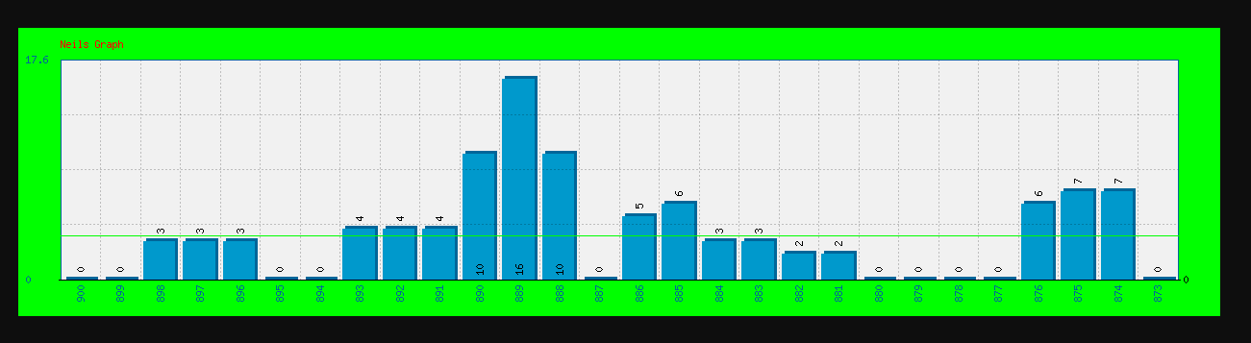
Displaying the data above is for Morriston or Datagraph #2. This is shown on a separate webpage. To display onto the webpage there is a ‘while loop’ which displays the data. Ideally it would display the date timestamp, however the author selected the ID which doesn’t help the reader to discover when the timings were taken. It would be simple enough to fix/ Code below demonstrates this While Loop:
The graph displays a line of average/ medium, this was added to give the user an idea if it was above or below here it should be, added as an extra feature to the PHPmygraph page:
To demonstrate the ability to search for a particular day, the author also added this function to his site, it mostly featured the same credentials as above, althought the SQL statement searched on the date instead, the ‘%’ is a wildcard which searches the first part and the second part of the timestamp doesn’t have to be exact:
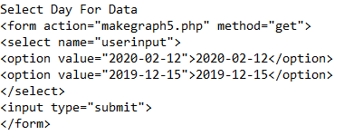
The ‘Get’ method of moving data was used here. This is to show the data that was being passed in the URL to make it easier for the author to see what was happening.
The final search the author has created relates to the calculation of the wettest day. There is not information transferred from the webpage as is done prevously it just runs the query from the linked webpage itself:

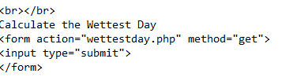
The query inside the SQL statement first calculates the total sum of mydata field across all in rainfalldata, they are grouped according to the datetimestamp into a decending order by using the ‘ORDER BY’ command. The author then displays the top result and displays according to what has been produced inside a while loop. ‘ORDER BY’ is desgined to rank by a specific column where as GROUP BY is designed to summise combinations of columns.
The ‘Order By’ ‘Sort returned results by one or more colums in ascending or decsending order’. [5]
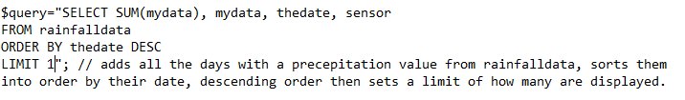
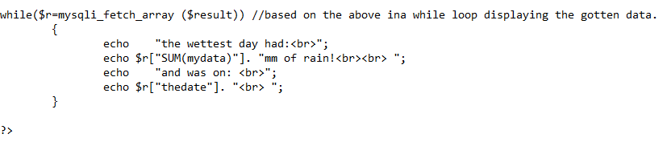
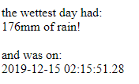
An improvement on this could have been to remove elements of the timestamp, but for reasons of time the author was unable to do so.

Transfer of Data
There are 3 different files that need to be read into the database, the author created a loop for this with the element ‘j’ which can be substituated for the last number in the filename (as long as it matches rainfall). This is set from 1-3 in the ‘For Loop’:
The file is opened, checked for contents inside (if not information displayed that it isn’t) if it is the data is split into an array and read into the database. The variable of the rainfall number splits it into different fields for the sensor. Finally, the file is closed then the contents wiped so that it cannot be read again duplicating data, seen below:
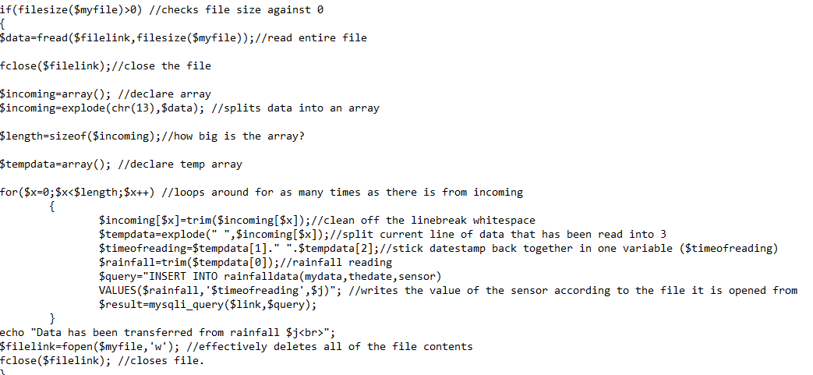

Close session
Here the session name is removed within the PHP, effectvely blanking it. This is a security element so that the next person cannot hit the back button and use the account to change data.

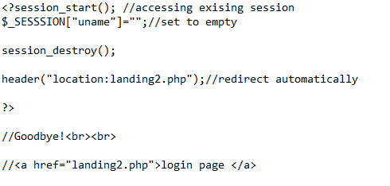

Conclusion
The overall feel of the site is a little clunky, the HTML doesn’t fit together properly and the author should have chosen an easier bootstrap program, due to time limitations this was not an option, however would have made editing it far easier later on.
The setting of the graph on the secret page should have been clearer and the width and height tags been applied to suit the size.
When drawing information to fill the drop-down lists, this should be done dynamically and be pulled from the SQL database. Hard coding into the HTML is not a good idea, as the dates could change, making more work for an administrator.
On the point of the graphs displaying the ‘id’ tag and not the ‘timestamp’ this was an easy change to make which should have been done to help the reader identify what they are looking at.
The calculations of the wettest day is functional, again too much information on the timestamp is a let-down, but using the ‘ORDER BY’ command which is compatible with this version of SQL as opposed to ‘GROUP BY’.
The ‘Conn Info’ file is a good central location to store database access details rather than referring in and out of the php in the page making separate connections this is one central location to do so.

References

[1] | H.-J. ,. W.-Y. S.-M. S. Soon Bum Lim, “CSS3 extensions for setting web content in a 3D view volume and its stereoscopic 3D display,” Computer Standards and Interfaces, vol. 50, pp. 65-75, 2017.
[2] | L. T. Luke Welling, PHP and MYSQL Web Development, USA: Pearson Education, 2009.
[3] | Unknown, “HTTP Request Methods,” W3 Schools, 25 Feb 2020. [Online]. Available: https://www.w3schools.com/tags/ref_httpmethods.asp. [Accessed 25 Feb 2020].
[4] | R. Nixon, PHP, MySQL & Javascript, CA: O'Rilley, 2009, p. 192.
[5] | R. Nixon, PHP, MySql & Javascript, CA: O'Reilly, 2009.

