

Research Methods and Professional Development
(ACFA7004)

In Bot We Trust:
A Thorough Study & Development of Chatbot and Its Impact on Industry 4.0

TABLE OF CONTENT
- ACKNOWLEDMENT 4
- ABSTRACT 5
- INTRODUCTION 6
- BACKGROUND 7
- PROBLEM STATEMENT 11
- AIM & OBJECTIVES 13
- METHODOLOGY 14
- LITERATURE REVIEW 15
- ETHICAL ISSUES 18
- PLAN OF WORK 21
- EVALUATION AND RESULT 27
- FLOW CHART 34
- CONCLUSION 39

TABLE OF FIGURES

Figure 1 9
Figure 2 10
Figure 3 14
Figure 4 21
Figure 5 24
Figure 6 25
Figure 7 28
Figure 8 29
Figure 9 30
Figure 10 31
Figure 11 32
Figure 12 34
Figure 13 35
Figure 14 36

ACKNOWLEDMENT

I would like to thank Dr. Terry Walcott at UWTSD for his valuable input and contribution to the paper. This study and the research underlying it would not have been feasible without his outstanding help. His passion, expertise, and meticulous attention to detail have inspired me and kept my work on track. Furthermore, I would like to thank the Director of studies, Dr. Tim Bashford for his valuable cooperation in the process. Finally, I would also like to acknowledge the help I got from my colleagues and friends who helped me in the process and provided me with their necessary inputs.

ABSTRACT
A Chatbot which sometimes can also be termed as conversational AI, is an instant way to answer other questions. It is a tiny pop up at the bottom-right corner of the window with whom we can ask questions while doing online purchases and shopping.
Chatbots are poised to revolutionize User Interface design. The idea of using them is to make the human interaction with machine a little interactive and easy to adapt. Chatbots have several other uses and are very versatile. They can be used in Digital Platforms, Business, Human Resources, administrations, education and in many other contexts.
Chatbots can handle simple tasks by using algorithms. The idea is to automate communication and streamline customer service by providing users with quick and convenient access to information and services. They can be programmed to handle a variety of tasks, including answering frequently asked questions, providing product recommendations, scheduling appointments, and even conducting transactions. They can be implemented into a variety of platforms, including websites, apps, and social media platforms, and they are becoming increasingly popular as businesses seek to enhance their customer experience and improve operational efficiency.

INTRODUCTION

The focal point of this research and assignment is to project a detailed study on how a chatbot can be created by using simple code and algorithms and how pivotal they can be when implemented in business, healthcare or technology. Although there is many other complex AI based chatbots like Alexa and Siri which uses higher level of coding, instances and programming, but we will be discussing the roots of how simple it is to create a simple chatbot and how effective it can be in booming the business and advancing the digital revolution.

BACKGROUND
In 1950, Alan Turing wondered whether a computer software could interact with a group of people without the recipients of the communication recognising that their interlocutor was artificial. Many people think that the Turing test, which was developed in 1950, is where chatbots first appeared. The first chatbot, called ELIZA, was developed in 1966. Weizenbaum (1966) claimed that ELIZA imitated the behaviours of a psychotherapist by responding to the user's statements in the interrogative form. It inspired the development of several chatbots in the years that followed, despite its restricted communication skills (Klopfenstein et al., 2017). Brandtzaeg and Flstad (2017) claimed that pattern matching, and a response selection mechanism based on templates are both used by ELIZA. Eliza's expertise is limited, thus she can only engage in debates on subjects related to that sector, which is a drawback.

In 1972, a person with schizophrenia first made an appearance under the moniker PARRY. It is thought that PARRY is more sophisticated than ELIZA because it has a "personality" and a superior governing structure. It describes his replies in terms of a set of assumptions and "emotional responses" that are triggered by the user's statements shifting in weight. In an experiment conducted in 1979, five psychiatrist judges utilised PARRY to ascertain whether a patient was a computer programme or a genuine schizophrenic patient. Therefore, psychiatrists offered ten diagnoses. While the second psychiatrist made two errors, the first psychiatrist made two accurate diagnoses. A person named PARRY with schizophrenia first appeared in 1972. It is believed that PARRY has a "personality" and a superior governance system, making it more advanced than ELIZA. It characterises his answers as a series of "emotional responses" brought on by the user's assertions changing in importance. In a 1979 experiment, five psychiatrist judges used PARRY to determine if a patient was a computer programme or a real person suffering from schizophrenia. Therefore, ten diagnoses were provided by psychiatrists. The first psychiatrist made two valid diagnoses, while the second psychiatrist made two mistakes.
In the field of chatbots, AI was initially applied in 1988 with the creation of Jabberwacky. It employed contextual pattern matching to answer based on past chats and was created in CleverScript, a language based on spreadsheets that aided the construction of chatbots. However, Jabberwacky is unable to respond quickly or support a large number of users.
In 1991, the phrase "chatterbot" was first used. It was an artificial player in a multiplayer real-time virtual world whose main job was to communicate. Speaking with Chatterbot seemed to be more popular among genuine players than with other real players. The Chatterbot was successful because participants in that universe assumed that everyone was a person and that it would only raise questions if it made a serious error. In 1992, a chatbot named Dr. Sbaitso (Sound Blaster Artificial Intelligent Text to Speech Operator) was developed to display the digitised voices that sound cards could generate.
The development of Artificial Linguistic Internet Computer Entity or ALICE, was the first online chatbot inspired by ELIZA, in 1995 and it marked another advancement in the history of chatbots. Didn’t have any real understanding of the entire dialogue. ALICE was based solely on pattern matching. However, with a capability for online conversation that included any topic and allowed longitude. It took some time, though, for it to be refined enough to win the Loebner Prize for the finest human-like computer programme. The key distinction between ALICE and ELIZA is that ALICE was constructed using Artificial Intelligence Markup Language (AIML), a new language established specifically for this purpose. When we compare ALICE's Knowledge Base to ELIZA's Knowledge Base, which only had 200 keywords and rules, the former had over 41,000 templates and related patterns. ALICE, however, lacked intelligence and was unable to produce human-like responses that expressed attitudes or emotions.
With the creation of SmarterChild in 2001, chatbot technology saw a major evolution. It was accessible on Messengers like America Online (AOL) and Microsoft (MSN). For the first time, a chatbot was able to assist users with actual daily chores by retrieving data from databases including movie times, sports scores, market prices, news, and weather. The capacity to access information systems through conversation with a chatbot was a significant advancement in both the machine intelligence and human-computer interaction trajectories. [13][14]

There has been a significant growth and increase in the use of chatbots since 2016 (Fig. 1). (Fig. 2) shows that USA is the top country that has shown more research interest in chatbots while the UK and Japan followed with less than one-third of the number. [1]

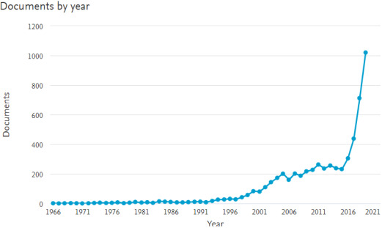
Figure 1

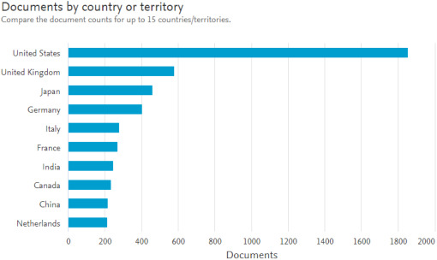
Figure 2
Fig 2. shows results in Scopus previe from 1966 to 2019 for the keywords “conversation agent” or “chatbot” or “conversational interface” by country or territory.

PROBLEM STATEMENT
Any firm must be able to provide good customer support services. However, conventional customer care techniques like phone calls and emails can take time and cannot always result in prompt responses. We suggest creating a chatbot that can help clients in real-time to solve this problem. The chatbot will be programmed to comprehend client inquiries, give pertinent information, and, if necessary, escalate complex issues to human employees. The chatbot will be accessible around-the-clock, giving users quick support and cutting down on response time. The project's goal is to develop a customer assistance system that is affordable, effective, and practical for both consumers and companies. By offering quick and convenient customer service, the chatbot will assist businesses in increasing their customer satisfaction ratings and decreasing customer churn.
The other problems it can solve are:

- Eliminating the costs to meet global customer demands.
We can engage with customers without having to hire additional people by using a chatbot. Chatbots are always available and may be designed to communicate with clients in whatever language we want. They can deliver such front-line assistance without making us hire more permanent or temporary employees than we can afford.

- Automating repeat customer support enquiries.
Since chatbot respond with any degree of dissatisfaction to mundane, repetitive tasks. They are merely programmed to perform their duties and provide customers with the required level of assistance. Most importantly, they can automate many of these tasks, reducing employee dissatisfaction and/or turnover and speeding up response times.

- Ending sales activity

We can engage with customers without having to hire additional people by using a chatbot. Chatbots are always available and may be designed to communicate with clients in whatever language we want. They can deliver such front-line assistance without making us hire more permanent or temporary employees than we can afford.

- Giving customers a channel to find solutions to their questions.
Customers can access chatbots at any time, and they can be coloured to stand out on the website while not in use. Customers can easily initiate a conversation with the chatbot by clicking on its pop-up window and interacting with it as needed. They can do this while browsing a variety of pages and acquire answers to urgent queries without having to conduct independent research to find those solutions. [11]

AIM & OBJECTIVES

Even though the concept of chatbots is fresh, it is revolutionising digital marketing and B2B marketing. Almost all significant digital platforms and companies currently use chatbots in some capacity. This suggests that creating a chatbot is not a difficult undertaking, but it remains to be seen if it can be utilised for purposes beyond just offering an interactive user interface.
Aim:
This project aims to understand the purpose and use of chatbots and to develop and integrate a simple chatbot on any website.
Objectives:
- To understand the use of chatbots in modern industry and its various sectors.

- To study its impact on various industry sectors and how it has helped the business and sectors to grow.

- To create a chatbot and demonstrate its ease of access and use.

- Determine the requirements needed to create the chatbot and the website.

- To demonstrate each step to create a simple working chatbot and evaluate the developed scenario and help making it accessible.

METHODOLOGY
To explain the data, usage and efficiency of a modern day chatbot, we must use a quantitative approach which helps us to evaluate the exact numbers, observe results, and study the flaws (if any), which can be useful to improve the backend, user interface and working of the bot.
We will be using quantitative data from a chatbot which was developed for health sector. The purpose of this approach is to find out what information people look for in a chatbot that offers support for their issues. It is necessary to investigate when and how the chatbot is utilized based on the time of day and the number of questions in each discussion. The questions that the chatbot was unable to answer are categorized. The fundamental goal is to look at quantitative client information in the chatbot's sign to propel the chatbot's turn of events.
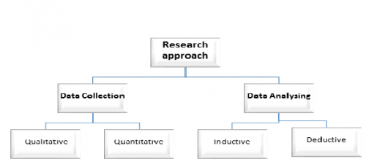
Figure 3

This figure shows the research approach which is used to create and analyse a simple working chatbot. Since AI based chatbots are based more on data collection and usage, this is the reason the quantitative research is used.

LITERATURE REVIEW

This study highlights the traits of recent empirical investigations on the interaction between humans and chatbots. It's interesting to note that most of the study on users engaging with them is very recent—more than two thirds of the publications we analysed were published in 2017. This reflects the recent growth of commercial chatbots and indicates the rising interest in this technology among academics. In terms of methodology, articles typically examine how people engage with chatbots.
In the last ten years, text-based chatbots (or simply chatbots), which enable human-machine communication through natural written language, have proliferated in a variety of application areas. This phenomenon has been referred to as a "chatbot tsunami". The ability for them to be seamlessly integrated into already-existing websites and applications, as well as flexible platforms that facilitate their creation, are what are driving this proliferation. Developers can create new chatbots quickly and simply by teaching the AI to react to questions with specific purpose that are posed in natural language using cloud based services of AI building blocks like the IBM Watson Developer Cloud.
Given this technical advancement, it is not surprising that chatbot investments have skyrocketed. According to Boiteux, in 2018 there were 300,000 chatbots operating solely on Facebook Messenger. By 2022, 85% of customer support interactions, according to Gasson et al. (2009) and Gartner (2017), will be driven by chatbots. Scholars started investigating how people use this technology after noticing these tendencies. Despite the early buzz and the optimistic market expectations, talking to artificial agents creates challenges that are beyond their existing technology and limitations, instead involving the human side of contact. This is why such study has been deemed significant. Chatbots may not live up to users' high expectations for, say, language proficiency. They may also provoke a range of (bad) emotions, such as irritation at not being understood, and they may promote the development of biases in users' perceptions of the technology.

The modern increase in chatbot usage
The start of the chatbot tidal wave might be traced all the way back to 2014, when interests in chatbots that could carefully describe specific points started to take off. However, the overall population just started to get comfortable with conversational specialist innovation in the mid 2010s. Social bots, which broadcast, follow, or transfer messages made by different bots or genuine clients, were overwhelmed on Twitter by 2010. Despite being speech-based, Siri made language-based interaction mainstream in the consumer market in 2010. In 2011, Rollo Carpenter's chatbot Cleverbot became the first AI program to pass the "Modified Turing Test" while IBM's Watson was competing on the game show Jeopardy.
Using the Grounded Theory Literature Review approach, we were able to locate relevant current research-related themes concerning human-chatbot interaction. This approach is based on Grounded Theory, a social science approach that uses an inductive data collection and analysis process to build theories and identify data themes. What recognizes Grounded Hypothesis from different methodologies is an inductive, as opposed to a speculative logical position. Grounded Theory has been utilized either as a strategy for making sense of a large amount of data, specifically a coding method, or as a method for developing theoretical models that emerge from the data. In order to add rigor to the process of searching, selecting, and analyzing studies in a review, this article primarily uses Grounded Theory as a method for data analysis.
The papers included in this systematic review were gathered in April 2020. Scopus, EBSCO APA PsycInfo, and the Association for Computing Machinery Digital Library (ACM DL) were utilized in our search for relevant publications on the interaction between humans and chatbots. The ACM DL accumulates software engineering distributions, PsycInfo assembles brain research papers, and SCOPUS is a more nonexclusive assortment, subsequently we picked them to possibly catch any article tending to relevant subjects in human-chatbot communication. [5]

The concept of a chatbot is the subject of the first part of the query, which includes synonyms that may refer to text-based conversational agents. Instead, the human aspects of interaction are discussed in the second section: They combine more general and more specific terms to cover a wide range of topics that might be useful for learning about the human side of chatbot interaction. The rundown of search terms was created after a few cycles and refinement by every one of the three creators, in accordance with other HCI research surveys.
FUTURE GENERATION
Future generation is the following undertaking that we need to consider. In the wake of cleaning the information, it ought to be changed over in to such a way a machine can comprehend.
Here the idea of Bag of Words (BOW) is considered for producing feature from the input text. In this model, a content like a sentence or even a document is addressed as the pack (multiset) of its relating words, without thinking about the syntax and even word request yet keeping variety.
The output from this feature generator will be given as the input to the deep learning Model to foresee the response. [6][7]

EHICAL ISSUES IN THE DEVELOPMENT AND STUDY OF CHATBOTS
There is a need to address the ethical issues while we study and develop chatbot.
Chatbots access a new fascinating area in the field of machine learning, user interaction, and information distribution. But in order to ensure that this technology is applied responsibly and effectively, there are ethical issues and ramifications that need to be considered.
This is particularly valid for innovations that utilization a "set it and fail to remember it" system, similar to most of chatbots. Advances in machine learning, particularly in relation to bots, may further conflate the situation and have far worse effects if businesses that employ them are not attentive. There are some ethical issues that needs to be addressed here.

User transparency
Straightforwardness is a vital moral issue for innovation according to the client's perspective. To put it another way, does the user know everything there is to know about chatbots and the consequences of using one? As was mentioned earlier, user data privacy and security are widespread concerns. Depending on the regulations in place, any information that users provide to the bot during their conversation may be collected, used, or sold without their consent. Moreover, the business or association that claims the bot would ultimately store up a developing measure of data, prompting a critical power lop-sidedness. Being open and straightforward about information use, proprietorship, and assurance is critical. One way to increase openness is to put in place a data regulation system like the EU's GDPR, which gives people more control over their personal data.

Trust
A crucial first step in prioritizing users' needs and welfare is to allow them to choose how they want to interact with an agent. For instance, it is essential to be transparent about an agent's status as an automatic (non-human) agent as well as the limits of its powers for users to be able to make informed decisions, which increases user trust. People respond and interact differently when communicating with an artificial agent as opposed to a human. This has been demonstrated by recent research. If users are aware of whether they are conversing with an automated or human agent, they may be better able to control their own actions, particularly when it comes to disclosing information. [12]

Privacy

Various privacy issues arise as a result of the collection of user data. Some of these issues have a legal basis and are addressed by regionally distinct data protection laws, such as the GDPR in Europe. The nature of these ethical dilemmas varies greatly depending on the domain in which the agent is deployed and the user group's level of vulnerability. We do, in any case, recommend that around here, where the default technique ought to be to possibly gather and save client information if important for the conveyance of the predefined administration and to do as such in a straightforward way, clear legitimate prerequisites ought to be considered as a gauge, not an objective. Client protection is urgent and turning out to be more critical as man-made intelligence frameworks are carried out in additional circles of society and are utilized to make decisions that are more huge and expansive. Therefore, the concept of privacy ought to be viewed as a larger social problem as opposed to merely a user-specific issue. The singular client is habitually denied the opportunity to arrange agreements that are drafted by organizations such that applies to everybody, or they come up short on assets to do as such. Consequently, it is critical to consider what the presentation of artificial intelligence frameworks might mean for society while choosing how to think about and administer protection. With the backing of this perspective, security can be reconsidered in a way that interfaces it to more extensive cultural goals.

4. Plurality of approaches

Conversational AI raises a variety of ethical questions depending on the application domain, intended user demographic, and agent goal(s). As a consequence of this, a comprehension of the domain as well as the issue that the agent is attempting to resolve ought to serve as a guide for the identification of potential ethical issues and solutions. A client or public-confronting specialist who might be expected to answer general or unhindered inquiries will have a totally different arrangement of contemplations than a chatbot involved inside an association by staff for a predefined reason. For responsible system design, a thorough understanding of the characteristics, circumstances, and interests of the user group is essential. [2]

PLAN OF WORK

Design coordinating and AI approaches are the two methods for developing a chatbot, contingent upon the calculations and strategies utilized.

1. Pattern Matching
Design Matching calculations are utilized by rule-based chatbots to contrast client input with a standard example and pick one arranged reaction from a scope of choices. Rule-based systems frequently do not provide novel responses due to the developer's pre-written knowledge in the form of conversational patterns. The greater the size of the rules database, the better a chatbot can respond to questions from users. Because this type of chatbot necessitates the application of hundreds of rules, it is challenging to address grammatical and syntactic issues that arise in user responses. Cleverbot, Chatfuel, and Watson are examples of chatbots that use rules.
The disadvantages of the pattern-matching approach include the answers' automated, repetitive nature, and lack of creativity and spontaneity in comparison to human responses. Because no additional syntactic or semantic analysis is performed on the supplied text, the response time is reduced.
- Artificial Intelligence Markup Language
To fabricate the Information Base for chatbots that utilization the Example Matching method, engineers constructed the Man-made consciousness Markup Language (AIML) somewhere in the range of 1995 and 2000. It is open source and has an XML foundation. The first chatbot with an AIML-based information base was called ALICE. Due to its usefulness, ease of use, and availability of pre-authored AIML collections, AIML is the chatbot language of choice. To a certain degree, setting mindfulness exists in an AIML-executed chatbot. It can respond to user input in a variety of ways, either based on the value of variables that are updated during the conversation or at random.
The figure below shows a portion of an AIML-based Knowledge Base.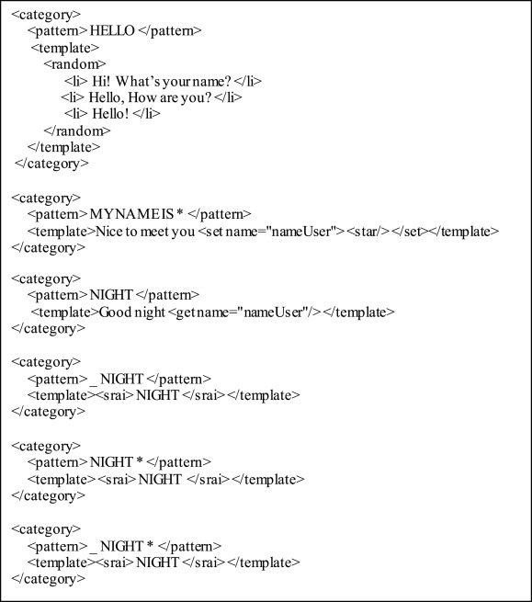
Figure 4

It is essential to keep in mind that AIML and other pattern-matching languages may occasionally be used in conjunction with Latent Semantic Analysis (LSA) and other methods. LSA, on the other hand, is able to produce responses to queries that cannot be answered in this way, whereas AIML can respond to queries using predefined templates. [3]

2. Machine Learning

Chatbots that use Machine Learning Approaches rather than Pattern Matching to extract information from user input using Natural Language Processing (NLP) lose their capacity to learn from conversations. They consider the entire dialogue context, not just the current turn, rather than requiring a predetermined response for each potential user input. They frequently require a substantial training set and locating one may be challenging due to insufficient dataset availability. A movie scripts corpus, for example, might be too broad, and an IT support line might be too narrow.
Counterfeit brain organizations (ANNs) are much of the time utilized in the advancement of these chatbots. In recovery-based models, the most probable reaction is looked over a gathering of reactions by doling out scores utilizing a brain organization. In contrast, generative models combine the response, typically employing deep learning techniques.
- Natural Language Processing

The investigation of how PC situation can understand and control normal language in text or discourse is known as regular language handling, or NLP. Information regarding the comprehension and application of human language is gathered in order to develop the appropriate methods for computer systems to handle human language and perform a variety of tasks. Most NLP strategies depend on AI. They are comprised of Normal Language Understanding, which fosters the obligation to grasp a text, and Regular Language Age, which adds the obligation to deliver the text commonly did by ANNs.

- Natural Language Understanding

Chatbots make use of Natural Language Understanding (NLU) to extract context from unstructured user input written in human language so that they can respond appropriately based on the purpose of the current user. The user's general knowledge, the user's mental processes, and the interpretation are the three main issues raised by the NLU process.

STEPS TO CREATE CHATBOT MODEL

In this chatbot model, we follow the following steps to develop full working chatbot system.
- Creation of dataset or loading of dataset
- Pre-processing of data
- Feature generation and creation of training data
- Building of Deep Learning model
- Predicting the response

- CREATION AND LOADING OF DATASET
Information is considered as the fundamental key to a chatbot model. On the off chance that we need our chatbot to be conversational, we ought to consider its dataset as an essential component. To fabricate a conversational framework with moderate knowledge is extremely difficult as it requires bountiful exchange data and interdisciplinary strategies. Here ais made physically to get more precision. As the model is a retrieval based one, it works for the most part on a closed domain.
Dataset which is utilized here is a collection of JavaScript objects that rundowns various tags that relate to various kinds of word patterns and is stored as a JSON file which contains the intents.

- PREPROCESSING OF DATA
After dataset creation, different pre-processing tasks are done for cleaning the data. Pre-processing task is named as a significant job while we are managing any NLP job.
- BUILDING OF DEEP LEARNING MODEL
A DL based retrieval chatbot model is implemented here in the project definition, we already stated that our number one purpose is to build a chatbot which accepts input as a set of queries that are being queried by the user with a couple of personas and gives the maximum accurate responses and to carry on the communication in a more significant manner.
- IMPLEMENTATION AND WORKING
To run this chatbot model, we have two important file named as train_chatbot.py for training the model and chatgui.py for interacting with chatbot with the help of GUI.
- Training the chatbot model
First we have to train the model with the help of command given in the terminal window:
Python train_chatbot.py

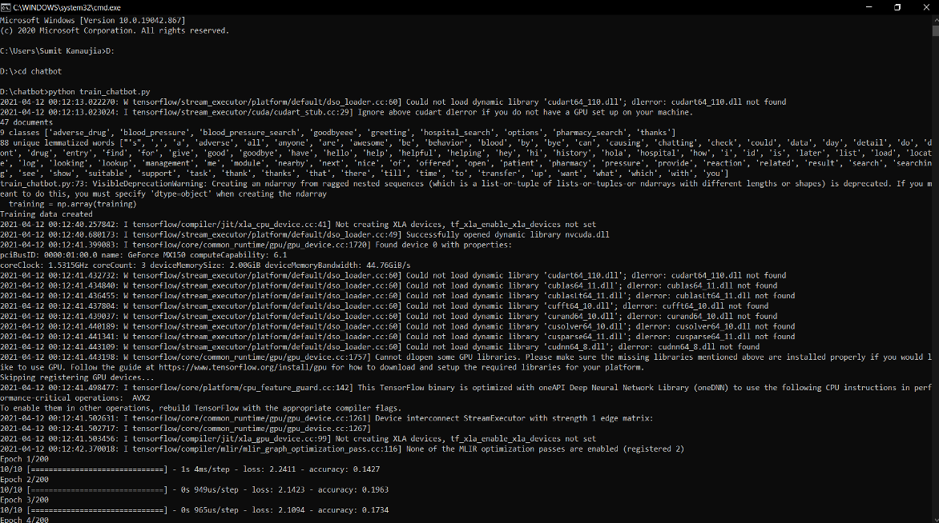
Figure 5

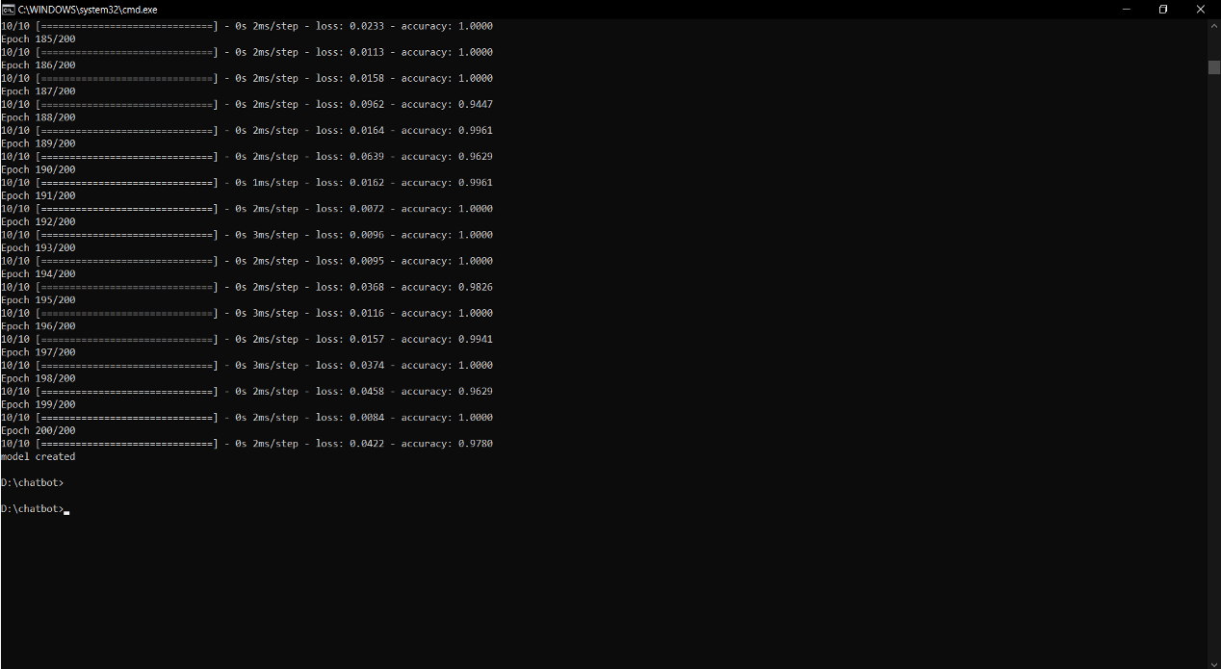
Figure 6

[8][9]

EVALUATION AND RESULT
The outcome and examination can be isolated into two classifications: estimating the clients and estimating the transformations that happen. Since chatbots are designed to assist your customers, the ultimate objective is a superior user experience. As a result, it makes sense to begin with your user base. How would you characterize the user experience as a whole? What kind of interaction are they having with the chatbot? Because they all have a significant impact on the user experience, conducting analysis of each is crucial.
- Conversation Length: How long does a chatbot take to interact with its users may be an important metric to focus on if one of your objectives is to improve efficiency. This metric varies from situation to situation and is subject to change. Marketing chatbots that prioritize user involvement would benefit from longer conversation times. However, a decrease in conversation length over time is positive for support chatbots aimed at promptly resolving issues and questions.
- Bounce Rate: Similar to when visitors leave a website after viewing only one page, this metric indicates how helpful the chatbot was to them. Who is leaving, when in the discussion would they say they are dropping off, and why? A high bounce rate will occur, for instance, if a customer leaves a session early because they find it unhelpful.
- New Users: The clients development. During the Coronavirus pandemic, for example, carrier West Fly saw a 45X spike in new clients and client demands, with a large number of inquiries in regard to their undoings and flying limitations. The company was able to expand its support staff and divert tens of thousands of calls from human agents by making use of Juliet, Netomi's AI-powered chatbot.

- Return or Reactive Users: The evaluation of the users, and are they finding it useful enough to come back.
- Customer Satisfaction: How valuable or accommodating was the chatbot, according to the client. The customer satisfaction surveys, which are sent out immediately following an interaction, enables us to determine whether you are meeting the expectations of your customers, allowing you to identify areas in the customer journey where things go wrong and improve the experience as necessary. Customers can feel appreciated and that their opinions and concerns are being taken into consideration with these customer service tools.
- Escalation Rate: A chatbot may have to escalate a conversation to a human agent in some instances. This could be in light of multiple factors: it doesn't comprehend a client's feedback, has not been prepared on a particular theme or a client unequivocally requests a human specialist. If encountering a high heightening rate, it very well may merit leading extra preparation and expanding the chatbot's extension to convey a lift in execution.

PREDICTING THE RESPONSE
The response Prediction is the last assignment of the framework model. The DL model provide us with the list of intents subsequent to separating it with threshold limit alongside their comparing probabilities. It is the responsibility of response generation module to select the one from that list that is most appropriate for the inputted inquiry.
This module takes the output from the Deep Learning module as it's input. At that point these lists of intents are checked with the repository (here JSON file of intents) & the one with most noteworthy likelihood that matches totally well for the input is delivered as the final output.
We use graphical user interface for predicting the response from the bot. [15][16]

1. Importing and Loading of data file
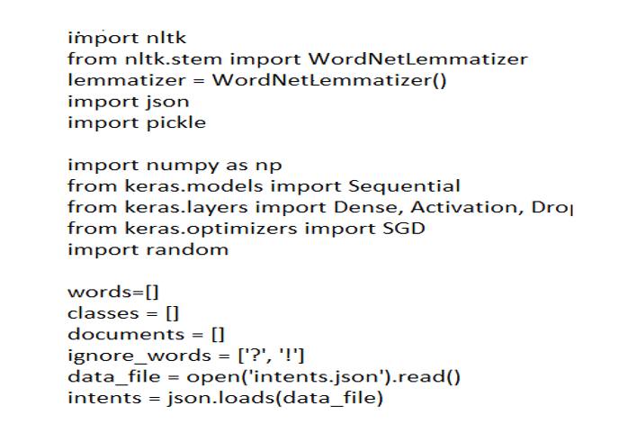
Figure 7

2. Pre-processing of Data

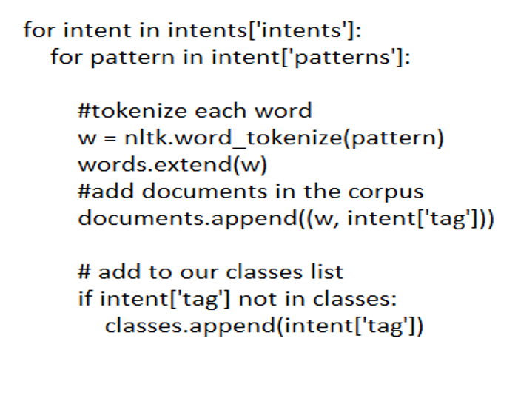
Figure 8
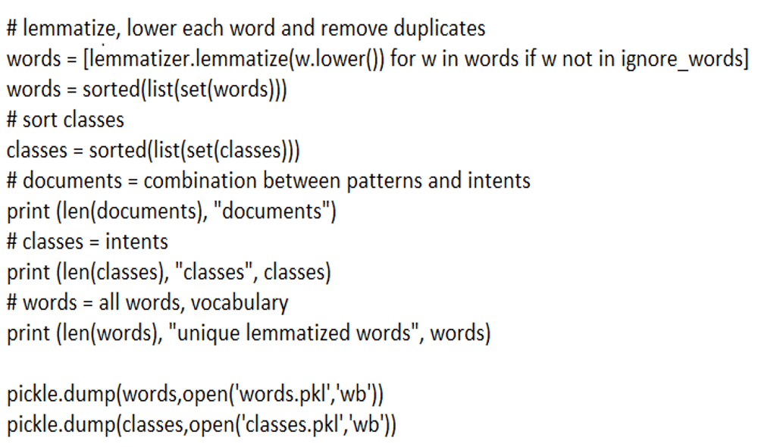
Figure 9

3. Creation of Data

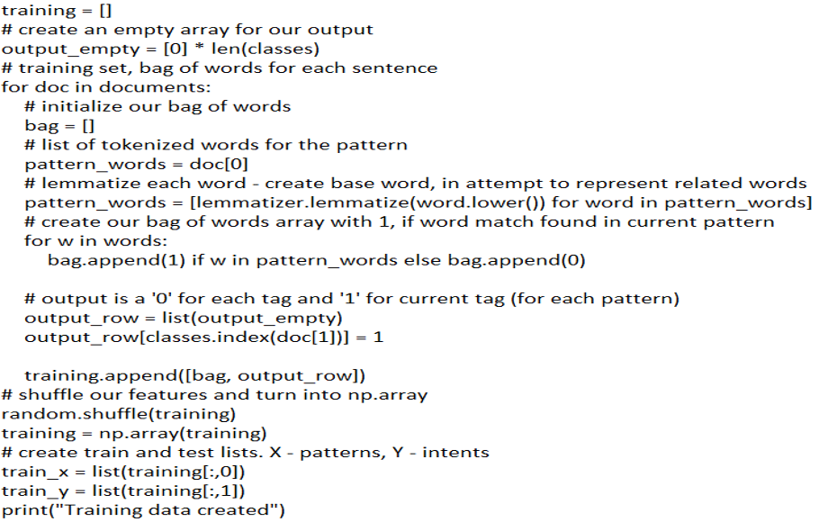
Figure 10

- Response Prediction

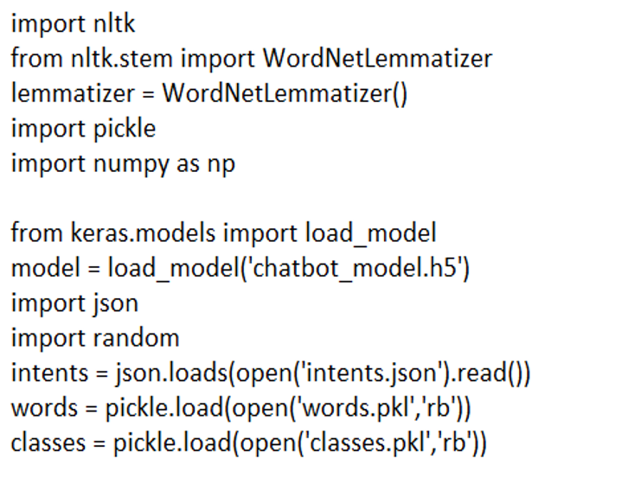
Figure 11

INTERACTING WITH THE CHATBOT MODEL
Since we have created the model successfully and trained it for 200 Epochs and achieved 100% accuracy.
The only thing left to do is interaction with the chatbot with the help of command in the terminal window:
Python chatgui.py
After the program run successfully, it will pop up a GUI window in a little time. Now user can easily interact with the chatbot and chatbot will give response to user query.

FLOW CHART
Using a flow chart that outlines the steps in a chatbot's operation, we can demonstrate how well it works. We can generate flow diagrams for each intent by making use of the dialog flows. We can better articulate and evaluate the interaction early on by creating flows.
It turns out to be a lengthy procedure with numerous back-and-forth communications and multiple steps. This additionally implies added intricacy, vulnerability, and expanded possibilities of mistake at each step.
We must supplement the conversational UI with a graphical UI interaction to update reminders. In this interaction, set reminders are always visible, and edit and cancel options are next to them.
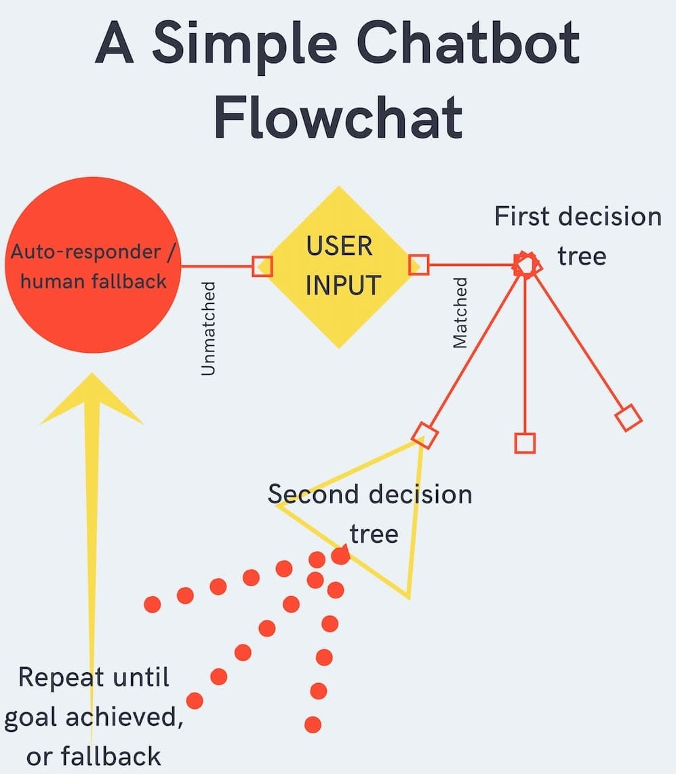
Figure 12
The above diagram shows the simple background and pre-processing of an ordinary chatbot. We can find a more interactive working of the working in the below figure. [4]
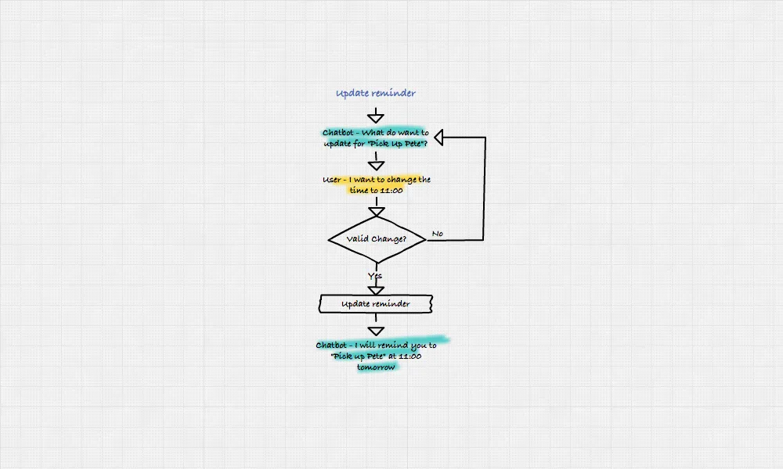
Figure 13
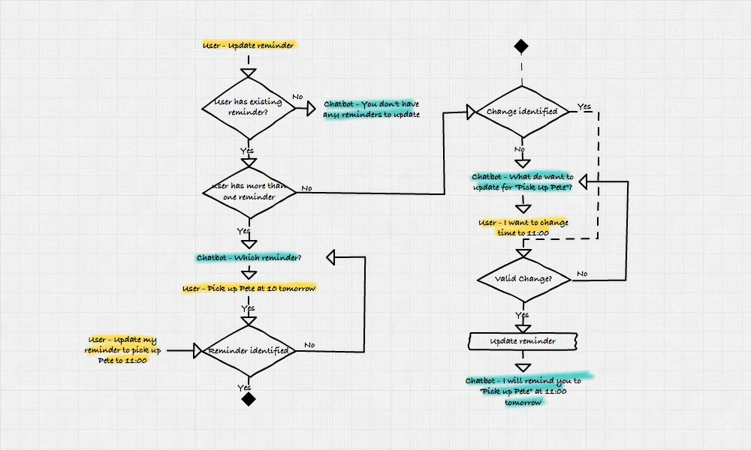
Figure 14

A user has provided input. When a user provides a keyword, the chatbot is triggered at this point.

As an illustration, we demonstrated an idea to one of the clients using a flow chatbot that used the keyword "SEO" as a trigger. When the keyword "SEO" is sent, the chatbot's initial message transforms into a comprehensive SEO course that is provided over Facebook Messenger.

A message is therefore sent by the user.

If the chatbot is unable to recognise the message, we take the left-side branch and fall back to using an autoresponder or human.

Typically, we include autoresponders, fallbacks, and finally a human fallback in every chatbot we design. A simple welcome message and a list of keywords or commands that new users might utilise make up an autoresponder.

When a user sends numerous unidentifiable inputs in a row, a fallback is typically triggered, reminding the user of the instructions they can use.

A human fallback is precisely what it sounds like, to sum up. The chatbot notifies a human to step in after several user inputs that are unrecognisable in order to encourage them to take over.

If there is a keyword in the message, the flow takes the right-side branch. Here, you may observe how the bot and its user communicate in a decision-driven manner. The user selects one of the possibilities the bot presents before presenting the next set, and so on.

At some point, the user will have either arrived at the user’s destination and discovered what they were seeking for, or the bot's fallbacks will have been used.

There it is—a flowchart showing the most basic chatbot design!

CONCLUSION
We have added fresh knowledge about the development of interactions between people and social chatbots. This research has shown that even a normal working chatbot has huge impact and benefits across various industries like economically available service, user satisfaction, reaching a demographic, reducing costs and increasing the revenue.
A chatbot can be used anywhere. The whole idea of a virtual assistant and “live agent” has help is to help increasing the efficiency and decreasing the workload. Chatbots have proved to be beneficial across various industries like Sales and Marketing, Human Resources, IT, Digital and Social Platforms.
This study, in my opinion, may help us better understand a phenomenon that will become more and more important in the future: the emergence of human-AI social chatbot relationships.

‌ REFERENCE LIST
- Adamopoulou, E. and Moussiades, L. (2020). Chatbots: History, technology, and applications. Machine Learning with Applications, [online] 2. doi:https://doi.org/10.1016/j.mlwa.2020.100006. [1]
- Amditis, J. (2017). What are some ethical considerations that chatbots raise, and how should they be addressed? [online] Medium. Available at: https://medium.com/mobilenewslab/what-are-some-ethical-considerations-that-chatbots-raise-and-how-can-those-be-best-be-addressed-7f7fed23557. [2]
- Bruno Marietto, M. das G., Aguiar, R.V., Barbosa, G. de O., Botelho, W.T., Pimentel, E., Franca, R. dos S. and da Silva, V.L. (2013). Artificial Intelligence Markup Language: A Brief Tutorial. International Journal of Computer Science & Engineering Survey, [online] 4(3), pp.1–20. doi:https://doi.org/10.5121/ijcses.2013.4301. [3]
- Debecker, A. (2017). A Simple Chatbot Flowchart. [online] blog.ubisend.com. Available at: https://blog.ubisend.com/optimise-chatbots/simple-chatbot-flowchart. [4]
- Gasson, S. (2009). Employing a Grounded Theory Approach for MIS Research. Handbook of Research on Contemporary Theoretical Models in Information Systems, pp.34–56. doi:https://doi.org/10.4018/978-1-60566-659-4.ch003. [5]
- Gentner, T., Neitzel, T., Schulze, J. and Buettner, R. (2020). A Systematic Literature Review of Medical Chatbot Research from a Behavior Change Perspective. 2020 IEEE 44th Annual Computers, Software, and Applications Conference (COMPSAC). doi:https://doi.org/10.1109/compsac48688.2020.0-172. [6]
- Grudin, J. and Jacques, R. (2019). Chatbots, Humbots, and the Quest for Artificial General Intelligence. Proceedings of the 2019 CHI Conference on Human Factors in Computing Systems. doi:https://doi.org/10.1145/3290605.3300439. [7]
- Moorjani, Y. (2017). Designing chatbots. [online] Medium. Available at: https://uxdesign.cc/how-to-design-a-robust-chatbot-interaction-8bb6dfae34fb.
[8]

- Ramesh, K., Ravishankaran, S., Joshi, A. and Chandrasekaran, K. (2017). A Survey of Design Techniques for Conversational Agents. Communications in Computer and Information Science, [online] pp.336–350. doi:https://doi.org/10.1007/978-981-10-6544-6_31.
[9]

- Ranoliya, B.R., Raghuwanshi, N. and Singh, S. (2017). Chatbot for university related FAQs. 2017 International Conference on Advances in Computing, Communications and Informatics (ICACCI). doi:https://doi.org/10.1109/icacci.2017.8126057.
[10]

- Rice Mcaulay, J. (2022). What Problems Does A Chatbot Solve? | Kindly. [online] www.kindly.ai. Available at: https://www.kindly.ai/blog/what-problem-does-a-chatbot-solve.
[11]

- Ruane, E., Birhane, A. and Ventresque, A. (2019). Conversational AI: Social and Ethical Considerations. [online] Available at: https://ceur-ws.org/Vol-2563/aics_12.pdf. [12]

- Sagstad, M.H., Morken, N.-H., Lund, A., Dingsør, L.J., Nilsen, A.B.V. and Sorbye, L.M. (2022). Quantitative User Data From a Chatbot Developed for Women With Gestational Diabetes Mellitus: Observational Study. JMIR Formative Research, 6(4), p.e28091. doi:https://doi.org/10.2196/28091. [13]
- Tucker, K. (2017). A Chatbot Abstract. [online] Medium. Available at: https://chatbotslife.com/a-chatbot-abstract-1cd002e7a480. [14]
- Wallace, A. (2021). The Top 10 Chatbot Evaluation Metrics. [online] Netomi. Available at: https://www.netomi.com/chatbot-evaluation-metrics [Accessed 25 Apr. 2023]. [15]
- Wolfswinkel, J.F., Furtmueller, E. and Wilderom, C.P.M. (2013). Using grounded theory as a method for rigorously reviewing literature. European Journal of Information Systems, 22(1), pp.45–55. doi:https://doi.org/10.1057/ejis.2011.51. [16]
‌

