GIS ASSIGNMENT 2

Sabrina Abdul Malek

Contents
1.0 Location-based Services 2
2.0 Data Collection & Data Preparation 3
3.0 Description of Spatial Data Sets 9
4.0 Layers Development 10
5.0 Conclusion 15
6.0 References 16

Table of Figures
Figure 1 3
Figure 2 4
Figure 3 5
Figure 4 5
Figure 5 6
Figure 6 6
Figure 7 7
Figure 8 8
Figure 9 8
Figure 10 10
Figure 11 11
Figure 12 12
Figure 13 13
Figure 14 13
Figure 15 14
Figure 16 14

Location-based Services
Location-Based Services (LBS) are services offered using geographical location. It is usually used to provide precise information. It is typically heavily dependent on a user’s location when used on mobile devices. LBS are commonly applied in “local news, directions, points of interest, directory assistance, fleet management, emergency, asset tracking, location-sensitive building, and local advertisement” [1]. It could be used to specify a person’s location through their mobile devices, or could be an advertisement medium. Using GPS satellites enhances LBS applications in real world.
There are different types of LBS and their functionalities. First is as stated above, using mobile devices and their location to provide information. Another type of LBS is integration with a digital map. It is called map services. It is a map with street network. After providing information, this map becomes capable of becoming different types of services. It could be a city guide service, a navigation service, or in this task, a public service.
LBS is closely related to Geographic Information Systems (GIS). Software standardization in data transfer from a database of geolocation makes geoprocessing possible. In developing LBS, GIS considers the data collection and conversion. Coordinates integrate with GIS in order to convert them into a map service. Geographic data can be transferred and processed easily. Spatial data processing using GIS analysis tools is made possible for LBS. GIS analysis is “making a major transition from simple geometry and topology-based analysis tools towards more advanced computational methods” [2]. Location-based services can gain from GIS analysis.

Data Collection & Data Preparation

While choosing schools for children, parents are most concerned about the location of the school. Apart from that, other contributing factors such as its safety and health issues affect the decision as well. Children are exposed to many things these days. A lot of factors contribute to a child’s growth. Hence, it is important for parents to choose the right school for their children. Different data were collected in order to inform parents of schools around Swansea.
The name of every school in Swansea was obtained to provide basic information of the schools. Data for secondary schools around Swansea were collected from the Swansea Council website. Full list of secondary schools in Swansea is available on the website, with additional information such as the school’s website, their contact details, their emails, their phone numbers, and their social media platforms.

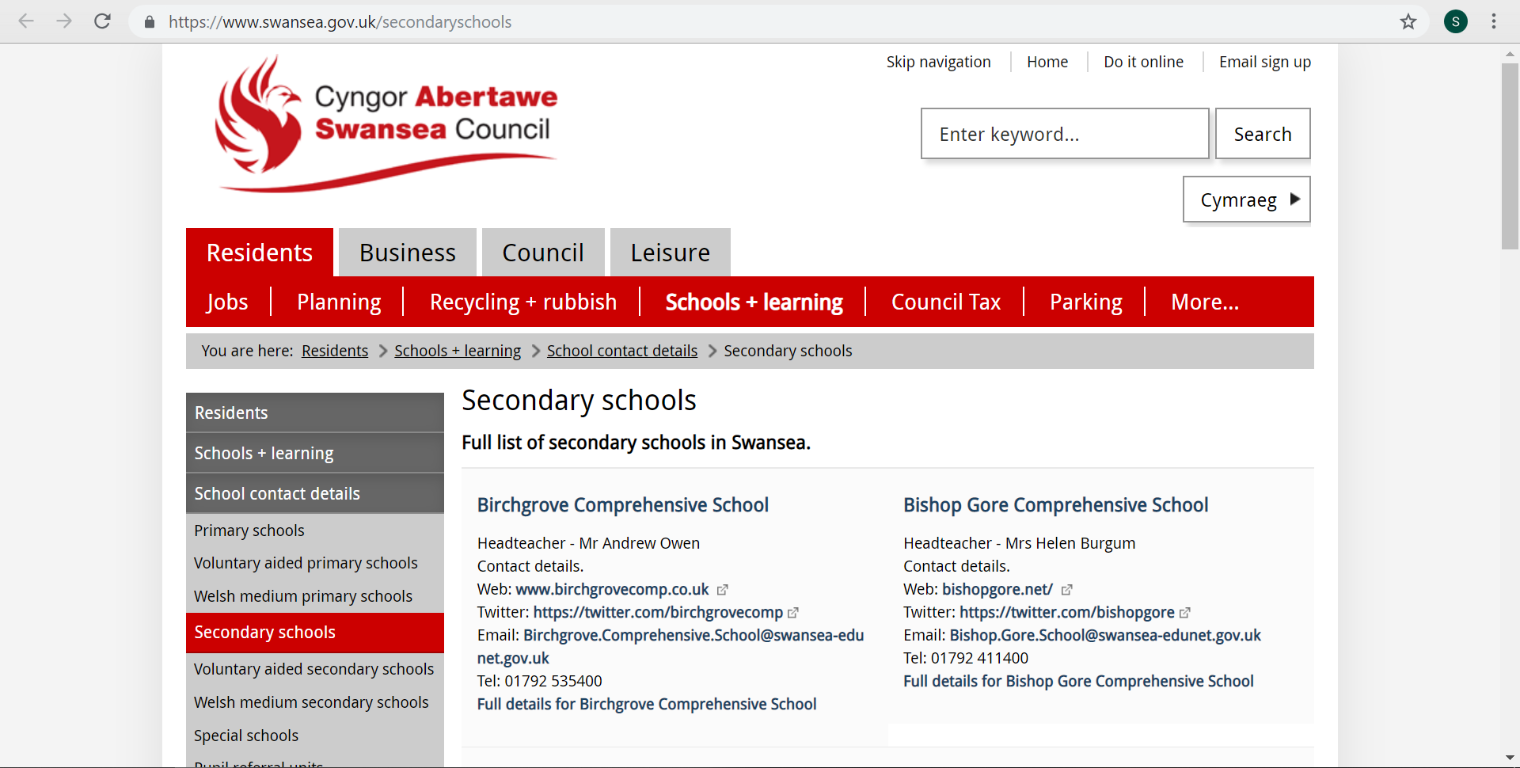
Figure 1

The name of every secondary schools in Swansea was copied into a spreadsheet to store the information. In order to obtain data for GIS, the location of each school must be known. The addresses of each school were obtained through Google Maps. All schools’ names were copied into Google Maps one by one to generate the full address. The postcodes are then taken from the addresses to get the coordinates of each school. The postcodes are also stored in the same spreadsheet as the names of each school.
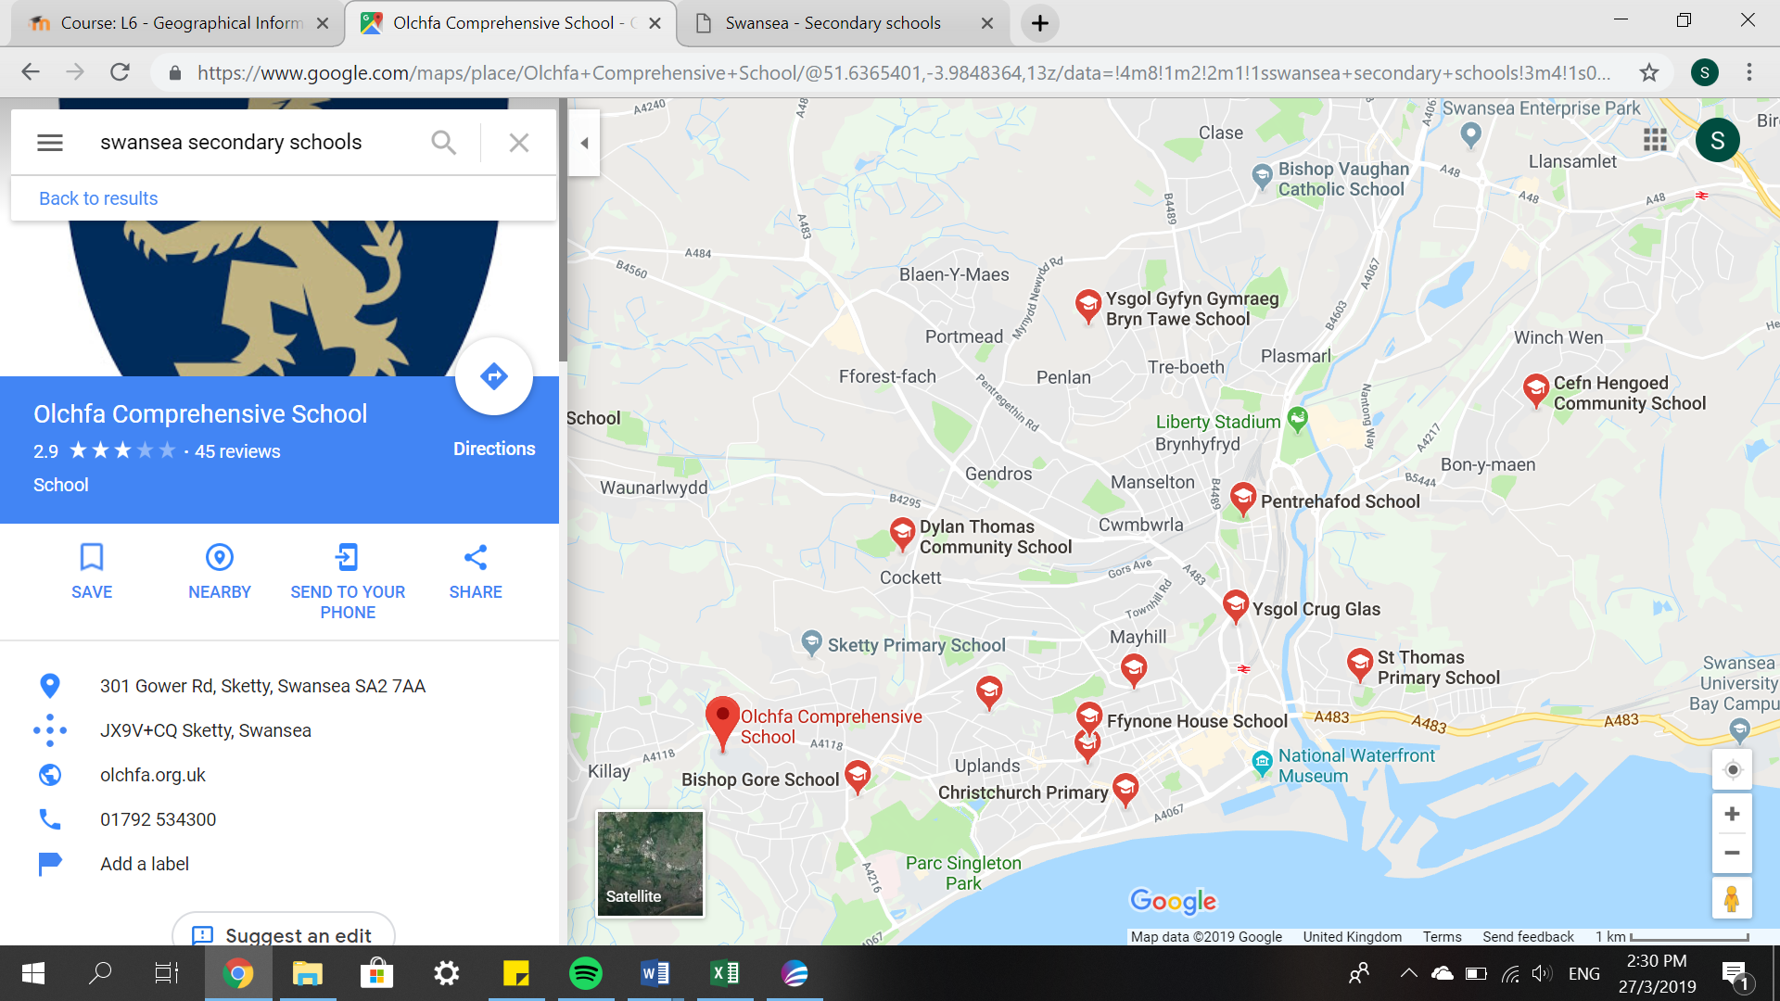
Figure 2

Once the postcodes are retrieved, we can proceed to the next step, converting them into coordinates. The postcodes can determine the longitude and latitude of each school through an online converter. ‘FreeMapTools’ is an online website that provides conversion from postcodes to latitudes and longitudes. All schools’ postcodes were copied into the website and their latitudes and longitudes were generated. Then, the coordinates were stored in a spreadsheet. Figure 3 shows the online converter tool.
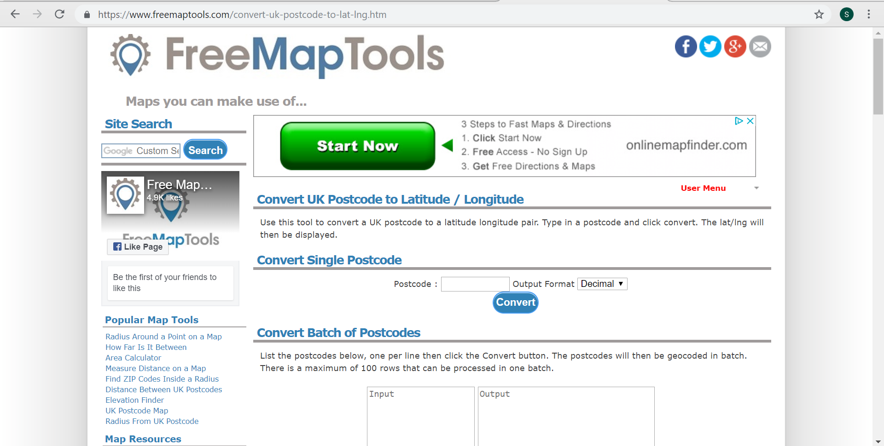
Figure 3
More data was collected in order to help parents to make better decisions. Supporting data was obtained from My Local School website under the Welsh Government. Figure 4 shows mylocalschool.wales.gov.uk website.
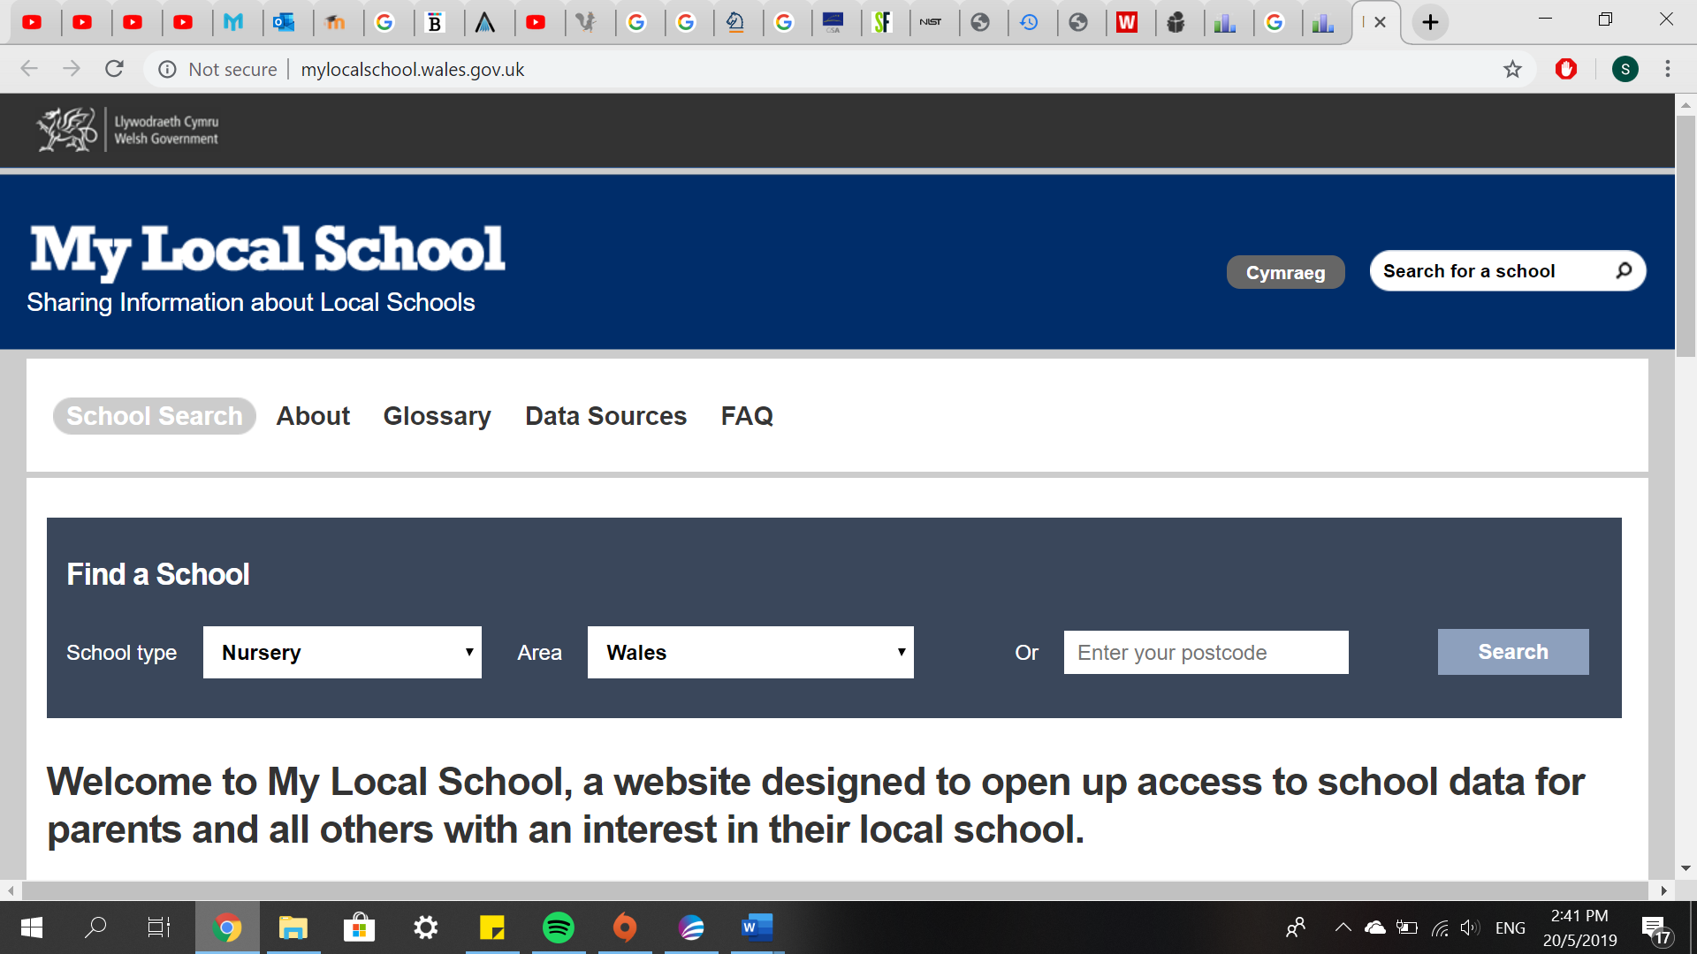
Figure 4
Data collected about secondary schools around Swansea with additional data describing each school. Different categories of data were obtained to provide more information in order to support parents’ decisions in choosing schools. Figure 5 shows information about Birchgrove School. Important information such as age range, gender mix, and language were then extracted from the website to be inserted into a spreadsheet.
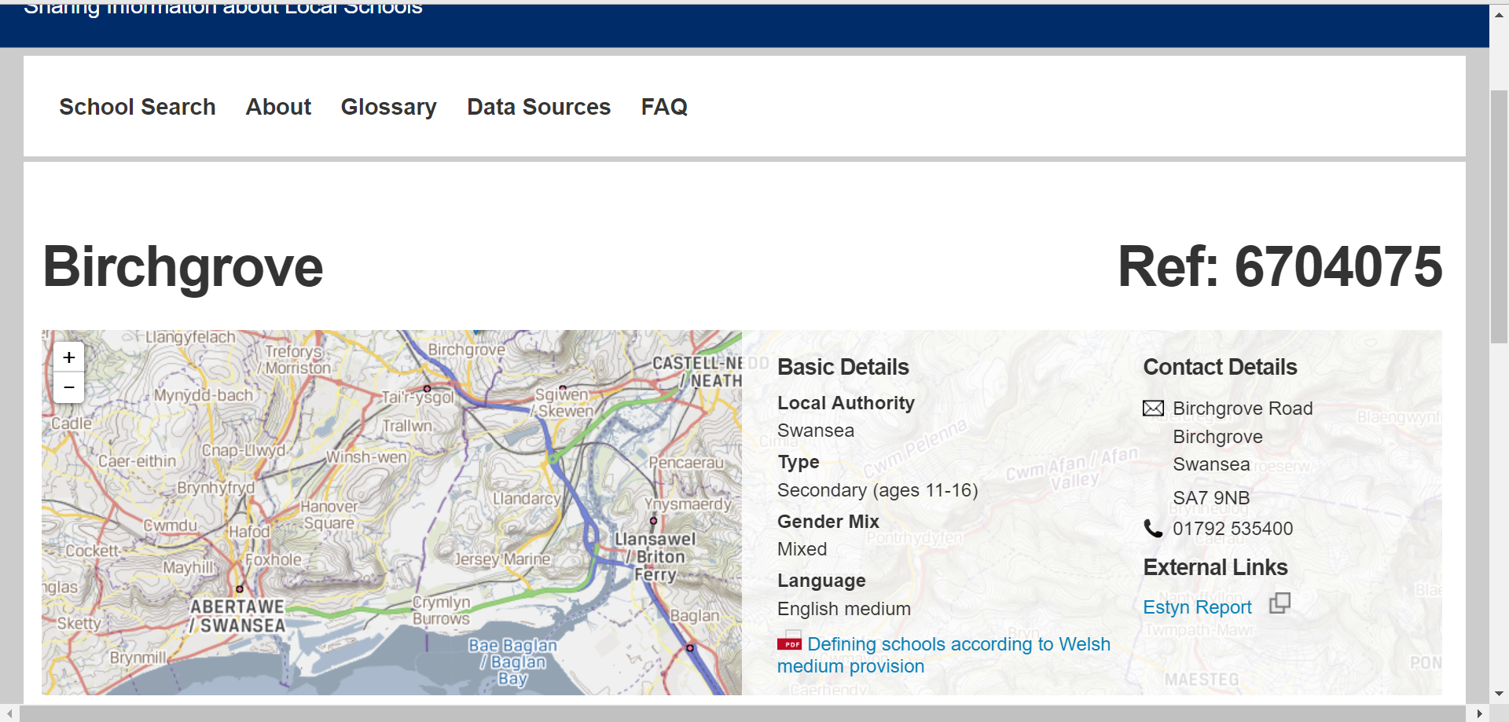
Figure 5

Apart from the basic details, the website also provides more information about each school. This information can be used to enhance parents’ knowledge and decision-making. This information includes; number of pupils, percentage of free school meals given, pupil teacher ratio, school budget per pupil, average capped 8 points score, average capped 9 points score, number of pupils eligible for free school meal, and number of pupils not eligible for free school meal.
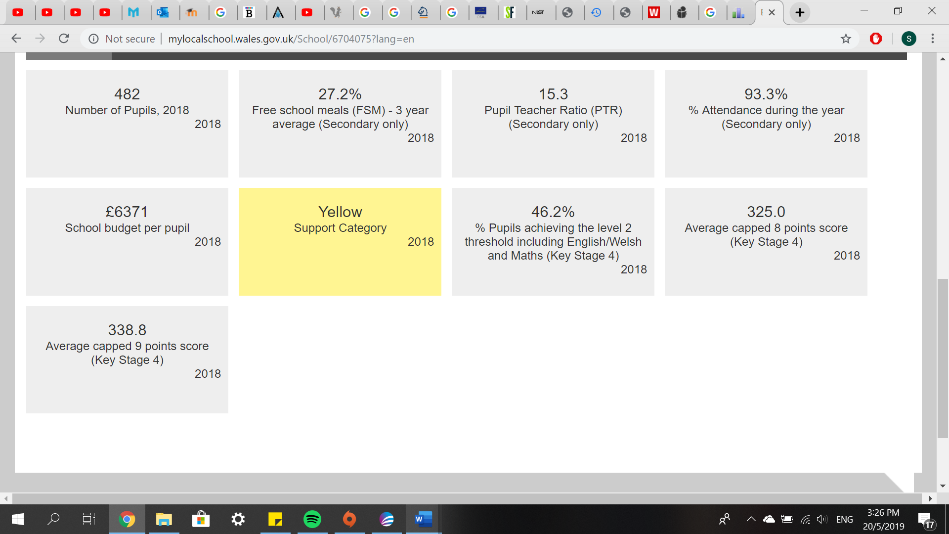
Figure 6
All data gathered from different websites were imported into the same spreadsheet. This spreadsheet also includes the postcode, latitude and longitude in order to display the data as a layer on MapInfo. Figure 7 shows the spreadsheet named ‘data for gis spring 2019 revised’ containing all data gathered.
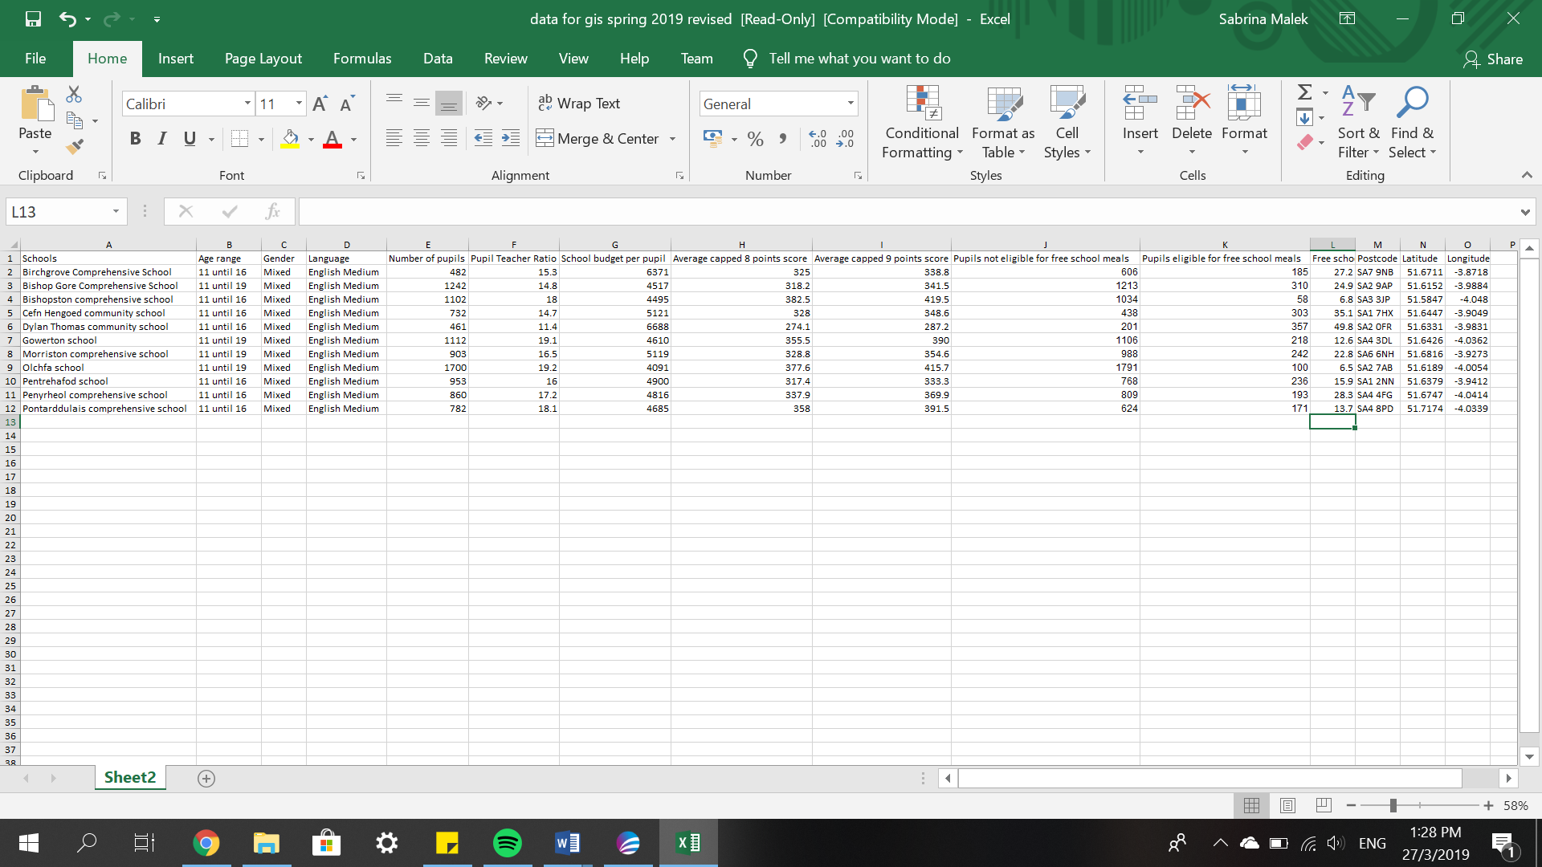
Figure 7
The local health board wished to build a service to inform not only parents, but also healthcare professionals about school locations and its areas. Therefore, to increase the effectiveness of this service, locations of health centres around the area is added into GIS. Names and locations of health centres were obtained from www.nhsdirect.wales.nhs.uk/LocalServices/Default.aspx. NHS Direct Wales provide information about every General Practitioner (GP), hospitals, pharmacies, dentists, and eye care location around Swansea. Figure 8 shows the information available on the website.

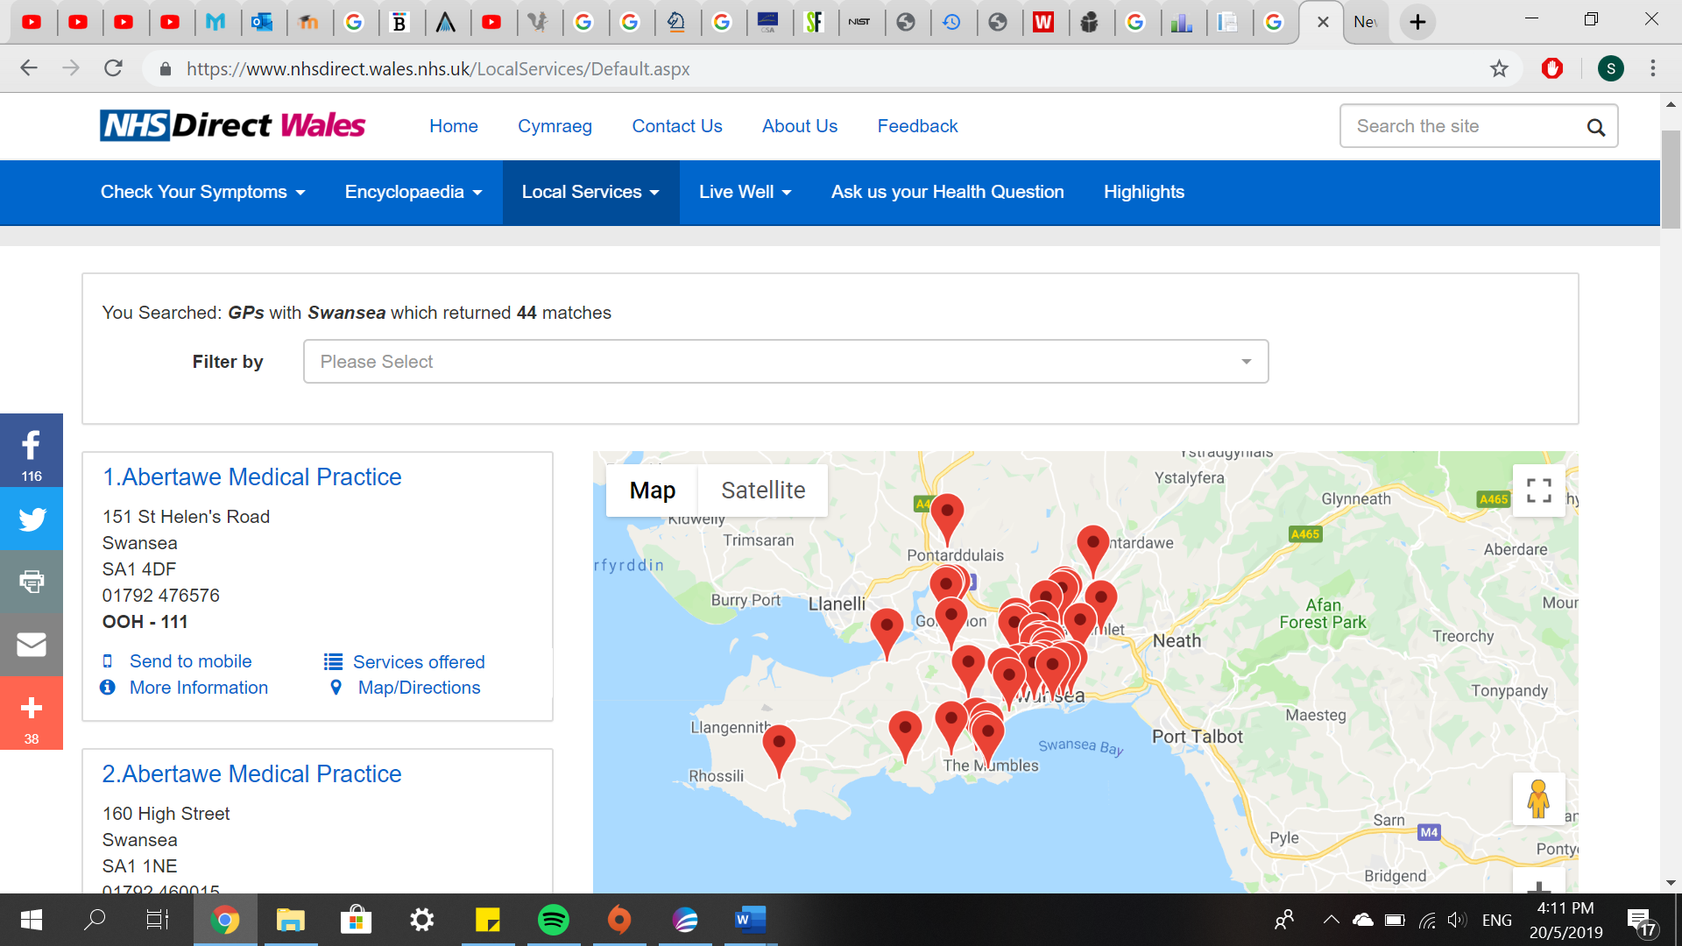
Figure 8
All health centres nearby the schools are significant and must be included in the service. Names and locations of these health centres are extracted and imported into a different spreadsheet. A spreadsheet named ‘health centre data’ containing health centres data are shown in the figure below.
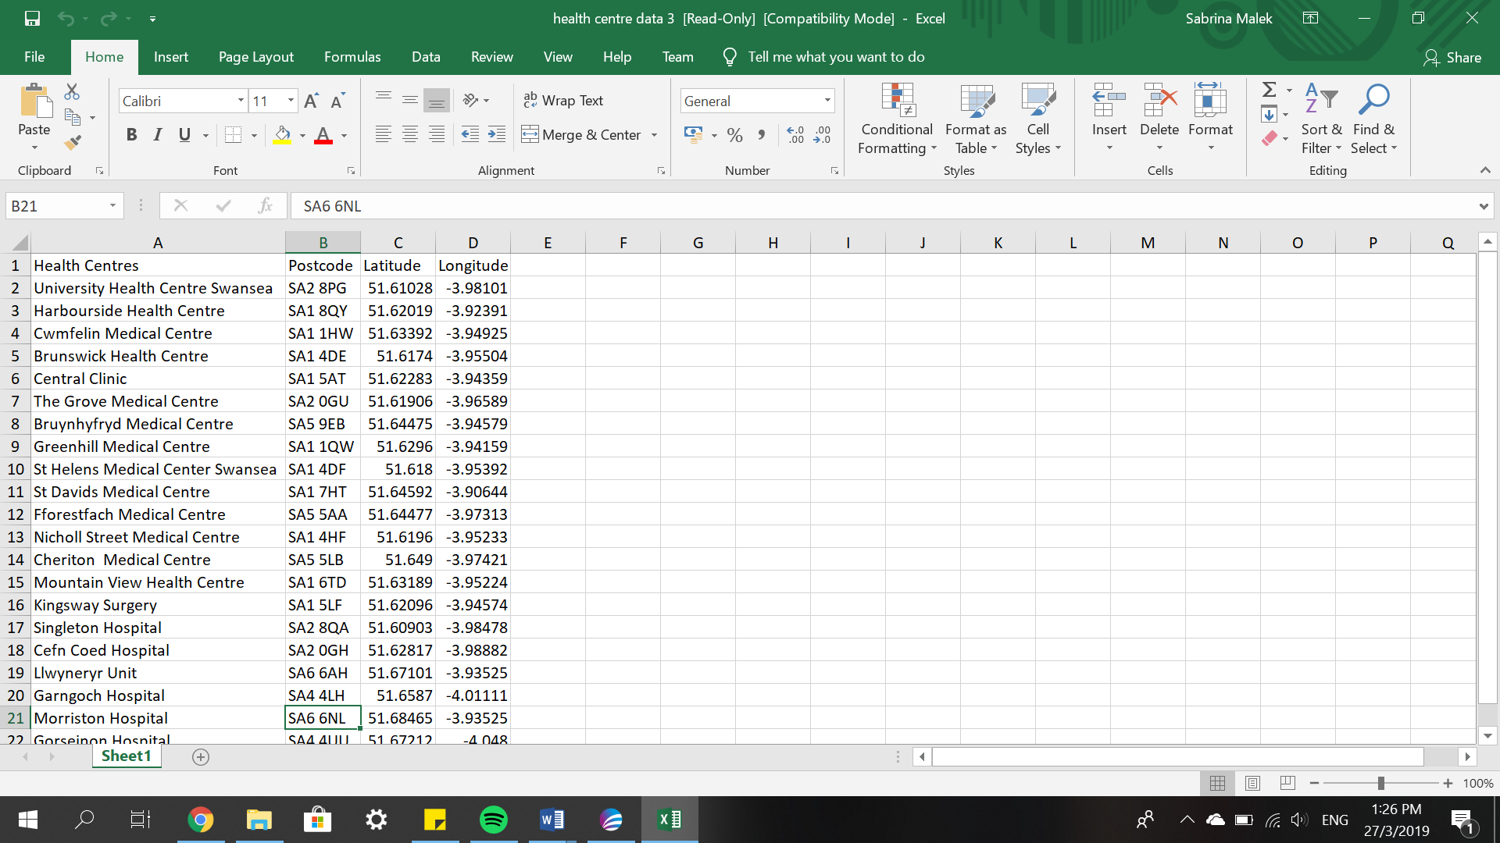
Figure 9
Both spreadsheets were then imported into MapInfo.

Description of Spatial Data Sets

The supporting data was gathered to improve parents’ information of each school. Several data were considered important in informing parents and healthcare professionals. These data include age range, gender, language, number of pupils, pupil to teacher ratio, school budget per pupil, average capped 8 points score, average capped 9 points score, number of pupils not eligible for free school meals, number of pupils eligible for free school meals, and percentage of free school meals given in each school. Age range in a school determines the age appropriate to receive education and education level in that school. The gender and language of each school are provided as basic details of the school. Number of pupils in each school determines the concentration of the school. Pupil to teacher ratio gives parents an impression of how much attention a student gets from their teacher, and how it affects the student positively. School budget per pupil shows how much per-pupil funding is available in each school. Performance measures for every school can be determined using average capped 9 points score or average capped 8 points score, which is the science indicator for GCSE. If any parent receives income-based benefit, it is possible for the child to get free school meals. If there are a lot of free school meals given in a school, it can be concluded that the area is a deprived area.
Apart from the schools’ attribute details, health centres data around Swansea was gathered to make the map more effective. All health centres nearby schools within the study area were taken into consideration. These health centres names and locations were added into the spreadsheet. This allows parents to rely on nearby health centres for their children’s health during school. There have been a few cases about children falling sick in school. Without immediate treatment, the sickness could be fatal. This matter concerns all parents, especially working parents. Once immediate proper treatment is accessible within a short amount of time, parents will not have to worry about their children’s health. Healthcare professionals need to be informed of any schools within their area, in case if any emergency happened. Therefore, the location of health centres around Swansea is beneficial for both parents and healthcare professionals.

Layers Development

Areas that are of low immunization uptake have been displayed in a map that was developed for coursework 1. This map contains Townsend Index and meningitis data for areas around Swansea. Townsend map is used as the base map using thematic mapping – grid. Areas that are marked red indicates a more deprived area, while areas that are marked blue indicates less deprived areas. Data collected for meningitis is displayed as a layer (star shape) on the map. The shade of stars indicates the average number of people vaccinated with Haemophilus Influenzae type B (HIB). Figure 10 shows the map developed in the workspace.
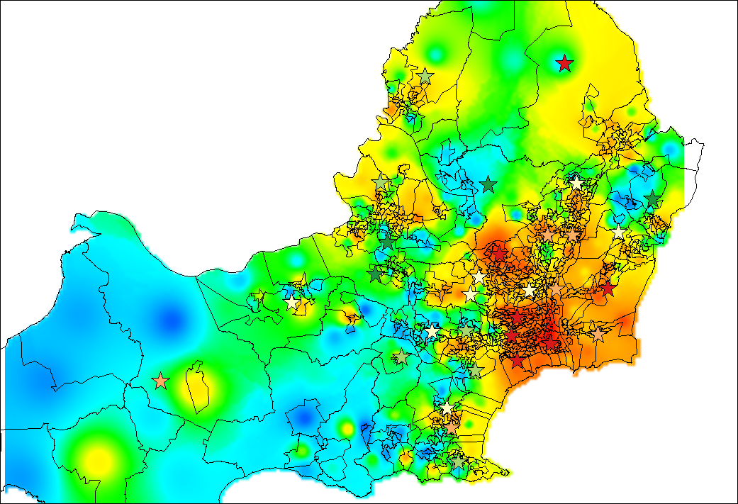
Figure 10
Once the map is developed in the workspace, data collected earlier can be added as layers. Data from spreadsheet ‘data for gis spring 2019 revised’ was imported into the workspace. Layers were then added according to the effectiveness of each data. Figure 11 shows the workspace with townsend map, meningitis vaccination data, and school data.
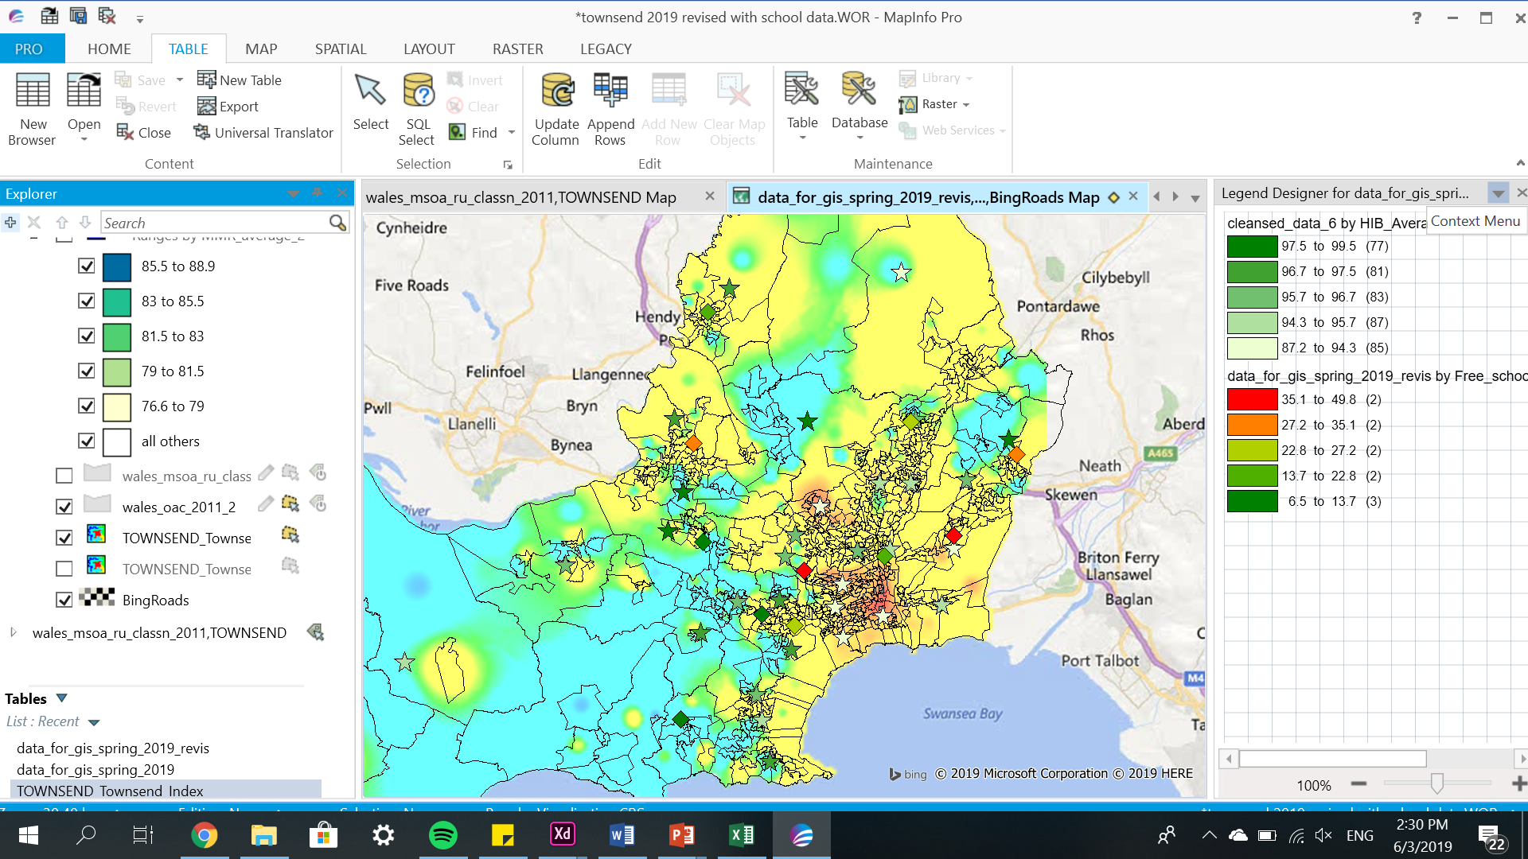
Figure 11
The data was able to be displayed using create point feature. The location of schools were added as a layer after points were created. Diamond shapes show the schools’ locations. The shade of each of the diamonds indicate the percentage of free school meals given in that school. Diamonds that are shaded red indicates that the school has high percentage of free school meals given to its pupils. As the shade converts to a greener hue, the percentage of free school meals given to that school’s pupils decrease.
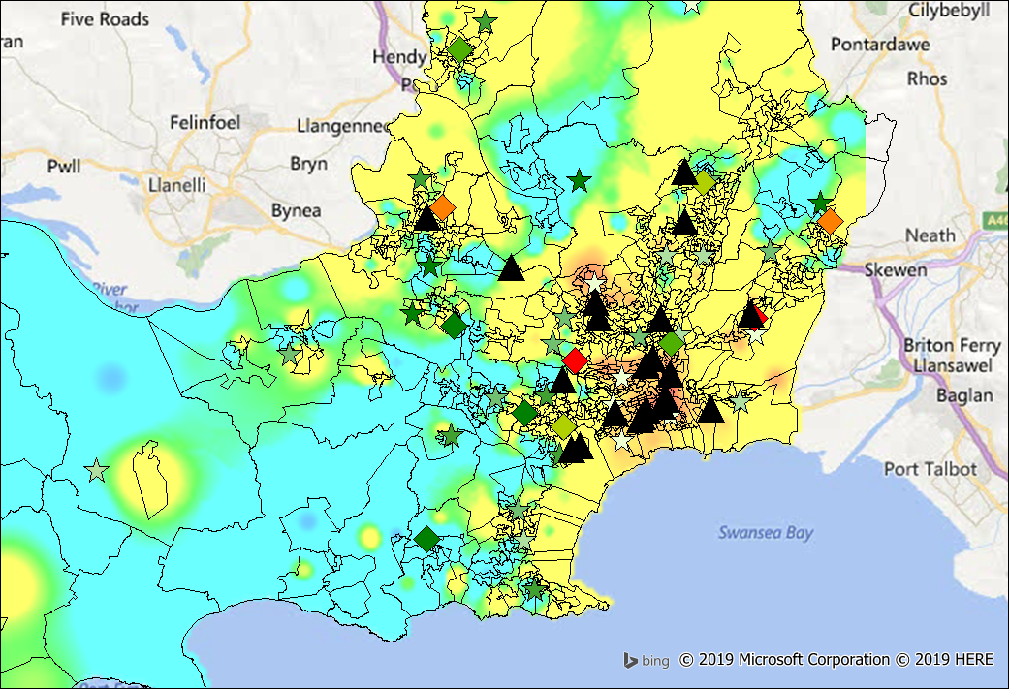
Figure 12
The spreadsheet containing locations of each health centres were imported into the workspace. A layer was added into the workspace to show the location of health centres nearby each school. The location of the health centres can be determined by the triangular shapes shaded black on the map.
Once the GIS is developed, LBS system can be constructed. An add-on software platform called MapBasic was added to create an interactive GIS. MapBasic was used to create additional tools and functionality in MapInfo. It enables the creation of electronic mapping within GIS.
MapInfo2Leaflet is a tool that enables a MapInfo Table to be exported into a web page. An HTML file, a JSON file and CSS files will be produced. Thematic layers can be exported as well.

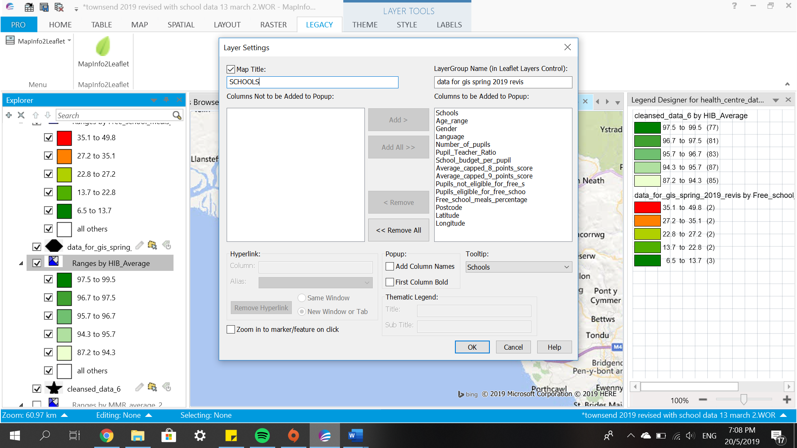
Figure 13

Figure above shows the process of exporting a MapInfo Table into a web page. After clicking ‘OK’, an output folder for html file will be created. Figure below shows the output. Arrows pointing to different places indicate the location of each schools.
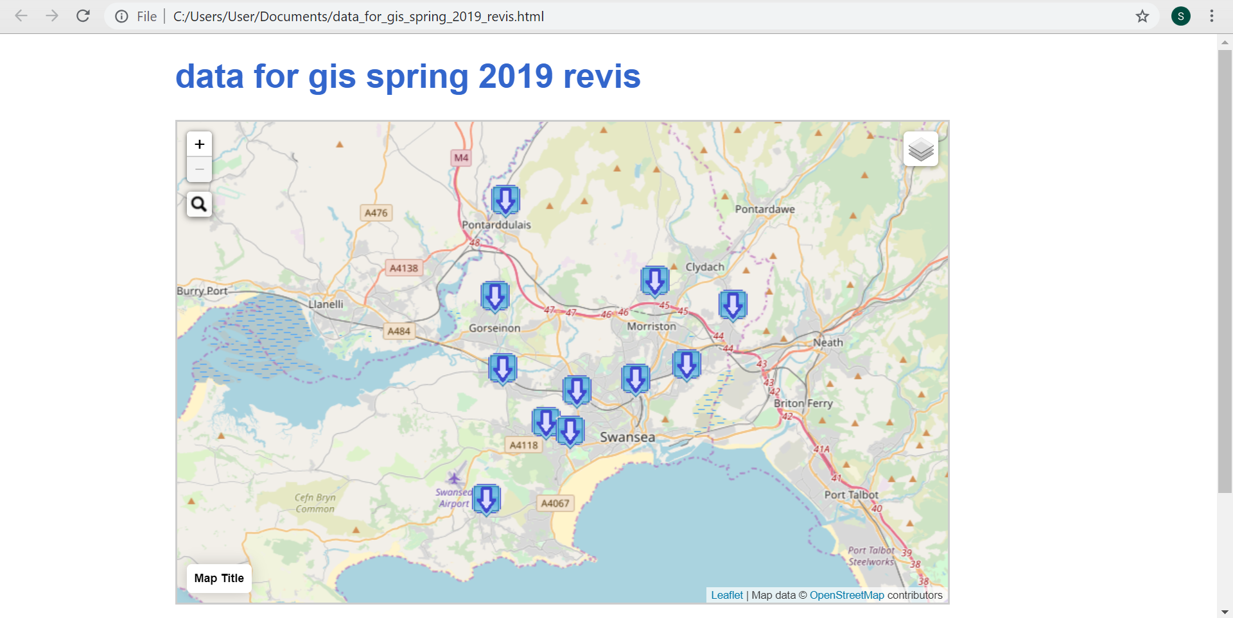
Figure 14

Figure below shows the map generated in HTML. Figure 15 shows the output. This feature generates landing pages for all schools. The image allows users to click on each school’s location or points. A new page will be generated, and it will show every important attributes of the school.
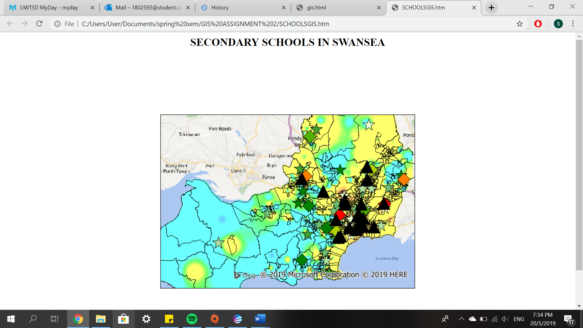
Figure 15

The output generated was then modified in Notepad. It was edited to make the pages more presentable.

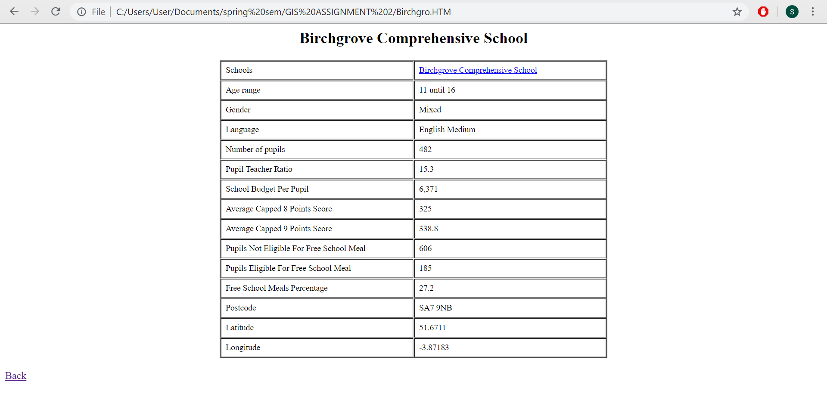
Figure 16

Conclusion

After implementing both LBS and GIS, the local health board can provide public service information. Parents and healthcare professionals will be aware of schools around the Swansea that are in areas of low immunization uptake. Using Townsend map as the base, it allows the audience to be informed of deprived areas around Swansea. Shades of star shapes on the map show how many people received the HIB immunization. This can help the public to focus on low immunization uptake areas. Locations of comprehensive schools around Swansea are marked with diamond shape. Shades of each diamond shapes shows how many number of pupils receive free school meals. The map generated will show locations and attribute details of all comprehensive schools within Swansea. It is interactive, providing all information needed in order to inform parents and healthcare.

References
- “What are Location Based Services (LBS)? - Definition from Techopedia,” Techopedia.com. [Online]. Available: https://www.techopedia.com/definition/12888/location-based-services-lbs. [Accessed: 19-May-2019].
- K. Virrantaus, J. Markkula, A. Garmash, V. Terziyan, J. Veijalainen, A. Katanosov, and H. Tirri, “Developing GIS-supported location-based services,” Proceedings of the Second International Conference on Web Information Systems Engineering.

