ENVIRONEMENTAL IMPACT ASSESMENT STUDY REPORT PROPOSED FOR THE CONSTRUCTION OF THE
JAYNE PIERSON SCHOOL OF FASHION, ART & DESIGN

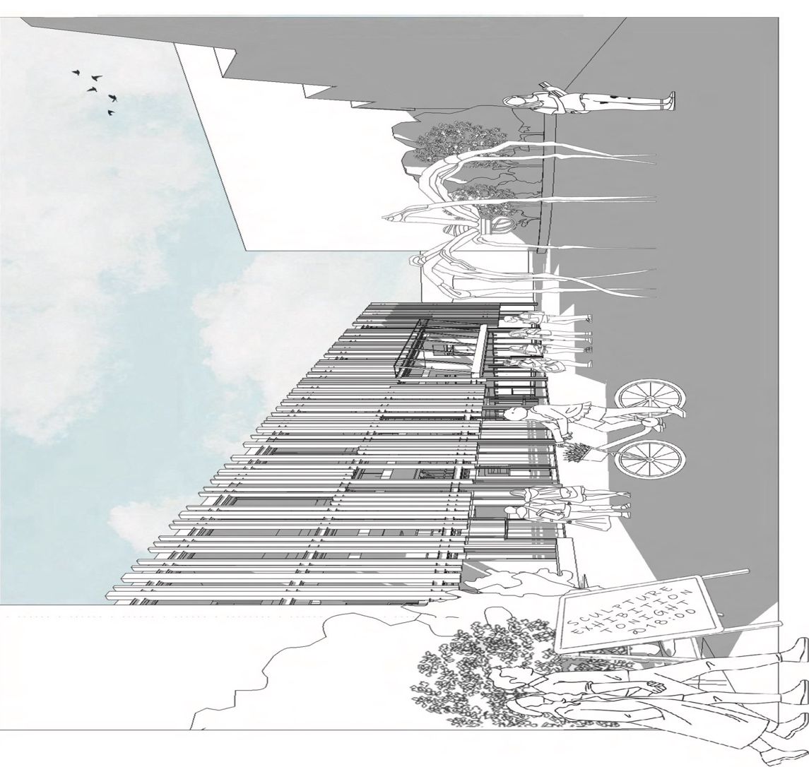

Prepared by: Alpha Designs


Table of Contents
1 INTRODUCTION 3
2. PROJECT DESCRIPTION 4
3. Site Location and History 4
4 REGULATIONS 5
5. ENVIRONMENTAL IMPACT ASSESSMENT SUMMARY AND THE MITIGATION PRACTICES. 6
5.2 Water Resources 6
5.3 Noise Pollution (Vibration) 7
5.4 Air Quality 7
7. SIGNIFICANCE RATING 8
6. CONCLUSION 9

1 INTRODUCTION

This Environmental Impact Assessment (EIA) report aims to investigate the potential environmental implications of establishing a new school facility within Port Talbot. As education remains vital in promoting social development, the proposed school seeks to provide a environment for learning, inclusion of the public while considering the ecological integrity of its surroundings.

As the primary source of project details and objectives, the information presented in this Environmental Impact Assessment (EIA) is based on findings derived from the feasibility report for the proposed college construction project. The feasibility report served as the foundational document, providing crucial insights into the project's scope, objectives, and design considerations as well as the Environmental factors located in Chapter 1 part F.

The proposed project involves the construction of a new building in Port Talbot, Wales. Construction activities will include site preparation, foundation laying, building erection, and interior fitting.

2. PROJECT DESCRIPTION

The proposed development involves the construction of a three-story educational facility as a second phase of the existing Port Talbot College. The building will include classrooms, studios, exhibition spaces, and facilities for Jayne Pierson's fashion business. The project also entails the creation of a sculpture garden and collaboration spaces with adjacent creative studios. Funding for the project will be provided by ACE Capital Projects LTD, the Arts Council for Wales, and Jayne Pierson.

This initiative aligns with the community’s educational needs and aspirations, aiming to enhance access to quality education in the fashion industry while fostering a vibrant and inclusive learning environment.

3. Site Location and History

The project site, formerly a car park, is in an urban area with many historical transformations over the years. Historic maps indicate past railway tracks and housing developments which can be found in the location report in chapter 1 section B. Site investigations reveal potential contamination due to past industrial activities, including steelmaking. Recommendations include further assessment of soil and groundwater conditions which will be discussed in the ground investigation report.

4 REGULATIONS

Town and Country Planning (Environmental Impact Assessment) Regulations 2017 (Wales) outline the procedures for conducting EIAs for certain projects.

With the site being near the Afan river and near two (2) churches it highlights some factors indicating that the project is well within to scope to operate under Town and Country Planning (Environmental Impact Assessment) Regulations 2017 Wales regulations.

The project is also in accordance with the Environmental Management and Coordination Act (EMCA) 1999 and the Environmental (Impact Assessment) and Audit regulations 2003 which requires that every development project must have an EIA report prepared for submission to the National Environmental Management Authority (NEMA).

Based on the findings found in the Environmental Impact Assessment Report here is a summary on the main aspects that are affected:

5. ENVIRONMENTAL IMPACT ASSESSMENT SUMMARY AND THE MITIGATION PRACTICES.

5.2 Water Resources

Runoff stemming from the construction site has the potential to transport sediment and contaminants into nearby waterways (The Afan River) which can affect the water quality and cause harm to the aquatic population living in the river. The runoff into the river can have a knock-on effect on the biodiversity located within the river.

Implementation of stormwater management practices to capture and treat runoff before it is discharged into water bodies (use of sedimentation basins to capture sediment and allow it to settle out before discharging clean of less contaminated water).

Appropriately schedule construction activities to minimize the risk of high runoff therefore paying attention to the weather forecast in the area is quite important. Where there is forecast for heavy rainfall earthwork activities should be avoided can help reduce the potential for runoff and erosion.

5.3 Noise Pollution (Vibration)

Construction activities generate noise, potentially impacting nearby residents and wildlife. Notifying nearby residents and stakeholders in advance of planned construction activities that may generate noise or vibration such as management of the Carmel Bethany Presbyterian Church which will remain open during construction providing information on the timing, duration, and nature of the activities, as well as any mitigation measures being implemented to minimize impacts.
Careful selection of equipment and machinery that are designed to minimize noise and vibration emissions. Choose equipment with low noise ratings and vibration-damping features to reduce the overall impact on the surrounding environment.

5.4 Air Quality

Construction activities create dust and emissions, leading to air quality deterioration and pose health risks to workers and nearby residents.

Mitigation measures such as dust suppression methods such as enclosing construction area within temporary enclosures to contain dust discharge. Installing temporary barriers or screens around high-dust actions, such as earthworks or demolition, can help lessen the amount of dust spreading to neighbouring areas and compliance to emission standards will be applied to reduce air pollution. Additionally, scheduling of activities to minimize dust-generating operations during periods of high wind velocity will be considered.

7. SIGNIFICANCE RATING

Air Quality - High Significance: Air quality is a crucial aspect that directly affects the health of humans and the environment. Construction activities often lead to emissions and dust, which can have significant impacts on air quality in the surrounding areas.

Water Resources - High Significance: Water resources are important for ecosystems and human well-being. Construction runoff can introduce pollutants into water bodies, affecting water quality and aquatic life. Protecting water resources is critical for sustainability.

Biodiversity - High Significance: Biodiversity is essential for ecosystem functioning, maintenance, and reproduction. Construction activities can disrupt habitats and threaten biodiversity, making it crucial to assess and mitigate these impacts.

Noise Pollution - While noise pollution can impact human health and wildlife. Mitigation measures are important, but the severity of impact may not always be as high as other factors.

6. CONCLUSION

The construction of a new building in Port Talbot, Wales, presents both opportunities and challenges in terms of environmental impact. By implementing hands-on mitigation measures, adhering to environmental regulations, and embracing sustainable development strategies, the project can minimize its environmental footprint and contribute to the long-term welfare of the local ecosystem and community.

