LEVEL 4

SEMESTER 2

MODULE CODE: SHSS4079
FACILITATING ADVENTUROUS ACTIVITIES
ASSESSMENT TYPE: ASSIGNMENT
Assessment/Component: 2

COMPONENT WEIGHTING: 50%

WORD COUNT: 1500 WORDS

MODULE TUTOR: JON HAYLOCK

Task – LESSON PLANNING

Individually, students are to plan a 1-hour adventurous activity session for a group of primary school children. The annotated lesson plan, should provide a brief justification for the decisions made in the planning process, including choice of appropriate teaching/facilitation style(s). A portion of the grade will be awarded with regards the suitability of the plan for its “real world” application. Additionally students must produce a risk assessment to accompany the lesson plan.

Therefore, the final submission should contain:
- A lesson plan – annotated with justifications for the decisions made.
- A risk assessment for the lesson plan.

SUBMISSION DETAILS: 3pm - 1st May 2020

School of Sport, Health & Outdoor Education

Assessment Feedback Sheet

Student No./Name: Macey Bowen
Module: Facilitating Adventurous Activities
Module Code: SHSS4079

Personal Evaluation – to support your academic progress please complete the section below BEFORE submitting your work.
What do you consider to be the best aspects of this work? |  |  | I think my overall lesson plan is good as I have justified my decision during the activities.
Which aspects do you consider could have been improved in this piece of work? |  |  | I think my risk assessment could have been more specific to my activities.
What have you found most satisfying whilst undertaking this submission? |  |  | I have enjoyed looking at the different problem solving games in order to integrate the children.

ASSESSMENT CRITERIA | Learning  Outcomes |  | GRADE
ASSESSMENT CRITERIA |  |  | Poor  < 20% | Weak  20-29% | Unsatisfactory  30-39% |  | Satisfactory  40 – 49% | Good  50 – 59% | Very Good  60 – 69% | Excellent  70 – 84% |  | Exceptional  85– 100% | %
The design of the lesson, including clarity, appropriateness of the activities chosen, timings, progression, resources used. | 1/2 |  |  |  |  |  |  |  |  |  |  |  | 50%
Identification and justification of choice of teaching/facilitation style(s) | 1/2 |  |  |  |  |  |  |  |  |  |  |  | 25%
Awareness of health and safety within the risk assessment. | 1/2 |  |  |  |  |  |  |  |  |  |  |  | 25%
It is expected that students will present work that is proof read, correctly referenced and adheres to the Assessment Checklist. Therefore a range of 0 – 10 marks will be deducted for non-completion of any of the points on the checklist below.

Tutor Comments:

Submission date: 01.05.20 |  | Return date:  (at least within 4 weeks) |  |  |  | Tutor: J. Haylock |  |  |  |  | Mark:

Generic Risk Assessment :
Hazards | Who is at Risk? | Unmanaged Risk | Control Measures | Controlled Risk
Weather Conditions | Students and Instructor | Medium | - Instructors check all participants are dressed suitably to the weather conditions .  - Instructor to carry mobile phone and first aid kit.  - In extreme conditions the activity may be delayed, postponed or cancelled | Low
Ankle injuries | Students | Medium | - Instructors are qualified first aiders.  - Suitable footwear should be worn.  - Appropriate stretching and warm up should be carried out prior to activities. | Low
Inappropriate behaviour | Students | High | - Ground Rules to be discussed with all students regarding required behaviours.  - Abandon session if bad behaviour could affect the safety of the group. | Medium
Medical Emergency | All | Medium | - Participants complete a medical declaration prior to the session.  - Participants are requested to make themselves known to their supervising instructor if they have any pre-existing conditions. | Medium
Lack of Supervision and Instruction | Students | Medium | - All qualifications and training will be verified and logged in the Staff Training Log and CPD files.  - All staff leading activities shall hold the appropriate, current qualification. | Low

Lesson Plan
Day: Wednesday Class: |  | Date:  Period: | Number of pupils: 10  Ability level: Amateurs |  | Duration (mins) 60mins  Title of unit of work:  Facilitating Adventurous Activities |  | NC ref
Resources: For my session I will need 2 narrow Benches, 2 long ropes, Sections of plastic guttering, 60cm – 80cm , in length, a variety of lengths are best. A container and around 20 cones. |  |  |  |  | Health and Safety Issues: Students will be learning outside therefore it is going to be cold. They must bring coats and warm clothing.  There is also a few recourse we have which may cause harm if used incorrectly however we will do our very best to make sure this does not happen.
Learning Outcomes: By the end of the lesson, most pupils should be able to communicate easily with each other and learn more about their peers. They should also understand the process of problem solving as they complete many tasks as a team.
By the end of the day pupils should feel comfortable to apply their knowledge to the task and share their ideas with the group.
Pupils should leave the activity feeling confident that they have improved their skills.

Lesson Structure
Time | Activity Sequence |  |  | Organisation |  | Teaching and learning  Methods |  | Points to Remember | Assessment Focus
 | Warm-Up/Introduction  - To start off we will have one big circle. Everyone in  - the the group says their name and suggest 1 type of  static stretch to be carried out by everyone.  - Myself as a leader will introduce myself and explain  my aims for the student to complete during the session.  - Their task by the end of the activities is to tell me 1  fact about 3 of their peers. |  |  | This will be completed as a whole class. |  | I will be teaching  using Command  style for the beginning, as I understand students will be nervous and  not yet confident enough to learn  without and help form myself. |  | I will also remind the students that safety is key during all of the activities so there is to be no messing around.  I will also remind the student that a positive attitude is essential for them to leave the activity learning new skills. | My focus for the introduction is to observe which pupils find it easier to communicate than others.  This will be my aim to help the more nervous students more than others. I will do this by observation and pupils' responses.
 | Development  - I have different levels for each activity  therefore if pupils are finding it to easy there is always a  way to progress it to make this more challenging.  - Also if student are finding it too difficult  there is a way to make this easier in order for them to complete it.  - For the main activity I am focussing on getting the students to work together in order for them to complete the challenge.  - They won't be able to complete the task if they  do not all give 100 percent effort in order to pass it.  - I will ensure pupils are organised in groups of  mixed abilities to ensure all teams have a level playing  field.  - I will also ensure all teams are including  everyone to ensure they all get the same learning  outcomes. |  |  | For the main activity the students will be split into 2 equal groups of 5. These groups will be chosen by me in order to mix up friendship groups.  This is important because some students may concentrate less on the task if they are playing around with their friends. |  | For this activity I will be using Problem solving teaching style. This means that I will sit back and observe how the students try and solve this activity. If students begin to struggle with completing the task I may use guided discovery to give them clues on home to complete it. |  | The main purpose of this activity is to see which children become the leader of the group for it to be successful.  The main way for me to recognise this is to intervene as least as possible.  It is important for me to make sure all chilldren are participating and that there is no discrimination taking place. | My focus for this activity is to help as least as possible.  This activity will help pupils feel comfortable to apply their knowledge to the task and share their ideas with the group. Hopefully completing my learning outcomes.
 | Warm Down / Conclusion/ Review:  - I will complete my third activity as a cooldown as  it will bring students that little bit closer after the activity.  - This will bring their heart rate right down  and get them thinking about the task that I set them  at the beginning.  - After this activity student will then be  asked for their 3 new facts they have learnt when  getting to know the other students during my  Session. The aim of this was to mix the student friendship groups up in order for them to gain confidence and also improve their skills. |  |  | After this activity students will come back together as one big group as it will help them understand that we are finishing the session. Also students will be stepping forward to explain their new skills and attributes that they have learnt. |  | For the conclusion I  will be using  reciprocal teaching style as I will be  asking questions  to student to understand their opinion on my session and how it can be improved.  This will be a question and answer type review as student will be telling me their enjoyment from the session. |  | The student will be providing feedback to help me improve my session. Here I will ask students just some questions about the process and activities of my session to get them remembering each activity they did. This will just be quick fire question to jog their memories. | By the end of this students would have completed all 3 activities and hopefully learn new skills from this. Pupils should leave the activity feeling confident that they have improved their skills.
Contingency Activity (what if?): As we are an Outdoor course all activities will be outside so students must bring warm clothing in order for them to be healthy and safe. If we have non participants then we will change the size of the groups in order to complete my activities.

ACTIVITY 1
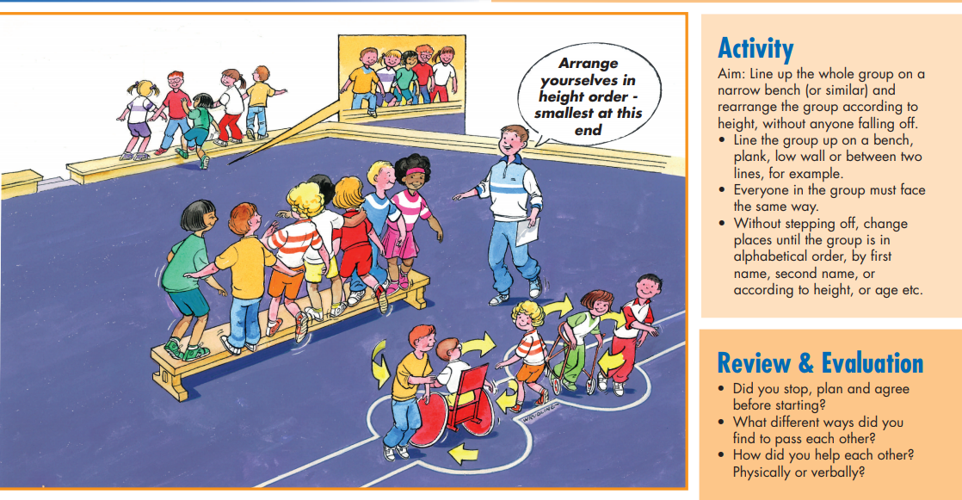

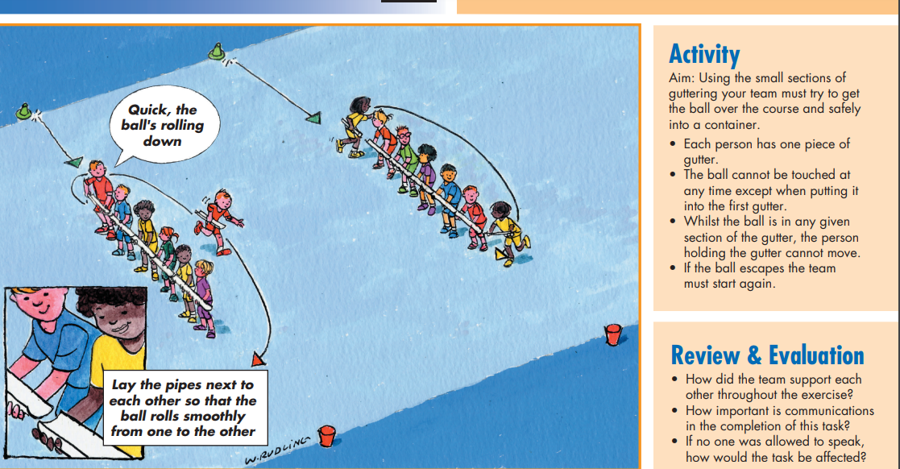
ACTIVITY 2

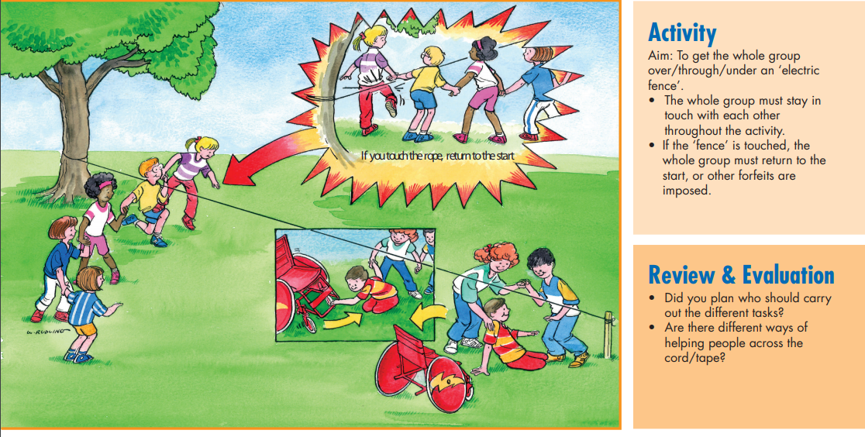
Activity 3

