Dissertation Research Proposal
James de Kerckhove
1707439
Business & Finance
18th November



Evaluating Corporate Social Responsibility Strategies and Implementation for the Employment of Persons with Disabilities.

Table of Contents
1. Table of Figures 1
2. Executive Summary 2
1. Introduction 3
1.1 Background 3
1.2 Literature Review 5
1.3 Rationale 7
1.4 Hypothesis 7
1.5 Aim 7
1.6 Objectives 7
2. Research Design and Methodology 8
2.1 Paradigm 8
2.2 Research Strategy 9
2.3 Sample 10
2.4 Data Collection and Analysis 10
2.5 Limitations & Ethical Risks 11
3. Resources and Planning 11
3.1 Resources 11
3.2 Timescale 12
4. References 13

1. Table of Figures

Figure 1. The Pyramid of Corporate Social Responsibility
Figure 2. The Six Core Characteristics of CSR
Figure 3. The Research Onion
Figure 4. Gantt Chart

2. Executive Summary

This research proposal evaluates Corporate Social Responsibility (CSR) and the implementation of CSR strategies for employing People with Disabilities (PWD). CSR theory states businesses need to become socially responsible to all stakeholders, and is critical to modern business for sustainability (Adams & Zutshi, 2004). As CSR is optional, no business is legally bound to it. This provides the need for corporate governance, which is issued by the Financial Reporting Council (FRC) in the UK. Disability is defined as anyone who has long term physical, mental, intellectual or sensory impairment which limits their participation in society (Leonardi, et al., 2006).

This proposal discusses differing theories such as Freemans (1984) wide view, to be socially responsible, Friedman’s (1970) narrow view, to make money, the CSR pyramid and its core characteristics.

This dissertation seeks to evaluate differing businesses for the employment of PWD, including: Llys Nini Animal Centre, Remploy and Autistic Spectrum Disorder Employment Support (ASDES).

The literature review found UK corporations tend to only meet compulsory regulations (Khan, et al., 2019). Some argue disability is a societal issue not governance (Williams, 2017). These separations can be rendered mute as business and society are connected (Wood, 1991).

This research’s rationale stems from the imperative need for equality. CSR strategies are already in use, for PWD, however lack implementation. The research hypothesis assumes CSR is the motivator for employing PWD. Whilst most companies do not deliver, Llys Nini were found to effectively implement this strategy.

The aim of the study is to investigate the CSR strategies in place for the employment of PWD and evaluate the strategy’s implementation. The objectives are: to investigate the motivation behind the strategies, investigate strategies in Llys Nini and its implementation and, finally, to analyse the success of strategy implementation within differing businesses.

This research uses interpretivism to examine qualitative and quantitative data, using a phenomenology philosophy. This will therefore include both inductive and deductive approaches to examining the data. The research strategy involves surveys, interviews and focus groups. The sample involves: Llys Nini, ASDES and Remploy. The analysis methods will be content and narrative analysis for qualitative data. Also, cross tabulation and text analysis for quantitative data.

There are limitations such as using two small companies. Also, the potential of participants to decline involvement. The ethical risks include: consent, confidentiality, privacy and psychological risks. The paper discusses appropriate solutions to these limitations and risks.

The resources involved include primary and secondary data gathered by the researcher and the use of computer software to analyse the data. The timescale of each section of the proposed research is presented in a Gantt chart as a visual aid to the planning process.

1. Introduction

This dissertation aims to evaluate CSR strategies and its implementation regarding the employment of PWD, focusing on the charity sector. CSR is an ever more pressing social expectation of business. Friedman’s (1970) narrow view of CSR states that a business only has responsibility to itself, as long as it remains within the law. Freeman’s (1984) stakeholder theory states the responsibility to benefit every member of society (Schwartz & Saiia, 2012).

1.1 Background

CSR requires responsibility beyond purely financial. Freeman’s views were that corporations have responsibility to every stakeholder. However, Friedman explains, provided everything is legal, a business’s sole responsibility is to make money.

Carroll (1979) developed the four responsibilities of CSR, which developed into the CSR pyramid in 1991 (Carroll, 1991).

Figure 1. The Pyramid of Corporate Social Responsibility
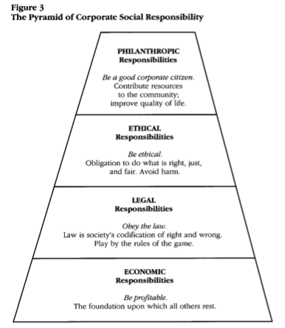
(Carroll, 1991)

Crane and Matten describe the six basic characteristics of CSR (Crane, et al., 2019).

Figure 2. The Six Core Characteristics of CSR
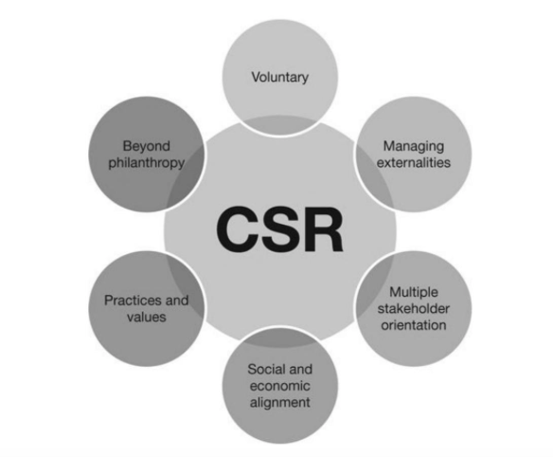
(Crane, et al., 2019)

Cottrell (2017) states theories are ideas that help to explain why something occurs. Elkington developed the theory of the triple bottom line, which analyses three P’s: profit, people and planet. This shows the connection between business and others (Elkington, 2013).

Whilst CSR is optional, others argue it is essential for sustainability (Adams & Zutshi, 2004). However, it is not legally binding. Corporate governance is the guidelines for a business’s best practice and governed on whether they abide by these rules. The FRC issue corporate governance codes for the UK. This entails legal requirements of corporations. This has incorporated the disability confident government scheme. This requires businesses to make ‘reasonable’ adjustments to their recruitment processes (Powell, 2019). However, corporations can find loopholes in this code. For example, if the location of an interview is inaccessible this can create a barrier to entry for PWD.

The Convention on the Rights of Persons with Disabilities (CRPD), defines disability as anyone who has long term physical, mental, intellectual or sensory impairment which limits their participation in society (Leonardi, et al., 2006).

Llys Nini is a self-funded independent charity for animal welfare (RSPCA Llys Nini Animal Centre, 2015). ASDES stands for Autistic Spectrum Disorder Employment Support. This is a not for profit organisation which helps PWD find employment (ASDES, 2019). Remploy is a government owned business dedicated to the employment of PWD and providing support skills. Remploy have many programmes and a mission to improve lives of PWD facing barriers in employment (REMPLOY, 2019). Their CSR policy has many aims; one being furthering the ambitions of PWD and changing societies perception of them (REMPLOY, 2019).

1.2 Literature Review

Khan, et al., (2019) explains that corporations in the UK only meet compulsory regulations instead of adapting best approach strategies. Williams (2017) states that amendments in a report were abandoned as they classed disability to be a societal issue not a corporate governance issue. However, the correlation between business and society being interlinked are becoming increasingly recognised (Wood, 1991). Adams and Zutshi (2004) state CSR is a tool for the sustainability of business. They argue corporations have responsibilities venturing further than meeting economic success to improving the surrounding society. Embracing CSR can increase profitability and lead to competitive advantage.
There are benefits of employing PWD, such as tax incentives, improved public image, and increased talent. The CRPD is a treaty for human rights which has been ratified by 177 countries (Kanter, 2019). The EU 2020 strategy for inclusive growth details the need for employment of deprived communities (Marlier, 2010).
Being employed is part of social inclusion, bringing benefits. In 2019 the employment rate for PWD was 52.6%, leaving 47.4% unemployed. For non-disabled workers the employment rate was 81.5%. Giving a disability employment gap of 28.9% (Powell, 2019).

There are many disabilities, such as non-visible. Having a disability makes employment hard therefore having a non-visible disability can hinder employment chances more (Roberts & Macan, 2006). Companies need more education on disabilities to provide support.

Hiring PWD is important for workforce diversity and an essential part of CSR strategy (Kuznetsova, 2012). Inclusive corporate culture is the full inclusion of a diverse workforce. A diverse workforce would only be successful alongside inclusive corporate culture. However, corporate governance is needed on its implementation (Kuznetsova, 2012).

PWD are the largest minority stakeholder group (Khan, et al., 2019). There needs to be utilisation of this untapped resource. Disclosure is part of breaking barriers down, as employees worry for their career if hidden disabilities surface. PWD can be advantaged by awareness programmes, training for staff, flexible contracts, and support by management (Williams, 2017).

1.3 Rationale

CSR requires businesses to be responsible, not just for economic performance but societal impacts (Schwartz & Saiia, 2012). CSR is an ever more present, essential part of a sustainable business (Adams & Zutshi, 2004). The employment of PWD is an important part of CSR strategies by providing equality and value to businesses. The research into this problem can identify the differing CSR efforts made to include PWD and the implementation on proposed initiatives. Khan, et al., (2019) explains how companies are not delivering on the implementation of such strategies. Equality is a valuable field for research. There are similar studies to analyse the current standard of employment for PWD. However, there is a research gap on its implementation, as most companies state their intentions without delivering on them.

1.4 Hypothesis

The hypothesis assumes the motivation to employ PWD stems from CSR. The implementation within Llys Nini is successful due to the inclusive corporate culture. However, the very existence of Remploy and ASDES suggests that this action is not embraced across most corporations.

1.5 Aim

This research aims to investigate the CSR strategies in place for the employment of PWD and evaluate the implementation of those strategies.

1.6 Objectives

The objectives of the aim:

- Investigate motivation behind strategies to employ PWD.
- Investigate strategies in place for employment of PWD in Llys Nini, and its implementation.
- Analyse the success of strategy implementation within differing businesses.

2. Research Design and Methodology

2.1 Paradigm

This proposal will use the research onion model to construct its research strategy (Saunders, et al., 2016). The research onion is a theoretical structure for logical research design (Melnikovas, 2018).

Figure 3. The Research Onion

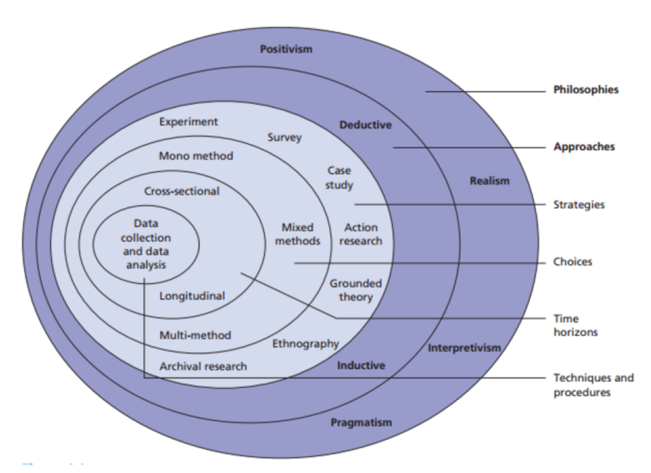

(Saunders, et al., 2016)

A paradigm is a philosophical concept of differing theories to guide research (Collis & Hussey, 2013). Two approaches are positivism and interpretivism. Goldkuhl (2012) determines that interpretivism is associated with qualitative research and requires the researcher to understand the individuals view of life from their perceptions and experiences. The researcher then interprets their own understanding from this communication (Thanh & Thanh, 2015). This approach is not definitive as it is subject to the researchers interpretation of events. Positivism is associated with quantitative research methods and involves being able to define outcomes through a scientific approach (Ayer, 1959). It relies on maths or logic to determine the outcome of the research. This is capable of definitive proof.

This research uses interpretivism as it requires interpretation of the data from interviews on the participants’ life experiences. This approach will utilise both qualitative and quantitative research. Sale, et al., (2002) discusses how mixed method research can be used. They state the two methods are compatible, as they both share core principles to understand the reasoning for events. However, Howe (1988) states that these two methods are incompatible, due to the fact they require differing approaches.

The proposed research will use a phenomenology philosophy. This involves qualitative research which uses life experience of a certain group of individuals. From these life experiences, derives understanding (Pietkiewicz & Smith, 2014).

Inductive research starts with a specific area; through the data gathered the researcher then gains interpretation (Thomas, 2006). Deductive research typically tests a scientific or mathematical research hypothesis (Thomas, 2006). Inductive research is associated with qualitative research whereas deductive involves quantitative. Thomas (2006) explains that research can adopt both methods. This research will use an inductive approach to derive logical explanations of findings from the qualitative research. This is a simple way of analysing qualitative data to establish correlations and produce dependable findings (Thomas, 2006). This will be best suited to analysing life experiences of the individuals during the interviews. However, this research will also utilise deductive analysis for quantitative data, such as surveys.

2.2 Research Strategy

There will be three research methods used which are surveys, interviews and focus groups. This will utilise both qualitative and quantitative data resources.

2.3 Sample

The sample group will involve Llys Nini animal centre volunteers and staff. There will be interviews or focus groups, on around 4-8 people, in order to gain qualitative information. Also, surveys to gain quantitative data. There will be easy access through current involvement as a volunteer. There is strong validity from this qualitative data as the information is coming from a specified subject group, directly attributed to the research question. The only limitation is the size of the sample group.

2.4 Data Collection and Analysis

The collection of data will involve: interviews, surveys and document reviews. Interviews are a communication between the researcher and individual (Harrell & Bradley, 2009). Surveys involve using questionnaires to gain quantitative data (McColl, et al., 2001). There will also be the data collected from other research previously conducted in this field.

The commencing research will involve an analysis of qualitative and quantitative data. Qualitative data is descriptive in nature and often recorded through measures such as interviews (Bryman & Burgess, eds., 1994). This method focuses on the quality of data recorded rather than the amount of data. Quantitative data is vast amounts of data which can be utilised to determine trends. Collis and Hussey (2013) state the drawbacks data analysis can have. One factor is the difficulty in interpreting qualitative data.

Smith (2000) discusses the following two approaches of data analysis associated with qualitative research. Content analysis uses text data to be evaluated in order to provide meaning. Also, narrative analysis for a transcribed action such as an interview. The researcher organises the narrative of the interaction and provides an overview to the reader. The narratives are based on the individuals own experiences.

Quantitative data analysis will use cross-tabulation and text analysis. Cross tabulation involves analysing data with differing variables to show correlations (Kamakura & Wedel, 1997). Text analysis uses software to interpret the textual data from surveys and provide results (Ball, 1994).

2.5 Limitations & Ethical Risks

The limitations of this proposed research would be a small sample group. Another limitation is the focus on two partnering businesses which might not provide a wider view. There is a lack of research into implementation of CSR strategies, which could limit secondary research. A further limitation is the potential for subjects to decline being interviewed.

Ethical risks would be consent in using peoples data, this would be avoided by confidentiality and also having the right to withdraw. Confidentiality and privacy are important in employment; therefore, everything remains anonymous. There can also be psychological risks of interviews, therefore only reasonable questions will be asked that are not intrusive. Also, this research involves vulnerable adults; therefore appropriate safeguarding measures will be adhered to.

3. Resources and Planning

3.1 Resources

The resources used for this research would be both primary and secondary data. Primary data is original data which is collected from the researcher. Secondary data is another researchers data being reused for a differing purpose (Hox & Boeije, 2005). There will also be the use of Internet Communication Technology (ICT) resources, such as Statistical Package for the Social Sciences (SPSS), in order to analyse the data effectively, as datasets would be time consuming to complete without this aid.

3.2 Timescale

This research will require planning and project management. In order to manage time effectively a Gantt chart will be used. This is a production planning tool which can be used for managing projects (Wilson, 2003). The Gantt chart displayed in the next sector provides information on the deadlines for each area of research for this proposed dissertation.

3.3 Gantt Chart

Figure 4. Gantt Chart



4. References

Adams, C. and Zutshi, A., 2004. Corporate social responsibility: why business should act responsibly and be accountable. Australian accounting review, 14(34), pp.31-39.

ASDES, 2019. Home: Welcome to ASDES. [Online] Available at: <http://www.asdes.org.uk> [Accessed 12th November 2019].

Ayer, A.J., 1959. Logical positivism. Simon and Schuster.

Ball, C.N., 1994. Automated text analysis: Cautionary tales. Literary and Linguistic Computing, 9(4), pp.295-302.

Bryman, A. and Burgess, R,G., eds., 1994. Analyzing Qualitative Data. Routledge: London.

Carroll, A.B., 1979. A three-dimensional conceptual model of corporate performance. Academy of management review, 4(4), pp.497-505.

Carroll, A.B., 1991. The pyramid of corporate social responsibility: Toward the moral management of organizational stakeholders. Business horizons, 34(4), pp.39-48.

Collis, J. and Hussey, R., 2013. Business research: A practical guide for undergraduate and postgraduate students. Macmillan International Higher Education.

Cottrell, S., 2017. Critical thinking skills: Effective analysis, argument and reflection. Macmillan International Higher Education.

Crane, A., Matten, D. and Spence, L. eds., 2019. Corporate social responsibility: Readings and cases in a global context. Routledge.

Elkington, J., 2013. Enter the triple bottom line. In The triple bottom line (pp. 23-38). Routledge.
Freeman, R. E. 1984. Strategic management: A stakeholder approach. Boston: Pitman
Friedman, M., 1970. The social responsibility of business is to increase its profits. In Corporate ethics and corporate governance (pp. 173-178). Springer, Berlin, Heidelberg.

Goldkuhl, G., 2012. Pragmatism vs interpretivism in qualitative information systems research. European journal of information systems, 21(2), pp.135-146.

Harrell, M.C. and Bradley, M.A., 2009. Data collection methods. Semi-structured interviews and focus groups. Rand National Defense Research Inst santa monica ca.

Howe, K.R., 1988. Against the quantitative-qualitative incompatibility thesis or dogmas die hard. Educational researcher, 17(8), pp.10-16.

Hox, J.J. and Boeije, H.R., 2005. Data collection, primary versus secondary.

Kamakura, W.A. and Wedel, M., 1997. Statistical data fusion for cross-tabulation. Journal of Marketing Research, 34(4), pp.485-498.

Kanter, A.S., 2019. Let's Try Again: Why the United States Should Ratify the United Nations Convention on the Rights of People with Disabilities. Touro L. Rev., 35, p.301.

Khan, N., Korac‐Kakabadse, N., Skouloudis, A. and Dimopoulos, A., 2019. Diversity in the workplace: An overview of disability employment disclosures among UK firms. Corporate Social Responsibility and Environmental Management, 26(1), pp.170-185.

Kuznetsova, Y., 2012. Inclusive corporate culture and employment of persons with disabilities: analysis of CSR strategies of multinational enterprises in Norway and the UK. In UFHRD 2012 Conference.

Leonardi, M., Bickenbach, J., Ustun, T.B., Kostanjsek, N. and Chatterji, S., 2006. The definition of disability: what is in a name?. The Lancet, 368(9543), pp.1219-1221.

Marlier, E., 2010. Europe 2020: towards a more social EU?(No. 69). Peter Lang.

McColl, E., Jacoby, A., Thomas, L., Soutter, J., Bamford, C., Steen, N., Thomas, R., Harvey, E., Garratt, A. and Bond, J., 2001. Design and use of questionnaires: a review of best practice applicable to surveys of health service staff and patients. Core Research.

Melnikovas, A., 2018. Towards an Explicit Research Methodology: Adapting Research Onion Model for Futures Studies. Journal of Futures Studies, 23(2), pp.29-44.

Pietkiewicz, I. and Smith, J.A., 2014. A practical guide to using interpretative phenomenological analysis in qualitative research psychology. Psychological journal, 20(1), pp.7-14.

Powell, A., 2019. People with disabilities in employment. [pdf] House of Commons Library. Available at: <https://www.google.com/url?sa=t&rct=j&q=&esrc=s&source=web&cd=10&ved=2ahUKEwj0z7-XtNHlAhXSOcAKHZHODgkQFjAJegQIAhAH&url=https%3A%2F%2Fresearchbriefings.files.parliament.uk%2Fdocuments%2FCBP-7540%2FCBP-7540.pdf&usg=AOvVaw2dwh5I63hrDQ7QSEbLPUsM> [Accessed 4th November 2019].

REMPLOY, 2019. Home: About Us. [Online] Available at: < https://www.remploy.co.uk/about-us> [Accessed 12th November 2019].

REMPLOY, 2019. Our Business: Governance. [Online] Available at: < https://www.remploy.co.uk/about-us/our-business/governance> [Accessed 12th November 2019].

Roberts, L.L. and Macan, T.H., 2006. Disability disclosure effects on employment interview ratings of applicants with nonvisible disabilities. Rehabilitation Psychology, 51(3), p.239.

RSPCA Llys Nini Animal Centre, 2015. History. [Online] Available at:< http://www.rspca-llysnini.org.uk/history.php> [12th November 2019].

Sale, J.E., Lohfeld, L.H. and Brazil, K., 2002. Revisiting the quantitative-qualitative debate: Implications for mixed-methods research. Quality and quantity, 36(1), pp.43-53.

Saunders, M., Lewis, P. and Thornhill, A., 2016. Research methods for business students. 7th Edition. Munich/Harlow: Pearson.

Schwartz, M.S. and Saiia, D., 2012. Should Firms Go “Beyond Profits”? Milton Friedman versus Broad CSR 1. Business and Society Review, 117(1), pp.1-31.

Smith, C. P., 2000. Content analysis and narrative analysis. Handbook of research methods in social and personality psychology. New York: Cambridge University Press.

Thanh, N.C. and Thanh, T.T., 2015. The interconnection between interpretivist paradigm and qualitative methods in education. American Journal of Educational Science, 1(2), pp.24-27.

Thomas, D.R., 2006. A general inductive approach for analyzing qualitative evaluation data. American journal of evaluation, 27(2), pp.237-246.

Williams, B.R., 2017. Disability in the Australian workplace: corporate governance or CSR issue?. Equality, Diversity and Inclusion: An International Journal, 36(3), pp.206-221.

Wilson, J.M., 2003. Gantt charts: A centenary appreciation. European Journal of Operational Research, 149(2), pp.430-437.

Wood, D.J., 1991. Corporate social performance revisited. Academy of management review, 16(4), pp.691-718.

