FeasibilityStudy of Electric Vehicles to reduce Carbon Impact
P147262 | UWTSD
SUSTAINABILITY tHROUGH TECHNOLOGY
Rhys Richards
2017
Contents Page
- Abstract
- Introduction
- Research
- Emissions
- Cost
- Practicality
- Ethics
- Analysis
- Conclusion

Abstract
This assignment is a look at how electric vehicles are becoming more popular and the feasibility for the wide spread deployment. The report will specify the progress of electric cars in the motorsport and automotive industry today, and research the benefits and possible disadvantages of the electric vehicles, along with effect short, medium, and long-term implications will have. Analysation of the operation and effectiveness of the alternative to petrol and diesel will be carried out to complete the report, mainly focusing on the changes it will have on the environment and the energy systems.

Introduction
This report will focus on electric hybrid and their impact on the environment. The analysis and conclusion will be based on the thorough research carried out to greater understand the impact of electric and hybrid vehicles. When trying to understand the effect the switch from petrol and diesel to electric would have, we must take into consideration:
- Emissions (CO2 and other harmful gases)
- Cost (Manufacture, Selling Price, maintenance, cost of charging the vehicle)
- Practicality (How practical will the vehicles technology be compared to those of diesel and petrol vehicles)
- Ethics (Does the electric vehicle provide an improvement as it claims)
A large proportion of the analysis will be based on the short, medium and long-term implications that would be caused by introducing this technology to the motorsport and automotive industry, this will cover all the considered factors listed above, and any other important information discovered during research.
It is important to also focus on why the automotive and motorsport industry are moving towards electric power after so many years of using petrol and diesel, and how they intend on doing so.

Research
Over the last decade and more automotive and motorsport industries have continuously thrived while making major advancements in technology, whether it’s purpose is to gain greater power from the engine, provide lower emissions, and any other important changes that manufacturers would intend to carry out due to certain Laws. All these factors are very important and should be taken in to consideration when trying to discover why companies are now looking towards electric power, but the main reason is being able to sustain a renewable energy source. Petrol and Diesel have worked extremely well while providing an energy source over countless years, but it has been made aware that these fossil fuels will not be around for much longer, especially with the major increase in use of engine powered transportation, this means that a different and more advanced form of energy must be discovered to replace these fossil fuels before they run out.
Emissions
Emissions are one of the main causes of air pollution in the world today, because of this it was only a matter of time before laws would be introduced to lower the harmful emissions released in to the atmosphere from petrol and diesel vehicles. In 1992 the first legislation was introduced by the EU, this was called ‘Euro 1’, this limited the amount of CO (g/km), and HC and NOx (g/km) that the vehicles emitted, the euro emission laws have since been updated numerous times with the last update being introduced in 2014, ‘Euro 6’, which saw many more restrictions.

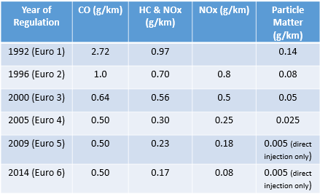
Diesel Emission Laws Petrol Emission Laws
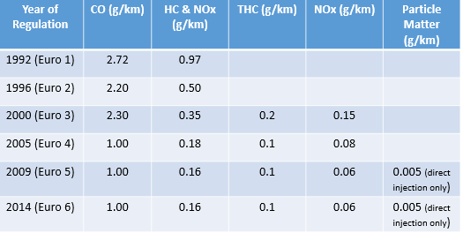

This is one major factor for the introduction of electric powered vehicles as they don’t pour out harmful emissions from their exhausts. All people who want to save and protect the environment are all for electric powered vehicles, but one question they never consider is ‘how beneficial to the environment are electric vehicles?’, because they claim to produce no harmful emissions from exhausts that is enough to convince most eco-friendly citizens that it will significantly help the environment, but what energy source is actually used to power the vehicle.
It is clear in the name ‘electric vehicle’ that it is powered by electric, but where does your electric come from? All electric comes from a local power grid, and many local power grids in this decade are fuelled by fossil fuels, many are coal-fired power plants, therefore to charge your ‘electric powered and environment friendly vehicle’ you are burning fossil fuels, therefore you must really consider whether you are reducing the carbon foot print claimed to be caused by petrol and diesel vehicles. If power grids convert from the fossil fuel based energy and change to solar and wind, like places such as California then electric vehicles will benefit the environment and the atmosphere.

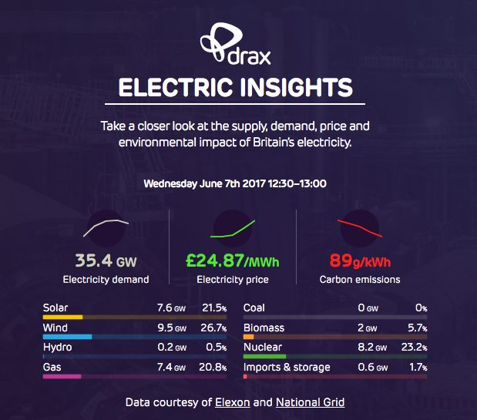

The image above shows how the UK is advancing when it comes to using environmental friendly sources of energy. As shown there is no use of coal anymore, it is unfortunate that there is still such a large use of nuclear and gas and such little use of hydro, but there is promise for the future of environmental friendly power supplies with a large increase in the energy provided by solar and wind. After further research it seems that the UK have vastly improved over the last couple of years, in 2017 the United Kingdom was ranked 12th out of all countries for environmental friendliness, whereas ten years ago the country was much lower. If the UK continues on this path, then electric powered vehicles will almost definitely live up to their eco-friendly claims.
Cost
As well as emissions cost is a major factor when changing from fossil powered vehicles to electric. As well as the price tag of electric vehicles, manufacturing and maintenance costs are extremely high.
Tesla is a company owned by Elon Musk which is devoted to creating electric powered vehicles, they have created a number of electric powered vehicles, although their biggest downfall is the cost of purchase and manufacturing. For the performance side of the vehicle the price tag seems reasonable, but it still too expensive for the majority of population to afford.
Purchase
When comparing Tesla’s vehicles to modern day super cars, the performance is astonishing. Tesla’s Roadster out performs the newest vehicle produced by Bugatti, the Chiron. It is faster from 0-60mph and 0-100mph, faster on a quarter mile, has more seats making the vehicle more practical (4 seats, compared to the Chiron’s 2), has a longer mileage range before refuelling, and is 1/15th of the purchase price ($200,000 compared to $3million). This is fantastic but as stated earlier is still out of the price range of a majority of the population. This is a downfall for electric vehicles as 69% of consumers claim price is the main factor when purchasing a vehicle and would not be comfortable spending more than $30,000 which is roughly around £22,500. Tesla are not the only company that are developing electric powered vehicles, companies such as:
BMW – I3 – RRP £33,340
Nissan – Nissan Leaf – RRP £30,935
Chevrolet – Bolt – RRP £28,000 - £32,000
Ford – Focus Electric – RRP £31,000
Volkswagen – e-Golf – RRP £31,215
Kia – Soul EV – RRP £30,495
This shows that the production of electric vehicles has peaked the interest of many top vehicle manufacturers. Although the prices above are much higher than the price most consumers are willing to pay, we must take in to consideration the governments plug-in grant scheme. There are six categories which come under this scheme, and all vehicles listed above are in Category 1, this means that when purchasing any of the vehicles in this category the government will pay back 35% of the vehicles RRP, as long as it does not exceed £4,500, that is the maximum amount they will grant. To be a category 1 vehicle they must emit less than 50g/km of Carbon Dioxide and travel a minimum of 70 miles without emitting any Carbon Dioxide. The purpose of the scheme is to promote the use of electric vehicles.

Manufacturing and Maintenance
Cost of manufacturing is a major factor for the companies making these vehicles, as well as components being so expensive, the cars must reach certain requirements, legal and others set by the company. Profit on vehicles is also a main concern for business, therefore companies must take in to consideration whether money will be lost on manufacturing these vehicles.
The graph above shows what components cost the most when manufacturing a conventional vehicle in comparison with a battery powered electric vehicle.
In 2017 electric vehicle price of purchase, manufacturing, and maintenance are all going to be higher than those of a conventional petrol and diesel powered vehicle, this is expected due to the lack of resources of an electric engine vehicle, and as certain components cost more than others when comparing the two vehicles. But by 2025/2030 this could change dramatically.
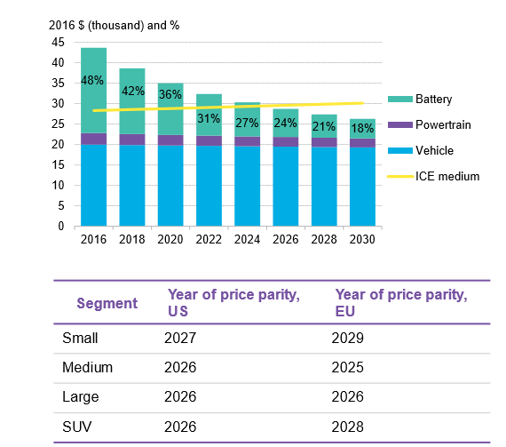

The graph above shows the medium breakdown of battery powered electric vehicles pre-tax price in comparison to the conventional engine vehicles, and share of battery costs.
The expectation is main vehicle components such as base and chassis for EV’s will reduce over time as they will be simpler designs in comparison to CPV’s (ICE on graph) which will increase If they continue to meet Euro Emission Laws as the components will be made with lighter materials to reduce the pollution produced from the vehicles such as carbon dioxide. Another factor that will be affected is the cost of the electric vehicles powertrain which should theoretically drop by 20-25% in the next 10 years+ as the volume of manufacturing is expected to increase. From the graph explaining the percentage cost of the vehicles components on the previous page and other research, the battery of the EV costs around 40% maybe more of the vehicles overall manufacturing cost, this is also expected to drop to a max of 23%, hopefully making EV’s significantly cheaper in the next decade.
In Europe the price parity for medium vehicles will theoreticall be reached by 2025, in less than 10 years, meaning that the price for an EV will be the same as CPV. Unfortunately this is not the case for Small EV’s as small ICE’s prices will still be extremely low in comparison. All vehicles will reach price parity by 2030.

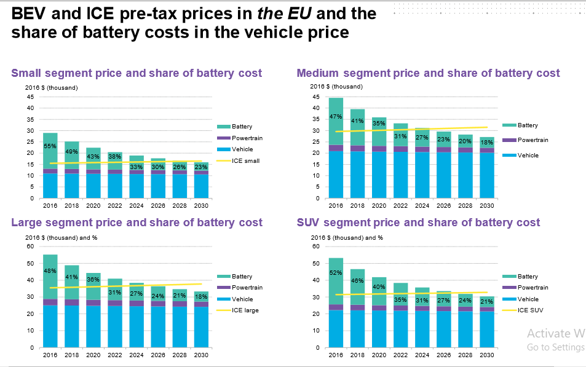

As well as this it is stated that larger vehicles and SUV’s powered by batteries will require less power by 2030 in comparison to now, falling from roughly 100Kwh to 85 Kwh, this will be very beneficial in the long run.
This is proven when looking at the prices of a 2017 petrol ford focus in comparison to the Focus-Electric. The Focus-Electric costs around £31,000, when considering the plug-in grant which is a max of £4,500 then the vehicle will cost around £26,500, when comparing this to a brand new ecotech ford focus which costs £20,195 there is £5000+ difference. It is even more surprising when the ST-2 also goes for less £25,735, not a massive difference, but this is one of the top range focus’, the only focus which exceeds the price of the Focus-Electric is the ST-3 which is an upgrade from the ST-2 costing an additonal £2,050, with this you get:
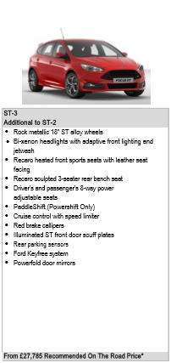

The ST range are vehicles are produced to have better performance, higher speeds and more noise than the standard Ford Focus, and therefore petrol heads are willing to pay this much as it’s solely designed for performance. In 2017 many people would question the Ford-Electrics performance compared to the Focus’ as well as price and practicality , although if theory is correct in suggesting that BEV (Battery Electric Vehicles) will be cheaper and produce much more power than CPV (Conventional Powered Vehicles) by 2025/30, then this could no longer be an issue.
From all the data collected we can also confirm that maintaining the battery powered electric vehicles will also be very costly based on how expensive it is to manufacture one these vehicles in 2017, by 2025 it may not be a major issue but for now when comparing the maintenance cost of a ICE against a BEV, it is clear there is no competition and that it is more practical and wallet friendly for all consumers.

Practicality
Practicality is a major factor especially in Britain as many people will spend their money based on how practical something is for them, therefore many consumers will question how practical BEV’s will be. There are many pros and cons to electric vehicles as listed below.
Pros
- Zero Emissions
- Buying Incentives (Plug-In Grant)
- Low Running Costs
- Tax Benefits
- Comfort
- Acceleration
Cons
- Charging Points
- Charging Time
- Battery Range
- Purchase Price
- Driving Fun
As we can see there are many pros and cons for the electric vehicle, but how do these affect the practicality of the BEV and how short, medium, and long-term implication will affect the pros and cons listed.
Zero Emissions is clearly a winner as governments are attempting to reduce the harmful emissions that conventional vehicles (petrol and diesel) produce, by eliminating any emissions and changing entirely to EV’s there will be no need for the EU to write up any further emission laws, and there will be no pollution to damage the environment, this is affective short, medium, and long-term.
A buying incentive is a very intelligent move by the government as it will push consumers to purchase electric vehicles, paying back 35% of the vehicles cost or a max of £4,500, this will attract the attention of many consumers and possible the reason for the number of the population who own EV’s rising from 1% to 2% in the last year. But this is also a downfall as the incentive for the governments Plug-In grant is the very costly price of electric vehicles, with many of them costing near £30,000+, £8,000 more than the consumers comfortable price range of £22,000. The plug-in grant is pro but is also out-weighed by the EV’s RRP.
Another pro that you will find with electric powered vehicles is the running cost, the price to charge the battery is significantly lower, with a full charge costing around a tenth of the cost spent on filling a petrol/diesel powered vehicle, again the price will vary at different charging points across the UK, but this isn’t a problem as charging the vehicle from home would cost around £1.50. But there is another con to this, the practicality of charging an electric vehicle is very minimal, this is due to the amount of time it will take to charge the vehicle as well as the limited amount of services which provide charging ports. After further research it shows in the UK there are only 14109 connectors, 8130 devices, 4956 locations, and 367 that have been added to these figures in the last month, with a majority based in London. When looking at this you can see that it is a very minimal amount when considering the amount of people who drive in the UK, if the government wanted to increase the purchase of electric vehicles then more devices and connectors must be introduced in more garages as I believe this puts many people off purchasing the vehicle with the lack of charging points. Charging the vehicle at home is also a downfall as 20% percent of the population live in flats, and 40% in rented accommodation, meaning they may not have the facilities or space to park and charge their vehicle from home.
Tax is a large benefit for consumers as any electric vehicle which costs under £40,000 will be exempt from tax, while anything over that price range will cost £340 a year for 5 years, then will also be exempt. This means the only people who will be paying road tax are people who can afford the more expensive vehicles. But due to growing popularity EV’s now have a 9 percent BIK rate, which will increase over the next couple of years but will still remain less than petrol and diesel, I believe that this is a con but not as major as some of the other factors that have been listed above.
Comfort is a big selling point in the UK when designing cars, I believe that this is a pro that cannot be diminished, why would anyone complain about comfort. Whether the age of the customer is below 30 or above 65, no matter what age range I believe there is no reason to complain about how comfortable the vehicle is.
Battery Range is a downfall but is not a major issue unless commuting on long journeys, the average mileage of a EV battery is 120-150 miles, with many companies claiming that soon they will be able to travel 300 miles without needing charge. This isn’t a problem if you’re able to charge your vehicle regularly from home, again the time of charging also affects this. The Tesla Roadster which costs $200,000 is clearly not a car for typical every day drivers, but has a range of 620 miles, this is promising for the near future as smaller more affordable EV’s such as the BMW i3 may be able to increase their mile range.
The Acceleration of electric vehicles is incredible as you have this instant output of torque as soon as your feet touch the accelerator, most EV’s have a faster 0-30mph, 0-60mph, 0-100mph, and a quarter mile than most affordable ICE’s (petrol/diesel). But for petrol heads this is a problem due to the vehicles silence, again this isn’t a major issue and is only specific to people who really enjoy petrol/diesel powered cars as the noise produced by the engines when accelerating adds some sort of excitement and feel to driving. This only really applies to petrol heads who most likely will stick with conventional vehicles for as long as possible.

Ethics
As I was unsure of what was meant by ethics, my interpretation is ‘does the research carried out and the information gathered confirm the claims made by companies about EV’s.’.
I believe that it does as the companies aren’t claiming that electric powered vehicles will instantly replace petrol and diesel, but over a long period of time, and many years of development and manufacturing will be an improvement/replacement on todays’ conventional vehicles.
Analysis
After a lot of research and analysation I believe that Electric Vehicles are a significant advancement in technology and will aid in the improvement of motorsport and automotive vehicles. Unless power grids run of natural renewable resources rather than fossil-fuels and other means of power sources, then we can assume that EV’s are economically friendly and produce zero emissions as claimed.
Short Term Improvements
In the short-term I believe that companies could attempt to increase the overall mileage of the vehicles, decrease the batteries charging time, and deploy more charging stations across the whole of the UK. I believe this will encourage more people to switch to EV’s, even when this is done I believe the increase in users will still only be minimal.
Medium Term Improvements
After the short-term improvements are made the companies and government should then focus on greater aspects. Changing the source of fuel for the power grids to solar, wind, and hydro would majorly increase the number of users as electric vehicles can then claim they are economically friendly and produce zero emissions, I believe this is still a reason for many people not changing. As well as power grids, manufacturers should focus more on how they can minimally decrease the cost of electric vehicles rather than waiting for a mass production in 2030 as it will then be closer to a price people are comfortable paying, causing an increase in sales. The batteries for EV’s are also made from lithium-ion, this is a problem because just like fossil fuels there is a limited amount and therefore will also eventually run out, which is why companies are looking in to other alternatives such as sodium-ion.
Long Term Improvements
All the improvements listed above should be looked at in more depth to improve all flaws with the Electric Vehicles. This means that there should be an even greater increase in mile range, number of charging ports, and battery life as according to Tesla the roadster batteries expected life time is 5 years or around 100,000 miles. This is not a long-life time as there are petrol and diesel vehicles that have exceeded the expected electric battery life time, and as they are much more affordable to replace than those of an electric vehicle.
Although I believe this, I also think that manufactures and governments main-focus should be on power grids, price and other alternatives to lithium-ion. I say this because I don’t believe that anyone should pay above realistic costs especially for vehicles which claim to be environmental friendly when that solely depends on the source of power that run the Power Grids in the UK, as this is also false advertisement. Only then will the vehicles eliminate carbon impact.
Conclusion
I conclude that Electric Vehicles are the future and will be very beneficial when attempting to eliminate the carbon foot-print, but it will be a long process as right now they are not practical enough to be used widely, and many alternatives to lithium ion must be looked at as these materials will also be very limited eventually. Companies may also look at hydro based vehicles as they also have many pros such as zero emissions, but just like electric have additional cons, and are also much more expensive. Toyota have already created a hydro car that’s value is estimated to be around $65,000 which is significantly more expensive than the everyday Electric Vehicles. If companies such as Tesla continue their work and the government continue to push for the use of electric cars, then it is a possible and very efficient alternative to petrol and diesel.

References
(Zap-Map), A. (2017). How many charge points are there in the UK 2017. [online] Zap-Map. Available at: https://www.zap-map.com/statistics/ [Accessed 11 Dec. 2017].
Ambrose, J. (2017). UK sets new renewable energy record as wind and solar surge. [online] The Telegraph. Available at: http://www.telegraph.co.uk/business/2017/06/07/uk-sets-new-renewable-energy-record-wind-solar-surge/ [Accessed 9 Dec. 2017].
Anon, (2017). [online] Available at: https://www.researchgate.net/profile/Robert_Kochhan/publication/260339436_An_Overview_of_Costs_for_Vehicle_Components_Fuels_and_Greenhouse_Gas_Emissions/links/588801c64585150dde503d57/An-Overview-of-Costs-for-Vehicle-Components-Fuels-and-Greenhouse-Gas-Emissions.pdf [Accessed 10 Dec. 2017].
Auto Express. (2017). Could you live with an electric car? The pros and cons of owning an EV today. [online] Available at: http://www.autoexpress.co.uk/car-news/electric-cars/100285/could-you-live-with-an-electric-car-the-pros-and-cons-of-owning-an-ev [Accessed 11 Dec. 2017].
Automotivebusiness.com.br. (2017). Cite a Website - Cite This For Me. [online] Available at: http://www.automotivebusiness.com.br/abinteligencia/pdf/EV-Price-Parity-Report.pdf [Accessed 10 Dec. 2017].
Energysage.com. (2017). 2017 Best Electric Car Companies and Manufacturers | EnergySage. [online] Available at: https://www.energysage.com/electric-vehicles/buyers-guide/top-ev-companies/ [Accessed 9 Dec. 2017].
Ford.co.uk. (2017). Cite a Website - Cite This For Me. [online] Available at: https://www.ford.co.uk/content/dam/guxeu/uk/documents/price-list/cars/PL-Focus.pdf [Accessed 10 Dec. 2017].
Ft.com. (2017). Electric car costs forecast to hit parity with petrol vehicles. [online] Available at: https://www.ft.com/content/6e475f18-3c85-11e7-ac89-b01cc67cfeec [Accessed 9 Dec. 2017].
Garden, H., Efficiency, F. and Vehicles, F. (2017). How Electric Car Batteries Work. [online] HowStuffWorks. Available at: https://auto.howstuffworks.com/fuel-efficiency/vehicles/electric-car-battery4.htm [Accessed 11 Dec. 2017].
Gov.uk. (2017). Low-emission vehicles eligible for a plug-in grant - GOV.UK. [online] Available at: https://www.gov.uk/plug-in-car-van-grants [Accessed 10 Dec. 2017].
Kia.com. (2017). Kia Soul EV Prices & Guides | Kia Motors UK. [online] Available at: http://www.kia.com/uk/new-cars/soul-ev/pricing/ [Accessed 10 Dec. 2017].
Oliver Smith (2017). Earth Day: The world's most (and least) environmentally-friendly countries. [online] The Telegraph. Available at: http://www.telegraph.co.uk/travel/maps-and-graphics/most-and-least-environmentally-friendly-countries/ [Accessed 9 Dec. 2017].
Reliableplant.com. (2017). Will the cost of electric cars come down? A Q&A session with A123. [online] Available at: http://www.reliableplant.com/Read/27174/Cost-electric-vehicles-A123 [Accessed 9 Dec. 2017].
Sciencedirect.com.ezproxy.uwtsd.ac.uk. (2017). Cite a Website - Cite This For Me. [online] Available at: http://www.sciencedirect.com.ezproxy.uwtsd.ac.uk/science/article/pii/S030142151200403X?via%3Dihub [Accessed 11 Dec. 2017].
Twitter. (2017). Drax on Twitter. [online] Available at: https://twitter.com/Draxnews/status/872426125338845186/photo/1?ref_src=twsrc%5Etfw&ref_url=http%3A%2F%2Fwww.telegraph.co.uk%2Fbusiness%2F2017%2F06%2F07%2Fuk-sets-new-renewable-energy-record-wind-solar-surge%2F [Accessed 9 Dec. 2017].
Wade, L. (2017). Tesla’s Electric Cars Aren’t as Green as You Might Think. [online] WIRED. Available at: https://www.wired.com/2016/03/teslas-electric-cars-might-not-green-think/ [Accessed 9 Dec. 2017].
Www-sciencedirect-com.ezproxy.uwtsd.ac.uk. (2017). Cite a Website - Cite This For Me. [online] Available at: https://www-sciencedirect-com.ezproxy.uwtsd.ac.uk/science/article/pii/S030142151200403X [Accessed 11 Dec. 2017].
Www-sciencedirect-com.ezproxy.uwtsd.ac.uk. (2017). Cite a Website - Cite This For Me. [online] Available at: https://www-sciencedirect-com.ezproxy.uwtsd.ac.uk/science/article/pii/S0301421509008805 [Accessed 10 Dec. 2017].
Www-sciencedirect-com.ezproxy.uwtsd.ac.uk. (2017). Cite a Website - Cite This For Me. [online] Available at: https://www-sciencedirect-com.ezproxy.uwtsd.ac.uk/science/article/pii/S0301421513004771 [Accessed 10 Dec. 2017].
Www-sciencedirect-com.ezproxy.uwtsd.ac.uk. (2017). Cite a Website - Cite This For Me. [online] Available at: https://www-sciencedirect-com.ezproxy.uwtsd.ac.uk/science/article/pii/S0301421511000164 [Accessed 10 Dec. 2017].

