Research Practices

Luce Buchanan

BA Illustration. Year 2

Scott L Smith

1703056

2333 Words

Research Practices

For this project, I will be researching the area of concept art. I intend to look at a wide variety of sources to develop a dissertation question ready for my third year. To come to this dissertation question, I will be focusing on three keywords in the context of concept art. They will be the works of three media projects and I’ll pick 3 images that support these themes I want to explore, as well as up to 3 artist or thinkers that are related to the images to help expand upon these ideas.

I started my research of concept art by asking myself “what is concept art?” it varies from property to property in style, mood and focus in such a wide variety, ranging from polished digital art pieces to charcoal sketches. According to a blog written by James Pickhall, a seasoned artist in the video game industry

“The main goal of concept art is to convey a visual representation of a design, idea, and/or mood for use in films, video games, animation, or comic books before it is put into the final product.” (Pickhall, 2012)

So, I have decided to look at specifically how design, style and mood of an artist’s work shapes concept art that creates rich settings for forms of media to take place in.

Design

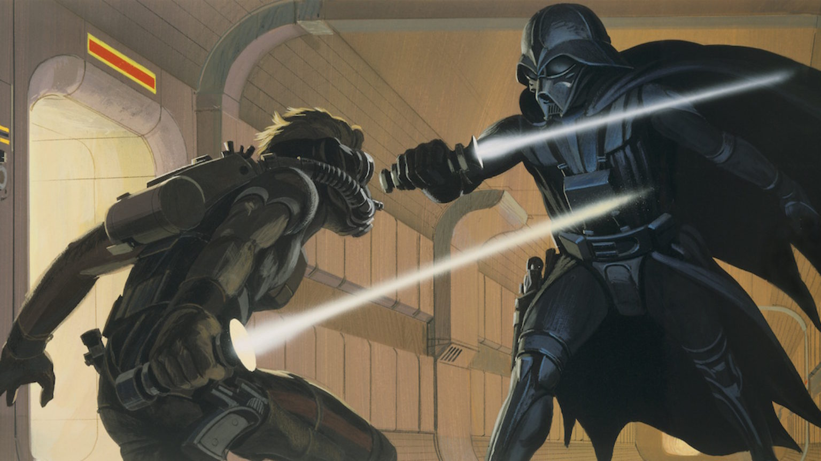

The definition of design according to the oxford dictionary is - “The art or action of conceiving of and producing a plan or drawing of something before it is made.” (Oxford University dictionaries, 2019) So, it is easy to see how this applies to the job of a concept artist as it is their role to bring the vision of the writers to life so that everyone else working on the project can get on the same page. After looking at a lot of concept art for research on this project I settled on one image from Ralph McQuarrie’s The dual (1975). This is because when focusing on the design alone you can see just by looking at this one image how closely it fleshed out one of the most popular villains in one of the most popular movie franchises of all time. In my own opinion it shows the strength of the design, and from this one image you can instantly understand the context of the scene even without watching the movie it was created for.

From this one image it shows the key aspects of the two characters, showing the personality of each and giving the indication of how they should act. From the very first image of the character that came to be known as darth Vader certain aspects are present from the tall overpowering position he poses in the picture and the motion he is in shows a robotic and intimidating figure, that looks menacingly inhuman with the face being hidden behind a black mask. A lot of the inspiration for the actual design of the came from functionality in an interview the concept artist who gave Star Wars its iconic look Ralph McQuarrie said
“George had described Vader as having flowing black robes. In the script, Vader had to jump from one ship to another and, in order to survive the vacuum of space, I felt he needed some sort of breathing mask. "George said, 'OK,' suggested adding a samurai helmet, and Darth Vader was born. Simple as that." (Magid,R.)
Although the design for “deak starkiller” changed over time to become Luke skywalker the way he looks in this picture also show some of the traits that carried over through the iterations of the script. The motion of the frame and position of the “laser sword” makes his stance look more emotional and untrained which is emphasised by the rouge looking character design. This is also helped by the point of view looking slightly up in a worm’s eye view .It show Darth Vader in a more dominant position that increases the intimidation factor which really encourages the feeling of this character is evil.
The motion in this frame is created by the asymmetrical positioning and this is done to create a more dynamic visual drawing your eye towards the characters in the foreground. This gives the illusion of movement which helps those working from this piece as it gives an idea how movement of the characters would look, rather than having to imagine from the script. In the picture, most of the lighting comes from the background which makes the scene more dramatic again drawing the eye naturally towards the foreground. Of which will be drawn to the black figure of Darth Vader because of the contrast between brighter orange radiating from behind him out towards the more muted grey and yellow of the doorway.

As well as working on individual characters, concept artists will also work on the worlds they inhabit. It’s important for the artist to capture the essence of the setting of the story due to the importance in the narrative, Ralph included a lot of geometric shapes to compose the “used future” designs for Star Wars imagined a lived-in galaxy that was gritty, dirty, and in advance states of decay.” (Blauvelt, C, 2012) In the context of the photo I chose to focus on for this project, this is represented in the colour choice of orange, yellows and grey. They illuminate the narrow futuristic hallway and this colour pallet was unheard of at the time because of the contrast with other works that mainly used whites and silvers for a more sterilised design in sci-fi of this era.

Style
Art style is the classification of categories of art based on similar aspects of the art piece such as how art deco styles “are simple, clean shapes, often with a “streamlined” look; ornament that is geometric or stylized from representational forms” (Encyclopaedia Britannica, 2019) or how surrealism would often go beyond the rational, tapping into the unconscious and using it in part of the creation process to capture the raw concept of thought, without the regulation of control such as reason and morals. While style is largely inspired by the culture, era and philosophies of the time it is very much a personal thing as unique as a person’s finger print and intimately shares your personality through which medium you choose to show it through.

While researching concept art it was interesting how an artist’s style affects the project they work on. This is due to how important their role is in regards to how it affects the other designers that complete the project because of how visually communicative is has to be. While looking at more unique pieces of released concept art work one artist stood out because of how visually striking it was. H.R. Giger was head hunted for Ridley Scott’s movie Alien because of his previous work on an unreleased project was so uniquely nightmarish and fit the original view for the project. This is because the basis for the idea behind the xenomorph in the movie was to contrast the view of the sci-fi genre at the time of extra-terrestrial life being the best of what humanity could be with higher technology and enlightened. With the xenomorph representing the worst, “Giger's creature is a filthy, primal parasite whose very survival is contingent on its continued rape and exploitation of other species.” (Snyder, D, D. 2017)
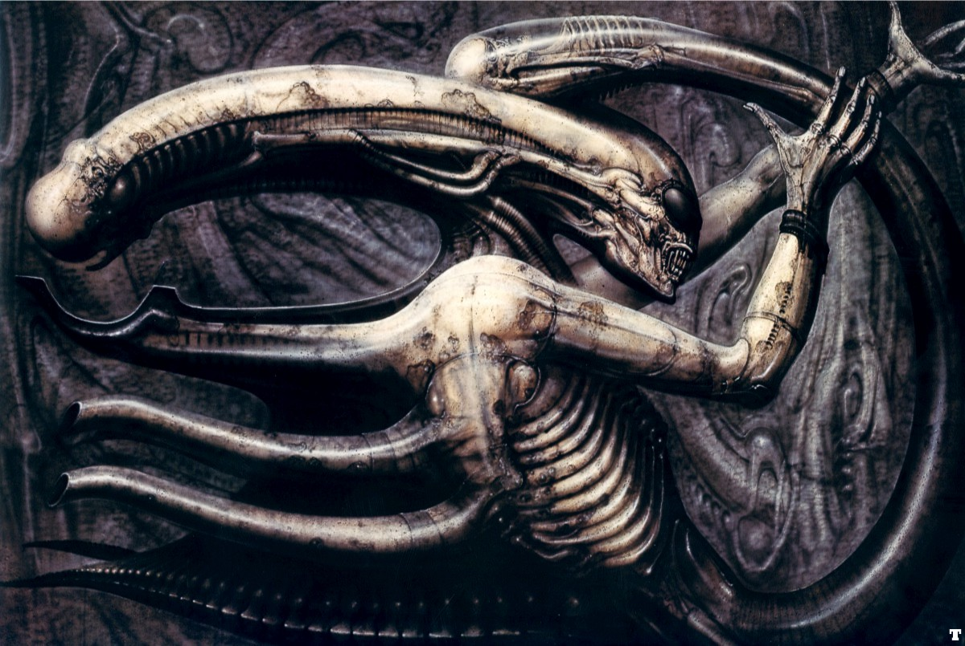

This piece (Giger, H,R. 1977, Necronomicon lV ) represents Giger’s work well because it shows all the traits that define his style, sexual imagery, the monochrome shading and the relationship of “biomechanics” all wrapped into a nightmare inducing package. The symbolism of sex, death and technology is heavy throughout this picture, the background is metallic silvers and blacks but the detail looks like compressed sinewy organs and from the blades and pipes on the spine of the monster to the bone like colour. Each part is merged to give a visual representation of H.R. Giger’s philosophy.

“Equally extraordinary is the way in which Giger blends deviant sexuality with violence and emblems of death. Skulls and bones morph into sexual organs or parts of machines and vice versa to such degree and so smoothly that the resulting images portray sexual rapture, violence, agony, and death with equal symbolic power.” (Grof, S, MD. 2015)

The picture above was inspired by the idea of the reproductive image of a penis is merged with the form of a monster. This is done to represent the idea that the reproductive cycle holds the potential for pain and suffering, this is worked into the biomechanical aspect of his work that looks at the idea that we are little more than machines programed to survive. Within concept art capturing the correct style it is vital to make sure the game, movie and or other piece of media’s goal of creating an experience is expressed in an effective way. Giger’s personal style is so expressive and horrific that its imagery easily immerses you into the experience, especially when it comes to the horror genre. This is because of the surrealism of his art. Whereas most surreal pieces of art feel almost as if you stumbled into a dream, Giger’s style subversively makes you feel like you fell into a nightmare. By overloading the picture with so much detail of interconnected horrors it bombards you, smartly not drawing you to any specific part of the alien. This lets your focus be drawn to what unnerves you the most about the monster. By drawing from his subconscious it finds a way to intimately connect with the viewer drawing from their own imagination and fears.

Mood
Mood in art is defined as the general atmosphere, state of mind and what it makes you feel, when you experience a piece of art. It’s what draws us towards particular styles and designs that intimately connects to each person in different ways for different reasons. This can be achieved in a variety of ways such as the use of colour and composition.

Mood is ever present in art and is key to get right regardless of medium you practice. For a concept artist, their role is to capture the mood the writer wants to convey in both an overall undertone of the story and the immediate scene. Then to help convert this into visual clues to try instil an emotion in the audience.
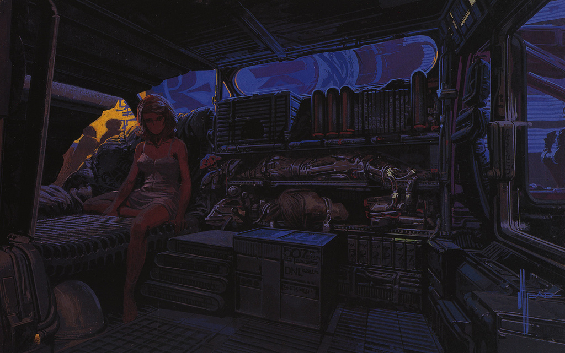

This piece of concept art by the artist Syd Mead (1982, Sebastian’s van interior)
is a good example of how effective colour, subject matter and lighting create atmosphere. The subject matter in this artwork is a landscape view of a cluttered bedroom with a woman inside. Syd Mead is famous for the amount of detail he puts into his art for example:

“When he created a new vehicle, for instance, it was plausible even if it was a sleek futuristic motorcycle, largely because Mead though the end result through in its entirety, working out how the vehicle would actually function based on existing technologies.” (Webster, A. 2017 )

This was a particular strength of Mead’s developed earlier in his life as a designer for transportation and architecture. The cluttered components stacked against the wall gives the painting a claustrophobic feel, this is because the parts of the cybernetic horse and futuristic containers. They take most of the space in the middle leaving very little left to display much else.

The various detail gives a sense of weight and purpose for all the items crammed into the room adding gritty realism to the sci-fi content. A quote from the book by Judith Kerman’s (1997, pp 93), retrofitting blade runner: issues in Ridley Scott’s blade runner and Philip K Dick's do androids dream of electric sheep? summarises how Syd meads skills in industrial design lent its self to the project and affects the mood of the concept art he produced. “Mead, in turn, has explained his vision of the future as one derived neither from SF (science fiction) literature nor film, but from his philosophy of industrial design.” This is important because it grounds the science fiction element in reality which gives a sense of familiarity and I feel this effect of the mood as it makes you feel more immersed.

The blue colours that dominate the paintings background gives a sombre lonely mood that is highlighted by the solitary figure of the woman on the bed. The orange lighting from the background shining through the window illuminates the woman in a reddish colour that complements the darker blue that surrounds the room. With the use of greys and silver portray the room as being almost completely cold and metallic with the only lights coming from outside and small details on the robotic parts. This adds to lonely feel of the piece that together paints a dense, dark and depressing view of the future.

In conclusion, after using various methods of research for an eventual dissertation such as visiting the library, using google scholar and looking for quotes from primary and secondary sources online to explore the topic of concept art. Using the technique of focusing in depth on the three keywords and researching three artists. Then applying their work to help give context to these themes has helped me come to a better understanding of the field of interest I would like to write about in my dissertation. I feel like by picking the key words I did it helped me understand and appreciate the important role of concept art as well as some of the important features it needs to convey to be successful at this role. By orientating myself to the keywords of Design, Style and Mood this has increased my understanding of how interconnected these three aspects are with each other and provides a solid base to expand upon in a dissertation.

I have decided that in the dissertation I will explore: What are the characteristics that define concept art? And how does this affect concept artists use of various mediums/ styles?

Bibliography

Quotes used

- Pickhall, J. (2012) “Just what is concept art?”
Available at: https://www.creativebloq.com/career/what-concept-art-11121155
(Accessed: 24th April 2019)
- Oxford University dictionaries (2019)
Available at: https://en.oxforddictionaries.com/definition/design
(Accessed: 24th April 2019)
- Magid, R. “Ralph Mcquarrie on Designing Star Wars”
Available at:
http://awdsgn.com/classes/fall09/webI/student/trad_mw/mcnamara/rmq/pages/interview.html#TOP
(Accessed: 24th April 2019)
- Mcquarrie, R. (1975) The Dual
Available at: https://www.starwars.com/news/ralph-mcquarries-most-memorable-masterpieces
(Accessed: 24th April 2019)
- Blauvelt, C .(2012) “Ralph Mcquarrie, ‘Star Wars concept artist, dies at 82”
Available at:https://ew.com/article/2012/03/04/ralph-mcquarrie-star-wars-artist-dies/
(Accessed: 25th April 2019)
- Encyclopaedia Britannica (2019) Art Deco art movement
Available at: https://www.britannica.com/art/Art-Deco
(Accessed: 27th April 2019)
- Snyder, D, D. (2017) ‘The horrible philosophy behind the star of ‘alien,’H.R. Giger’s Xenomorph’ Pacific Standard June 14th
Available at:https://psmag.com/social-justice/horrible-philosophy-behind-star-alien-h-r-gigers-xenomorph-81641
(Accessed: 27th April 2019)
- Grof, S, MD. The visionary world of H.R.Giger (2015)
Available at:http://www.stanislavgrof.com/wp-content/uploads/2015/02/Visionary.World_.Giger_.pdf, pp 4.
(Accessed :29th April 2019)
- Giger, H,R. (1977) Necronomicon lV
Available at: https://imgur.com/gallery/WdYwA
(Accessed: 27th April 2019)
- Webster, A. (2017) ‘Inside Syd Mead’s visions of the future, from Blade Runner to Tron.’
Available at:https://www.theverge.com/2017/9/24/16345612/syd-mead-art-design-book-blade-runner
(Accessed: 1st May 2019)
- Mead,S. (1982) Sebastian’s van interior
Available at: https://br.pinterest.com/pin/313281717800113470/
(Accessed: 1st May 2019)
- Kerman, J. (1997) Retrofitting Blade runner: issues in Ridley Scott’s Blade Runner and Philip K Dick’s do androids dream of electric sheep?2nd Ed, pp93
The University of Wisconsin press.

Looked at for information

- Shenoy, G. (2017) ‘Designing reality ahead of schedule: The science fiction worlds of Syd Mead, visual futurist’.
Available at: https://factordaily.com/syd-mead-visual-artist/
(Accessed: 1st May 2019)

Sopov, I, The Basic Principles for Great Character Design

Available at:https://blog.inkydeals.com/basic-principles-for-great-character-design/

(Accessed 24th April 2019)
- Railton, M. (2015) The art of designing appealing characters for animation
Available at: https://www.explanimate.com.au/the-art-of-designing-appealing-characters-for-your-animated-video/
(Accessed: 25TH April 2019)
- Reese, R,R. (2017) H.R. Giger’s ‘Alien’ art
Available at:https://futurism.media/h-r-giger-s-alien-art
(Accessed 27th April 2019)
- Beginners Guide to digital painting and Photoshop (2014) 3D Total publishing
(Accessed April 2019)
- Wmmvrrvrrmm. (2011) ‘Alien : Evolution of the Space Jockey via Giger’s Necronomicon’, Alien Exploration [blog].
Available at: http://alienexplorations.blogspot.com/2011/01/space-jockey-evolution-from-gigers.html
(Accessed: 27th April 2019)

- Tate galleries ‘Surrealism’
Available at: https://www.tate.org.uk/art/art-terms/s/surrealism
(Accessed 29th April 2019)
- Rassa, J (2018)‘ Concept art creation methodologies’
Avalible at : https://www.theseus.fi/bitstream/handle/10024/146949/Julia_Rassa_Thesis.pdf?sequence=1&isAllowed=y
(Accessed: 1st May 2019)
- Syd Mead.com(2019)’Biography’
Available at: http://sydmead.com/biography/
(Accessed 1st may 2019)
- Gelber, E.(2002) ‘A rare U.S. showing of H.R. Giger’s work’.
Available at:http://www.littlegiger.com/articles/files/Churn_6.pdf
(Accessed 27th April 2019)

