Name of the student: Nicoleta Briceag
Module Title: Introducing the Modern Workplace
Assignment title: Assessment 1 – Structure and Culture
Lecture's Name: John-Paul Okeke
Amazon

Table of Contents
Introduction 2
Discussion 3
Conclusion 9
Reference 10

Introduction
With the development in business methods and technology, many significant changes have been noticed in the modern workplace culture that has been designed to make more productivity. Earlier in an organisational environment there were only discussions related to work and both the employer and employees were interested to perform their part on a regular basis and leave. But with the development of modern theories, frameworks, models which not only explains the human nature and expectations, but also the possible ways to make a person closer to what he is performing, can increase the interactional level between an employee and employer. Also, these interactions create good workplace culture that boosts the moral of the employees. The present work will discuss the modern workplace culture of Amazon which is one of the leading e-commerce business organisations which will help other organisations to follow their lead and grow their own business culture.
Amazon is a multinational technology company which has its head quarter in Seattle and works mainly on e-commerce, cloud computing, digital streaming, and artificial intelligence. The company is considered as "one of the most influential economic and cultural forces in the world". The company was established in 1994 and within very short time grew its fame as one of the worlds’s most trusted brand. Apart from its various services it is mostly famous for its online marketplace which serves people with household products, electronic, grocery, book, apparel and jewellery. They also have made successful investments in entertainment system and e -wallet application. There are approximately 840,400 employees generating net income of 11.588 billion US Dollar for the company (Amazon, 2020).


Figure 1: Amazon head office
(Source: Amazon, 2020)

Discussion
In order to make an organization successful in every term, not only the product quality can help but it needs more individual improvement. For a complete growth, a good organizational culture is required which largely depends on the company values, its people, its structure which creates the benchmark for the organizational performance. An organizational structure plays an important role in the determination of the roles and responsibilities of the employees specially the managers and leaders who are responsible for driving the others for a said purpose (Solanki, 2019). Due to the large size of Amazon and its operation it was brilliant idea to follow the Hierarchical corporate structure for the company. In this system there is a senior management team which comprises 4 CEOs and 5 Senior Vice Presidents who are in charge of all the organizational operations and directly report to the CEO Jeff Bezos. This senior management team or the group of directors along with their executive officers take part in all decision- making activities while the chief finance officer takes care of the finance related issues.
There is also real estate and control section also under his supervision. In the second level of the management system chief technology officer, business development, North American retail officer, legal and secretary, international retail and kindle offices, e-commerce platform, digital media and web services officers are positioned. They are in charge of service implementation for the customers. The next level is associated with the delivery of the products while the second level officers answer the chief executive officer. In this laid structure it becomes easier to operate and communicate with each other and information comes using proper channel so that everyone can get access of it. Also, the management has ensured that the top management remains stable, so that in critical situations also the company can take concrete decisions. Therefore, the important dignitaries are there for several years. This hierarchical structure also helps to be highly flexible in nature despite of being such a large size organization (Zhang et al., 2018) This helps them to adapt any changes that are required to deal with the external marketplace. This visionary leadership and strategy have created a disruptive innovation in logistics industry.
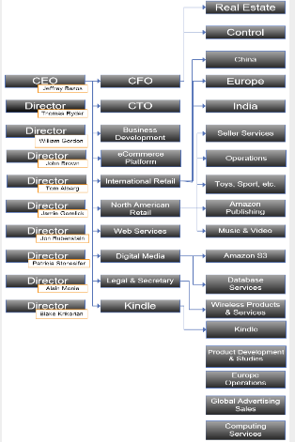
Figure 2: Organisational structure of Amazon
(Source: Amazon, 2020)
Organizational culture is another important aspect that helps employees to understand the mode of working at the organization (Paul et al., 2018). Good workplace culture helps to make new ideas and implement them and work peacefully, while stressed condition can result in disaster. According to the official website of Amazon, the company has taken the middle way of two (Amazon, 2020). The working culture of Amazon pushes the employees to think and work beyond traditional limits and make the better use of time and efforts. As they have a well laid plan for everything, therefore, after getting the fresh talent every now and then they arrange training sessions so that the trainees can understand how to perform for them. The environment is a bit workaholic in time in order to remain the best in customer satisfaction. The work culture of Amazon inspires its employees to be bold, to take risks and promotes openness.
In this case, it can be stated that the organisational culture and structure emphasises the performance level of each employee that ensure the growth of business operation. The organisational culture of Amazon influences the organisational structure so that the organisation has been able to determine specific roles and responsibilities of employees. The structure determines that they are working as a giant company and thus they always look for productivity, customer satisfaction and profit making. The management is also confident that as the senior board members take the necessary decisions for the company therefore the other employees should stick to their job and be performance oriented so that they could be paid well to be satisfied with the company. It has been stated that organisational culture can help in stimulating the mindset of employees to work simultaneously.
According to the Edgar Schein’s Model of Organizational Culture, no organization develop it values in one day but it is a result of experiences which shapes the values, practices and behaviours for the best results (Nakhaei et al., 2019). There are three levels of this model, of which the outermost part is called artefacts. This is the visible part of any organization such as décor, office design, dress code etc. and could be noticed by an outsider. Use of technology and traditional displays are also a part of it. The middle part of this model is value which helps the organizational members to take decision under desirable or undesirable situations. Often the company values are articulated, listed and arranged according to the priority but do not form a pattern. The innermost part of this model is basic assumptions which are not written but believe and thus is never challenged. When employees the basic assumptions related with a company, then the artefacts and values become coherent.
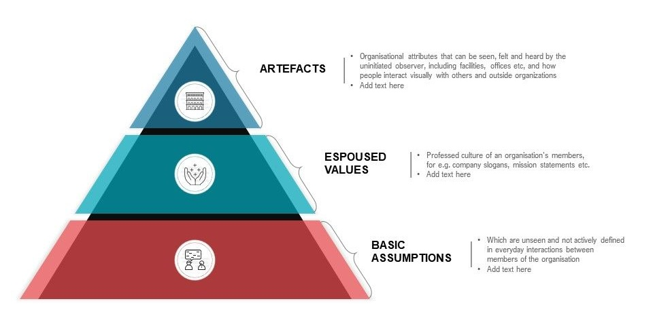
Figure 3: Edgar Schein’s Model of Organizational Culture
(Source: Nakhaei et al., 2019)
It is evident from the above discussion that for maintaining the top position of the company in regard to customer’s satisfaction the management of Amazon has made some rules and working guideline to strive for the best. The people over there are good, supportive and encouraging though the competition is high. This type of organizational culture makes a person focused on the life and career goals. From financial point of view this is remarkable though it can create immense pressure which may cause strain on human resources which can impact the organizational performance in a negative way.
In a workplace like Amazon there are many managers working with a lot of people under them to reach company objectives. They have mainly four functions to perform with their professional skills. Every manager needs to make a plan to be followed by everyone then he needs to organize resources for doing it. He is also responsible for leading the followers to work according to the plan and control them by monitoring and measuring the progress of the work (Lai et al., 2017).
It is essential for both managers and leaders to maintain and manage the organisational performance according to determined goals and objectives. The leaders of the organisation define the standard guidelines in which the projected goals can be achieved. They motivate their subordinates to improve their skills and performance level. Therefore, the high-quality performance can ensure the business growth and sustainability in the competitive market. In this context, managers of the organisation are expected to develop plan and rules for the employees to maintain, while accomplishing the projected tasks within workplace (Mash and Adler, 2018). The demography of both internal and external stakeholders, the decision making and leadership is conducted. Amazon is operating in a multicultural and economically diverse background, which needs to be studied by managers and strong decision or strategy making, can be conducted.
The last stage shows the monitoring and evaluating skill of the manager through comparing, measuring, finding deviation and correction of the activities done by the employees so that the target could be achieved without compromising the standard. In Amazon also, the managers of different departments take up their role as described here.
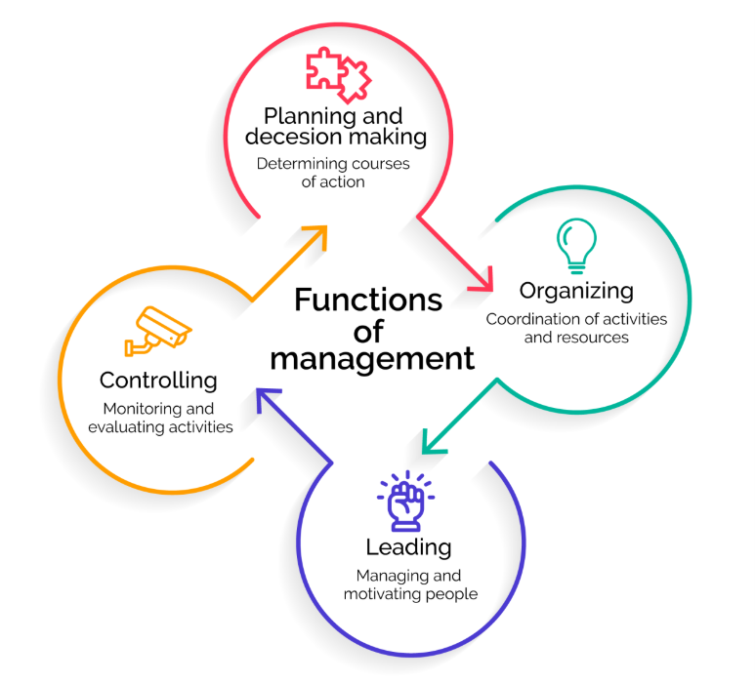
Figure 4: Managerial function and processes
(Source: Mash and Adler, 2018)
Apart from managers there are requirement of leaders who can motivate the employees to perform well to meet the organizational goal. Leaders are the people who lead a group by directing, coaching, supporting and delegating the followers (Nguyen et al., 2017). The choice of method among the above list reflects the decision- making characteristic of a leader. In directing method, the leader tells the follower the task, its method and the target timeline. Leaders who use the second method are visionary in type as they help the followers to understand the same vision before performance. Effective communication is made along with motivating the followers to believe in the project so that they can perform well. The third process is more or less collaborative in nature where leaders share their idea with his team and makes interesting leadership approach. All the team members are encouraged to put forward their views so that they also feel connected and develop interest to perform for it. In the last method, the leader does not actually lead a group but gives the authority to the followers so that they can take decision on their own and perform accordingly. In Amazon the leaders follow the directing approach as they hire the best people of the industry and expects that they will be given chance to prove their worth through performance (Bowers et al., 2017).
There are several variables that determine the effective management and leadership capabilities. Interpersonal and external connection skills, teamwork ability, sharing information, creating motivation among employees, initiating reforms and problem solving are some of them. The employees always want to stay connected with their leaders or managers so that they can convey any problem to them to get guidance for overcoming the situation. For this good connection between them are important (Palladan, 2018). Also, the manager or leader is the responsible person for the teamwork so that any target could be achieved within time. In this case of sharing information among them is required and employees should be motivated and encouraged with different approaches. While performing a work, there could be different problem facing situation and their employees need the guide of the leader so that they can learn from the situation with the expertise of an experienced person and solve the situation too. If this needs any reform then it should also be implemented for the sake of benefit. Amazon’s managers and leaders try to maintain all the factors so that their team can perform well. To understand their strategies the behavioural theory of leadership could be of great help.
According to the Behavioural Theory of Leadership, in any condition the observation can give the ultimate solution of a problem. This theory suggests that apart from the born leaders, it the behaviour of a leader that influences the other to get motivated. The whole thing depends on the situational demand and the leader needs to understand it and make reasonable decisions which could be fruitful over the time (Nawaz and Khan, 2016.). This theory believes that leaders can be made based on definable and learnable behaviour. Specific behaviours are given priorities which decide the leadership qualities that can influence others for performing well. The best leaders ate thus capable of adaptability to face any critical situation to walk on the right path. Adaptation of this theory helps the managers of Amazon to make a balance between different styles of leadership and evaluate the work progress.

Conclusion
In conclusion it could be said that Amazon and its working culture is different from many other organisations and they have the only focus for making their customers happy. Their strategy has been proved to be the pioneer for making their position high while providing the best services. The employees are getting good and competitive environment which helps them to learn and adapt with the situation and make their own benefit. The managers and leaders are also doing their best for making Amazon world’s best e-commerce organization.

Reference
About Amazon 2020. Available at: <https://www.aboutamazon.com/> [Accessed 6 August 2020].
Bowers, M.R., Hall, J.R. and Srinivasan, M.M., 2017. Organizational culture and leadership style: The missing combination for selecting the right leader for effective crisis management. Business Horizons, 60(4), pp.551-563.
Lai, T.C., Lai, M.C., Wei, C.S. and Wei, C.C., 2017. The model of role transformation for project managers. International Journal of Industrial and Systems Engineering, 27(2), pp.295-310.
Mash, R. and Adler, O., 2018. Human Resource Managers' Role Perception and Their Conflict Management Style. Journal of Sociology, 6(1), pp.41-55.
Nakhaei, K., Yazdifar, H. and Fagani, M., 2019. The Impact of Propagating Management Accounting Innovations on Organizational Culture. International Journal of Finance & Managerial Accounting, 4(13), pp.1-9.
Nawaz, Z.A.K.D.A. and Khan_ PhD, I., 2016. Leadership theories and styles: A literature review. Leadership, 16(1), pp.1-7.
Nguyen, T.T., Mia, L., Winata, L. and Chong, V.K., 2017. Effect of transformational-leadership style and management control system on managerial performance. Journal of Business Research, 70, pp.202-213.
Palladan, A.A., 2018. Toward Effective Strategy Implementation: the Role of Strategic Leadership Organizational Innovativeness and Information Technology Capability. Empirical Evidence. institutions, 18, p.20.
Paul, R., Saini, R. and Beniwal, R.K., 2018. Importance of organizational culture & its different dimensions. International Journal of Research in Economics and Social Sciences (IJRESS), 8(2).
Solanki, K., 2019. ‘To what extent does Amazon. com, Inc success be accredited to its organizational culture and ND Jeff Bezos's leadership style?. Archives of Business Research, 7(11), pp.21-40.
Zhang, Y., Li, J., Jiang, W., Zhang, H., Hu, Y. and Liu, M., 2018. Organizational structure, slack resources and sustainable corporate socially responsible performance. Corporate Social Responsibility and Environmental Management, 25(6), pp.1099-1107.

