
Databases and Application Development
Student Name | Dharar Ahmad Ahmad Morshid
Student ID | 2411713
Programme: | BSc Applied Computing
Module: | Databases and Application Development
Module code: | ACCA5026
Lecturer: | Mohd Syafiq Bin Zolkeply
Assignment Title: | Database Design & Implementation  Part A
Submission deadline: | Friday 31st July, 2026

Table of Contents
1. Introduction 1
2. Database Design 2
2.1 Entities and Attributes 2
2.2 Relationships 2
2.3 Entity Relationship Diagram (ERD) 3
2.4 Database Tables and Constraints 4
3. Database Implementation 4
3.1 Data Definition Language (DDL) 4
3.2 Data Manipulation Language (DML) 10
4. Stored Procedures 13
4.1 AddPatient Procedure 13
4.2 UpdatePatient Procedure 15
4.3 DeletePatient Procedure 17
5. Triggers 18
6. Performance Tuning 20
7. Conclusion and Reflection 23
8. References 24

1. Introduction
MedAssets Clinic is a remote healthcare facility in the United Kingdom that provides a range of patient healthcare services, include general medical consultations, diagnostics, specialist referrals, and treatment management. As the number of registered patients continues to raise, managing medical records using manually methods becomes efficient and rises the risk of data inconsistency, duplication, and human error.
To improve operating efficiency, the clinic requires a centralized relational database management system unable of securely storing and managing patient information, doctor details, appointment timetables, treatment records, departmental information, and patient feedback. The suggested database also supports many users, including administrative employees and healthcare professionals, while ensuring data integrity and consistency.
This project aims to design and implement a relational database for MEd Assist Clinic using MySQL. The database has been improved according to relational database design principles and normalized to Third Normal Form (3NF) to minimize redundancy and improve data integrity. The implementation including primary and foreign keys, constraints, stored procedures, triggers, transactions, indexes, and audit functionality to satisfy the functionality requirements of the clinic.
The final solution providing an efficient and scalable database capable of supporting the clinic's daily operations while ensuring secure, reliable, and accurate management of healthcare information.

2. Database Design

2.1 Entities and Attributes
The suggested database consists of six entities: Department, Doctor, Patient, Appointment, Treatment, and Feedback. Each entity stores a specific category of information required for managing the clinic.[1]
Stores information about medical department
Entity | Attributes
Department | DepartmentID (PK), DepartmentName, Location.
Doctor | DoctorID (PK), FirstName, LastName, Specialization, Phone, Email, DepartmentID (FK).
Patient | PatientID(PK), FirstName, LastName, DOB, Gender, Phone, Email, Address.
Appointment | AppointmentID, (PK), AppointmentDate, AppiontmentTime, Reason, Statues, PatientID (FK), DoctorID (FK).
Treatment | TreatmentID (PK), Diagnosis, Prescription, Notes, TreatmentDate, AppointmentID (FK).
Feedback | FeedbackID (FK), Rating, Comments, FeedbackDate, PatientID(FK), AppointmentID(FK),

2.2 Relationships
The entities are linked using primary and foreign key limitations to maintain referential integrity. These relationships ensure that the data remains accurate and consistent throughout the database.[2]
Relationship | Cardinality | Foreign Key
Department > Doctor | (1:M) | Doctor, DepartmentID
Doctor > Appointment | (1:M) | Appointment, DoctorID
Patient > Appointment | (1:M) | Appointment, PatientID
Appointment > Treatment | (1:1) | Treatment, AppointmentID
Appointment > feedback | (1:M) | Feedback, AppointmentId

2.3 Entity Relationship Diagram (ERD)
An Entity Relationship Diagram (ERD) was improved to visualize the database structure and relationships between all entities. The ERD including the six entities together with their attributes, primary keys, foreign keys, and relationship cardinalities.
The diagram explains how doctors belong to departments, appointments connect patients with doctors, treatments are associated with appointments, and feedback is submitted by patients following completed consultations.[3]
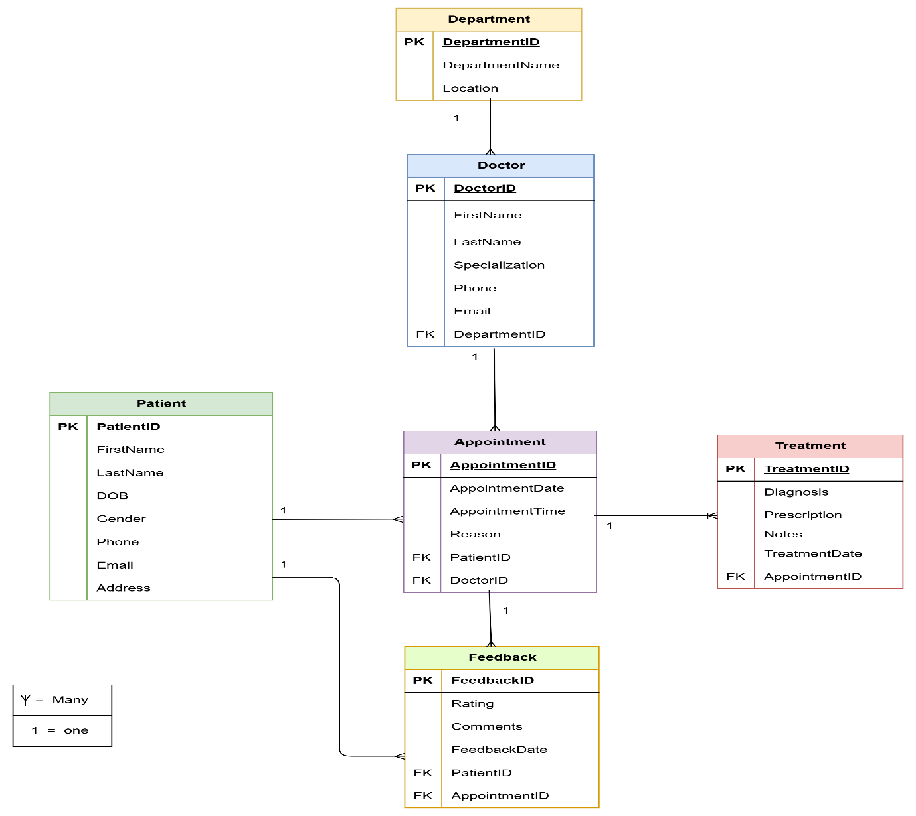

Figure 2.1: Entity Relationship Diagram (ERD) of the MedAssist Clinic Database.

2.4 Database Tables and Constraints
The database was implemented in MySQL using six relational tables based on the ERD. Each table including a primary key to unique identify records, while foreign keys establish relationships between related tables.[4]
Primary Keys (PK) exclusive identifies all record for each table.
Foreign Keys (FK) enforce referential integrity between relevant tables.
NOT NULL restrictions ensure that mandatory information cannot be left empty.
AUTO_INCREMENT automatically generates unique identification for primary key fields.
2.5 Database Normalization.
reduce redundancy, elimination data anomalies, and optimize data integrity. It divides data into linked tables and establishes relationships using primary and foreign keys. The objective of normalization is to confirm that each piece of information is stored only once while maintaining consistency through the database.[5]

(1NF): All tables contain atomic values with no repeating groups.
(2NF): Every non-key attribute depends entirely on its primary key.
(3NF): There are no transitive dependencies, and each non-key attribute depends only on the primary key.

3. Database Implementation
The MedAssist Clinic database was implemented using MySQL through phpMyAdmin. The implementation followed the Entity Relationship Diagram (ERD) and relational database design principles. Six relational tables were created with suitable primary keys, foreign keys, and integrity restrictions to ensure consistency and accurate of the stored data.
The functioning process consisted of creating database tables, inserting realistic sample data, development stored procedures, implementing triggers and functions, creating transactional scenarios, and optimizing database performance through indexing.[6]

3.1 Data Definition Language (DDL)
Data Definition Language (DDL) was used to create the database structure for the MedAssist Clinic system. The SQL statements define the database tables, primary keys, foreign keys, and integrity restrictions required to maintain accurate relationships between the entities. The database consists of six main tables: Department, Doctor, Patient, Appointment, Treatment, and Feedback. Each table was created according
to the Entity Relationship Diagram (ERD) to ensure consistency, eliminate redundancy, and enforce referential integrity.[7]

Table structure for table `department`
CREATE TABLE `department` (
`DepartmentID` int(11) NOT NULL,
`DepartmentName` varchar(100) NOT NULL,
`Location` varchar(100) DEFAULT NULL
) ENGINE=InnoDB DEFAULT CHARSET=utf8mb4 COLLATE=utf8mb4_general_ci;

-- Table structure for table `appointment`
CREATE TABLE `appointment` (
`AppointmentID` int(11) NOT NULL,
`AppointmentDate` date NOT NULL,
`AppointmentTime` time NOT NULL,
`Reason` varchar(200) DEFAULT NULL,
`Status` varchar(20) DEFAULT NULL,
`PatientID` int(11) NOT NULL,
`DoctorID` int(11) NOT NULL
) ENGINE=InnoDB DEFAULT CHARSET=utf8mb4 COLLATE=utf8mb4_general_ci;

Table structure for table `doctor`
CREATE TABLE `doctor` (
`DoctorID` int(11) NOT NULL,
`FirstName` varchar(50) NOT NULL,
`LastName` varchar(50) NOT NULL,
`Specialization` varchar(100) DEFAULT NULL,
`Phone` varchar(20) DEFAULT NULL,
`Email` varchar(100) DEFAULT NULL,
`DepartmentID` int(11) DEFAULT NULL
) ENGINE=InnoDB DEFAULT CHARSET=utf8mb4 COLLATE=utf8mb4_general_ci;

-- Table structure for table `patient`
CREATE TABLE `patient` (
`PatientID` int(11) NOT NULL,
`FirstName` varchar(50) NOT NULL,
`LastName` varchar(50) NOT NULL,
`DOB` date DEFAULT NULL,
`Gender` varchar(10) DEFAULT NULL,
`Phone` varchar(20) DEFAULT NULL,
`Email` varchar(100) DEFAULT NULL,
`Address` varchar(200) DEFAULT NULL
) ENGINE=InnoDB DEFAULT CHARSET=utf8mb4 COLLATE=utf8mb4_general_ci;

- Table structure for table `treatment`
CREATE TABLE `treatment` (
`TreatmentID` int(11) NOT NULL,
`Diagnosis` varchar(200) DEFAULT NULL,
`Prescription` text DEFAULT NULL,
`Notes` text DEFAULT NULL,
`TreatmentDate` date DEFAULT NULL,
`AppointmentID` int(11) DEFAULT NULL
) ENGINE=InnoDB DEFAULT CHARSET=utf8mb4 COLLATE=utf8mb4_general_ci;

Table structure for table `feedback`
CREATE TABLE `feedback` (
`FeedbackID` int(11) NOT NULL,
`Rating` int(11) DEFAULT NULL CHECK (`Rating` between 1 and 5),
`Comments` text DEFAULT NULL,
`FeedbackDate` date DEFAULT NULL,
`PatientID` int(11) DEFAULT NULL,
`AppointmentID` int(11) DEFAULT NULL
) ENGINE=InnoDB DEFAULT CHARSET=utf8mb4 COLLATE=utf8mb4_general_ci;

Department Table
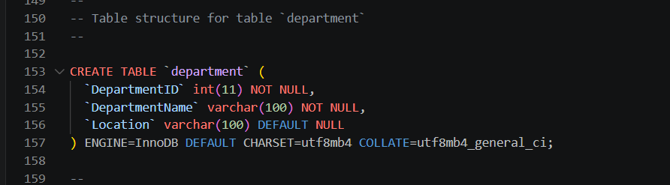
Figure 2: SQL statement used to create the Department table.
This table stores the clinic departments. Each department is identified by a unique DepartmentID and can be associated with multiple doctors.
Doctor Table
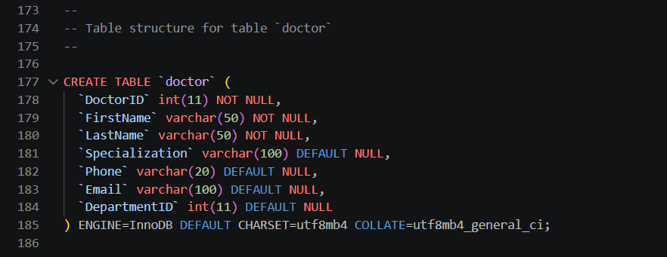
Figure 3: SQL statement used to create the Doctor table.
This table stores doctor information. The DepartmentID foreign key links each doctor to a specific department, establishing a one-to-many relationship.

Patient Table
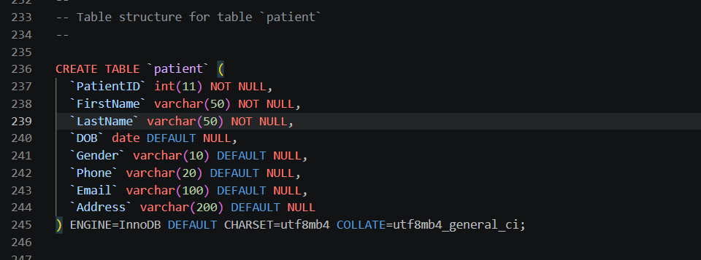
Figure 4: SQL code for creating the Patient table.
This screenshot displays the SQL CREATE TABLE statement used to create the Patient table in the MedAssist Clinic database. The table stores the personal information of registered patients, including their first name, last name, date of birth, gender, phone number, email address, and home address. The PatientID field is defined as the primary key to unique identify each patient record, while the remaining fields store essential information required for patient registration and appointment management. This table serves as the institution for maintaining accurate patient records and supports relationships with other tables such as Appointment, Treatment, and Feedback.

Appointment Table
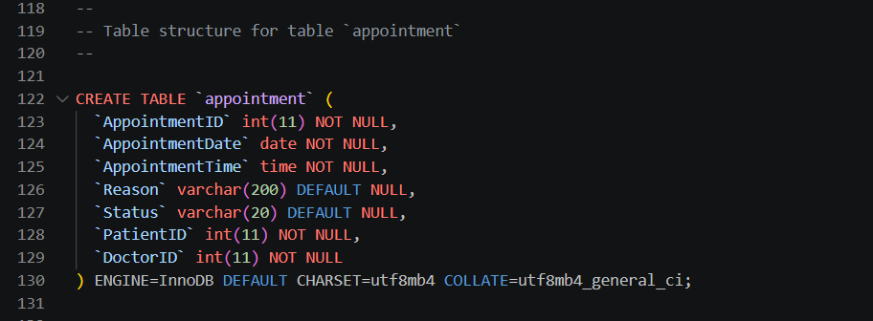
Figure 5: SQL code for creating the Appointment table.
This screenshot appears the SQL CREATE TABLE statement used to create the Appointment table in the MedAssist Clinic database. The table stores information about patient appointments, includes the appointment date, appointment time, reason for the visit, and appointment status. It also contains the PatientID and DoctorID fields, which are used to establish relationships with the Patient and Doctor tables. This design ensures that every appointment is linked to a valid patient and doctor, supporting efficient appointment planning and main training data integrity within the database.
Treatment table
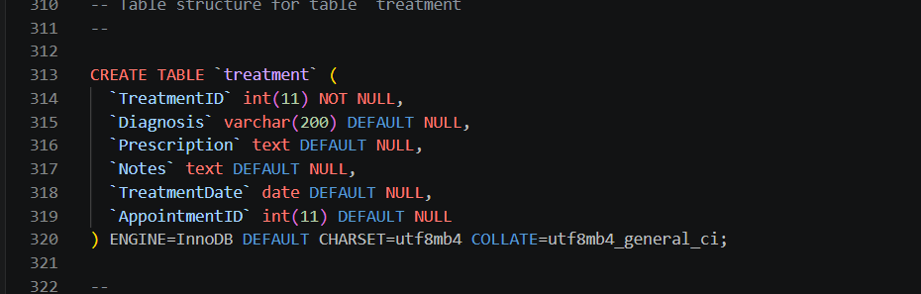
Figure 6: SQL code for creating the Treatment table
This screenshot shows the SQL CREATE TABLE statement used to create the Treatment table in the MedAssist Clinic database. The table stores treatment information linked to each patient appointment, with the diagnosis, prescription, medical notes, and treatment date. The AppointmentID field is used to link each treatment record to a specific appointment, ensuring that treatment details are associated with the correct consultation. This table enables the clinic to maintain accurate treatment histories and supports effective patient care and medical record management.

Feedback table
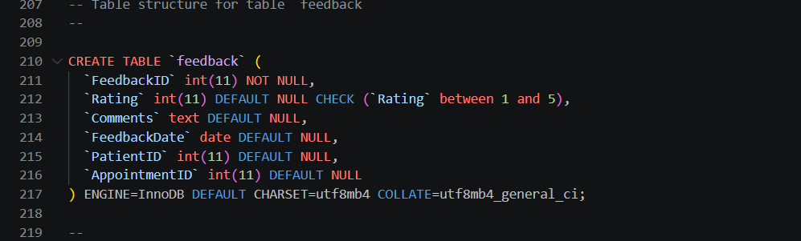
Figure 7: SQL code for creating the Feedback table.
This screenshot displays the SQL CREATE TABLE instruction used to create the Feedback table in the MedAssist Clinic database. The table stores feedback submitted by patients after their appointments, includes the evaluating, comments, and feedback date. A CHECK constraint is applied to the Rating field to ensure that only values between 1 and 5 are accepted, maintaining data accuracy. The PatientID and AppointmentID fields are used to associate each feedback record with the corresponding patient and appointment, allowing the clinic to monitor patient satisfaction and evaluate the quality of health care services.

3.2 Data Manipulation Language (DML)
Data Manipulation Language (DML) was used to populate the MedAssist Clinic database using realistic sample data. The included records simulate the daily operations of the clinic, includes departments, doctors, patients, appointments, treatments, and patient feedback. The sample data was gently designed to test the relationships between tables and verify that all primary key and foreign key constraints were functioning correctly.[8]

Department Table
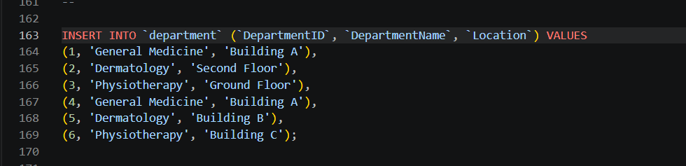
Figure 8: SQL code for inserting sample data into the Department table.
This screenshot shows the SQL INSERT INTO statement used to populate the Department table with sample data. The records include department names and their corresponding locations within the MedAssist Clinic. Sample data was added to simulate real-world functions and to test the relationships between the Department table and other related tables, such as the Doctor table. This data ensures that the database can support realistic queries and maintain referential integrity during testing.

Doctor table
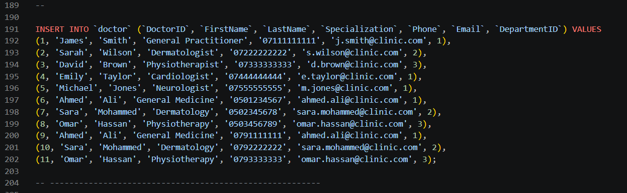
Figure 9: SQL code for inserting sample data into the Doctor table.
This screenshot shows up the SQL INSERT INTO statement used to populate the Doctor table with sample data. The records include each doctor's first name, last name, medical specialization, phone number, email address, and the corresponding DepartmentID. The sample data was inserted to simulate real clinic staff and to establish connections between the Doctor and Department tables. This enables the database to supporting appointment schedule and ensures that doctors are correctly assigned to their respective departments during testing.
Patient table
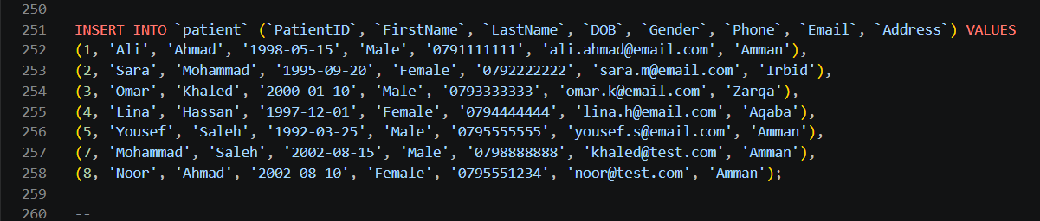
Figure 10: SQL code for inserting sample data into the Patient table.
This screenshot shows the SQL INSERT INTO statement used to populate the Patient table with sample patient details. The inserted data including each patient's first name, last name, date of birth, gender, email address, phone number, and home address. These sample details were added to simulate true patient information and to support testing of the database relationships with the Appointment, Treatment, and Feedback tables. Using accurate sample data helps verify that the database functions correctly and supports efficient patient management within the MedAssist Clinic system.

Appointment table
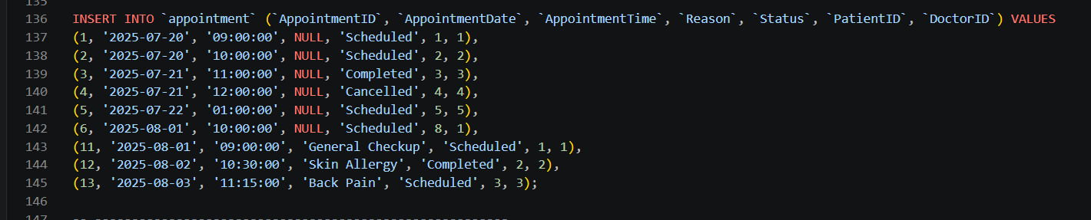
Figure 11: SQL code for inserting sample data into the Appointment table.
This screenshot shows the SQL INSERT INTO statement used to populate the Appointment table with sample appointment details. The inserted data including the appointment date, appointment time, appointment status, reason for the visit, and the corresponding PatientID and DoctorID. These records were created to simulate real appointment bookings and to test the connections between the Appointment, Patient, and Doctor tables. The sample data also allows the database to support scheduling, consultation management, and transaction testing within the MedAssist Clinic system.
Treatment table
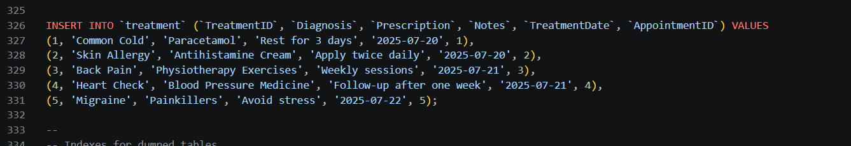
Figure 12: SQL code for inserting sample data into the Treatment table.
This screenshot shows the SQL INSERT INTO statement using populate the Treatment table with sample treatment details. The inserted data including the diagnosis, prescribed medication, medical notes, treatment date, and the accompanying AppointmentID. These sample records simulate the treatments provided to patients after their consultations and ensure that each treatment is correctly linked to a specific appointment. This data was used to test the functionality of the database and verify the connection between the Treatment and Appointment tables.

Feedback table
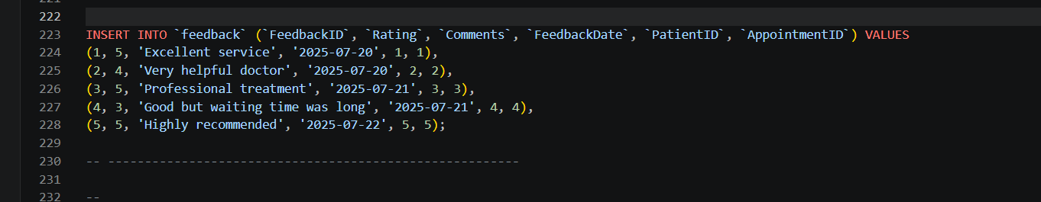
Figure 13: SQL code for inserting sample data into the Feedback table.
This screenshot shows the SQL INSERT INTO statement using populate the Feedback table with sample patient feedback details. The inserted data includes the patient rating, feedback date, comments, and the associated PatientID and AppointmentID. These sample records were added to simulate patient feedback after medical consultations and to test the connection between the Feedback, Patient, and Appointment tables. This information allows the clinic to evaluate patient satisfaction, monitor service quality, and ensure that each feedback record is linked to the correct patient and appointment.

The successful insertion of sample data proved that all relationships between the tables were correctly implemented. The foreign key constraints ensured that related records could only be inserted when valid parent records already existed, supporting the integrity and consistency of the database.

4. Stored Procedures
Stored procedures were executed to automate common database operations and improve the efficiency of the MedAssist Clinic database. Using stored procedures reduces repetitive SQL code, improves consistency, and ensures that database operations are executed in a controlled and secure manner. Three stored procedures were developed to perform the basic CRUD (Create, Update, and Delete) operations on patient records.[9]

4.1 AddPatient Procedure
The AddPatient stored procedure is used to insert a new patient into the Patient table. The procedure accepts the patient's personal information as input considerations and stores the record in the database. This simplifies the patient registration process and reduces the possibility of data entry errors.

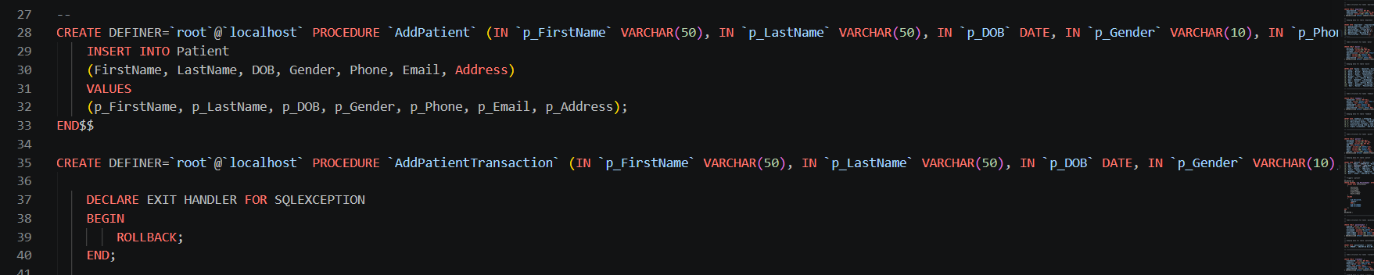
Figure 14: SQL code for the AddPatient and AddPatient Transaction stored procedures.
This screenshot shows the SQL code used to create the AddPatient and AddPatient Transaction stored procedures in the MedAssist Clinic database. The AddPatient procedure inserts a new patient record into the Patient table using the information provided by the user. The AddPatient Transaction practice performs the same operation within a database transaction and including exclusion handling with ROLLBACK to maintain data integrity if an error occurs. These stored procedures automate patient registration, reduce repetitive SQL code, and ensure that data is inserted consistently and securely.

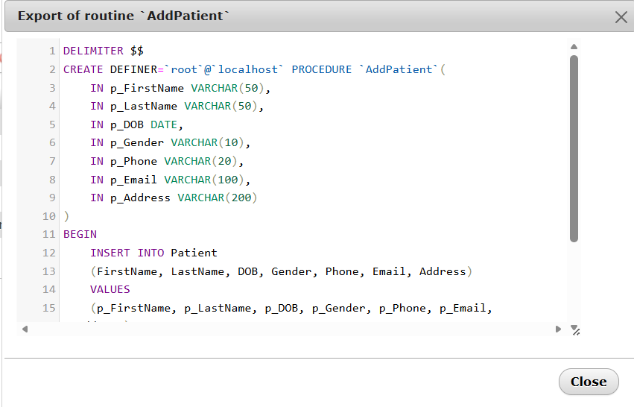
Figure 15: SQL code for the AddPatient stored procedure.
This screenshot shows the SQL code used to create the AddPatient stored procedure in the MedAssist Clinic database. The procedure accepts patient details, including the first name, last name, gender, date of birth, phone number, email address, and home address as input limits. It then inserts these values into the Patient table, allowing new patient records to be added efficiently. Using a stored procedure simplifies data entry, betters consistency, and reduces the need to repeatedly write SQL INSERT statements.

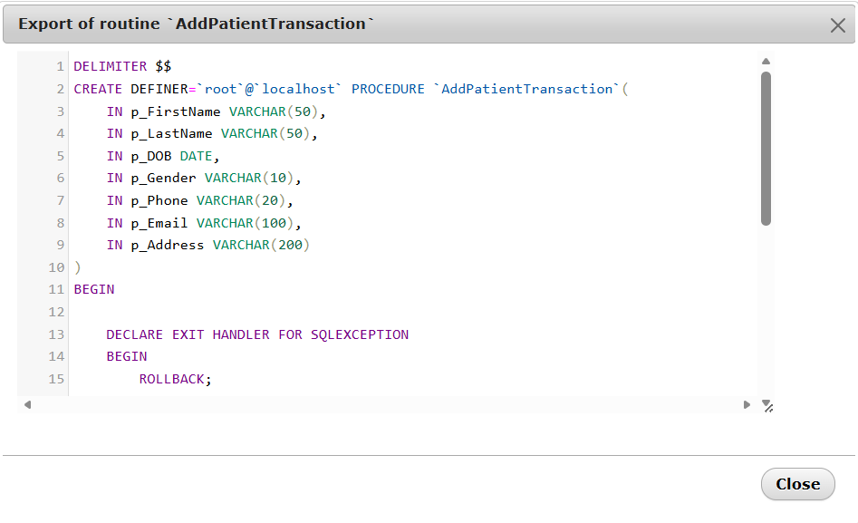
Figure 16: SQL code for the AddPatient Transaction stored procedure.
This screenshot shows the SQL code used to create the AddPatient Transaction stored procedure in the MedAssist Clinic database. The procedure accepts patient information as input limits and performs the insertion within a database transaction. It includes an EXIT HANDLER for SQL exclusions, which automatically executes a ROLLBACK if an error occurs throughout the transaction. This ensures that short or invalid data is not stored in the database. If the transaction is completed successfully, the changes are saved using COMMIT, maintaining data consistency and integrity.

4.2 Update Patient Procedure
The Update Patient stored procedure updates an existing patient's information, such as phone number and email address. The procedure recognizes the patient using the PatientID primary key and modifies only the specified fields while keeping the remaining data.
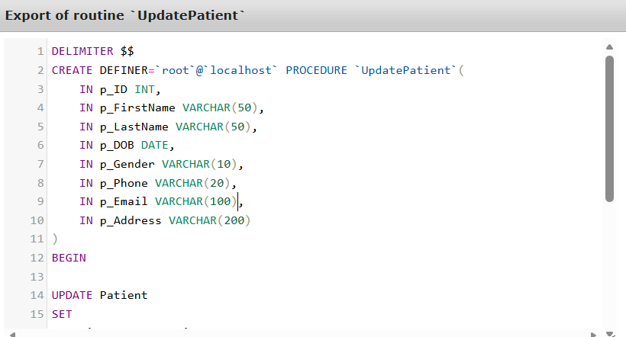
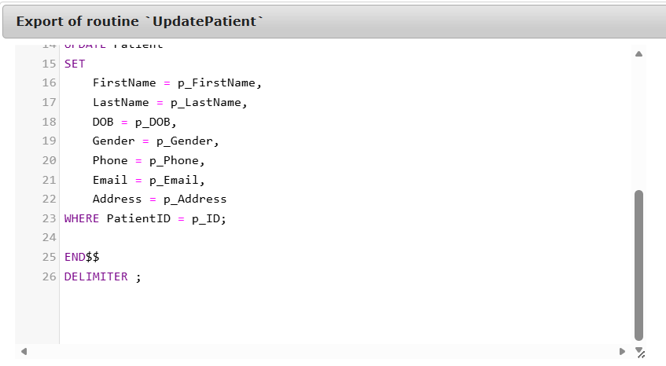
Figure 17: SQL code for the Update Patient stored procedure.
screenshot shows the SQL code used to create the Update Patient stored procedure in the MedAssist Clinic database. The procedure accepts the PatientID together with updated patient information, including the first name, last name, gender, date of birth, phone number, email address, and home address. It then updates the corresponding patient details in the Patient table using the UPDATE statement. This stored procedure allows patient information to be modified efficiently while ensuring that only the selected patient record is updated. Using a stored procedure also improves consistency, simplifies database operations, and enhances application security by centralising the update logic.

4.3 Delete Patient Procedure
The Delete Patient stored procedure deletes a patient record from the database using the PatientID. This procedure helps administrators manage obsolete records while maintaining database consistency. 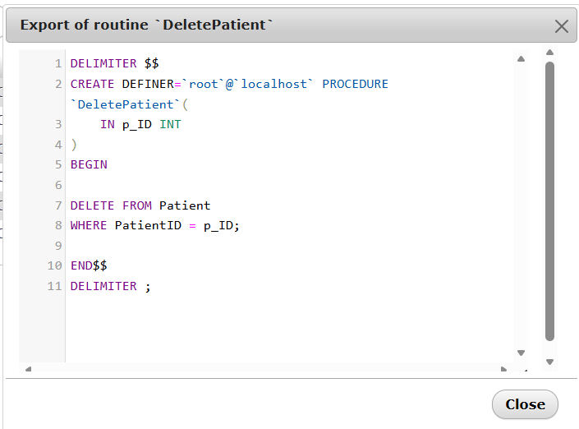Referential integrity constraints prevent the deletion of records that are still referenced by related tables.

Figure 18: SQL code for the Delete Patient stored procedure.
This screenshot shows the SQL code used to create the Delete Patient stored procedure in the MedAssist Clinic database. The procedure accepts the PatientID as an input parameter delete off the corresponding patient record from the Patient table using the DELETE statement. By using a stored procedure, patient records can be deleted in a controlled and consistent manner while reducing the need to execute manual SQL commands. This approach improves database management, simplifies maintenance, and helps ensure that deletion operations are performed accurately.

5. Triggers
A database trigger was implemented to provide an auditing mechanism for the MedAssist Clinic database. The trigger automatically details changes made to patient information whenever an update operation is performed on the Patient table. This ensures that important modifications are logged without requiring manual intervention.[10]
The trigger inserts the patient's prior and updated information into the Patient Audit table collected with the type of action and the date on which the change occurred. This auditing process improves accountability, supports data tracking, and helps executives monitor changes made to patient records.
The trigger executes automatically before a patient details is updated, ensuring that the original values are preserved before any modifications are applied.
The trigger was tested by updating a patient's first name in the Patient table. After the update was completed, the Patient Audit table was queried to verify that the previous and latest values had been successfully recorded.
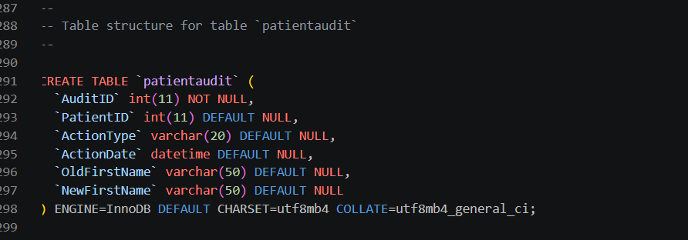
Figure 19: SQL code for creating the Patient Audit table.
This screenshot shows the SQL CREATE TABLE statement used to create the Patient Audit table in the MedAssist Clinic database. Though this is not the trigger itself, it is the table that the trigger uses to store audit records whenever a patient's information is updated. The table records main details such as the PatientID, Action Type, Action Date, Old FirstName, and New FirstName. By maintaining these records, the Patient Audit table gives an audit trail of changes, allowing executives to monitor database modifications, improve accountability, and support data integrity and security.

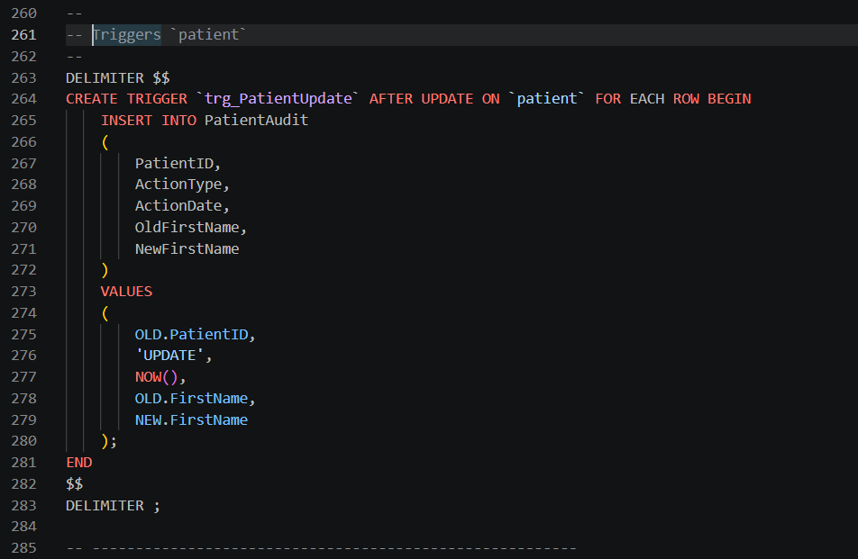
This screenshot shows the SQL code used to create the trg_PatientUpdate trigger. The trigger is executed routinely whenever a patient's record is updated. It inserts an audit record into the Patient Audit table, storing the patient ID, the action type, the date of the update, and both the old and new first names. This reviewing mechanism improves data integrity and supplies a history of changes made to patient records.
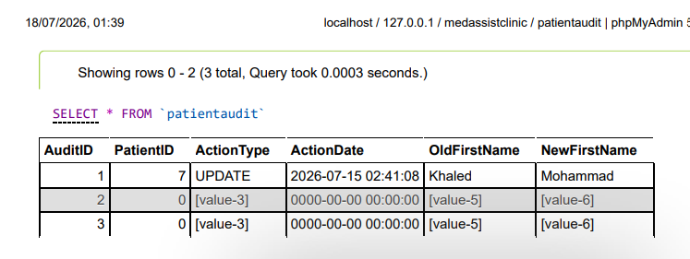
This screenshot shows the contents of the Patient Audit table after the trigger was executed. When a patient's first name was updated, the trigger automatically created an audit history containing the patient ID, the action type (UPDATE), the date and time of the change, and both the old and new first names. This confirms that the trigger executed successfully and provides a reliable audit trail for tracking changes to patient records.

6. Performance Tuning
Performance tuning is an important aspect of database design because it develops the speed and efficiency of data recovery. In the MedAssist Clinic database, indexing was used as the primary performance optimization method. Indexes were created on frequently read columns such as Patient LastName, Appointment Date, and DepartmentID in the Doctor table. These columns are commonly used in search operations, filtering, and table joins.
Without indexes, the database management system must scan each row in a table to locate the expected information, which becomes inefficient as the amount of data improves. By creating indexes, MySQL can fast locate matching records, lowering query execution time and improving whole system performance. This optimisation is particularly beneficial for organizational staff who regularly search for patient records, doctors within specific departments, and appointments scheduled on a particular date.[12]
The indexing plan also supports the links between tables by improving the performance of queries involving foreign keys. As the MedAssist Clinic database grows, indexes will help maintain immediate response times and ensure efficient access to medical records and appointment information. Therefore, implementing indexes enhances both the scalability and usability of the database while supporting the clinic's day-to-day operations and improving the general user experience.
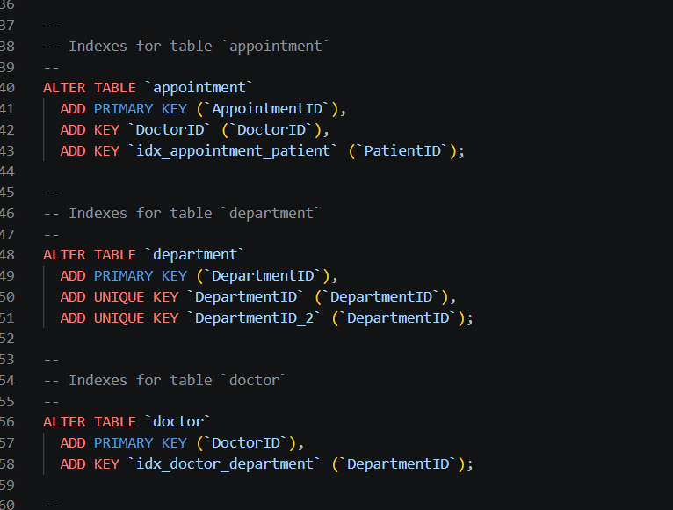
Figure 21: SQL code for creating indexes to improve database performance.
This screenshot shows the SQL statements used to create indexes on the Appointment, Department, and Doctor tables. Primary keys are defined to uniquely identify every record, while additional indexes are created on DoctorID, PatientID, and DepartmentID to improve query performance. These indexes reduce the time needed to retrieve data when searching for appointments, doctors, or departments. By indexing frequently queried columns, the database can execute search and join operations more efficiently, resulting in faster response times and improved overall system performance for the MedAssist Clinic database.

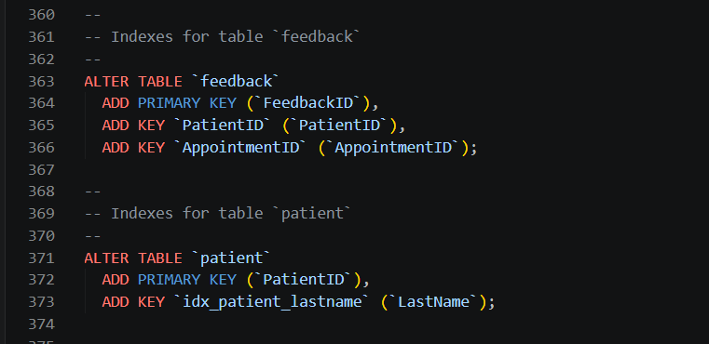
Figure 22: SQL code for creating indexes on the Feedback and Patient tables.
This screenshot shows the SQL statements used to create indexes on the Feedback and Patient tables to better database performance. A primary key is defined for each table to ensure that every record is uniquely identified. Additional indexes are created on PatientID, AppointmentID, and LastName, which are frequently used in search conditions and table joins. These indexes help the database retrieve records more efficiently, lowering query execution time when searching for patient information or retrieving feedback related to a specific patient or appointment. As a result, the indexing strategy betters the overall performance, scalability, and responsiveness of the MedAssist Clinic database.

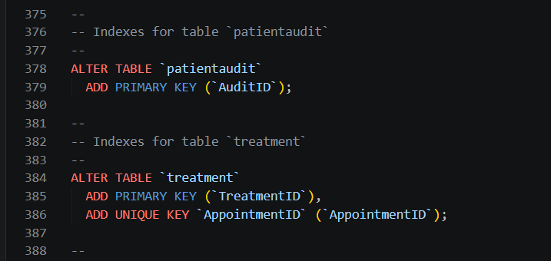
Figure 23: SQL code for creating indexes on the PatientAudit and Treatment tables.
This screenshot shows the SQL statements used to create indexes on the Patient Audit and Treatment tables. The AuditID field is defined as the primary key in the Patient Audit table to confirm that each audit record is uniquely recognised. Similarly, the TreatmentID field is assigned as the primary key in the Treatment table, while a UNIQUE index is created on the AppointmentID column to ensure that each appointment is linked to only one treatment record. These indexes improve query performance, support efficient data retrieval, and help maintain data integrity by enforcing uniqueness where required. The indexing strategy enhances the overall efficiency and reliability of the MedAssist Clinic database.

7. Conclusion and Reflection
This project successfully designed and implemented a relational database system for the MedAssist Clinic using MySQL. The database was developed to manage key clinic operations, including patient recording, doctor management, appointment scheduling, treatment recording, and patient feedback. An Entity Relationship Diagram (ERD) was created to model the relationships between the main entities, and the database was normalised to Third Normal Form (3NF) to minimise data redundancy and maintain data integrity.
The implementation included the design of tables with appropriate primary and foreign key constraints, realistic sample data, stored procedures, triggers, and transaction handling using BEGIN, COMMIT, and ROLLBACK. These aspects helped ensure that database operations were reliable and that data remained consistent even when errors occurred. In addition, indexing was applied to frequently accessed columns to improve query performance and support efficient data retrieval.
One of the main challenges during the development of this project was ensuring that all relationships between tables were correctly implemented. Several foreign key constraint errors occurred while including sample data, which required careful attention to the order in which records were inserted. Another challenge was realizing triggers and stored procedures correctly, particularly when testing transaction handling and audit functionality. These challenges were resolved through testing, debugging, and verifying the SQL statements.
Whole, the completed database satisfies the functional requirements of the MedAssist Clinic and provides a secure, structured, and efficient solution for managing clinic information. The development also improved my practical understanding of relational database design, SQL programming, and database administration. In the future, the system could be enhanced by adding user authentication, role-based access control, encrypted sensitive patient information, automated appointment reminders, and a graphical web interface. These improvements would increase the security, usability, and scalability of the system while providing a better experience for both clinic staff and patients.

8. References
[1] M. J. Hernandez, Database Design for Mere Mortals: A Hands-On Guide to Relational Database Design, 4th ed. Hoboken, NJ, USA: Addison-Wesley Professional, 2021.
[2] Shin, S.-S. (2022). Teaching Method for Entity-Relationship Models Based on Semantic Network Theory. IEEE Access, 10, 94908–94923. https://doi.org/10.1109/ACCESS.2022.3206028
[3] Avignone, A., Tierno, A., Fiori, A., & Chiusano, S. (2025). Exploring Large Language Models’ Ability to Describe Entity-Relationship Schema-Based Conceptual Data Models. Information (Basel), 16(5), 368. https://doi.org/10.3390/info16050368
[4] Hernandez, M. J. (2021). Database design for mere mortals : a hands-on guide to relational database design (Fourth edition.). Addison-Wesley.
[5] Albarak, M., Bahsoon, R., Ozkaya, I., & Nord, R. (2022). Managing Technical Debt in Database Normalization. IEEE Transactions on Software Engineering, 48(3), 755–772. https://doi.org/10.1109/TSE.2020.3001339
[6] Geerts, F., Ngo, H. Q., & Sintos, S. (2023). PODS ’23 : Proceedings of the 42nd ACM SIGMOD-SIGACT-SIGAI Symposium on Principles of Database Systems. Association for Computing Machinery. https://doi.org/10.1145/3584372
[7] T. Connolly and C. Begg, Database Systems: A Practical Approach to Design, Implementation, and Management, 7th ed. Harlow, U.K.: Pearson, 2023.
[8] Wanjiru, B., Van Bommel, P., & Hiemstra, D. (2026). Clause-Driven Automated Grading of SQL’s DDL and DML Statements. Proceedings of the 57th ACM Technical Symposium on Computer Science Education V.1, 1117–1123. https://doi.org/10.1145/3770762.3772599
[9] Hu, G., Wang, Z., Tang, C., Shen, J., Dong, Z., Yao, S., & Chen, H. (2024). WeBridge: Synthesizing Stored Procedures for Large-Scale Real-World Web Applications. Proceedings of the ACM on Management of Data, 2(1), Article 64. https://doi.org/10.1145/3639319
[10] Le, A. H., Van Khanh, T., & Thuan, T. N. (2021). Formal Analysis of Database Trigger Systems Using Event-B. International Journal of Software Innovation, 9(4), 158–173. https://doi.org/10.4018/IJSI.20211001.oa1
[11] Oracle, MySQL 8.4 Reference Manual: Triggers. Oracle Corporation, 2025. Available: MySQL Reference Manual – Triggers. Accessed: Jul. 24, 2026.
[12] A. Jones, SQL Server: Advanced Performance Tuning and Optimization Strategies. Walzone Press, 2025.
[13] G. Fritchey, SQL Server 2022 Query Performance Tuning. Berkeley, CA, USA: Apress, 2023.

