Assignment 1:
Leadership and Management, Theory and Practice
LinkedIn CEO- Jeff Weiner

Executive Summary:
For the following assignment I will be selecting a leader of a business organisation and investigating the leadership approach they utilise, especially focusing on how it benefits the business. Furthermore, I will also highlight some of the weaker attributes of the leader to find new innovative styles to recommend.
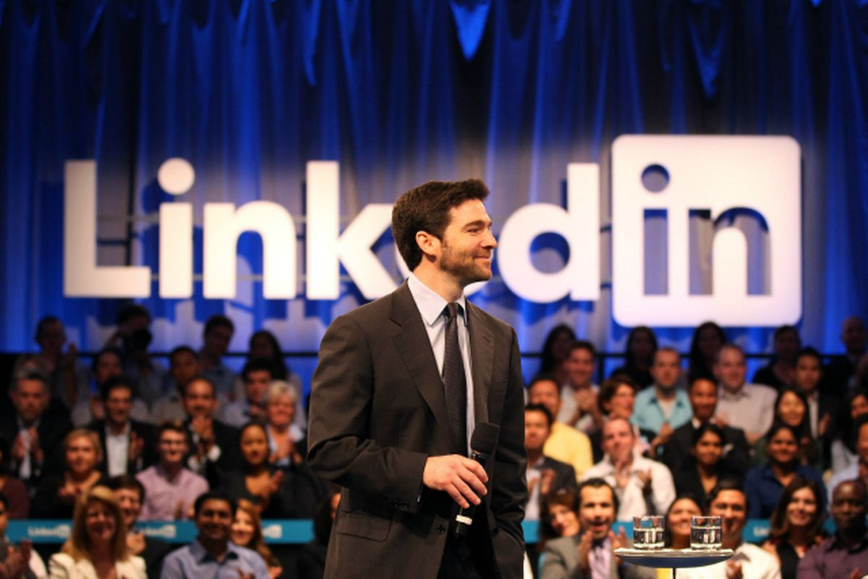This report will also be focusing on the use of different models and frameworks of leadership and how organisations use the various different styles to lead and manage in the most efficient way. The history of leadership theories and theorists is also a key area where I will be comparing both dated and modern styles. Lastly I will be aiming to illustrate how Jeff Weiner leading his teams and individuals has built the organisation allowing it to maintain productive working relationships.

Introduction:
The main focus of this module is Leadership which has various definitions both online and in textbooks all showing slight variations. The definition which I considered as the most accurate is, “The process of influencing others to understand and agree about what needs to be done and how to do it, and the process of facilitating individual and collective efforts to accomplish shared objectives”(G, Yukl, 2006)
This description was written by Gary Yukl who is the author of several books, including the highly influential text, Leadership in Organisations which is widely used around the world and was translated into several languages. I feel his definition accurately highlights what leadership should be about in my eyes, which is the talking into and the knowing of a shared task ahead and collectively looking at the best ways for the group to complete the task.
“The only definition of a leader is someone who has followers”. (The Drucker Foundation, 1996) I decided to include a more dated definition of leadership to show an example of the stereotypical contrast of how Leadership may have been perceived in the past.

Jeff Weiner:
The individual who I have chosen to analyse for this report is world renowned entrepreneur Jeff Weiner. Mr. Jeffrey Weiner, is an American business man who was born in 1970 in New York. He is the chief executive officer (CEO) of LinkedIn, a business-related social networking website which has seen huge growth recently within the business sector.
Mr Weiner attended The Wharton school of Economics at the University of Pennsylvania where he obtained a B.S Degree in 1992. His business LinkedIn has the web’s largest and most powerful network of professional people. Previously, Jeff Weiner was an Executive in Residence at Accel Partners and Greylock Partners.
These jobs were focused around Jeff advising the leadership teams of the firm's existing consumer portfolios and he also worked closely with the firm’s partners to evaluate new investment opportunities.
He served in his first key leadership role at web service provider Yahoo! For over seven years. He worked his way up the company ladder finishing as the Executive Vice President of Yahoo!'s Network Division. As Executive Vice President of Yahoo, he demonstrated his exceptional skills as a leader with a team of over 3,000 employees, managing products reaching over 500 million consumers.
“You have to maintain a culture of transformation and stay true to your values.” Jeff Weiner

History of Leadership:
The understanding of leadership has seen a huge alteration since the last century, with new research from theorists being the driver for our behaviours. Many people have tried to define leadership to a tee. However even in our current practices leaders often show various styles and traits. Many different excellent researchers, philosophers and professors have published leadership theories.
I felt it would be important to mention one of the first theories on leadership called The Great Man Theory. “Though the historic timeline consistently plants the Great Man Theory in the 19th century, we can see its deep roots present in many of today’s practical assumptions about leadership. While there are minor adjustments, the heroic leader remains rooted in individualistic cultures.” (G, Early, 2017)

Behavioural Theories (1940's - 1950's)
This theory was given a unique perspective looking more towards the behaviour of a leader as oppose to their mental, physical or social traits. At this time the use of psychometrics was coming into play which allowed researchers to carry out factor analysis. I feel this theory demonstrates a strong understanding that a leader should fulfil their role, working their way to the top. Theories previous to this would argue people are born leaders and that the characteristics are natural.
Theories such as the Ohio State University Study and the University of Michigan study became the dominant approaches to leadership in the 1940’s & 1950’s.
The Ohio study of leadership did not follow the usual approach of looking at someone’s traits. Instead they analysed how an individual acted when in the leader position, they asked the staff to fill out questionnaires about there leaders. The study led to the composition of the LBDQ which consisted of 150 questions. (Hemphill & Coons 1957)
Six years ahead and Ralph Stogdill who was a Professor of Management Science and Psychology at Ohio State University managed to construct a shortened version of the LBDQ. This is a widely used instrument in heaps of organisations such as the military and in education.
The second theory which I mentioned was the Michigan State Theory which researched how leadership functioned in small groups.
Rensis Likert focused on two different types of leadership both employee orientation which related to a leaders personal needs. Then he looked at product orientation which is almost the opposite and views the leader as a means of getting tasks completed. In today’s workplace you would still see these dated approaches to leadership.
To finish on the Michigan studies carried out by Likert his results showed that a leader focusing more on employees rather than task based goals proved to get a more positive outcome.
“Likert eventually developed four "systems" of management based on these studies; he advocated System 4 (the participative-group system, which was the most participatory set of leader behaviours) as resulting in the most positive outcomes (Encyclopedia of Management, 2009).

Contingency Theories (1960's)
Moving on sharply from the behavioural approach to leadership, a theory was derived that believed that there is no one correct way to lead. This is a very different theory which outlined that leadership styles should be relevant to particular situations. Essentially leaders tend to prefer to be in a certain environment therefore if taken out of there element they may not perform as well.
“Tannenbaum and Schmidt (1975) were among the pioneers to describe various factors (within the manager, the subordinates and the situation) they believed influenced a manager’s choice of leadership style. They put the factors in a continuum varying from leader-centered / boss centered (autocratic) to subordinate–centered (democratic). The authors pointed out that a leader should not choose a strict „autocratic‟ or democratic style but should be flexible enough to be able to choose a style to cope with different situations.”(O, Peretomode, 2012)
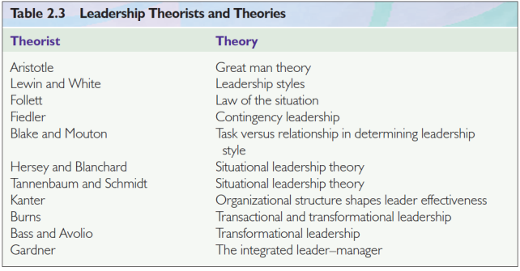In Figure 1 I have provided a table showing the timeline of theory’s and there writers.
(The Functions of Manager in an Organisation, About.com -Economics. (2009)

Figure 1

Throughout my research I have seen that there are links between contingency theory and trait theory. Both of these theories involve the leader exercising there roles in order to get the most proactive result from the followers. (S, Virkus, 2009) This is a widely used theory with many benefits such as the fact It is a flexible approach for a leader stressing that they need to find out about their followers needs and adapt to support them. (Yukl, 1989)

Jeff Weiner- Modern leadership and Management
Personally I feel leadership in management has always remained a talking factor with different organisations having different leaders for different positions.
“Over the past 75 years, the leadership literature has become a morass of competing theories. Each one has argued its own unique perspective about what makes leaders successful. As newer theories have developed, older perspectives have continued unabated.” (N.R Abramson, 2009) I feel this theorist describes well how the use of both new and old leadership styles is still very prominent in most organisations.
For example Jeff Weiner stresses the importance of his leadership being specific to the company’s needs. I feel this correlates with the contingency theory, illustrating that there is no one correct way to lead and that different followers react differently. “At LinkedIn, Leadership is the ability to inspire others and achieve shared results. It starts with defining a clear vision. In the case of LinkedIn it is to create economic opportunity for the 3.3 billion people in the global workplace by matching skills with job opportunities.”(Jeff Weiser Video Interview 2009, J, Meister)

The first theory I will be analysing is Full range Leadership Theory was stemmed from transformational leadership models in the early 21st Century. “This theory, originally developed by Antonakis, Avolio, and Sivasubramaniam (2003), suggests that there are nine factors impacting leadership style and its impact on followers; five are transformational, three are transactional, and one is a non leadership or laissez-faire leadership factor” (Rowold & Schlotz, 2009)

The first factor of this theory is inspirational motivation which relates to the leader’s ability to motivate employees by using there vision. Employees in the 21st century want to feel a part of something big in an organisation as opposed to just being a number. Furthermore I feel Jeff Weiner is an excellent example of a leader who motivates employees with his bigger picture for LinkedIn.
In 2009 CEO of LinkedIn, Jeff Weiner conducted his first video interview which was live streamed on Youtube and other platforms. He stresses a point surrounding the encouragement of his employees to think more like him which I feel relates to the Full range leadership theory.
“Employees in a start-up must understand the business decisions they make are ones that have P&L implications. In the case of LinkedIn, this means understanding how the decisions they are making impact the company mission of connecting the world’s 640 Million professionals and making them more successful.” (J, Meister, 2012)
I selected Jeff Weiner for this study on leadership because I wanted to analyse a leader who was very relevant in the modern workplace. LinkedIn is a very unique application with a huge network of 364 million users with offices in over 30 different countries. The leadership of a mass organisation like LinkedIn would require undivided attention.
"You have to feel it deeply to be able to overcome those challenges and for people to want to follow you. And if you're not authentic in that belief and you don't have true conviction, they're not going to be behind you."(J, Weiner, 2012)
Weiner is not the typical CEO in my eyes as he prefers to be directly involved with all levels of the hierarchy. The stereotypical CEO of today would be known for delegating work to people and giving out instructions. However Weiner says he finds it important to allow his employees to put there personality into working towards the joint vision of the company.
Conclusion
In conclusion to this report I feel my findings have illustrated Jeff Weiser as a team orientated leader who drives his passion into employees in the hope it will reflect on the organisation as whole. In my opinion leadership should focus on the leader’s ability to realise what the people in the organisation require to perform to there best ability. Instead of leader’s who focus purely on results and show a lack of compassion to employees.
"The more people you're responsible for, the more your words and the way you communicate those words and your body language and essentially everything you do is taken into consideration by the team,"(J, Weiser,2012)
“Different individuals also require different styles. You may need to manage an intelligent, competent and trustworthy team member by using transformational techniques whereas someone who is lazy and unreliable may require an authoritarian style.”(A, O’Malley)

References:

- Gary Yukl (2012). Leadership in Organisations. England: Pearson Education. 17-60.

- Peter. F. Drucker (1996). Your Leadership Is Unique. San Francisco: Drucker Foundation. 1-2.

- "BLANK". (2013). Leadership Theories. Available: http://www.leadership-central.com/leadership-theories.html#axzz5B3ssvhfN. Last accessed 28th March 2018.

- J, Weiser. (2018). Jeff Weiner. Available: https://www.linkedin.com/in/jeffweiner08/. Last accessed 21st March 2018.

- Definition. (2016). Leadership. Available: http://www.businessdictionary.com/definition/leadership.html. Last accessed 26th March 2018.

- Blank. (2016). Dr. Gary Yukl. Available: https://hstalks.com/expert/2213/dr-gary-yukl/. Last accessed 28th March 2018.

- Dr (Mrs.) Otaroghene Peretomode. (2012). Situational And Contingency Theories Of Leadership: Are They The Same?. IOSR Journal of Business and Management. 4 (3), p 1-5.

- S, Virkus. (2009). Leadership model. Available: http://www.tlu.ee/~sirvir/IKM/Leadership%20Models/the_university_of_michigan_studies.html. Last accessed 27/03/18.

- International Leadership Association . (2013). Ralph Stodgil. Available: http://www.ila-net.org/LeadershipLegacy/Ralph_Stogdill.html. Last accessed 29/03/18.

- University of Kent. (2017). How to find out your style of leadership.Available: https://www.kent.ac.uk/careers/sk/leadership.htm. Last accessed 29/03/18.

- Jeanne Meister . (2012). 10 Leadership Lessons From Jeff Weiner, CEO of LinkedIn. Available: https://www.forbes.com/sites/jeannemeister/2012/09/10/10-leadership-lessons-from-jeff-weiner-ceo-of-linkedin/#6f9255d439a4. Last accessed 2013

