

Student Name: Kishan Sangani
Student ID: 2527211
Module Name and code: LCMB7024
Marketing Management
Title: Unilever EcoLoop – Smart Refill & Circular Packaging Network

Table of Contents
Element 1: Sustainable Brand Extension Poster Presentation 3
Element 2: Develop a Segmentation, Targeting, Differentiation, and Positioning (STDP) 4
2.1 STDP Analysis 4
2.2 Target Audience Analysis 6
2.3 Differentiate Strategy 7
2.4 Positioning Outline 8
Element 3: 7Ps Marketing Mix 9
Element 4: Reflection 16
References 20
Appendix 1: Poster Content 24

Element 1: Sustainable Brand Extension Poster Presentation
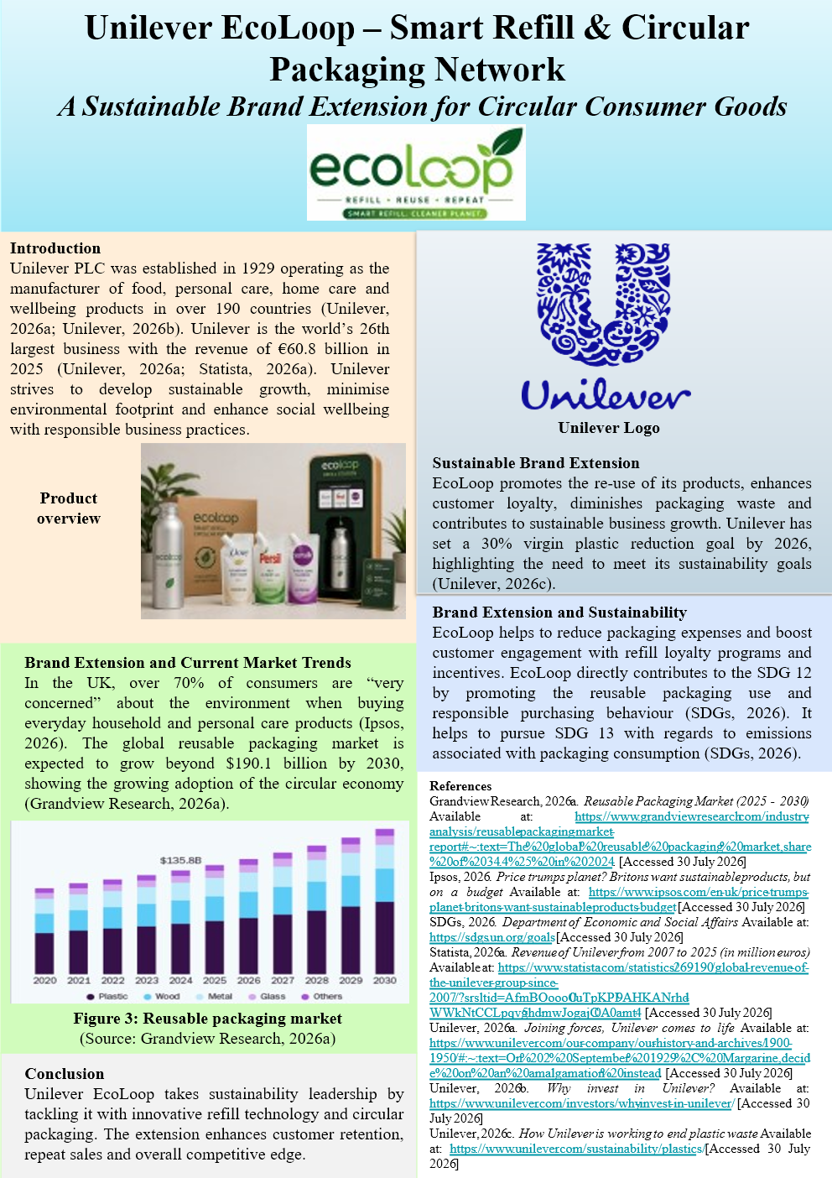

Element 2: Develop a Segmentation, Targeting, Differentiation, and Positioning (STDP)
Analysis for the brand extension

2.1 STDP Analysis
Segmentation (S) | Targeting (T) | Differentiation (D) | Positioning (P)
Geographic, focusing on location-based approaches | Individuals live in metropolitan cities such as London, Birmingham, Manchester and Edinburgh. | Unilever EcoLoop enables refill stations using AI, carbon neutral delivery services and easy access to supermarkets. | Technology integration and environmental benefit for the busy urban consumer seeking a convenient refill option.
Demographic, focusing on population-based approaches | Millennials and Generation Z, aged 25-40 years, with moderate household incomes. | Unilever EcoLoop offers reusable, aluminium containers, inexpensive refill subscriptions and rewards. | The high-quality refill economy brings affordability to the modern household in the UK.
Psychographic, focusing on lifestyle and value-based approaches | Environmentally conscious individuals who prefer technology and sustainable-oriented brands that ensure circular economy approaches. | Unilever EcoLoop combines QR-based lifecycle tracking, environmental impact data and personalised incentives, fostering consumer trust. | Transparent circular packaging ecosystem supports and educates environmentally aware consumers to make conscious and responsible choices.
Behavioural, focusing on purchase intention-based approaches | Individuals who prefer to buy products from Unilever and already participate in the loyalty programmes. | Unilever EcoLoop offers personalised refill subscription programs with AI reminders, increasing repeat purchases. | The refill ecosystem builds sustainable consumption in the long-term relationship with the customer.
Table 1: STDP Analysis
(Source: Self-developed)
Geographic Segmentation
The geographical segment centers on the consumers of London, Manchester, Birmingham and Edinburgh, where there are a range of sustainability programs, refill stations and digital retailing in place. Circular economy practices are more prevalent and accessible among these urban markets (Siderius and Zink, 2023). The cities are chosen due to high demand for convenient, technologically advanced and sustainable home-buying solutions.
Demographic Segmentation
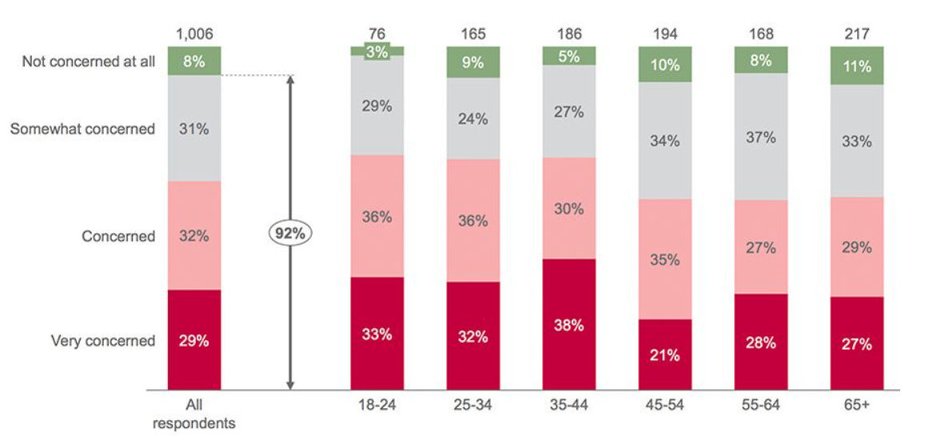Figure 1: UK consumers prefer sustainability products
(Source: Consultancy UK, 2026)
Unilever will target the middle income, aged 20-45 individuals as these people show most concern towards the environmental dimensions (Consultancy UK, 2026). This audience will make regular purchases of top-tier household products, making Unilever EcoLoop a sustainable and cost-effective refill option.
Psychographic Segmentation
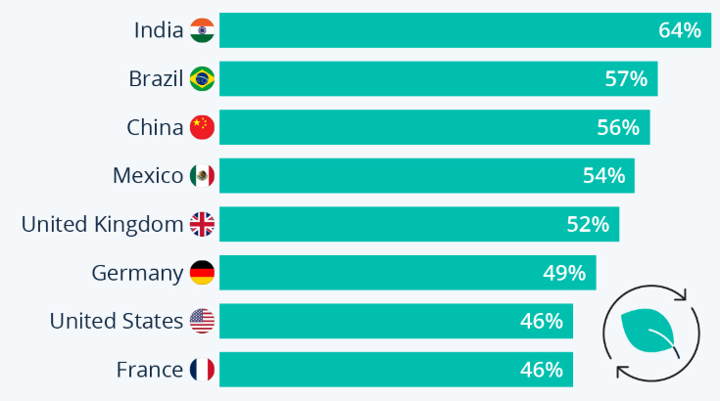
Figure 2: UK consumers preferences towards eco-friendly packaging
(Source: Statista, 2026b)
The psychographic segment consists of tech-savvy consumers who seek premium quality products and use digital platforms to research and purchase products. Further, the eco-minded customers as about 52% of UK consumers prefer eco-friendly packaging in contemporary days (Statista, 2026b). Therefore, Unilever EcoLoop can meet the eco-friendly packing demand by implementing smart refill technology, reducing the plastic packaging waste.
Behavioural Segmentation
The behavioural segment consists of consumers who buy more frequently with a loyalty for Unilever products. It has been seen that Unilever products are found among 95% of UK households with 3.7 billion consumers (Unilever, 2026b; Unilever, 2026c). Hence, by promoting refill programmes, Unilever EcoLoop can reinforce long-term purchasing behavior and customer retention.

2.2 Target Audience Analysis
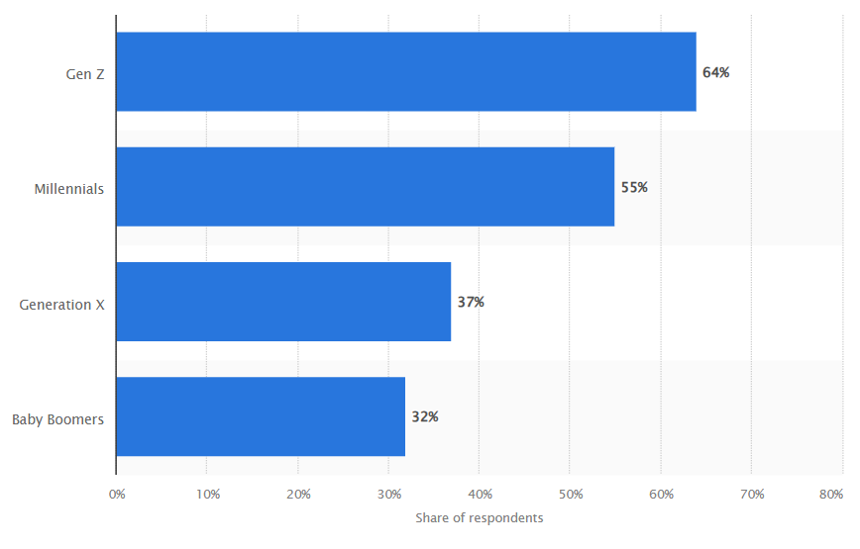
Figure 3: Consumers who prioritise sustainable practices
(Source: Statista, 2026c)
Their main target audience includes Millennials and Generation Z consumers, aged 20-45, live in urban areas with medium household income. About 64% of Gen Z and 55% of millennials prefer sustainable practices compared to older populations and refill based consumption offers illustrate such sustainable practices, highlighting the suitability of selecting this specific population (Statista, 2026c) . Teenagers are not included as they have less purchasing power than adults for products and services within the household. The selection of such a specific audience can be supported by The Diffusion of Innovation (DoI) theory as it states that people who accept new ideas first, namely the innovators and early adopters, can shape broader market acceptance for new products (Mbatha, 2024). Unilever EcoLoop will engage these consumers with AI-driven refill reminders, QR codes for sustainability information, supermarket refill stations and personalised loyalty incentives.

2.3 Differentiate Strategy
Unilever has always differentiated itself by the trusted global brands, product innovation at every turn, robust sustainability commitments and by marketing campaigns with a purpose. The focus of differentiation will shift from product quality to providing a full circular consumption ecosystem, including AI-powered refill reminders, QR-enabled lifecycle transparency and refill subscriptions for Unilever EcoLoop. This aligns with the Value Proposition theory which states that the essence of competitive advantage is the provision of functional, emotional and environmental benefits that are not easily imitated by competitors (Brunner et al., 2024). Therefore, Unilever EcoLoop is about providing superior customer value by convenience, measurable environmental impact and long-term cost savings.

2.4 Positioning Outline
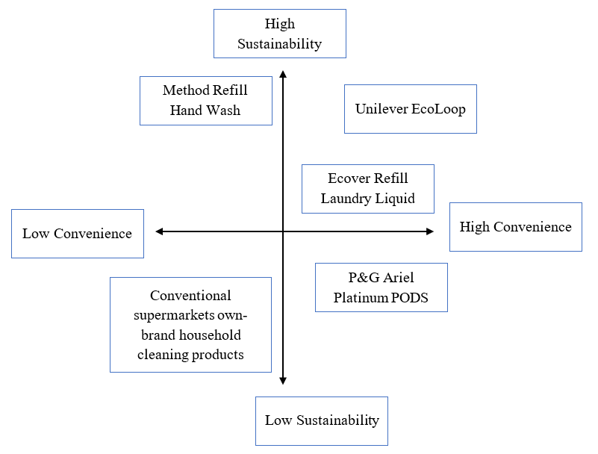
Figure 4: Competitive Positioning
(Source: Self-developed)
P&G Ariel Platinum PODS, Ecover Refill Laundry Liquid and Method Refill Hand Wash are key competitors, offering sustainable alternatives with the potential to be disruptive. These products do not come with AI refill reminders, QR code tracking of product lifecycles, carbon neutral delivery and cross-brand loyalty rewards such as Unilever EcoLoop. This holistic solution provides enhanced convenience, deeper customer connection, and long-term customer value (Bing et al., 2024). EcoLoop thus succeeds in making digital innovation more competitive, while concurrently working towards environmental sustainability and re-establishing customer relationships.

Element 3: 7Ps Marketing Mix
The 7Ps Marketing Mix helps organisations to create a strategy and integrated marketing approach to create a customer value from seven interconnected marketing elements (Jain et al., 2022).
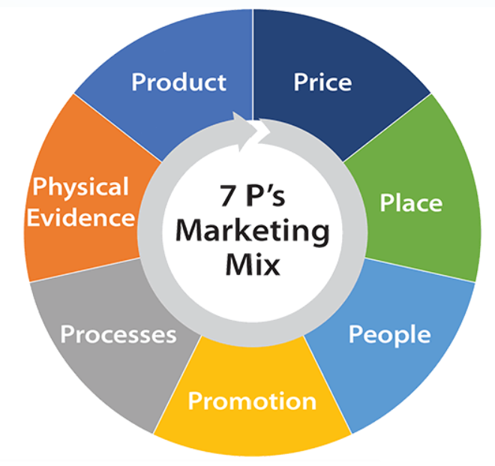
Figure 5: 7Ps Marketing Mix Concept
(Source: Self-developed)
The 7Ps framework is used by Unilever EcoLoop to ensure that all marketing decisions align with sustainability goals, enhance customer engagement, foster circular usage, and contribute to sustainable business growth.
Factors | Illustration
Product | - EcoLoop reusable aluminium refill bottles for Dove, Persil and Sunsilk  - A lifecycle tracking and refill subscription service for QR codes powered by AI
Price | - Premium introductory bottle (available for £12.99) and cheaper refills (£4.99 to £6.99)  - Monthly membership discounts and EcoLoop loyalty discounts
Place | - Refill stations are present in supermarkets such as Tesco, Sainsbury's, and ASDA  - Available on Unilever website and application, allowing customers to order online
Promotion | - Social media campaigns, sustainability influencers and digital advertising  - QR education campaigns, personalised e-mail promotions
People | - Retail employees and customer service with sustainability training  - EcoLoop brand ambassadors and delivery partners
Process | - Contains purchase of the product, scan QR code, receive AI reminders, refill and earn EcoLoop rewards
Physical Evidence | - Premium aluminium bottles, smart refill stations and EcoLoop mobile app and environmental impact dashboard
Table 2: 7Ps Marketing Mix for Unilever’s EcoLoop
(Source: Self-developed)
Product
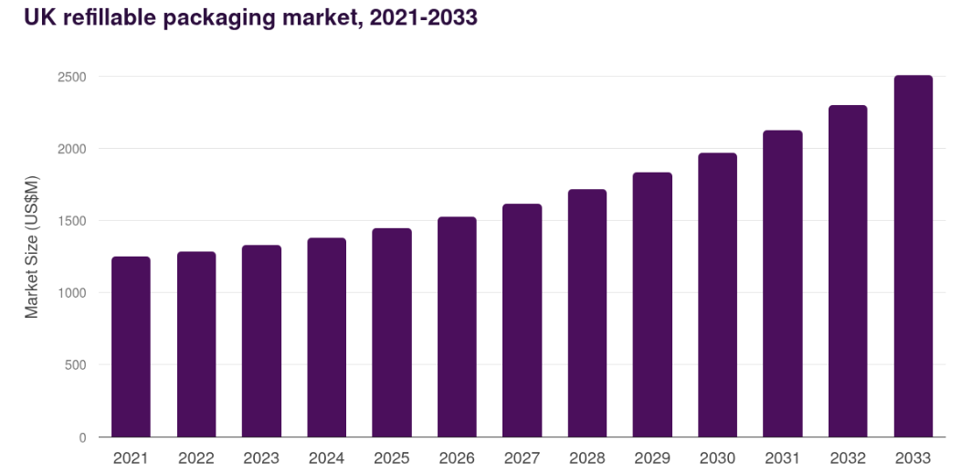
Figure 6: Refillable packaging market
(Source: Grandview Research, 2026b)
The EcoLoop product is a combination of reusable aluminium containers, reusable refill pouches and AI-based refill technology, to help minimise single-use plastic use while keeping the premium quality of Unilever’s products. However, the product not only includes the physical packaging only, but also digital lifecycle transparency with QR codes providing environmental information. Although the reusable containers will cost more upfront, it will save money in the long run because of the reusability. The refillable packaging market is growing at a CAGR of 7.3% with the current size of $1,449.6 million, illustrating the high demand of such products (Grandview Research, 2026b). Therefore, Strategically, EcoLoop is turning the consumption of conventional household products into a technology-enabled circular consumption experience, creating sustainable competitive advantage.
Price
At Unilever, value-based pricing is realised by pricing reusable containers at a premium and refills at a lower price and providing subscription discounts. However, price sensitive consumers not familiar with refill systems may be deterred by the higher starting price (Tassell and Aurisicchio, 2023). Selling on a subscription model or offering loyalty rewards for customers, Unilever will expect greater retention and a recurring revenue stream. A different approach will be to offer discounts to students or promotional packages to swiftly stimulate trial among young eco-conscious shoppers.
Place

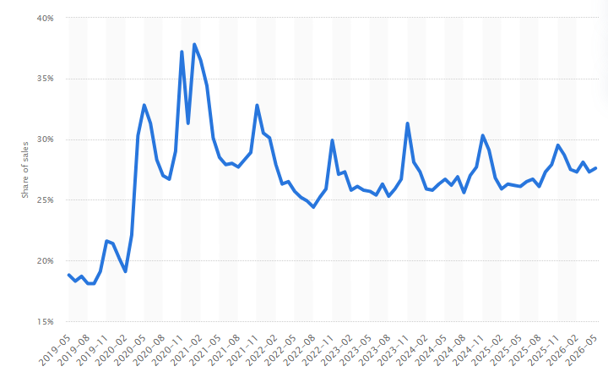
Figure 7: UK online sales
(Source: Statista, 2026d)
The Unilever EcoLoop will adopt an omnichannel approach, through the supermarket refill stations, online ordering and home delivery, to maximise the reach of its proactive circular campaign. However, making physical refill stations is the only way to access products, it will negatively impact the availability of products to rural consumers. The online retail sales in the UK is more than 27%, showing that the use of online channels will boost market penetration (Statista, 2026d). Therefore, beside adding the product to Tesco, Sainsbury’s and ASDA, digital buying platforms will be added. Strategically, the physical and digital supply chain integration creates a more convenient customer experience, securing EcoLoop’s competitive edge.
Promotion
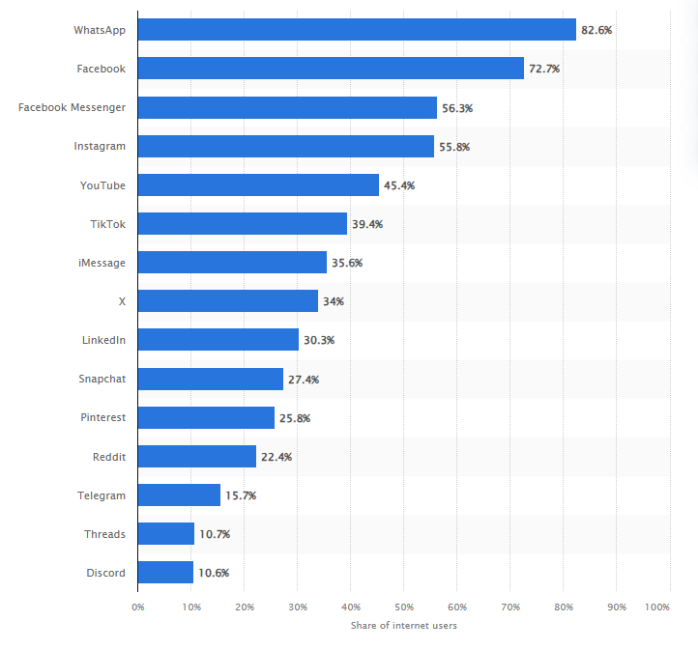
Figure 8: Social media usage in the UK
(Source: Statista, 2026e)
In promotion, Unilever will share quantifiable environmental gains via digital marketing, sustainability narratives and tailored interaction. The social media platforms, especially Instagram, Facebook and YouTube will be used to promote the product as more than 55%, 72% and 45% are actively using these platforms (Statista, 2026e). Nonetheless, education and loyalty promotions will be used to keep customers engaged. On the other hand, individualised digital communication will be used as it has the potential to enhance emotional commitment and motivate further participation.
People
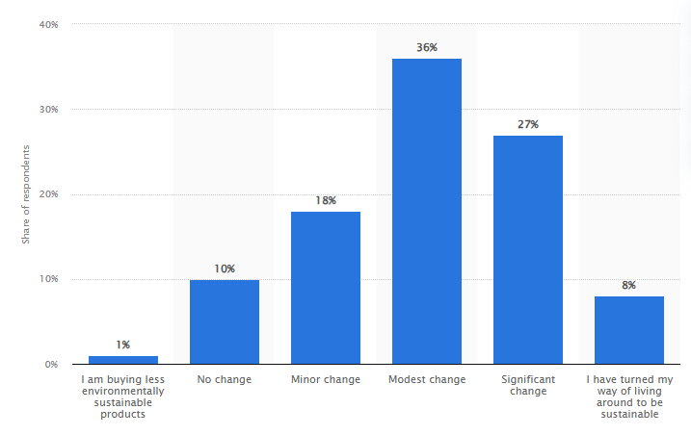
Figure 9: Consumers preference change towards sustainability products
(Source: Statista, 2026f)
People contain employees, retail partners, customer support teams and consumers to ensure a consistent service and company growth. However, due to lack of information among staff, there will be a decrease in consumer confidence in product adoption. Hence, there will be a need for sustainability training, digital application guidance and refill system demonstration for the retail employees of Unilever. On the other hand, about 36% and 27% of UK consumers show modest change and significant change towards the sustainable product purchasing (Statista, 2026f). Therefore, the well-trained employees can positively attract the consumers who show a shift towards eco-friendly products and will help Unilever to launch the product successfully.
Process
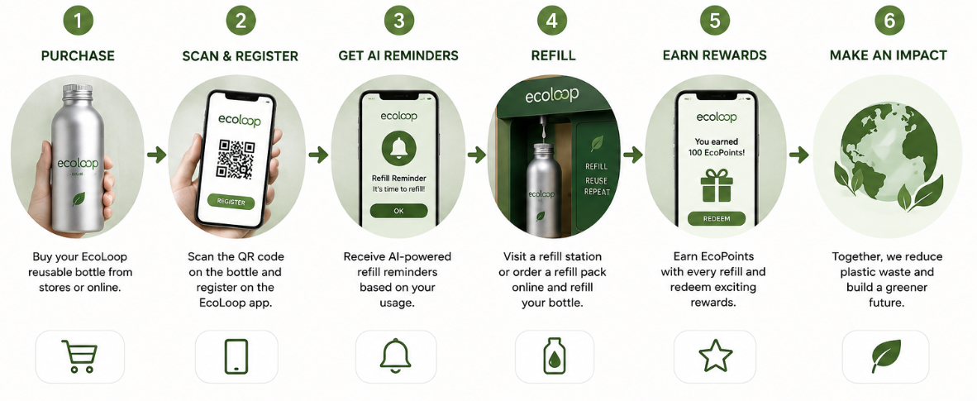
Figure 10: Process of product purchasing
(Source: Self-developed)
The customer process starts with the purchase of a reusable bottle, registration via the EcoLoop application, QR code scanning, and the AI-created refill reminder prior to the arrival at the refill stations or before the online ordering of refill-packs. However, this can put off first-time users because of the complex registration process (Begum et al., 2022). Hence, Unilever must streamline the digital onboarding process and include easy-to-follow instructions in their store. A different approach will be to offer physical loyalty cards as well as digital services to make it easier to access.
Physical Evidence
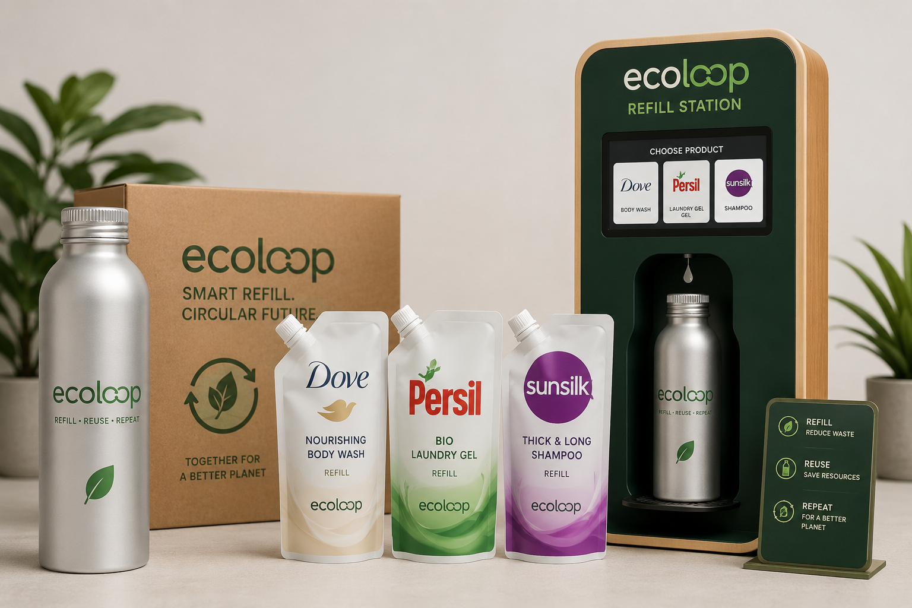
Figure 11: EcoLoop products preview
(Source: Self-developed)
Premium aluminium bottles, branded refill stations, environmentally friendly refill pouches which can be reused and the EcoLoop mobile application which shows the environment performance are all physical evidence. Tangible evidence needs to be continuously delivered to keep the confidence of customers high, to fulfil Unilever’s promises in sustainability. Packaging is important in prompting purchases; however, it is the environmental performance that builds brand credibility (Majeed et al. 2022). When the carbon savings, plastic reduction facts and sustainability certifications are demonstrated, it boosts consumers’ confidence. Strategically, all physical interactions reinforce EcoLoop’s premium positioning and brand differentiation from traditional household products, which are mainly packaged in single-use packaging.

Element 4: Reflection
The Gibbs’ reflective model helps to assess the past actions to identify weak areas and improve them for the future activities (Gibbs, 1988). The model has a total of 6 steps as shown in the below figure.
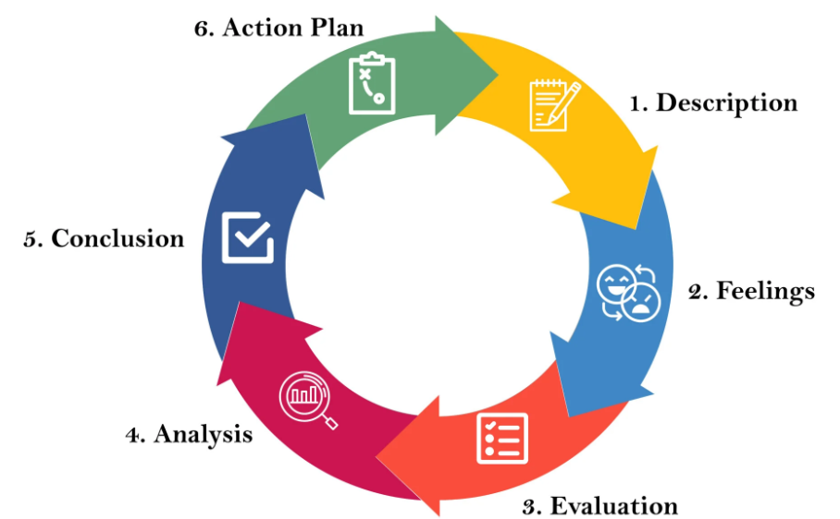
Figure 12: Gibbs’ Reflective Model
(Source: Self-developed)
Description
I have researched the branding extension, sustainability and strategic marketing concepts into a unified proposal as the key to the development of Unilever EcoLoop - Smart Refill & Circular Packaging Network. I analysed Unilever’s sustainability initiatives, consumer trends, application of STDP and the 7Ps Marketing Mix for the environment and business.
Feelings
At first, I was not sure about being able to come up with a sustainable yet commercially viable brand extension. My belief continued to grow as the project continued because I conducted research on the Unilever Sustainability goals and used marketing frameworks. The presentation of the idea helped me to build my confidence in communicating strategic ideas however I was aware that I needed to improve my presentation delivery and visual storytelling skills.
Evaluation
I gained an understanding of sustainable marketing and strategic brand development through the project. The use of STDP and the 7Ps Marketing Mix facilitated the link between the needs of customers and the aims of the organisation (Rajer, 2023). However, choosing the appropriate market data, a balance between creativity and academic research proved to be difficult. I understood that the poster needs to be effective in getting across complex ideas. Overall, the project has reinforced my research and analytical thinking abilities as well as my professional communication abilities will help future research.
Analysis
I was able to assess some of the effects of sustainability principles and theories of marketing on strategic decision making. I gained deeper knowledge of analysing consumer behaviour, sustainable brand positioning and integrated marketing strategies. However, I realised that industry comparisons would be helpful and would be more confident in presenting the work in the future. This experience brought to light the requirement to balance the parameters of customer value, environmental responsibility and commercial performance to achieve sustainable marketing success.
Conclusion
This project improved my strategic marketing knowledge, increased my level of sustainability awareness and presentation confidence. Future projects should include a wider competitor analysis and more robust visual communication and use of existing industry evidence to create more convincing and well-presented marketing strategies.
Action Plan
Area | Planned Action | Required Resources | Timeline
Marketing Analysis | Apply higher level marketing theories to further case studies. | Journal, articles and books on marketing | 3 weeks
Sustainability Knowledge | Learn about the new circular economy and ESG marketing strategies. | Sustainability reports of companies, academic databases | 4 weeks
Presentation Skills | Enhance public speaking skills, poster design and visual storytelling. | Presentations using Canva, PowerPoint and presentation workshops. | 3 weeks
Research Skills | Improve academic and industry evidence evaluation. | Google Scholar, library databases | 5 weeks
Digital Marketing Knowledge | Discover the role of AI in marketing and customer engagement online. | Online marketing courses, industry reports | 6 weeks
Table 3: Action Plan
(Source: Self-developed)

References
Begum, N., Chowdhury, R., Khan, W. and Sazzad, S.A., 2022. Sustainable Merchandising: Integrating Eco-Friendly Practices in Retail Product Presentation. Pathfinder of Research, 3(1), pp.1-12. https://doi.org/10.69937/pf.por.1.2.29
Bing, G., Al Mughairi, B., Karim, A.M. and Karim, A.M., 2024. Study on importance of brand loyalty for customer retention for consumer durable products: New era viewpoint. International Journal of Academic Research in Business and Social Sciences, 14(1), pp.453-464. http://dx.doi.org/10.6007/IJARBSS/v14-i1/20464
Brunner, M., Bachmann, N., Tripathi, S., Pöchtrager, S. and Jodlbauer, H., 2024. Sustainability as a key value proposition-a literature review and potential pathways. Procedia Computer Science, 232, pp.1-10. https://www.sciencedirect.com/science/article/pii/S1877050924000012/pdf?md5=ffefe93c5bd843cc060d45a04bd63f6a&pid=1-s2.0-S1877050924000012-main.pdf
Consultancy UK, 2026. UK consumers embracing more sustainable behaviour Available at: https://www.consultancy.uk/news/30077/uk-consumers-embracing-more-sustainable-behaviour [Accessed: 30 July 2026]
Gibbs, G., 1988. Learning by doing: A guide to teaching and learning methods. Further Education Unit. https://cir.nii.ac.jp/crid/1571417125052979584
Grandview Research, 2026a. Reusable Packaging Market (2025 - 2030) Available at: https://www.grandviewresearch.com/industry-analysis/reusable-packaging-market-report#:~:text=The%20global%20reusable%20packaging%20market,share%20of%2034.4%25%20in%202024. [Accessed: 30 July 2026]
Grandview Research, 2026b. UK Refillable Packaging Market Size & Outlook, 2026-2033 Available at: https://www.grandviewresearch.com/horizon/outlook/refillable-packaging-market/uk [Accessed: 30 July 2026]
Ipsos, 2026. Price trumps planet? Britons want sustainable products, but on a budget Available at: https://www.ipsos.com/en-uk/price-trumps-planet-britons-want-sustainable-products-budget [Accessed: 30 July 2026]
Jain, R., Jain, S. and Jain, S., 2022. Analyzing and exploring the effectiveness of each element of 7Ps of marketing mix. International Journal of All Research Education and Scientific Methods (IJARESM), 10(1), pp.2455-6211. https://www.researchgate.net/profile/Riddhisha-Jain/publication/357657009_Analyzing_and_Exploring_the_Effectiveness_of_Each_Element_of_7Ps_of_Marketing_Mix/links/61d84cdfb6b5667157d148c7/Analyzing-and-Exploring-the-Effectiveness-of-Each-Element-of-7Ps-of-Marketing-Mix.pdf
Majeed, M.U., Aslam, S., Murtaza, S.A., Attila, S. and Molnár, E., 2022. Green marketing approaches and their impact on green purchase intentions: Mediating role of green brand image and consumer beliefs towards the environment. Sustainability, 14(18), p.11703. https://doi.org/10.3390/su141811703
Mbatha, B., 2024. Diffusion of innovations: How adoption of new technology spreads in society. In Information, knowledge, and technology for teaching and research in Africa: Human machine interaction and user interfaces (pp. 1-18). Cham: Springer Nature Switzerland. https://doi.org/10.1007/978-3-031-60267-2_1
Rajer, N., 2023. New marketing models for developing a marketing strategy. International Journal of Innovation in Marketing Elements, 3(1), pp.23-29. https://doi.org/10.59615/ijime.3.1.23
SDGs, 2026. Department of Economic and Social Affairs Available at: https://sdgs.un.org/goals [Accessed: 30 July 2026]
Siderius, T. and Zink, T., 2023. Markets and the future of the circular economy. Circular economy and sustainability, 3(3), pp.1569-1595. https://doi.org/10.1007/s43615-022-00196-4
Statista, 2026a. Revenue of Unilever from 2007 to 2025 (in million euros) Available at: https://www.statista.com/statistics/269190/global-revenue-of-the-unilever-group-since-2007/?srsltid=AfmBOoooC0uTpKPI9AHKANrhd-WWkNtCCLpqvg5hdmwJogajC0A0amt4 [Accessed: 30 July 2026]
Statista, 2026b. Consumers See the Need for Eco-Friendly Packaging Available at: https://www.statista.com/chart/32141/perceived-importance-of-eco-friendly-packaging-for-sustainable-consumption/?srsltid=AfmBOop18bUWHjC8pCrXlfqy008ktVOE2qkijmkLDFbzO614X-G9OqH8 [Accessed: 30 July 2026]
Statista, 2026c. Consumers who prioritize buying from brands that demonstrate sustainable and ethical practices in the United Kingdom in 2025, by generation Available at: https://www.statista.com/statistics/1626153/shoppers-who-prefer-buying-from-sustainable-brands-uk/ [Accessed: 30 July 2026]
Statista, 2026d. Internet retail sales as a percentage of total retail sales in Great Britain from May 2019 to May 2026 Available at: https://www.statista.com/statistics/286384/internet-share-of-retail-sales-monthly-in-the-united-kingdom-uk/?srsltid=AfmBOooCBhjhc9mKRv4IItQWV3FHKNiMFYlbPDR7WuhixlDwuar1OYxu [Accessed: 30 July 2026]
Statista, 2026e. Most popular social media platforms in the United Kingdom (UK) as of the second quarter 2025, by usage reach Available at: https://www.statista.com/statistics/284506/united-kingdom-social-network-penetration/?srsltid=AfmBOoqqgyWMHKPcKE1lzNiW0qI6EILXjrlGZTMwzZDNyXDNibAJaVM4 [Accessed: 30 July 2026]
Statista, 2026f. Degree to which consumers' purchasing behavior and choices shifted towards buying more sustainable products over the past five years worldwide in 2022 Available at: https://www.statista.com/statistics/1377869/global-shift-to-buying-sustainable-products/?srsltid=AfmBOorM9Azo9hPHakLVHyonoLoj8OBaM4bHnmnmMv4ebU4wmMN-AYmv [Accessed: 30 July 2026]
Tassell, C. and Aurisicchio, M., 2023. Refill at home for fast-moving consumer goods: Uncovering compliant and divergent consumer behaviour. Sustainable Production and Consumption, 39, pp.63-78. https://doi.org/10.1016/j.spc.2023.04.018
Unilever, 2026a. Joining forces, Unilever comes to life Available at: https://www.unilever.com/our-company/our-history-and-archives/1900-1950/#:~:text=On%202%20September%201929%2C%20Margarine,decide%20on%20an%20amalgamation%20instead. [Accessed: 30 July 2026]
Unilever, 2026b. Why invest in Unilever? Available at: https://www.unilever.com/investors/why-invest-in-unilever/ [Accessed: 30 July 2026]
Unilever, 2026c. How Unilever is working to end plastic waste Available at: https://www.unilever.com/sustainability/plastics/ [Accessed: 30 July 2026]
Unilever, 2026c. Unilever in the UK Available at: https://www.unilever.co.uk/unilever-in-the-uk/ [Accessed: 30 July 2026]

Appendix 1: Poster Content
Introduction
Unilever PLC was established in 1929 operating as the manufacturer of food, personal care, home care and wellbeing products in over 190 countries (Unilever, 2026a; Unilever, 2026b). Unilever is the world’s 26th largest business with the revenue of €60.8 billion in 2025 (Unilever, 2026a; Statista, 2026a). Unilever strives to develop sustainable growth, minimise environmental footprint and enhance social wellbeing with responsible business practices.
Sustainable Brand Extension
EcoLoop promotes the re-use of its products, enhances customer loyalty, diminishes packaging waste and contributes to sustainable business growth. Unilever has set a 30% virgin plastic reduction goal by 2026, highlighting the need to meet its sustainability goals (Unilever, 2026c).
Brand Extension and Current Market Trends
In the UK, over 70% of consumers are “very concerned” about the environment when buying everyday household and personal care products (Ipsos, 2026). The global reusable packaging market is expected to grow beyond $190.1 billion by 2030, showing the growing adoption of the circular economy (Grandview Research, 2026a).
Brand Extension and Sustainability
EcoLoop helps to reduce packaging expenses and boost customer engagement with refill loyalty programs and incentives. EcoLoop directly contributes to the SDG 12 by promoting the reusable packaging use and responsible purchasing behaviour (SDGs, 2026). It helps to pursue SDG 13 with regards to emissions associated with packaging consumption (SDGs, 2026).
Conclusion
Unilever EcoLoop takes sustainability leadership by tackling it with innovative refill technology and circular packaging. The extension enhances customer retention, repeat sales and overall competitive edge.

(Source: Self-developed)

