26th April 2018
The significance of textiles in the interconnections of the bronze age Mediterranean.
Module code: AHAR5005- Connected Worlds: Exploring Interactions between Egypt, the Aegean, and the East.
By Sofie Keddie
Contents:

Introduction

Theories

Clothing

Tools

Raw materials

Conclusion

Bibliography

Introduction
Textiles have been used as an expression of cultural and individual identity from the ancient to the modern era. Today it is clear that the differing styles and manufacture of textiles have been shared and spread throughout the world quickly and without much effort. However, during the bronze age Mediterranean period, the focus of this report, the interconnections between societies in the terms of textiles is difficult for archaeologists to decide definitively because of the lack of material evidence from this time. The evidence that is available to us, administrative texts and artworks show us that interconnections did exist, though the extent is debatable. By examining societies such as Crete, Cyprus, and Assyria along with Egypt, the possible interconnections and their significance will be explored.
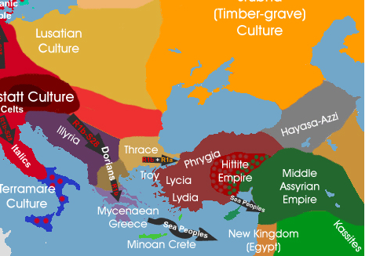Map of late Bronze age Mediterranean cultures

Theories
Two theories that are often used to examine the areas of trade in ancient societies are the theory of gift exchange and inalienable objects. In the case of gift exchange, anthropologists such as Marcel Mauss believe that gift exchange builds relationships between people despite the differences in cultures and language (Siegel 2013). Mauss even believed that “the obligation to give and to receive, formed the foundation of sociality” (Siegel 2013:61), within his theory the varying degrees of self interest and generosity play a big part in the motivations behind the exchange of gifts. The Bronze age specifically, ritual, economic and religious reasons would have also been involved in the trading of useful objects (Siegel 2013).
The theory inalienable wealth, however, specifies that while many objects are exchanged between cultures, there are some that are ‘inalienable’. Which means that these objects cannot be detached from their origins (Weiner 1985). This means that some objects, usually inherited through generations, would have been kept out of circulation because of the ‘power’ of the object, which would often who/what a culture is in a historical sense (Weiner 1985). When examining the bronze age interconnections, it will have to be considered that a lot of the techniques and styles were not necessarily given freely and if they were exhibited in other societies, force may have been involved.

Clothing
Textiles were known to be major components in ancient economies and social relationships, which means that people of the ancient world would have put a lot of effort into the manufacture and styling of the clothing as well as other goods (Foxhall 2017). By examining the styles of clothing from the bronze age, it can be seen how the societies differed in their fashion, which can indicate interconnections.
Firstly, looking at the Mediterranean culture of Crete, during the bronze age, it is thought that the clothing had a lot of uniqueness in the terms of the individual. Different patterns and colours are thought to have been used to create a bold fabric (Smith and Tzachili 2012), separate pieces of fabric were also used to make up a complete ensemble. This is reflected in other societies in the Mediterranean such as Cyprus and Assyria. For example, it is thought that Assyria used strips of fabric to form borders which were either sewn onto the main fabric or used to make a belt or girdle (Dalley 1991). Along with this, bold colours imperial colours were used as the base, “imperial colours began in the middle east, apparently in the late bronze age” (Dalley 1991: 123-124). This means that it is possible that Imperial were used in Mediterranean countries and the differing patterns and borders were used to add a measure of personalisation. As the differing patterns are shown by both the Cretan and Assyrian people from the evidence available, which is mostly through sculptures and paintings from the regions, though practically no physical evidence remains. Cyprus does have a small bit of physical evidence in the form of fragments of a purple textile held together by pins and buttons from a twelfth century grave (Smith and Tzachili 2012). Apart from this however, there is not a lot of evidence to indicate if this style of clothing was regular. This means that a lot of the evidence used by archaeologists is from pieces of art.
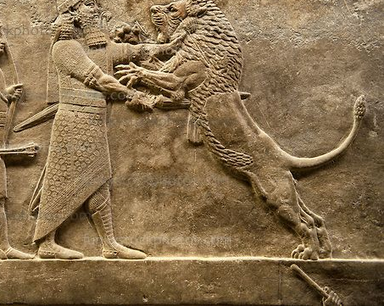
Assyrian relief sculpture panel of Ashurbanipal lion hunting. From Nineveh North Palace, Iraq
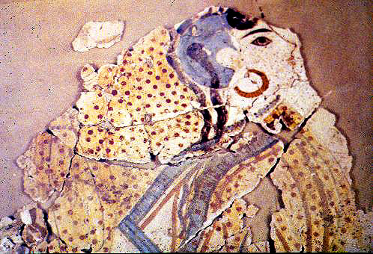
Painting from Akrotiri
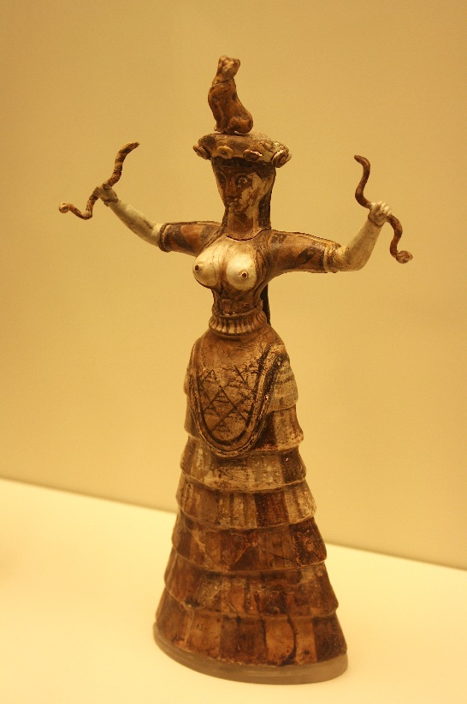
Minoan snake goddess statue found in Knossos

As the images above show, both the cultures of Assyria and Akrotiri (Santorini) used what appears to be dots within the patterns of their clothing and the goddess statue from Knossos shows different layers of fabric being used as borders and a pattern is used at the top of the skirt. The problem with using these artworks as evidence is that; they are all presenting a story or mythical person, so it is difficult to say that the clothing presented are in fact what people actually wore. Despite this, it must be stated that there are some similarities in the patterns of the clothing, although the Assyrian relief sculpture and Knossos statue have lost most of the colour (Dalley 1991), it is probable that they were very bright to begin with. The similarities do show the possible borrowing of styles from other cultures, whether that be through trade or other means. This is probable because cultures within the Mediterranean having similar ways of wearing clothes is a little too coincidental.
In contrast to these societies, Egypt had an almost completely different style of textile when it came to clothing. As is shown in the wall paintings and statues that the style of clothing of the ancient Egyptians was much simpler in appearance. It is shown to be of a single colour, usually white, and was made up of a single piece of fabric (Smith and Tzachili 2012). This does show that if the Egyptians were aware of how the other Mediterranean countries manufactured styled their clothing, they did not choose to copy it. This is possible because the Egyptians could have preferred the simple style when it came to clothing and instead showed their wealth through things like the jewellery they wore and other things that they owned.
If it is true and the style of clothing was being imitated between countries means that it can be said that clothing was not thought of as ‘inalienable’ by the people. This could then mean that the spread of information and ideas was used as a way of communicating between the countries and that their evolution of clothing moved at a similar pace between the countries. It is also possible that the similar look of the clothing was used as an indicator of the beliefs and relations between the countries. For example, it is thought that countries within the Mediterranean admired Egypt to an extent where it was seen to be the ‘wisest’ civilisation, which meant that the clothing in Egypt being unique compared to the other countries may be an indicator of this. It is also just as possible that the relations between the Assyrian, Cretan and Cyprian societies were more personal or that they held similar religious beliefs. Hence the sharing of style, the gift exchange of religious objects and beliefs may have taken place (Siegel 2013).

Tools
The distribution of tools does show connections between the Mediterranean societies. For example, the types of loom used in different areas show that the sharing of ideas between the societies. There is evidence that the warp-weighted loom was used in both Cyprus and Crete around the same time. it is also stated that Cyprus used tools for textiles that were brought by settlers from Anatolia (Smith and Tzachili 2012) , so some techniques and tools for textiles were brought through the mixing of different cultures. As well as this, there is also evidence of the ground, vertical looms (originating in Syria) being used in both Egypt and the levant (Smith and Tzachili 2012). This shows that there must have been at least some form of sharing of information between the countries, whether it be intentional or not, to mean that they had similar methods of weaving. The distribution of loom weights dating back to the bronze age throughout the Mediterranean show that the method was widely used though techniques differed slightly. This again may show that the tools used to produce textiles were viewed as things that could be freely shared rather than the methods being kept secret, also it would also show that the textiles being produced by the different countries were not vastly different, so the trade and exchange of them may not have been as successful compared to other items.

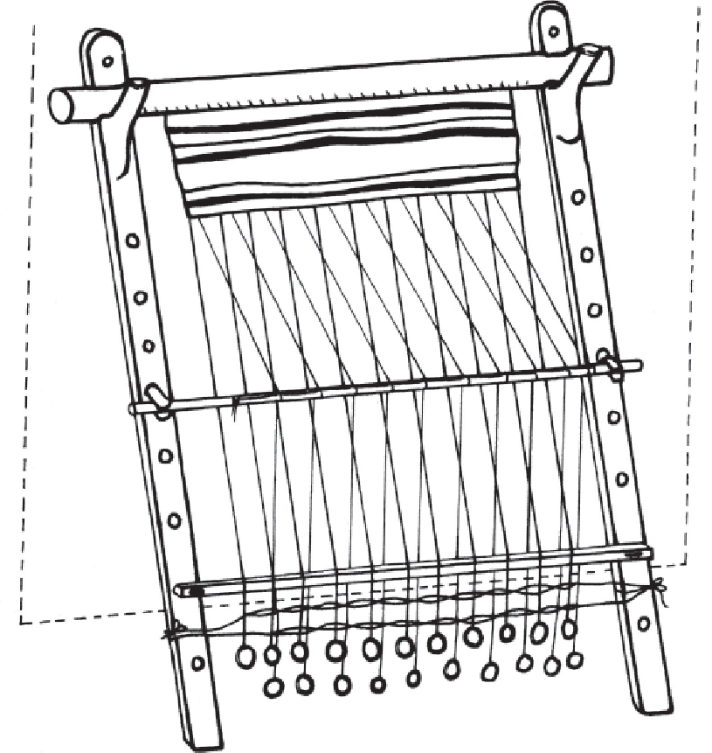 Warp-weighted loom with loom weights drawing

Raw materials
A lot of administrative evidence is involving the raw materials used to make textiles, the main one being wool. In the case of Crete, there was a standardised administration in the keeping of flocks as well as the amount of wool. Linear B tablets found at Knossos show a recording showing a year of wool production, it states that 52,000kg of wool was expected and that this made approximately 5700 pieces of cloth (Smith and Tzachili 2012). This shows that the leadership would have controlled the wool production and trade. It is also possible that considering there was wool, and textiles being produced in a palace, that some of it would have been given to other countries through gift exchange. This is because being given textiles from an important building like a palace would be seen as something of great value. Since not all the people within the country the object originated from would have the same thing. It is more likely that only the finer fabrics would have been given away in gift exchanges while the less fine would have been circulated in trade or just around the country. Cyprus also kept flocks to produce wool as well as meat but there is less administrative evidence to back this up, other than there being evidence of bigger flocks than it just being used for a food source (Smith and Tzachili 2012). It is also stated that Cyprus was a key point for western contacts in the later bronze age (Sherratt and Sherratt 1993), so they would have more than likely produced many objects for trade, including textiles. As well as this, Assyria had evidence of wool production and possible linen production. Ancient writings state that “sheep were plucked for their wool and goats were shorn until the first millennium BC” (Dalley 1991:120). This means that different ways of retrieving wool was used, therefore possibly different ways of producing textiles may also have existed in Assyria. It is also a possibility that the differing types of wool were used for certain purposes, eg. Textiles for trade. In the case of linen, it is possible that it was produced in Assyria from flax seed, although it is likely that this was used “more for producing oil than fibre” (Dalley 1991:120). As it is only possible that line was produced in Assyria during this time, it might mean that there was a small amount produced and it was prized as a valuable textile compared to wool.
It is shown in the Amarna letters that there was a high demand for fabric dyes or textiles that had already been dyed (Foxhall 2017). This is because some colour dyes were only accessible from certain countries. For example, purple dye was mainly derived from a few types of shell, therefore only coastal areas with the right shells would be able to produce it (Reese 2000). Also, the shade of the purple depended on the species of shell the societies had and the way they treated them, they usually varied from a pale pink to a dark purple (Reese 2000). This means that if a person wanted a specific colour purple dye, it would have to come from a certain place. This can also be linked to the idea of gift exchange as well, because since certain dyes are not available in places without a coast, being given purple dye or a piece of purple textile, would be a rarity and therefore increase the item’s value. There were also some red and orange dyes that were taken from a mountain area, like the Troodos mountains (Smith and Tzachili 2012). These would have been difficult to retrieve and therefore increase the value of the product. It is also possible that the trading of different colour dyes also took place, for example, a society by the coast gave some purple dye to a society that specialised in a reddish dye that the coastal people did not have then they may have exchanged them and by doing so, made social relationships (Siegel 2013). It is also probable that the dyes specifically found in coastal areas were not circulated to a large extent because the cultural value of it was too high (Weiner 1985).

Conclusion
In conclusion, the little evidence available to us does show some interconnection between bronze age societies. This is shown by the similarities in the styles of clothing from places such as Crete and Cyprus, though it also indicates some divide. As well as the similarities in the manufacture of the textiles themselves. Using the theories of gift giving and inalienable wealth, it is probably that most examples of this in the terms of textiles is shown in the quality of the raw materials. Such as the fine weave of the textile and the dyes used to colour the fabric. Therefore, the connections made within the Mediterranean in the context of textiles was likely succeeded by the passing on of information as well as the trade and exchange of the finer textiles.

Bibliography:
Scholarship:
Dalley, S. 1991. Ancient Assyrian Textiles and the Origins of Carpet Design. Iran 29: 117-135. [Online: http://www.jstor.org/stable/4299853] [Accessed: 20th April 2018]
Sherratt, S. and Sherratt, A. 1993. The Growth of the Mediterranean Economy in the Early First Millennium BC. World Archaeology 24: 361-378. [Online: http://www.jstor.org/stable/124714] [Accessed: 19th April 2018]
Smith, J S. and Tzachili, I. 2012. Cloth in Crete and Cyprus. British School at Athens Studies 20: 141-155. [Online: http://www.jstor.org/stable/23541206] [Accessed: 20th April 2018]
Reese, D S. 1987. Palaikastro Shells and Bronze Age Purple-Dye Production in the Mediterranean Basin. The Annual of the British School at Athens 82: 201-206. [Online: http://www.jstor.org/stable/30103089] [Accessed: 19th April 2018]

Foxhall, L. 2017. The Fabric of Society: Recognising the Importance of Textiles and their Manufacture in the Ancient Past. Antiquity; Cambridge 91: 808-811. [Online: https://search.proquest.com/docview/1977230494?accountid=130472] [Accessed: 19th April 2018]

Seigel, J. 2013. False Beggars: Marcel Mauss, The Gift, and its Commentators. Diacritics 41(2): 60-79. [Online: https://search.proquest.com/docview/1510496486?accountid=130472] [Accessed: 22nd April 2018]

Weiner, A B. 1985. Inalienable Wealth. American Ethnologist 12: 210-227. [Online: http://www.jstor.org/stable/644217] [Accessed: 22nd April 2018]

Illustrations:

Warp-weighted loom with loom weights drawing. [Online] Available from https://www.researchgate.net/profile/Ron_Pinhasi/publication/269986833/figure/fig9/AS:614121036840988@1523429273403/Warp-weighted-loom-with-loom-weights-From-Gleba-and-Manning-2012-p-15-Drawing.png [Accessed: 22nd April 2018]

Map of late bronze age Mediterranean cultures. [Online] Available from https://i.pinimg.com/originals/91/09/d5/9109d53496a442594a91f5a55cce1fe2.jpg [Accessed: 22nd April 2018]

Assyrian relief sculpture panel of Ashurbanipal lion hunting. From Nineveh North Palace, Iraq. [Online] Available from https://i.pinimg.com/originals/ce/6c/91/ce6c91b6ca4e9597c56b12630e9da125.jpg [Accessed: 23rd April 2018]
Painting from Akrotiri. [Online] Available from http://cobalt.rocky.edu/~mark.moak/acrogirl2.JPG [Accessed: 23rd April 2013]
Minoan snake goddess statue found in Knossos. [Online] Available from https://www.ancient.eu/uploads/images/398.jpg?v=1504514401 [Accessed: 24th April 2018]

