Leoni Lewis

Computer architecture and networks ACCA01005

Contents
CEO/HR Administrator/Sales Marketing/Finance Assistant 2
Film Editors 4
Graphics/Animation Engineers + Interns 5
Printers 6
Staff 6
CEO and HR/Finance assistant 6
Video conferencing facility at Conference/Lounge area 7
Projector Screen: 7
ACER H6517ST Full HD Home Cinema Projector 7
PowerEdge R830 Server 8
Server Rack; 8
Software 9
Software for all office users 9
Graphics/Animation Engineers/art designers/interns software 11
Film Editors software 11
VoIP phone system for all staff including remote workers 12
Anti-Virus 13
Wireless Network 14
Packet Tracer 14
Appendix 18

Item | Price
Computers | 27,316.37
Printers | 1,044
Video Conferencing | 954.99
Server | 15,724
Software | 16,409.36
Wireless | £540
Total | 61,988.72

CEO/HR Administrator/Sales Marketing/Finance Assistant
5 X HP 260-a104na Desktop PC £449.99 = £2249.95(1)
Job Role: CEO (Administrative Manager) + HR administrator + Sales marketing + Finance assistant
Location:
Component | Recommendation
Processor: | Intel Celeron J3060  Dual-Core  1.6 GHz/ 2.48 GHz  (Manufacturer, Model, Speed)
Memory: | 8GB RAM  2 MB Cache  (Type, Amount)
Hard Drive: | 1TB HDD  7200rpm
CD-ROM/DVD:
USB Ports: | 2 X USB 3.0  4 X USB 2.0
Video Card:
Sound Card: | DTS Studio Sound
Network Card(s): | Wireless 802.11 b/g/n  Ethernet Gigabit Ethernet 10/100/1000
Operating System: | Windows 10 (64-bit)
Monitor: | 21.5”  1920x1080  LED Backlighting  Anti-glare
Speakers:
Internet Connection: | Wireless  USB  Ethernet

I recommended a desktop which has a dual-core processor to increase the systems performance and allow the processor to handle more actions at a faster rate. This will allow users to complete tasks in a faster time and therefore be more time efficient which is important within a business. I selected a desktop with a sufficient amount of RAM needed to complete the jobs which these users will need to perform. I don’t think any more RAM would be important for these users as they do not need to be running any programs which need high RAM capabilities. The desktop has a hard drive capacity of 1TB which is more than sufficient for these roles, however if the users did find they were close to the storage limit they could increase the size of storage by using a USB or portable hard drive. This recommendation comes complete with 6 USB slots (2x USB 3.0 and 4 x USB 2.0) this will allow users to both take any work home and bring any work completed at home back into work, it also allows for the above recommendation of using USB’s a an extra storage device. The desktop allows for both wireless and wired internet so can be connected both ways depending on preference, I would recommend wireless as it would be costly for the company to wire 3 floors of computers. The operating system which comes with the desktop is Windows 10, this is an excellent addition to the computer as Windows is compatible with pretty much any software available and is well known by computer users. The monitor itself is both full HD and anti-glare perfect for users who will be working on the computer for a large part of the day. Overall I think for the price of the computer and the work these users are going to be performing this is the perfect desktop. ✓

Film Editors
21 x Lenovo Idea Centre 510 £479.97 total: £10,079.37 (2)
Job Role: film editors, media engineers, media technicians, web designers/developers -
Location:
Component | Recommendation
Processor: | AMD A9-9410 Processor  Dual-core  2.9 GHz/ 3.5 GHz (turbo)
Memory: | 8GB RAM DDR4  2 MB Cache
Hard Drive: | 1TB HDD  7200rpm
USB Ports: | 2 X USB 3.0  3 X USB 2.0
Sound Card: | Dolby advanced audio  3 W x 2
Network Card(s): | Wireless- AC  Ethernet Gigabit Ethernet 10/100/1000
Operating System: | Windows 10 (64-bit)
Monitor: | 21.5”  1920x1080  LED Backlighting
Internet Connection: | Wireless  USB  Ethernet
I recommended a desktop which has a dual-core processor to increase the systems performance and allow the processor to handle more actions at a faster rate. This will allow users to complete tasks in a faster time and therefore be more time efficient which is important within a business. The speed of this processor is higher than that of the desktop recommended above, this is due to these users needing to run programs which demand more processor speed such as adobe premiere pro.✓ The hard drive again has a 1TB capacity which is large enough for most users, however because these users will be completing work which may take up a large amount of storage I would recommend investing in USB’s or portable hard drives when this storage runs low.or put through a file server With 5 USB slots available these users can both take work home and bring work in from home with no issue, also work can be backed up onto a USB as a part of disaster recovery and extra storage can be added through the use of a USB. The desktops can be connected to the internet through both wireless and wired connectivity, but as stated above I would recommend wireless as the speeds will be fast enough for what these users will use the internet for and the cost will be much cheaper compared to wiring each computer. The monitor is full HD and a good size so that users will be comfortable when using the desktop for long periods of time.

Graphics/Animation Engineers + Interns
Apple iMac with 4K Retina Display- £1249 Total: £14,988(3)
Job Role: 4 x graphics/Animation engineers 4 x interns 4 x art designers –
Location:
Component | Recommendation
Processor: | Intel core i5  Quad core  3.0GHz  Turbo up to 3.5GHz
Memory:  (Type, Amount) | 8GB RAM DDR4 configurable to 16GB  2400MHz  2 MB Cache
Hard Drive:  (Type, Capacity) | 1TB serial ATA drive  5400 rpm
USB Ports:  (Number, Location) | 4 X USB 3.0 (compatible with USB 2)  2 X Thunderbolt 3 (USB-C)
Video Card:  (Manufacturer, Model, Video RAM) | Radeon Pro 555 with 2GB video memory
Sound Card:  (Manufacturer, Model) | Microphone  3.5mm headphone jack
Network Card(s):  (Ethernet: speed, Wireless, Standard) | 10/100/1000 Base-T Gigabit Ethernet  802.11ac Wi-Fi wireless networking  IEEE 802.11a/b/g/n compatible
Operating System:  (Manufacturer, Version, Compatibility) | Mac OS High Sierra
Monitor:  (Size, Resolution, Refresh Rate) | 21.5”  4K Retina Display  4096 x 2304 resolution  Wide colour (P3)
Speakers:  (Manufacturer, Model, Type) | Stereo Speakers
Internet Connection:  (USB, Ethernet, Wireless) | USB  Ethernet  Wireless

I decided to look into Apple computers for these members of staff as I have heard they are good for graphics and art departments. The desktop I chose has a quad-core processor, this is good for these users as they will need to have multiple programs open at once, as well as running processor demanding programs such as the adobe suite. The 1TB hard drive should last users for a long time but due to the type of work these users will be performing storage expansion may be needed. This desktop also hold 4 USB slots which are compatible with both versions 2 and 3 with the additional thunderbolt 3 (USB-C) slots which provides power up to 100 watts. You can now connect monitors and laptops with the USB-C removing the need for large AC adapters. The USB-C is also able to transfer data at a rate of 10Gbps which allows movies to be transferred in a matter of seconds. You could probably afford a higher spec here

Printers

Staff
2 x HP Colour LaserJet Pro M477fdw Wireless Multifunction printer with Fax
£378 Total:£756
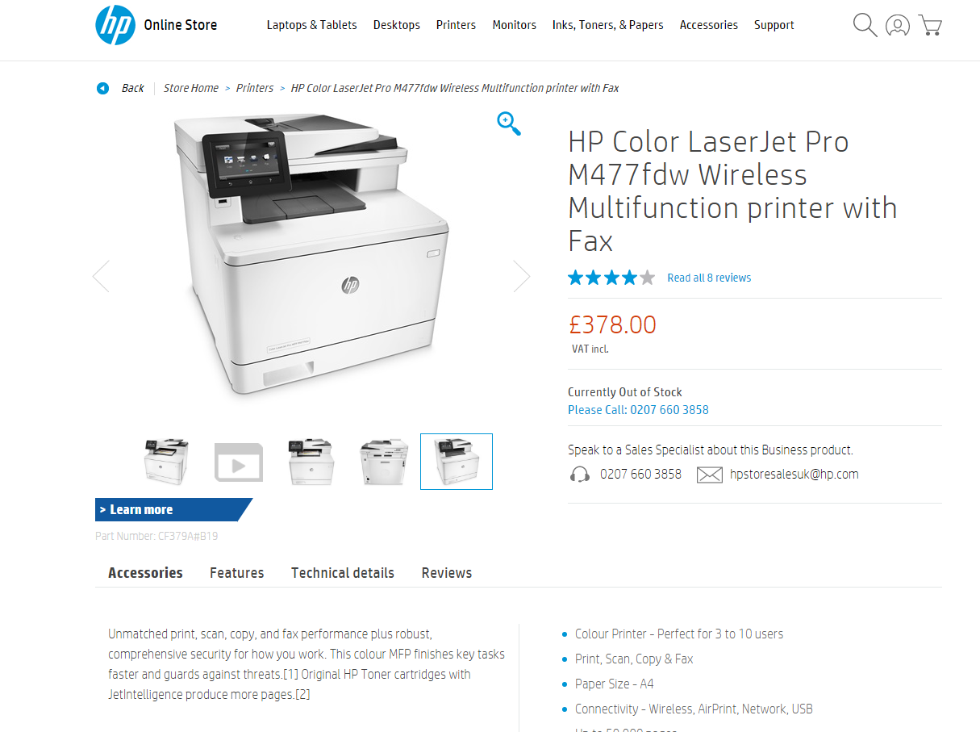
I decided on this printer for the staff members as you can easily manage any print jobs directly from the printer, print from multiple devices including smartphones/tablets, this printer is energy-efficient helping to conserve energy while printing at exceptional speeds (27ppm). The size of this printer is also suitable for the amount of staff using it.

CEO and HR/Finance assistant
2 x HP OfficeJet Pro 7730 A3 Wireless All-in-One Printer
£144 Total: £288
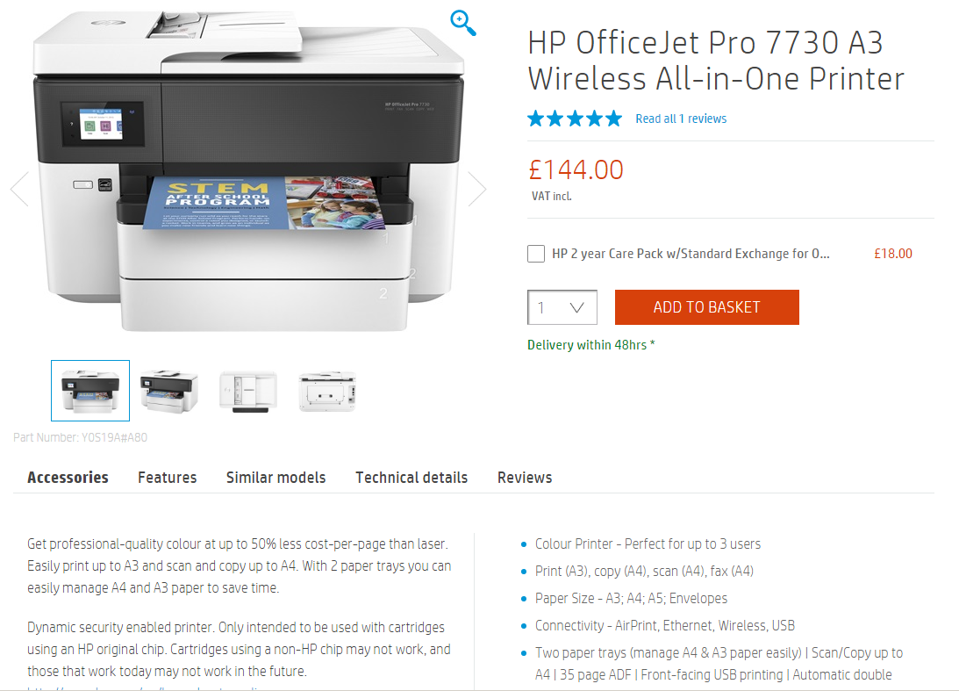
I decided to look at a smaller printer for both the CEO and HR/Finance assistant as they will be the only people using them, However this printer allows users to print up to A3 with two paper trays, print from a variety of devices, connect your devices directly to the printer and print without having to connect to a network, as well as this you can print a fully coloured page in just 10 seconds.

Video conferencing facility at Conference/Lounge area

Projector Screen:
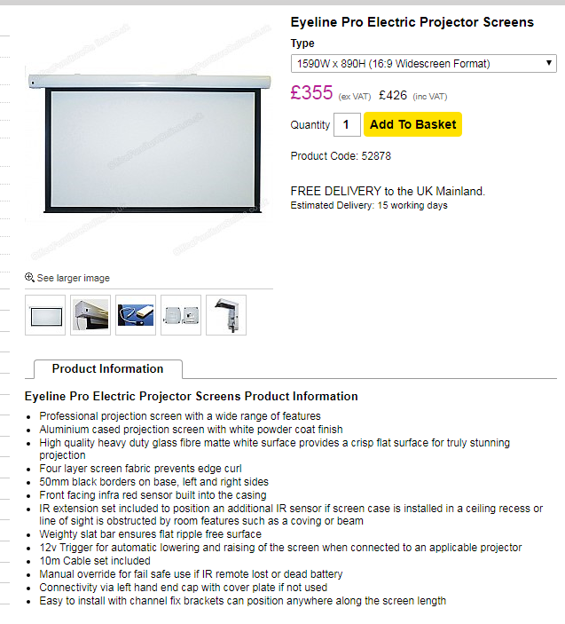

ACER H6517ST Full HD Home Cinema Projector
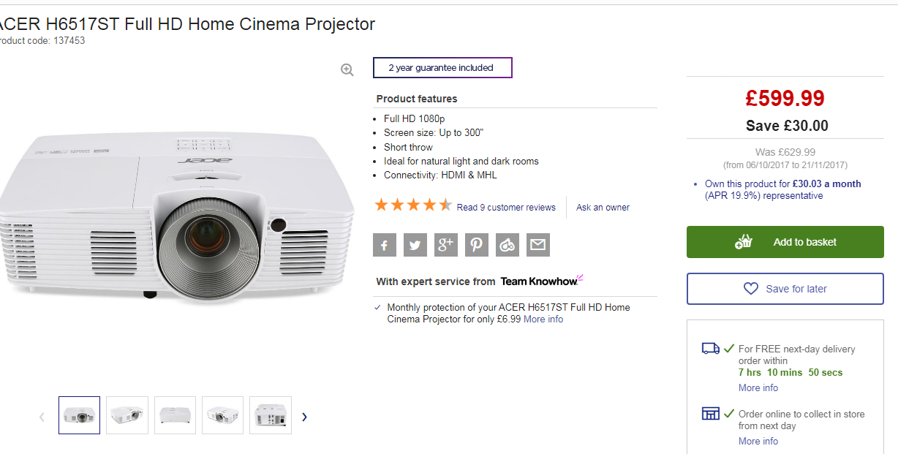(4)

PowerEdge R830 Server
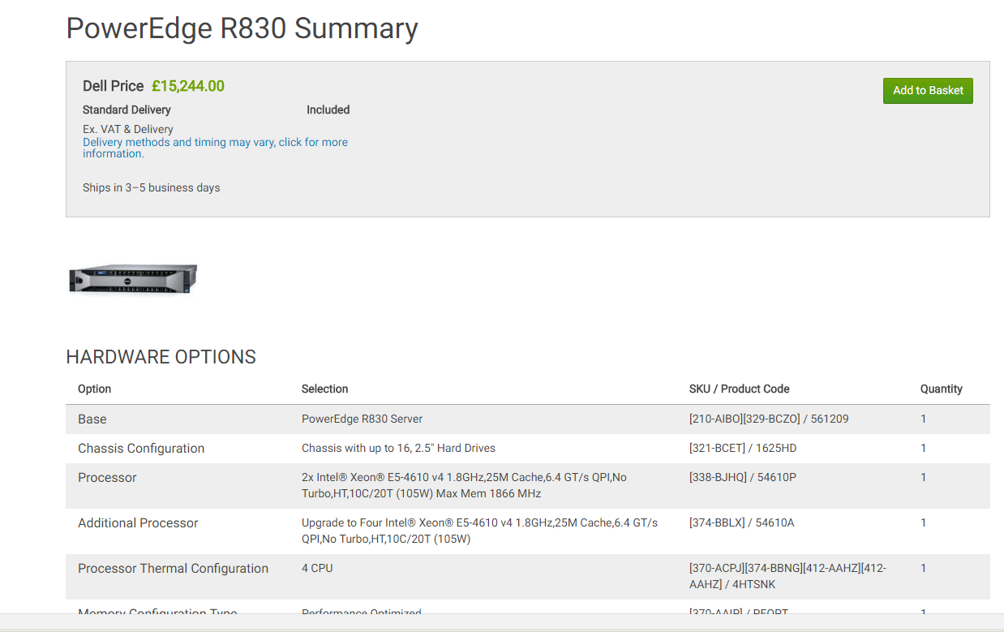(5)
Are hard drives included – if so what?

Server Rack;
12u 600mm(w) x 1000mm(d) CCS Server Cabinet
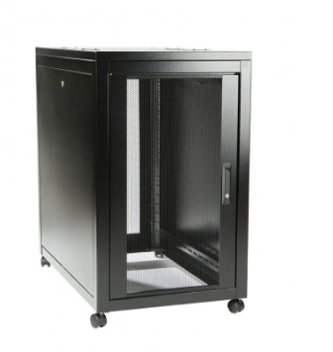
£480.00 Inc VAT.
Features:
- Full height adjustable 19" mounting prfofiles front and rear
- Fully removable sides
- Mesh doors front anr rear allows for maximum ventilation
- Lockable doors all around provide excellent security
- High quality paint finish
- Supplied fully assembled

Compatible with:
Dell:
Dell Poweredge Rackmount Servers with ReadyRails
Dell Poweredge Rackmount Servers with RapidRails
Dell Poweredge Tower Servers (requires either a fixed shelf or telescopic shelf)
HP
HP ProLiant DL Servers
HP ProLiant ML Servers (requires either a fixed shelf or telescopic shelf)
Fujitsu
Fujitsu Primergy RX Rack Servers
Fujitsu Primergy TX Tower Servers (requires either a fixed shelf or telescopic shelf)
Lenovo
Lenovo Rack Servers
Lenovo Tower Servers (requires either a fixed shelf or telescopic shelf)
IBM
IBM System X Rackmount Servers
IBM System X Tower Servers (requires either a fixed shelf or telescopic shelf)
Cisco
Cisco UCS Rack Servers
I decided on this server rack as I think it is the perfect size for the company’s needs, it will fit the server chosen perfectly with plenty of room for expansion if this was desired in the future.

Software
Software for all office users
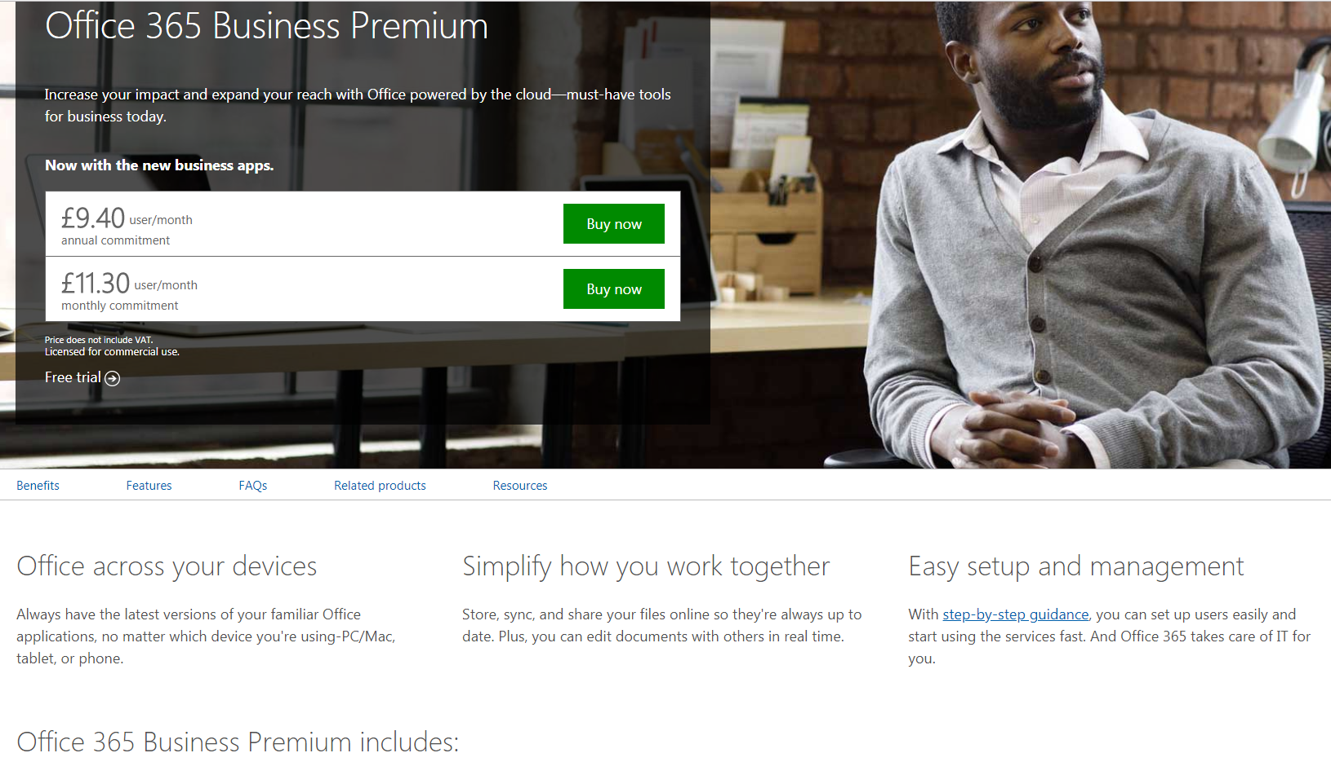

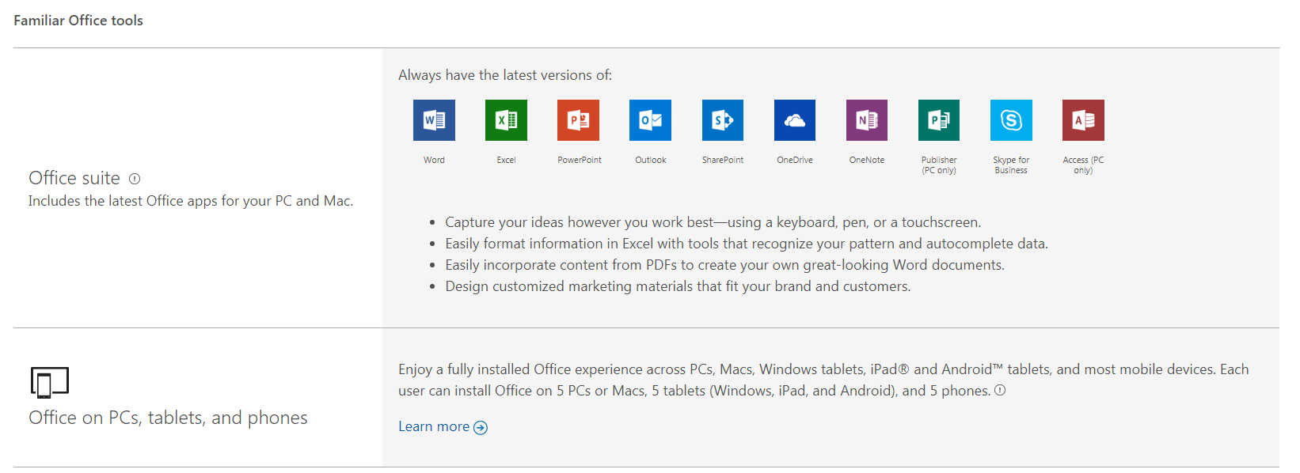
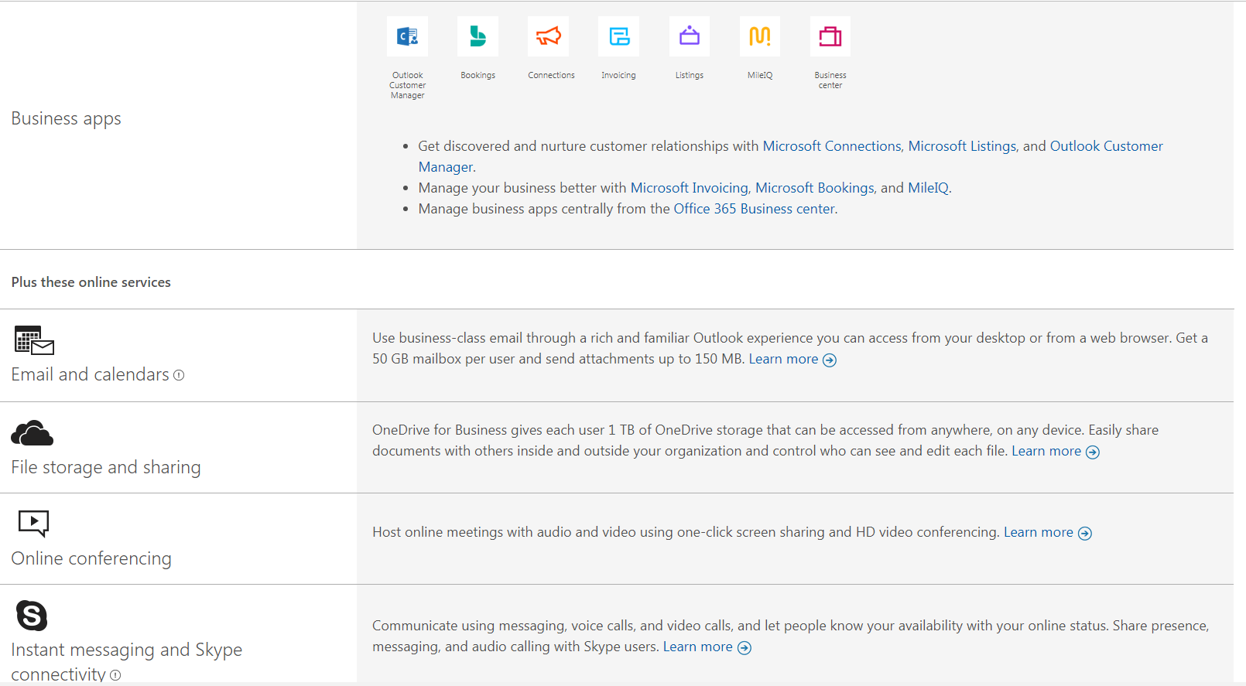

£9.40 per user/per month x 48 staff members = £451.20 per month and 5,414 per year.
I chose this software option as I think it is best suited to the company needs, all staff members would have access to the programs needed to create spreadsheets, reports, PowerPoints and posters. They would also have access to an email account and the option to save their work on the OneDrive. Microsoft Office is used worldwide and is definitely the most well-known software of its type, adding this into the company would mean any documents sent or received would be compatible with almost every computer around the world.✓

Graphics/Animation Engineers/art designers/interns software
Adobe Creative Cloud for Business
£59 per person/per month x 12 = £708 per month and £8,496 per year.

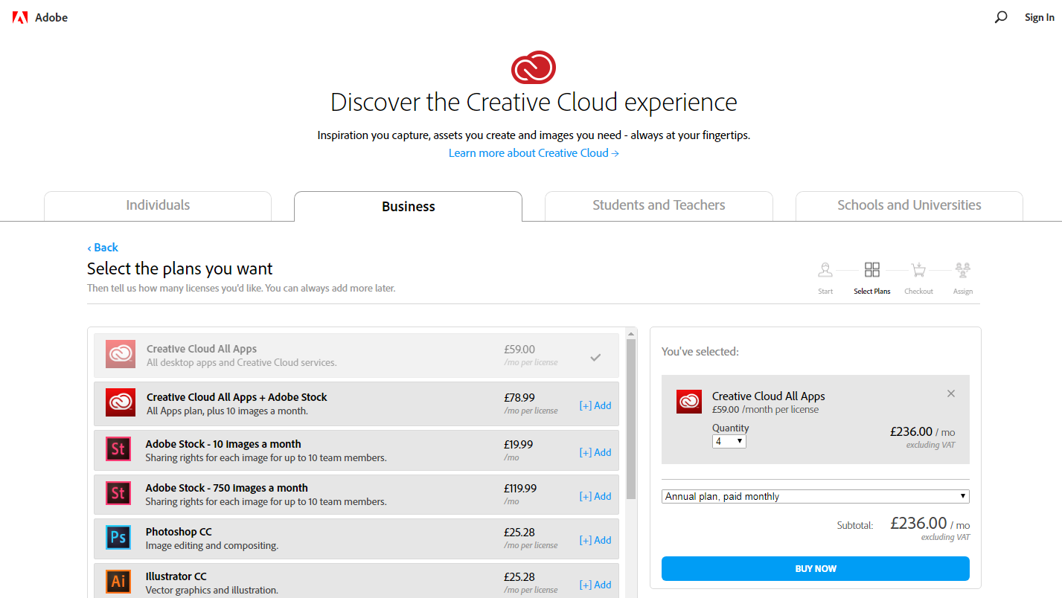

Film Editors software
Premier Pro CC £25.28 per user/ per month x 4 = £101.12 per month and £1213.44 per year.

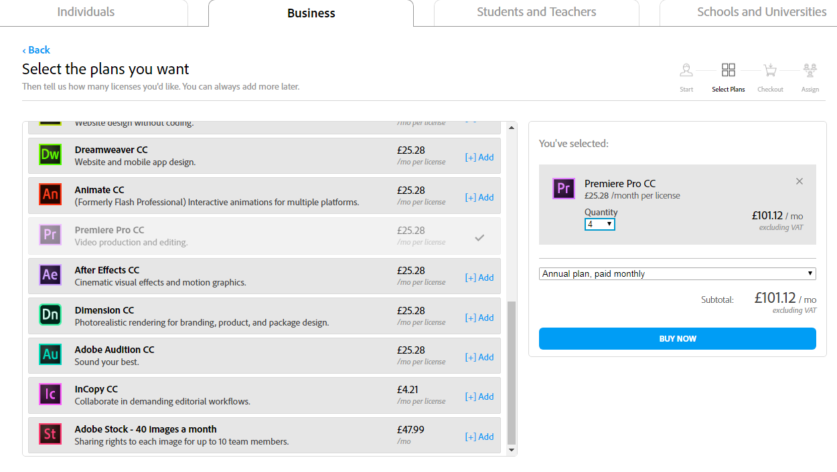

VoIP phone system for all staff including remote workers
Run through the office 365 for business package which includes online conferencing, skype for business and file sharing in order for all staff members to interact with each other when they think necessary.

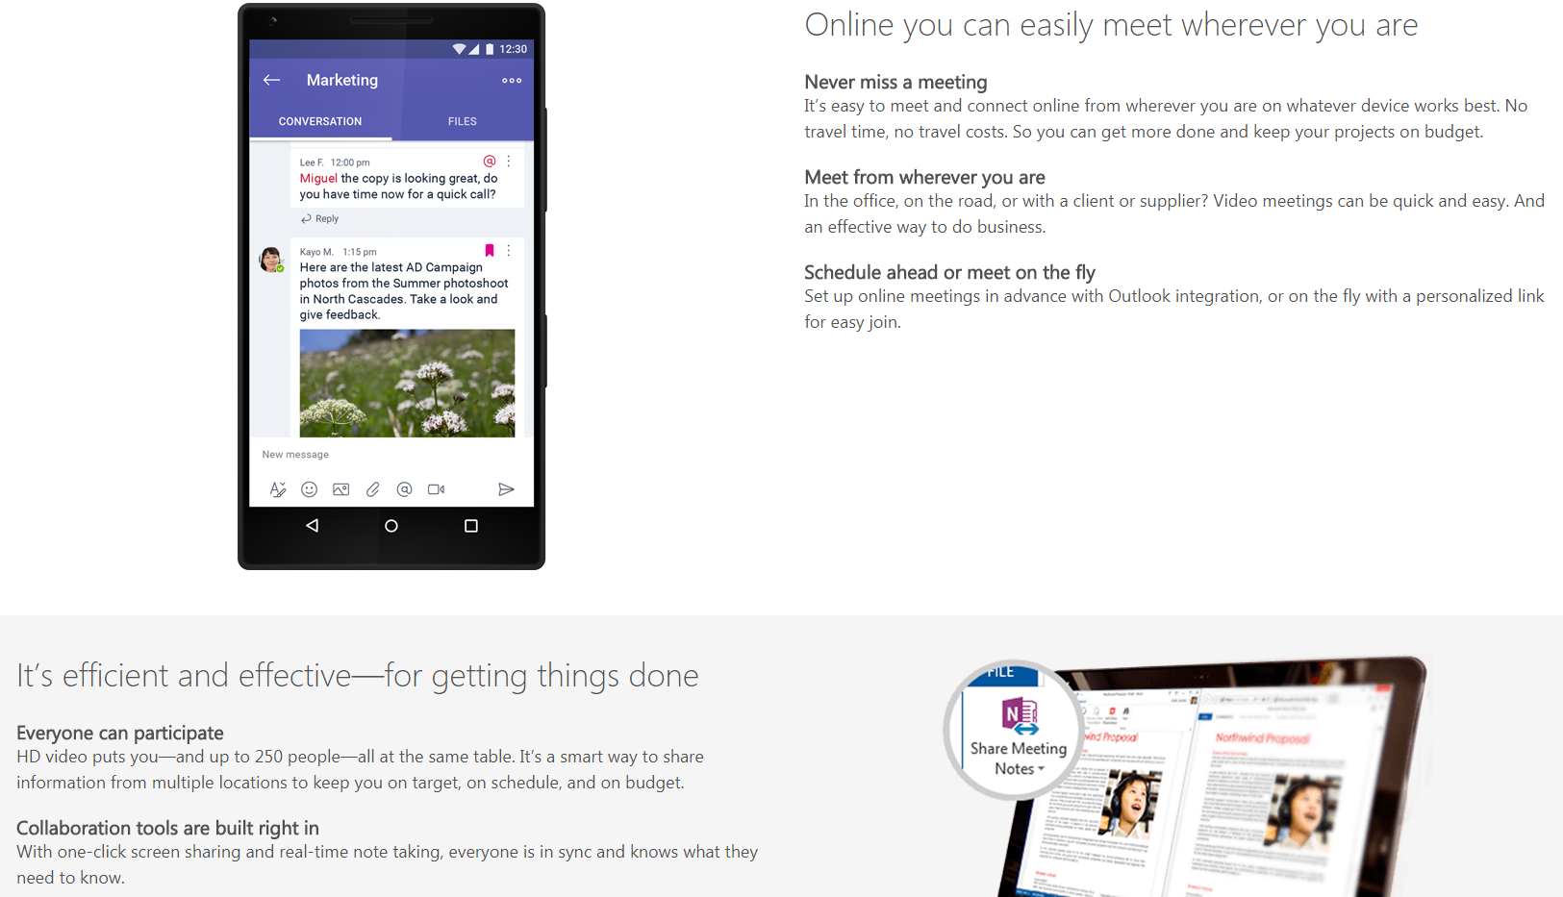
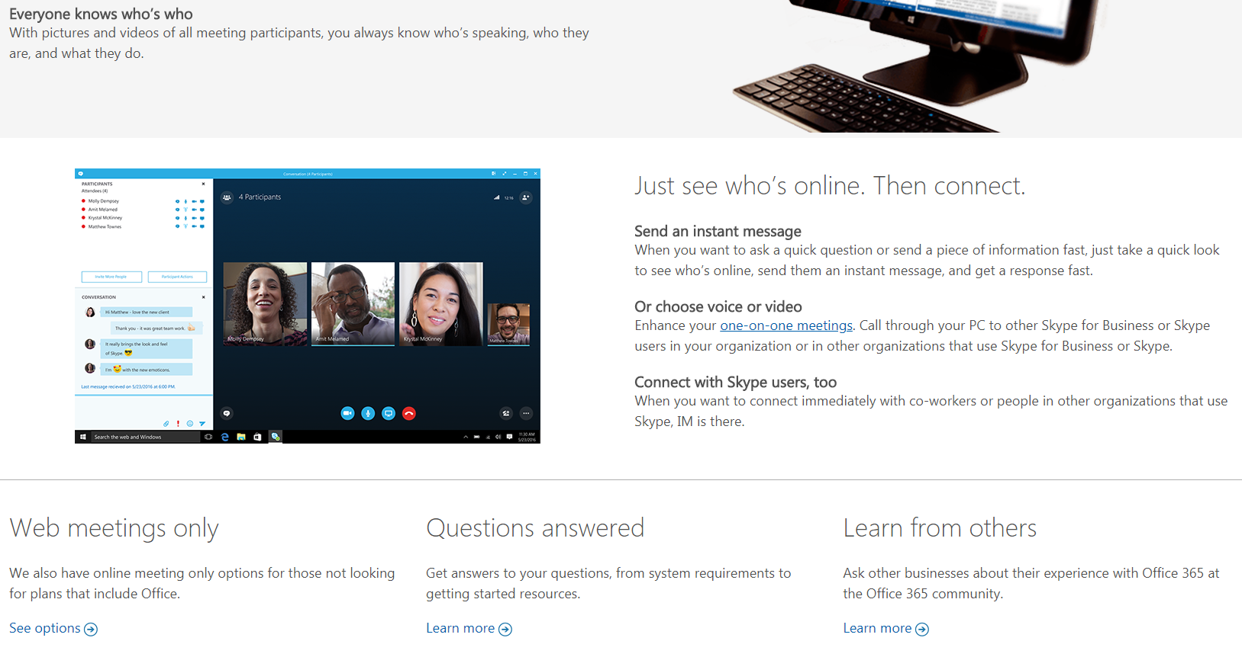

Anti-Virus
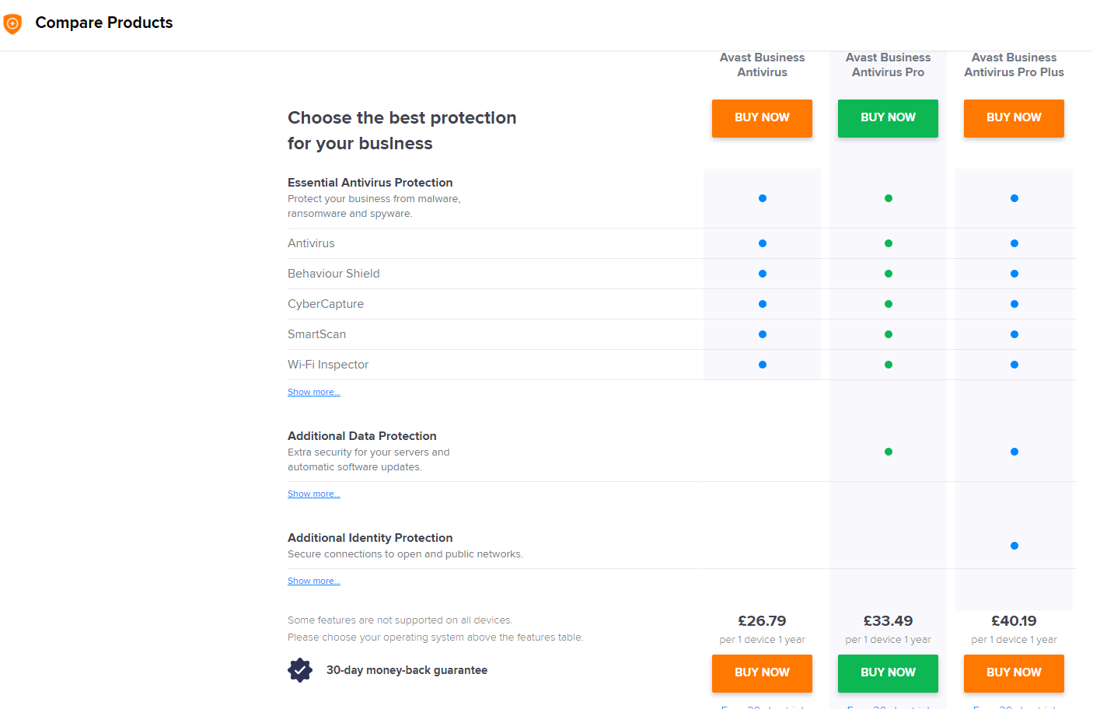
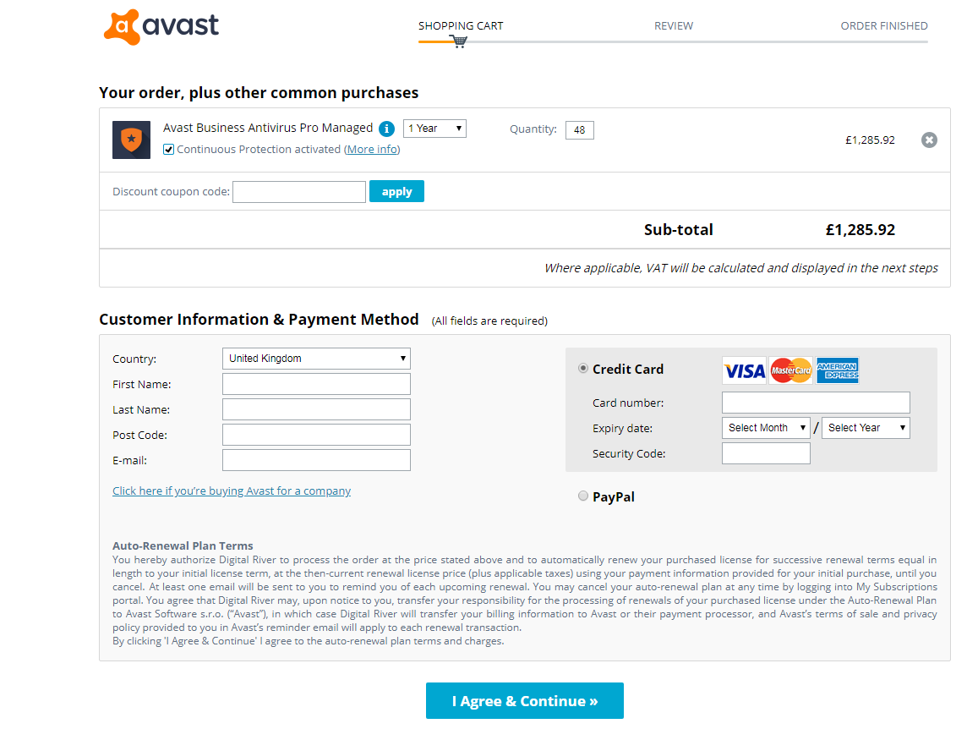

I decided to pick AVAST anti-virus software as it is a trusted brand which has many 5* reviews. Avast business antivirus pro offers the best protection with a 100% malware detection rate preventing the business from being subject to an attack. The antivirus software doesn’t use up large amounts of processing speed allowing staff members to carry on working no matter what tasks the software is performing. A management computer can be set up to monitor all devices in the business to ensure you see exactly what is going on, you can also customize any settings from here.

Wireless Network
Vroom Fibre Option 2 £45 a month = £540 a year

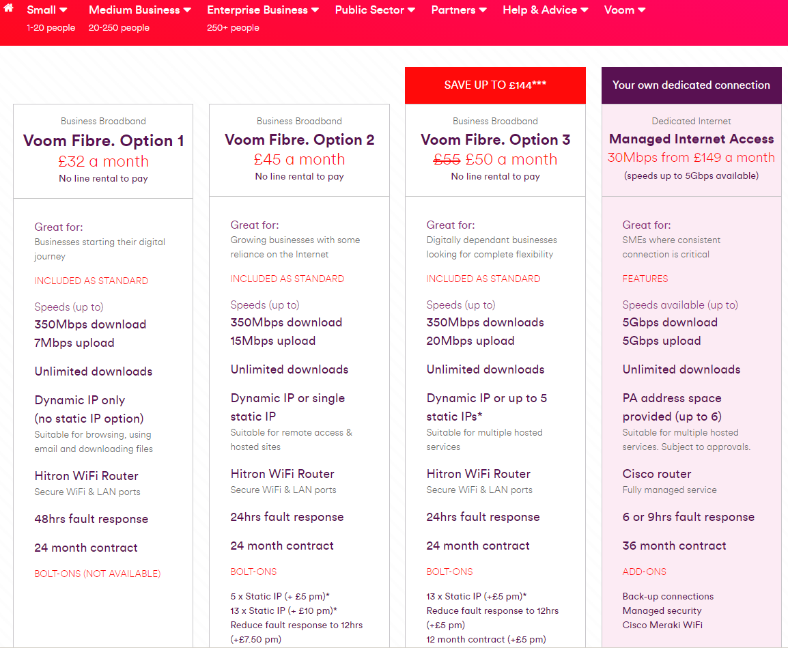

I decided to go with Virgin business broadband as they provided some of the fastest broadband speeds across the country, this would allow the business to successfully download and upload anything they wish with no problems.
Printers don’t appear connected?

Packet Tracer
Floor One
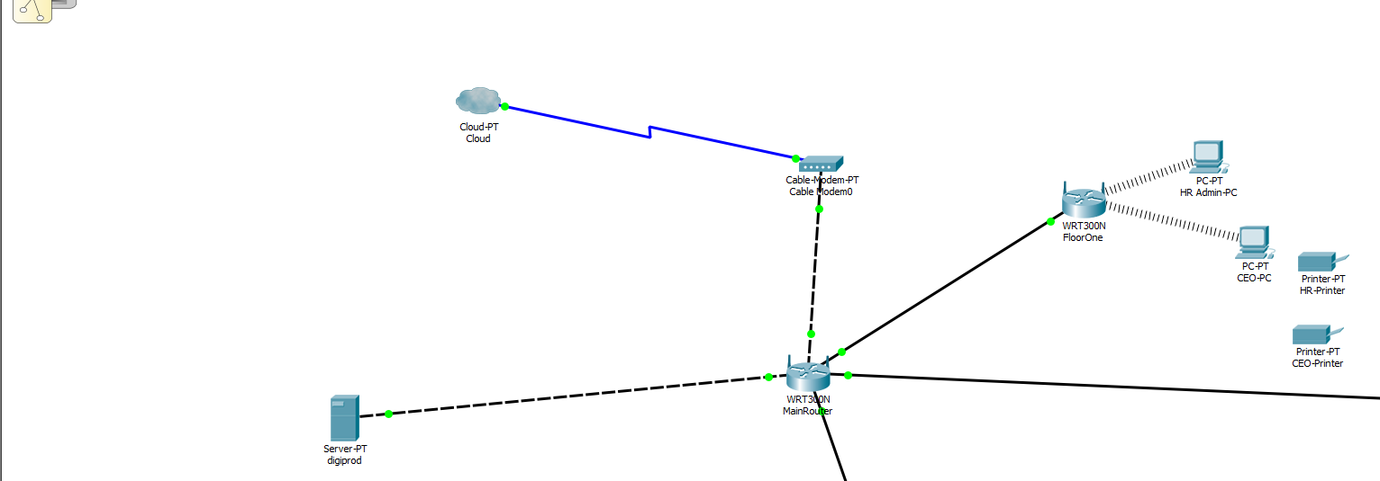

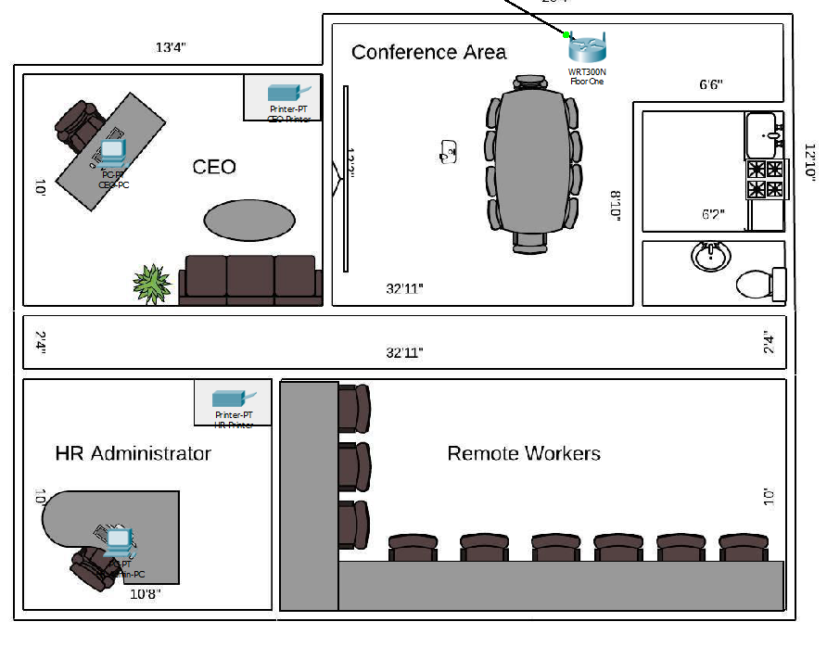

Floor Two
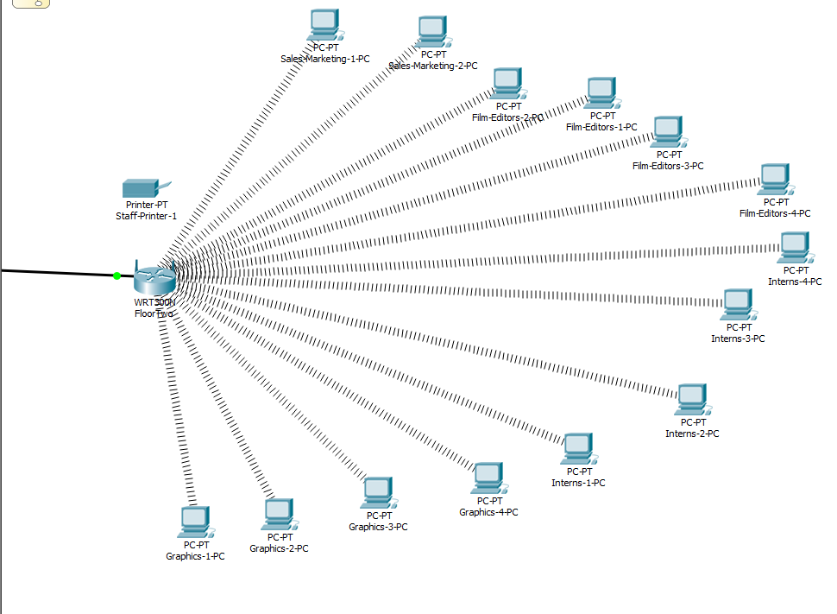
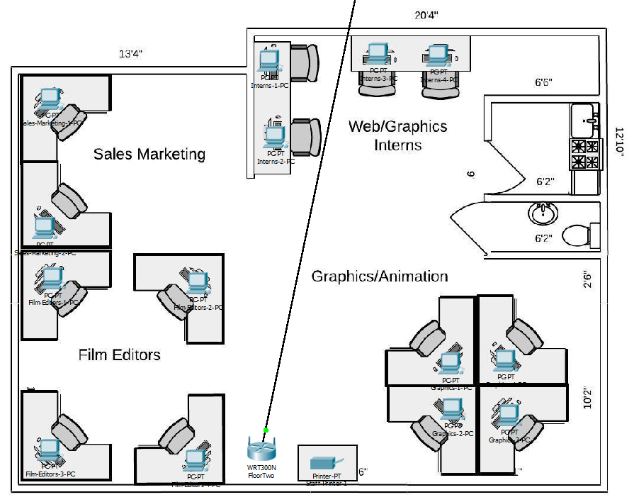
Floor Three
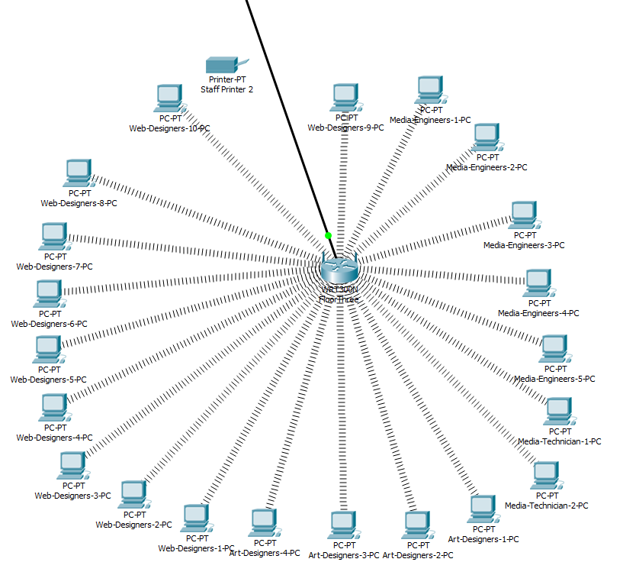
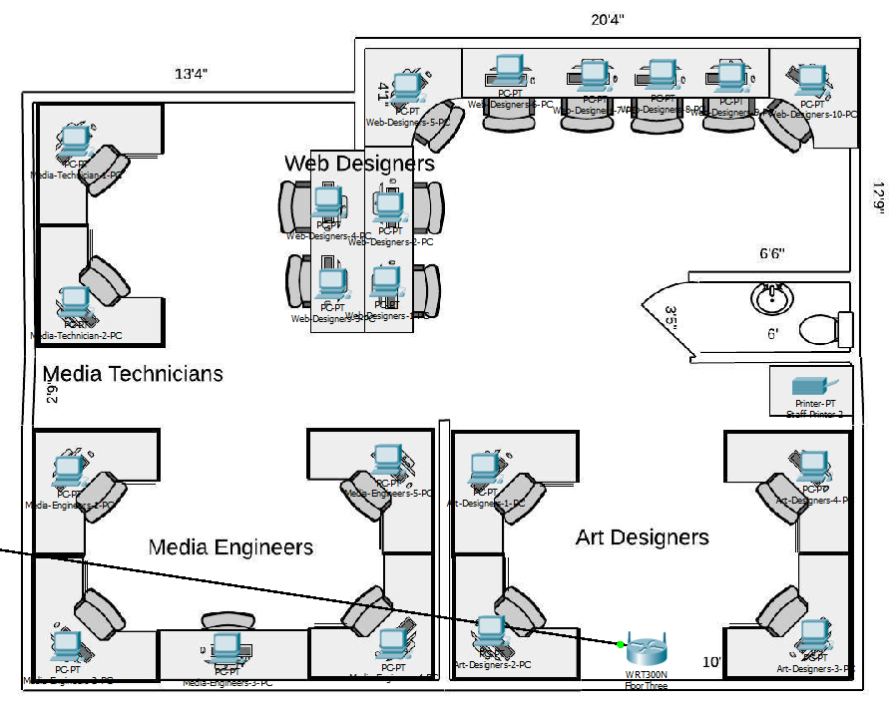
I created the three floors and placed workers on the floor I thought they would work best on, for example I kept the CEO and HR Administrator together next to the conferencing room so that they would always be close to any big business meetings. I also kept all the web/graphics interns next to the graphics/animation workers so that if they needed support they were working next to the right people to help. I kept both media technicians and engineers on the same floor so they could also easily communicate any crossover information. I then started to insert all the hardware such as desktop PC’s, routers, printers and a server. Once all of this had been added into each floor I connected it all together and ensured the network was running as it should. I did this by connecting the three floor routers to a main router and connecting this main router to a modem which was receiving the internet connection from the cloud. This main router then broadcasted this connection to the three floors allowing each PC to connect to the internet wirelessly. The server also connected to the main router, I used DHCP to configure the server and enabled DNS services. I also configured both the Ethernet and global settings of the server. As you can see from the images above all connections are green meaning they are receiving and transmitting a signal, as well as this you can see that the routers on each floor are broadcasting a wireless signal to the PC’s on the corresponding floor.

Appendix
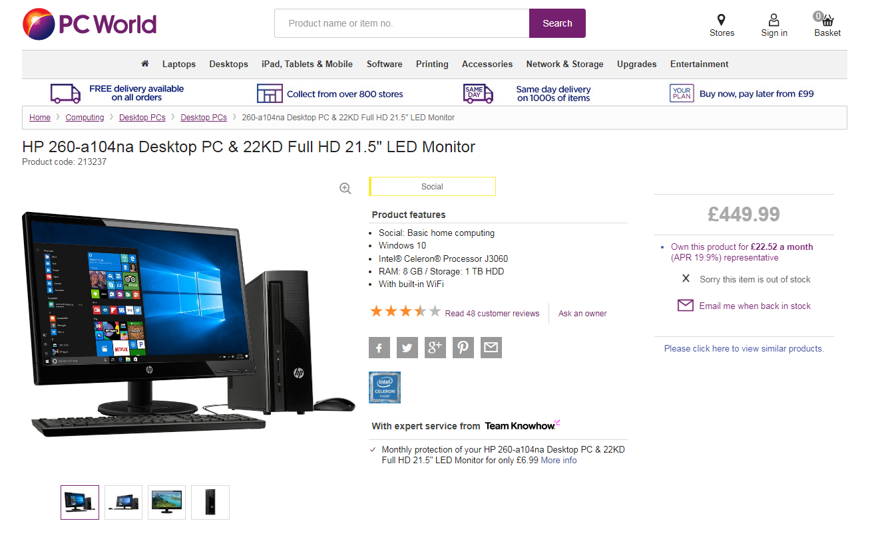(1)
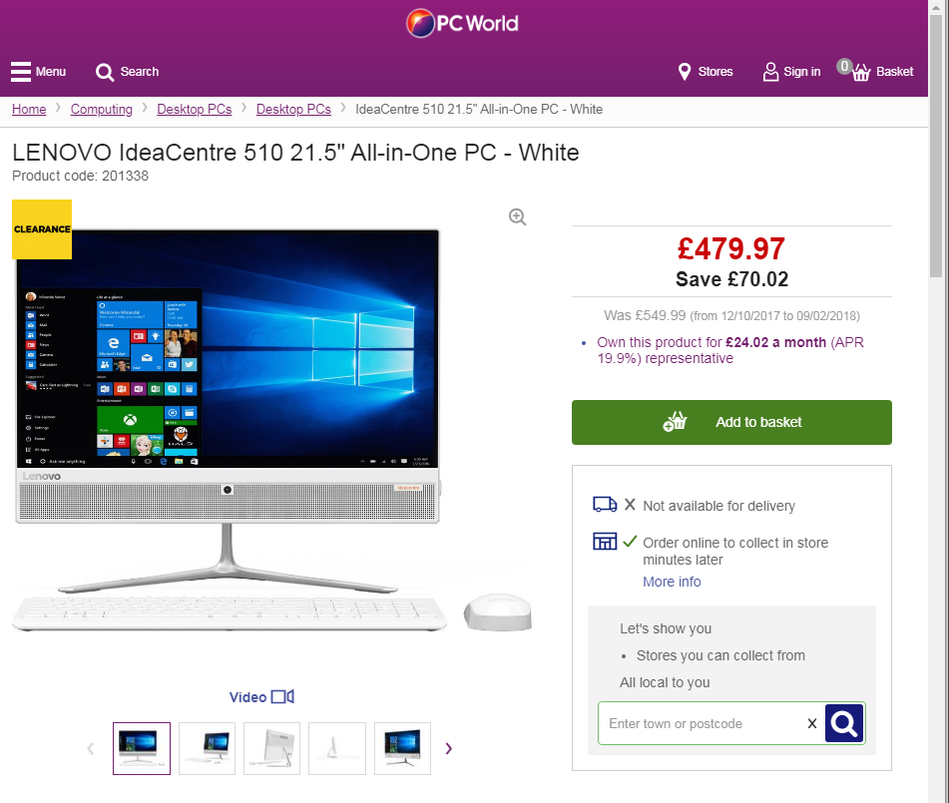(2)
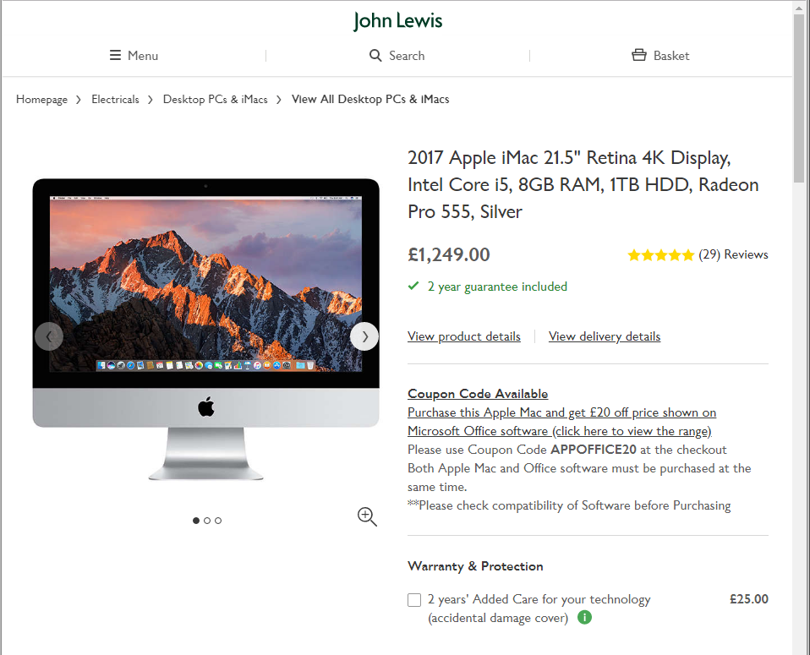(3)

Technical specifications for ACER H6517ST Full HD Home Cinema Projector
OVERVIEW
Type | Home cinema
Resolution | 1920 x 1080
Technology | DLP

PROJECTION
Projection type | Short throw
Screen size range | 45" – 300”
Projection range | 0.5 - 3.3 m
Video standard | - EDTV  - HDTV  - NTSC  - PAL  - SDTV  - SECAM
Brightness | 3500 lumens
Aspect ratio | 16:9
Contrast ratio | 10,000:1
Focus | Manual
Zoom | 2 x
3D ready | Passive 3D
Start-up time | 7 seconds
Other features | - ColourBoost 3D  - Colour Safe II

AUDIO
Number of speakers | 1
Audio power | 2 W

CONNECTIVITY
Wireless connectivity | No
Video interface | - HDMI x 1  - MHL x 1  - VGA x 1
Audio interface | Audio-in x 1

ENERGY
Noise level | 33 dB
Lamp type and consumption | Osram 250 W
Lamp life | 3500 hours
Energy saving features | EcoProjection technology

GENERAL
Colour | White
Box contents | - Acer H6517ST Full HD Home Cinema Projector  - VGA cable  - Remote control with batteries  - Lens cap  - Security cap
Dimensions | 314 x 223 x 93 (H x W x D)
Weight | 2.5 kg
Manufacturer’s guarantee | 2 years
(4)
Server Specifications:
Option | Selection | SKU / Product Code | Quantity
Base | PowerEdge R830 Server | [210-AIBO][329-BCZO] / 561209 | 1
Chassis Configuration | Chassis with up to 16, 2.5" Hard Drives | [321-BCET] / 1625HD | 1
Processor | 2x Intel® Xeon® E5-4610 v4 1.8GHz,25M Cache,6.4 GT/s QPI,No Turbo,HT,10C/20T (105W) Max Mem 1866 MHz | [338-BJHQ] / 54610P | 1
Additional Processor | Upgrade to Four Intel® Xeon® E5-4610 v4 1.8GHz,25M Cache,6.4 GT/s QPI,No Turbo,HT,10C/20T (105W) | [374-BBLX] / 54610A | 1
Processor Thermal Configuration | 4 CPU | [370-ACPJ][374-BBNG][412-AAHZ][412-AAHZ] / 4HTSNK | 1
Memory Configuration Type | Performance Optimized | [370-AAIP] / PEOPT | 1
Memory DIMM Type and Speed | 2400MT/s RDIMMs | [370-ACPH] / 2400MT | 1
Memory^{i} | 16GB RDIMM, 2400MT/s, Dual Rank, x8 Data Width | [370-ACNX] / 16GBMM | 8
Operating System | No Operating System | [611-BBBF] / 806002 | 1
Enabled Virtualization | None |  | 1
OS Media Kits | No Media Required | [605-BBFN] / 535227 | 1
Internal SD Module | None |  | 1
OS Partitions | None |  | 1
RAID | C5 RAID 6 for H730/H730P (4-16 HDDs or SSDs) | [780-BBZK] / C5MSR6 | 1
RAID Controller | PERC H730 RAID Controller, 1GB NV Cache | [405-AADT][440-BBGW] / H7301G | 1
Additional Software Offerings | None |  | 1
Hard Drive | 300GB 15K RPM SAS 12Gbps 2.5in Hot-plug Hard Drive | [400-AJRU] / 300GB1 | 4
Power Management BIOS Settings | Performance BIOS Setting | [384-BBBL] / HPBIOS | 1
Power Supply | Dual, Hot-plug, Redundant Power Supply (1+1), 750W | [450-ADWS] / 750R | 1
Power Cords | Rack Power Cord 2M (C13/C14 10A) | [450-AADY] / 518051 | 2
ADDITIONAL HARDWARE OPTIONS
Option | Selection | SKU / Product Code | Quantity
Embedded Systems Management | iDRAC8, Enterprise with vFlash 8GB SD | [385-BBHO][385-BBHZ] / VI8EN | 1
Network Daughter Card | Broadcom 5720 QP 1Gb Network Daughter Card | [540-BBBW] / 5720QP | 1
Bezel | Dell/EMC Bezel for 2U PowerEdge | [325-BCJT] / 1038400 | 1
Rack Rails | ReadyRails™ Sliding Rails With Cable Management Arm | [770-BBBR] / RRCMA | 1
Optical Drive | Internal DVD+/-RW, SATA | [429-AAPS] / DVRWSA | 1
Trusted Platform Module | Trusted Platform Module 1.2v2 | [461-AAED] / TPM12 | 1
BACKUP SOLUTIONS AND SOFTWARE OPTIONS
Option | Selection | SKU / Product Code | Quantity
System Documentation | No Systems Documentation, No OpenManage DVD Kit | [631-AACK] / NODOCS | 1
SHIPPING | PowerEdge R830 Shipping EMEA1 (English/French/German/Spanish/Russian/Hebrew) | [340-BIEB] / 561213 | 1
EXTENDED SERVICES AND INSTALLATION OPTIONS
Option | Selection | SKU / Product Code | Quantity
Base Warranty | 3Yr Basic Warranty - Next Business Day | [709-13131][709-14257] / 998707 | 1
Warranty | 3Yr Basic Warranty - NBD Included | [710-10844] / 658397 | 1
(5)

