RESEARCH PROPOSAL
TITLE: SUSTAINABILITY AND GREEN OPERATIONS AT LONDON CITY AIRPORT (LCY)

Student: Cristian Ailincai
Student number: 2029264

Abstract
The global aviation industry is under growing criticism for its significant environmental effect, encouraging airports to embrace more environmentally friendly operations. London City Airport (LCY), an important international airport, is at the crossroads of possibilities and problems associated with the aviation industry's journey to sustainability. This research aims to examine LCY's sustainability and green operations, including its role, approaches, and problems, as well as to offer options for improvement. The research focuses on the governance of sustainability and green operations at LCY and covers four research questions. The critical literature review highlights the significance of sustainability in airport operations, highlighting several measures used by airports to lessen their environmental imprint. The Triple Bottom Line (TBL) hypothesis provides a theoretical framework for analysing airport operations' social, environmental, and economic elements. The method uses a descriptive design and an Interpretivism perspective to provide a thorough knowledge of LCY's sustainability activities. Secondary qualitative data is collected from scholarly papers and reports using web sources, and then thematic analysis is used to discover reoccurring sustainability topics. The suggested research is significant as it contributes to the discussion of sustainability in the aviation industry. The research intends to give practical insights and innovative ideas for airports globally by evaluating LCY as an international centre and helping them to a future that is more environmentally friendly. However, due to the dynamic characteristics of the aviation business, inherent confidentiality limits, and the requirement for continuing observation and adaptability to respond to industry changes, the research has limitations. Finally, using LCY as a case study, this research provides useful insights into green procedures in the aviation sector and contributes to the current discussion about balancing economic expansion with environmental preservation.

Table of Contents
1. Introduction 3
2. Critical Literature Review 4
3. Methodology and Methods 5
4. Discussion 7
5. Provisional work schedule 8
References 9
Bibliography 11

1. Introduction
Research Rationale
The global aviation sector has come under growing criticism due to its considerable environmental impact. Airports, as essential participants in the aviation industry, are under pressure to adopt more environmentally friendly operations as public awareness about climate change and sustainable development grows. London City Airport is a significant international airport which has faced both problems and opportunities involved with the aviation industry's transition to sustainability (Londoncityairport.com, 2023). The inspiration for this research arises from the aviation industry's pressing demand for sustainable practices. The interest in sustainability and environmental conservation has led to investigating solutions in the aviation industry, where the conflict between economic growth and environmental preservation is particularly intense (International Civil Aviation Organization, 2023). Furthermore, the growing public awareness and preference for sustainable practices underscored the need to scrutinise significant participants in the aviation sector like London City Airport.
Aim: This research aims to analyse the sustainability and green operations at London City Airport (LCV)
Objectives
The objective of this research is:
- To analyse the role of sustainability and green operations in the management of London City Airport (LCV)
- To evaluate the approaches of London City Airport (LCV) in managing sustainability and green operations
- To identify the issues faced in sustainability and green operations at London City Airport (LCV)
- To recommend strategies to improve sustainability and green operations at London City Airport (LCV)
Research question
RQ1: What is the role of sustainability and green operations in the management of London City Airport?
RQ2: What are the approaches of London City Airport in managing sustainability and green operations?
RQ3: What are the issues faced in sustainability and green operations at London City Airport?
RQ4: What are the strategies recommended to improve sustainability and green operations at London City Airport?

2. Critical Literature Review
Sustainability is extremely important in the overall operation of Airport companies. Airport companies recognise their duty to minimise their environmental footprint, decrease carbon emissions, and participate in actions that contribute to long-term ecological well-being in addition to its legal and regulatory requirements (Gómez Comendador et al. 2019). Green operations are critical to reducing the environmental effect of airport operations, and include anything from energy use to trash management. Airport companies diversely manage sustainability and green operations. Airport companies invest in power-efficient infrastructure, use renewable energy, and have trash reduction and recycling programmes in place (Cirella et al. 2021). Furthermore, Airline companies work with ground services, and municipal governments to set and adhere to strict environmental requirements. The airport continuously explores innovative solutions to improve operating efficiency while reducing its environmental impact.
Aviation has a major environmental effect, making sustainability and environmentally friendly practices in airports a complex problem. The carbon footprint of air travel is one of the main problems which fuels climate change (Terrenoire et al. 2019). Airport operations, public transit, and terminal facilities all contribute significantly to greenhouse gas emissions. Furthermore, resource-intensive procedures are frequently involved in the building and upkeep of airport infrastructure, which exacerbates environmental issues. Airports can employ a variety of tactics to improve sustainability and solve these issues. Firstly, putting energy-saving techniques and technology into place can lower operating emissions (Lin, 2020). It involves making investments in renewable energy sources like solar and wind power to satisfy energy demands. Another way to reduce the environmental effect of travelling with airlines is to maximise ground transportation choices, such as encouraging public transportation, electric cars, and cycling infrastructure (Garrow et al. 2021). Thirdly, improving recycling initiatives and cutting back on single-use plastics on airport property improve waste management systems and support environmental preservation.
Additionally, airports can work together to establish and promote renewable aviation fuels with air carriers, manufacturers, and regulatory agencies. These fuels can drastically reduce aeroplane carbon emissions. Greener airport operations also include employing water conservation measures, using sustainable materials, and adopting eco-friendly architectural designs (Bamidele et al. 2023). In addition, airports need to develop a comprehensive strategy that incorporates technical innovation, teamwork, and a dedication to eco-friendly practices to reduce their environmental effect and promote sustainability.
Theoretical Framework
The Triple Bottom Line (TBL) theory is a suitable framework for investigating sustainability and environmentally friendly operations at airports. The three main components of TBL such as economic, social, and environmental provide a comprehensive framework for evaluating the performance of an organisation (Nogueira et al. 2022). TBL acts as a guiding concept in this study to assess airport operations procedures and sustainability measures. Theory plays a crucial role as a framework through which to methodically examine and understand complicated occurrences. The project intends to apply and improve sustainability principles in the aviation sector by using TBL to evaluate the financial ethical, social, and environmental effects of airport operations.

3. Methodology and Methods
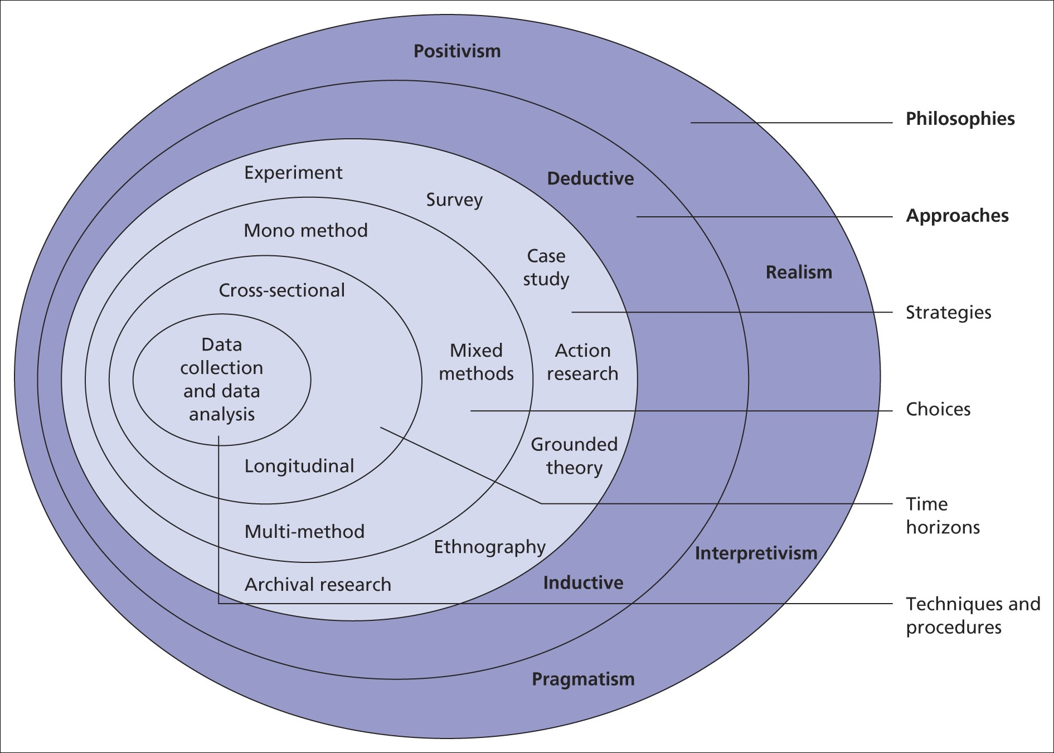
Figure 1: Research Onion
(Source: Saunders et al. 2009)
Research Design
The suggested study will use a descriptive design and an Interpretivism philosophy. Interpretivism philosophy places a strong emphasis on seeing and interpreting society from the viewpoints of the people who are engaged (Al-Ababneh, 2020). This way of thinking is consistent with the study's objectives, which are to investigate and comprehend London City Airport's (LCY) green operations and sustainability initiatives. Choosing a descriptive design allows LCY to present a thorough overview of its sustainability activities without the need for variable manipulation. This design is appropriate as it makes it possible to gather detailed, contextual data that facilitates comprehension of the complexities of sustainable aviation operations.
Research Context
The study is based on the aviation sector and focuses on London City Airport (LCY). LCY, a well-known international airport, is a perfect example due to its importance to international air traffic. Qualitative data can provide valuable insights into research along with maintaining quality and applicability (Earnest, 2020). 9 journals and articles, including LCY reports, will be part of the chosen sample. The selection method will follow the non-probability self-selection sampling technique which is based on the capacity to select certain sources whose information is simultaneously relevant and in-depth.
Procedure
Secondary qualitative articles and reports will be involved in this research. Implementing the UK's copyright laws is essential as ethical concerns take priority in using secondary information from journals and articles. The "Copyright, Designs and Patents Act 1988" can provide permission to use existing research works ethically (Legislation.gov.uk, 2023). In addition, open communication, appropriate acknowledgement, and respect for intellectual property rights will help to foresee and handle any problems that can arise when putting the research method into practice.
Methods for data collection
The process of collecting “secondary qualitative data” for the data collection approach will include searching internet databases for scholarly publications, papers, and official reports from LCY. This approach will be appropriate as it provides access to a wide variety of information without requiring direct contact. The selection of online databases guarantees effectiveness and a wide range of data gathering. The exploratory nature of the study and the emphasis on qualitative data will allow for the extraction of complex insights regarding LCY's sustainable practices.
Methods for data analysis
The selected approach for examining the gathered information will be thematic analysis. Finding, examining, and summarising patterns or themes in the data constitute the process of thematic analysis (Peel, 2020). This method is ideal for answering the study question as it can identify recurrent themes about sustainability and environmentally friendly activities at LCY. An organised approach to thematic analysis will guarantee a thorough investigation of the data with 4 themes and aid in the creation of a significant understanding of the airport's sustainable operations.

4. Discussion
Significance of proposed research
The study that has been proposed on sustainability and green operations at London City Airport (LCY) has a major significance in the current discussion about environmental responsibility in the aviation sector. Airports are essential in determining the ecological effect of the aviation industry as it grows. LCY is a great example of a global hub that can be used to better understand the potential problems involved in making the shift to more environmentally friendly and sustainable practices. The study's value is in its ability to offer practical advice and creative solutions to airports across the world, assisting in the implementation of eco-friendly procedures. This research intends to steer airports to a more sustainable future by evaluating LCY's present operations, identifying effective green projects, and suggesting customised tactics. Furthermore, it advances the area of research by providing a comprehensive grasp of the complexity inherent in the convergence of aviation and sustainability.
Research limitation
There are several restrictions on the research, despite its potential. The aviation sector is dynamic, with fast-changing rules and technology which presents a difficulty in collecting data and analysing them. The temporal scope of the investigation can render it more difficult to record all significant advancements. Furthermore, confidentiality considerations may restrict access to sensitive information and data from airport stakeholders, which can restrict the scope of the research. Keeping in mind these constraints, the study will make an effort to provide a thorough and perceptive analysis while also recognising the necessity of continuing observation and flexibility in response to changes in the business.

5. Provisional work schedule
Tasks | Week 1 | Week 2 | Week 3 | Week 4 | Week 5 | Week  6 | Week  7 | Week  8 | Slippage  Week 10
Proposal Approval
Reviewing literature selected for the study
Methodology development
Designing research
Collecting data
Data Analysis
Discussion of the study outcomes
Final write up
Table 1: Provision work schedule
(Source: Created by Author)

References
Al-Ababneh, M., (2020). Linking ontology, epistemology and research methodology. Science & Philosophy, 8(1), pp.75-91.
Bamidele, R.O., Ozturen, A., Haktanir, M. and Ogunmokun, O.A., (2023). Realizing Green Airport Performance through Green Management Intransigence, Airport Reputation, Biospheric Value, and Eco-Design. Sustainability, 15(3), p.2475.
Cirella, G.T., Russo, A., Benassi, F., Czermański, E., Goncharuk, A.G. and Oniszczuk-Jastrzabek, A., (2021). Energy re-shift for an urbanizing world. Energies, 14(17), p.5516.
Earnest, D., (2020). Quality in qualitative research: An overview. Indian Journal of Continuing Nursing Education, 21(1), pp.76-80.
Garrow, L.A., German, B.J. and Leonard, C.E., (2021). Urban air mobility: A comprehensive review and comparative analysis with autonomous and electric ground transportation for informing future research. Transportation Research Part C: Emerging Technologies, 132, p.103377.
Gómez Comendador, V.F., Arnaldo Valdés, R.M. and Lisker, B., (2019). A holistic approach to the environmental certification of green airports. Sustainability, 11(15), p.4043.
International Civil Aviation Organization.com, (2023). Aviation & Sustainability. Available at: https://www.icao.int/publications/journalsreports/2011/6606_en.pdf [Accessed on: 14.12.2023]
Legislation.gov.uk, (2023). Copyright, Designs and Patents Act 1988. Available at: https://www.legislation.gov.uk/ukpga/1988/48/contents [Accessed on: 14.12.2023]
Lin, W., (2020, February). Air transport carbon reduction optimization based on low carbon emissions. In IOP Conference Series: Earth and Environmental Science (Vol. 450, No. 1, p. 012065). IOP Publishing.
Londoncityairport.com, (2023). London City Airport Achieves Level 4+ Carbon. Available at: https://www.londoncityairport.com/media-centre/press-releases/london-city-airport-achieves-level-4-carbon-accreditation-certification [Accessed on: 14.12.2023]
Nogueira, E., Gomes, S. and Lopes, J.M., (2022). The key to sustainable economic development: a triple bottom line approach. Resources, 11(5), p.46.
Peel, K.L., (2020). A beginner's guide to applied educational research using thematic analysis. Practical Assessment, Research, and Evaluation, 25(1), p.2.
Saunders, M., Lewis, P. and Thornhill, A., (2009). Research methods for business students. Pearson education.
Terrenoire, E., Hauglustaine, D.A., Gasser, T. and Penanhoat, O., (2019). The contribution of carbon dioxide emissions from the aviation sector to future climate change. Environmental research letters, 14(8), p.084019.

Bibliography
Goetze, A., McGinn, B., Vishwanath, N., Kato, R. and Clark, S., (2022). From Controversy to Collaboration: Re-imagining London City Airport as a Beacon for Urban Ecological Justice. Cities Studio Annual Review, 2.
Gómez Comendador, V.F., Arnaldo Valdés, R.M. and Lisker, B., (2019). A holistic approach to the environmental certification of green airports. Sustainability, 11(15), p.4043.
Greer, F., Rakas, J. and Horvath, A., (2020). Airports and environmental sustainability: A comprehensive review. Environmental Research Letters, 15(10), p.103007.
Jiang, Y., Yang, R., Zang, C., Wei, Z., Thompson, J., Tran, T.H., Encinas-Oropesa, A. and Williams, L., (2021). Toward baggage-free airport terminals: A case study of london city airport. Sustainability, 14(1), p.212.
Kacar, B., Turhan, E., Dalkiran, A. and Karakoc, T.H., (2023). Green Airport building certification comparison: a practical approach for Airport Management. International Journal of Green Energy, 20(6), pp.602-615.
Nold, C., Haklay, M., Walker, T., Doherty, J., Morris, M. and Boon, G., (2023). Citizen Science Study of Overflight Noise from New and Old Generation Aircraft at London City Airport. Community Science.

