
Project proposal: Employee Health and wellbeing
Megan Howard (1901567)

July 3, 2020
University of Wales Trinity Saint David

Executive Summary
The purpose of this report is to analyse how Marriott as a global company appreciate their employees. Through Health and Wellbeing programs, benefits and much more. A comparison between Marriott International and Wyndham Hotels and Resorts will be completed to show the differences in how companies motivate their employees, and how the performance of these employees show positively back into the business. An analysis of the two companies Corporate Social Responsibility programs will be analysed and compared, to see which business has the most return on investments into their employees.

Table of Contents
Executive Summary 1
Introduction 3
Main Findings 3
Marriott International 3
MMS’s Wellness and You. 3
TakeCare Certification 3
Employee Benefits 3
Employee Progression 4
Wyndham Hotels & Resorts 4
Wellness Program 4
Employee Benefits 5
Employee Progression 5
Comparison: Marriott vs. Hilton 5
Corporate Social Responsibility 5
Reflection for the future 6
Appendix 7
References/Bibliography 10

Introduction
Health and Wellness of employees is important to the hospitality industry, as the employees make up the workforce that are caring for the customers, who make up the business. Without the employees treating the customers, the business may not thrive.
According to Covey (2004) “always treat your employees exactly as you want them to treat your best customers.” We will analyse how Marriott International and Wyndham Hotels and Resorts treat their customers, and how it positively returns back into the businesses.

Main Findings

Marriott International
Marriott International began their global career with their root beer stand in 1927. Today they are the world’s leading hotel business with 7,000+ properties in 131 countries holding over 30 brands. Their global reach touches a great deal of countries and therefore many employees.
Marriott International (2008) views on employee health and wellbeing are “when our employees feel respected and valued, we know that they’ll make our guests, suppliers, owners and franchisees feel the same way too.”
To show their employees the respect and value them, the company have implemented various programs. These programs include Corporate Fitness Facility, Work-Life Programs, Healthy Expectations, Associate Health Services, Employee Assistance Program, and MMS's Wellness & You (Health Project, 2020.)

MMS’s Wellness and You.
Launched in 1993, this program was one of Marriott’s’ earliest demonstration of Employee health and wellness, which offers many components for its employees. A few main are, health counselling, walking club, focused follow up for high risk individuals, screenings (e.g. skin cancer) and Tai Chi classes (Health Project, 2020.) One of Marriott’s main health kicks is exercise. They provide employees with free access to the hotel’s gyms and promote exercise where they can. According to Marriott News Center (2019), “88 percent of Marriott managed properties support physical activity during work hours by hosting walking breaks or by sponsoring "fitness breaks."”

TakeCare Certification
“Established in 2010, TakeCare was initially developed to give Marriott staff ‘easy, efficient ways to improve their health’” as explained by Whitby (2019.) This program was such a success among employees and showed a great impact on the business, that Marriot expanded this program into an app so other hotels can benefit from the positive employee experienced and learnt from a global company’s achievements. Marriott News Center (A, 2019) announced in 2018 of an expansion to the TakeCare program, taking the scheme to Titanium Level, which is to promote wellbeing for all, not just staff.
“As we continue to grow the global TakeCare wellbeing brand, this certification will help promote the timeless people-first values behind Marriott’s culture beyond our hotels to organizations around the world,” said Dr. David Rodriguez, Executive Vice President and Global Chief Human Resources Officer at Marriott International (Marriott News Center-A, 2019.)

Employee Benefits
Marriott International offer their employees many benefits during their time working with the company. The include earning extra vacation days, paternity pay, language lessons, childcare, discounts, complimentary food on shift, free gym memberships, staff parties, up to 50% off hotel stays for employees and family members, educational programs, and much more. One main benefit Marriott offer, that continues to be a benefit even after leaving the company, would be their free stays in any Marriott International hotel in the world, for the rest of your life. According to Marriott’s vice president of benefits, Anjuman Nyam, “All employees, ranging from hourly staffers to company executives, qualify for the program after 25 years of employment” (Bhattarai, 2011.)

Employee Progression
According to Marriott Careers (A, 2020), the business “offer professional development, mentoring and training to help” with career progression. Marriott also issue awards for most motivated staff, therefore promoting the fact they inspire staff to progress.
As a business, Marriott see their associates like family, wanting the atmosphere to be surrounded by teamwork and creativity (Marriott Careers-B, 2020.)
According to an anonymous reviewer on Glassdoor (B, 2020), their most recent employee review for Marriott International (as of July 2nd, 2020), pros of working for the business were the following, “Leadership training, One on One meetings/coaching, Networking opportunities, [and] lots of opportunities to move up the corporate ladder.” This links back the company’s goal to help employees progress their career within the business.

Wyndham Hotels & Resorts
With 9,000+ hotels, in over 80 countries worldwide holding over 20 brands, Wyndham Hotels are a competitor for Marriott International (Wyndham Hotels-A, 2020.) Similar to Marriott, Wyndham Hotels offer a variety of different hotels for a vastly different clientele.
As spoke by Bruce Harkness, Senior Vice President Customer Experience and Human Resources, Wyndham Hotel “see a big correlation between staff well-being and staff retention, along with productivity, creativity, and innovation” (Christofis, 2019.)
To show their guest they care about their health and wellbeing, Wyndham Hotels implemented some health programs and benefits for their employees. The main being their Wellness Program (UCSD Center for Community Health, 2016.)

Wellness Program
Wyndham Hotel have a few employee wellness programs. However, their main is the Wyndham Wellness Program. In 2015, Wyndham San Diego Bayside became the first allocated Live Well San Diego hotel (UCSD Center for Community Health, 2016.) This was the start of an enlightening journey.
UCSD Center for Community Health (2016) reported “Wyndham’s wellness programming focuses on establishing workplace environments that support healthy eating and active living with particular focus on low-wage employees.”
Exercising and healthy eating has been proven to lower anxiety feelings, and depression, reduce stress, improve sleep, and increase self-esteem (Mead, 2015.) All of these translate into employees feeling healthier, happier, and more motivated. All of these affects can positively health the hotel business. When the staff are happier and motivated, the guests will see this, improving the guests experience.

Employee Benefits
A few benefits whilst working with Wyndham Hotels include Health insurance, Dental insurance, Vision insurance, Life/AD&D insurance, Short and Long-Term Disability coverage, 401(k) with generous company match, Paid Holidays, and hotel room discounts (Wyndham Hotels-B, 2020.)

Employee Progression
According to an anonymous reviewer on Glassdoor (A, 2020), one of the most recent employee review for Wyndham Hotels & Resorts (as of July 2nd, 2020), pros of working for the business were the following, “Stable company, good benefits, nice facilities, fantastic leadership and senior managers.” This indicates the company has room for employees to progress internally.

Comparison: Marriott vs. Hilton
When comparing employee wellness with internal progressions within the business, both companies have positive reviews and feedback, indicating both businesses have valuable insight on this subject and know how to help their employees to grow within their career. Yet, Marriott seemed to overtake Wyndham in other parts of business.
Even though Marriott has been labelled “The world’s largest hotel chain” (Cheslaw, 2019), in regard to the number of hotels, as of June 2019, Wyndham Hotel & Resorts hold the most hotels at 9,157 whilst Marriott holds 7,003 (Statista-A, 2020.) With more hotel building, that may possibly mean more staff for Wyndham Hotels, which indicates more work should need to go into showing appreciation for them. However, this isn’t the case, as Marriott has implemented more Health and Wellbeing programs, benefits, and rewards for their staff than Wyndham Hotels.
One reason Marriott may be able to implement more programs may be due to a higher revenue than Wyndham Hotels, therefore more money to spend on staff wellbeing. According to Statist (B, 2020) “global hotel giant Marriott International generated approximately 20.76 billion U.S. dollars in revenue in 2017”. However as stated by Statista (C, 2020) “Wyndham Worldwide Corporation generated approximately 5.1 billion U.S. dollars in revenue in 2017.”
One could argue Marriott’s revenue is higher than Wyndham’s due to Marriott’s employee health and wellness effort being vastly more implemented then Wyndham’s. As not only does Marriott help their staff to progress in nearly every part of their own lives, but society also, through Marriott’s multiple fundraisers for charities. One example would be Marriott’s ‘You Eat, We Give’ fundraiser (Marriott International New Center-B, 2019.) This successful charity promotion has raised 2.5million euros (2012-2019) for 15-24 year olds to follow their dreams of whatever talent they hold. Marriott raised the money by donating a euro for every lunch or dinner served in their hotel’s restaurants. Hotel employees were also promoting food purchases to raise money for charity, showing they care about the community’s wellbeing also.

Corporate Social Responsibility
Marriott International truly believe business reputation and image increases when employees are motivated and happy within the workplace (Marriott Careers-A, 2020.) A big part of Marriott’s strategy is their Serve 360 program. This program play a critical role on helping with the worlds most pressing environmental, social, and economic issues (Marriott International, 2019.) Marriott’s four main point of this program are, Nurture; Sustain; Empower; Welcome.
Nurture is to make the communities surrounding Marriott’s operations better places to live, work and visit. Sustainability contains Marriott’s pledge to be more mindful of the earth by limiting their carbon footprint, minimisation of waste and much more. Caring for the earth is caring for their staff. This world will be run by the next generation of managers that take over the positions of retirees. Empowering others is part of Marriott’s initiative to help stop unemployment and underemployment pushed by lack of opportunity and inequality. Welcoming a world for all is an initiative pushing to promote peace and cultural understanding for all. Cultural understanding is great cause, due to Marriott having such a prominent global presence, within many different cultures. Without cultural understanding, Marriott International would have many problems dealing with offence caused by those without cultural training (Marriott International, 2019.)
Wyndham Hotels believe “that you can do well by doing good” (Wyndham Hotels & Resorts, 2020.) A part of Wyndham’s employee welfare is their Social Responsibility program. This program has an important role for the business as its not only for employees, but surrounding communities too.
Wyndham strive for diversity and inclusion culture. Infusing different perspectives that reflect on customers and communities around the world. Environmental protection with sustainability leadership plays a role in how Wyndham conduct their business. By limiting their environmental footprint, they preserve natural resources also. Commitment to protecting human rights includes stopping all human trafficking, which is a major priority for Wyndham. With the franchise, they support UN Universal Declaration of human Right and the Polaris Project. These organizations combats human trafficking in all forms. As a hospitality company, giving and action is a service that they give daily. However, teams from the company travel around the world to engage in charities and give to communities.

Reflection for the future
As a conclusion from this report, it has been found that not only is Marriott the leading globalised hotel, it is also one of the best for caring for its employee’s wellbeing and health. Not only through their benefits and health programs, also through their caring for the earth and therefore their employee’s future, and through showing their staff everyday that they are always there.
They have adapting in more ways than one, to help their employees through updating their technology, lifetime sustainability, and generally having healthy atmospheres within their hotels.
Some researcher state “some employee reward programs can be cost-prohibitive” (Mayhew, 2017.) However, Marriott find spending money on their employees to be a massive return back into the business. They feel when the employee is motivated and cared for, it reflects positively onto the business (Marriott News Center-A, 2020.)

Appendix

Appendix 1
(Leading hotel companies worldwide as of June 2019, by number of properties.)
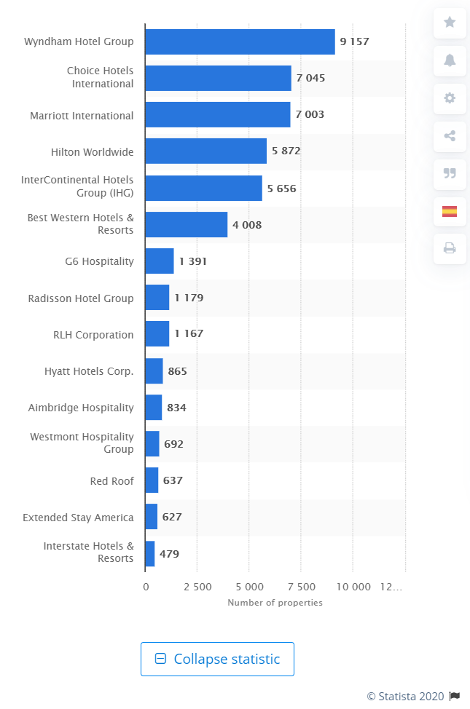
(Statista-A, 2020)

Appendix 2
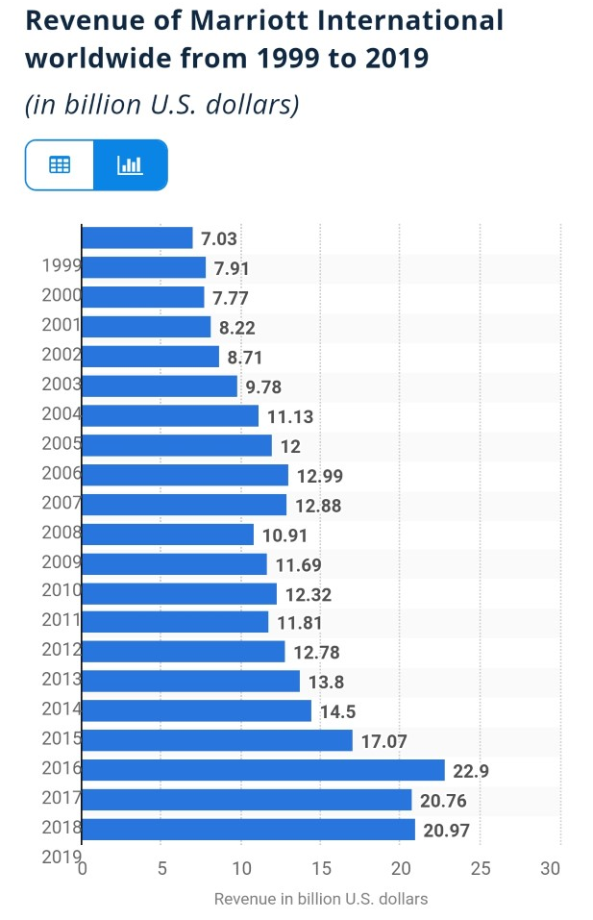
(Statista-B, 2020)

Appendix 3
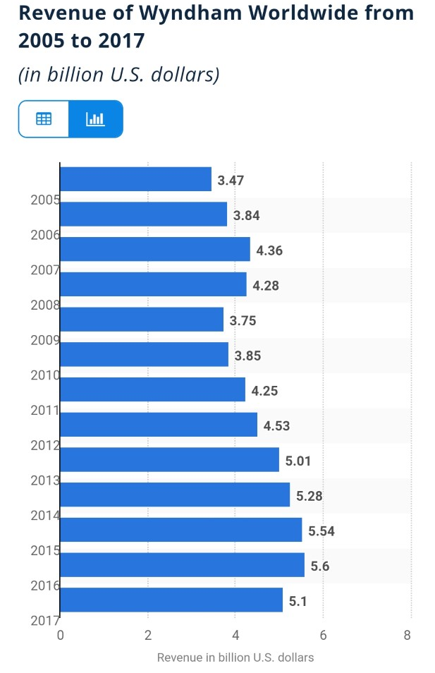
(Statista-C, 2020)

References/Bibliography

Bhattarai, A. (2011) After 25 years at Marriott, a free room – and sometimes breakfast. Available at: https://www.washingtonpost.com/business/capitalbusiness/after-25-years-at-marriott-a-free-room--and-sometimes-breakfast/2011/12/01/gIQA8u3bnO_story.html (Accessed: 1 July 2020)
Butler, A; Kwantes, C; Boglarsky, C. (2014) ‘The effects of self-awareness on perceptions of leadership effectiveness in the hospitality industry: A cross cultural investigation International Journal of Intercultural Relations’ International Journal of Intercultural Relations. Vol.40, pp.87-98. Available at: https://www-sciencedirect-com.ezproxy.uwtsd.ac.uk/science/article/pii/S0147176713001454 (Accessed: 2 July 2020)
Cheslaw, L. (2019) Marriott International, the World's Largest Hotel Chain, Is Banning Small Toiletries by 2020. Available at: https://www.cntraveler.com/story/marriott-international-the-worlds-largest-hotel-chain-is-banning-small-toiletries-by-2020?verso=true (Accessed: 2 July 2020)
Christofis, A (2019) Focus on Well-Being Keeps Wyndham Destinations Employees Active and Happy. Available at: https://resorttrades.com/focus-on-well-being-keeps-wyndham-destinations-employees-active-and-happy/ (Accessed: 2 July 2020)
Covey, S. R., (2004) The 7 Habits of Highly Effective People: Powerful Lessons in Personal Change. New York USA: Simon and Schuster, Inc. pg. 58.
Glassdoor (A, 2020) Great Company. Available at: https://www.glassdoor.co.uk/Reviews/Employee-Review-Wyndham-Hotels-and-Resorts-RVW33623397.htm (Accessed: 2 July 2020)
Glassdoor (B, 2020) Long Hours, High Stress, but Great Opportunity to climb Corporate Ladder. Available at: https://www.glassdoor.co.uk/Reviews/Employee-Review-Marriott-International-RVW34022827.htm (Accessed: 2 July 2020)
Health Project (2020) Marriott. Available at: http://thehealthproject.com/winner/marriott-wellness-and-you/ (Accessed: 2 July 2020)
Marriott Careers- A (2020) HERE’S TO THE JOURNEY. Available at: https://careers.marriott.com/en-GB/ https://careers.marriott.com/en-GB/career-paths/ (Accessed: 2 July 2020)
Marriott Careers- B (2020) CHOOSE YOUR CAREER PATH. Available at: https://careers.marriott.com/en-GB/career-paths/ (Accessed: 2 July 2020)
Marriott International (2019) 2019 Serve 360 Report: Sustainability and Social Impact at Marriott International. Marriott International. Unpublished.
Marriott International New Center- A (2019) Marriott International Announces Expanded Wellbeing Certificate Program. Available at: https://news.marriott.com/news/2019/09/18/marriott-international-announces-expanded-wellbeing-certification-program (Accessed: 1 July 2020)
Marriott International New Center- B (2019) Marriott International Fundraising Initiative Raises Over €400,000 To Support Young People In Europe. Available at: https://news.marriott.com/news/2019/02/01/marriott-international-fundraising-initiative-raises-over-400-000-to-support-young-people-in-europe (Accessed: 1 July 2020)
Mayhew, R. (2017) The Disadvantages of Employee Rewards Programs. Available at: https://bizfluent.com/info-7843439-disadvantages-employee-rewards-programs.html (Accessed: 3 July 2020)
Mead, N. (2015) 8 ways regular exercise boosts your workplace productivity. Available at: https://www.totaljobs.com/insidejob/8-ways-regular-exercise-boosts-your-workplace-productivity/ (Accessed: 2 July 2020)
Statista-A (2020) Leading hotel companies worldwide as of June 2019, by number of properties. Available at: https://www.statista.com/statistics/197869/us-hotel-companies-by-number-of-properties-worldwide/ (Accessed: 3 July 2020)
Statista-B (2020) Revenue of Marriott International worldwide from 1999 to 2019. Available at: https://www.statista.com/statistics/266279/revenue-of-the-marriott-international-inc-hotel-chain/ (Accessed: 2 July 2020)
Statista-C (2020) Revenue of Wyndham Worldwide from 2005 to 2017. Available at: https://www.statista.com/statistics/255062/wyndham-hotel-group-revenue/#:~:text=Global%20hotel%20company%20Wyndham%20Worldwide,dollars%20in%20revenue%20in%202017. (Accessed: 2 July 2020)
UCSD Center for Community (2016) Creating a Culture of Health: Wyndham. Available at: https://ucsdcommunityhealth.org/news/creating-a-culture-of-health-wyndham/ (Accessed: 3 July 2020)
Whitby, M. (2019) You an now access Marriott’s TakeCare wellness scheme. Available at: https://www.leisureopportunities.co.uk/news/You-can-now-access-Marriott%E2%80%99s-TakeCare-wellness-scheme/343136 (Accessed: 3 July 2020)
Wyndham Hotels & Resorts-A (2020) ABOUT WYNDHAM HOTELS & RESORTS. Available at: https://www.wyndhamhotels.com/about-us (Accessed: 1 July 2020)
Wyndham Hotels & Resorts-B (2020) Our Benefits. Available at: https://careers.wyndhamhotels.com/content/Our-Benefits/?locale=en_US# (Accessed: 3 July 2020)
Wyndham Hotels & Resorts (2020) Social Responsibility. Available at: https://corporate.wyndhamhotels.com/social-responsibility/ (Accessed: 3 July 2020)

