Personnel Resourcing and Development
BMIH5005

Student Name: Mario Costin Merisan
Student ID: 2114671
Lecturer’s name: Kathryn Roberts

Essay on
‘How to Engage Employees Throughout Employee Lifecycle’

Introduction
Employee engagement refers to the enthusiasm and dedication of employees towards the job. The employee lifecycle shows the compact period of different experiences which may be utilized to improve employee engagement (Kaliannan and Adjovu, 2015). The essay will elaborate on the importance of human resources in increasing employee engagement. Then the process of engaging employees will be described and the way to improve team engagement will be elucidated. Then the employee lifecycle will be analysed to highlight the required tasks to increase engagement in each stage. The essay will be concluded after presenting an employee management model to manage employees more effectively.

Importance of Human Resources in Employee Engagement
Employee engagement identifies the dedication of employees toward the organization while Human Resources means managing the employees and dealing with the issues that are related to the employees (Jha and Kumar, 2016). The central concept here is the employees and both of the terms revolve around it. Human Resources and Employee Engagement have a causal connection between them because the management of Human Resources can effectively manipulate the attitude of the employees towards the company, hence affecting employee engagement. So, the importance of productive human resource management is significant to ensure excellent employee engagement which eventually will help to increase the productivity of the organization. The ways Human Resources can be important are presented below (Al Mehrzi and Singh, 2016).
- Cultivating Healthy Organisational Culture
The role of maintaining the organizational culture is dependent on the management of human resource because HR start by choosing the type of culture appropriate for the organization and hires employees according to it. By ameliorating the issues within the culture HR ensures a hospitable environment for the environment, which, in turn, inspires dedication and obligation toward the organization as is proven by the improvement of Hilton, a hospitality company (Radda et al., 2015).
- Proper Training and Skill Development
Human resources deal with the training programs that are implemented on the employees and update their strategies to enhance productivity. Without HR, there will no focus on the development of the employees (Clack, 2020). HR inspires the employees by evaluating their performance and with sympathetic motivations and incentives, their interest in the job and compassion for the organisation is uplifted. HR gains the favour of the employees by helping to fix their mistakes by showing a positive outlook (Eldor and Vigoda-Gadot, 2017).

- Initiatives to Increase Engagement
The HR Department may start various initiatives to boost the commitment of the employees such as a Reward System, Recognition, teamwork etc. By rewarding well job HR may value the effort of an employee. If the employee may fail in attaining a goal, he must be appreciated for his effort. Doing these activities along with increasing teamwork environment will make work the place special for the employee thus ensuring more engagement (Mann and Harter, 2016).
- Keeping Track
HR also keeps track of the regularity of employee engagement in the office and separates issues that are hindering the employees from being empathetic toward the organisation.

Process of Employee Engagement and Advantages of Team Engagement
There are a lot of ways to improve employee engagement that is practised by renowned organisations to improve the morale of the employees.
- Valuing Inputs of the Employees
Cultivating an open environment for innovative ideas is a beneficial way to come up with new and productive ideas. By practising this process the organisation can get twofold profit. Firstly, it creates value for the opinions of the employees and shows them that they matter, which is a great way of showing respect and appreciation. Secondly, the organisation get to choose among many brilliant ideas which have the potential to improve the performance of the organization (Kumar and Pansari, 2015). Tesco has implemented this technic to improve engagement.
- Showing Transparency
An organisation should clarify the workers about their objectives and methods. By this, there will be no confusion while executing any project and the employees will be prepared for upcoming situations. Additionally, they can help the planning process and make things go smoothly. This is a great way of gaining the trust of the employees and ensuring employee engagement (Carasco-Saul et al., 2015).
- Celebrating Improvements
Celebrating improvements, even small ones, will help construct a positive and inspirational attitude. The focus on small things will be enlarged the employees and they will start caring about the organization (Turner, 2019).
- Feedback
Taking feedback from the employees about their performance, expectations and complications will make the environment more favourable for the employees and enable them to care more about the tasks they are given. Measuring their achievements and shortages HR may try to educate them and embrace the culture of mutual trust. Such a Culture fostering a criticism-taking attitude will undoubtedly be helpful for the employees because they can update their knowledge and the organisation can be better at managing the employees. Barclays, a UK-based company has implemented this method.
- Appreciating Diversity
An office is a place for talented and skilled workers motivated to develop the organisation and the office must appreciate the diversity among the employees rather than embrace it, by examining the special talents of different people and nurturing them. The office should prove that every employee matters no matter what their position is. By valuing people from different ethnicity, race and culture the office will be a great opportunity to organize their talents. This will make a good impression of the organisation on the employees and they will feel more dedicated to the cause of the organization (Chandani et al., 2016).
All of these practices stay relevant even in engaging a team to execute a certain activity. Practices like sharing objectives and goals are crucial to engaging a team. Caring about the employees and taking their input is also significant to operate a team operation. Proper training and improving skills can engage an employee in the team. Rewarding good performance and fixing the shortcomings of the team members can make them more productive. So, the factors that elevate the engagement of employees in the office can be responsible for engaging a team effectively (Sun and Bunchapattanasakda, 2019).

Explaining Employee Life Cycle and Its Relation to Employee Engagement
Employee Lifecycle represents the universal life circle of an employee which he or she goes through from start and end to employment. There are six stages in the Employee Lifecycle model and it has a close connection to employee engagement. Throughout the stages, some opportunities can ensure better employee engagement. The stages are elaborated on below.
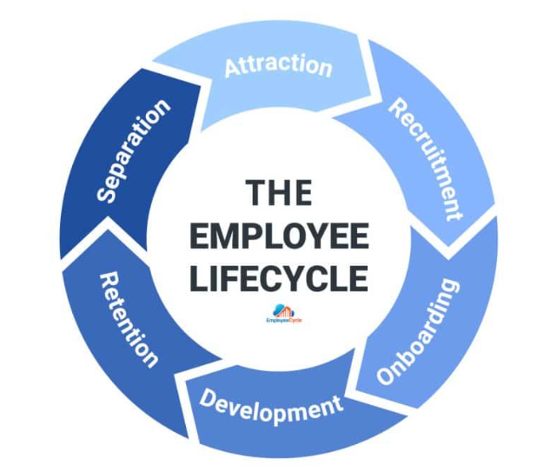
Figure 1: The Employee Lifecycle (Rosethorn, 2016).
Attraction
Attraction implies the pre-stage of employment where the employee recognizes a company from outside maybe through advertisement or reference and evaluates himself whether he would be perfect for the job. This stage may offer some activities that will attain better employee engagement. Such as, maintaining good brand value and reputation will entice people to work in the company. Strong employment campaign or advertisement showing positive cultural values.

Recruitment
Recruitment is the process of hiring and taking suitable candidates for the job. This stage is crucial for taking appropriate persons and skills that can be helpful for the job. It is important to both the employee. To create employee engagement in this section the interview can include joyful communication that may be personalized to the candidates. This is the perfect stage for getting to know the employee and creating a value statement about the candidate.
Onboarding
The stage starts when the candidate gets an offer for the job. On the first dew day, he gets to know the place and understand the culture by seeing the environment and experiencing the first impression of the office. So, this first impression is significant to ensure employee engagement. Showing a helpful attitude and explaining the objectives and goals to the new employees can be effective in creating a good impression. So, different technics elaborated on earlier can be deployed in suitable stages. This is the best time for establishing communication and making them comfortable. Because this segment determines the level of engagement. If a person does not feel welcomed in the offices he will not feel connected to the cause and profit of the company.
Development
The Development stage is the period of training and skill improvement. In this stage, the company can show the value of its employees by investing in their skill development and the progression of their career so that the employee could understand that they will be benefited personally and professionally If he sticks with the company. This learning culture will recognize the meaningfulness of the employees. By monitoring the employees the company can make the employee feel special and gain dedication. This will ensure employee engagement.
Retention
Retention is the stage where the company tries to retain the talented employee by recognizing and rewarding the employee. After the development stage, the employee becomes valuable and skilful because he has potential and the company has invested in him. So, to retain the employee a company can do several practices to increase engagement. Rewarding is the most important practice of those because it shows recognition and provides them with health resources along with other facilities like promotion so a company can retain an employee (Cattermole, 2019).
Separation
The separation process is the time when a company has to let go of employees. But this experience can be productive and engaging. Keeping good relations and wishing him good luck by giving good recommendations may structure a good relationship between an ex-employee and a company. This could help get new talented employees by the reference of the old employee or by the good impression of the job lifetime of the employee which will circularly affect the attraction process. This is how the employee lifecycle is complete (Sato et al., 2020).

Deploying Employee Engagement Model
The employee Engagement Model guides a company to value its employees and ensure contentment in jobs. Aon Hewitt Engagement Model will be implemented which focuses on the outcome of Staying. The model is hugely popular for its effectiveness and it has Six components.

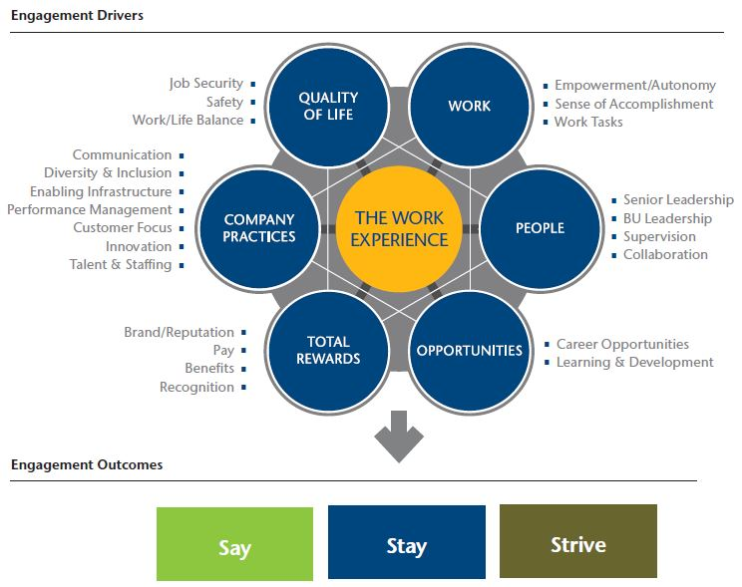
Figure 2: Aon Hewitt Engagement Model (Padhi et al., 2015).

Work
The work segment demonstrates giving the employee independence to his creative ideas for his job. His job must have an accomplishment since and have the element of autonomy. By doing this, the employee will feel self-confident and engaged with the company (Hinzmann et al., 2019). Salesforce is implying this process.

People
In an office environment, an employee must communicate with other people. There must be monitoring and supervision to guide a person to the new tasks. Decent leadership can augment the creativity of the employees so skilful leadership must be applied. The employee should be given the chance to thrive in teamwork which will increase his collaborative attitude like CISCO (Patonangi and Gustomo, 2018).

Opportunities
Every employee must have the chance to learn in the workplace and enhance his skills through work. The company should show that he is being personally and workwise benefited and give him the scope to gain a better career.

Total Rewards
Incentives and rewards are to be given by the organization to inspire the good work of the employees. This recognition will motivate them to be more productive (Rawat and Dadas, 2019).

Company Practices
The employees must be involved in the activities of the company to show their talent and innovation. The employee will learn to be customer focused and organized and communicate more effectively.

Quality of Life
Research has shown that companies with better job security and health safety tend to foster more talented employees.

Conclusion
The essay is focused on showing the importance of HR management of improve the engagement of employees. The employee engagement process has been demonstrated and the team engagement will be elucidated. The employee lifecycle will be analyzed showing that the stages can be used to engage employees. The Aon Hewitt Engagement Model will be implemented showing the way to manage employees.

References
Kaliannan, M. and Adjovu, S.N. (2015). Effective employee engagement and organizational success: a case study. Procedia-Social and Behavioral Sciences, 172, pp.161-168.
Al Mehrzi, N. and Singh, S.K. (2016). Competing through employee engagement: a proposed framework. International Journal of Productivity and Performance Management, 65(6), pp.831-843.
Mann, A. and Harter, J. (2016). The worldwide employee engagement crisis. Gallup Business Journal, 7(1), pp.1-5.
Eldor, L. and Vigoda-Gadot, E. (2017). The nature of employee engagement: Rethinking the employee–organization relationship. The International Journal of Human Resource Management, 28(3), pp.526-552.
Kumar, V. and Pansari, A. (2015). Measuring the benefits of employee engagement. MIT Sloan Management Review, 56(4), p.67.
Carasco-Saul, M., Kim, W. and Kim, T. (2015). Leadership and employee engagement: Proposing research agendas through a review of the literature. Human Resource Development Review, 14(1), pp.38-63.
Chandani, A., Mehta, M., Mall, A. and Khokhar, V. (2016). Employee engagement: A review paper on factors affecting employee engagement. Indian Journal of Science and Technology, 9(15), pp.1-7.
Sun, L. and Bunchapattanasakda, C. (2019). Employee engagement: A literature review. International Journal of Human Resource Studies, 9(1), pp.63-80.
Rosethorn, H. (2016). Methodology–A Concept in Action. In The Employer Brand (pp. 45-62). Routledge.
Sato, Y., Kobayashi, N. and Shirasaka, S. (2020). An analysis of human resource management for knowledge workers: Using the three axes of target employee, lifecycle stage, and human resource flow. Review of Integrative Business and Economics Research, 9(1), pp.140-156.
Cattermole, G. (2019). Developing the employee lifecycle to keep top talent. Strategic HR review.
Hinzmann, R.A., Rašticová, M. and Šácha, J. (2019). Factors of employee engagement at the workplace. Do years of service count? Acta Universitatis Agriculturae et Silviculturae Mendelianae Brunensis.
Rawat, P.A. and Dadas, A.B. (2019). A study of employee engagement models to build new business approaches. Neville Wadia Institute of Management Studies & Research.
Patonangi, A. and Gustomo, A. (2018). Improving Aon Hewitt Indonesia Employee Engagement Survey Product Using Engagement-Job Burnout Model. Jurnal Manajemen Indonesia, 18(3), pp.251-262.
Padhi, B., Panda, D. and Kumar, A. (2015). A study on employee engagement models for sustainability of the organisation. Padhi, B. and Panda, AK (2015)." A Study on Employee Engagement Models for Sustainability of Organisation". International Journal of Research and Development-A Management Review (IJRDMR), 4(4), pp.79-85.
Jha, B. and Kumar, A. (2016). Employee engagement: A strategic tool to enhance performance. DAWN: Journal for Contemporary Research in Management, 3(2), pp.21-29.
Clack, L. (2020). Employee engagement: keys to organizational success. The Palgrave Handbook of Workplace Well-Being, pp.1-28.
Radda, A.A., Majidadi, M. and Akanno, S. (2015). Employee engagement: The new model of leadership. Indian Journal of Management Science.
Turner, P. (2019). Employee engagement in contemporary organizations: Maintaining high productivity and sustained competitiveness. Springer Nature.

