BMSK4004 Problem Solving and Decision Making

Mark and Spencer report
1709301
Mark and Spencer CEO
Publication date 3rd December 2018

Executive Summary

This report has been assigned to analysis, conclude and suggest options for Marks and Spencer CEO. This research draws attention to the issues and problems within the company and how well the company have communicated through their changes and implementations. The researcher has included an overview of the findings of the last ten years. The planning and strategy of the company and the outcome of those decisions and projects. The researcher has recommended options to the CEO to develop and enhance for the support of the company.

Contents

Title Page – page 1

Executive summary – page 2

Contents page – page 3

1.0 Term of reference - page 4

2.0 procedure – page 4

3.0 Findings page 5 - 10

4.0 conclusion – page 11

5.0 Options – page 11

6.0 Appendix – page 12 - 14

7.0 Reference list – page 15 - 17

1.0 Term of Reference

This report has been requested on 18th June 2018 to the strategic planning at M&S by the Chairman of Marks and Spencer retail. The purpose of this report is to analyse the current situation that Marks and Spencer are currently enduring. This report will be submitted by 3rd December 2018. Chairman of Marks and Spencer has recently announced that there will be major changes within the organisation to help the business thrive in a new and challenging time. The decision to adjust is due to public and suppliers questioning, if Mark and Spencer are the next high street retailer heading towards administration.

2.0 Procedure

2.1 To support this report the researcher has used textbook, online newspapers and journalist articles. Marks and Spencer’s reports.

3.0 Findings

  - Introduction

Marks and Spencer is a retail company established in 1884, it is a major British retailer, listed on the London stock exchange, previously named as Penny Bazaar started in market stall in Leeds; Stall opened by Polish refugee Michael Marks. In 1894 Michael went into partnership with Thomas Spencer who was a former employee of wholesale company. First high street store opened in 1904, Leeds. In 1926 M&S LTD became public company. 1931 Food department introduced, 1933 employee welfare service set up offering pensions, health and dental services. 1935 The first British retailer to set up own research factory for new fabrics.
1975 first stores opened in Europe, France and Belgium. Online shopping introduced in 1999. 1035 UK stores, 428 international stores. They offer clothing, luxury food, homeware, beauty, flowers, hampers & gifts, M&S Bank, M&S Optician and M&S Energy. Former lady Prime Minister Margaret Thatcher was a loyal customer and the public followed her fashion trend. Marks and spencer is a household name for their product quality. M&S retail post-surgery bras for cancer patients who have had mastectomy, the products have hidden prosthesis pockets for natural shape, 10% from the sale is donated to Breast Cancer Now. M&S are involved with MacMillan Cancer charity, M&S has created a clothing line ‘easy dressing’ for children with different abilities, who need extra help getting dressed. This has demonstrated Marks and Spencer engagement with moving towards more development in social issues. This demonstrates it is a corporate social and ethical company.

  - How have M&S communicated, planned, monitored, resolved previous issues?

What did they plan?

In 2013 M&S Chief Executive (An individual with the highest position in a company or organisation), Proposed the promised improvements for online shopping after they opened automated warehouse that they forecasted to achieve 1 million orders per day. They concluded that the sales figures fallen due to existing internet service was outdated and inefficient. The website was in run with Amazon which has restricted UK stores to sell overseas, limiting buyers. www.theguardian.com (accessed on 2nd October 2018)
Marks and Spencer announced that website did not support better service, the proposal of same day delivery had been halted, due to outdated IT system. M&S would be able to offer same day delivery once IT updated and warehouse expansion.
M&S new strategy of ‘Next Day collect in store’ service has become popular and customer have high expectations of the flexibility of click and collect service. The collection service is a great opportunity in getting customers into stores, increasing the potential of physical sales. www.econsultancy.com (Accessed on 16th October 2018)

How did M&S communicate?

M&S reported half yearly and annually of their progression of their objectives on their website with detailed information; financial statements, group financial record, shareholder information and the Progression of PLAN A;
We aim to become the world’s most sustainable retailer and Plan A, our eco and ethical Programme, is at the very heart of how we do business. More than five years since launch, we continue to extend the influence of Plan A – engaging our employees, suppliers and customers. www.marksandspencer.com (Accessed on 16th October 2018)
Chief Executive communicated that M&S performed well, with sales increase. They reported that their general merchandise sales decreased, and they will set out a plan of action for improvements. They communicated through their annual report of the improvements and changes they will immediately re-appoint new teams to manage the business. They communicated that their commitment to performance will be reflected during the upcoming autumn/winter collections and they will continue to thrive in this new innovation. www.marksandspencer.com (accessed on 16th October 2018)

Strategies

Steve Rowe Chief Executive of M&S said: Plan A is M&S’s way to help protect the planet, reducing waste and helping communities to help people live happier, healthier lives and convert M&S into a zero-waste business. By making M&S packaging recyclable, raising money for charities – for cancer support, heart disease, mental health, dementia. All materials should come from sustainable sources. Innovation for social change. www.marksandspencer.com (accessed on 20th October 2016)

New technology Launched in 2012 ‘Browse & order’ hubs, physical shoppers are able to browse the catalogue or scan barcodes of items for more detailed information, this service allowed customers to order items and collect from the store. It was an intelligent approach of the company to encourage offline customers to familiarise with their online service. M&S have invested in technical devices; i.e. iPad for staff to become familiar with M&S online to help customers browse and order through the hub technology.
M&S communicated in February 2014 that migration from Amazon has been successful. Butler (2014). The strategy announced by E-Commerce director Laura Wade-Gery to recruit a creative and editorial team to produce daily magazine style content for online shopper, the director predicted that editorial contents can increase online sales by 24%, ‘Shoppers will be able to get tips and advice on putting outfits together, see videos and close ups of individual pieces and see how M&S is interpreting the latest fashion trends.’ www.theguardian.com (accessed on 3rd October 2018)

How did M&S communicate?

On M&S strategic report 2014 the then Executive director of general merchandise, the strategy outlined in 2013 was to focus on improving clothing, the implementation was a success and saw positive sales growth where overall revenue was stable and level. With the help of a stronger team and inventory of quality, styling and designing with the launch of M&S collection, replacing M&S women.
on their annual report the chief executor confirmed on making progress on M&S.com, with the new website launch. New systems will help store staff with accurate stock levels to cope with demands of online customers. M&S communicated in shareholder meeting revealing that 50% of its old site users registered with new site.

How did M&S monitor?

M&S discloses half yearly and annual loss/profits, which is an advantage for the journalist and media as their progression is broadcasted on television news or newspapers, business articles and online news; The Sun, The Guardian, Times et al. the issues that outlined M&S were quick to establishing what the issues were and what impact it had on the stakeholders. There have been gradual improvements on the sales performance. website received positive feedbacks on the initiative and enhancement of the fashion and style editorials. Marks and Spencer have been active on Twitter account, this is useful as this will help stakeholders be updated of the progressions of their new strategies. www.econsultancy.com (accessed on 16th October 2018) The investment in changing technologies has worked for M&S.

3.3 Describe the Nature, scope and impact of the current problem in Marks and Spencer

The researcher has found that it is vital for the future of the retailer to continue with the closure Programme started in 2016. 5-year transformation timeframe;
- Restoring the basics to be more relevant
- Shaping the future
- Making M&S special www.marksandspencer.com (accessed on 6th October 2018)
M&S believe relocations, downsize, and concession will help change its clothing and home space. They have struggled with the performance of clothing sale. The strategy is to close 100 High Street stores. Business restructuring looking to reduce its costs by 350 million by 2021. www.itv.com (accessed on 3rd October 2018) ‘M&S wants to move a third of its sales online and plans to have fewer, larger clothing and homeware stores in better location.’ www.bbc.co.uk (accessed on 2nd October 2018) Firm Chairman Archie Norman who joined the company in 2017 reported that the mission is to deliver profitable, growing business in five years’ time, Archie believes that retailer faced difficult competition from online retailers and discounted retailers such as Primark, Aldi and Lidl. www.itv.com (accessed on 3rd October 2018) here are some of the issues;
- 514.1 million has already been used for restructuring the business.
- Too many management roles
- tough trading conditions and rising cost,
- Outlet stores outdated
- High street stores too big to manage
- Internet rivals/competition
- Share price unstable

Who is affected?
- Customers
- Suppliers
- Community
- Shareholders
- Stakeholders
- Employees
- Online based retailers

How are they affected?
- Vice/versa - Loyal customers who like to shop in M&S stores, Customers who do not shop online (potentially elder customers)
- Customers don’t like change
- suppliers’ disadvantage – less merchandise purchases – negotiation for competitive quotation
- shareholder – profits increase/ decrease, share price unstable
- M&S proposed 351 redundancies, 1500 employees affected, M&S will try to redeploy staff before consideration of redundancy
- Brexit – new European legislations, border controls
- M&S focusing on online shopping, online rivalry; boohoo.com, ASOS.com, shein.com

3.4 Analysis of Marks and Spencer

3.4.1 SWOT Analysis (see appendix)

M&S, reputable brand. Despite loss of profits they are still trading, 133 years. Variety, luxury products. Negative press; Store closure, redundancies –negative can be overturned as on the long run lower expense, more capital. Customer satisfaction – marketing the brand clearly due to misinterpretation that the retail is for older citizen.
Social media platform;
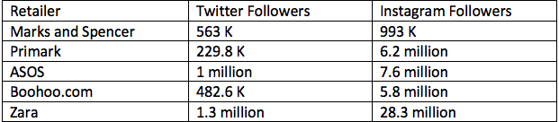
It is very much apparent as to which retailer is leading in the social media platform, Zara trade in store and online, they have been doing extremely well since they have established, they have had products that are always in dated and trending worldwide. Primark only trade in store with no online service, yet they have had higher profits than M&S, this is evident that M&S need to make exceptional improvements if they want to continue thriving in business.

Changing threats into opportunities; Promotional discounts – student discounts are offered by online competitors. More active on social media, online promotion of beauty products. Editorials of children wear, fashion, trends.

3.4.2 Marks and Spencer Pestle Analysis

…this concept is used as a tool by companies to track the environment they’re operating in or planning to launch a new project/product/service etc. www.pestleanalysis.com (accessed on 20th October 2018) It is very important to be aware of economic condition before making investments due to the new regulations of the Brexit it is better to keep the business on minimum until new regulations and legislations take effect.
It is important to know what the consumers want; new autumn launches with Holly Willoughby has encouraged consumers to ‘want’ rather than ‘need’ which is a good marketing technique. M&S are recognized for their ethical and social consideration. Recent media speculations on marketing the Hijab for children school wear have had a negative impact. They have been scrutinised and criticised for listening to their customers. M&S spokesperson said “We provide bespoke uniforms for 250...” www.itv.com (accessed on 20th October 2018) This demonstrates that the company have listened to their consumer needs and the demand is there in the market. Research has shown Parents have supported the retailer and rejected the backlash agreeing with diverse society.
Technology is advanced that consumer and the public in general no longer write they use their fingertips to type a message on a daily basis for basic things or even speak to handheld device. The economy has become robotic, where individuals have become antisocial, you see is consumers are using electronic devices. This is a convention for Marks and Spencer as they are able to use latest technology to reign in customers using adverts on internet browsers and editorials and more realistic and better edited YouTube videos or Instagram videos.

    - Stakeholder analysis
What is Stakeholder?
Strategic decisions are influenced by the expectations of stakeholders. Stakeholders are those who have some kind of stake in the future of the business. More formally, stakeholders are those individuals or groups that depend on an organisation to fulfil their own goals and on whom, in turn, the organisation depends. (Johnson et al. 2016, p.134)

Who are the stakeholders of M&S?

There are two types of stakeholders; Internal and external
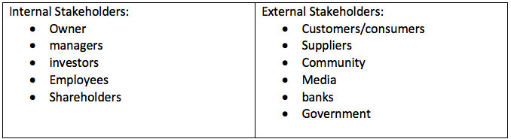

4.0 Conclusion

The researcher has concluded M&S have been trading over 133 years and are continuing, there is consistency in the company. However, with customer feedback on clothing and new team members on board in 2013 reporting stable profit on their clothing range, yet M&S are not able to get it right, M&S are still working on the fashion lines and clothing range. Recent collaborations with celebrities have been success with products have sold out at full retail price.
With the announcement of store closures by 2022 stakeholders’ employees, customers, community are affected. Employees have either been redeployed by the company or redundant. Consumers will need to pay for transport to visit the nearest store. More physical shoppers than online shoppers. This is a threat as physical shoppers will go to a competitor for their satisfaction. M&S communicating well with all their partners, shareholders and stakeholders through the digital channel.
The researcher has analysed that M&S trying to cater to all different types of consumers. M&S are trying to please everyone and anyone and, in that process, they are making marketing errors.
M&S focus on becoming digital, this strategy has been time consuming, however their half yearly profits have increased, that is overall figure, merchandises are a struggle.
They have a five-year plan, which is being reviewed regularly, despite being under the fire and scrutiny of recent media coverage, M&S have stayed stronger in their response to providing and supplying customer demands.

5.0 Options

- To support M&S on their plan, they need to start making changes on their consumer needs. They need to plan task and complete them before starting a new task. Once the digital area of the business has been settled.
- M&S need to re-structure their clothing team and address that consumers want to be trend and in fashion.
- By removing brand recall, not to manufacture outdated clothing which is costly for a margin of consumer demand. Consumers do not want previous years clothing back
- Be active on social media to see how influencers promote fashion- use their feedback to improve products
- Be present at fashion shows, UK and international
- Recruit editorial teams that have worked for high fashion magazines
- Reality tv star are good for collaboration
- Continue charity contribution

6.0 Appendix

6.1 M&S SWOT Analysis
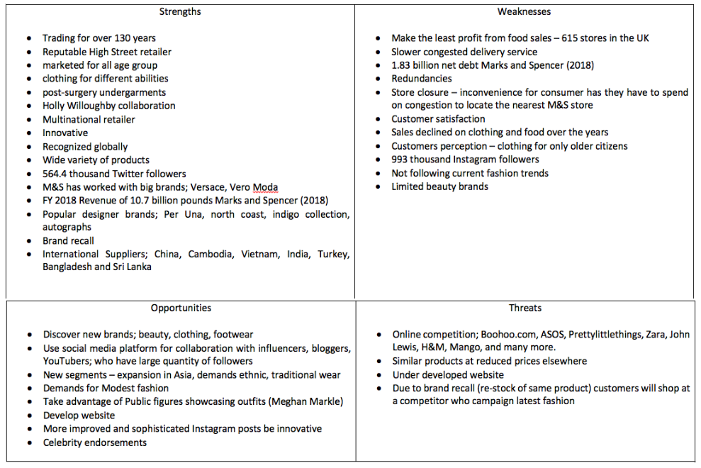

6.2 Pestle Analysis

Economic
Marks and Spencer believe in high quality products, with a high price tag. Yes, this may result in reduced sales, they are confident as 80% of their clothing are sold at full price. Consumers have confidence due to product quality, Chief Executive confirmed on statement that improved international business profits, by selling Hong Kong business to a franchise partner. www.marksandspencer.com (accessed on 6th October 2018) By operating from fewer, larger clothing and home stores, economically will reduce cost of annual rental of closed stores, not required staff roles. Pound fluctuation since Brexit vote. Brexit negotiations- border controls would affect daily supplies. “M&S Chairman Archie Norman has raised concerns that a hard Brexit with complicated border arrangements would impact daily exports across the channel.” www.thesun.co.uk (accessed on 6th October 2018)

Sociological
Many consumers say, ‘It is not a trendy store’, they need to improvise – potentially recruit influential fashionista to renovate the clothing department. They need to know the likes and dislikes of consumers. Different generation demands – different behaviors towards shopping. More use of technology whilst shopping. Consumers preferences for fashionable item and not targeting mature consumers. Trending is something that is liked and followed the social trend. If a follower, individual saw an outfit on a social media account, YouTube video, regardless where is was manufactured from consumers want it. The perception of British produced is not considered as high quality, because the misconception is that it is not fashion piece or its not trending. Recent launch of Holly Willoughby must-have collections has been successful as certain products have sold out at full retail price.

Technological
To continue the growth of M&S.com, CE should have partnership to sustain technical support for websites, and store checkouts. consumers now like to use; Apple Pay, launched in the UK October 2014, wireless payment direct from mobile device replacing cards, for a quicker, easier checkout.
“Londoners can also use Apple Pay to travel around the capital after Apple struck a deal with Transport of London (TFL), so you can use your watch or phone to travel around the Tube, bus and rail networks.” www.telepgraph.co.uk (accessed on 5th October 2018) “A contactless payment allows you to pay for something by waving or tapping your contactless device over a special ‘reader’ unit. You don’t need to enter your pin.” www.moneysupermarket.com (accessed on 6th October 2018)
When visa contactless introduced many retailer and companies did not have the new feature on the card reader, this did frustrate customers, this is why retailers and companies need to have technical enhancement so that they can keep up with the latest invention. Consumers use PayPal, the purpose of PayPal is for convenience, where all your card details are stored, so this reduces time spent giving all card details every time your checkout. Consumers like modern technology. it is inexpensive for any retailer to adjust to technologies that make life easier for digital customers.

6.3 Power/ Interest Matrix
M&S Stakeholders power and influence
High
Low
Minimal Effect  - Trade union  - Media | Keep informed  - Community  - Supplier
Keep satisfied  - Customers  - employees | Key players  - Owners  - Shareholders  - Managers  - Investors/Banks

High
Low
7.0 Reference List
Internet Reference;

BBC NEWS (2018) M&S in new phase of store closures
Available at: http://www.bbc.co.uk/news/business-45143404
(accessed: 2nd October 2018)

Butler, S. Wood, Z. (2018) The Guardian Marks and Spencer to close 100 plus stores by 2022 in “radical” plan
Available at: http://www.theguardian.com/business/2018/may/22/marks-spencer-close-stores?CMP=share_btn_link
(Accessed: 2nd October 2018)

Butler, S. (2013) The Guardian Marks and Spencer opens automated warehouse for online sales
Available at: http://www.theguardian.com/business/2013/may/08/marks-spencer-online-warehouse
(Accessed: 2nd October 2018)

Butler, S (2014) The Guardian, Marks and Spencer takes control of its online store from Amazon
Available at: https://www.theguardian.com/business/2014/feb/18/marks-spencer-control-online-shopping-website-amazon
(Accessed: 3rd October 2018)

Nguyen, A. (2014) Computerworlduk from IDG Marks and Spencer’s struggling new website hits sales
Available at: http://www.computerworlduk.com/it-business/marks-spencer-struggling-new-website-hit-sales-3529761/
(Accessed: 3rd October 2018)

Williams, R (2015) The Telegraph Apple Pay; everything you need to know
Available at: http://www.telegraph.co.uk/technology/apple/11720595/apple-pay-everything-you-need-to-know.html
(Accessed: 5th October 2018)

ITV NEWS (2018) ITV reports Final day of trading for several Marks and Spencer stores
Available at: www.itv.com/news/2018-8-11/final-day-of-trading-for-several-marks-spencer-stores/
(Accessed: 3rd October 2018)

Marks and Spencer (2018) AT A GLANCE
Available at: http://corporate.marksandspencer.com/annual-report-2018/mands_strategicreport_2018.pdf
(Accessed: 6th October 2018)

Marks and Spencer (2018) Transformation Underway
Available at: http://corporate.marksandspencer.com/annualreport
(Accessed 6th October 2018)

Rowe, S. (2018) Chief Executive statement
Available at: http://corporate.marksandspencer.com/annualreport
(accessed: 6th October 2018)

James, E. (2018) The Sun, Sarnies warning
Available at: http://www.thesun.co.uk/money/6930217/marks-spencer-sandwiches-brexit/
(accessed: 6th October 2018)

Carr, P. (2018) Money supermarket, what is contactless payment
Available at: http://www.moneysupermark.com/credit-cards/contactless-payments/
(accessed: 6th October 2018)

M&S (2018)
Available at: http://www.marksandspencer.com/wool-blend-single-breasted-coat/p/p60181114?prevpage=p/p&pdpredirect
(accessed: 7th October 2018)

Davis, B. (2014) E Consultancy
Available at: http://econsultancy.com/11-ways-m-s-is-improving-the-multichannel-experience/
(Accessed: 16th October 2018)

M&S (2013) Only at you M&S, Annual report 2013
Available at: http://annualreport2013.marksandspencer.com/overview/overview-of-the-year/
(Accessed: 16th October 2018)

Pestle Analysis (2018) What is PESTLE? A tool for Business analysis
Available at: http://pestleanalysis.com/what-is-pestle-analysis/
(Accessed: 20th October 2018)

M&S (2017) Press Release, M&S launches plan A 2025 – An ambitious, customer focused sustainability plan
Available at: https://corporate.marksandspencer.com/media/press-releases/2017/plan-a-2025
(Accessed: 20th October 2018)

Good Morning Britain ITV (2018) Marks and Spencer slammed for selling Hijab aimed at primary school children.
Available at: https://www.itv.com/goodmorningbritain/news/marks-spencer-slammed-for-selling-hijabs-aimed-at-primary-school-age
(Accessed: 20th October 2018)

Video Reference:

Willioughby, H. (2018) Youtube M&S/ Holly Willoughby’s autumn must-haves (video)
Available at: https://www.youtube.com/watch?v=D2zRf3E2qAI
(Accessed: 7th October 2018)

Textbook Reference:

Johnson, G. et al (2016) Exploring Strategy text and cases. 11th Ed. Harlow: Pearson Education M.U.A
Bott, F. (2014) Professional issues in information technology. 2nd Ed. Swindon: British company society

