
Project Proposal
AI-Powered Student Audio Analysis and Wellbeing Monitoring System

July 31, 2026
Rabia naeem
2310492

Contents
1.0 Introduction 3
1.1 Background 3
1.2 Problem Statement 3
1.3 Aim 3
1.4 Objectives 3
1.5 Scope and Limitations 4
2.0 Literature Review 4
2.1 Existing Systems 4
2.1.1 OpenAI Whisper 4
2.1.2 Google Speech to Text 4
2.1.3 Google Translate 4
2.1.4 TextBlob 5
2.1.5 IBM Watson Natural Language Understanding 5
2.2 Rationale and Research Gap 5
3.0 Methodology 5
3.1 System Development Approach 5
3.2 Tools and Technologies 5
3.3 System Requirements 6
Functional Requirements 6
Non-functional Requirements 6
3.4 System Architecture 6
3.5 Data Collection and Evaluation 7
3.6 Ethical Considerations 7
3.7 Reliability and Validity 7
3.8 Resources 7
3.9 Project Schedule 8
References 8

1.0 Introduction

1.1 Background
Student wellbeing is an increasingly significant concern [2] in higher education, as academic demands, financial stress, and personal difficulties can have a harmful impact on students’ mental and emotional health. When wellbeing is poor, it may lead to lower academic performance, reduced motivation, poor attendance, and decreased student retention. As a result, universities need effective ways to identify students who may require additional wellbeing support.
Developments in Artificial Intelligence (AI), speech recognition, and Natural Language Processing (NLP) offer new possibilities for analysing spoken language and detecting emotional patterns. AI-based predictive models are increasingly being applied in mental health research to support earlier identification and assessment of mental health conditions [5]. These technologies can help educational institutions gain timely insights into student wellbeing while reducing dependence on traditional assessment methods [1], [3], [4].

1.2 Problem Statement
Current wellbeing monitoring is largely based on questionnaires, counselling sessions, and staff observations. However, these methods rely on students willingly sharing their feelings and may fail to identify those who are hesitant to ask for help [2]. Recent advances in speech technology and natural language processing have demonstrated their potential to support mental health assessment through automated analysis of speech patterns [4]. Furthermore, many existing AI systems are primarily designed for English and provide only limited support for multilingual speech analysis [1], [6].

1.3 Aim
The aim of this project is to design, develop, and evaluate an AI-Powered Student Audio Analysis and Wellbeing Monitoring System that analyses student audio recordings using speech recognition, language translation, sentiment analysis, and emotion detection to assess students' emotional wellbeing and generate automated reports.

1.4 Objectives
The objectives of this project are to:
- Design and develop a web-based application using Flask.
- Implement speech-to-text transcription using OpenAI Whisper.
- Support English and Urdu language audio recordings.
- Translate Urdu speech into English for analysis.
- Perform sentiment analysis to classify speech as positive, negative, or neutral.
- Detect emotions such as happy, sad, angry, stressed, and neutral.
- Assess student wellbeing and determine risk levels.
- Generate downloadable PDF reports.
- Store analysis results securely in an SQLite database.
- Provide a history page for viewing previous reports.
- Evaluate the system through user testing and feedback.
- Automatically detect the spoken language.
- Develop a secure user authentication system that allows users to register, log in, and access their personal analysis history.

1.5 Scope and Limitations
The project is centred on creating a web application for multilingual student wellbeing monitoring using AI technologies. It allows users to upload audio or record speech live, generates wellbeing reports, and stores results securely. The system is designed to support, rather than replace, professional mental health services. Its evaluation is limited to a small group of participants, and it uses rule-based emotion detection, which may not capture every emotional context.

2.0 Literature Review
A literature review examines existing research and technologies relevant to the proposed project. It identifies current approaches, their strengths and limitations, and highlights the research gap that the project aims to address. This study focuses on technologies related to speech recognition, machine translation, natural language processing, and sentiment analysis for supporting student wellbeing [2].

2.1 Existing Systems

2.1.1 OpenAI Whisper
OpenAI Whisper is an Automatic Speech Recognition (ASR) model developed using transformer-based deep learning [8]. It supports multilingual speech recognition, including English and Urdu, and performs well in noisy environments and with different accents. Recent research has shown that Whisper can maintain high transcription accuracy while model quantization reduces latency and model size, making deployment more efficient [8]. However, Whisper does not perform sentiment or emotion analysis and therefore must be combined with additional AI techniques to support wellbeing monitoring. Recent studies have demonstrated that speech technologies can be effectively used to assess mental health by analysing vocal characteristics and speech patterns [4].

2.1.2 Google Speech to Text
Google Speech-to-Text is a cloud-based ASR service that converts speech into text using deep learning. It supports over 125 languages and includes features such as automatic punctuation and speaker diarisation. Although it provides accurate transcription, it cannot assess emotions or wellbeing, limiting its use as a standalone monitoring solution.

2.1.3 Google Translate
Google Translate is a Neural Machine Translation (NMT) service supporting more than 100 languages. In this project, it translates Urdu transcripts produced by Whisper into English, enabling multilingual speech analysis. However, it does not perform sentiment analysis or emotion detection and must be integrated with other technologies.

2.1.4 TextBlob
TextBlob is an open-source Python library that provides Natural Language Processing (NLP) functions, including sentiment analysis. It is simple to implement and classifies text as positive, negative, or neutral. However, because it uses lexicon-based analysis, it may not accurately recognise sarcasm or complex emotional context.

2.1.5 IBM Watson Natural Language Understanding
IBM Watson Natural Language Understanding analyses text to identify sentiment, emotions, entities, and keywords. Although it offers advanced analytics, it is primarily designed for enterprise applications and requires commercial licensing. For this reason, it is less suitable for a small academic project than open-source alternatives.

2.2 Rationale and Research Gap
Existing technologies perform individual tasks such as speech recognition, translation, or sentiment analysis but rarely combine these capabilities into a single multilingual wellbeing monitoring system [1], [4]. Recent studies have demonstrated that speech- and language-based AI systems can effectively monitor mental health while preserving user privacy; however, these systems do not provide integrated multilingual wellbeing assessment designed for higher education environments [6]. Current approaches also rely heavily on questionnaires or interviews, which may not identify students who are unwilling to discuss their emotional wellbeing, highlighting the need for AI-enabled approaches that support earlier and more objective assessment [2], [5].
This project addresses this gap by integrating OpenAI Whisper, Google Translate, TextBlob, rule-based emotion detection, SQLite, and PDF report generation within a Flask web application. The proposed system provides multilingual speech analysis and automated wellbeing assessment in a single, cost-effective platform designed to support higher education institutions.

3.0 Methodology

3.1 System Development Approach
This project will adopt the Agile Software Development methodology because it supports iterative development, continuous testing, and regular improvements throughout the project. Agile divides the development process into smaller stages, allowing each component to be designed, implemented, tested, and refined before progressing to the next stage. This approach enables early identification of errors, improves software quality, and provides flexibility to incorporate feedback during development [7].

3.2 Tools and Technologies
The system will be developed using Python and the Flask web framework. Flask provides a lightweight platform for developing web applications and integrating AI services. OpenAI Whisper will convert uploaded or recorded speech into text, while Google Translate will translate Urdu transcripts into English. TextBlob will perform sentiment analysis, and rule-based logic will classify emotions and wellbeing status. SQLite will securely store user information and analysis results. HTML, CSS, and JavaScript will be used to create a responsive and user-friendly interface, and ReportLab will generate downloadable PDF reports. SQLite will store user accounts, login credentials (using hashed passwords), and analysis results securely.

3.3 System Requirements

Functional Requirements
The system shall:
- The system shall allow users to register an account.
- The system shall allow users to log in securely.
- Allow users to upload or record audio.
- Convert speech into text.
- Detect spoken language.
- Translate Urdu transcripts into English.
- Perform sentiment and emotion analysis.
- Assess wellbeing and risk level.
- Store analysis results securely.
- Generate downloadable PDF reports.
- Display previously generated reports through a history page.
- The system shall allow users to log out securely.

Non-functional Requirements
The system should provide accurate transcription, reliable performance, secure data storage, and an easy-to-use interface. It should respond efficiently and protect user information through appropriate security measures.

3.4 System Architecture
The proposed system follows a layered architecture. Users interact with the web interface to upload or record audio. The application processes the audio using OpenAI Whisper for transcription and language detection. Speech-based analysis has been identified as a promising approach for monitoring emotional and cognitive health through vocal biomarkers [3]. If the detected language is Urdu, the transcript is translated into English using Google Translate. TextBlob and rule-based emotion detection analyse the transcript to determine sentiment, emotion, wellbeing status, and risk level. Results are stored in an SQLite database and displayed to users through the web application. Users can also generate PDF reports summarising the analysis. Users will register or log in through the web interface before uploading or recording audio. User authentication ensures that only authorised users can access their personal analysis reports and history.
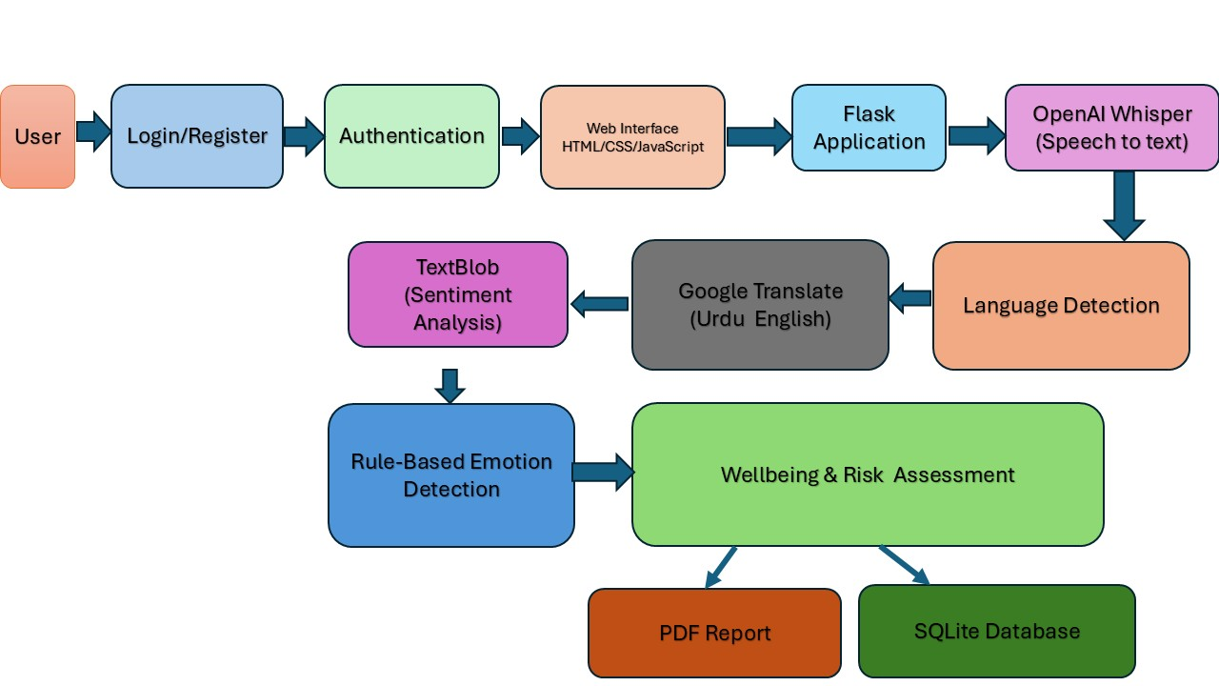
Figure 3.1: System Architecture of the AI-Powered Student Audio Analysis and Wellbeing Monitoring System

3.5 Data Collection and Evaluation
The system will be evaluated using audio recordings collected from volunteer participants. Both English and Urdu recordings will be used to test transcription accuracy, translation quality, sentiment analysis, emotion detection, and overall system performance. The use of speech recordings for digital health assessment is supported by recent research on vocal biomarkers [3]. User feedback will also be collected through a short questionnaire to assess usability and identify potential improvements.

3.6 Ethical Considerations
Participation will be voluntary, and informed consent will be obtained before collecting audio recordings. Personal information and recordings will be stored securely and used only for academic purposes. The system is intended to support wellbeing monitoring and is not designed to replace professional mental health assessment or diagnosis. User accounts will be protected using secure authentication, and passwords will be stored in hashed form. Personal data will only be accessible to the relevant user and authorised researchers.

3.7 Reliability and Validity
Reliability will be evaluated by testing the system with multiple recordings, speakers, and accents to ensure consistent results. Validity will be assessed by comparing generated outputs with expected results and reviewing user feedback. The evaluation will help determine the effectiveness and limitations of the proposed system.

3.8 Resources
The project requires Python, Flask, OpenAI Whisper, Google Translate, TextBlob, SQLite, ReportLab, Visual Studio Code, HTML, CSS, JavaScript, a computer with internet connection, a microphone, and relevant academic literature.

3.9 Project Schedule
The project will be completed over six months using Agile methodology. Figure 3.2 presents the project schedule, key development phases, and milestones from planning to final submission.
Task | Month 1 | Month 2 | Month 3 | Month 4 | Month 5 | Month 6
Project Planning
Literature Review
Requirements Analysis
System Design
System Development
Testing & Evaluation
Documentation
Final Submission
Figure 3.2: Gantt Chart for the AI-Powered Student Audio Analysis and Wellbeing Monitoring System

Shaded cells indicate the planned duration of each project activity over the six-month development period.

References
- S. Amiriparian, B. W. Schuller, N. Asghar, H. Zen, and F. Burkhardt, “Guest Editorial: Special Issue on Affective Speech and Language Synthesis, Generation, and Conversion,” Ieee Transactions on Affective Computing, vol. 14, no. 1, pp. 3–5, 2023, doi: 10.1109/taffc.2022.3233120.
- D. D. DeSouza, J. Robin, M. Gumus, and A. T. Yeung, “Natural Language Processing as an Emerging Tool to Detect Late-Life Depression,” Frontiers in Psychiatry, vol. 12, 2021, doi: 10.3389/fpsyt.2021.719125.
- I. Rodrigo and J. A. Duñabeitia, “Listening to the Mind: Integrating Vocal Biomarkers into Digital Health,” Brain Sciences, vol. 15, no. 7, p. 762, 2025, doi: 10.3390/brainsci15070762.
- C. Bhat and S. K. Kopparapu, “Harnessing Speech Technology for Mental Health Assessment and Detection,” 2023, doi: 10.21437/smm.2023-6.
- G. Lewin, E. Abakasanga, I. Titcombe, G. Cosma, and S. Gangadharan, "Artificial intelligence-enabled predictive modelling in psychiatry: overview of machine learning applications in mental health research," BJPsych Advances, vol. 32, no. 3, pp. 169–175, 2025, doi: 10.1192/bja.2025.10133.
- J. Shin, H. Yoon, S. Lee, S. Park, Y. Liu, J. D. Choi, and S.-J. Lee, "FedTherapist: Mental Health Monitoring with User-Generated Linguistic Expressions on Smartphones via Federated Learning," in Proceedings of the 2023 Conference on Empirical Methods in Natural Language Processing (EMNLP), pp. 11971–11988, 2023, doi: 10.18653/v1/2023.emnlp-main.734.
- S. G. Tetteh, "Empirical Study of Agile Software Development Methodologies: A Comparative Analysis," Asian Journal of Research in Computer Science, vol. 17, no. 5, pp. 30–42, 2024, doi: 10.9734/AJRCOS/2024/v17i5436
- A. Andreyev, "Quantization for OpenAI's Whisper Models: A Comparative Analysis," arXiv:2503.09905, Mar. 2025, doi: 10.48550/arXiv.2503.09905.

