- Business Plan –

BMSW4006

Esha Patel - 201341
Aminul Islam - 20187707
Alpesh Maachi - 202247

1-year 2021/22
UWTSD
Managing Enterprise in the 21st Century
Lecturer: Afzal Munna

Table of Content

1 Cover letter

2 Executive summaries

3 Table of content

4 Business description and History

5 Business Structure

6 Product and service description

7 Market Analysis and trends

8 Operations

9 Technology Plan

10 Management and organization

11 Social responsibility and sustain

12 Financial data

13 Appendix

FUNKY FOODS

Market Square,
Unit G12B,
22 London E14 6AB

Monday 23rd August 20

Dear whoever this may concern,

I, Esha Patel, the senior business analyst working in Funky Food takeaway is recently opened take away business in London. Funky Food is takeaway where we provide all kind of fast food for consumer to order online at www.funkyfoods.co.uk or by telephone or coming individual into the shop.

However, it was recently opened in 2021 in London. Funky food is taking away which has been opened by four friends and their individual’s ideas put together. We have great plan to make Funky Foods a franchise within London is near future. Funky Foods in London in near future. Funky food in London has partnered with Deliveroo, just eat and uber eats to deliver the food to consumers efficiently.

Funky Foods are not stopping until become a successful franchise of take away in heart of London and explore new market in near future.

Through my evaluation and analysis I have stretched out a plan that is sure going to bring in more money and provide visibility to our brand.

Thank you for your time and consideration in this time and consideration in this matter. I hope you will review my business plan. If you have any questions or would like to discuss the plan, please contact me at 079324045390 or at esha.patel@hotmail.com

Sincerely
Esha Patel

Introduction
This is report of Managing Enterprise in 21st Century and it will reflect and will analyse my knowledge and what I learnt during this module and how it has helped me individually to progress and gain my confident. For the report I will use Gibbs 1988 reflective model which we learnt during online classes. Gibbs 1988 reflective models has five stages I will cover some of those stages in my report which are Description, my thoughts and feeling about the module and class environment, analysis, evaluation, and the conclusion of my studies during this module.
During the module studies we were asked by our lecturer Afzal to make team of 4 or 5 to do group presentation which was part of same assignment our main subject for presentation was to make Business plan during the module and present to lecturer in the last week of module. As lecturer explained during study to use PowerPoint presentation, we all individual chose our topics and made PowerPoint individual and was handed over to our leader of the group.
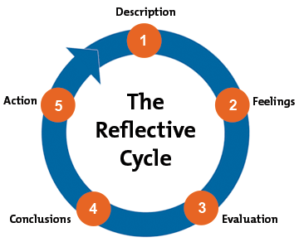

Description
As a student studying at university Certificate in Higher Education and in this term learning about Managing Enterprise in 21st Century. Our sir Afzal did explain in brief during first and second week regarding writing a reflective report.
In this study as student in group of four we were asked to make presentation of PowerPoint. What we done and study to write and present the power point I will discuss in this report and how we all in group completed our presentation. My group was introduced as group 1 and the members of our group were Alpesh (me), Aminul, Esha and Martin. In our presentation as a group, we formed a WhatsApp chat group and on Teams to discuss who will cover what topics during the presentation and individual will work on the topics in this module. Our main topic was Business plan under the business plan we had to cover these topics: Cover letter, Executive Summary, Table of content, Business Description & History, Business structure, Product and Service, Market Analysis, Operations, Technology plan, Management & Organisation, Social responsibility, Development, Financial Data and Appendix.
As all the team members we agreed to business plan on Take Away Shop all the members were happy about the business we chose in week two we chose the business name as Funky Foods which was Aminul idea which everyone liked it and we named our business as Funky Foods.
When we started the module, we chose Esha as our team leader who will introduce all the team during the presentation and upload our presentation and report on university Moodle. We all had briefed each other and discussed all the topics between us in the class and after the classes. In this module I have gained lot of confidence to communicate within team and have developed my confident to speak front of people.

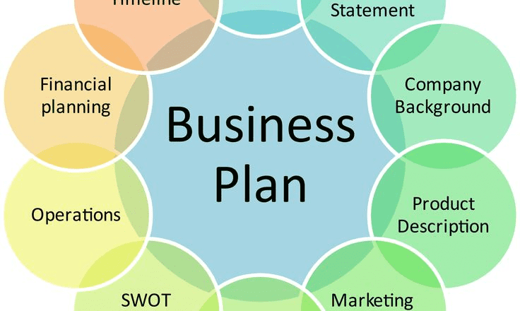

Topics Covered ( A Machhi)
Business Description and History
Unit G12B, 22 Market Square, London, E14 6AB
Funky Food is recently opened take away business in London. Funky Food is takeaway where we provide all kind of fast food for consumer to order online at www.funkyfoods.co.uk or by telephone or coming individual into the shop.
Funky Foods take away is recently opened in 2021 in heart of London. Funky Foods is takeaway which has opened by four friends and their individual ideas put together. These four good friends are Aminul Islam, Esha Patel, Martin and Alpesh.
We have great plan to make Funky Foods a franchise within London in near future. Funky Foods in London has partnered with Deliveroo, Just Eat and Uber Eats to deliver the food to consumers efficiently.
We the Funky Foods are not stopping until become a successful franchise of take away in heart of London and explore new market in near future.
Business Structure:
Funky Foods has recently opened in 2021. Four friends coming together to do business and now officially partners in business. Each of us have chosen the Individual duties already which will help us in future and make our business structure as planned, so everyone knows what part of business they are looking after.

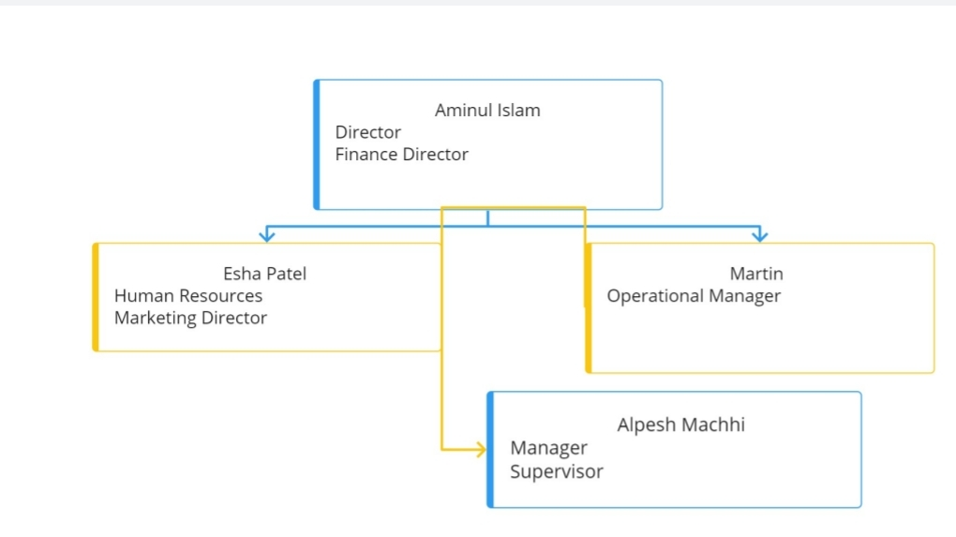

Conclusion
I as student I did find this module bit hard as I’m not from business background and understating how business and business plans works. To present the presentation front of the class is quite hard for me as English Is not my first language. There were couple times in week three and four that I felt will not complete this presentation on time. As having very less knowledge of business it will be always hard for me to understand how to write a business plan. But with help of my group and my lecturer Afzal I did gain lot of confident to achieve my goal and complete this module so I can progress further into the studies.

References
The Role of Managers in the 21st Century Is Increasingly... | Bartleby Visited (01Aug2021)
21st_Century_Leaders_CMI_Feb2018.pdf (managers.org.uk) Visited (01Aug2021)
It's time to build 21st century companies: Learning to thrive in a radically different world | McKinsey Visited (29July2021)
https://www.justeattakeaway.com/about-us/history/ Visited on 02August2021
Business Structure - Overview, Forms, How They Work (corporatefinanceinstitute.com) Visited on 09Aug2021

Market Analysis

Advertisements for fast food restaurants target children, teenagers, kids. Fast food corporations post advertising in media that they are more likely to view, or targeted marketing material is meant to appeal particularly to them.

This is a crucial burger industry study that should be included in any burger restaurant business plan you write. It may assist you in determining whether market demand matches your excitement, as well as identifying strengths, weaknesses, opportunities, and dangers that suggest how successful your excursion into the burger world will be, as well as the potential repercussions of your decision.

STRENGTHS:

Using premium products such as meat from corn-fed cows, organic food from local farms, and handmade buns in whole wheat, sourdough, and pumpernickel is another strength that would apply whether you currently operate a restaurant. You may also include in your burger business research the fact that you only cook your burgers when a client orders them, ensuring a fresh, juicy flavor. Offering late-night hours allows you to appeal to clients who are seeking a burger after hours, which is especially beneficial if your restaurant is in a busy nightlife area.

WEAKNESS:

Understanding the possible vulnerabilities of your SWOT analysis for the burger business is critical in any burger house business plan since if you're not prepared, such flaws might lead to failure. If you currently operate a restaurant and want to add burgers to the menu, one flaw might be a lack of efficient advertising or marketing to inform consumers about the new addition. As a result, you risk losing clients who desire burgers but are unaware that you now have them on the menu. Lack of distinctiveness is another possible flaw. Health problems connected to obesity and consuming red meat, changing dietary patterns, and the media's increased attention on identifying bad food are all risks that must be included in a thorough burger business study. These are obstacles that can derail your efforts until you come up with innovative solutions, such as supplying healthier beef and ensuring that your beef patties stay within the necessary ounces for a single serving of meals. The other restaurants in your market region that sell comparable priced burgers should be evaluated as part of your burger house business strategy. Fast food chains with large advertising costs that may dominate the industry could be your biggest danger.

Balance Sheet
Balance Sheet | year 2020 | year 2021
Assets
Current assets: | - | £15,000.00
Cash | - | £22,000.00
Accounts Receivable | - | -
Prepaid expenses | - | -
Inventory | - | £3,000.00
Total current assets | £ - | £25,000.00
Property & Equipment | - | -
Charity | - | -
Total Assets | £ - | £25,000.00
Liabilities
Current liabilities:
Accounts payable | - | -
Accrued expenses | - | -
Unearned revenue | - | -
Total current liabilities | £ - | £ -
Long-term debt | - | -
Other long-term liabilities | - | -
Total Liabilities | £ - | £ -
Shareholder's Equity
Investment capital | - | £40,000.00
Retained earnings | - | -
Shareholder's Equity | £ - | £40,000.00
Total Liabilities & Shareholder's Equity | £ - | £40,000.00
Balance | £ - | £15,000.00

1

Cash Flow Forecast
Pre-Start Income | June 21 | July 21 | Aug 21 | Sep 21 | Oct 21 | Nov 21 | Dec 21 | Jan 22 | Feb 22 | Mar 22 | Apr 22 | May 22 | TOTAL
0 | 1200 | 1800 | 2000 | 2100 | 2000 | 2300 | 3200 | 2600 | 2800 | 2200 | 2400 | 2100 | 26700
0 | 0 | 0 | 0 | 0 | 0 | 0 | 0 | 0 | 0 | 0 | 0 | 0 | 0
15000 | 0 | 0 | 0 | 0 | 0 | 0 | 0 | 0 | 0 | 0 | 0 | 0 | 15000
0 | 200 | 400 | 300 | 500 | 600 | 900 | 1000 | 1100 | 800 | 600 | 700 | 800 | 7900
15000 | 1400 | 2200 | 2300 | 2600 | 2600 | 3200 | 4200 | 3700 | 3600 | 2800 | 3100 | 2900 | 49600
Pre-Start Expenses
3000 | 200 | 400 | 600 | 400 | 500 | 600 | 1000 | 700 | 400 | 500 | 500 | 600 | 9400
0 | 0 | 0 | 0 | 0 | 0 | 0 | 800 | 800 | 800 | 800 | 800 | 800 | 4800
0 | 0 | 0 | 0 | 0 | 0 | 0 | 0 | 0 | 0 | 0 | 0 | 0 | 0
0 | 0 | 0 | 0 | 0 | 0 | 0 | 400 | 400 | 400 | 400 | 400 | 400 | 2400
1100 | 1100 | 1100 | 1100 | 1100 | 1100 | 1100 | 1100 | 1100 | 1100 | 1100 | 1100 | 1100 | 14300
0 | 150 | 150 | 150 | 150 | 150 | 150 | 150 | 150 | 150 | 150 | 150 | 150 | 1800
0 | 20 | 20 | 20 | 20 | 20 | 20 | 20 | 20 | 20 | 20 | 20 | 20 | 240
0 | 20 | 20 | 20 | 20 | 20 | 20 | 20 | 20 | 20 | 20 | 20 | 20 | 240
1000 | 0 | 0 | 0 | 0 | 0 | 0 | 0 | 0 | 0 | 0 | 0 | 0 | 1000
0 | 40 | 40 | 40 | 40 | 40 | 40 | 40 | 40 | 40 | 40 | 40 | 40 | 480
0 | 300 | 300 | 300 | 300 | 300 | 300 | 0 | 0 | 0 | 0 | 0 | 0 | 1800
0 | 150 | 150 | 150 | 150 | 150 | 150 | 150 | 150 | 150 | 150 | 150 | 150 | 1800
0 | 80 | 80 | 80 | 80 | 80 | 80 | 80 | 80 | 80 | 80 | 80 | 80 | 960
5100 | 2060 | 2260 | 2460 | 2260 | 2360 | 2460 | 3760 | 3460 | 3160 | 3260 | 3260 | 3360 | 39220
9900 | -660 | -60 | -160 | 340 | 240 | 740 | 440 | 240 | 440 | -460 | -160 | -460 | 10380
0 | 9900 | 9240 | 9180 | 9020 | 9360 | 9600 | 10340 | 10780 | 11020 | 11460 | 11000 | 10840
9900 | 9240 | 9180 | 9020 | 9360 | 9600 | 10340 | 10780 | 11020 | 11460 | 11000 | 10840 | 10380



Partner 1 Restaurant Manager
- Helping all round and wherever need to meet the needs of the business at least for the first 6 months.
- Rotate with back of house every week to learn the business.
- Hold monthly meetings with all Partners.
- Day to day restaurant operations and decision making.
- Training other partners on H&S and FSA Compliance.
- Helping with End of Day Cleaning.
- Rotate with Partners 1,2,3 once trained up in Operations.

Partner 2 Front of House Including Takeout through Platforms
- Rotate with back of house every week to learn the business
- Accepting orders from platforms and making sure walk-in customers are served along
With the manager.
- Help back of house as and when needed.
- Cleaning.

Partner 3 Back of house
- Food Preparation from A-Z
- FSA and H&S Adherence
- Stock control and preparing order list for goods needed
- Cleaning
- Rotate with Partner 3 every week

Partner 4 Back of House
- Food Preparation from A-Z
- FSA and H&S Adherence
- Stock control and preparing order list for goods needed
- Cleaning
- Rotate with Partner 3 every week

Development, Milestones

Milestone | Start Date | End Date | Budget | Responsibility
Business Plan | 01/05/2021 | 14/05/2021 | £0 | All Partners
Secure Start-up Funding | 02/05/2021 | 15/05/2021 | £0 | All Partners
Site Selection | 03/05/2021 | 16/05/2021 | £0 | All Partners
Platforms | 04/05/2021 | 17/05/2021 | £0 | Marketing
Equipment purchases | 05/05/2021 | 15/05/2021 | £12,000 | Finance
Operations | 06/05/2021 | 18/05/2021 | £0 | All Partners
Designs/Redesign | 07/05/2021 | 19/05/2021 | £0 | All Partners
Renovation | 19/05/2021 | 26/05/2021 | £3,000 | All Partners
Miscellaneous work | 26/05/2021 | 30/05/2021 | £0 | All Partners
Grand Opening | 01/05/2021 |  | £0 | All Partners
Totals |  |  | £15,000

STRENGHTS |  | WEAKNESSES
Affordable Prices | 1 | Market is saturated in the area a lot of competition
Environment friendly packaging | 2
offering 5 different specialty souses | 3
that the competition does not do | 4
most raw material sourced within u.k | 5
OPPORTUNITIES |  | THREATS
most outlets offer gourmet burger that are new | 1 | over 500+ food outlets within 5-mile radius
outlets within 2 miles | 2 | some products come from Europe so possible
USP ( unique selling point ) very competitive pricing | 3 | delays on products sold
to add other items to menu monthly to create buzz. | 4 | location hidden so maybe difficult to find
 | 5

POLITICAL |  | ECONOMIC
Must follow minimum wage rules | 1 | must look at pricing for target market
Must follow H&S also FSA rules | 2 | demographics of area served
changes in tax rules | 3 | disposable income of target market
changes in opening due to emergencies | 4
 | 5
SOCIOLOGICAL |  | TECHNOLOGICAL
to introduce food that is of good quality | 1 | We will be using social media mainly
standards of hygiene to be at the forefront of the | 2 | Constant changes in the new technology must be followed
Business | 3 | adapt the business needs to technological requirements
standards to be maintained when franchising | 4 | 3 of the biggest food delivery platforms will be used
 | 5 | Ubereats,Delivaroo,Just Eat.
LEGAL |  | ENVIRONMENTAL
Need to follow employee safety laws | 1 | all packaging used is biodegradable
look at hiring people with disability if possible | 2 | 2% of our net profits will be given to charity in the community
equality based employment | 3 | and left-over food will be distributed to local homeless
age restriction on employment | 4
H&S training | 5
FSA hygiene certificate | 6

References

https://wenta.co.uk/the-business-bookshelf/articles/profit-and-loss-statement-template/
(Islam. A uwstd 2021) Accessed 10/08/2021 (Balance Sheet,P&L,CashFlow forecast)

https://www.bplans.com/sample-business-plans/
Islam. A uwstd 2021) Accessed 10/08/2021

https://www.wolterskluwer.com/en/expert-insights/market-analysis-for-your-business-plan

https://www.thebalancesmb.com/executive-summary-of-the-business-plan-2948012S

