
Student Name: Himanshu Panchal
Student ID: 2423984
Module code: LCMB7026
International Marketing: Principles and Practices
Lecturer: Tushara Balendran
Word Count: 5021
Table of Contents
Introduction 3
Brand overview 4
Comparison of the socio-cultural context of the UK and South Korea 4
Comparison of Brand's STP strategies in the UK and South Korea 8
Comparison of Marketing Mix Strategies in the UK and South Korea 12
Evaluation of the performance of marketing strategies 16
Evaluation of marketing ethics practice 17
Recommendation & Conclusion 18
References 20
Appendices 29

Introduction
The current report has shed light on analysing the marketing strategies of Netflix in the UK and South Korea. Netflix is considered one of the leading entertainment services companies operating in 190 countries (Netflix, 2025a). The good quality products and services of the company have increased the revenue of Netflix. In 2024, the revenue of Netflix stood at approximately 11.1 billion U.S. dollars, as illustrated in Figure 1 (Statista, 2025). Every organisation requires a specific marketing strategy to meet the demands of consumers and the market in the form of products and services (Kaur et al., 2022). The report will first carry out a thorough comparison of the socio-cultural context of the UK and South Korea. The South Korean content accounts for approximately 8-9% of all viewing on Netflix, outpacing programming from the UK (Kahn, 2025). In terms of analysing the effective marketing strategies of Netflix, it has been selected for the report. The segmentation, targeting and positioning (STP) strategies of the brand in the two countries will be analysed in this report. The performance of the marketing strategies of the brand in the selected two countries will also be evaluated through this report. Finally, the report will analyse the marketing ethics practice of the selected brand.
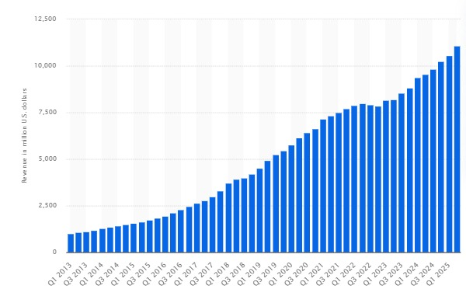
Figure 1: Revenue of Netflix
(Source: Statista, 2025)

Brand overview
Netflix, being a global entertainment services company, attracts audiences through different series and films. The brand is headquartered in the U.S and offers entertainment to half a billion people in more than 50 languages (Netflix, 2025b). Netflix is a traditional company which has reshaped the way in which people access and interact with the media (Song, 2024). In 1997, the brand was founded by Hastings and Randolph to provide movie rentals over the internet (Butler and Button, 2024). In the next year, the company opened Netflix.com, which uses the internet to offer consumers rentable DVDs. The products of Netflix are the subscription-based video services that offer movies, TV shows and documentaries.
Netflix dominates the entertainment industry in terms of producing, distributing and consuming the content. The effective streaming services of Netflix enable users to watch movies on their phones and computers, laying the key foundation for the on-demand model of the brand. The key competitors of Netflix are Amazon Prime Video, Disney+ and Hulu. Netflix applies massive amounts of behavioural data in its key selection of titles for commissioning and licensing. Netflix uses social media platforms such as Facebook, Twitter, Instagram and YouTube to connect with users and build good relationships with them (Rios and Castellano, 2023). Thus, Netflix reaches its customers through its active presence on social media platforms.
The UK and South Korea are the host countries where Netflix has expanded its business. The market entry of Netflix in the UK has become successful as the company has faced an increase of 15% share price (Sweney, 2012). On the other hand, the entry of Netflix into the South Korean market has developed its position as a popular subscription-based online video platform (Telecomlead, 2025). This has led to an increase in the total subscriber base of Netflix.

Comparison of the socio-cultural context of the UK and South Korea
PESTLE analysis
- Political: Political instability prevails on a large scale in the UK (NDTV, 2024). The rise of political instability is associated with the failure of British politicians (Diamond and Newman, 2024). This creates an unfavourable environment for Netflix that negatively affects its business by deterring investment. The current political instability environment in South Korea has resulted in a resurgence of open authoritarianism (Schottli, 2025). This is an unfavourable factor as it may result in reduced profitability for Netflix.
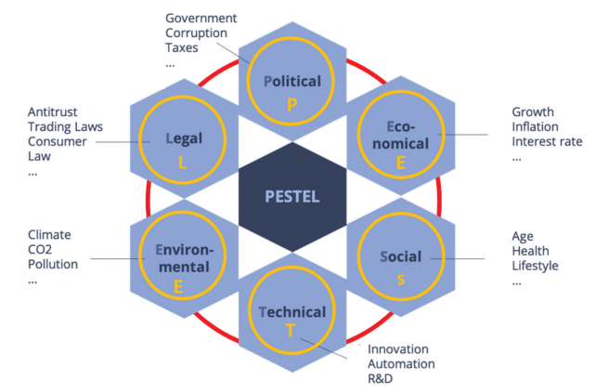
Figure 2: PESTLE Analysis
(Source: Khan et al., 2023)
- Economic: The inflation of the UK reached approximately 3.8% in 2025 (Sky, 2025). This may force Netflix to increase the prices, which may reduce the demand of consumers. In 2023, the GDP of South Korea stood at 1712.79 billion US dollars (Trading Economics, 2025). The enhanced GDP is a favourable factor as it may positively influence the purchasing power of consumers with respect to subscription to Netflix.
- Social: In 2025, more people in the UK prefer ad-supported streaming services, as the rate has increased from 10% to 31% (WARC, 2025). This may positively enhance the revenue of Netflix in the UK. The popularity of South Korean content reached its high level with Squid Game (Kim et al., 2023). This is one of the most successful series of Netflix launched in South Korea. Thus, the demand for South Korean content is a favourable factor for the business growth of Netflix.
- Culture: Hofstede’s cultural dimension model can be applied to analyse the socio-cultural context of the UK and South Korea. The key advantage of this theory is that it offers a clear framework for comparing the cultures (Nickerson, 2025). However, the key disadvantage is that the theory increases the risks of stereotyping the entire nation. In terms of the power distance dimension, the score of the UK is 35, whereas that of South Korea is 60 as indicated in Figure 3 (The Culture Factor, 2025). This denotes that in the UK, hierarchies prevail, and the employees expect to be consulted. On the other hand, the high score of South Korea denotes that they have a strong respect for hierarchy. Thus, Korea is more hierarchical than the UK.
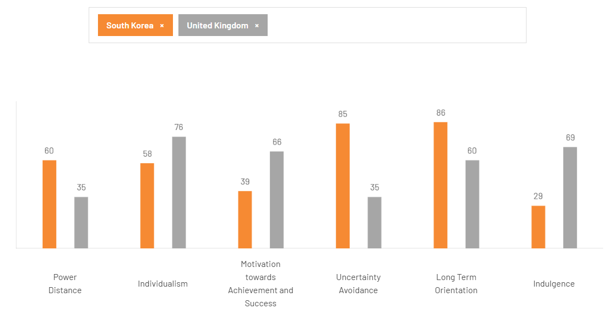
Figure 3: Country differences between the UK and South Korea
(Source: The Culture Factor, 2025)
The score of the UK is 76, and that of South Korea is 58 in terms of the individualism dimension (The Culture Factor, 2025). The key pillar of the South Korean culture is collectivism (Kawada, 2023). On the other hand, the UK is an individualistic country where autonomy is highly prioritised (Stone, 2017). In the UK, the main language is English, whereas in South Korea, Korean is the main language. This indicates the language differences between the two countries. In terms of uncertainty avoidance, the score of the UK is 35, and that of South Korea is 85 (The Culture Factor, 2025). The UK is open towards innovation and change, and the rules are not rigid systems. On the other hand, the high score of South Korea in this dimension denotes that the country has a strong preference for both predictability and structured procedures. The high degree of anxiety towards uncertainty results in risk avoidance. Thus, the key difference is that Koreans prefer clear rules and specific structure, whereas the people in the UK are immensely flexible and pragmatic. In terms of the indulgence dimension, the UK have a score of 69, whereas South Korea have a score of 29 (The Culture Factor, 2025). This denotes that leisure and enjoyment are the two valued attributes of life in the UK. On the other hand, South Korea has a restrained society and the behaviour is guided by social norms and self-discipline. Thus, the UK is expressive, whereas South Korea is reserved and well-disciplined. The cultural differences between the two countries can stand out as an unfavourable factor for Netflix, as it may lead to cultural backlash and a negative impact on its reputation in both countries.
- Technological: The UK ranks high among the leading artificial intelligence (AI) developing nations (Thormundsson, 2025). This advancement of the technology may offer more personalised options to the users in terms of Netflix. South Korea has been focusing on becoming one of the top three artificial intelligence (AI) powerhouses (Werner, 2025). This is a favourable factor as it can drive more innovation at Netflix.
- Legal: The Employment Rights Act 1996 in the UK prevents unfair dismissal and protects the rights of employees (Morris, 2025). Netflix is required to abide by this law to efficiently operate in the UK. The antitrust body of South Korea has tightened the leash on subscription businesses of Netflix (Lee, 2024). This is an unfavourable factor as the lack of adherence to this law may affect the business growth of Netflix.
- Environmental: Climate change issues have resulted in floods, severe storms and rising seas in the UK (Campbell, 2025). This is an unfavourable factor for the business of Netflix in terms of disruption to the supply chain. Environmental issues such as air quality, freshwater issues, and climate change have heightened in South Korea (OECD, 2025). This is an unfavourable factor that may increase the operational costs of Netflix.
Similarities and differences
In terms of the analysis of the external environment of the UK, it has been identified that a high level of instability exists in the political environment of the UK. It may create an uncertain environment, which may deter the investors from investing in Netflix. Similarly, the increased political instability may reduce the profitability of Netflix. Moreover, it has been identified that the inflation rate is high in the UK, which can affect the profit margin of Netflix. On the other hand, the improved economy of South Korea can boost growth opportunities for Netflix. The key similarity between the two countries is that environmental issues are high, which can pose a negative impact on the supply chain of Netflix. The increase in the number of people in the UK preferring ad-supported streaming services can foster the growth of Netflix. The economic growth of the South Korean market can enhance the purchasing power of the consumers, and this can increase the subscriber base of Netflix. Netflix develops various South Korean content, which attracts consumers towards the brand. The advancement of AI may offer Netflix the opportunity to increase the personalisation of its services to attract more customers in the UK. Similarly, the technological development in the South Korean market with respect to AI can bring more innovation to Netflix.

Comparison of Brand's STP strategies in the UK and South Korea
Segmentation
Segmentation enables the business to tailor the marketing strategies towards specific customer groups. By segmenting the market, the marketers can target the suitable customer groups with pricing, product quality, and marketing efforts customised to the preferences and behaviours (Tavor, Gonen and Spiegel, 2023). The key segmentation approaches are demographic, behavioural and psychographic. In terms of demographic segmentation, Netflix targets Millennials and Gen Z consumers, who are the tech-savvy users (Pereira, 2024). The company focuses on the professionals, families and students. Similarly, in South Korea, the company targets young adults who are tech-savvy and seeking global content. In terms of psychographic segmentation, Netflix targets consumers who value entertainment. Due to this, the brand invests in original content production, which attracts and retains subscribers (Medium, 2025). This has contributed towards the improved financial performance of Netflix.
In terms of behavioural segmentation, Netflix targets users of digital platforms and binge-watchers. Approximately four-fifths of people who are between 18 and 34 years of age in the UK with internet connections are either subscribers or possess access through their families or shared passwords (Sweney, 2022). In South Korea, the users who prefer Korean dramas with cultural relevance are targeted by Netflix. Korean content is the second most-watched on Netflix (Dasom, 2025). Netflix leverages local storytelling and Korean content production to fit the collectivist dimension of the Korean users. On the other hand, the segmentation approach of Netflix in the UK focuses on the binge-watching behaviour and aligns the product offering with the individualistic culture of the UK.
The values and lifestyles (VALS) can be applied to analyse the psychographic segmentation of Netflix in South Korea and the UK. The VALS approach involves eight segments, which are innovators, thinkers, believers, achievers, experiencers, strivers, makers and survivors (Ledesma-Chaves, Gil-Cordero and Maldonado-López, 2025). The audiences of the UK value authenticity and informative content (Jenkins, 2025). Netflix target this particular group through documentaries and social dramas. This aligns with the thinker segment of the VALS approach. The audiences of the UK, driven by curiosity and trends, engage with popular series such as the Stranger Things. For example, Stranger Things in the UK has generated £22.8m in brand replacement value (Axling, 2022). As a result, Netflix promotes quality and convenience, appealing to this segment that values efficiency and can be regarded as achievers as per the VALS approach.
The younger population of South Korea focuses on new trends and revolves around the consumption of K-pop and K-dramas (De la Mota, 2021). As a result, Netflix focuses on introducing localised Korean dramas, which reflect thrill-seeking narratives and resonate with their desire. This aligns with the experiencers segment of the VALS approach. Several South Korean viewers seek modern lifestyles, which aligns with strivers. The rise in popularity of Korean dramas has largely contributed to the increasing strength of Korean soft power (Choe, 2024). The global platform of Netflix enables customers to connect with Western pop culture, which demonstrates an image of cosmopolitan sophistication.
Targeting
Effective targeting approaches enable the brand to focus its resources on the likely buyers and result in more efficient campaigns. Netflix mainly uses the differentiated targeting approach as it has distinct groups of audiences in each market. However, the company serves all these users under a unified platform. The differentiated targeting approach allows the brand to target different market segments at differentiated prices (Medium, 2024). The diverse psychographic and demographic groups are targeted by Netflix in the UK, which aligns with the multicultural society of the country. The consumers who are tech-savvy, trend-driven and seek excitement are targeted by the brand. In the UK, Netflix have approximately 17.6 million subscribers (Sweney, 2025). This evidence indicates that the brand places emphasis on diversity and inclusivity, aligning with the key values of openness and representation.
Similarly, the differentiated targeting approach is used by Netflix in South Korea to address the digital sophistication of South Korea. The brand targets customers who are trend-conscious, seek thrills and value emotional storytelling. Netflix has invested approximately $2.5 billion in Korean content to appeal to the audience (Wan, 2023). The differentiated targeting approach of Netflix allows consumers of both markets to receive globally recognised content, reinforcing the loyalty of customers.
Positioning
Positioning strategy indicates the way a brand is mainly perceived in the minds of consumers with respect to its competitors. In the UK, Netflix has focused on converting more audiences towards the concept of streaming services (Sweney, 2022). This denotes that the company positions itself as the platform for quality storytelling, offering content at high prices, which appeals to the consumers, as indicated in Figure 4. The data-driven recommendations and the multi-screen flexibility position the brand as user-centric and also technologically advanced.
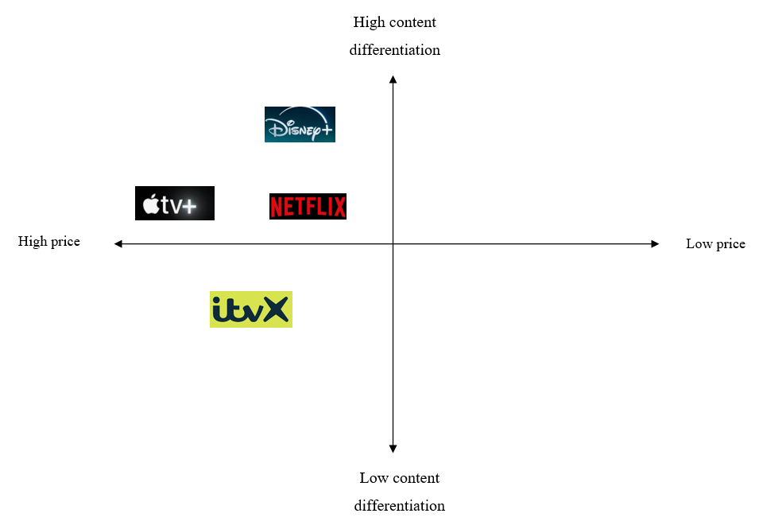
Figure 4: Positioning map of Netflix in the UK
(Source: Self-developed)
For the South Korean viewers, Netflix offers a premium platform combining Korean content with worldwide exposure. In 2021, the company invested approximately US$463 million in Korean content (Dal Yong et al., 2023). Netflix positions itself as a brand with a high cultural relevance and offers content at a high price, as indicated in Figure 5. The investment of the brand in Korean-language originals appeals to the national identity and also the storytelling traditions. The storytelling aspect of the brand highlights social issues resonating with the key cultural values of South Korea.
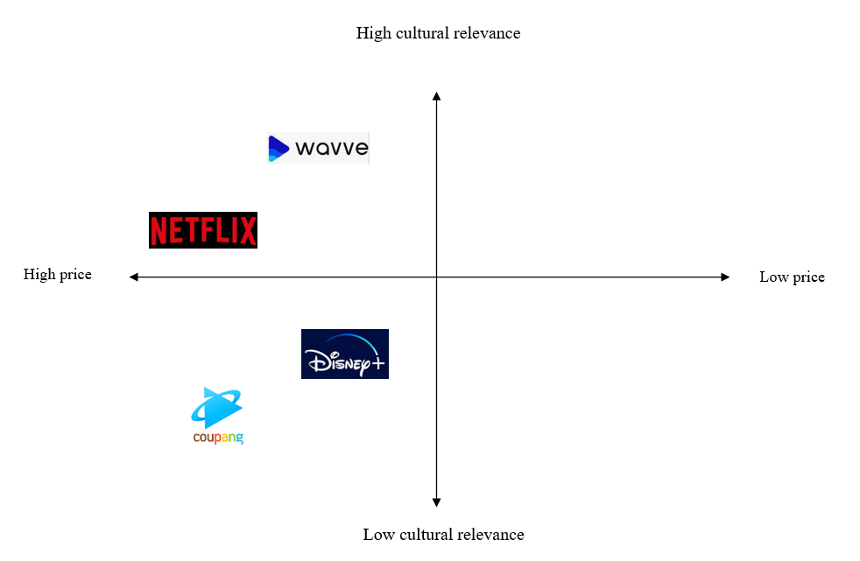
Figure 5: Positioning map of Netflix in South Korea
(Source: Self-developed)
Similarities and differences of STP
In terms of the analysis of STP, it has been observed that various similarities and differences prevail between the STP approach of Netflix in the UK and South Korea. One of the key similarities is that Netflix targets young adults and tech-savvy users in both countries. However, in terms of behavioural segmentation, the brand targets users of digital platforms and binge-watchers. However, in the context of this segmentation, the brand targets users who prefer Korean dramas with cultural relevance. Another key similarity is that Netflix applies the differentiated targeting approach in both the UK and South Korea to target customers. The positioning strategy of the brand varies in both countries. In the UK, Netflix has positioned itself as the platform for quality storytelling and content. On the other hand, the brand has positioned itself with respect to a high cultural relevance and offers content at a high price.

Comparison of Marketing Mix Strategies in the UK and South Korea
Brand strategy: Netflix positions itself as one of the popular streaming services, which offers high-quality content and convenience to customers. In terms of branding strategy, Netflix uses the brand extension strategy. Through the brand extension strategy, the firms can take advantage of the existing brand equity in the new product category (Marin, Ruiz De Maya and Rubio, 2018). Netflix mainly started as a DVD rental company and then extended its brand into online streaming and into original production of content and interactive content (BBC, 2018). The brand essence, such as entertainment, innovation and personalisation, mainly remains consistent across these key extensions.
Product: The core product strategy of Netflix in the UK and South Korea revolves around the on-demand digital streaming of movies and documentaries. The product lines in the UK involve British Originals, Hollywood films and documentaries. Netflix offers 4K streaming and subtitles in the UK (Cremona, 2025). On the other hand, the product lines of Netflix in South Korea are the Glory and the Squid Game (refer to Appendix 1) (Noh, 2023). Netflix is mainly a digital service, and thus, the packaging involves the interface design, thumbnails and language settings. In both the markets, Netflix have a wide product line; however, it has a strong dominance of Korean Originals. The standardised elements of Netflix involve the logo, app design and subscription structure. However, the adapted elements are language, subtitles and themes of the content.
Price: It has been previously analysed that Netflix faces an intense threat of competition in the UK. The brand applies a competitive pricing strategy in the UK, where the standard price with advertisements is £1 pricier (£5.99 a month) (Svetlik, 2025). This pricing method generates significant profit within the organisation. On the contrary, the brand follows a premium pricing strategy in South Korea. This strategy indicates exclusivity, which the consumers interpret as a key differentiating factor (Dwivedi and McDonald, 2025). The ad-supported standard plan of Netflix in the South Korean market is US$3.52 per month (Tech in Asia, 2025). This denotes the premium pricing strategy of the brand in South Korea. Pricing is adapted based on the local income levels of this market.
Promotion: The key promotional objective of Netflix in the UK is to maintain market leadership and growth in the subscriber rate. The brand uses Facebook, Instagram, TV ads and outdoor billboards for advertising its services. For example, Netflix has approximately 4.3 million followers on Instagram, as denoted in Appendix 2 (Instagram, 2025). Similarly, in South Korea, the brand uses social media platforms and celebrity endorsements to advertise its new documentaries or movies. The brand has attracted 111 million viewers within a month of the release of Squid Game in South Korea (Marketing Interactive, 2023). This denotes that Netflix leverages the potential of South Korean celebrities to increase conversion. Squid Game and several other popular shows on Netflix in South Korea have indicated the brutality of the country towards the poor and the homeless (Lee, 2025). The brand posts the teasers and short videos of the show on social media platforms, which denotes the use of emotional appeal in advertising. Emotional appeal crafts a strong emotional connection between the customers and the brand (Vrtana and Krizanova, 2023). On the other hand, Netflix uses storytelling in the UK. In 2024, Netflix attracted a large number of audiences in the UK, becoming the most popular TV service in the country (City George's, 2025). This denotes that the brand used rational appeal in advertising. Rational messages offer information to persuade through logical appeals to recipients (Kim, Jeon and Lee, 2020). Netflix follows the adaptation strategy as the advertisements are highly localised. For example, the Korean dubbing team of Netflix carries out workshops on linguistic and cultural nuances to ensure that the local expressions and sayings are appropriately represented (Netflix, 2024).
Place: Netflix is available in both the countries through smart TVs, mobile apps and web browsers. The movies and documentaries can be downloaded on an Android phone or tablet, iPhone, iPad or Smart TVs (Netflix, n.d, a). The brand does not follow any physical distribution channels. Rather, Netflix uses Amazon Web Services (AWS) to deploy thousands of servers and also terabytes of storage within a few minutes (Kumar, 2021). The Netflix users of both the UK and South Korea can access its services through the strong internet coverage.
People: In 2023, Netflix expanded its workforce and increased the number of full-time employees from 153 to 202 (Economic Times, 2023a). This indicates the dedication of the company to enhance its presence in the UK. In South Korea, Netflix ensures that all its working practices abide by the Korean law (Hellerman, 2023). This influences the smooth business performance of Netflix in South Korea.
Process: The production facilities of Netflix are a key part of the business process of Netflix. In South Korea, Netflix has set up two production facilities in Paju-si and Yeoncheon-gun (Netflix, 2021). The brand has invested approximately $2.5 billion in South Korean content to support the creation of Korean TV series and movies (Telecom Lead, 2025). On the other hand, Netflix has built a production hub in the UK, which features 14 sound stages, workshops and office space (Netflix, 2019). The brand has invested approximately $6bn in the UK to make TV shows and films (Sweney, 2023). This indicates the business processes followed by Netflix in the UK and South Korea.
Physical evidence: Netflix follows the standardisation strategy in both the UK and South Korea in terms of its brand logo. The signature colour of the brand logo of Netflix is red (Netflix, n.d.b). The consistent logo design of the brand has set up a differentiating image in the minds of the customers. In South Korea, Netflix has designed Korean-language originals to attract users (Economic Times, 2021). On the other hand, in the UK, the brand introduces movies and dramas in English.
Similarities and differences
One of the key differences between Netflix in the UK and South Korea is in terms of the product strategy. It has been identified that the product lines of Netflix in the UK involve British Originals, Hollywood films and documentaries, whereas Squid Game and The Glory are the movies introduced by the brand in South Korea. In comparison to the UK, Netflix has introduced more Korean Originals to attract users in the UK. The pricing strategy of the brand also differs in the UK and South Korea. Netflix follows the competitive pricing strategy in the UK, whereas the premium pricing strategy is followed in South Korea. This denotes the key difference in the pricing strategy of the brand in the two markets.
In both the UK and South Korea, Netflix follows the social media platforms. This allows the brand to understand the needs and preferences of the users. Although Netflix follows the celebrity endorsement strategy in the South Korean market, this strategy is not followed in the UK. Apart from this, the emotional appeal in advertising is followed by the brand in South Korea. On the contrary, the rational appeal is followed in the UK, indicating the difference in advertising appeal in the two markets. It has been analysed that the documentaries and movies of Netflix can be accessed on smart TVs, mobile apps and web browsers. No such physical distribution channels are followed by the brand in the two countries.
In the context of the people element, it has been identified that the employees of Netflix in the UK and South Korea are one of the significant resources. The maintenance of effective working practices of the brand has ensured its smooth performance in both the countries. In terms of the process element, one of the key similarities of the brand in the two markets is that it has set up production hubs. This influences the business process of Netflix in the UK and South Korea. The brand has also invested in content production in both markets, and this has contributed to its user growth.

Evaluation of the performance of marketing strategies
It has been analysed in the previous section that Netflix follows a wide range of marketing strategies in both the UK and South Korea. This has made the brand successful in the two markets. The effective promotional strategy has increased the market share of Netflix in South Korea. In 2022, Netflix generated a market share of 38.2% in South Korea (Economic Times, 2023b). On the other hand, in 2025, Netflix dominated the streaming market in the UK. In the UK, the brand accounts for 59% of the top 100 original streaming titles (Senal News, 2025). The content volume of the brand in the UK has contributed to its brand loyalty.
Netflix has a large dominance over the UK market. Approximately 17.6 million households in the UK subscribed to the streaming service of Netflix in 2025, as indicated in Figure 6 (Statista, 2025). This evidence denotes that Netflix is the top recognised and highly recommended streaming brand operating in the UK. The early entry of Netflix in the South Korean market and its increasing investment in original South Korean content have strengthened its position as one of the leading subscription-based online video platforms. The total subscriber base of the brand in the South Korean market is 31% (Telecom Lead, 2025). Thus, this evidence denotes the effective performance of the brand in South Korea.
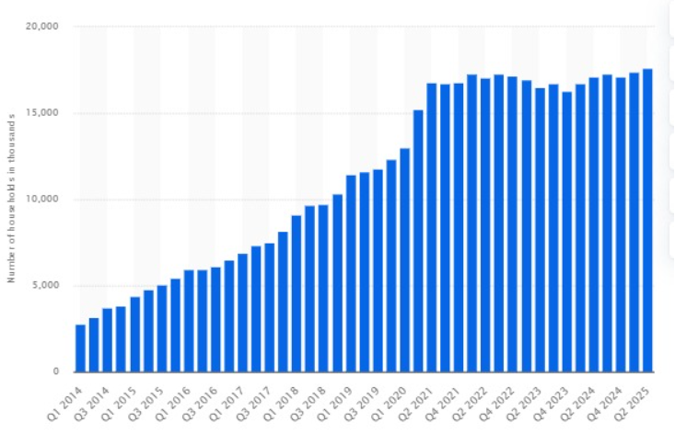
Figure 6: Number of households in the UK subscribing to Netflix
(Source: Statista, 2025)
It has been analysed in the previous section that Netflix uses different price tiers to target different segments. The rollout of the different price tiers has enabled Netflix to target users and generate significant revenue. Netflix have raised its prices in both the UK and South Korea, and this has maximised the profitability of the brand.

Evaluation of marketing ethics practice
Marketing ethics are significant as they support the rights of customers and ensure effective business operations. Netflix maintains transparency in advertising in the UK. In 2025, it has been identified that users of Netflix could face a Rs 1 lakh fine if they are caught watching live TV without any proper coverage (Thakur, 2025). In terms of data privacy compliance, Netflix is required to follow the General Data Protection Regulations (GDPR). However, the company has faced a fine of approximately €4.75 million for violating the transparency regulations of GDPR (Centraleyes, 2024). Thus, this evidence indicated the maintenance of ethics in the business practices of Netflix.
Netflix also focuses on ethical content representation, which indicates the maintenance of the brand. The brand invests in diverse and inclusive content, which represents the ethical minority group (Ravindran, 2021). All these efforts of the brand align with the positioning of Netflix as a socially responsible brand. On the other hand, Netflix has focused on investing $2.5 billion in South Korean content over the next four years (Economic Times, 2023c). This can be observed as an ethical and positive contribution of the brand to cultural industries. Apart from this, Netflix has faced a fine of 220 million won for illegally gathering the personal data before the users had mainly completed their subscription procedures (Lee, 2021). This evidence denoted the poor transparency of the brand in subscription terms. Thus, this directly relates to ethical marketing and the rights of consumers.

Recommendation & Conclusion
In terms of the thorough analysis of the marketing strategies of Netflix, it has been identified that in several areas, the brand requires necessary improvements. The brand has acquired strong market penetration; however, various strategic adjustments are needed for the maintenance of competitiveness and ethical integrity.
- It has been identified in the previous section that Netflix has heavily invested in local content in both the UK and South Korea. However, the company is required to strengthen co-production partnerships, specifically in South Korea, where there are significant concerns about market dominance. Co-production is a significant way of fostering collaboration among different stakeholders (Ikhile et al., 2023). In terms of strengthening local co-production partnerships, Netflix can increase long-term partnership contracts with different South Korean studios and efficiently share the production risks more equitably.
- Ethical concerns exist in both the UK and South Korea with respect to the recommendation systems for the content. Netflix can increase visibility for the diverse Korean, British and various independent creators beyond the key algorithmic bias. Algorithmic bias is when the bias is not in the input data; however, it is created by the algorithm (Belenguer, 2022). The adoption of this strategy can support ethical marketing by enhancing the autonomy of the users.
- In terms of the pricing element of the marketing mix, it has been identified that the increase in subscription rate has occurred in the UK. This may lead to dissatisfaction among Netflix users in the future. In this context, Netflix can link the price changes to tangible consumer benefits such as enhanced recommendation algorithms and new original content. This strategy can maintain price transparency among the users in the UK. Price transparency results in price satisfaction, enhanced customer loyalty and stimulating willingness to purchase the service (Chu et al., 2025). Thus, this strategy can enhance ethical pricing communication of Netflix.
The marketing strategies of Netflix in both the UK and South Korea have stood out as successful in driving brand visibility and subscription growth. By incorporating the recommended strategies, Netflix can strengthen its brand position and support the long-term consumer trust and sustainable growth.

References
Axling, I. (2022). Stranger Things drives over $27m in brand placement value in UK and US. Available at: https://www.campaignlive.co.uk/article/stranger-things-drives-27m-brand-placement-value-uk-us/1796105 (Accessed: 20 October 2025)
BBC (2018) Netflix's history: From DVD rentals to streaming success. Available at: https://www.bbc.com/news/newsbeat-42788099 (Accessed: 20 October 2025)
Belenguer, L. (2022) ‘AI bias: exploring discriminatory algorithmic decision-making models and the application of possible machine-centric solutions adapted from the pharmaceutical industry’, AI and Ethics, 2(4), pp.771-787.Available at: https://doi.org/10.1007/s43681-022-00138-8 (p 774)
Butler, D. and Button, D. (2024) The Netflix story: From mailbox to mega-cap. Available at: https://www.thestreet.com/technology/history-of-netflix-15091518 (Accessed: 20 October 2025)
Campbell, L. (2025). Climate Change in the British Mind. Available at: https://environment.yale.edu/news/article/climate-change-british-mind (Accessed: 20 October 2025)
Centraleyes (2024) Netflix Fined €4.75 Million Over GDPR Transparency Issues. Available at: https://www.centraleyes.com/netflix-fined-e4-75-million-over-gdpr-transparency-issues/ (Accessed: 20 October 2025)
Choe, S. (2024) Sympathy for the K-Drama. Available at: https://gjia.georgetown.edu/2024/06/11/sympathy-for-the-k-drama/ (Accessed: 20 October 2025)
Chu, L., Bai, S., Shi, F., Wei, W. and Song, J. (2025) ‘Less pains and more gains: an experimental study of the impact of price transparency of vacation packages on purchase intention’, Current Psychology, 44(4), pp.2532-2547.Available at: https://link.springer.com/content/pdf/10.1007/s12144-024-07157-0.pdf (Accessed: 20 October 2025)
City George’s (2025) Netflix is snapping at the heels of the BBC. But there’s more to the battle than just viewing figures. Available at: https://www.citystgeorges.ac.uk/news-and-events/news/2025/january/netflix-overtakes-bbc-one (Accessed: 20 October 2025)
Cremona, P. (2025) The best streaming services in 2025: How to choose between Netflix, Prime and Disney+. Available at: https://www.radiotimes.com/tv/what-to-watch-tv/best-streaming-service-uk/ (Accessed: 20 October 2025)
Dal Yong, J.I.N., Sangjoon, L.E.E. and Seok-Kyeong, H.O.N.G. (2023) Netflix and the Global Receptions of Korean Popular Culture: Transnational Perspectives: Introduction. International Journal of Communication, 17, pp.6887-6895.Available at: https://scholars.cityu.edu.hk/files/194777564/191691439.pdf (Accessed: 20 October 2025)
Dasom, L. (2025) Korean content on Netflix in 2024 ranked 2nd in global views. Available at: https://www.korea.net/NewsFocus/Culture/view?articleId=269924 (Accessed: 20 October 2025)
De la Mota, R.S., (2021) Beyond the K-pop & the K-dramas: what life in South Korea was for me. Available at: https://medium.com/@riendasara/beyond-the-k-pop-the-k-dramas-what-life-in-south-korea-was-for-me-20d508044219 (Accessed: 20 October 2025)
Diamond, P. and Newman, J. (2024) ‘Instability and inequality in the British state’, Parliamentary Affairs, 77(4), pp.1-20. Available at: https://drive.google.com/file/d/10V7DPIp8YIkq9w9lAJd7JZ6vCXJ9q247/view (Accessed: 20 October 2025)
Dwivedi, A. and McDonald, B. (2025). A model of brand price premiumness and its marketing outcomes. Journal of Marketing Theory and Practice, pp.1-22. Available at: https://doi.org/10.1080/10696679.2025.2544671 (Accessed: 20 October 2025)
Economic Times (2021) Netflix’s Squid Game success sparks debate in South Korea over debate IP rights. Available at: https://brandequity.economictimes.indiatimes.com/news/media/netflixs-squid-game-success-sparks-debate-in-south-korea-over-ip-rights/87462822 (Accessed: 20 October 2025)
Sweney, M. (2023) ‘Netflix doubles down on UK productions despite slowdown’, The Guardian, Available at: https://www.theguardian.com/media/2023/apr/26/netflix-uk-productions-spend (Accessed: 20 October 2025)
Economic Times (2023a) Netflix’s UK branch achieves significant growth in turnover and profits in 2022. Available at: https://m.economictimes.com/news/international/uk/netflixs-uk-branch-achieves-significant-growth-in-turnover-and-profits-in-2022/articleshow/104314738.cms (Accessed: 20 October 2025)
Economic Times (2023b) 'Netflix Effect' lifts Korean content but market control worries grow. Available at: https://brandequity.economictimes.indiatimes.com/news/media/netflix-effect-lifts-korean-content-but-market-control-worries-grow/101134990 (Accessed: 20 October 2025)
Economic Times (2023c) Netflix to invest $2.5 billion in South Korean content. Available at: https://economictimes.indiatimes.com/tech/technology/netflix-to-invest-2-5-billion-in-south-korean-content/articleshow/99746427.cms?from=mdr (Accessed: 20 October 2025)
Hellerman, J. (2023) How Is Netflix Taking Advantage of South Korean Workers? Available at: https://nofilmschool.com/south-korea-netflix-workers (Accessed: 20 October 2025)
Ikhile, D., Glass, D., Frere‐Smith, K., Fraser, S., Turner, K., Ramji, H., Gremesty, G., Ford, E. and van Marwijk, H. (2023) ‘A virtuous cycle of co‐production: Reflections from a community priority‐setting exercise’, Health Expectations, 26(6), pp.2514-2524.Available at: https://doi.org/10.1111/hex.13851
Instagram (2025) Netflix UK. Available at: https://www.instagram.com/netflixuk/feed/ (Accessed: 20 October 2025)
Kahn, E. (2025) South Korean content overtakes UK in global Netflix viewership. Available at: https://www.screendaily.com/news/south-korean-content-overtakes-uk-in-global-netflix-viewership/5203968.article (Accessed: 20 October 2025)
Khan, U.U., Ali, Y., Petrillo, A. and De Felice, F. (2023) ‘Macro-environmental factors and their impact on startups from the perspective of developing countries’, International Journal of Sustainable Engineering, 16(1), pp.166-183.Available at: https://www.tandfonline.com/doi/pdf/10.1080/19397038.2023.2238754 (Accessed: 20 October 2025)
Kaur, R., Singh, R., Gehlot, A., Priyadarshi, N. and Twala, B. (2022) ‘Marketing strategies 4.0: Recent trends and technologies in marketing’, Sustainability, 14(24), pp.1-17. Available at: https://doi.org/10.3390/su142416356
Kawada, Y. (2023) CULTURE MATTERS Part 3: Collectivism and Individualism. Available at: https://medium.com/design-bootcamp/culture-matters-part-3-collectivism-and-individualism-706f2ba185c6 (Accessed: 20 October 2025)
Kim, C., Jeon, H.G. and Lee, K.C. (2020) ‘Discovering the role of emotional and rational appeals and hidden heterogeneity of consumers in advertising copies for sustainable marketing’, Sustainability, 12(12), pp.1-20. Available at: https://doi.org/10.3390/su12125189
Kim, K.A., Park, J.H., Yoon, S., Wang, Y., Bae, H. and Luc, K.T. (2023) ‘Duality of K-Content in the Era of Netflix: An Investigation of Korean" Netflix Original" Characteristics’, International Journal of Communication (19328036), 17, pp. 7015–7039. Available at: https://ijoc.org/index.php/ijoc/article/download/20725/4399 (Accessed: 20 October 2025)
Kumar, R. (2021) Netflix Case Study On AWS. Available at: https://rahul319sinha.medium.com/netflix-case-study-on-aws-9b33e6660bab (Accessed: 20 October 2025)
Ledesma-Chaves, P., Gil-Cordero, E. and Maldonado-López, B. (2025) ‘Metaverse use intention as a function of psychographic segmentation: the VALS scale applied to tourist behavior’, Journal of Enterprise Information Management, pp.1-47.Available at: https://idus.us.es/bitstreams/8621050f-28a2-46cd-b5a3-939a30719efa/download (Accessed: 20 October 2025)
Lee, D.D. (2025) ‘Versions of Hell’: Squid Game and S Korea’s historical homeless centres’, Aljazeera, Available at: https://www.aljazeera.com/news/2025/3/1/versions-of-hell-squid-game-and-s-koreas-historical-homeless-centres (Accessed: 20 October 2025)
Lee, J. (2021) S.Korea fines Facebook, Netflix over privacy infringement. Available at: https://www.kedglobal.com/tech/newsView/ked202108260007 (Accessed: 20 October 2025)
Lee, S. (2024) Korea tightens rules on Netflix, Spotify subscription billing. Available at: https://www.kedglobal.com/regulations/newsView/ked202408220017 (Accessed: 20 October 2025)
Marin, L., Ruiz De Maya, S. and Rubio, A. (2018) ‘The role of identification in consumers' evaluations of brand extensions’, Frontiers in Psychology, 9, pp.1-12. https://doi.org/10.3389/fpsyg.2018.02582
Marketing Interactive (2023) Bolstering brands: Tap into the powerful influence of South Korean celebrities. Available at: https://www.marketing-interactive.com/bolstering-brands-tap-into-the-powerful-influence-of-south-korean-celebrities (Accessed: 20 October 2025)
Medium (2024) Targeting Strategies: Differentiated Marketing. Available at: https://medium.com/@JerryGrzegorzek/targeting-strategies-differentiated-marketing-723047e7bf5b (Accessed: 20 October 2025)
Medium (2025) Netflix: Industry Leader in Streaming Entertainment. Available at: https://bytebridge.medium.com/netflix-industry-leader-in-streaming-entertainment-3fddb2c7f15d (Accessed: 20 October 2025)
Morris, A. (2025) Employment Rights Act 1996: Essential Summary. Available at: https://www.davidsonmorris.com/employment-rights-act-1996/ (Accessed: 20 October 2025)
NDTV (2024) UK Political Crisis: Why The Country Has Seen 3 Prime Ministers In 3 Years. Available at: https://www.ndtv.com/world-news/uk-political-crisis-why-the-country-has-seen-3-prime-ministers-in-3-years-6008758 (Accessed: 20 October 2025)
Netflix (2019) NETFLIX CREATES UK PRODUCTION HUB AT SHEPPERTON STUDIOS. Available at: https://about.netflix.com/en/news/netflix-creates-uk-production-hub-at-shepperton-studios (Accessed: 20 October 2025)
Netflix (2021) Expanding Our Presence in Korea: Netflix Welcomes the New Year With Two New Production Facilities. Available at: https://about.netflix.com/en/news/expanding-our-presence-in-korea-netflix-production-facilities (Accessed: 20 October 2025)
Netflix (2024) How Netflix Dubbing Connects the World to K-Content. Available at: https://about.netflix.com/en/news/how-netflix-dubbing-connects-the-world-to-k-content (Accessed: 20 October 2025)
Netflix (2025a) Company profile. Available at: https://ir.netflix.net/ir-overview/profile/default.aspx (Accessed: 20 October 2025)
Netflix (2025b) About Netflix- Homepage. Available at: https://about.netflix.com/en (Accessed: 20 October 2025)
Netflix (n.d.a) What is Netflix? Available at: https://help.netflix.com/en/node/412#:~:text=Netflix%20is%20a%20subscription%2Dbased,watch%20without%20an%20internet%20connection. (Accessed: 20 October 2025)
Netflix (n.d.b) Netflix: Brand assets, logos. Available at: https://brand.netflix.com/en/assets/logos/ (Accessed: 20 October 2025)
Nickerson, C. (2025) Hofstede’s Cultural Dimensions Theory. Available at: https://www.simplypsychology.org/hofstedes-cultural-dimensions-theory.html (Accessed: 20 October 2025)
Noh, J. (2023) Netflix to invest $2.5bn in South Korean content. Available at: https://www.screendaily.com/news/netflix-to-invest-25bn-in-south-korean-content/5181325.article (Accessed: 20 October 2025)
OECD (2025) Environment at a Glance: Korea. Available at: https://www.oecd.org/en/publications/environment-at-a-glance-country-notes_59ce6fe6-en/korea_acc98282-en.html (Accessed: 20 October 2025)
Pereira, D. (2024) Netflix Target Market Analysis. Available at: https://businessmodelanalyst.com/netflix-target-market/?srsltid=AfmBOopMsJ9-zauUm3pUFTZuUHmEyXbPo2Dcw8DmI_8OOKCJG_qedgz5 (Accessed: 20 October 2025)
Ravindran, M. (2021) Netflix U.K. Supports Grassroots Organizations to Create Opportunities For Diverse Talent. Available at: https://variety.com/2021/film/global/netflix-uk-invests-diverse-talent-anne-mensah-1234889781/ (Accessed: 20 October 2025)
Rios, D. and Castellano, M. (2023) ‘Imaginaries of Success About Netflix Original Series: The Case of Cidade Invisível’, International Journal of Communication, 17, pp. 4563–4582. Available at: https://ijoc.org/index.php/ijoc/article/viewFile/19267/4253 (Accessed: 20 October 2025)
Schottli, U. (2025). South Korea’s political turmoil: Roots and implications. Available at: https://www.gisreportsonline.com/r/south-korea-trump-yoon-suk-yeol-unrest/ (Accessed: 20 October 2025)
Senal News (2025) UK: Netflix dominates streaming market in 2025 amid rise in selective subscription. Available at: https://senalnews.com/en/data/uk-netflix-dominates-streaming-market-in-2025-amid-rise-in-selective-subscription (Accessed: 20 October 2025)
Sky (2025) UK to have highest inflation in G7, IMF says. Available at: https://news.sky.com/story/uk-to-have-highest-inflation-in-g7-imf-says-13449998 (Accessed: 20 October 2025)
Song, J. (2024) ‘The evolution and impact of streaming services: Changing the media landscape’, Global Media Journal, 22(72), pp.1-3.Available at: https://www.globalmediajournal.com/open-access/the-evolution-and-impact-of-streaming-services-changing-the-media-landscape.pdf (Accessed: 20 October 2025)
Statista (2025) Number of households subscribing to Netflix in the United Kingdom (UK) from 1st quarter 2014 to 2nd quarter 2025. Available at: https://www.statista.com/statistics/529734/netflix-households-in-the-uk/?srsltid=AfmBOorvhSYS0qZ0TJYWTjwJFlLwGjsYwOBT1ipBE3mdh2FDYXggqUMo (Accessed: 20 October 2025)
Statista (2025) Revenue generated by Netflix from 1st quarter 2013 to 2nd quarter 2025. Available at: https://www.statista.com/statistics/273883/netflixs-quarterly-revenue/?srsltid=AfmBOoo_NzZ9_wouO-Jtu-fMulng-cVgmmHPdxC-tWOcxnvHnVLYx1_O (Accessed: 20 October 2025)
Stone, J. (2017) Britain is the most individualistic country in the EU, Europe-wide survey finds. Available at: https://www.independent.co.uk/news/uk/politics/brexit-britain-eurobarometer-individualism-soldarity-eu-politics-a8118581.html (Accessed: 20 October 2025)
Svetlik, J. (2025) Netflix's UK prices are rising – here's how much more you'll pay. Available at: https://www.whathifi.com/streaming-entertainment/tv-streaming-services/netflixs-uk-prices-are-rising-heres-how-much-more-youll-pay (Accessed: 20 October 2025)
Sweney, M. (2012) Netflix hails successful UK launch. Available at: https://www.theguardian.com/media/2012/jan/26/netflix-uk-launch (Accessed: 20 October 2025)
Sweney, M. (2022) As UK hits peak Netflix the streaming giant will have to work harder. Available at: https://www.theguardian.com/media/2022/jan/03/uk-hits-peak-netflix-streaming-giant-work-harder-suscriber-growth (Accessed: 20 October 2025)
Sweney, M. (2025) UK broadcasters hail rare win over Netflix in battle for streaming ads. Available at: https://www.theguardian.com/media/2025/jun/14/uk-broadcasters-netflix-battle-streaming-ads (Accessed: 20 October 2025)
Tavor, T., Gonen, L.D. and Spiegel, U. (2023) ‘Customer Segmentation as a Revenue Generator for Profit Purposes’, Mathematics, 11(21), pp.1-20. Available at: https://doi.org/10.3390/math11214425
Tech in Asia (2025) Netflix raises prices in Korea, third highest globally. Available at: https://www.techinasia.com/news/netflix-raises-prices-in-korea-third-highest-globally (Accessed: 20 October 2025)
Telecom Lead (2025) Netflix strategy and dominance in Korea’s streaming market. Available at: https://telecomlead.com/broadcasting/netflix-strategy-and-dominance-in-koreas-streaming-market-121171 (Accessed: 20 October 2025)
Telecomlead (2025) Netflix strategy and dominance in Korea’s streaming market. Available at: https://telecomlead.com/broadcasting/netflix-strategy-and-dominance-in-koreas-streaming-market-121171 (Accessed: 20 October 2025)
Thakur, A. (2025) Netflix Users In UK Could Face Rs 1 Lakh Fine For Watching Brand New Show. Available at: https://www.ndtv.com/world-news/netflix-users-in-uk-could-face-rs-1-lakh-fine-for-watching-brand-new-show-8110185 (Accessed: 20 October 2025)
The Culture Factor (2025) Country Comparison Tool. Available at: https://www.theculturefactor.com/country-comparison-tool?countries=south+korea%2Cunited+kingdom (Accessed: 20 October 2025)
Thormundsson, B. (2025) Artificial intelligence (AI) in the United Kingdom - statistics & facts. Available at: https://www.statista.com/topics/11518/artificial-intelligence-in-the-uk/?srsltid=AfmBOor6WJkYfBligf-baUgNp7273ScokTw_DLLqyrubPOUO08D1zJqF (Accessed: 20 October 2025)
Trading Economics (2025) South Korea GDP. Available at: https://tradingeconomics.com/south-korea/gdp (Accessed: 20 October 2025)
Vrtana, D. and Krizanova, A. (2023) ‘The power of emotional advertising appeals: Examining their influence on consumer purchasing behavior and brand–customer relationship’, Sustainability, 15(18), pp.1-18. Available at: https://doi.org/10.3390/su151813337
Wan, A. (2023) Netflix’s $2.5 billion investment in Korean content appeals to audiences worldwide. Available at: https://www.cnbc.com/2023/05/12/netflixs-2point5-billion-investment-in-korean-content-targets-global-audience.html (Accessed: 20 October 2025)
WARC (2025) Ad-supported streaming services in UK more popular than ever. Available at: https://www.warc.com/content/feed/ad-supported-streaming-services-in-uk-more-popular-than-ever/10252 (Accessed: 20 October 2025)
Werner, J. (2025) South Korea Unveils Ambitious AI Strategy to Drive Growth Amid Economic Headwinds. Available at: https://babl.ai/south-korea-unveils-ambitious-ai-strategy-to-drive-growth-amid-economic-headwinds/ (Accessed: 20 October 2025)

Appendices
Appendix 1: Product line of Netflix in South Korea

Figure 1: The Glory
(Source: Noh, 2023)
Appendix 2: Number of Instagram followers of Netflix in the UK
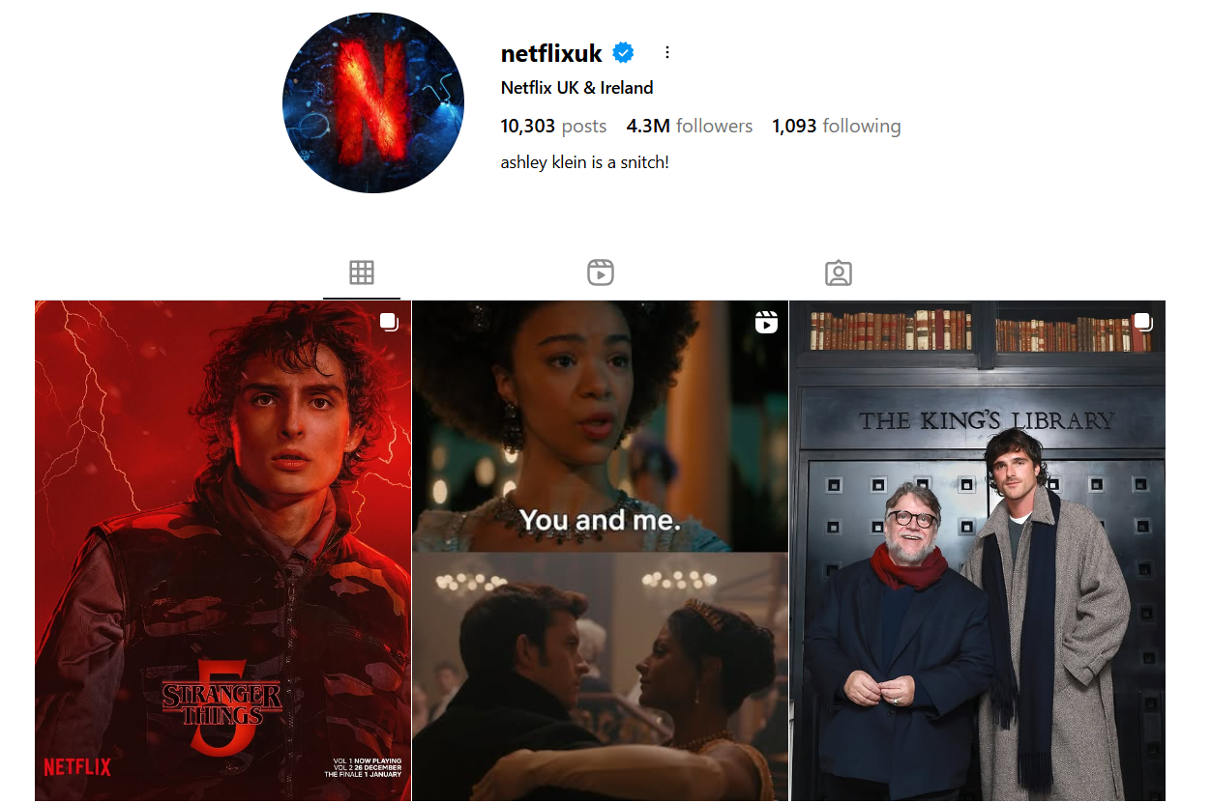
(Source: Instagram, 2025)

