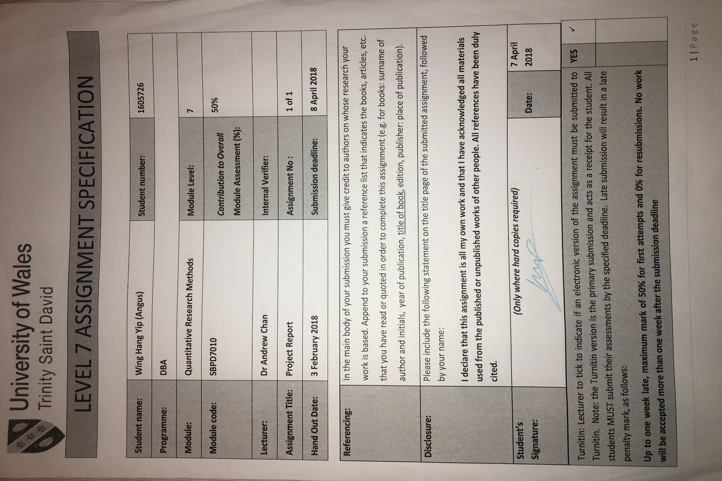
University of Wales, Trinity Saint David
DBA module and code: Quantitative Research Methods SBPD7010
Name: Wing Hang YIP (Angus)
7 April 2018

Component 1: Project Report

Research Topic:
Attributes for Sustainable Investment – A study of retail investors in Hong Kong

- Introduction
Defining Sustainable Investment
Sustainability is a relatively new discipline in academia, different definitions come from different perspectives, such as ecological perspective, succession perspective, business perspective, etc., that makes the definitions blurred in one way or another. As sustainable investment is business in nature, business perspective for its definition is adopted. A mainstream of defining sustainability in business and development is to view it in three components: 1. Economic, 2. Social and 3. Environmental. The 2005 World Summit on Social Development identified sustainable development goals, such as economic development, social development and environmental protection (United Nations General Assembly, 2005). To strike a balance among profit, society and environment is very essential for business resilience (Elkington,1998). Along this line, sustainable investment can be understood as investment that can achieve sustainability simultaneously. Sustainable investment is also generally termed as “Socially Responsible Investing (SRI)”

In order to have a broader understanding of the context of sustainable investment. A framework articulated by Salzmann (2013) is used because of its inclusiveness and completeness. Salzman classifies sustainable investment under “Sustainable Finance”. Sustainable Finance is defined as the most basic approach that investors/fund providers invest money in entrepreneurs who conduct business in a sustainable manner to gain a competitive edge.

Sustainable Finance has three branches:
- Sustainable Investment – investors incorporate environment, social justice and corporate governance (ESG) issues into their investment decision making and so better align their objectives with those of society at large (Salzman, 2013).
- Sustainable Banking – banks attend to the social and environmental effects of its investments and loans.
- Sustainable Corporate Finance – Companies adopt measures to address and improve their ESG issues to attract capital with lower cost.

This research focuses on sustainable investment and investigates the motives for investment decision making process. There are different strategies in practice to implement sustainable investment, Haigh and Hazelton (2004) commented that the most common one is that investors make passive investments in the shares of environmentally and socially responsible companies through mutual funds (sustainable funds). Therefore, “sustainable fund” is the subject investment vehicle in this research.

- Aims and Objectives
This research aims to find out a complete set of the attributes for sustainable investment in the perspective of retail investors as the existing literature only focus on a few attributes and/or those attributes were not tested by rigorous academic methodology. Which attribute is the most influential one and which one is the least? And which one(s) has no impact in making sustainable investment decision? Finding a complete set of attributes and understanding their significance in making sustainable investment decision can benefit the product feature design, sales and marketing strategies, etc., which in turn can further promote sustainable investment.

- Research question
What attributes motivate people to invest in sustainable funds?
Sub questions:
- Among the attributes found, which one is of the utmost importance for decision making?
- Which attribute is of the least importance for making sustainable investment decision?
- Which attribute(s) does not have impact?

- Literature Review
Sustainability became a pressing issue which is widely accepted as the equivalent of 1.5 planets are being consumed to maintain the existing activities of human beings (Grooten, Almond & McLellan, 2012). This inconvenient truth is that the greenhouse gas (GHG) emissions of the past have already loaded the Earth System sufficiently to bring about disastrous global warming (Schellnhuber, 2008). Sustainable investing is one of the many ways to tackle the issue of “unsustainability”.

Sustainable investment could be termed as “Social Responsible Investment”, “impact investment” and “ethical investment” (Renneboog, Ter Horst & Zhang, 2008). Though there is no one single absolute definition yet, when it comes to sustainable investment, it may mean an investment discipline that considers environmental, social and corporate governance (ESG) criteria to generate long-term competitive financial returns and positive societal impact (The Forum for Sustainable and Responsible Investment). Sustainable investment has experienced an explosive growth around the world in the past decade, reflecting the increasing awareness of investors to the ESG issues (Renneboog, Ter Horst & Zhang, 2008). Globally, there are now $22.89 trillion of assets being professionally managed under responsible investment strategies, an increase of 25 percent since 2014 (Alliance, 2016). Generally, sustainable investment can be done by individuals through mutual funds and via charitable foundations and pension funds by institutions (Sparkes, 2008). Juravle and Lewis (2009) found that individual investors investing their money is a major driving force for mutual funds to invest in a socially and environmentally responsible way.

From individual’s perspective, the motivation to invest sustainably can be many-fold. Retail investors may use it for risk diversification because the public policy usually supports sustainable investment (Ghoul and Karam, 2007). But seeking profit is the most common motive for investment. Jansson & Biel (2011) found out that individual investors were influenced by beliefs about long-term returns. However, the financial return for sustainable investment is mixed and unclear. According to Statman (2000), the sustainable mutual funds seemed to perform better than the conventional ones, but the risk-adjusted return of sustainable investment does not show the difference, both groups of mutual funds trailed the S&P 500 Index. Renneboog, Ter Horst & Zhang (2008) concluded that sustainable investors are willing to accept suboptimal financial performance to pursue the good to environment and society. However, the focus of research has been on the profitability, i.e. financial performance of the investment, because most of the literature are data-driven for empirical studies (Capelle‐Blancard & Monjon, 2012). Capelle‐Blancard & Monjon (2012) further commented that particularly more research on the aspirations of sustainable investors is needed. To conclude, Nilsson (2008) indicated that there should be more attributes that influence sustainable investment behavior. Moreover, the dimensions of each attributes are not fully explored.

This study aims to address the research gap in finding a more complete set of motives for retail investors towards sustainable investment. There should be more insights and details on the decision-making process when taking into account of different attributes, for example, the financial return, individual’s aspirations of sustainability and risk diversification, etc. Which one is more and less important?

- Research Philosophy
Sustainable investment emerged in the recent decades and only got popular in the past decade (Umlas, 2008), the research on this field is not extensive and deep enough to see a complete list of attributes for motivating retail investors to make sustainable investment decision. There is also insufficient exploration on the complex interaction among different attributes in the decision-making process. Inductive reasoning is needed, problems and questions should first be examined to work out how they are caused. The inductive approach is adopted for this research to start from collecting and analyzing data, then hopefully to generalize inferences.

This research’s epistemological position is interpretivism because it requires grasping the subjective meaning of social action. This explicitly applies to the attributes for sustainable investment as the opinions given by retail investors are subjective according to their individual’s interpretation and personal experience. It is not abnormal that different people will have opposite comments on the same subject matter. For example, some people make sustainable investment due to the financial return, but some may be due to the fiduciary responsibility. As for the ontological position, my research belongs to constructivism where social phenomena and their meanings are continually being generated by social actors; and the social categories are produced through social interaction and in a constant state of revision (Bryman and Bell, 2015). The constructivism is reflected in the ever-changing nature of investment industry due to the interaction among different stakeholders and its operating environment including competition and regulation. Therefore, the researcher’s own accounts of the social world are construction and the knowledge is viewed as indeterminate (Bryman and Bell, 2015). As a result, the findings would only be correct at a certain point of time and in a certain type of context.

In view of the nature of this study, the research strategies are mainly exploratory and analytical as this study is the first of its kind. Qualitative method is used to facilitate the interpretation and helps to discover the in-depth knowledge about the attributes for sustainable investment from retail investors’ views. And quantitative method is employed to measure the importance of each attribute and its dimensions.

- Research Strategy
A mixed-method is used to tackle the research questions. Qualitative method is used to answer: “What attributes motivate people to invest in sustainable funds?”. Quantitative method is adopted to answer the sub questions: “Among the attributes found, which one is of the utmost importance for decision making?”, “Which attribute is of the least importance for making sustainable investment decision?” and “Which attribute(s) does not have impact?”

Therefore, there are two parts in the research:
1. Finding a complete set of attributes (constructs) for retail investors to invest in sustainable funds by using qualitative method. The results found are used for the second part, quantitative method.
2. Finding the importance of the attributes and dimensions in sustainable investment decision making process by using quantitative method. As the focus of this part is to examine the influence of different attributes on sustainable investment decision making process.

- Methodology
Part 1 (Qualitative Method)
First, the attributes and underlying rationale are found by an extensive literature review (including grey literature). Second, semi-structured interviews are used to check these initial findings and make improvements and additions where necessary. The figure below shows the overall methodology of Part 1.

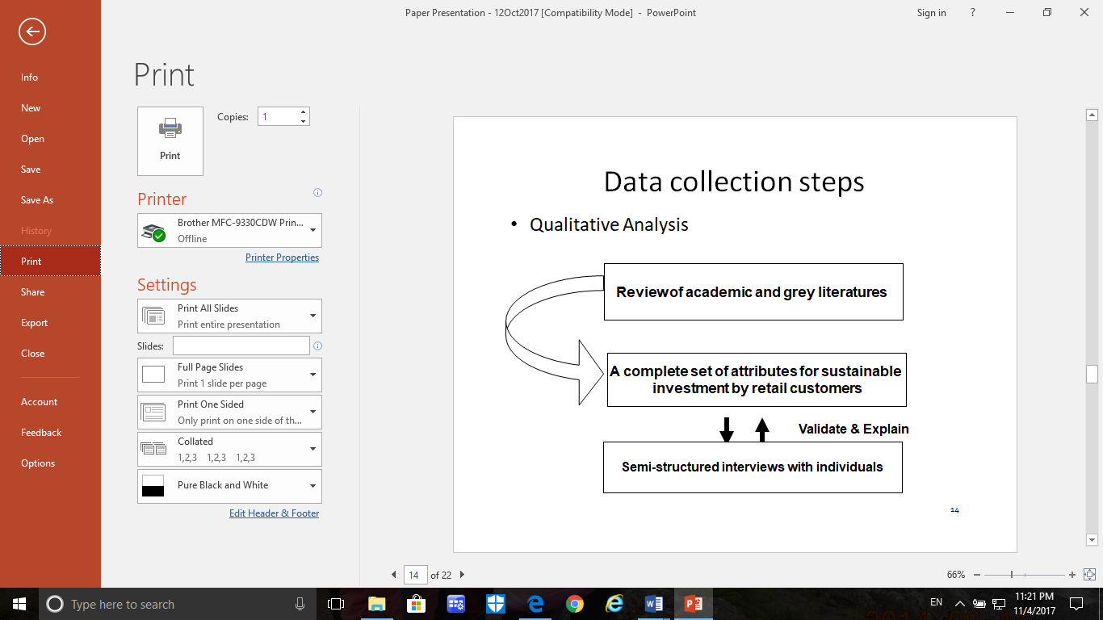
Firstly, the attributes and rationale for making sustainable investment decision by retail investors were collected by reading predominantly traditional literature. As the research topic is fairly new, which may evolve swiftly, in order to obtain the up-to-date information, the grey literature (i.e., not subject to academic peer-reviewed) was also reviewed. The websites of sustainability activists, Non-Government Organizations (NGOs), investment banks, universities and consultancy firms are reviewed to find out the sustainable investment issue. For example, to name a few: Environmental Finance, Swiss Sustainable Finance, Centre for Sustainable Finance (Cambridge Institute for Sustainability Leadership), Institute for Sustainable Investing (Morgan Stanley), 2degrees, McKinsey & Company.

Secondly, Grounded Theory was used by conducting semi-structured interviews (in person or telephone) with 18 retail investors in Hong Kong (three from each demographic category such as age groups and gender) by convenience sampling. The reason for using age groups and gender to categorize the interviewees is that the investment decision is heavily affected by different stages of life and gender (Hallahan, Faff & McKenzie, 2004), more complete insights could be collected to represent the population. The purpose was to, on best effort basis, find out what the attributes are and the insights of how these attributes influence their decision making, until saturation, i.e. no new theme emerges. For a preliminary study, 18 interviewees with different demographical characteristics as per the Hong Kong Census 2015 are deemed sufficient. If data saturation cannot be obtained, further interviews will be done.

The interviews were conducted in person or by phone. Each interview lasts for about 30 to 45 minutes, starting with explaining the objectives of this research, followed by explaining the concept of sustainable investment. Since the concept of sustainable investment is new to most interviewees, examples of sustainable investment will be given (e.g. renewable energy mutual funds). Notes will be taken during the interviews but no recording will be made in order not to create a barrier between the interviewer and interviewee, this allows them to talk freely. At the end of each interview, a summary of the ideas collected will be communicated to the interviewee for verifying the completeness and correct interpretation.

Data analysis and preliminary results
The methodology of grounded theory is adopted for data analysis. As this part of the research is qualitative and inductive in nature, through reviewing the data collected, grounded theory can generate themes by coding, i.e. grouping the repeated ideas into themes and then categories. The notes taken from the interviews will be undergone a content analysis. Four attributes (constructs or themes) are found as follows:
- Trust
- Altruism
- Financial return
- Risk management

Owing to the word limit, “Trust” is selected for developing research measure/scale and a pilot test.

Part 2 (Quantitative Method)
The research objective of Part 2 is to find out the impact of the four attributes (constructs) on sustainable investment decision making. Therefore, two sets of hypotheses are set. One is for testing the correlation between dimensions and the respective constructs. The other one is to test the correlation between the attributes (constructs) and purchase intention.
For example:
- Null Hypothesis: Trust has no impact on purchase intention
a. Null Hypothesis: Ability of fund managers has no impact on having trust
b. Null Hypothesis: Integrity of investees has no impact on having trust
c. Null Hypothesis: Real impact to support sustainability has no impact on having trust

“Trust” as an example for scale development
From the results generated by grounded theory in Part 1, “Trust” is found to be one of the constructs (concept) for making sustainable decision. This resulted from content analysis which provides content-related evidence that ensures the validity of the measurement. Trust is a kind of indirect construct which cannot be measured directly like “height”, therefore, the dimensions and items of trust have to be known for measurement. In order to have a systematic approach for scale development, the 8-step Scale Development Guidelines by DeVellis (2003) is adopted.

Measure development for the construct: “Trust”
Step One: Determine clearly what it is you want to measure
Many of the previous researches on trust are in the fields of donation behavior to non-profit-making organizations (e.g. Sargeant et al., 2006), relationship marketing (e.g. Garbarino and Johnson, 1999) and branding (e.g. Delgado-Ballester and Munuera-Aleman, 2005), however, all these are not relevant to the trust in sustainable investment. In this research, context-specific construct is needed to understand the decision-making process specifically applicable to sustainable investment. A more generic approach for trust was proposed by Morgan and Hunt (1994), emphasizing that trust is a “perception of confidence in the exchange partners reliability and integrity”. This generic definition of trust can be a good conceptualization for trust and can be used as a foundation for further development of a more specific measurement scale for sustainable investment.

In order to further clarify the concept of trust, different meanings for trust are grouped as its dimensions. There are 3 dimensions of trust were discovered from Part 1 semi-structured interviews via content analysis, they are:
- Ability of fund managers
- Integrity of investees
- Real impact to support sustainability

Step Two: Generate an item pool
The dimensions of trust can be more observable by generating items (indicators) which are overt manifestations of a common latent variable. Items were generated as many as possible to capture the phenomenon; and finally, some of them were eliminated because of redundancy, unclearness, irrelevancy and unnecessary similarity. According to DeVellis (2003), the characteristics of good items are observed:
- Clear and unambiguous
- No lengthy items
- Consider reading level of the audience
- Avoid multiple negatives
- Avoid double barreled items
- Avoid ambiguous pronoun references

Basically, the items for the three dimensions are developed by the following methods:

- Generated from the semi-structured interviews conducted in Part 1.
By the content analysis, it was found that some interviewees showed the concern of the trustworthiness of sustainable investment. Further asking what the problems related to trust, they questioned the integrity of the fund managers or the investee companies (i.e. dimensions of trust). They worried about whether there are proper guidelines and monitoring system to ensure the money can really go to sustainable projects or operations (i.e. items). This method is an inductive approach for little theory could be used to identify the relevant dimensions and items. The task is to uncover dimensions/items and clarify concepts.

- From the literature review
The generic definition of trust proposed by Morgan and Hunt (1994) emphasizes that trust is a “perception of confidence in the exchange partners reliability and integrity”. Nilsson (2008) built on this generic meaning and developed five items for the pro-social and pro-environmental attitude in sustainable investment, they are:

1. fund houses follow the socially responsible guidelines used in marketing.
2.fund houses honestly attempt to improve social and environmental issues.
3.fund houses do their best in trying to get companies to act in a way to address the sustainability issues.
4. fund houses do not invest their capital in companies that manufacture weapons and tobacco.
5. fund houses have no genuine interest in improving sustainability because they are like other fund houses which only want to make profit (reversed).

These items serve as a solid base for inspiring and developing the actual items used in this research.

Step Three: Determine the format for measurement
7-point likert scale is used for response options, ranging from strongly disagree to strongly agree. Compared to 5-point scale, 7-point scale gives more delicate choices for respondents to reflect their detailed levels of agreement. Likert scales are relatively simple to construct and they are easy for respondents to complete. Statements (stems) are derived from the items and are carefully drafted to avoid too mild, biased and leading statements.

Step Four: Have an initial item pool reviewed by experts
Two experts from investment industry were invited to review the relevance, clarity and comprehensiveness of the statements (items). And they also helped tap the phenomenons which are missed in the original items. One expert is Executive Director of Goldman Sachs (Hong Kong) and the other one is the former Vice President of GE Capital, both of them are well versed of sustainable investment.

Furthermore, an oral presentation was held on 10 March 2018 (the last session of this module). After my presentation, Professor Andrew Chan gave his feedback on some items that they may be incomprehensible to respondents because sustainable investment is relatively new field of study and the item content wording seem to be too professionals for laymen to understand. These are very useful opinions for me to further refine the items and statements. In addition, more background briefings will be added before asking respondents to do the survey.

Step Five: Consider inclusion of validation items
The items measuring some other related constructs (dependent variables) can be included to determine criterion-related validity. The final version of the questionnaire may refer to the Appendix.

Step Six: Administer items to a development sample
Convenience sampling was used. The questionnaires were distributed in an evening class which I am teaching. The students are studying Financial Planning. Most of them are market practitioners working in banks or insurance companies. Their age is in the range of 20 to 50. Finally, 20 samples are collected for analysis.

Step Seven: Evaluate the items
Descriptive Statistics
 | N | Minimum | Maximum | Mean | Std. Deviation
att1 | 20 | 3.00 | 6.00 | 4.7500 | 1.01955
att2 | 20 | 2.00 | 7.00 | 4.6000 | 1.39170
att3 | 20 | 2.00 | 7.00 | 5.0500 | 1.19097
att4 | 20 | 3.00 | 7.00 | 4.7500 | 1.16416
att5 | 20 | 2.00 | 7.00 | 4.7500 | 1.33278
att6 | 20 | 2.00 | 7.00 | 4.4000 | 1.31389
att7 | 20 | 3.00 | 7.00 | 4.7000 | 1.41793
att12 | 20 | 2.00 | 7.00 | 4.6000 | 1.66702
att11 | 20 | 2.00 | 7.00 | 4.9000 | 1.37267
att10 | 20 | 2.00 | 7.00 | 4.5000 | 1.46898
att8 | 20 | 2.00 | 7.00 | 4.8000 | 1.39925
att9 | 20 | 2.00 | 7.00 | 4.3500 | 1.46089
Valid N (listwise) | 20

The mean scores of all the questions are close to the middle of the scales (i.e. 4 on 7-point scale, which is a good indicator for the ability to detect most of the values. The variances are also large enough to reflect the variety of the choices of the respondents.
Dimension 1: “Ability of fund managers”
Reliability Statistics
Cronbach's Alpha | N of Items
.842 | 4

Dimension 2: “Integrity of investees”
Reliability Statistics
Cronbach's Alpha | N of Items
.881 | 4

Dimension 3: “Real impact to support sustainability”
Reliability Statistics
Cronbach's Alpha | N of Items
.885 | 4

All the Cronbach’s alpha values are above 0.7, it means a good internal consistency among the items, especially there are only 4 items in each measurement. Furthermore, it is no need to take away any item to raise the alpha value.

Step Eight: Optimize scale length
Since longer scales are more reliable, though it may be difficult for participants to respond, more items might be added as now each dimension only has the minimum of 4 items. Sustainable investment is a relatively new area of study with cross-discipline in nature, which should have more items to reflect its complexity and enhance its reliability.
(Reflection is in another file for submission)
- End -
Appendix
Questionnaire
Research Topic: Trust in sustainable investment
Sustainable Investment, in this study, is defined as an investment in mutual funds which can benefit environment or society
1 | 2 | 3 | 4 | 5 | 6 | 7
Strongly disagree | Disagree | Somewhat disagree | Neutral | Somewhat agree | Agree | Strongly agree

Fund managers are capable in sustainable investment
- Fund managers have clear criteria to define what sustainable projects/companies are
- Fund managers have a clear methodology to choose profitable sustainable projects or companies.
- Fund managers have the relevant investment experience.
- Fund managers have positive track record for sustainable investment.

Investees (invested companies) have good integrity
- The investees strictly comply with the guideline of using the fund in the designated sustainable business.
- The investees genuinely report the impacts on environment/society of their investments.
- The management of the investees have a good standard of ethics.
- The investees have good corporate image in society

There is a real impact to support sustainability (doing good to environment or society)
- The investees report quantifiable metrics for the impacts on environment/society.
- The investees provide evidences to support the metrics.
- Independent auditors are employed to assure the accuracy of the metrics.
- The top management of the investees are responsible for the accuracy of the metrics.
References
Alliance, G. S. I. (2016). Global sustainable investment review. Available at: http://www.ussif.org/files/Publications/GSIA_Review2016.pdf (accessed 2 March 2018)

Bryman, A., & Bell, E. (2015). Business research methods. Oxford University Press, USA.

Capelle‐Blancard, G., & Monjon, S. (2012). Trends in the literature on socially responsible investment: Looking for the keys under the lamppost. Business Ethics: A European Review, 21(3), 239-250.

Delgado-Ballester, E., & Luis Munuera-Alemán, J. (2005). Does brand trust matter to brand equity?. Journal of product & brand management, 14(3), 187-196.

DeVellis, R. F. (2003). Scale development: Theory and applications. Applied social research methods series. Bickman, L and DJ Rog.

Elkington, J. (1998). Partnerships from cannibals with forks: The triple bottom line of 21st‐century business. Environmental Quality Management, 8(1), 37-51.

Garbarino, E., & Johnson, M. S. (1999). The different roles of satisfaction, trust, and commitment in customer relationships. the Journal of Marketing, 70-87.

Ghoul, W., & Karam, P. (2007). MRI and SRI mutual funds: A comparison of Christian, Islamic (morally responsible investing), and socially responsible investing (SRI) mutual funds. The Journal of Investing, 16(2), 96-102.

Grooten, M., Almond, R., & McLellan, R. (Eds.). (2012). Living planet report 2012: Biodiversity, biocapacity and better choices. World Wide Fund for Nature.

Haigh, M., & Hazelton, J. (2004). Financial markets: a tool for social responsibility? Journal of Business Ethics, 52(1), 59-71.
Hallahan, T. A., Faff, R. W., & McKenzie, M. D. (2004). An empirical investigation of personal financial risk tolerance. Financial Services Review, 13(1), 57.

Jansson, M., & Biel, A. (2011). Motives to engage in sustainable investment: a comparison between institutional and private investors. Sustainable Development, 19(2), 135-142.

Juravle, C., & Lewis, A. (2009). The role of championship in the mainstreaming of Sustainable Investment (SI) what can we learn from SI pioneers in the United Kingdom?. Organization & Environment, 22(1), 75-98.

Morgan, R. M., & Hunt, S. D. (1994). The commitment-trust theory of relationship marketing. The journal of marketing, 20-38.

Nilsson, J. (2008). Investment with a conscience: Examining the impact of pro-social attitudes and perceived financial performance on socially responsible investment behavior. Journal of Business Ethics, 83(2), 307-325.

Renneboog, L., Ter Horst, J., & Zhang, C. (2008). Socially responsible investments: Institutional aspects, performance, and investor behavior. Journal of Banking & Finance, 32(9), 1723-1742.

Research Office, Information Services Division, Legislative Council Secretariat. Hong Kong as an international financial centre. Available at: http://www.legco.gov.hk/research-publications/english/1617issh18-hong-kong-as-an-international-financial-centre-20161223-e.pdf (accessed 2 November 2017)

Salzmann, A. J. (2013). The integration of sustainability into the theory and practice of finance: an overview of the state of the art and outline of future developments. Journal of business economics, 83(6), 555-576.

Sargeant, A., Ford, J. B., & West, D. C. (2006). Perceptual determinants of nonprofit giving behavior. Journal of Business Research, 59(2), 155-165.

Schellnhuber, H. J. (2008). Global warming: Stop worrying, start panicking?. Proceedings of the National Academy of Sciences, 105(38), 14239-14240.

Sparkes, R. (2008). Socially responsible investment. John Wiley & Sons, Inc.

Statman, M. (2000). Socially responsible mutual funds (corrected). Financial Analysts Journal, 56(3), 30-39.

The Forum for Sustainable and Responsible Investment. Available at: http://www.ussif.org/sribasics (accessed 31 October 2017)

The Wall Street Journal (1 December 2015). Hong Kong is No. 1 again for IPOs globally. Available at: http://www.wsj.com/articles/hong-kong-is-no-1-again-for-ipos-globally-1449120929 (accessed 2 November 2017)

United Nations General Assembly (2005). 2005 World Summit Outcome, Resolution A/60/1, adopted by the General Assembly on 15 September 2005

Umlas, E. (2008). The global expansion of SRI: facing challenges, meeting potential. Development and Change, 39(6), 1019-1036.

