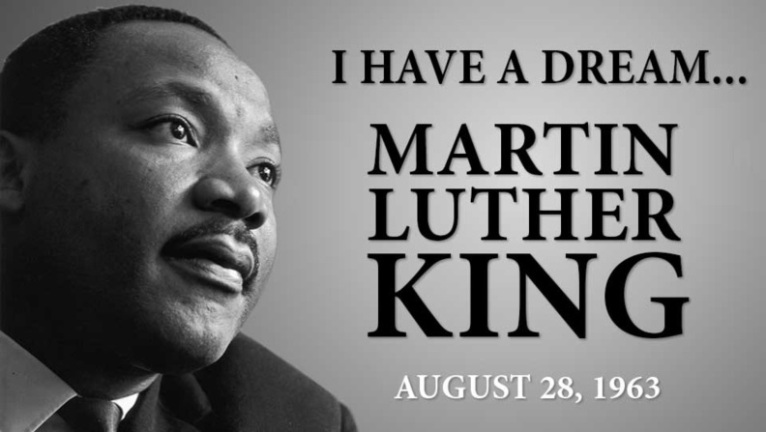
ALESSANDRO CALZAVACCA

1817700

M4X01917

BUSINESS SKILLS FOR INTERNATIONAL HOTE INDUSTRY

LECTURE: DALE CLARKE
I HAVE A DREAM

PAGE CONTENTS
INTRODUCTION

SWOT

PERSONAL DEVELOPMENT PLAN

CONCLUSION

REFERENCIES
p3

p3

p4

p6

p7
INTROSUCTION
“I have dream” Martin Luther King, Jr.(Luther King Jr, 1963) stood on the steps of the Lincoln Memorial fifty years ago and spoke to a great people about their greater future, he didn’t say, “I have a plan”(Burrus,2015) here Daniel burrus in his illuminating article tries to let understand the reader how important is for a leader, a nation or even a manager define an objective, a goal or a dream as for Martin Luther king with all the united states, close or impossible to achieve doesn’t matter. Now I would never contradict a worldwide economic guru, but I will express my concern about how it is vital to have a goal as a detailed plan to develop them.
We plan to reach our goals every day, I am not just speaking about long term lifegoal, I am simply talking of go at the super market with a shop list, best example of planning, and the goal is basically planning what to buy to bake a cake.
But when it comes to plan about our future is not always as easy as open the fridge and do a shop list, that is why we have armed whit strong weapons to analyse our self and plan the best way to achieve ours objectives step by step.
Two of them are SWOT and PdP and today through this tools I will try to define goals and highlighting opportunities and right strengths to maximize them, based on academic and employability skills

SWOT
Starting from a brief presentation of SWOT we need to go back in the middle of 1960 when Albert Humprey decided to do a close research on the future planning of the top companies of the time delineating which was going to fail. According to the website rapidbi.com, born as SOFT analysis (Satisfactory point, Opportunity, Fault, Threat) lately changed in SWOT ( Strengths, Weaknesses, Opportunities, Threats)(Morrison,2016) always keeping a profile of analysis of what good and bad in the present and what will be in the future with also an internal and external point of view.
As origin point to develop a plan I will present my SWOT, analysing academic and employability strength, weakness, opportunities and threats, giving also a quick personal explanation of the chosen answers.

STRENGTH WEAKNESSES
- Dedication, motivation and ambition  - Team work  - Confidence | - communication and leadership  - business and marketing skills  - feelings

About this two beauty of the SWOT, on my personal opinion, the most important is understand that the first doesn’t make you win and the second lose, it could take a while to highlight them and think intensely about yourself, but I also think that are simply to faces of the same medal.
For my strength I have chosen in particular employability skills based on my wider experience on the field than academic path, on the opposite weakness, mostly are what I wish to reinforce with a strong academic training.

OPPORTUNITIES THREATS
- University  - London (live in a metropolis)  - Field chosen | - Relationship  - Stress  - Political decisions

Many, many opportunities around us, it is all about focus and decide which one is the right one to take, but several threats that you don’t see coming can really make you struggle and change your plans that is why working hard on the other three points you build the strongest shield.
Obviously my biggest opportunity is the university that it is not just teaching me new subject and giving me a degree, already a huge opportunity, but it is also open my mind to new horizons, after come my beloved job, everything on my life has been built on it, industry that will never end and where I am still growing and learn day by day. Last but not least the city and the country which has permitted all of it, but every joy is coming with a bit of sacrifice like distant relationship, stress for a busy schedule to don’t miss anything and every political decision that have been worried us in the last few months.

PERSONAL DEVELOPMENT PLAN
Second step of my assignment I will create my Personal Development Plan, in this case the topic is define my goals, short and long term, and go deeper in details to develop a way to achieve them. I personally started following a little guide schedule to help me find out any answers and create a plan with a time frame of six months to five years.

AIM | OBJECTIVE | RESOURCE | TIME FRAME | REVIEW DATE
Final goals | Means to achieve the aim | Personal tools to help the conclusion | Time to reach the aim | Check the development time

Obviously there are several way to develop the plan, I found fascinating how Blake Jenny, in pivot, suggests to write your own ideal day and develop your plan with that as a topic (Blake,2016) or according to the blogger Michael Hyatt who lists ten key questions to develop a 360 degrees plan, going through much more deeper points(enhancv.com,2019). Giving a conclusion to this little introduction at the PdP, I think it is something really personal, so the way to create it, it takes time and effort but also everything is related to real determination on reach your goals.
I will not say much more, and I will give MY version of PdP followed by my personal explanation of the chosen answers.

 | Short term  time frame | Mid term  Time frame | Long term  Time frame
My goals | - Good results in the assignments  - Get promoted  - Computer skills | - end my university path  - golden scholarship  - business and leadership skills  - new foreign language | - obtain a management role  - aim to an economy stability  - leave London for better opportunities  - entrepreneur mentality
Skills and knowledge to be learned | - focus on both job and lessons  - spend all my free time to improve myself  - regular use of the computer | - attend to trainings and masterclass  - attend to the lectures  - read books | - plain a security save bank account  - marketing research
Next steps | - improve my knowledge on the field  - update my computer | - travel abroad to use a new language  - express my ideas  - don’t be afraid to communicate in public | - “thinking out of the box”  - Never lose regularity and faith on what I do
Resources | - myself  - Strong schedule | - University  - Funding | - Job environment
Time schedule | Six months | Two years | Five years
Start by | Now | Now | Now
Finish by | January 2020 | July 2021 | Later in 2024

My PdP is focused, as it has been asked, on my employability and academic goals, referring on what I have found through my SWOT I decide to define goals in particular about academic skills that are mostly my actual weaknesses, without forget the field chosen that give me opportunity to grow every day and which needs constant motivation and dedication to achieve the given goals. I decided to keep the first two third for something more tangible and close to realize and the last third are more kind of futurviews that need to be achieved and maintained from then on. Everything is resource I personally think is a constant during the whole time frame of the PdP, I simply compered it as my environment, probably being the same for the next five years.

Reading an advertising feature of the Financial Times about the exploit in 2018/19 of the KGHM, Polish firm in production of copper and silver, the CEO claims in the end of his interview that rely on luck and times when the company is in excess of liquidity it is easy, but real challenge is plan to be prepared to grow under any condition(Financial Times,2019).
Here my inspiration to develop a plan that I feel mine, personal and I am ready to carry it on in any condition.

CONCLUSION
In a final conclusion I would like to express how, for a second, while I was writing this report I was really concern about which topic was academically right to develop, but word after word I have understood that I had to feel it mine, from the head to the tale, every goals had to be written in my mind and weaknesses had to be something troubling me just thinking about, not just time spent to fill up an empty space of prewritten form or complete a thousand and five hundred words. I took this assignment as a quote to the life and as first important brick to build my house of academic and employability knowledge.
When I was young my grandad used to bring with him on a Sunday reunion of a bunch of old hunters who love organise big lunches and spend hours telling story of their great hunters time, I remember one of them in particular that every Sunday was repeating this quote, that actually I couldn’t understand at the time but I found much of nice connection now “every time you aim at the game, aim at the highest, because in the worst case scenario your bullet will catch something lower but will never touch the ground” (Anonymous hunter, 2006) I don’t know if there is any sense on hunter, but today I felt like that old hunter trying to catch always the highest goals.

REFERENCIES

Anon hunter, 2006, past memories

Blake, Jenny, 2016, Pivot, Random House

Luther King, Martin Jr, 1963, I have a dream speech

Poland, 2019, 4E strategy, Financial Times, 27 June 2019, advertising feature

Burrus, Daniel, 2015, Burrus Research, Why Martin Luther King Jr. did not say “I have a plan” available at; https://www.burrus.com/2013/08/why-martin-luther-king-jr-did-not-say-i-have-a-plan/ [accessed 5 july 2019]

Morrison, Mike, 2016 rapidbi.com, History and Background – SOFT & SWOT Analysis available at; https://rapidbi.com/swotanalysis/

Valchanova, Vassilena, 2017, enhancv.com, 4 steps to a successful personal development plan, available at; https://enhancv.com/blog/personal-development-plan/

