-
qatar airways
M6X02113- Consultancy Project

10/06/20

Dee Lee Jones
1700521

A report submitted in fulfilment of the requirements for Course M6X02113, Consultancy Project, University of Wales Trinity Saint

Table of Contents

Executive Summary

Introduction

Research Methodology

Main Findings

Recommendations

Conclusion

Appendices

Executive Summary
The purpose of this report is to create a marketing strategy plan, which is to be ready for Qatar Airways, Discover Qatar, Cardiff Airport and the Welsh Government, on how best to prepare and in readiness for their relaunch post COVID-19. Relevant theoretical models of destination management, categories of tourists and tourist experiences have been discussed and researched to highlight the key challenges the airline and airport are up against. With the key findings being that most respondents are not considering booking a holiday to Qatar, as they are unclear about the leisure purposes the destination has to offer. Welsh tourists are seeking to book holidays within Europe, and are still engaged to fly with the main competitors, including Bristol Airport. The key recommendations are for Qatar Airways, Discover Qatar, Cardiff Airport and the Welsh Government to raise awareness of the destination’s profile and image as a short-break holiday destination with regards to tourism and emphasise the safety of the country post COVID-19. To get the key message across “Taking Wales to the World (The Welsh Government, 2019) could promote the leisure and cultural activities available by using social media platforms, such as Instagram, involving influencers with a large following to participate in helping to increase passenger numbers. The key conclusions are that Cardiff Airport needs to be more competitive against their main rivals by creating a strategy plan to increase marketing around the destination which will help to support and increase passenger numbers flying from Cardiff Airport.

Introduction
As a result of the global pandemic, COVID-19, this project is now being undertaken independently, the last meeting with the client took place on 14th April 2020, the client is now classified as furloughed from their job role. However, the client approved the project to be continued throughout COVID-19 (see appendix 1) without guidance and the attention of the sales executive of Qatar Airways. The main aim of the report is to investigate and, gather information from travel consumers in order to develop and advise Qatar Airways, Discover Qatar, the Welsh Government and Cardiff Airport, on how to attract Welsh tourists to support Qatar as a destination, as this will be a contribution to their re-launch post Covid-19. To satisfy the aim, the objectives are to come with a marketing strategy plan that will be ready for Qatar Airways to market the destination as a short break and stop over destination.
According to Qatar Airways (2020), they created the Qatar Stopover, a unique product developed in partnership with the National Tourism Council and its Destination Management, who are known to be Discover Qatar. The purpose of the programme is to enable tourists to experience Qatar with a stopover at Doha while crossing through on their holiday or even a scheduled travelling trip. During the stopover, Discover Qatar (2020) wish for tourists to be able to experience electrifying activities, as well as Arabian hospitality, offering a diverse variety of tours and excursions to either walk through the lively labyrinth of Souq Waqif alleyways, explore the phenomenal scenery on a desert safari adventure, see the illuminated skyline of Doha cruising on board a traditional wooden dhow, or simply relax at the beaches. This indicates that Qatar as a destination offers many different types of tourist experiences that would attract a range of market segments to visit and explore, giving the opportunity to “enjoy two holidays in one journey” (Discover Qatar, 2020).
Back in May 2018, Qatar Airways made headlines, with Cardiff Airport (2019) announcing that the airline had introduced new flights giving tourists the opportunity to board a Boeing 787 Dreamliner to Hamad International Airport, linking to 160 destinations globally. According to Wales Online (2019), during the first nine months since the launch, the airline attracted an average of 6,900 travellers per month which gives a total of just over 62,000, with Business News Wales (2019) agreeing that the daily operation of the airline to Doha was part of a 7% increase in cumulative Cardiff traveller numbers, as the programme’s most popular destinations include Qatar, Thailand, Malaysia, Hong Kong and Sri Lanka.
Cardiff Airport plays a significant role both as an international gateway and as a key component of the Welsh economy, providing 1,800 aviation-related jobs at the airport and domestically and internationally providing 2,675 more jobs in the wider region. The estimated gross value-added effect on the local economy is £102 million and 30% of the passengers are tourists to Wales (Cardiff Airport, 2019). Furthermore, since 2018, Cardiff Airport (2019) state that Qatar Airways is significantly important to Cardiff airport, quickly becoming a critical gateway for both Wales and the United Kingdom, which greatly enhances the relationship across the world. As the CEO of Cardiff Airport, Deb Barber, discussed, the route between Cardiff and Doha has helped to open a region of accessibility for travellers throughout Wales and the South West of England (Business Traveller, 2019). Additionally, Business Live (2019) confirmed that the route carried almost 50,000 travellers from May to October, which is an approximately 13.5% increase, in contrast to 2018, where the route carried almost 44,000 travellers.

Research Methodology
The global pandemic, COVID-19 has had a significant impact on the aviation industry, with numerous airlines being forced to change schedules and cancel flights in response. (Travel Supermarket, 2020). This includes airlines like Qatar Airways, with Al Arabiya (2020) announcing that the airline recently laid off approximately 200 employees due to COVID-19 issues impacting travel, in addition, Wales Online (2020) reported that the most frequent term on the arrival and departure boards at airports is “cancelled”, due to the coronavirus significantly impacting flight operators.
To undertake the aim of the project to help Qatar Airways in their re-launch post COVID-19, the approach that the researcher decided to undertake is primary research via online investigate information that can help the re-launch, in order for the airline to support Qatar as a holiday destination. The researcher felt that this was a beneficial way to gather key points without breaking the government guidelines, to stay at home and away from others, and not to travel away from home apart from very specific circumstances (GOV.UK, 2020). In addition, the researcher will also be undertaking secondary research, which consists of information gathered online, for example, library research, data of statistics and figures from tourism organisations. All research collected is going to be analysed through pie charts, bar graphs and statistics, which will help to enhance the marketing strategy plan for Qatar Airways and Cardiff Airport.
One of the primary research methods was creating a questionnaire to share on various social media platforms, such as Facebook, Twitter, Instagram, LinkedIn, aiming to reach a range of ages and backgrounds with different experiences. The questionnaire consisted of qualitative data, with the researcher allowing participants to share their answers and opinions on specific questions. The researcher made this decision for qualitative data to be included, as it is believed to give honest feedback, which would help Qatar Airways gain a deeper understanding within Wales and South East, likewise Wilson & Hollinshead (2015) agree that qualitative studies have greatly contributed to the study of tourism, as the usage and recognition of qualitative research has driven a greater understanding of social, cultural and political integration within and for tourism. Additionally, although the feedback is qualitative, it does come from a quantitative questionnaire, as the questions were produced by the individual, with some of the questions being closed responses, as the purpose was to identify patterns and make generalisations. Similarly, Hara (2008) states the importance of quantitative method in advancing tourism industry development, which therefore, allows the researcher to undertake market research effectively.
Additionally, the global pandemic of COVID-19, has greatly restricted the researcher in the undertaking of the investigation, as the research has been limited to the internet and using social media platforms. This means that when the questionnaire was created and shared on various social media platforms, it was targeted at personal contacts. Therefore, it follows that the contacts are more or less in the same age group as the researcher, with a significant figure of respondents stating the main purpose of their travel, when they book their first holiday post COVID-19, would be for leisure purposes, as opposed to other purposes such as business or visiting friends and family. Although the researcher did post the questionnaire on LinkedIn to attract business respondents, this platform did not provide as many responses as other social media platforms due to low number of connections and followers.
With regards to the questionnaire created by the researcher for primary analysis, while the questions significantly helped develop a market strategy plan for Qatar Airways and Cardiff Airport, the researcher acknowledges that to have included other specific questions would have enhanced the information further to show Qatar as an attractive stop over and short-break destination. For example, some of the questions raised were “Would you book to go abroad or stay in the United Kingdom?” and “What is your preferred first holiday destination?”, these were beneficial questions in gathering information, but should have perhaps given a list of popular holiday destinations, and then given an option to state other holiday destinations. This would have allowed further investigation into which other destinations are doing to attract tourists compared to Qatar, as The Peninsula (2019) declared that 1.8 million tourists visited Qatar, motivated by European and Asian travellers. This would have highlighted the importance of knowing which type of tourists could be targeted to visit Qatar, as Plog’s psychographic principle of inspiration can be used for the evaluation of visitors. Plog’s theory categories tourists into psychocentrics at one extreme to allocentrics at the other with their personal attributes, beliefs and lifestyle, with the psychocentrics are portrayed on their own behalf by individuals involved, for example, non-adventurous holidaymakers, who need regular facilities, in contrast to the allocentrics who are holidaymakers that seek to have exploration or experiences, including the midcentrics in amongst the two extremes (Šimková & Holzner, 2014).

Main Findings
Firstly, one of the positive findings from the questionnaire was that from 161 responses, 80.1% are planning to book a holiday after COVID-19 (see appendix 2), which indicates that booking a holiday is going to be a main priority for post-outbreak purchase, with customers expecting a gradual return to public spaces, and health and safety continuing to be core concern. However, Global Web Index (2020) also demonstrated on their online poll that from the 40+ tourist board members, 77% of who say that they will see leisure travellers from the United Kingdom, book a holiday to their chosen destination approximately 3-6 months ahead, which is an indication of confidence for the travel and tourism industry. Likewise, when the researcher asked how soon holiday makers would want to travel, the higher percentages do fall in between the 3-6 months period, with 16.1% wanting to travel after 3 months and 20.5% after 6 months (see appendix 7). This is important information for Qatar Airways to prepare for the re-launch, as it is a great indication of how confident travellers are to book a holiday post COVID-19, allowing Qatar Airways to create package holidays at the right time.
On the other hand, one of the main findings from the social media questionnaire is that from the 148 responses, a significant 79.1% stated that they have not considered booking a holiday to Qatar (see appendix 13), including 72.3% who see it as a safe destination. Many of the respondents are considering other holiday destinations, with an enormous 68.9% preferring their first holiday, post COVID-19, to be within the European continent (see appendix 6). This is a key concern for Qatar Airways as travellers continue to be seeking to travel elsewhere despite the European Centre for Disease Prevention and Control (2020) confirming that the deaths in Europe are currently a total of 177,161, which include 39,728 in the United Kingdom, in contrast to the Middle East where the death rate currently in Qatar is a total of 45 deaths. Additionally, countries like New Zealand, who are involved to connection flights at Qatar stopover, Worldometer (2020) confirm that the coronavirus cases are 1,504 with a death toll of 22, likewise The Guardian (2020) reported that people had stayed at home more than British, US and Australian residents had, which has resulted in the National Health Officials announced that no known active coronavirus cases.
Pavelka (2013) expresses that a significant aspect of tourism education is the awareness of the link between tourists and the destinations they want to visit, this consolidates the idea that Qatar Airways and Cardiff Airport need to raise awareness together showing why Qatar is a holiday destination that Welsh tourists should visit. This is made clear by one of the many of the examples of the respondent’s comments on their feelings towards Qatar as a holiday destination which states “Never really thought of it as a holiday destination” (see appendix 20). With Qatar Airways (2020) revealing the new safety measures at the Hamad International Airport, including thermal screening, smart screening helmets, face mask detection system and fully autonomous disinfection robot, this is another area the airline and airport could capitalise on by raising awareness that it is a safe stopover.
The Government Communications Office (2020) confirmed that tourism is listed by the country’s government as one of the five key sectors that are crucial to broadening Qatar’s economy and developing the involvement of the private sector. However, despite this, the National tourism Council (2018) reported that in 2018 Qatar saw a 19% decline (to 1.819 million) in tourist numbers from 2017.This demonstrates the decline period of Butlers Model life Cycle, which is a theoretical and functional way to discover and forecast the growth of a tourist destination (Todorovic, 2019). In comparison, the National Tourism Council (2019) reported a reversal of this decline with an increase of 10% in tourist numbers from 2018 with Qatar receiving 588,072 visitors. This increase may attribute to an assortment of activities that encouraged visits from tourists for example, the Qatar National Museum, the launch of Katara Cultural Village retail quarter and the Qatar International Food Festival’s 10th Anniversary Edition. All this indicates that the different events provided more attention and interest from tourists and represents the rejuvenation stage of the Butlers Model Life Cycle.
Although, 70.9% of the respondents are considering flying from Cardiff Airport when they can go on their first holiday post COVID-19, as shown on the bar graph (see appendix 14), Cardiff faces stiff competition from Bristol Airport with Gripaios, Gripaios & Munday (1997) confirming that there is explicit competing between both airports, as they are just over 40 miles away from each other, even though there is a big difference, Cardiff is not just another region of the United Kingdom, it is also in another country, a factor that may be of some significance to possible regional relocations. This shows how poorly Cardiff Airport are performing, as the bar graph indicates (see appendix 14), there are still Welsh respondents willing to travel to Bristol Airport, despite the fact that Cardiff is more local. Additionally, the Welsh Government (2019) announced that the goal for Qatar is to draw 5.6 million tourists by 2023 and the estimated 1.5 million tourists by 2022, which is when the country is hosting one of the most f major events in the world, the FIFA World Cup, with accessible flights from Cardiff to Doha and the desire to take Wales across the world. It is crucial for Qatar Airways and Cardiff Airport to get across the key message that the local airport gives opportunities for “Taking Wales to the World” (Welsh Government, 2019), as Business Live (2019) also state that the journey from Cardiff Airport to Doha’s Hamad International will now run up to Qatar’s 2022 World Cup hosting.
Furthermore, Anonymous (2009) indicated that The Qatar Tourism Authority wanted to enhance the image of Qatar as a holiday destination for United Kingdom tourists, putting emphasis on the country’s hot climate and areas of historical interest, including the Al-Ghuwair Castle. When the researcher requested the respondents to comment on their feelings towards Qatar as a holiday destination, one commented that “I have never seen it as a holiday destination due to the fact there isn’t a lot of attractions or marketing around Qatar, like there is with Dubai for example”, with another stating, “There would be lots of interesting cultural sites to see. I imagine it would be really hot. It doesn't seem like a very exciting or fun place to go which is why I would not choose to go there for my holiday”. This indicates that there is still a lack of marketing with regards to what Qatar has to offer as a holiday destination that would encourage Welsh tourists to book a flight and experience the activities and culture. This links with Cohen’s (1972) typology where the interaction between tourists and the tourist environments of a destination is analysed and ultimately finds that a validated and progressed context in a destination becomes a bigger and more powerful barrier as the true characteristics of a destination disintegrate. Additionally, Chang-Keaun (2018) discusses Cohen (1979) the five modes of tourist experiences, which included recreational (entertainment), diversionary (simple escape from schedule), experiential (experiencing another authenticity), experimental (linking different opportunities that meet one’s wishes) and existential (engaged to an elective state religion such as a tourist’s traditional society and culture) modes.
With the majority of the respondents being 18-25 seeking leisure activities whilst being on holiday, it suggests that Discover Qatar need to focus on the recreational, experiential and existential Welsh tourists, with Weber (2017) agreeing that the amount of global tourism activity in Qatar relates to businesses outside the Gulf Cooperation Council (GCC) of Bahrain, Kuwait, Oman, Qatar, Saudi Arabia and the UAE, a significant 73% of non-GCC tourists visited Qatar for business purposes, whilst only 23% of tourists visited Qatar exclusively for leisure activities. Evaluation of the statistics indicates that the destination is not considered as a leisure and cultural or creative arts short-break destination, whilst Weber (2017) discusses that the indigenous residents are strongly traditional, conducting strict Wahhabi or Salafist Sunni Islam, and hesitates to encourage specific Western cultural practices to embody the country, for example, Western popular music concerts, alcohol bars and clubs, backpacking tourism and hostels. When it comes to consuming alcohol, which is only permitted to non-Muslims, it is limited to international establishments, and major concerts of popular music are restricted.

Recommendations
The researcher has undertaken a SWOT analysis to make recommendations for the marketing strategy plan (see appendix 22).
A recommendation to put forward to Qatar Airways and Cardiff Airport would be to raise awareness by enhancing the image of the country as a short holiday break destination. For example, the Welsh Government (2019) pointed out that the flights from Cardiff to Doha provide easy access, this needs to be promoted more as clear key message, as well as advertising the range of events and attractions available, including Qatar National Museum and the Katara Cultural Village Retail Quarter, ready for the relaunch post COVID-19. As proven from the research, most respondents see Qatar as a safe stop over holiday destination (see appendix 13 & 14), when they are focusing on the fact that Qatar is accessible from their local airport, it is crucial that the partnership emphasise that the World Health Organisation (WHO) stated recently that the UAE has proven itself to be one of the safest countries during the pandemic. As well as being a pioneer in national COVID-19 research, it has been ranked in the top 3 countries worldwide (see appendix 23), by including all the safety measures they have put in place at Hamad International Airport, which was discussed in the main findings.
Additionally, it is also vital that they are getting that key message across to Welsh tourists “Taking Wales to the World” within the Welsh Government report, as the message does not stand out, which is recognized in the questionnaire that 79.1% of respondents have not considered a short break holiday to Qatar (see appendix 13). For this reason, a recommendation to be included in the marketing strategy would be to market more on social media platforms such as Instagram. For example, there is an account named ‘Inside.Lifestyle’ which is a travel company, that organise their guests in hotels, villas, staycations, experiences, events, collaborating with famous influencers on board to experience leisure purposes whilst being on holiday in Dubai. The purpose of this is for the influencers to demonstrate to their large following what a destination has to offer, including the experiences and excursions that holidaymakers could experience if they decided to book. As demonstrated in appendix 24, the social media platform has highlighted their guests for the week, undertaking an excursion that potential tourists could experience if they were to book. Perhaps getting influencers with a large following to participate to a short-break holiday experience in Qatar could help to showcase the leisure purposes instead of business purposes, leading to increase passenger numbers.

Conclusion
In conclusion, the research demonstrates that Qatar Airways, Cardiff Airport and Discover Qatar need to be more competitive in their marketing approach to Welsh tourists, and most importantly, that they attract people to fly from their local region, Cardiff airport, instead of travelling to their main competitors such as Bristol, London Heathrow, Gatwick and so on. Creating a marketing strategy plan will help and support making small incremental steps into expanding its economy through tourism strategies, as the purpose of the plan is to be ready for the relaunch post COVID-19. The destination of Qatar offers a strongly cultured traditional destination with Qatar Airways encouraging tourists to stay overnight in the city to provide the ultimate experience before heading to the next destination. The main findings have demonstrated that the respondents do not have enough information about what the destination has to offer, due to the lack of the marketing. The lack of marketing from Cardiff Airport and Qatar Airways before COVID-19 has been highlighted significantly throughout the report, however, from detailed quantitative and qualitative information that has been collected by the researcher, the plan can impact on the new initiatives that will benefit the airport and the airline, by attracting tourists to visit Qatar for short-break destination leisure purposes.

Bibliography
Al Arabiya. (2020). ‘Qatar Airways lays off around 200 staff as coronavirus concerns affect travel’, [Online]. Available: https://english.alarabiya.net/en/News/middle-east/2020/03/18/Qatar-Airways-lays-off-around-200-staff-as-coronavirus-concerns-affect-travel , Last Accessed: [2020, April 07].
Anonymous, (2009). ‘Agencies line up for Qatar tourism brief’. Campaign, p.3.
Business Live. (2019). ‘How many passengers flew in the first year of Qatar Airways' Cardiff to Doha route?’, [Online]. Available: https://www.business-live.co.uk/economic-development/how-many-passengers-flew-first-16701011 , Last Accessed: [2020, June, 08].
Business Live. (2019). ‘How many people are flying on Qatar Airways’ Cardiff to Doha route?’, [Online]. Available: https://www.business-live.co.uk/economic-development/how-many-people-flying-qatar-17396007 , Last Accessed: [2020, May, 27].
Business News Wales. (2019). ‘Qatar Airways Celebrates First Anniversary at Cardiff Airport’, [Online]. Available: https://businessnewswales.com/qatar-airways-celebrates-first-anniversary-at-cardiff-airport/ , Last Accessed: [2020, June, 04].
Business Traveller. (2019). ‘Cardiff Airport says Qatar Airways services have been “transformational” ‘, [Online]. Available: https://www.businesstraveller.com/business-travel/2019/05/09/cardiff-airport-says-qatar-airways-services-have-been-transformational/ , Last Accessed: [2020, May, 27].
Cardiff Airport. (2019). ‘Cardiff Airport’s Annual Update: 2019’, [Online]. Available: https://www.cardiff-airport.com/news/2019/01/29/cardiff-airports-annual-update-2019/ , Last Accessed: [2020, June, 04].
Cardiff Airport. (2019). ‘Setting intentions for Wales’ National Airport Cardiff Airport 2040 Masterplan’, [Online]. Available: https://www.cardiff-airport.com/uploads/Masterplan%20Report%20FINAL%20JUNE19%20lower_compressed%20%281%29.pdf , Last Accessed: [2020, May, 13].
Chang-Keun, Y. (2018). ‘Tourist motivation: an integral approach to destination choices’. Tourism Review of AIEST - International Association of Scientific Experts in Tourism, 73(2), pp.169–185.
Discover Qatar. (2020). ‘Experience Qatar during your Stopover’, [Online]. Available: https://www.discoverqatar.qa/stopover/ , Last Accessed: [2020, June, 04].
European Centre for Disease Prevention and Control. (2020). ‘COVID-19 situation update worldwide, as of 4 June 2020’, [Online]. Available: https://www.ecdc.europa.eu/en/geographical-distribution-2019-ncov-cases , Last Accessed: [2020, June, 04].
Gripaios. P, Gripaios. R & Munday, M. (1997). ‘The Role of Inward Investment in Urban Economic Development: The Cases of Bristol, Cardiff and Plymouth’. Urban Studies, 34(4), pp.579–603.

Global Web Index. (2020). ‘Coronavirus: insights from our multinational study wave 3’, [Online]. Available: https://blog.globalwebindex.com/trends/coronavirus-multinational-study-3/?_ga=2.105696587.996188816.1589475005-417546513.1589475005 , Last Accessed: [2020, June, 01].
GOV.UK. (2020). ‘Staying at home and away from others (social distancing)’, [Online]. Available: https://www.gov.uk/government/publications/full-guidance-on-staying-at-home-and-away-from-others/full-guidance-on-staying-at-home-and-away-from-others , Last Accessed: [2020, May, 29].
Government Communications Office. (2020). ‘Tourism The Importance of Tourism in Qatar’, [Online]. Available: https://www.gco.gov.qa/en/focus/tourism/ , Last Accessed: [2020, June, 03].
Hara, T. (2008). ‘Quantitative Tourism Industry Analysis Introduction to Input-Output, Social Accounting Matrix Modelling and Tourism Satellite Accounts’. Buttersworth-Heinemann, Elsevier, Oxford. pp.27.
National Tourism Council. (2018). ‘Qatar 2018 Annual Tourism Performance Report’, [Online]. Available: https://www.visitqatar.qa/binaries/content/assets/corporate/statistics/en/2018/qntc_2018-annual-tourism-performance-report_english.pdf , Last Accessed: [2020, June, 08].

National Tourism Council. (2019). ‘Tourism Performance Report Q1 2019’, [Online]. Available: https://www.visitqatar.qa/binaries/content/assets/corporate/statistics/en/2019/tourism-performance-report%E2%80%93q1_2019_eng.pdf , Last Accessed: [2020, June, 08].
Oneworld.com. (2020). ‘Airline Detail - Qatar Airways | oneworld | oneworld’, [Online]. Available at: https://www.oneworld.com/members/qatar-airways [Last Accessed: 2020, June, 08].
Pavelka, J. (2013). ‘Plog in Public. "Taking Tourism Theory to Practice" ‘. Schole: A Journal of Leisure Studies and Recreation Education, 28(2), pp.42–48.

Qatar Airways. (2020). ‘New Safety Measures at Hamad International Airport’, [Online]. Available: https://www.facebook.com/qatarairways/videos/669639820267441 , Last Accessed: [2020, June, 08].
Qatar Airways. (2020). ‘Qatar Airways Is Taking Firm Steps to Respond to COVID-19’, [Online]. Available: https://www.qatarairways.com/en/press-releases/2020/April/COVID19Response.html , Last Accessed: [2020, April, 07].
Qatar Airways. (2020). ‘Qatar Stopover’, [Online]. Available: https://qatarairways.zendesk.com/hc/en-us/sections/360003187293-Qatar-Stopover , Last Accessed: [2020, June, 04].
Šimková, E. & Holzner, J. (2014). ‘Motivation of Tourism Participants’. Procedia - Social and Behavioral Sciences, 159, pp.660–664.
Travel Supermarket. (2020). ‘The situation in Qatar: will it affect my travel plans?’, [Online]. Available: https://www.travelsupermarket.com/en-gb/blog/travel-news/the-situation-in-qatar-will-it-affect-my-travel-plans/ , Last Accessed: [2020, April, 07].
The Guardian. (2020). ‘New Zealand drops Covid-19 restrictions after nation declared 'virus-free', [Online]. Available: https://www.theguardian.com/world/2020/jun/08/new-zealand-abandons-covid-19-restrictions-after-nation-declared-no-cases , Last Accessed: [2020, June, 08].
The Peninsula. (2019). ‘Qatar received over 1.8 million visitors last year’, [Online]. Available: https://www.thepeninsulaqatar.com/article/17/02/2019/Qatar-received-over-1.8-million-visitors-last-year , Last Accessed: [2020, June, 05].
Todorovic, B. (2019). ‘The importance of life cycle on the future development of tourist destination’. CES Working Papers, 11(2), pp.143–156.

Wales Online. (2019). ‘How many passengers are flying on Qatar Airways' Cardiff to Doha route?’, [Online]. Available: https://www.walesonline.co.uk/business/business-news/how-many-passengers-flying-qatar-16085589 , Last Accessed: [2020, June, 04].
Wales Online. (2020). ‘The bleak state of the departure board at Cardiff Airport as coronavirus hits’, [Online]. Available: https://www.walesonline.co.uk/news/wales-news/bleak-state-departure-board-cardiff-17972436 , Last Accessed: [2020, May, 29].
Weber, A. (2017). ‘CREATIVE INDUSTRIES TOURISM IN QATAR: ECONOMY DIVERSIFICATION THROUGH ARTS AND HERITAGE DEVELOPMENT’. Tourism in South East Europe. Vol.4, pp.645–655
Welsh Government. (2019). ‘FOOD & DRINK WALES TRADE DEVELOPMENT VISIT DOHA, QATAR’, [Online]. Available: https://businesswales.gov.wales/foodanddrink/sites/foodanddrink/files/38168_Qatar%20Export%20Flyer%20%28E%29.pdf , Last Accessed: [2020, June, 03].
Wilson, E & Hollinshead, K. (2015). ‘Qualitative tourism research: Opportunities in the emergent soft sciences’. Annals of Tourism Research, vol.54, pp.30–47.
Worldometer. (2020). ‘New Zealand’, [Online]. Available: https://www.worldometers.info/coronavirus/country/new-zealand/ , Last Accessed: [2020, June, 07].

Appendices
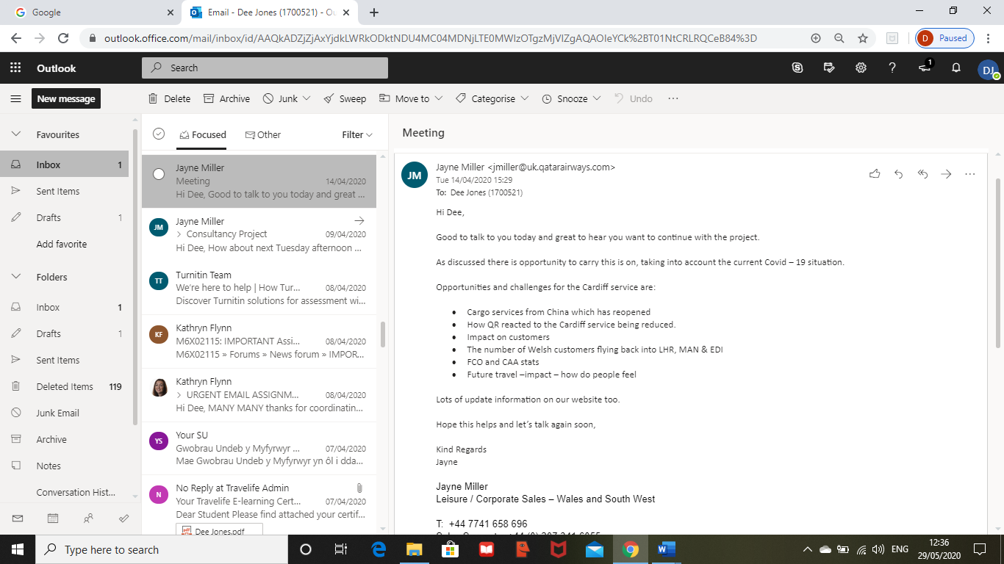
Appendix 1- Screen shot of Jayne’s email approving the project to be continued throughout Covid-19.

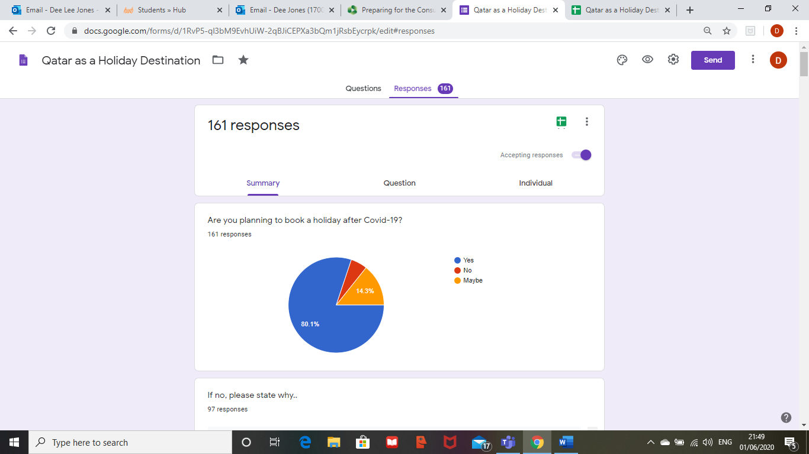
Appendix 2- Question 1 of the Questionnaire

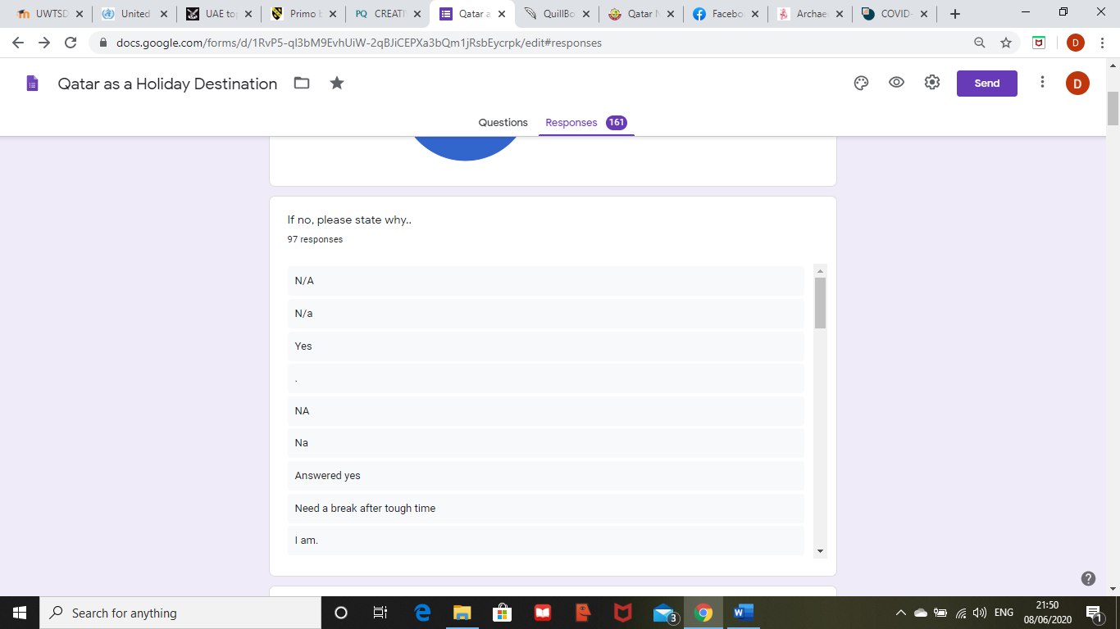
Appendix 3- Question 2 of the Questionnaire

Appendix 4- Question 3 of the Questionnaire
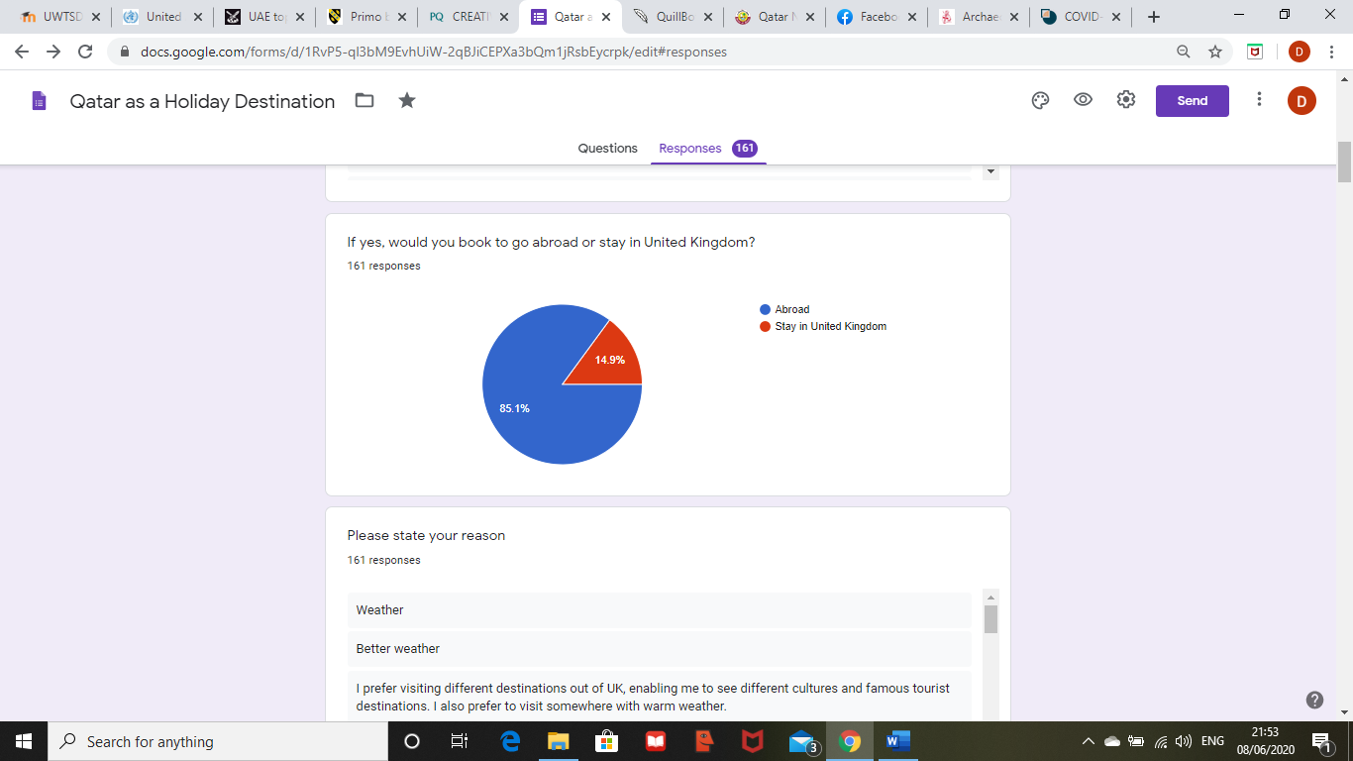

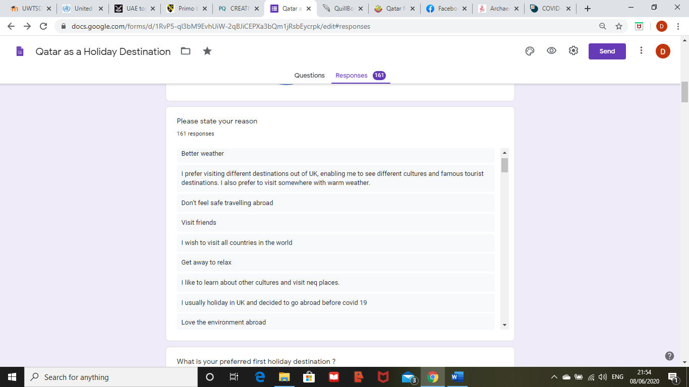
Appendix 5- Question 4 of the Questionnaire

Appendix 6- Question 5 of the Questionnaire
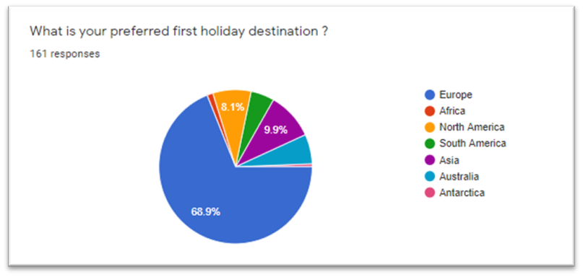
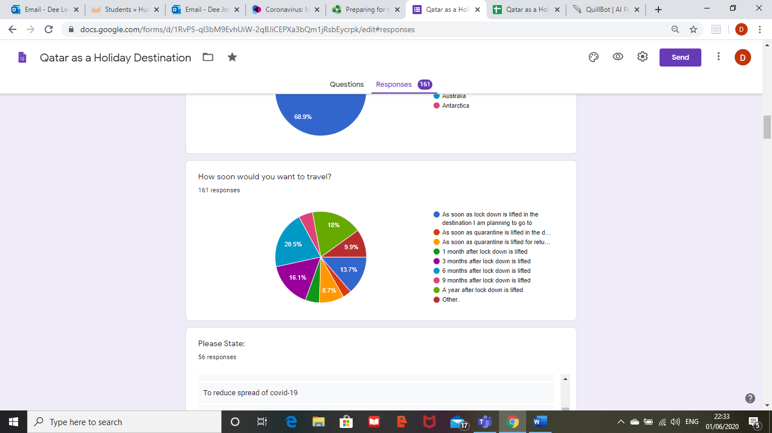
Appendix 7- Question 6 of the Questionnaire

Appendix 8- Question 7 of the Questionnaire
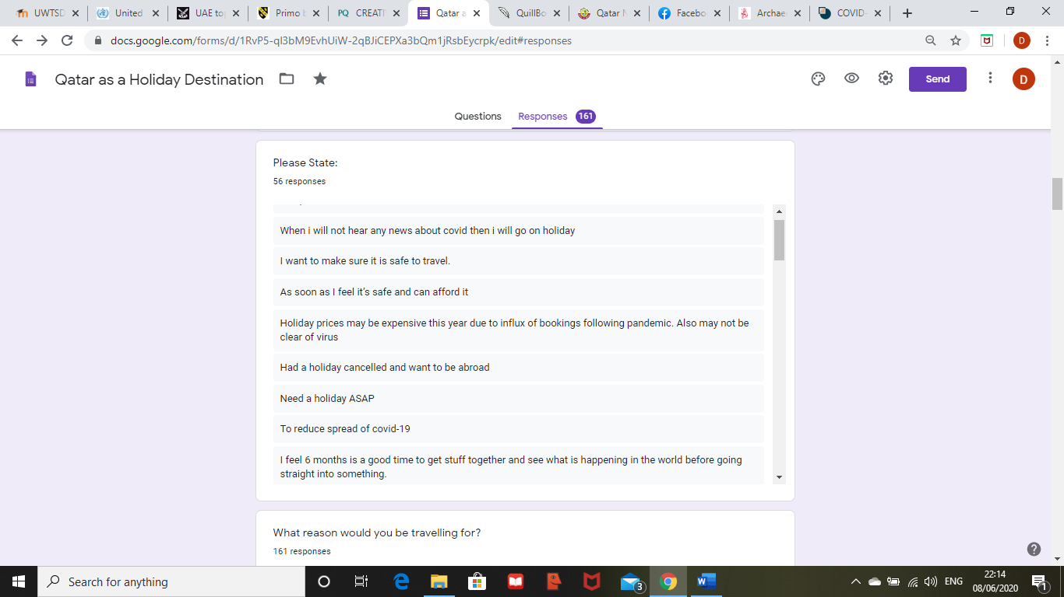
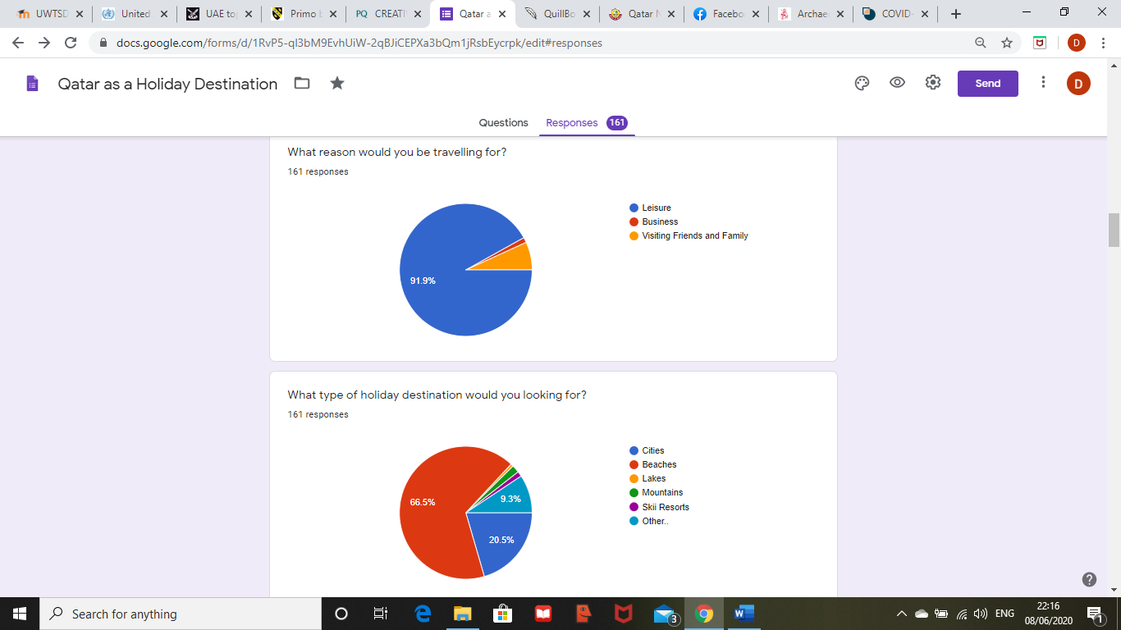
Appendix 9- Question 8 & 9 of the Questionnaire

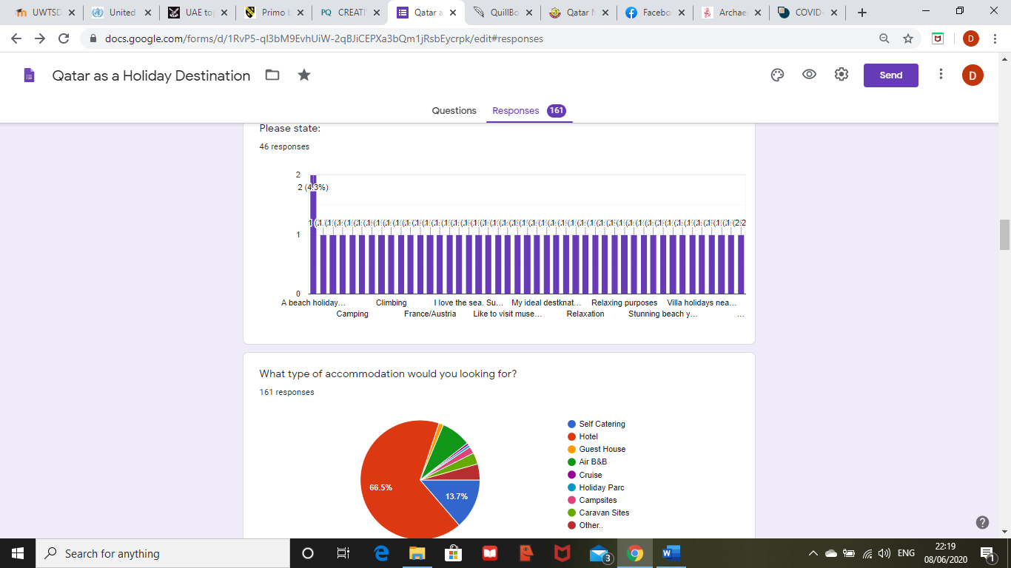
Appendix 10- Question 10 & 11 of the Questionnaire

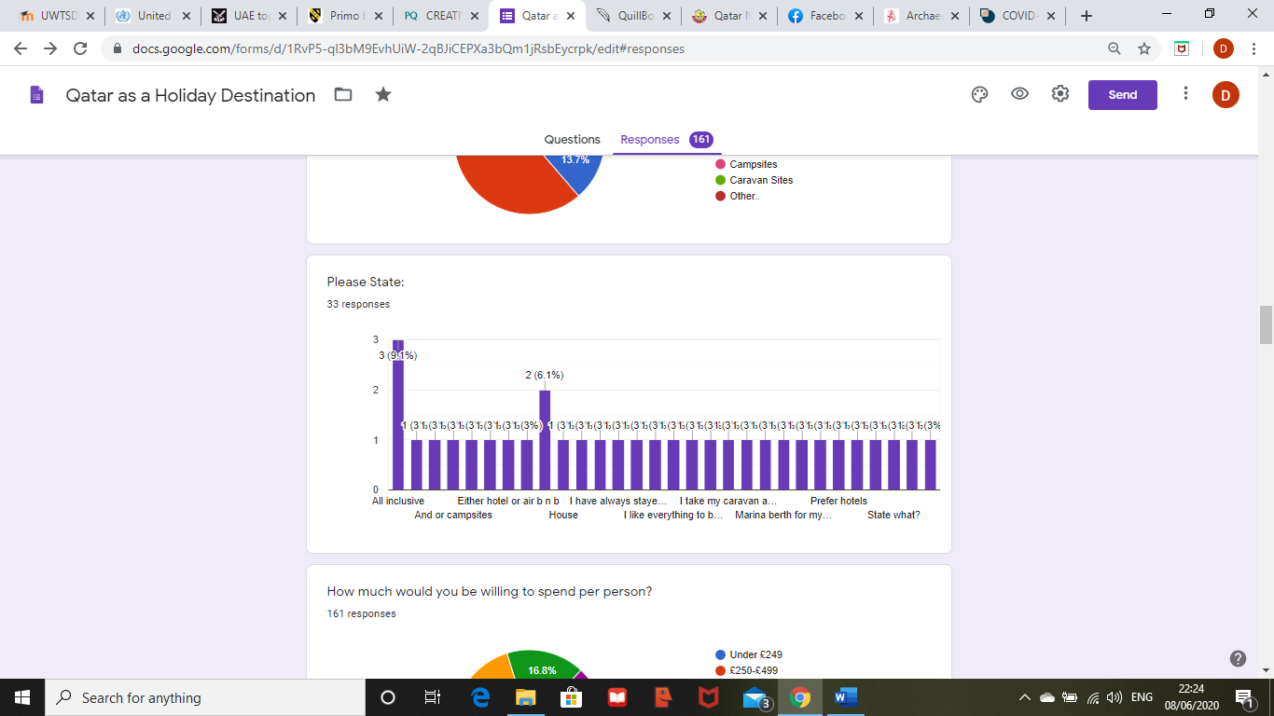
Appendix 11- Question 12 of the Questionnaire

Appendix 12- Question 13 & 14 of the Questionnaire
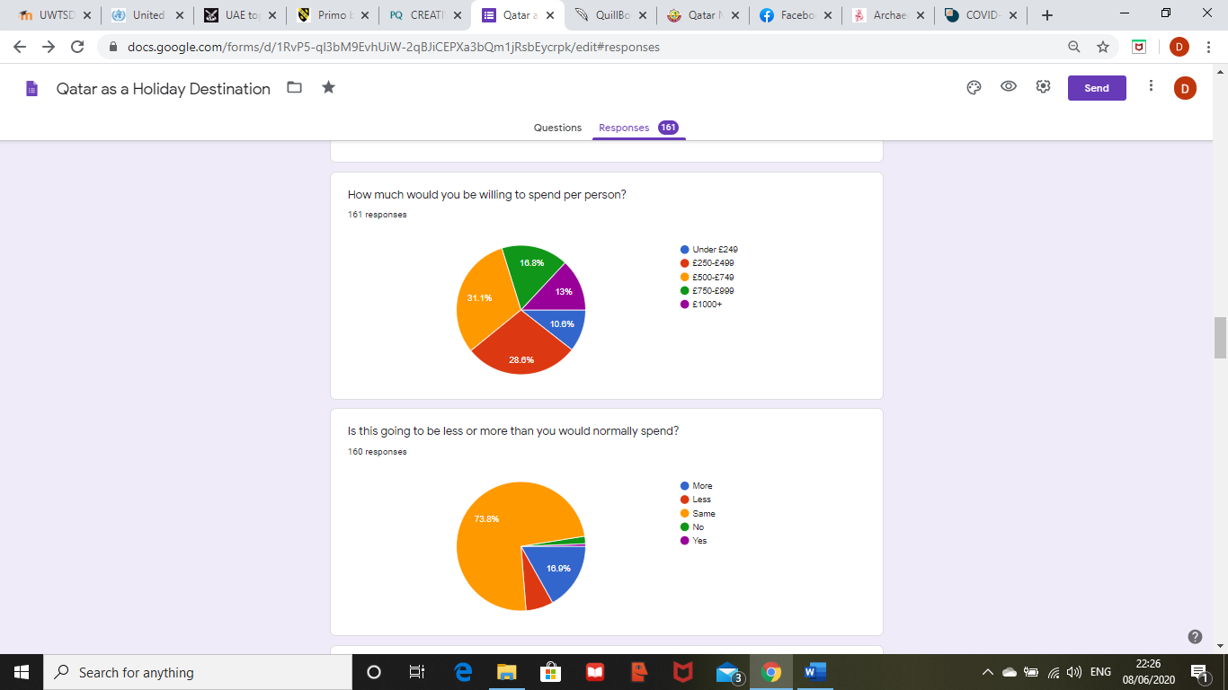
Appendix 13- Question 15 & 16 of the Questionnaire
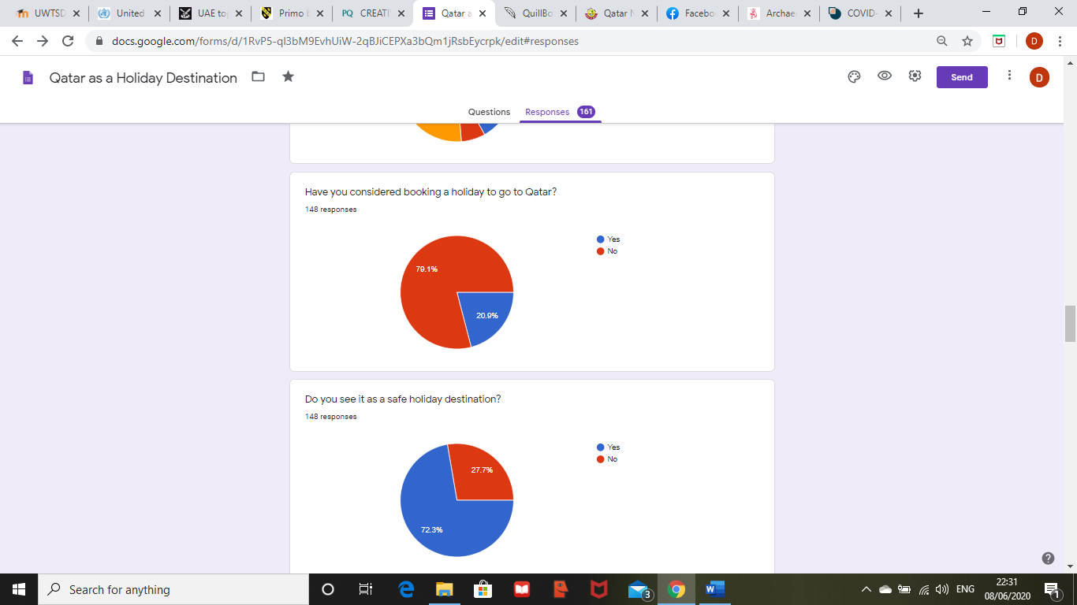
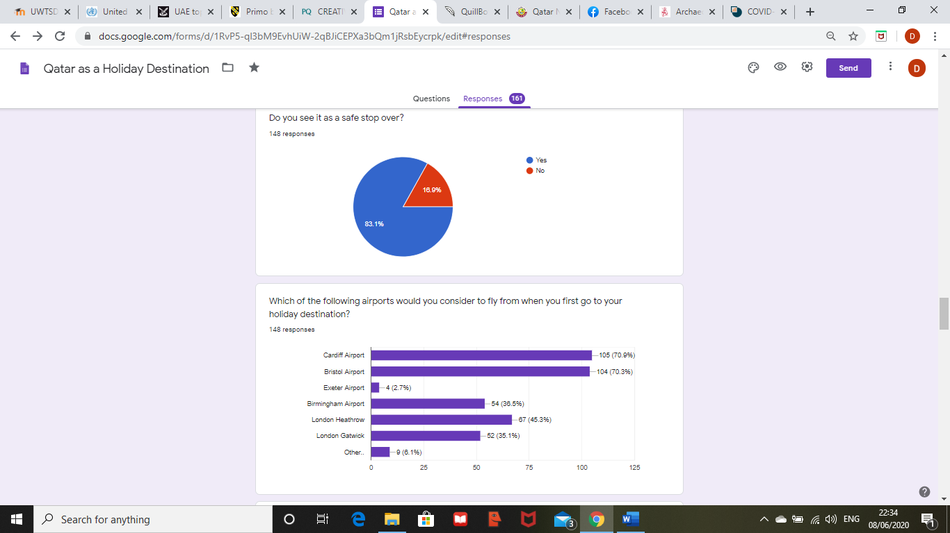
Appendix 14- Question 17 & 18 of the Questionnaire

Appendix 15- Questions 19 & 20 of the Questionnaire
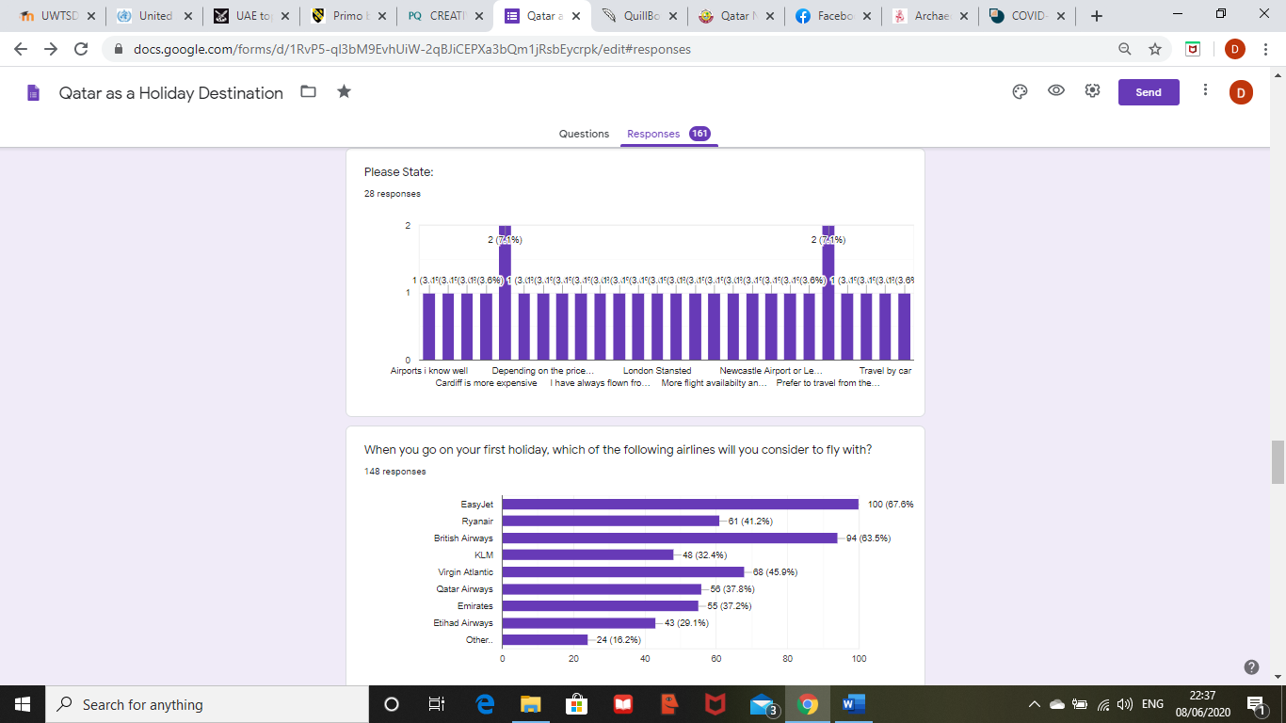
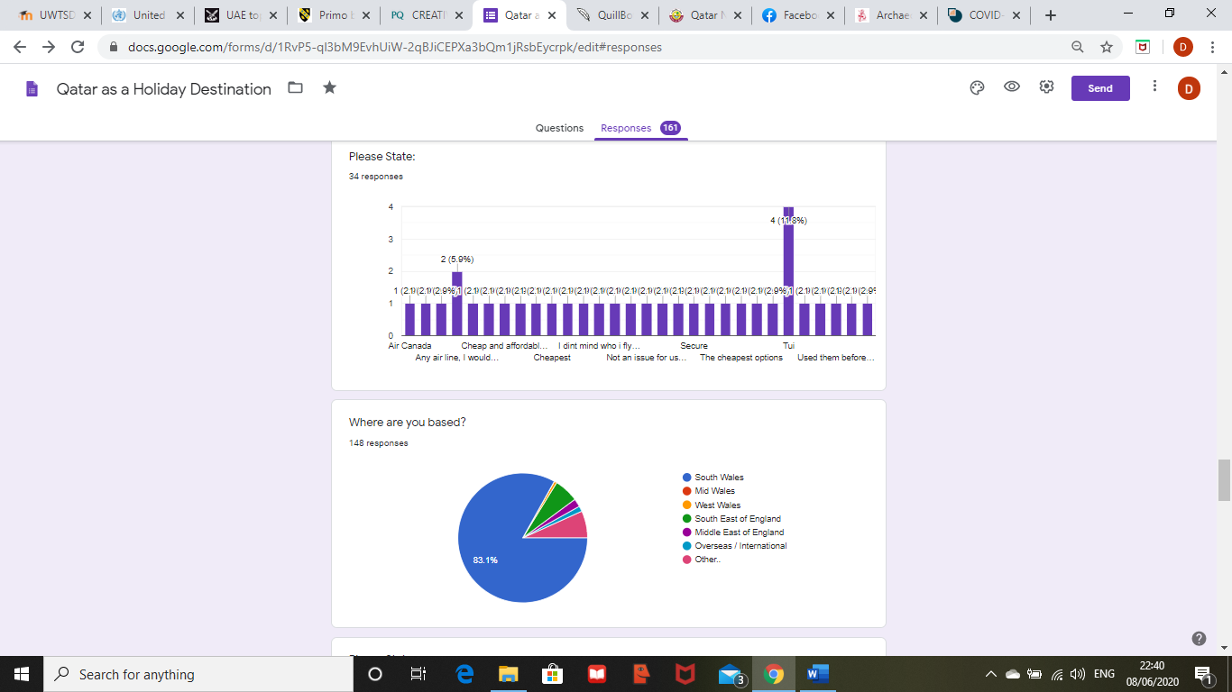
Appendix 16- Questions 21 & 22 of the Questionnaire

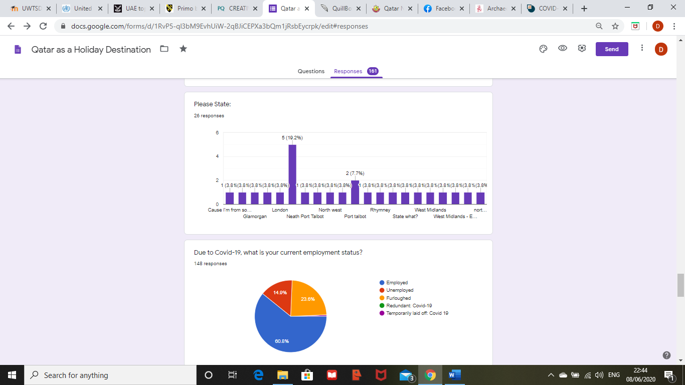
Appendix 17- Questions 23 & 24 of the Questionnaire
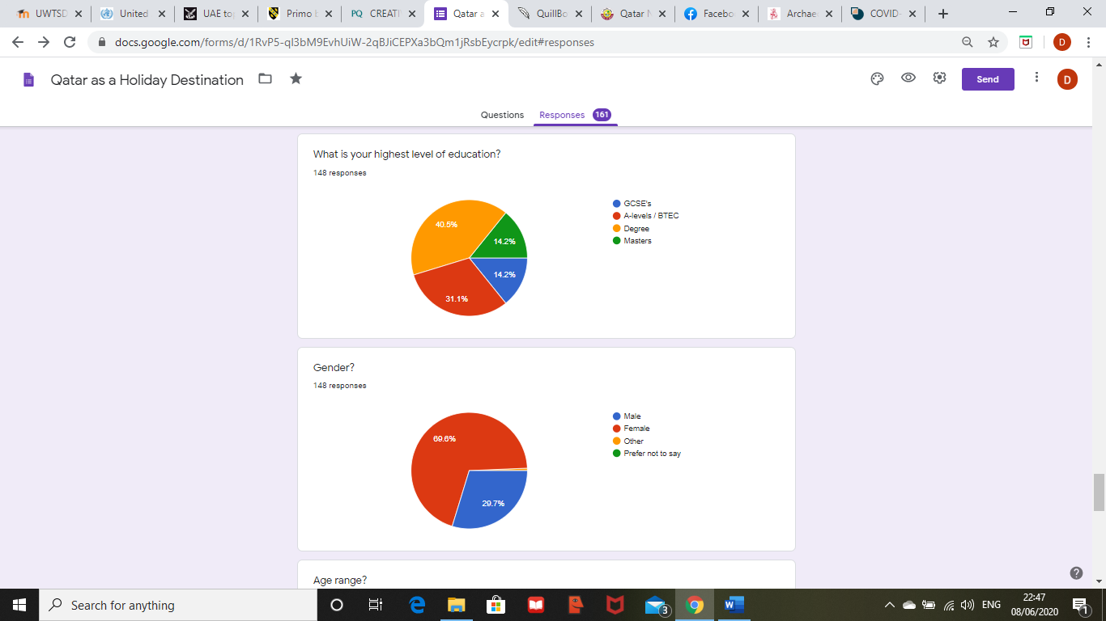
Appendix 18- Question 25 & 26 of the Questionnaire

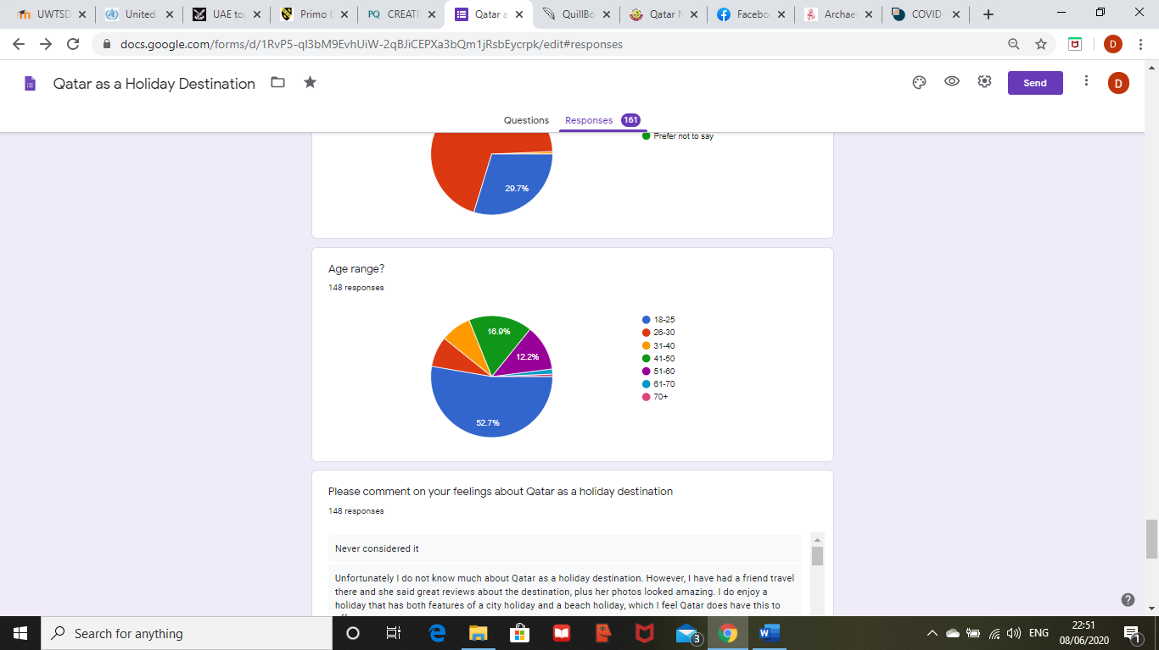
Appendix 19- Question 27 in the Questionnaire

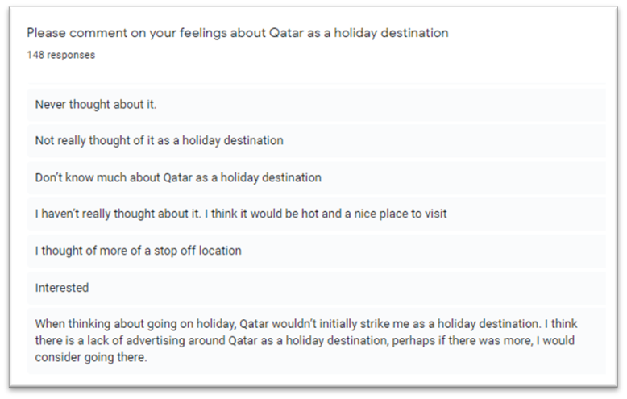
Appendix 20- Question 28 in the Questionnaire

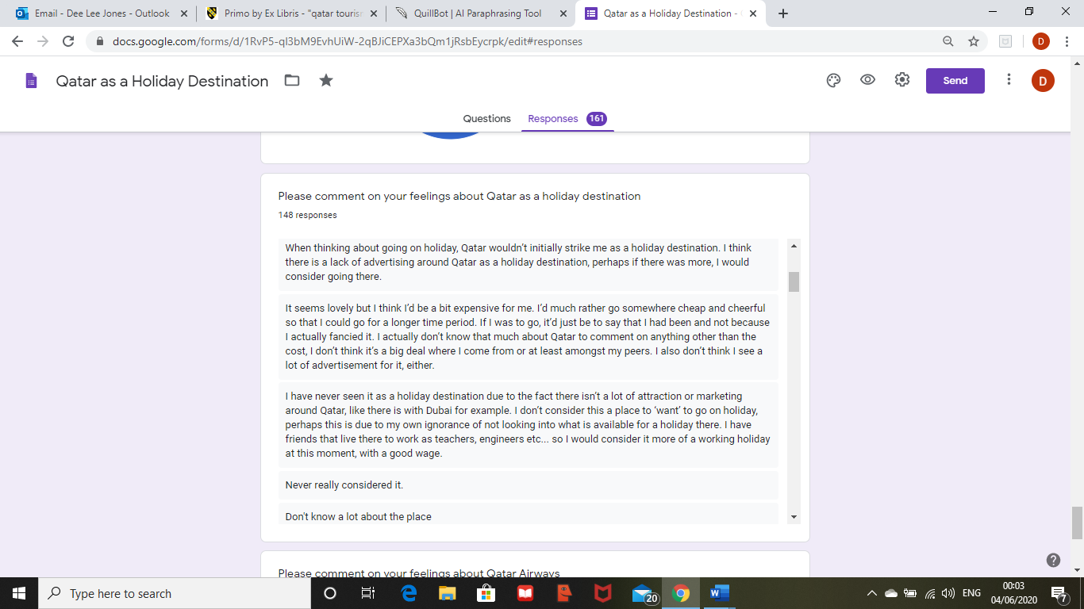
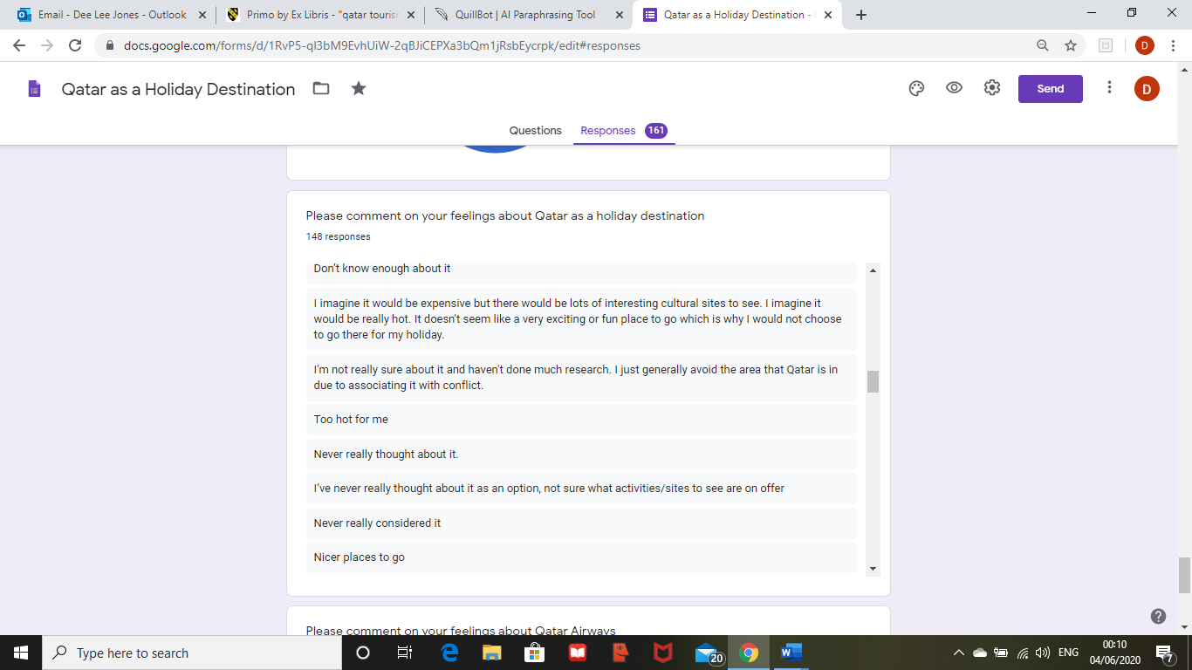

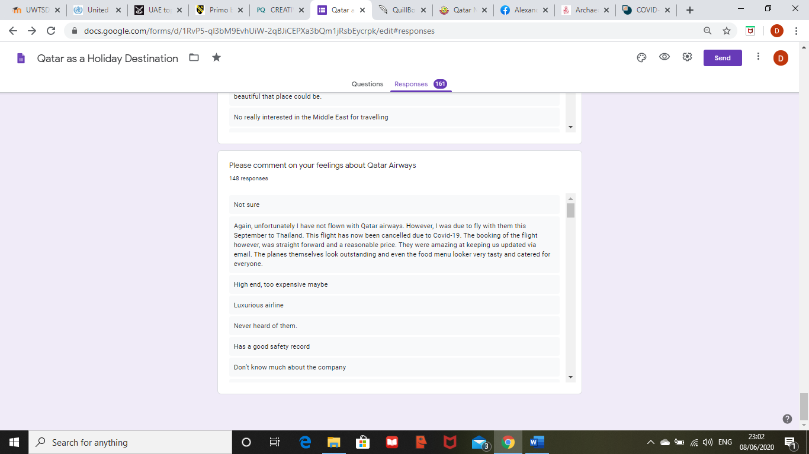
Appendix 21- Question 29 of the Questionnaire
Appendix 22- SWOT Analysis
STRENGTHS  - World’s best Airline – Only carrier to win 5 times ‘Airline of the Year’  - Only major airport in Wales  - Preserved a Skytrax five-star ranking since 2004 (Oneworld.com, 2020).  - Qatar National Museum, Cultural Village Retail Quarter and the Qatar International Food Festival’s milestone 10th Anniversary Edition = different types of tourism  - “Taking Wales to the World” (Welsh Government, 2019) | WEAKNESSES  - Lack of awareness of routes available  - Location of Cardiff Airport  - Lack of traveller’s post COVID-19
OPPORTUNTIES  - Connections to over 170 countries  - Short-break holiday destination  - “Taking Wales to the World” (Welsh Government, 2019)  - More marketing on social media platform, for example, Instagram. | THREATS  - Other airlines as competitors  - Other airports as competitors  - COVID-19  - Western cultural practices

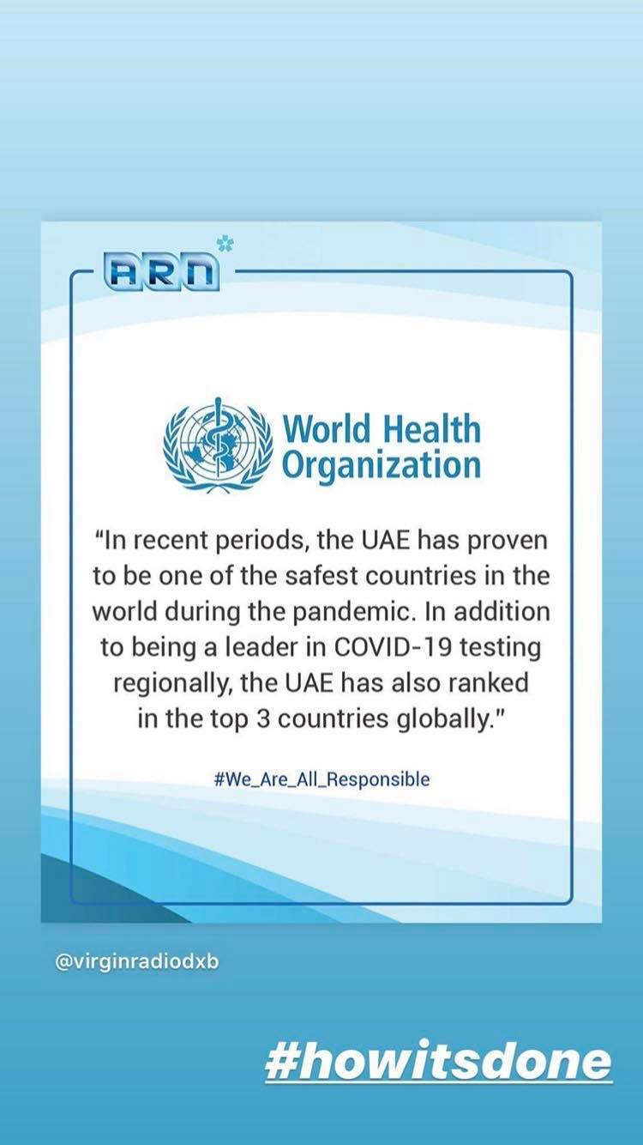
Appendix 23- WHO Statement


Appendix 24- Instagram Account of Famous Influencers


