Network Operating Systems and Services
Configure and Manage a Virtualised Network
Matthew Hatherly (2306287)
2306287@student.uwtsd.ac.uk

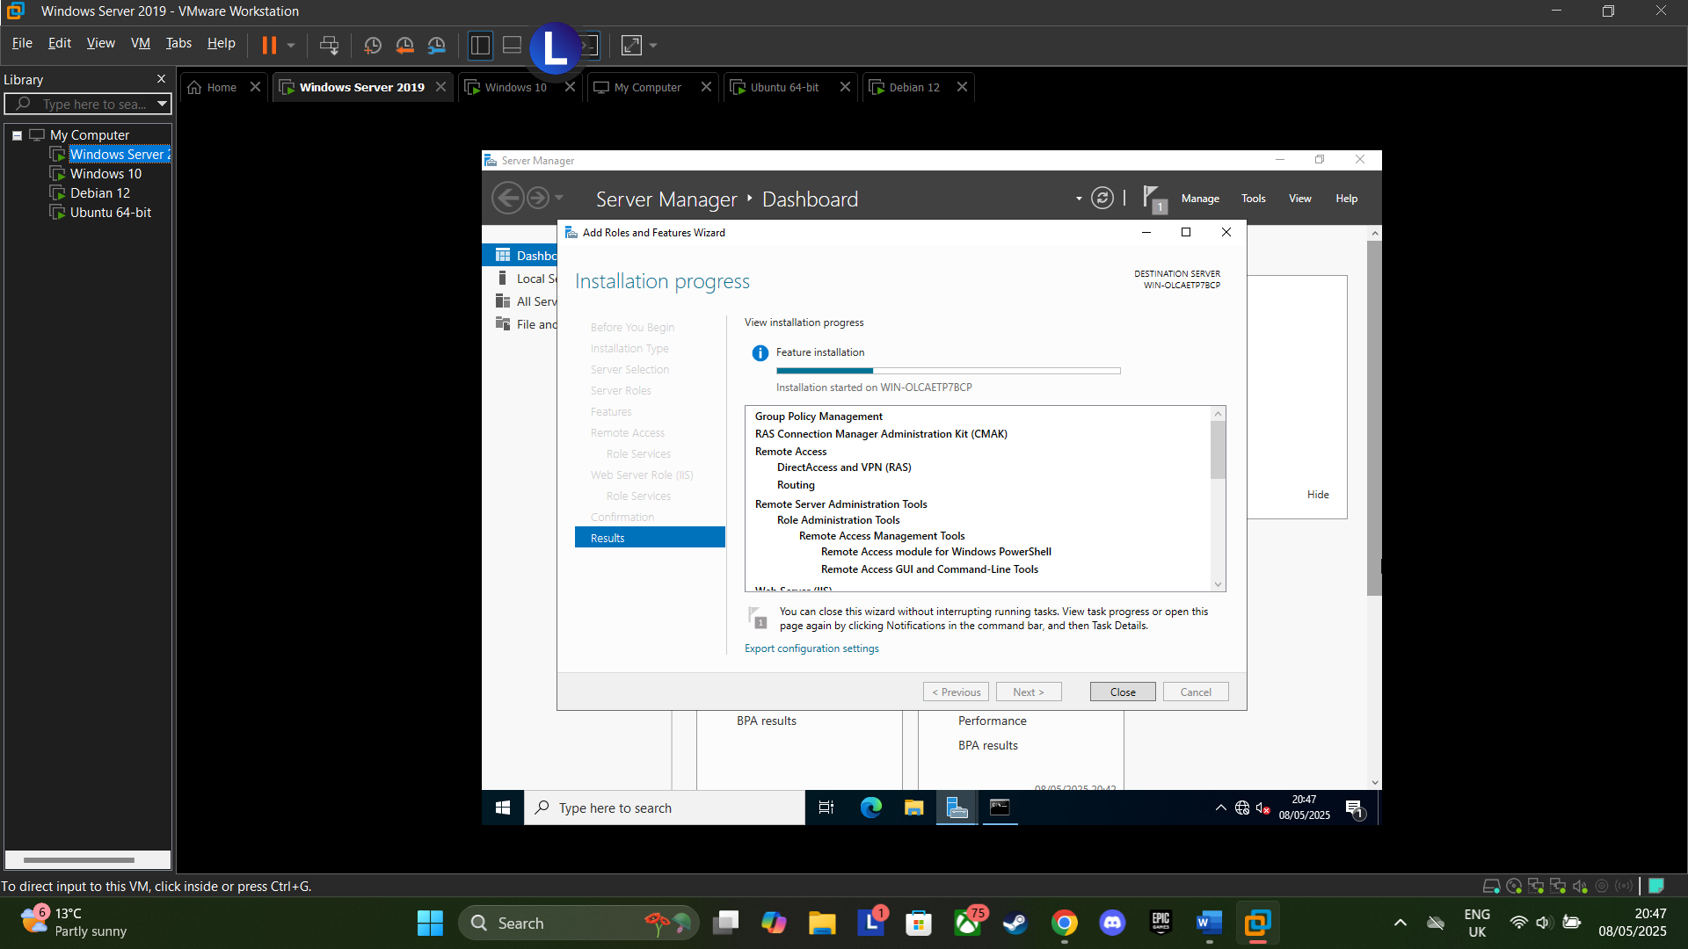
Figure 1: Install RRAS
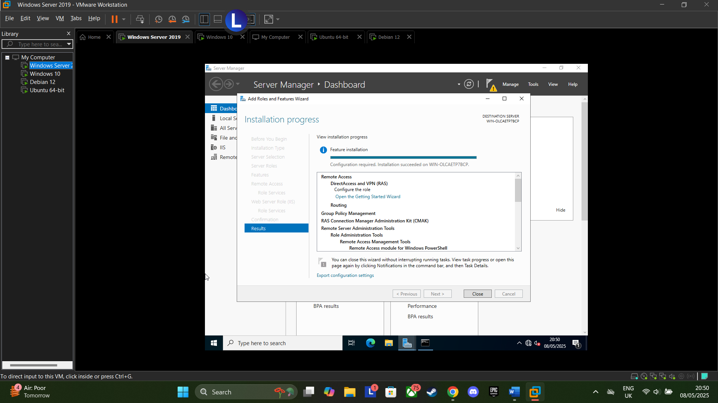
Figure 2: RRAS Finalise Install
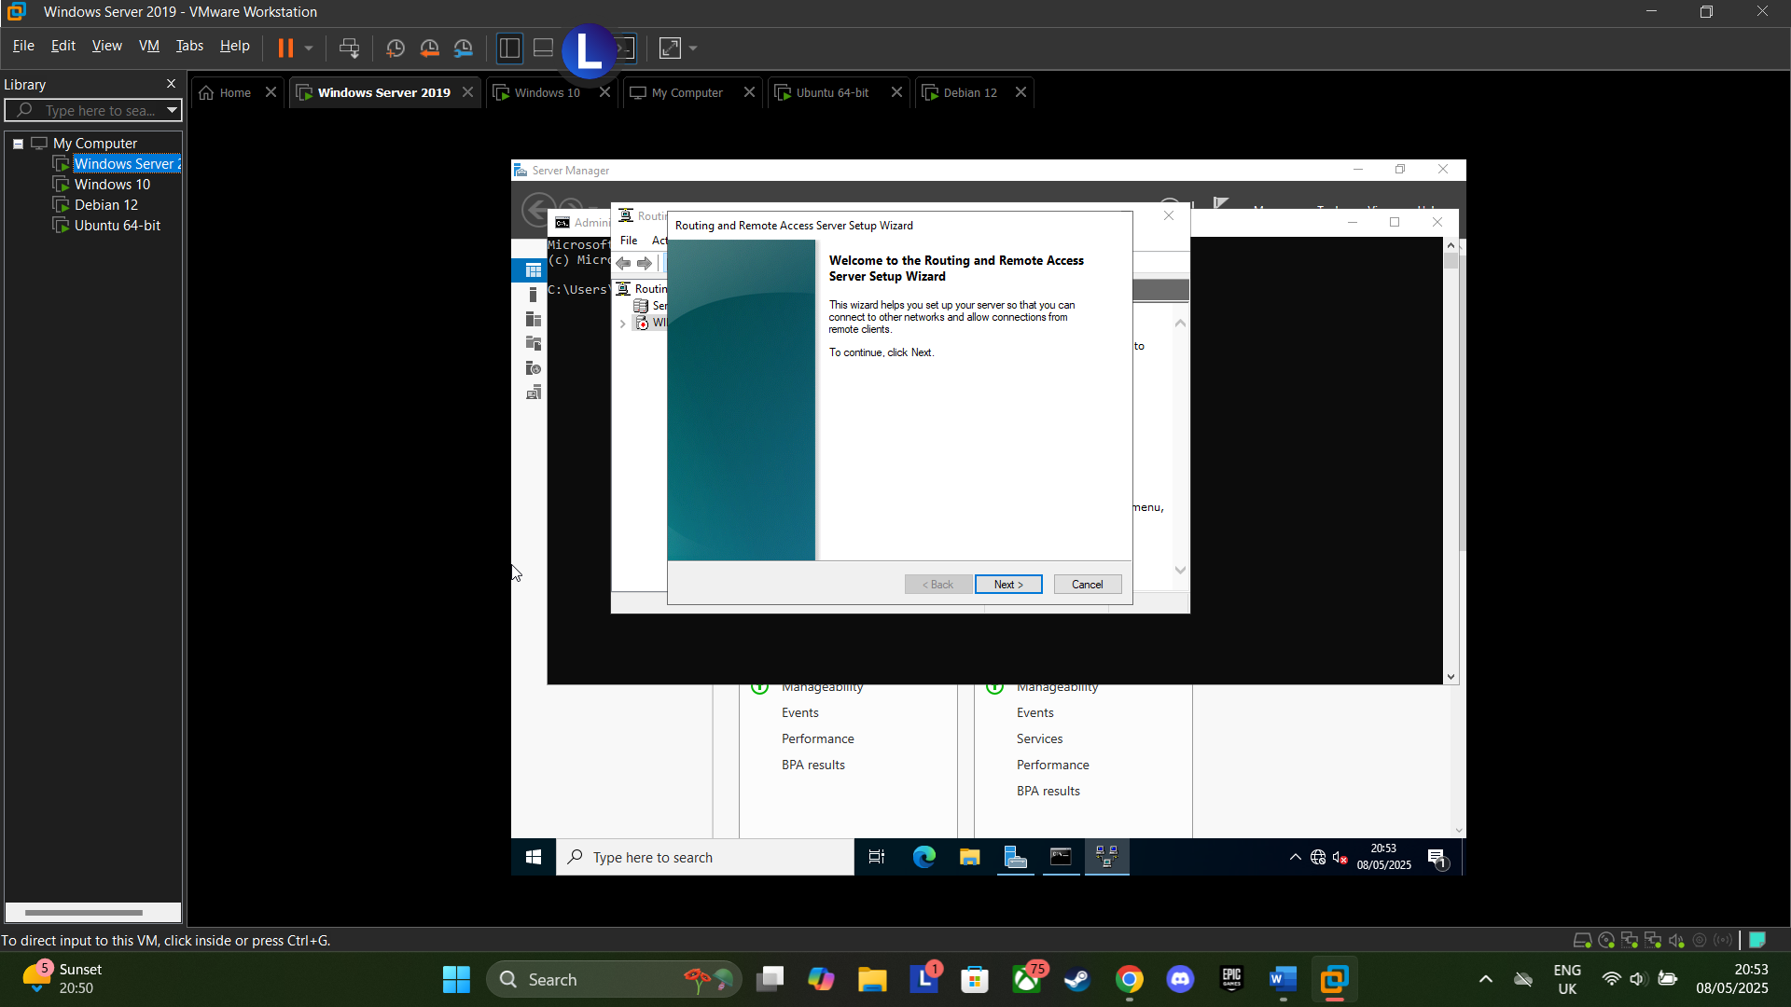
Figure 3: RRAS Setup
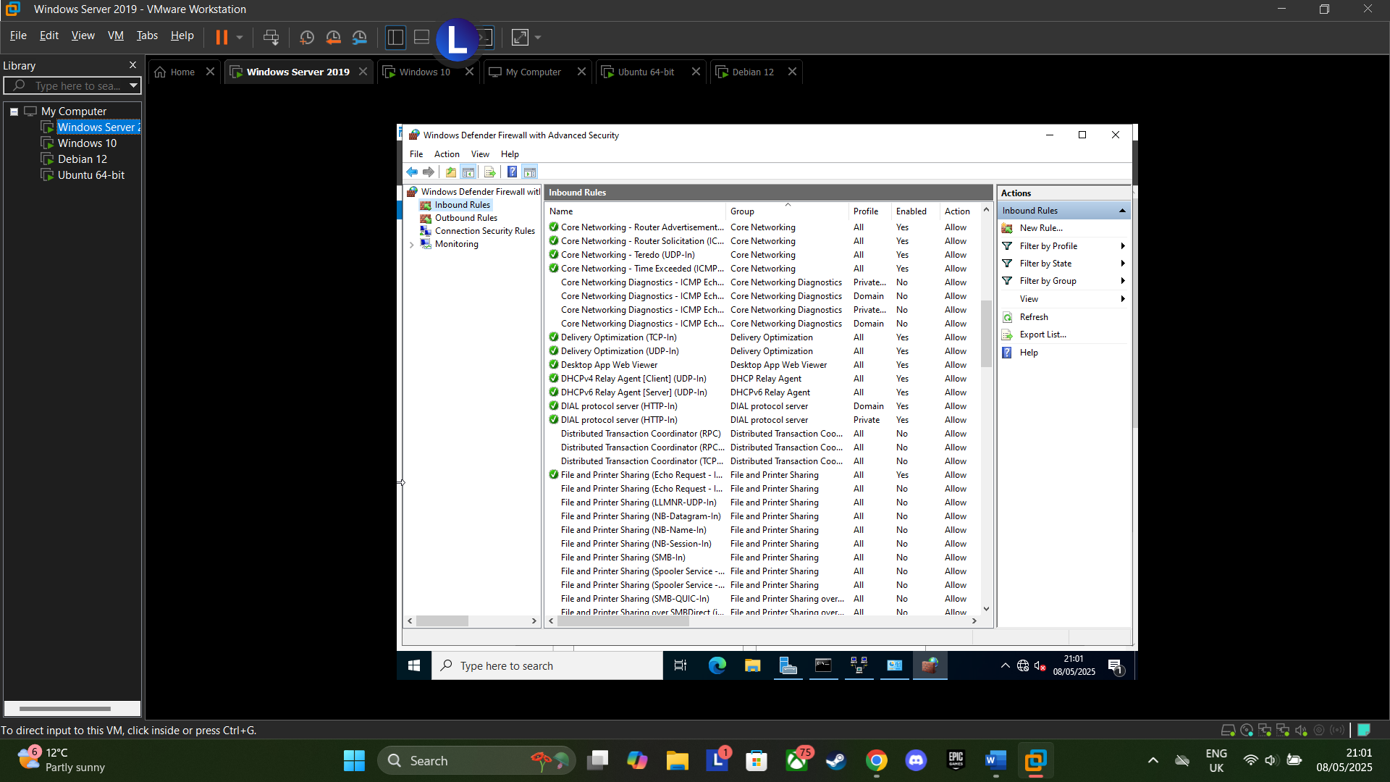
Figure 4: Configure Inbound Rules
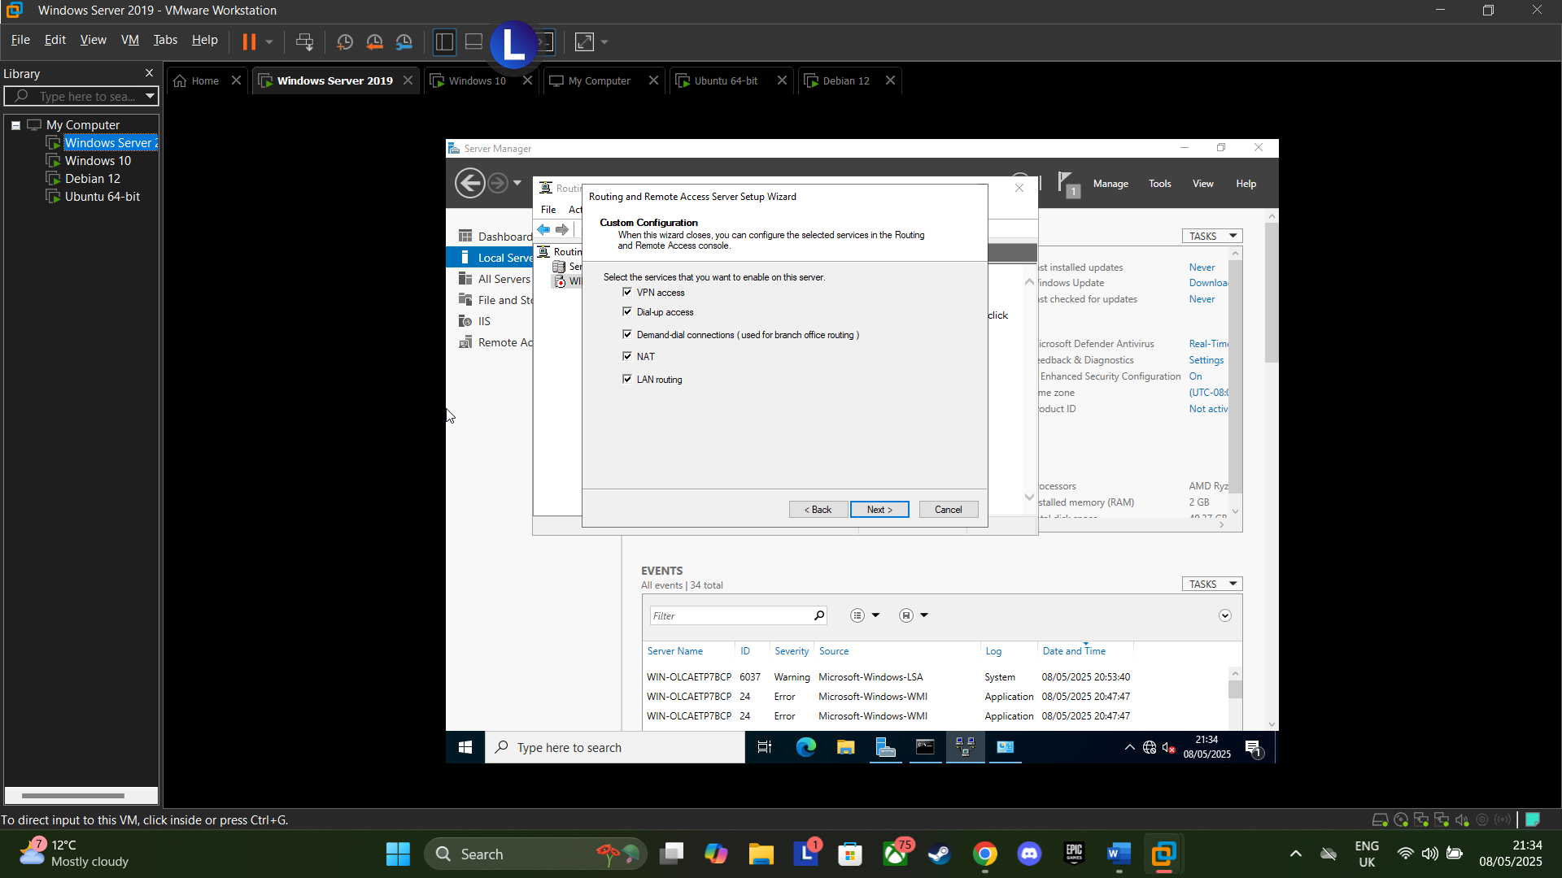
Figure 5: RRAS Config. Enabled everything just to cover all possible eventualities
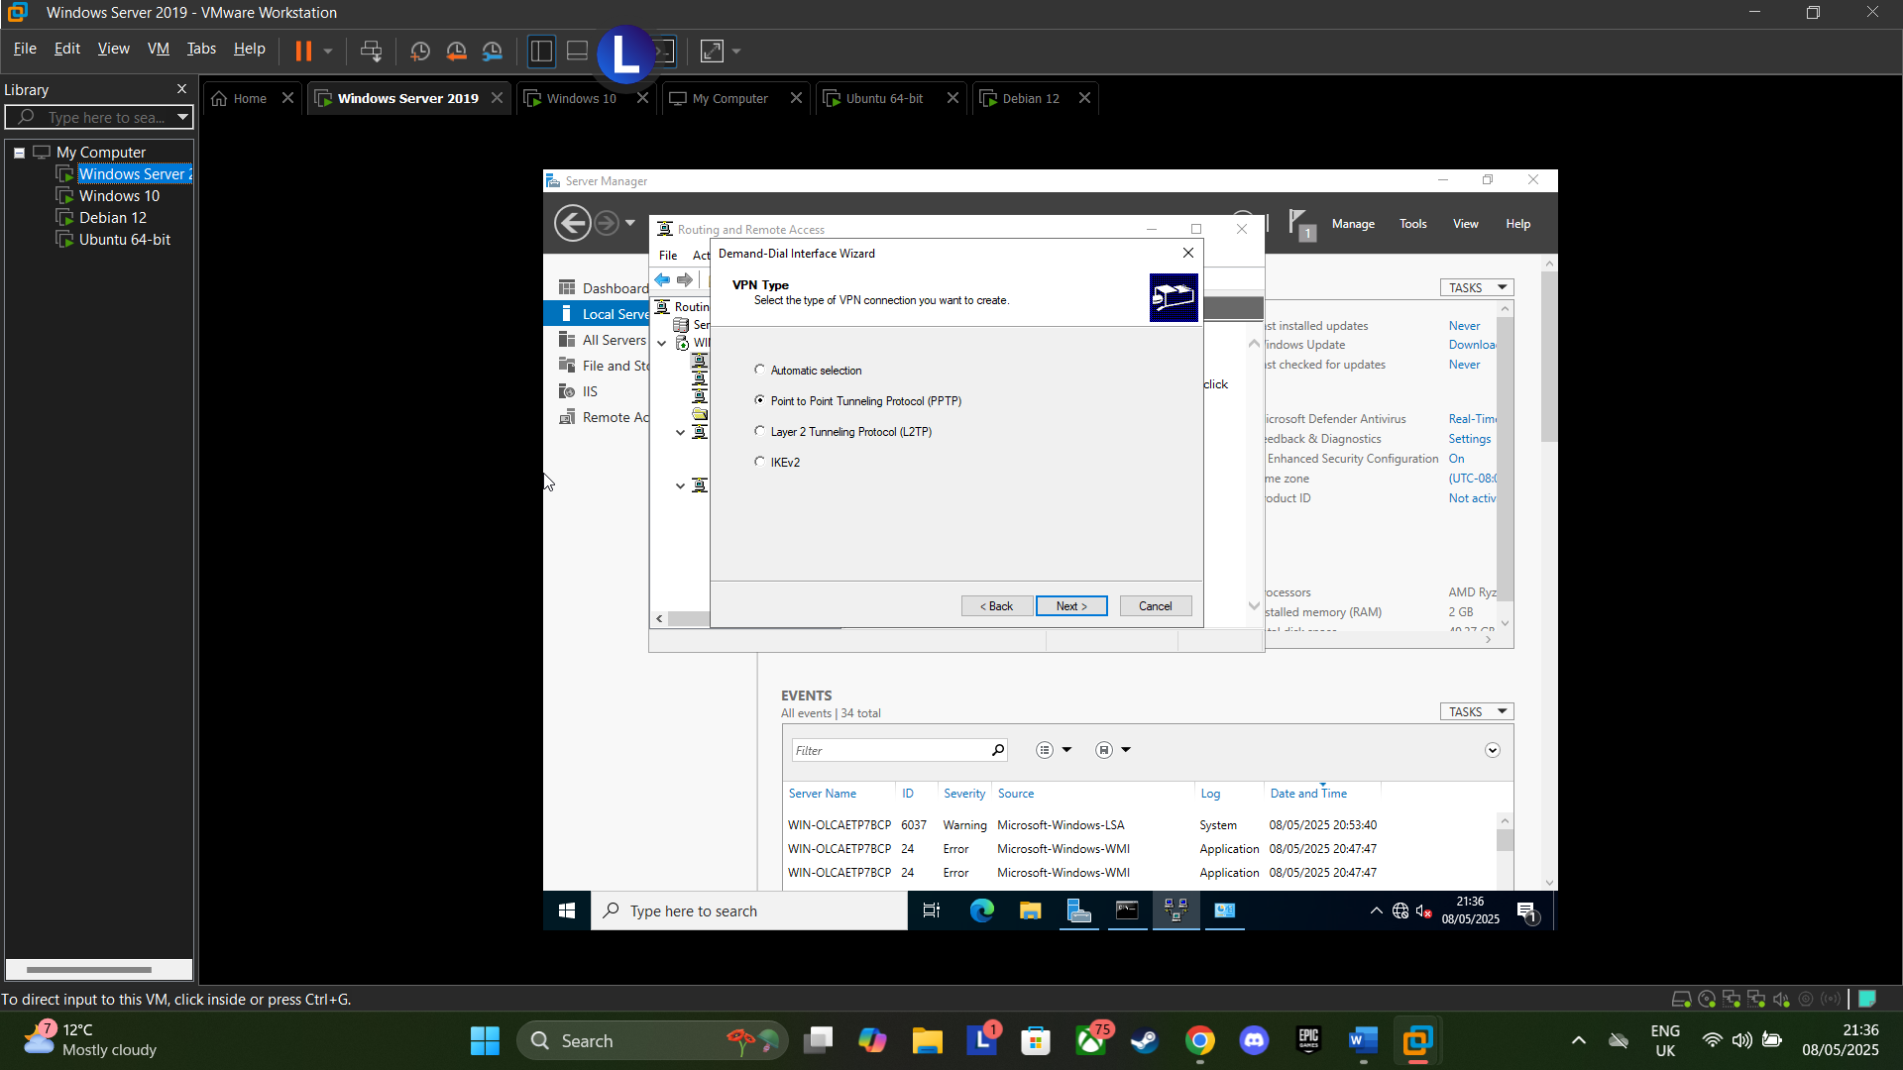
Figure 6: Demand-Dial Interface Wizard. Selected Point to Point Tunnelling Protocol due to speed and ease of setup
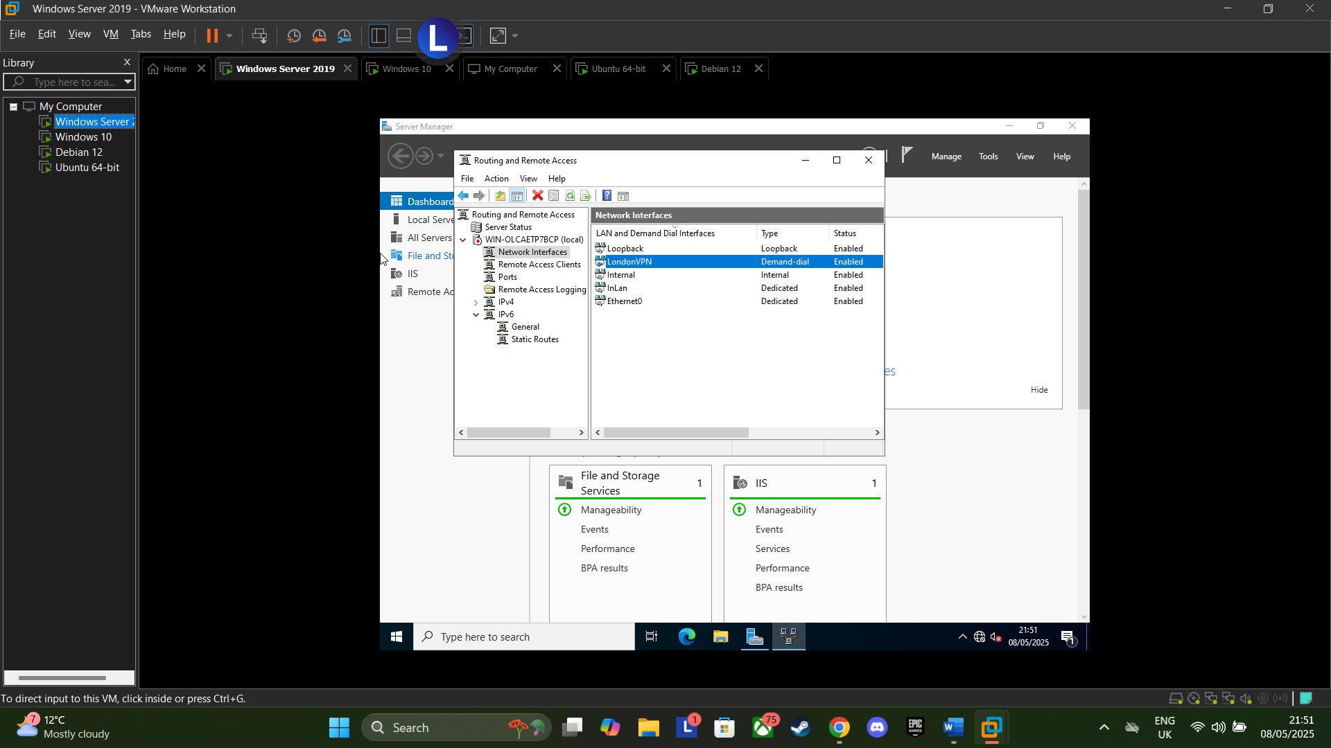
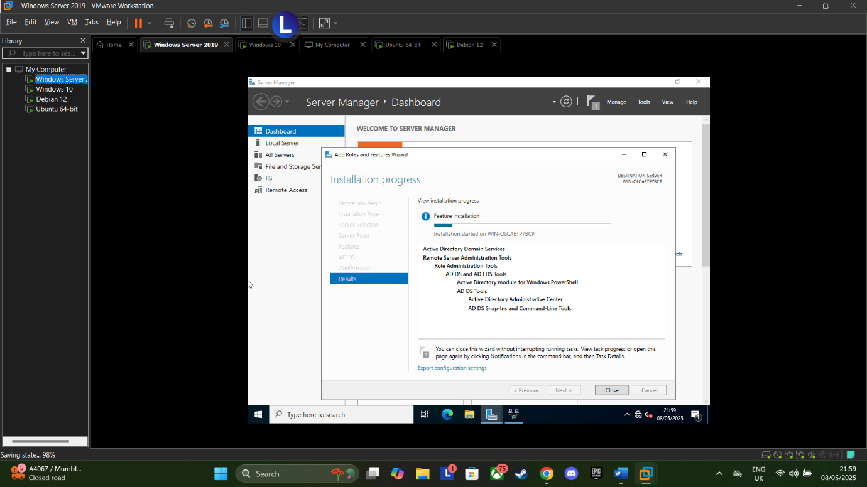
Figure 8: Routing to London VPN Demand-dial
Figure 7: Install Active Directory Domain Services
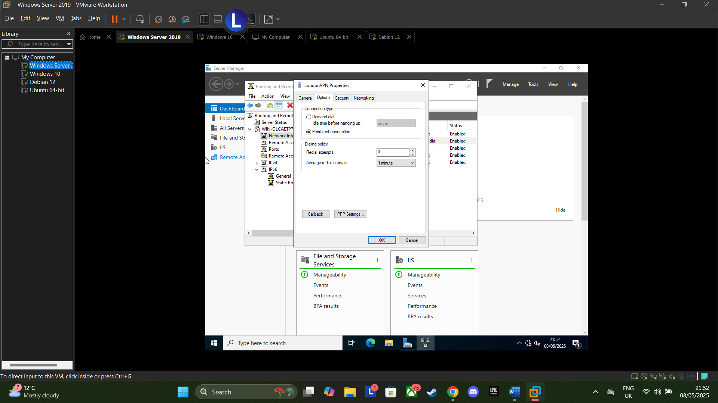
Figure 9: London VPN - selected Persistent Connection
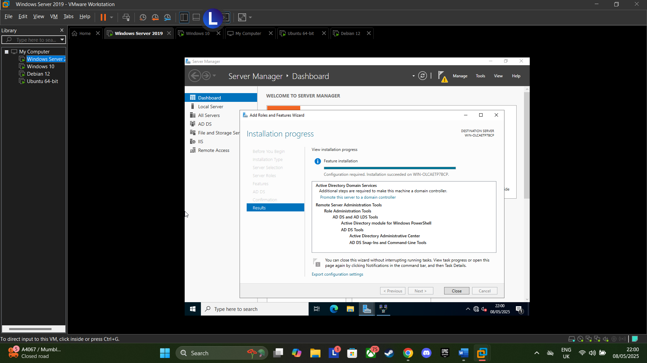
Figure 10: Installation Finalised
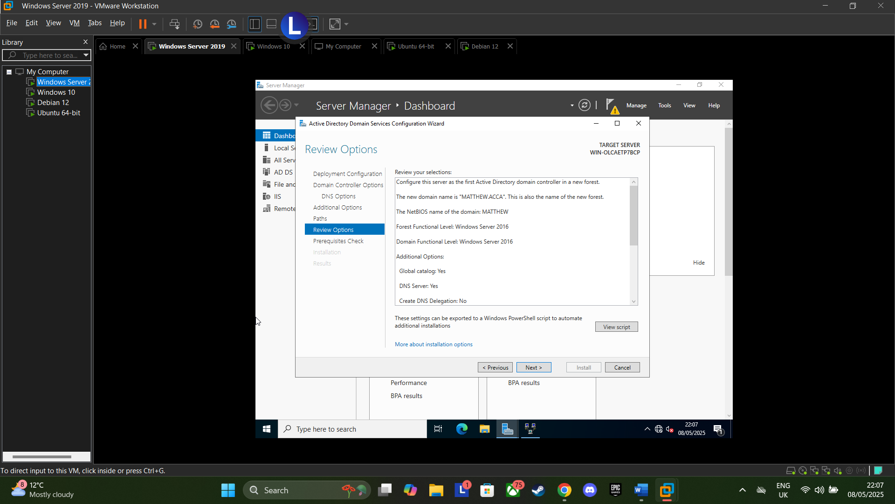
Figure 11: created forest with domain name MATTHEW.ACCA
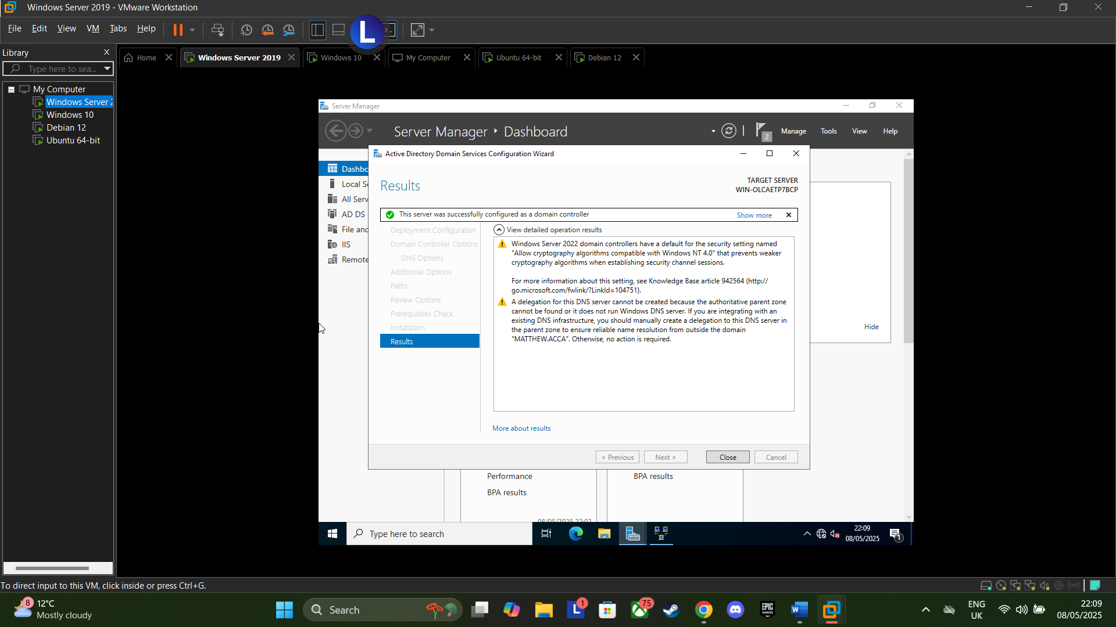
Figure 12: Successfully configured Windows server as domain controller
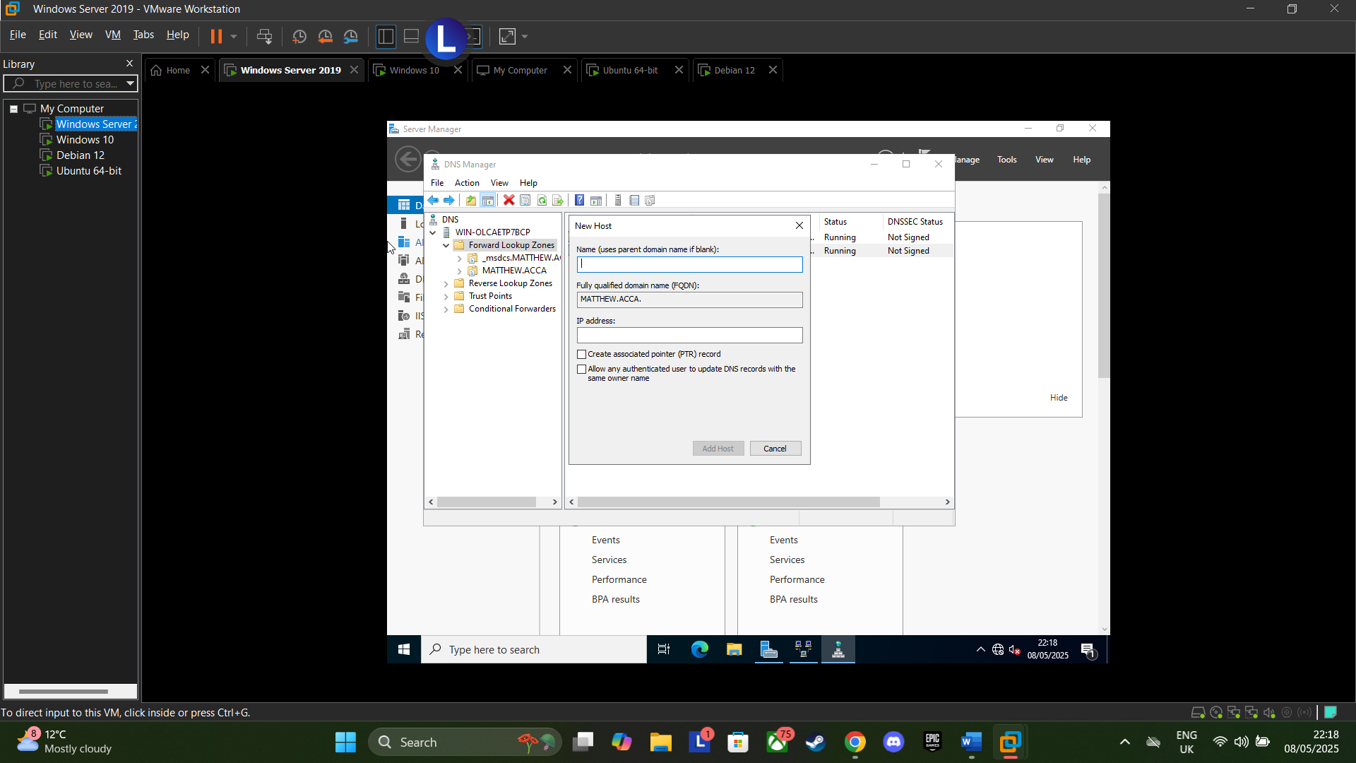
Figure 13: Displayed domain name
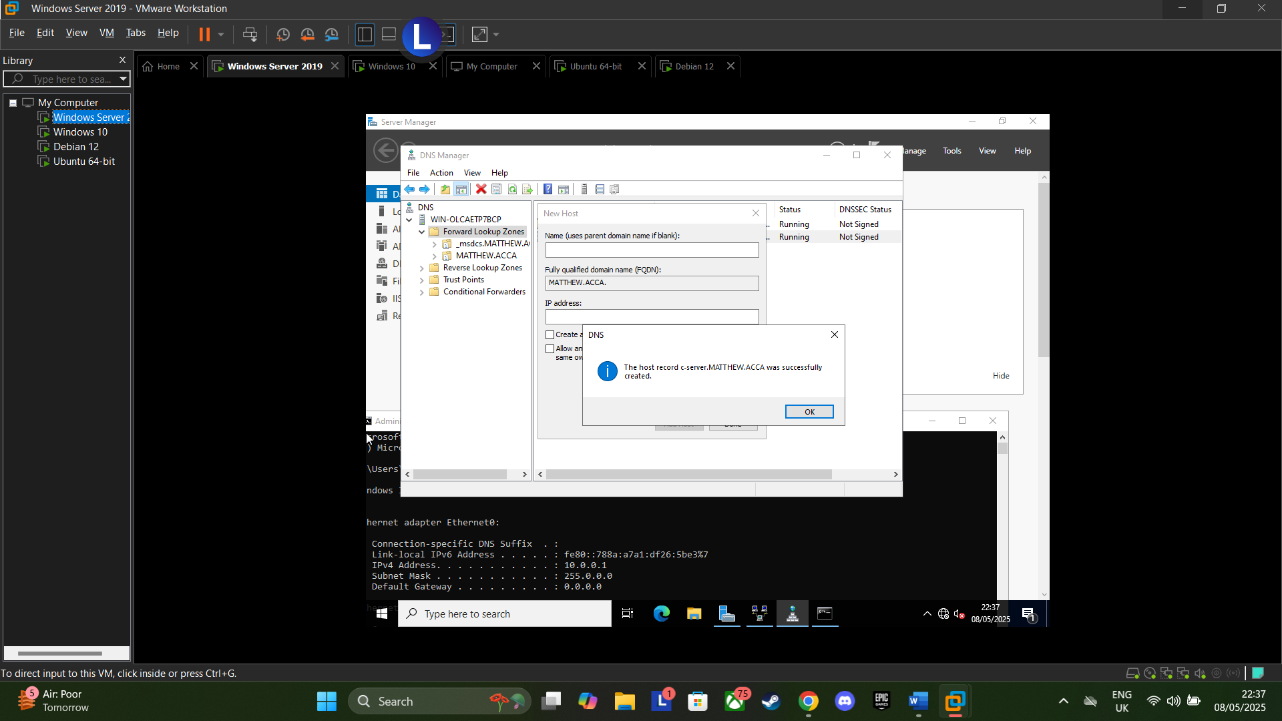
Figure 14: Successfully created host record
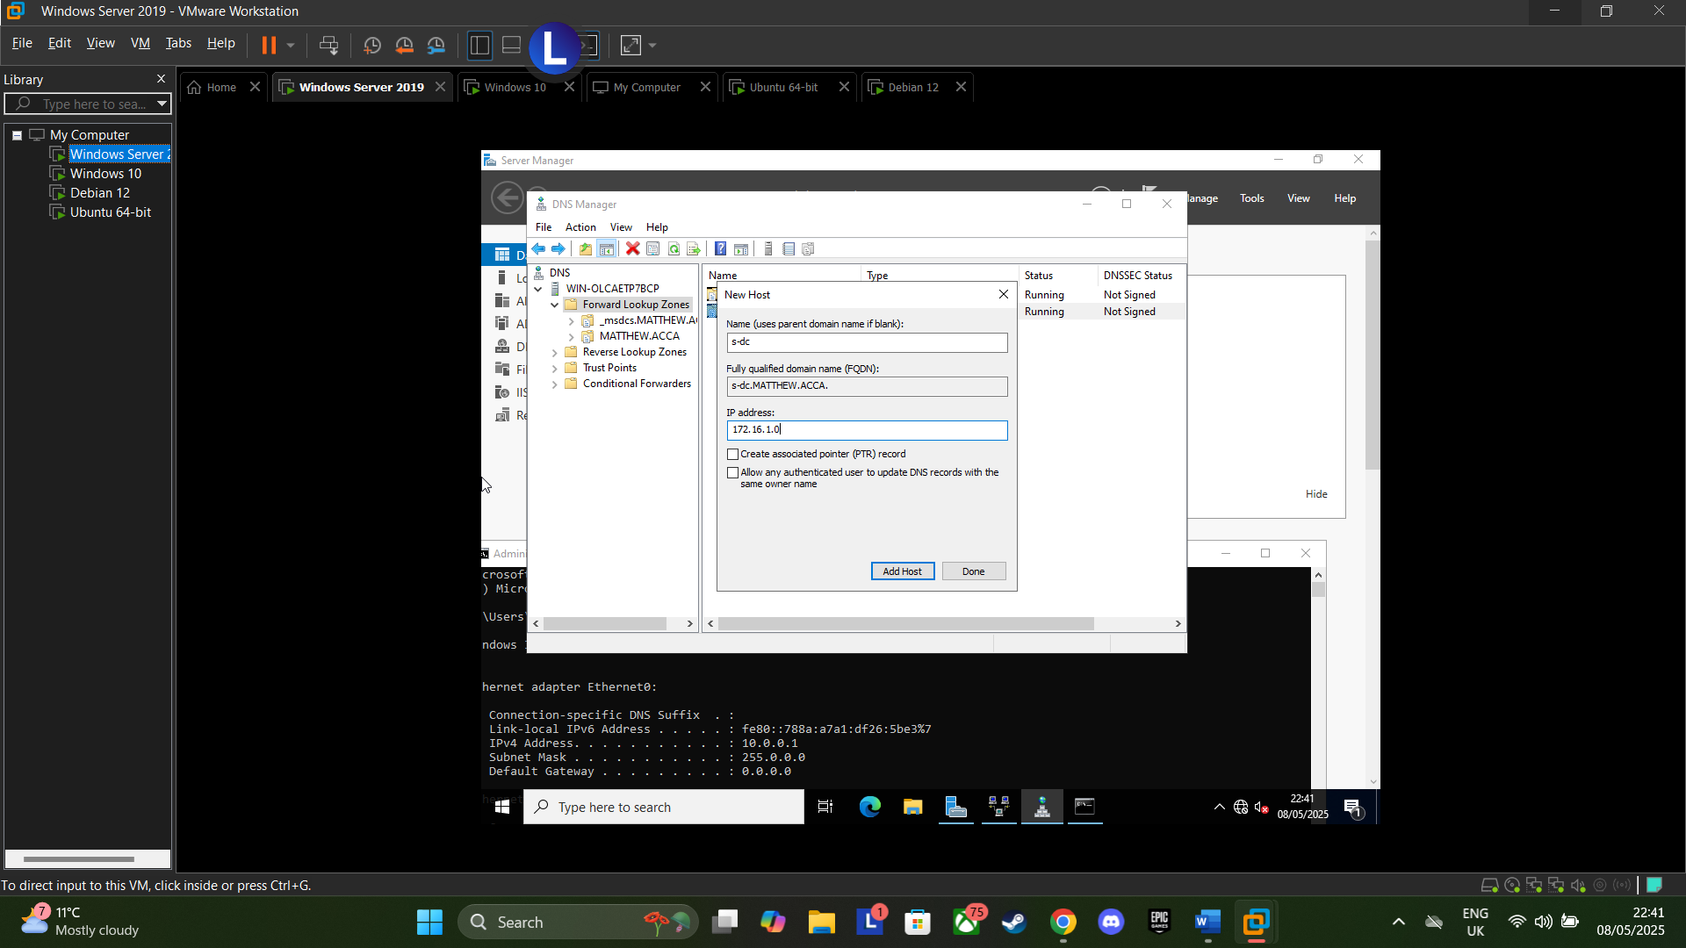
Figure 15: Created name and added IP address 172.16.1.0
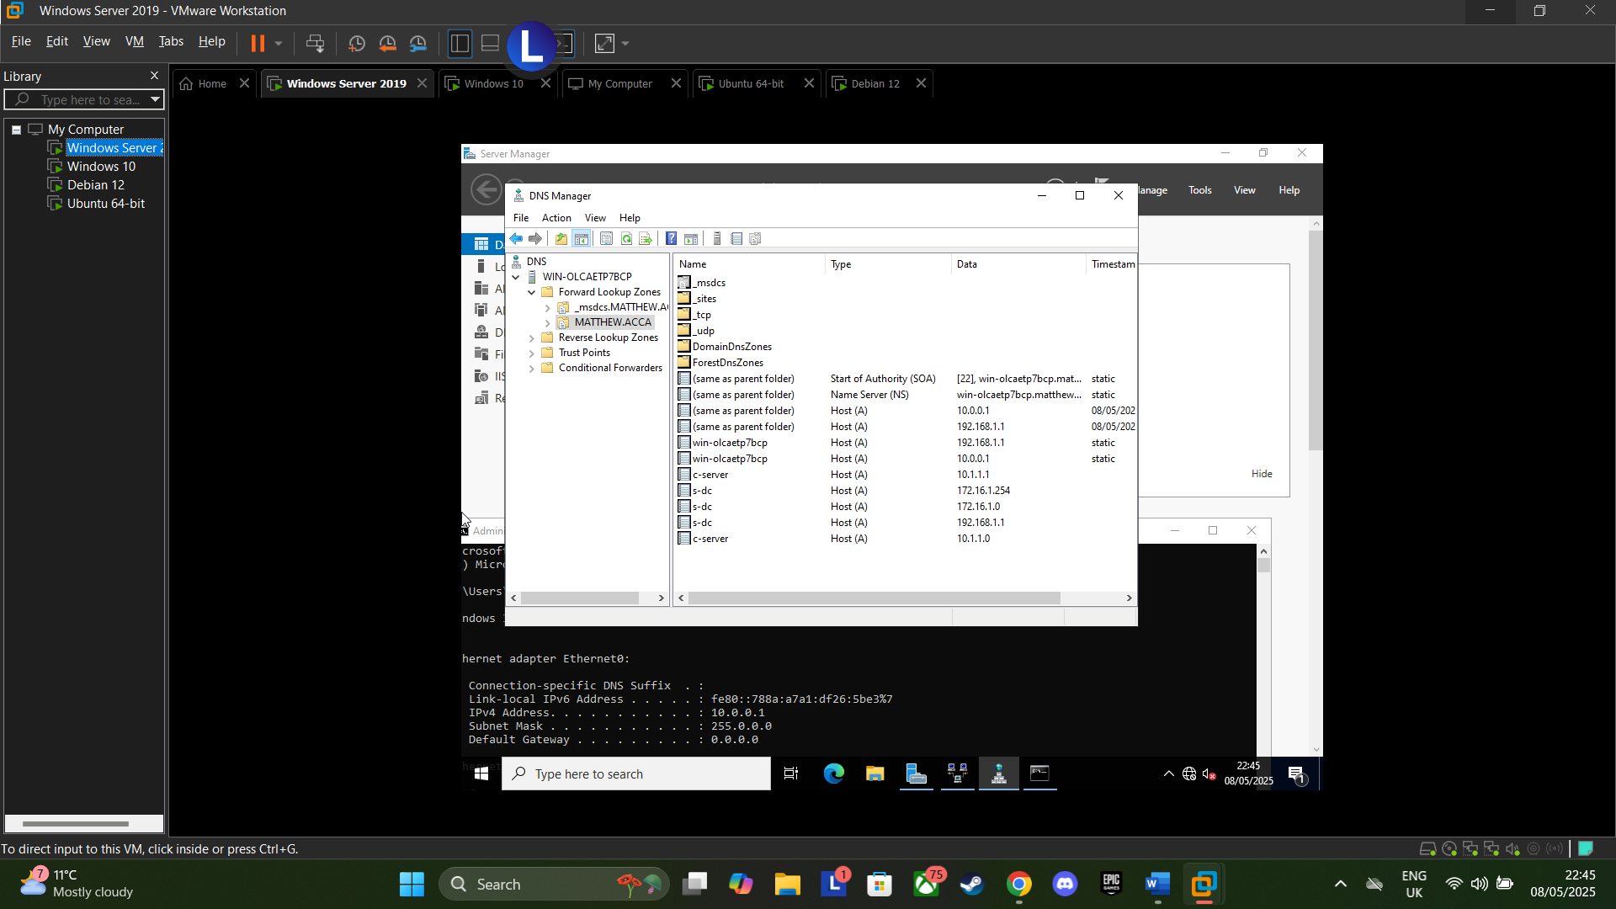
Figure 16: DNS Created

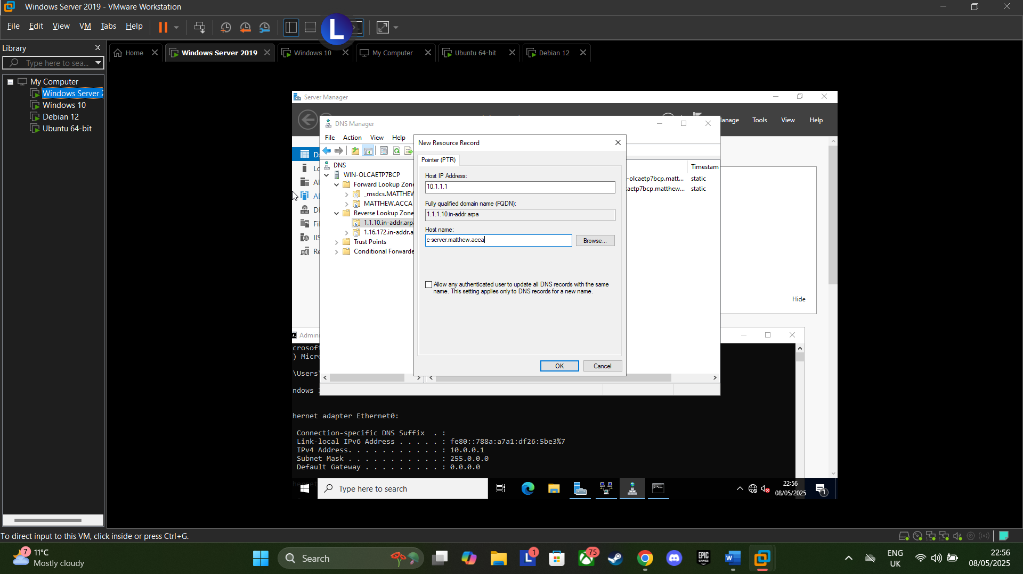
Figure 17: Creating Record for C-Server
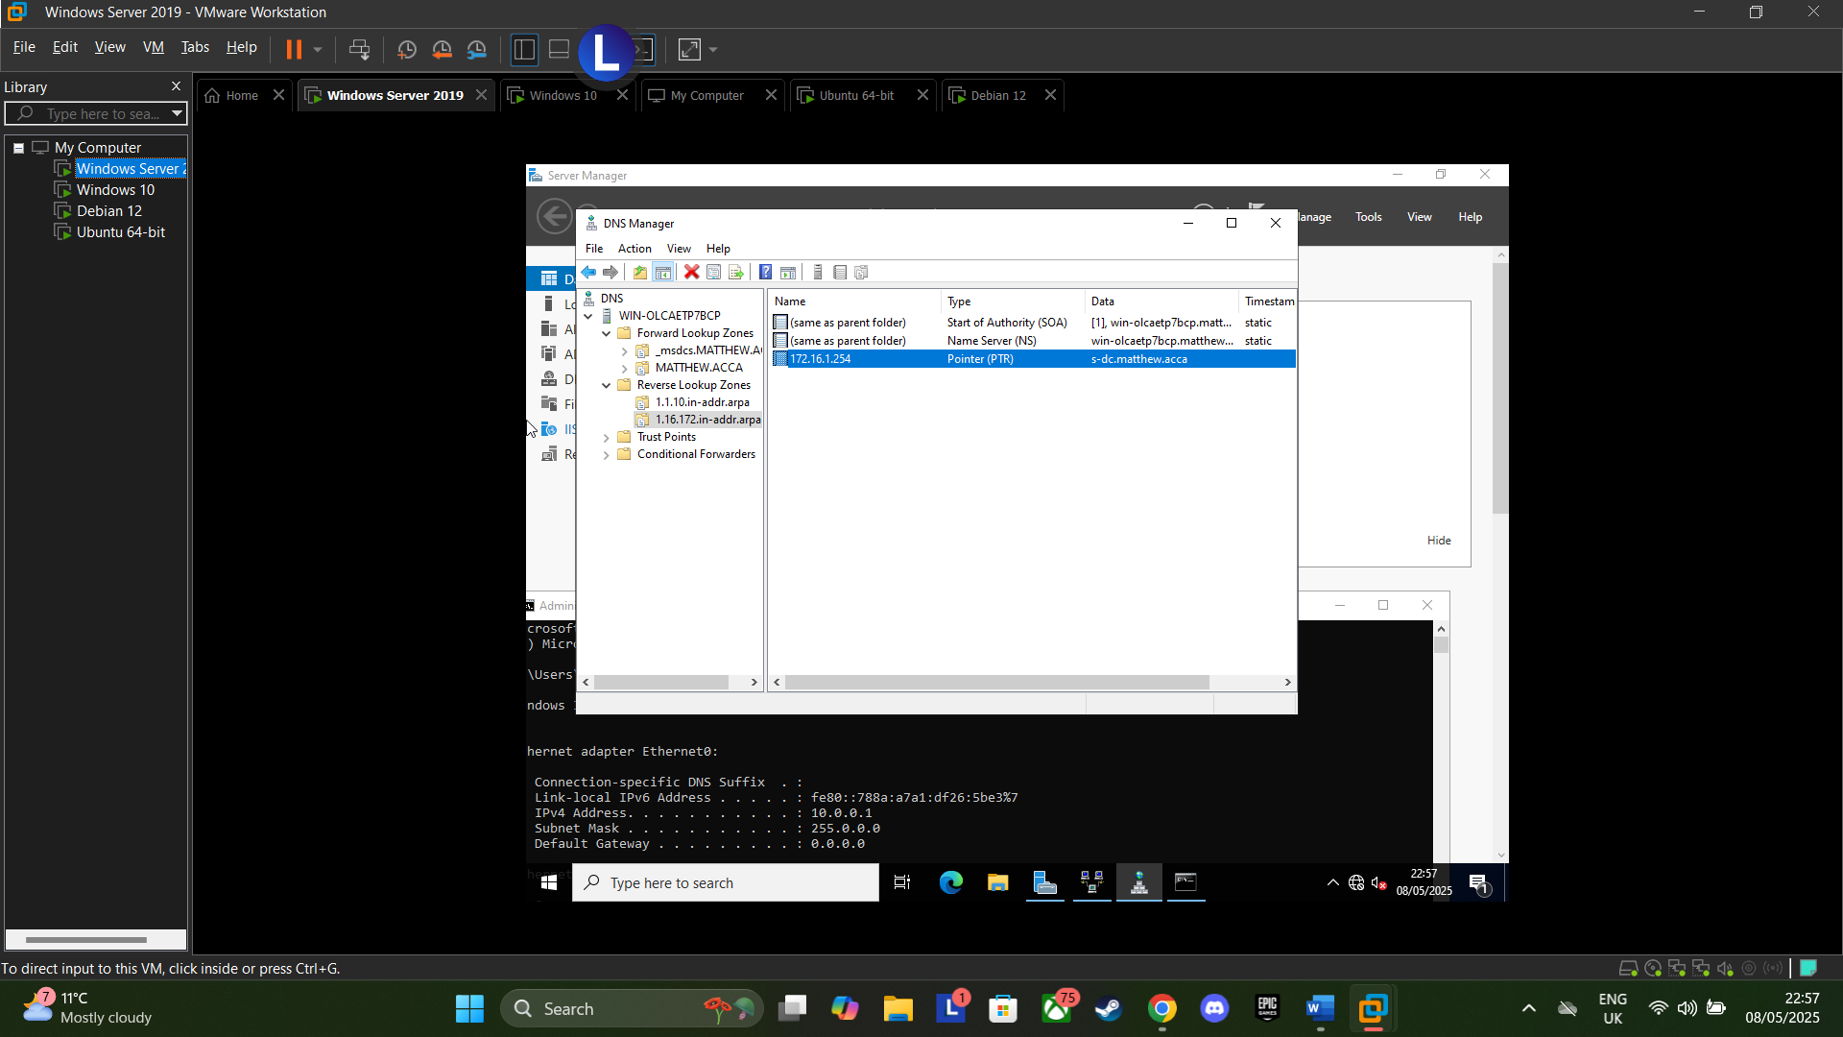
Figure 18: Confirmed S-DC and C-Server DNS on DNS Manager
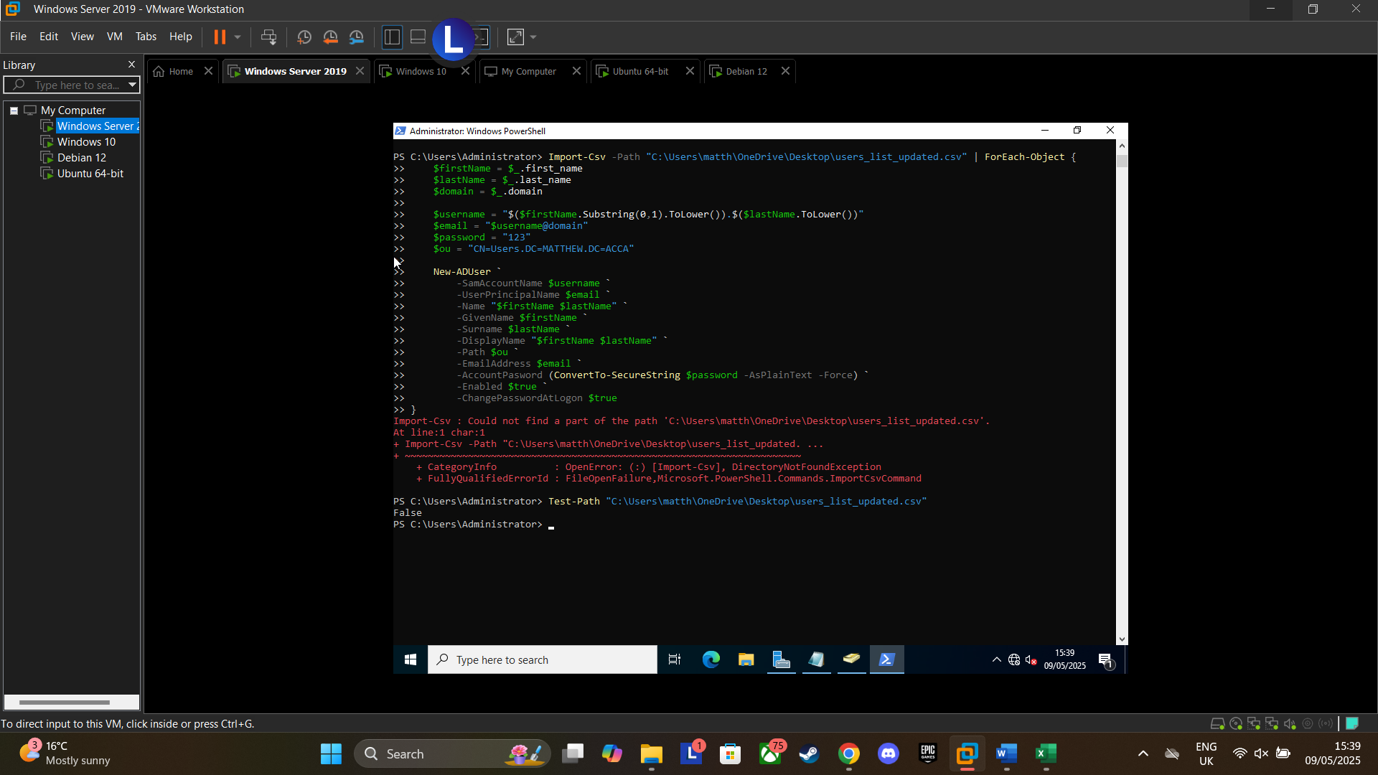
Figure 19: Attempted Powershell Script to input users’ information, but ran into persistent errors so instead opted to add user data manually
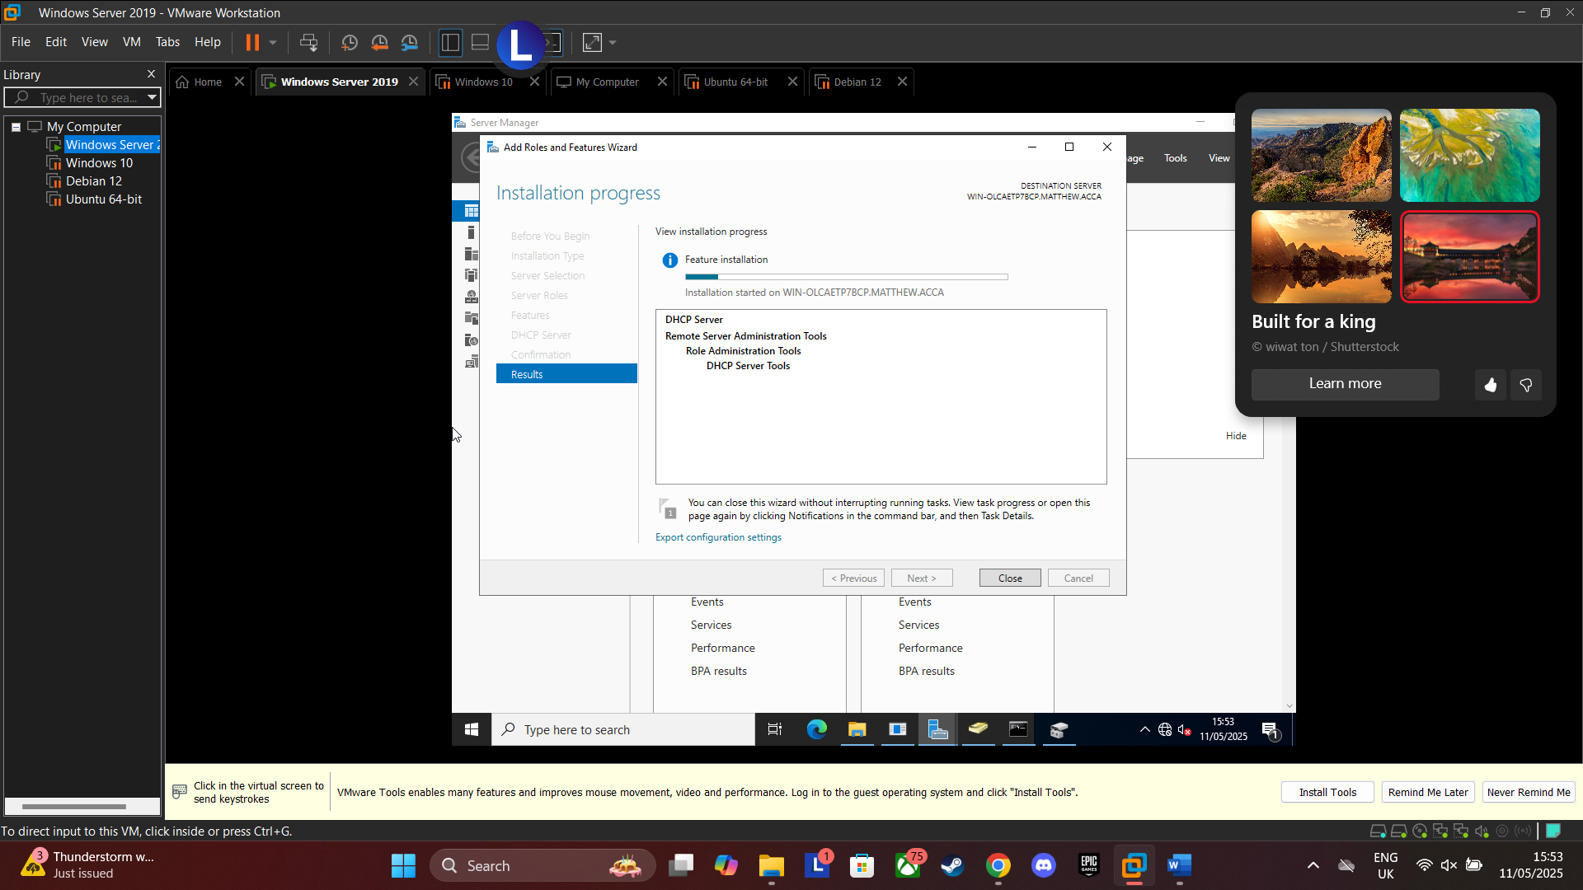
Figure 20: Installed DHCP Server
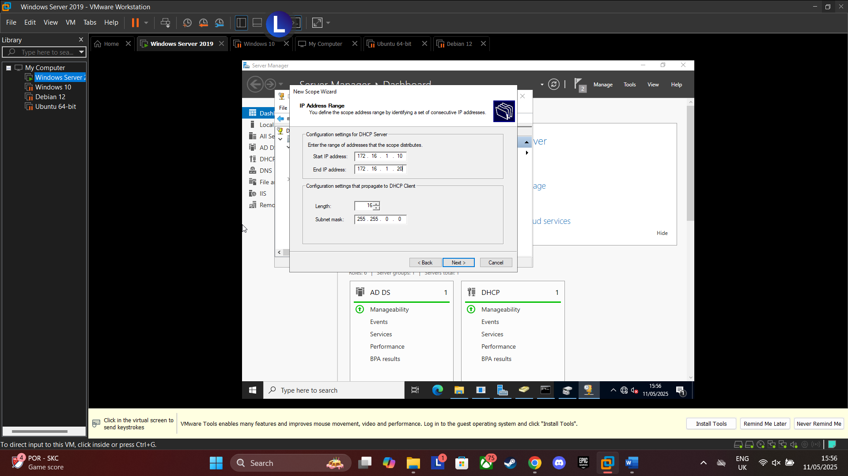
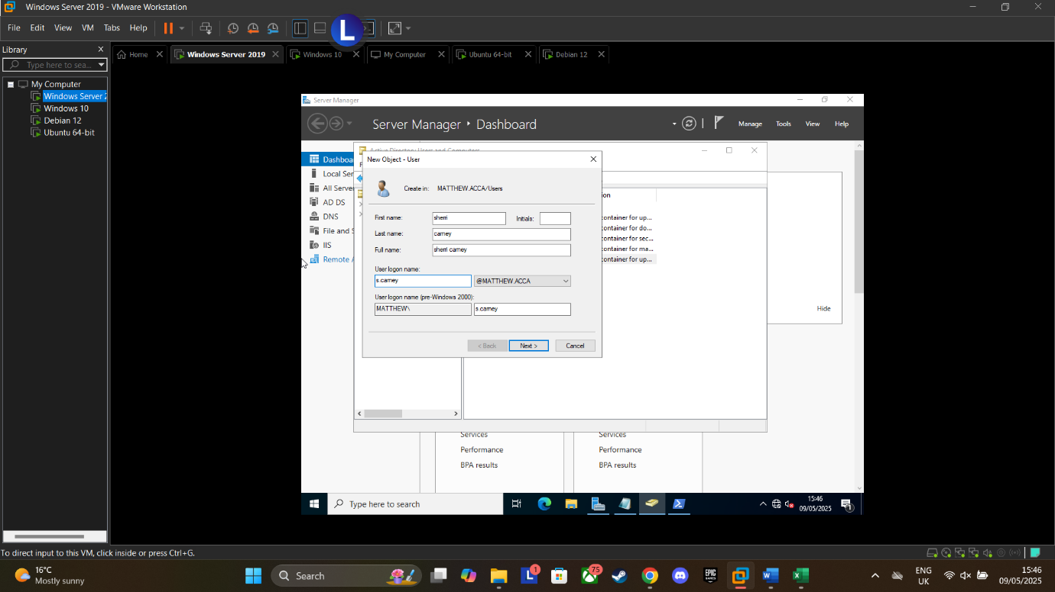
Figure 22: Added IP Address Range of 172.16.1.10 - 172.16.1.20 as per the assignment request
Figure 21: Adding user information manually as script didn’t work.

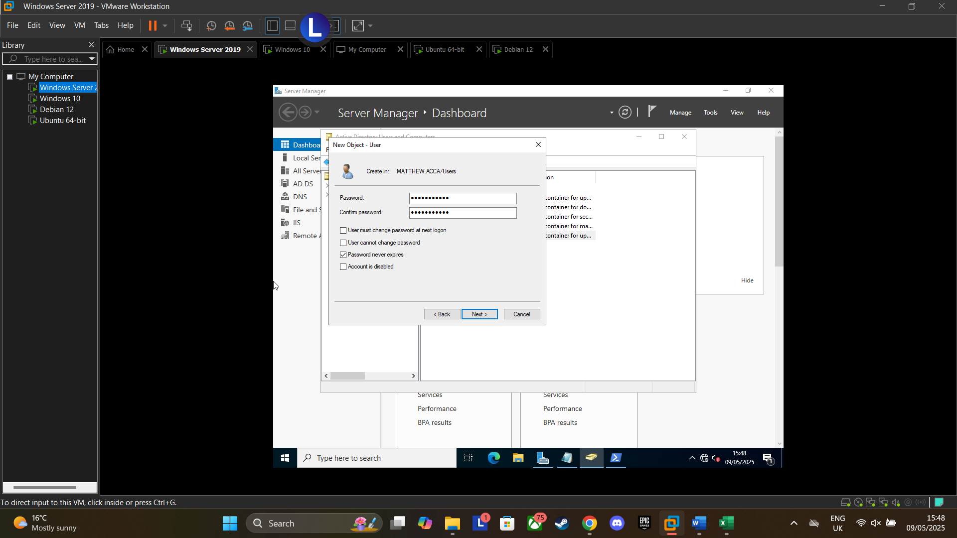
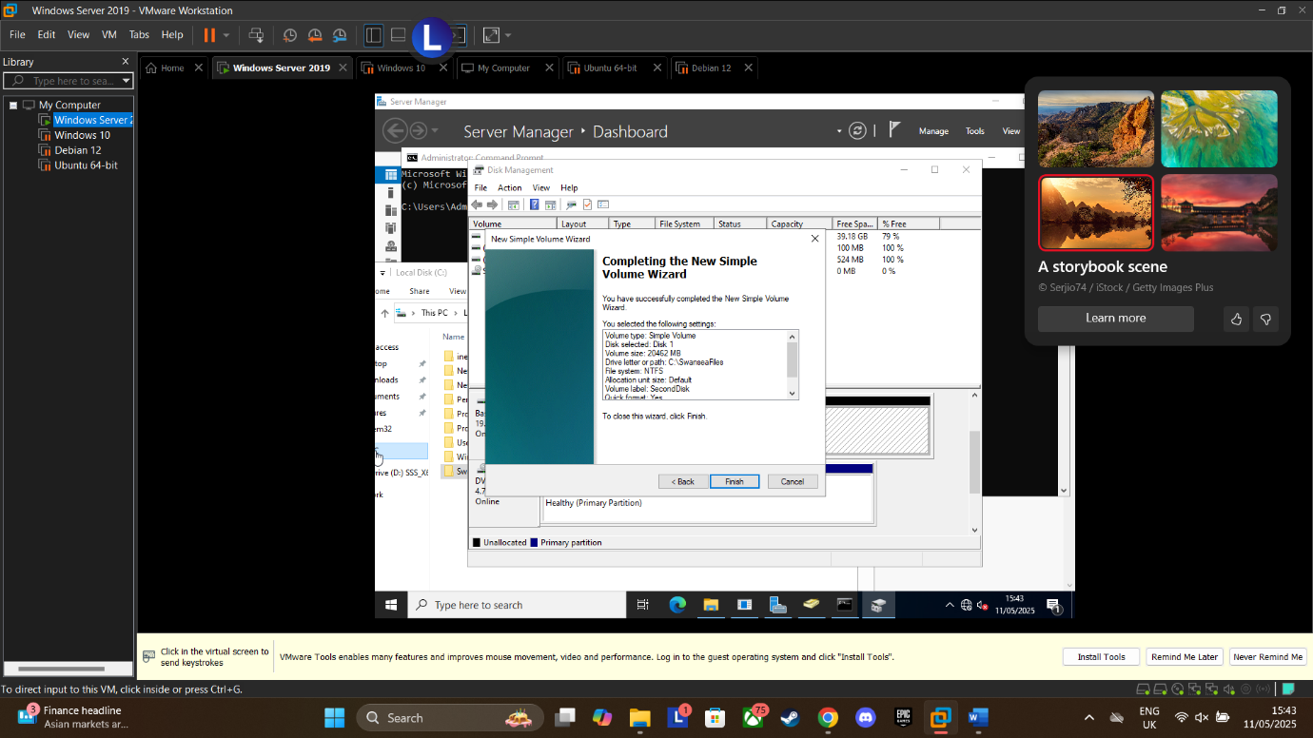
Figure 24: Added user password and ticked box for password never expires for purpose of assignment
Figure 23: Completed New Simple Volume Wizard for Adding Disk. Was unable to add to D:\SwanseaFiles to instead had to do C:\SwanseaFiles

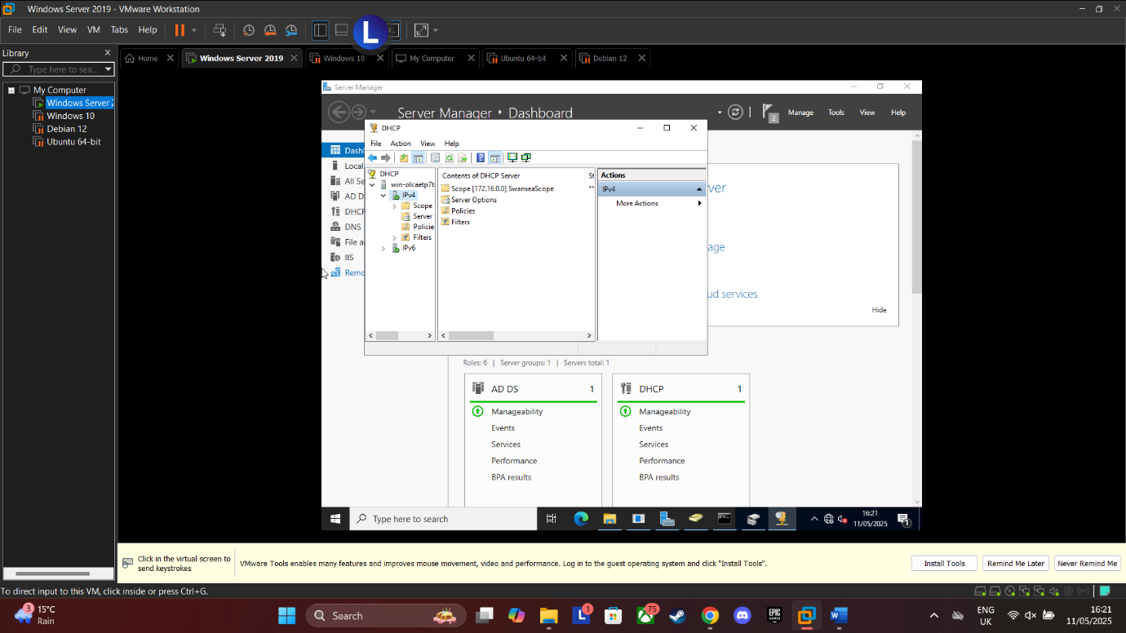
Figure 25: DHCP displaying SwanseaScope in the Domain Controller
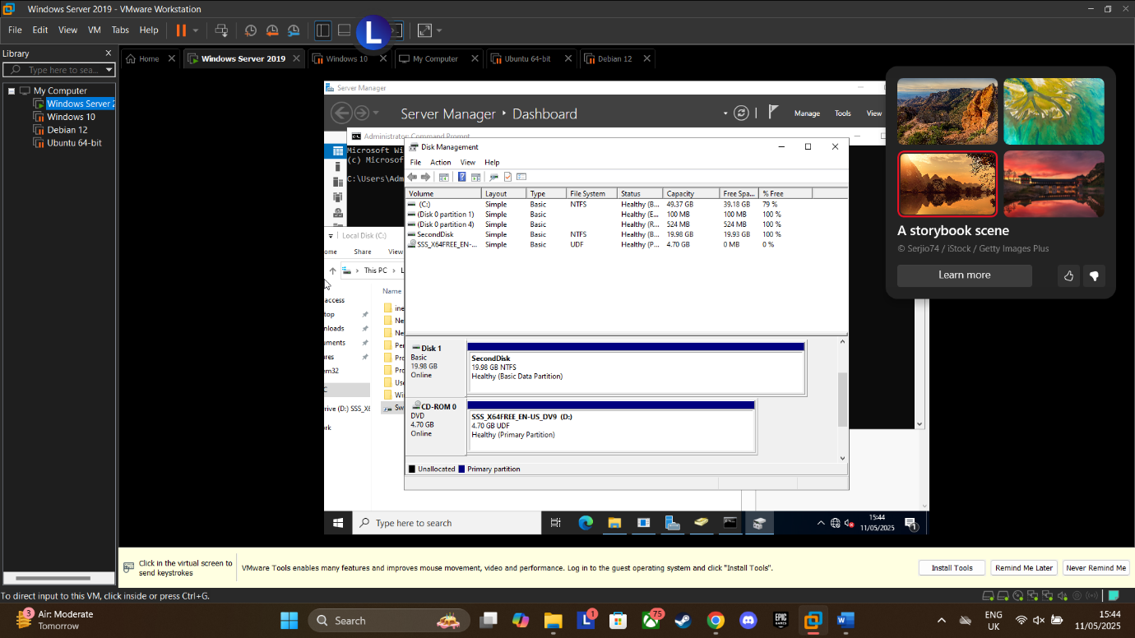
Figure 26: Confirmation of having added a second disk drive

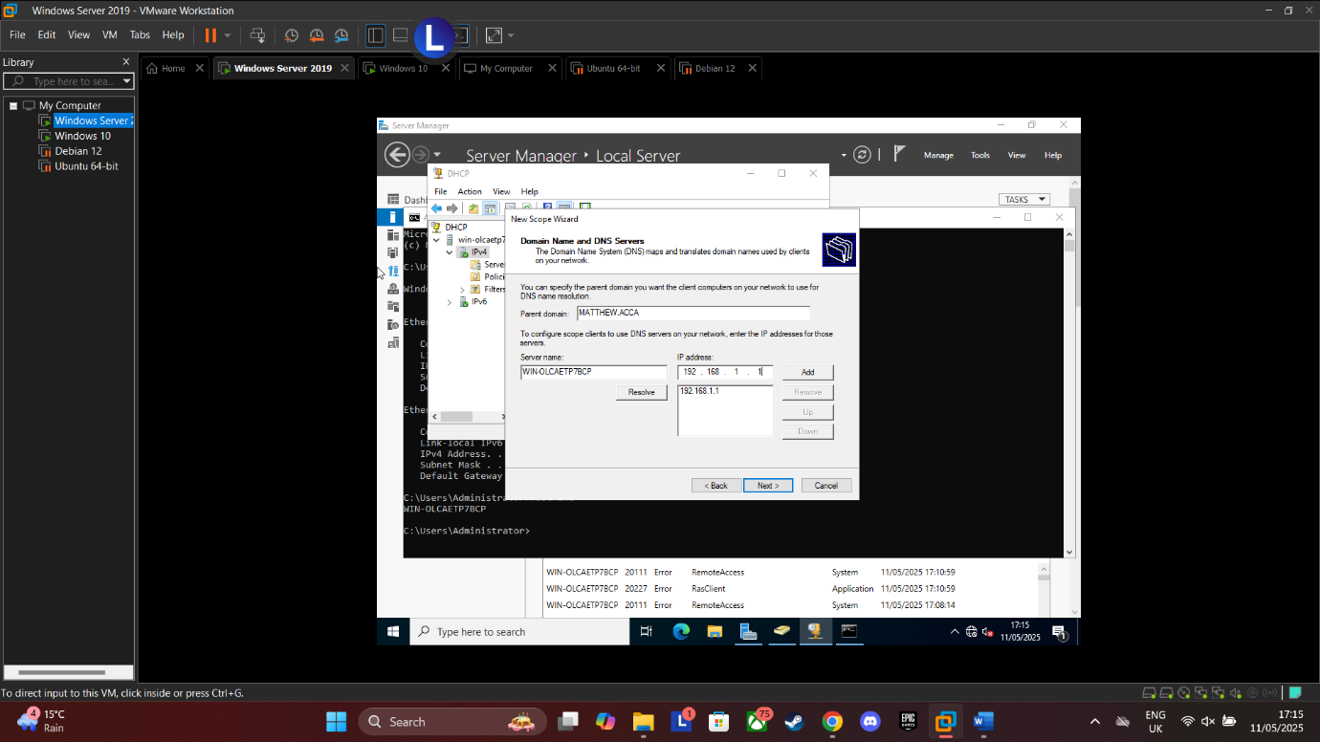
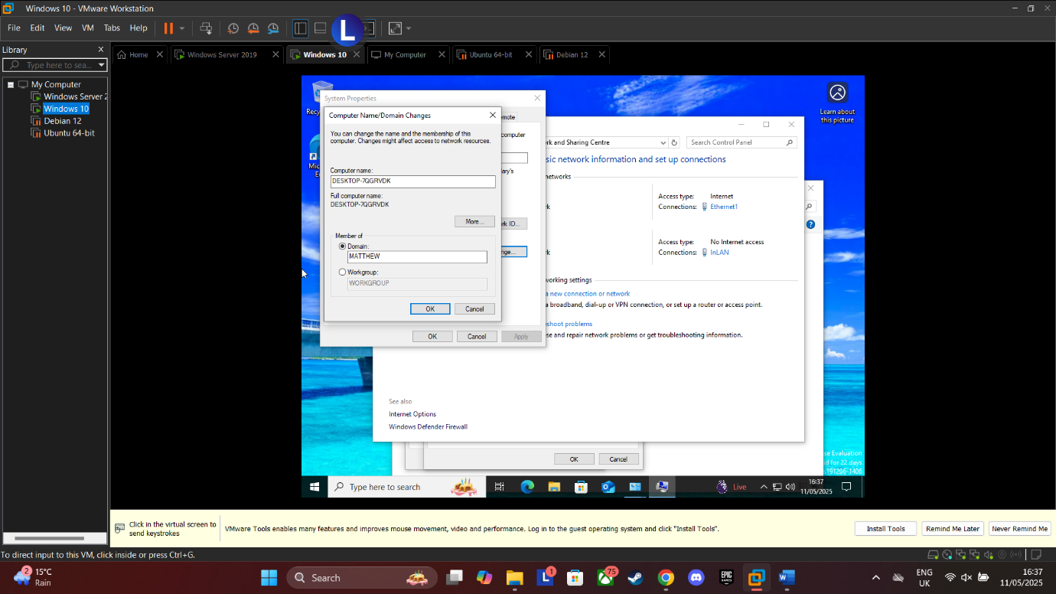
Figure 27: Added parent domain name of MATTHEW ACCA with the server and added the domain controller IP address
Figure 28: Attempted Name change but faced an error. tried MATTHEW & MATTHEW.ACCA and received errors on both tries

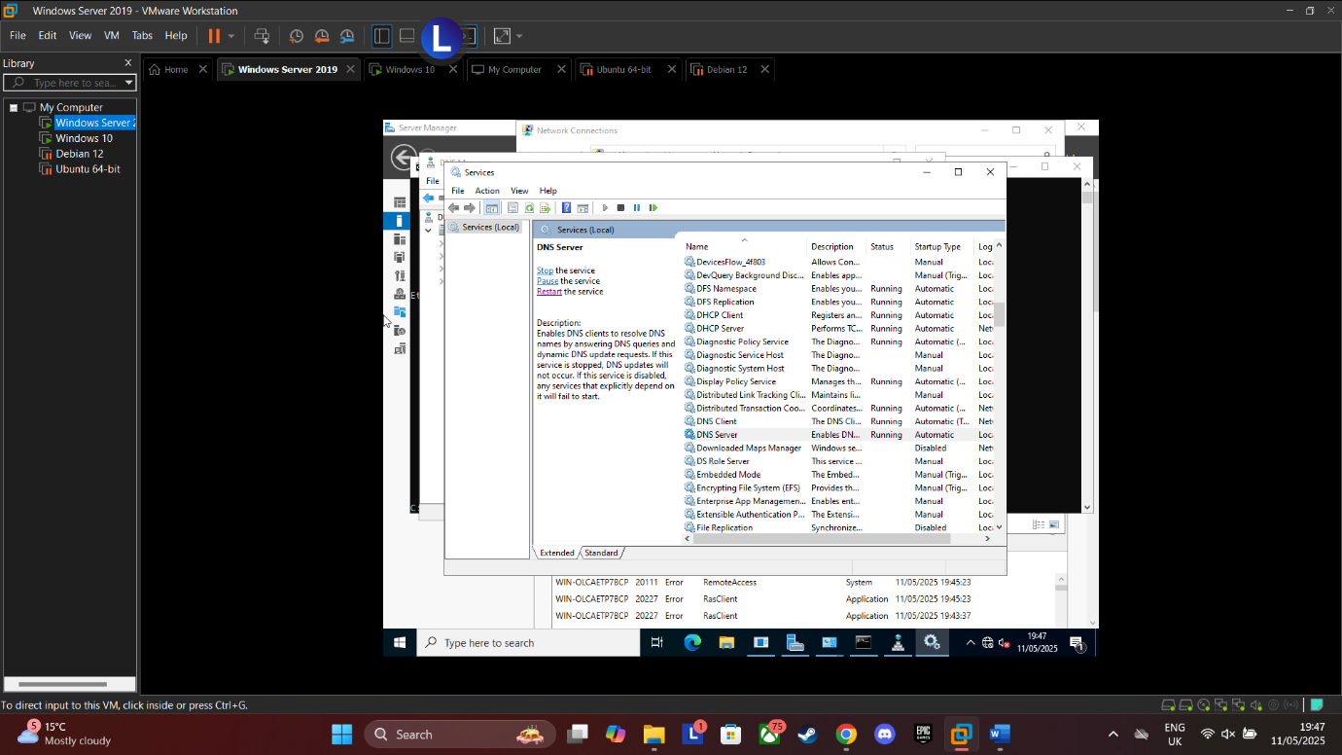
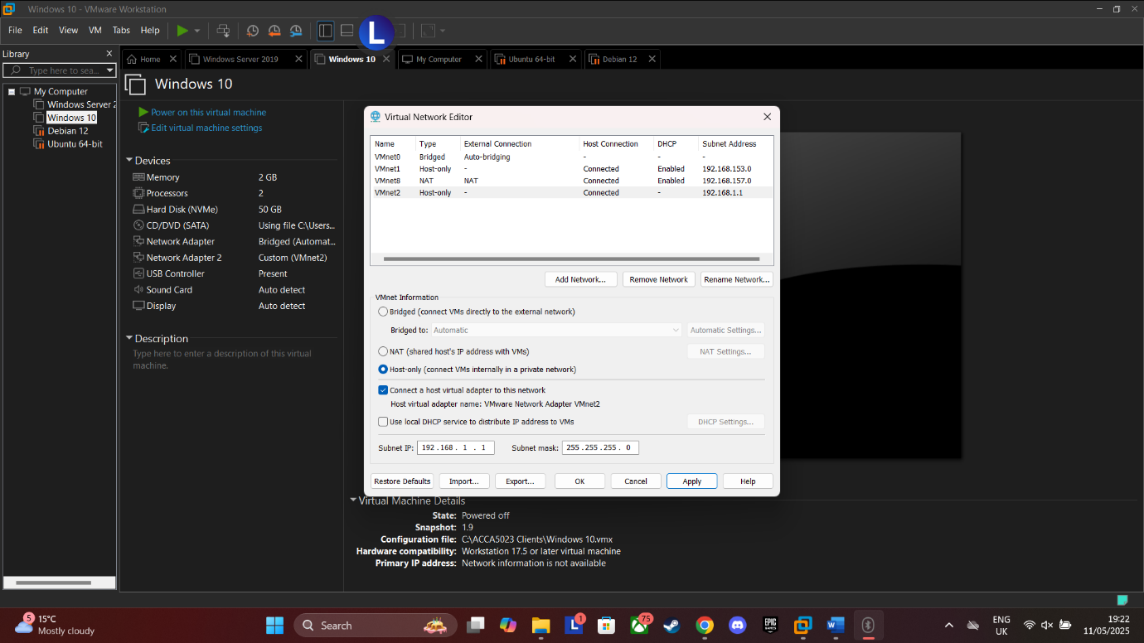
Figure 29: Attempted to restart DNS server as part of troubleshooting
Figure 30: Opened VMWare Settings and added VMNet2 as a Host-only network with a set IP as an attempt at troubleshooting

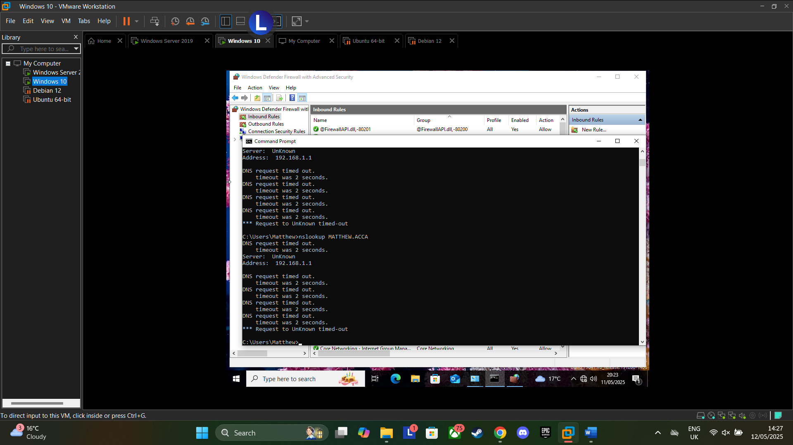
Figure 31:Current state when trying to ping DC from client. IP address is recognised but DNS request will continuously time out.
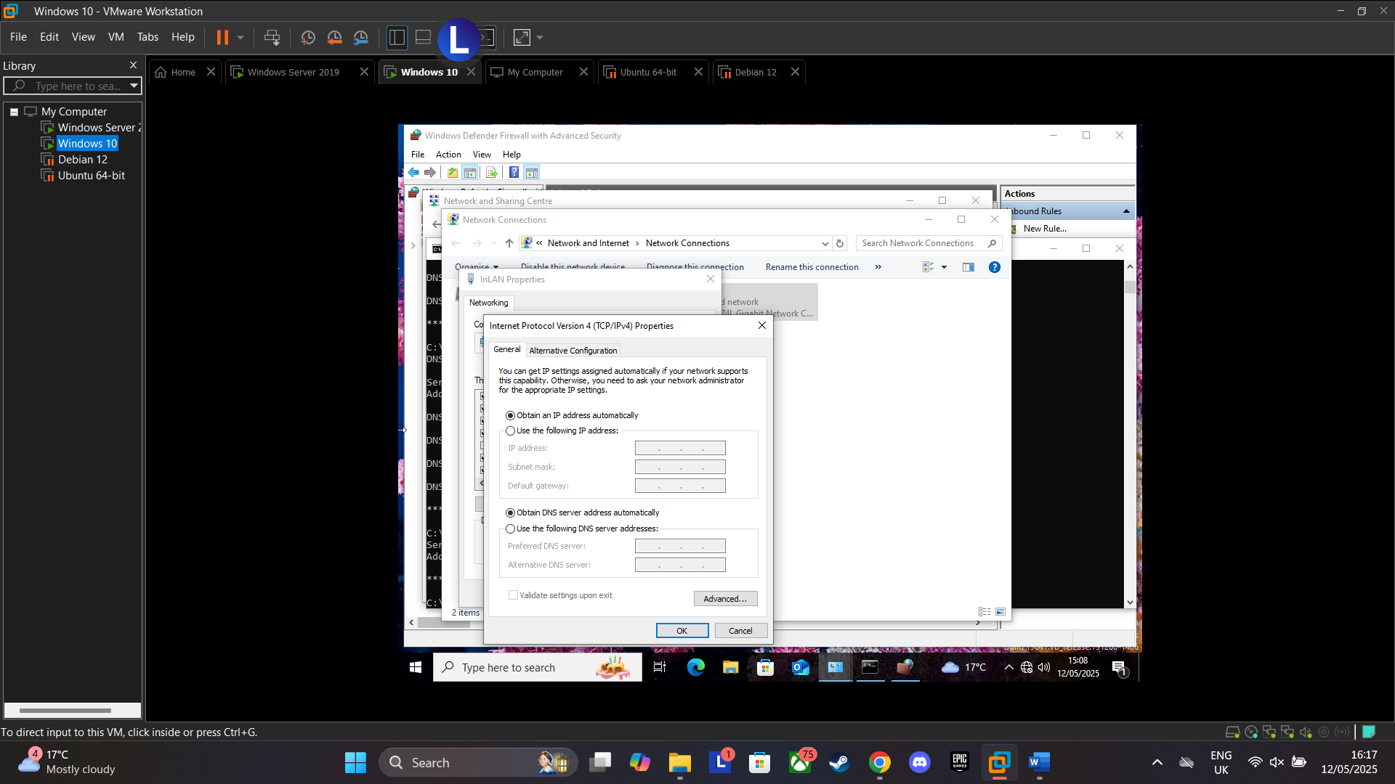
Figure 32: Set to obtain an IP address and DNS server automatically for task 1.10
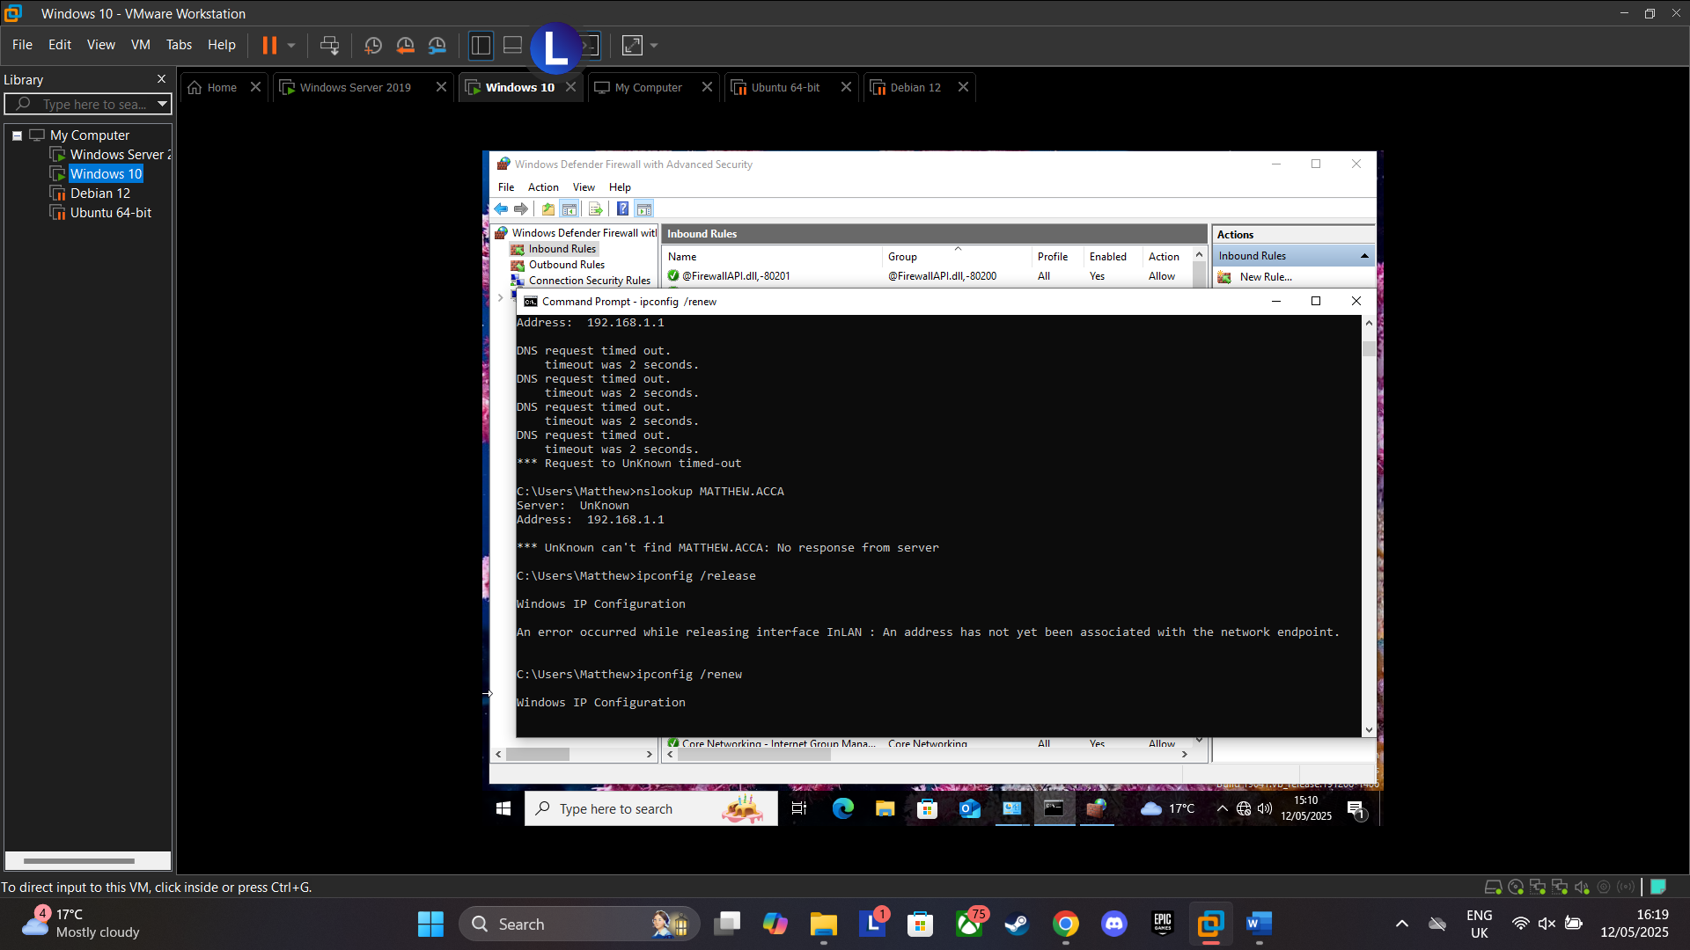
Figure 33: Error when running "ipconfig /release"
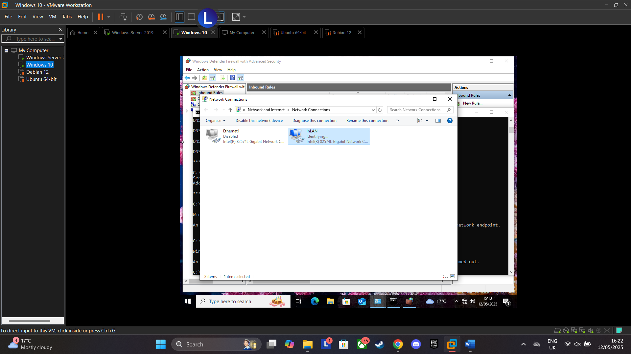
Figure 34: Disabled and InLan
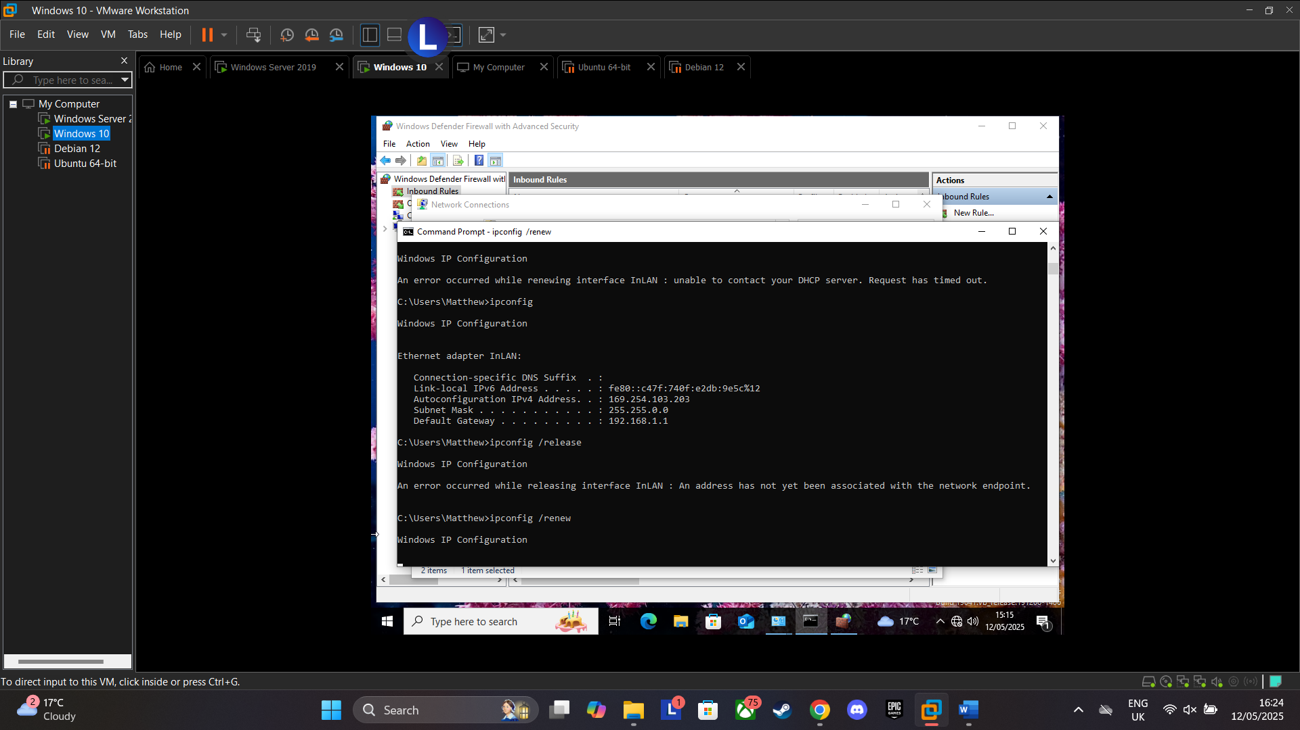
Figure 35: Continued error after troubleshooting step
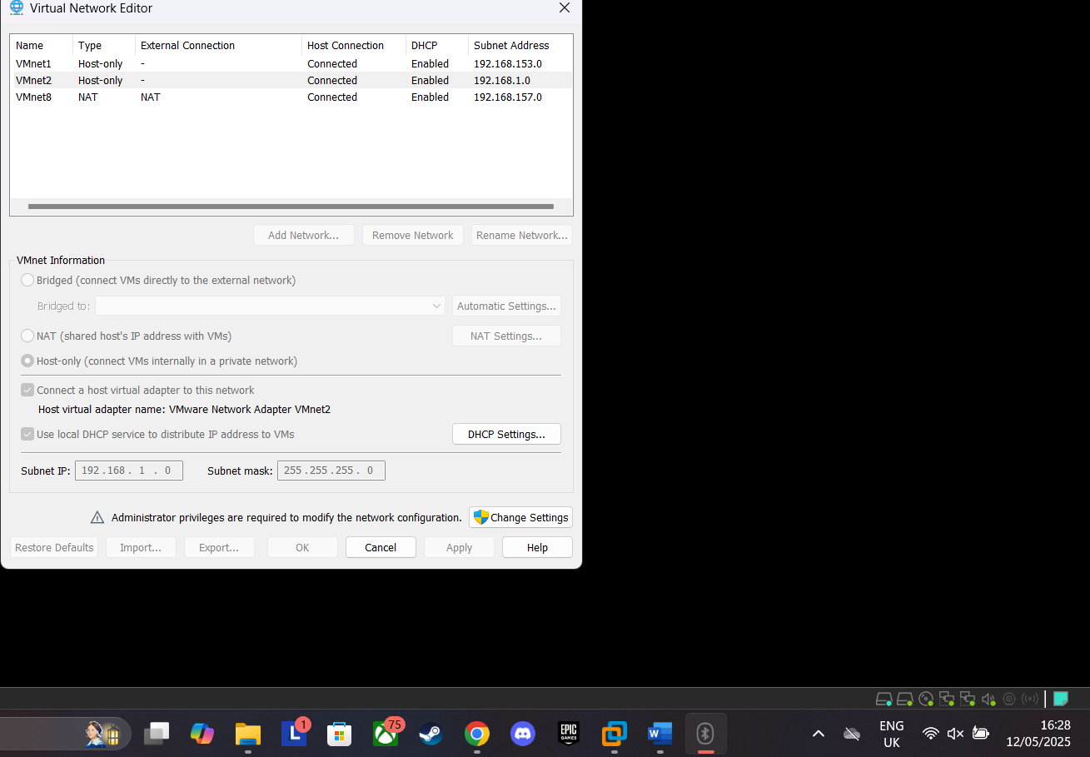
Figure 36: Enabled "use local DHCP service to distribute IP address to VMs

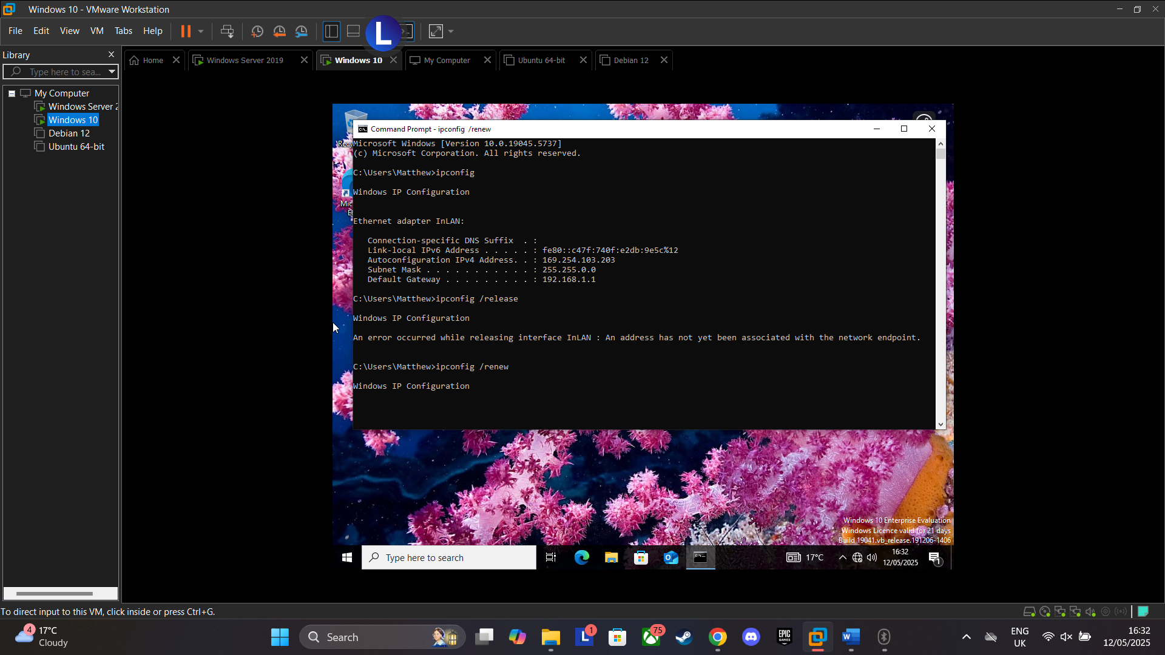
Figure 37: Error persisting after troubleshooting step
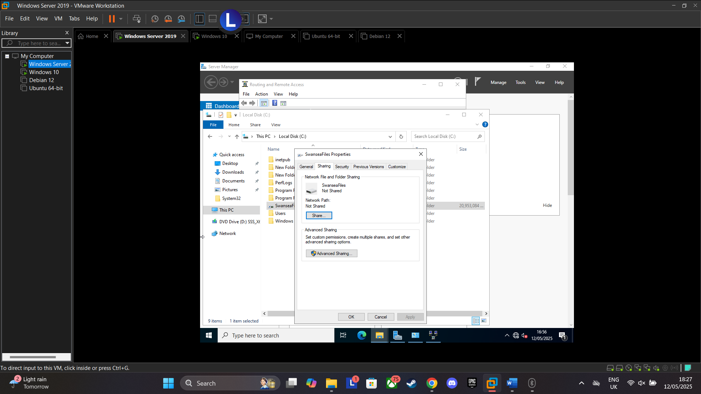
Figure 38: Sharing C:\SwanseaFiles
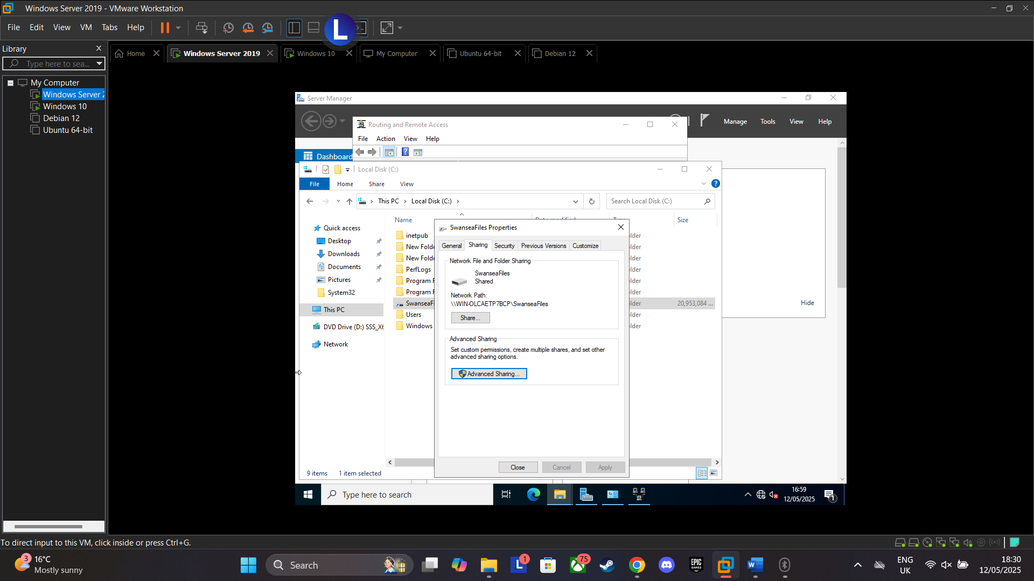
Figure 39: C:\Swansea Files shared
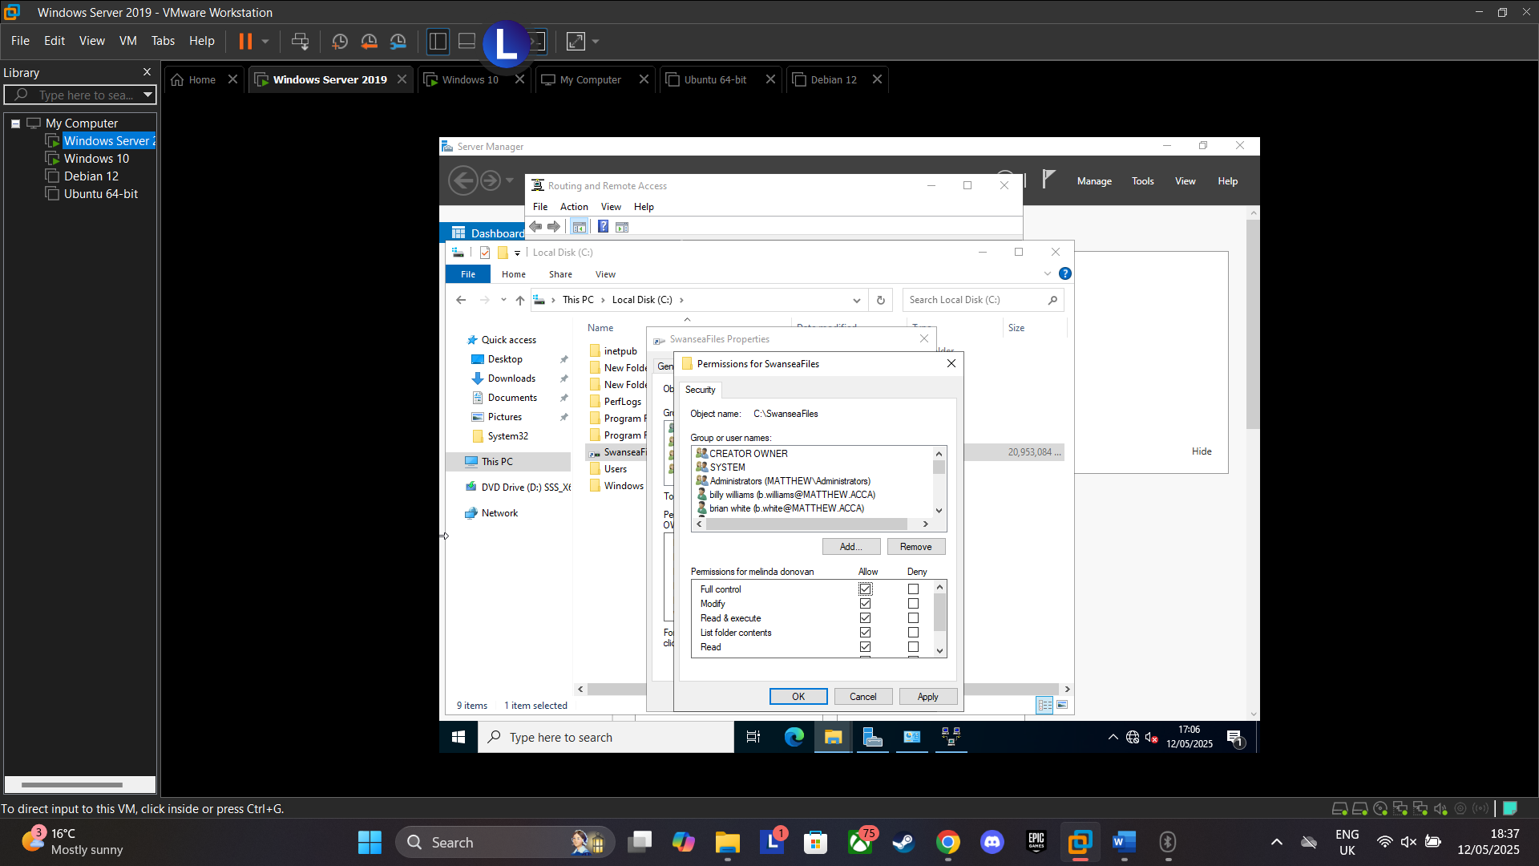
Figure 40: Inserted Users from users_list_updated.xlsx and gave full control
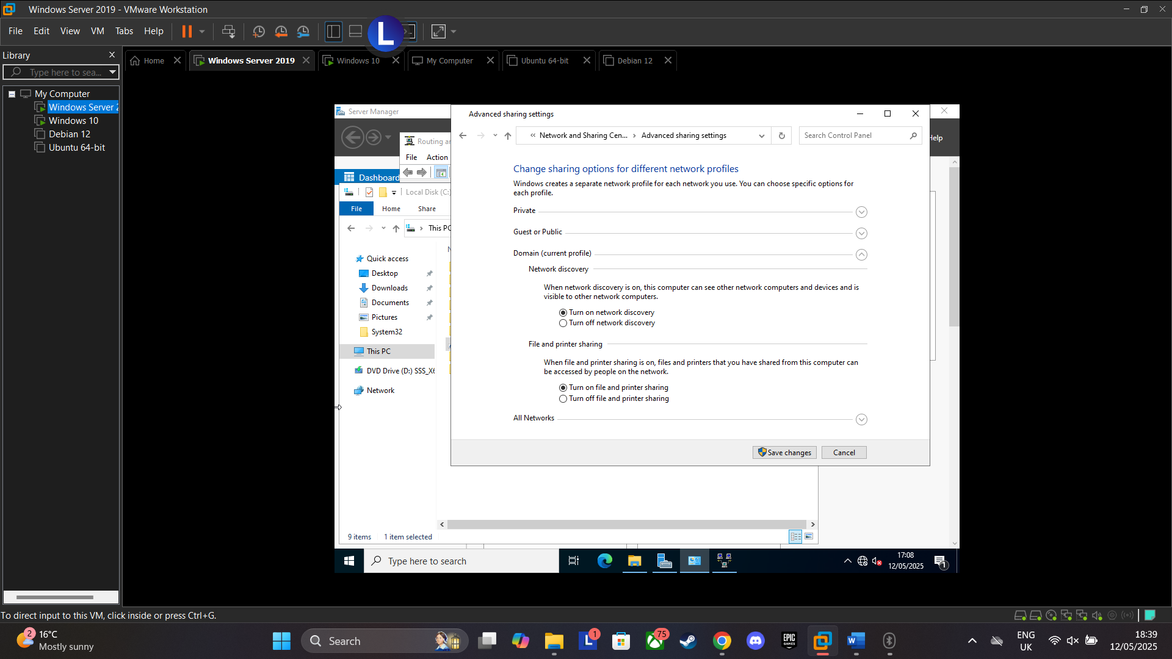
Figure 41: Turned on network discovery and file and printer sharing
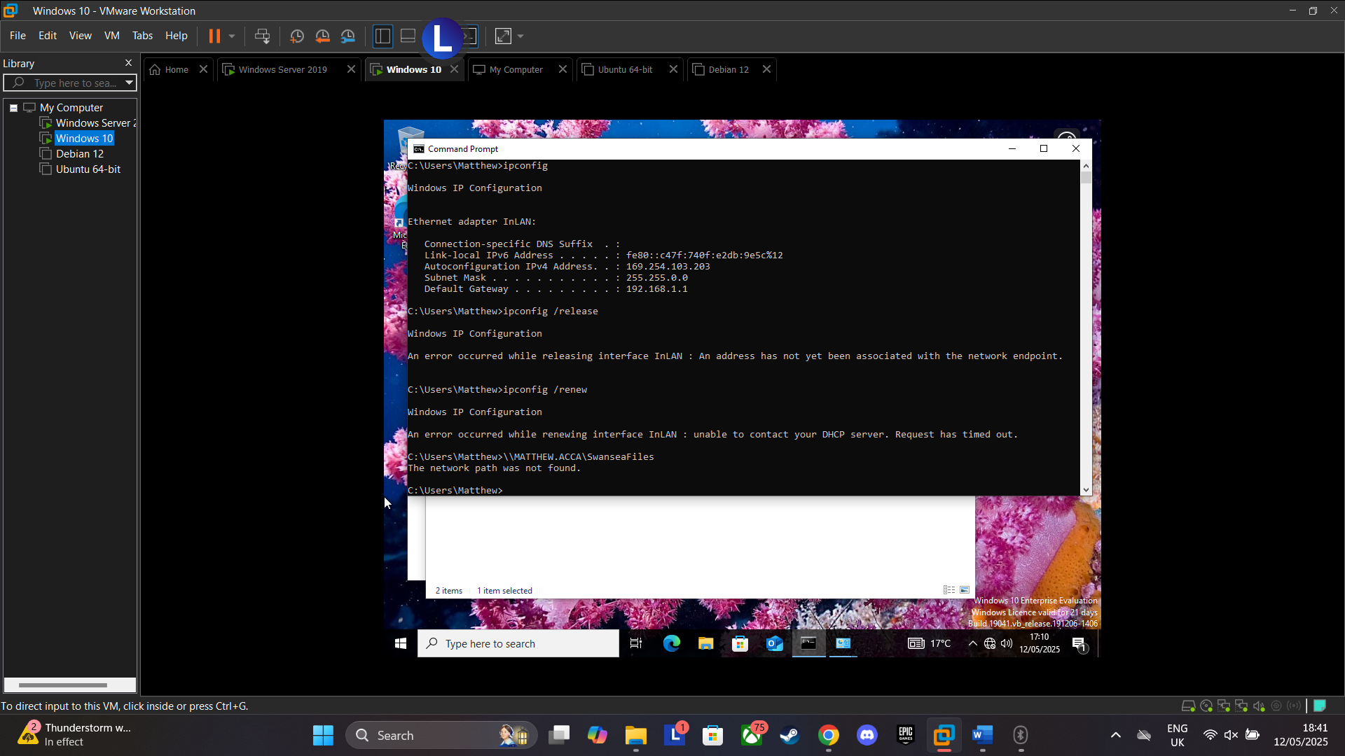
Figure 42: Error on Windows Client stating "The network path was not found" possibly linked to prevous errors and failed troubleshooting
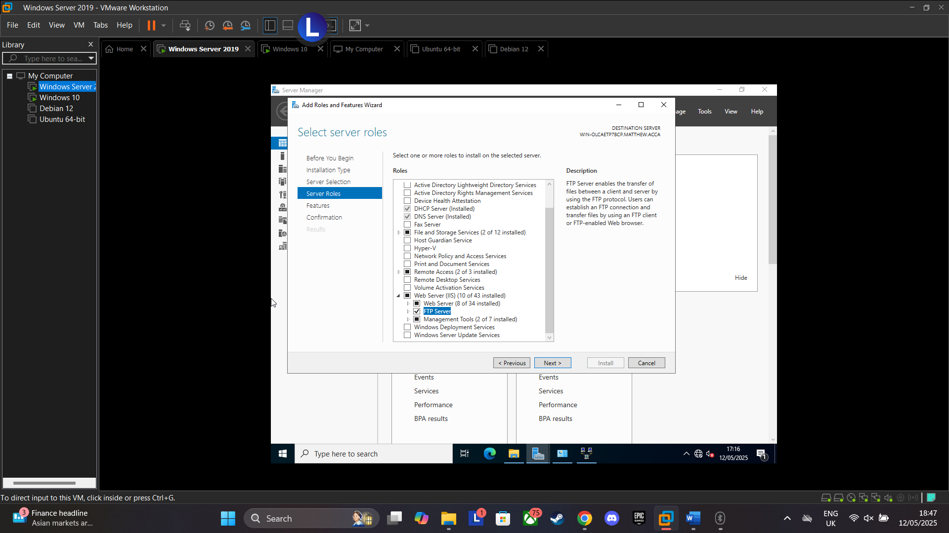
Figure 43: Web server install
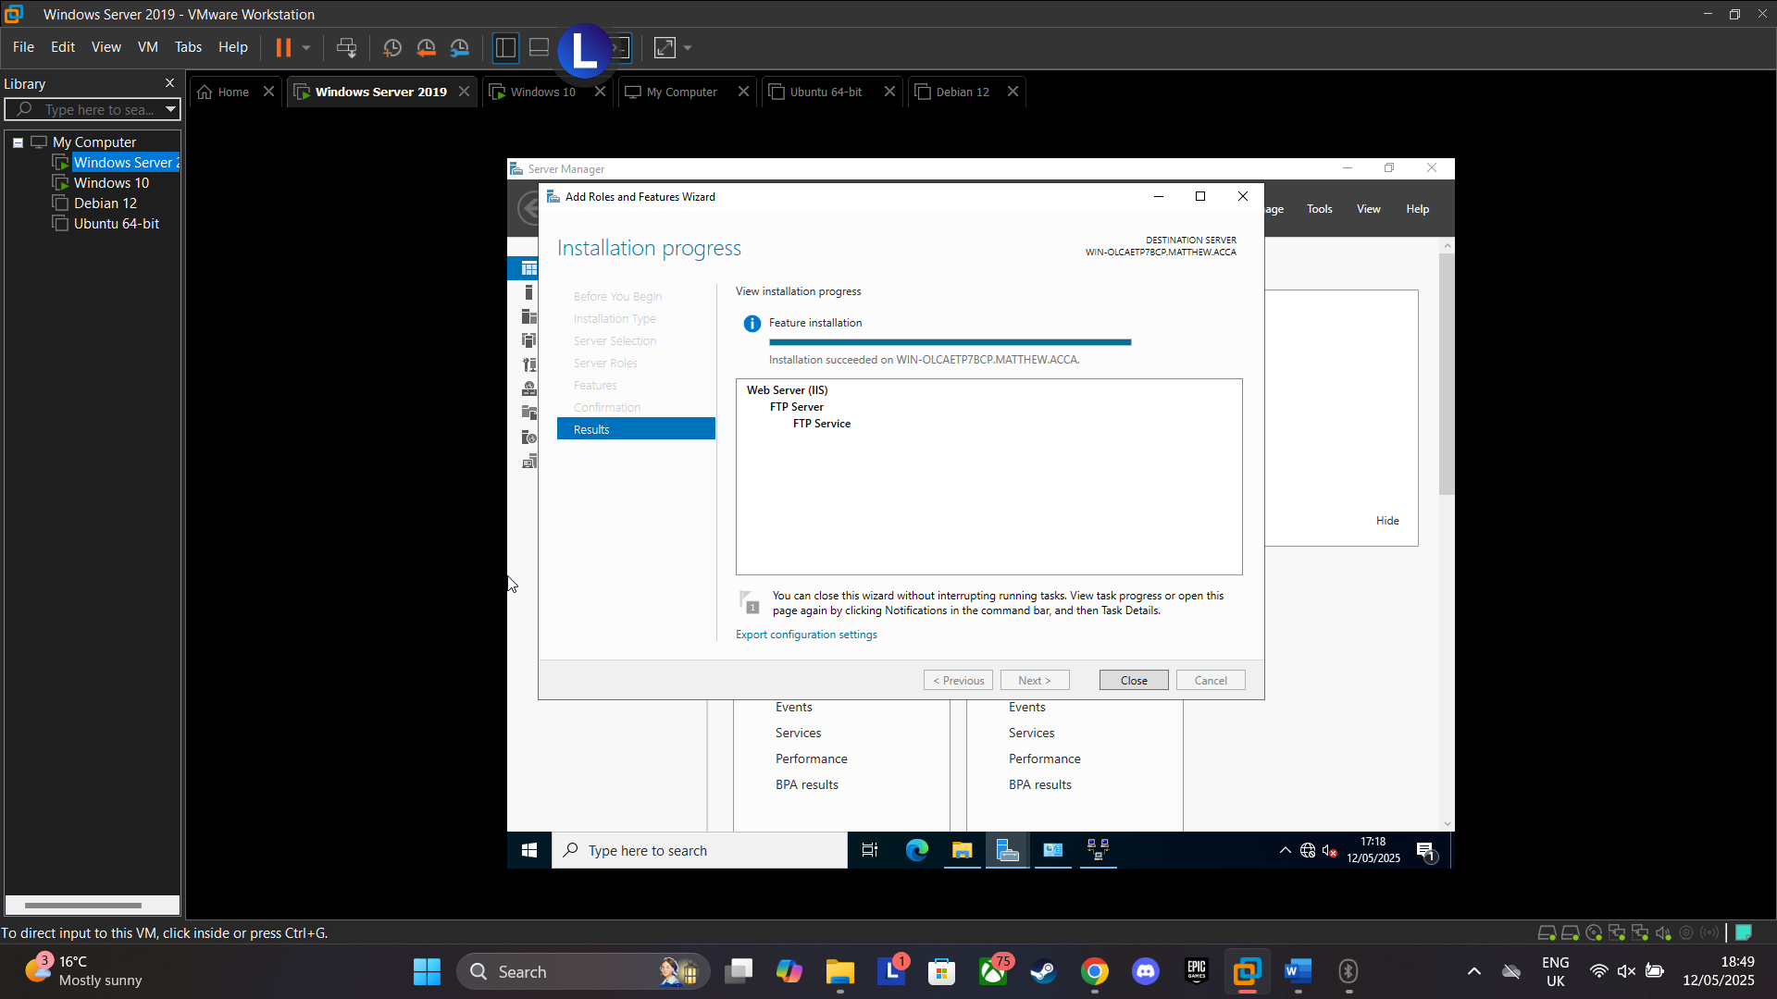
Figure 44: Install Complete
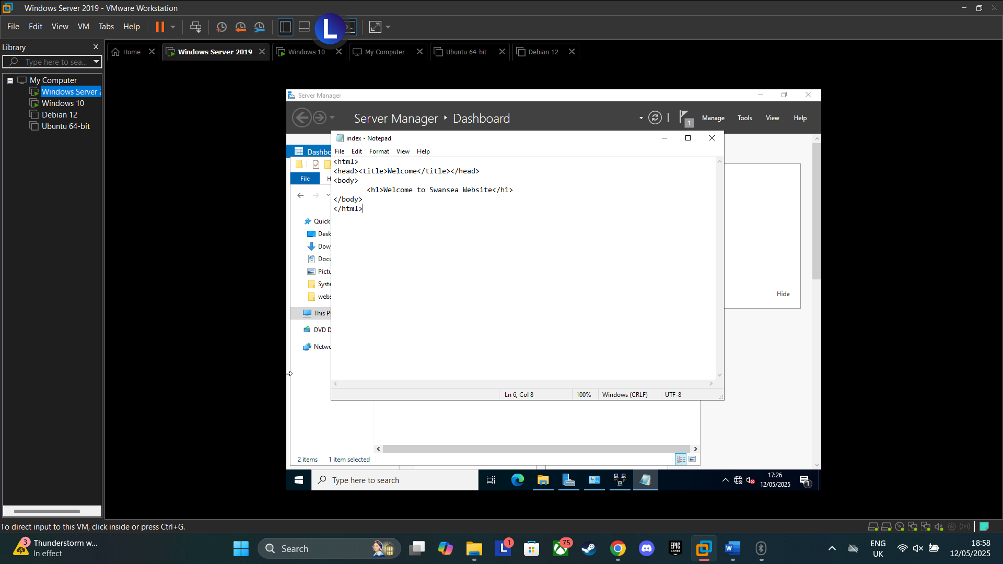
Figure 45: Added HTML code with 'Welcome to Swansea Website' as per assignment instructions
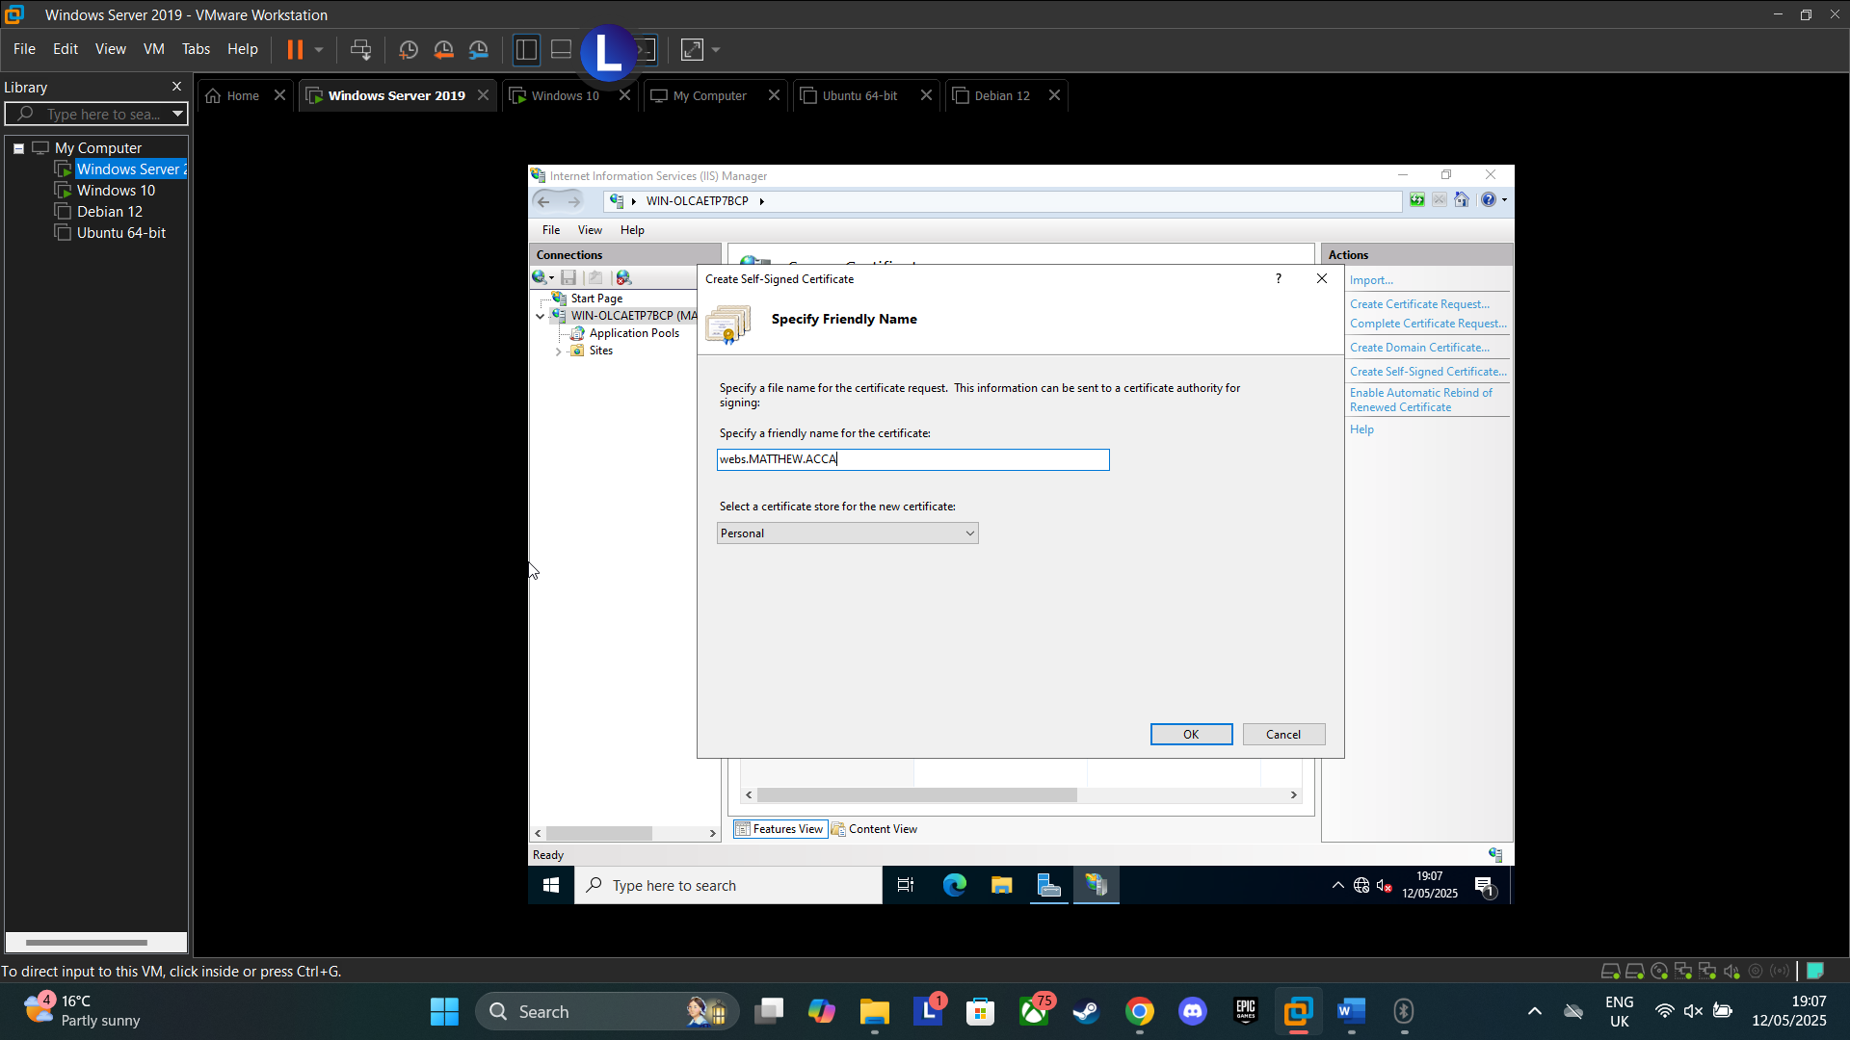
Figure 46:Creating SSL Cert
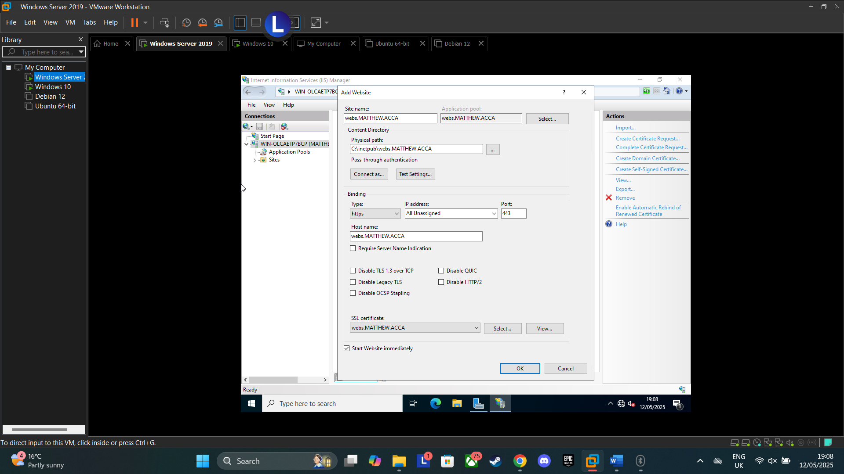
Figure 47: configuring website, added name and SSL Cert
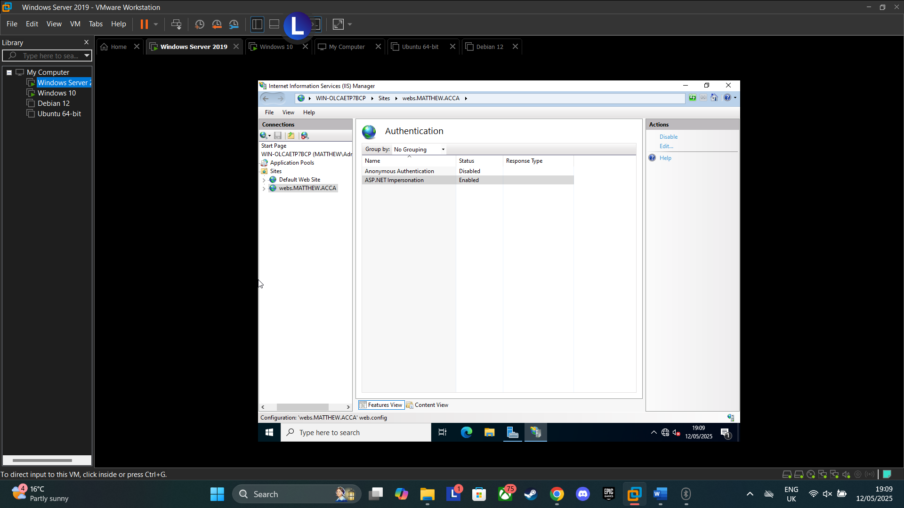
Figure 48: Adjusted Authentication
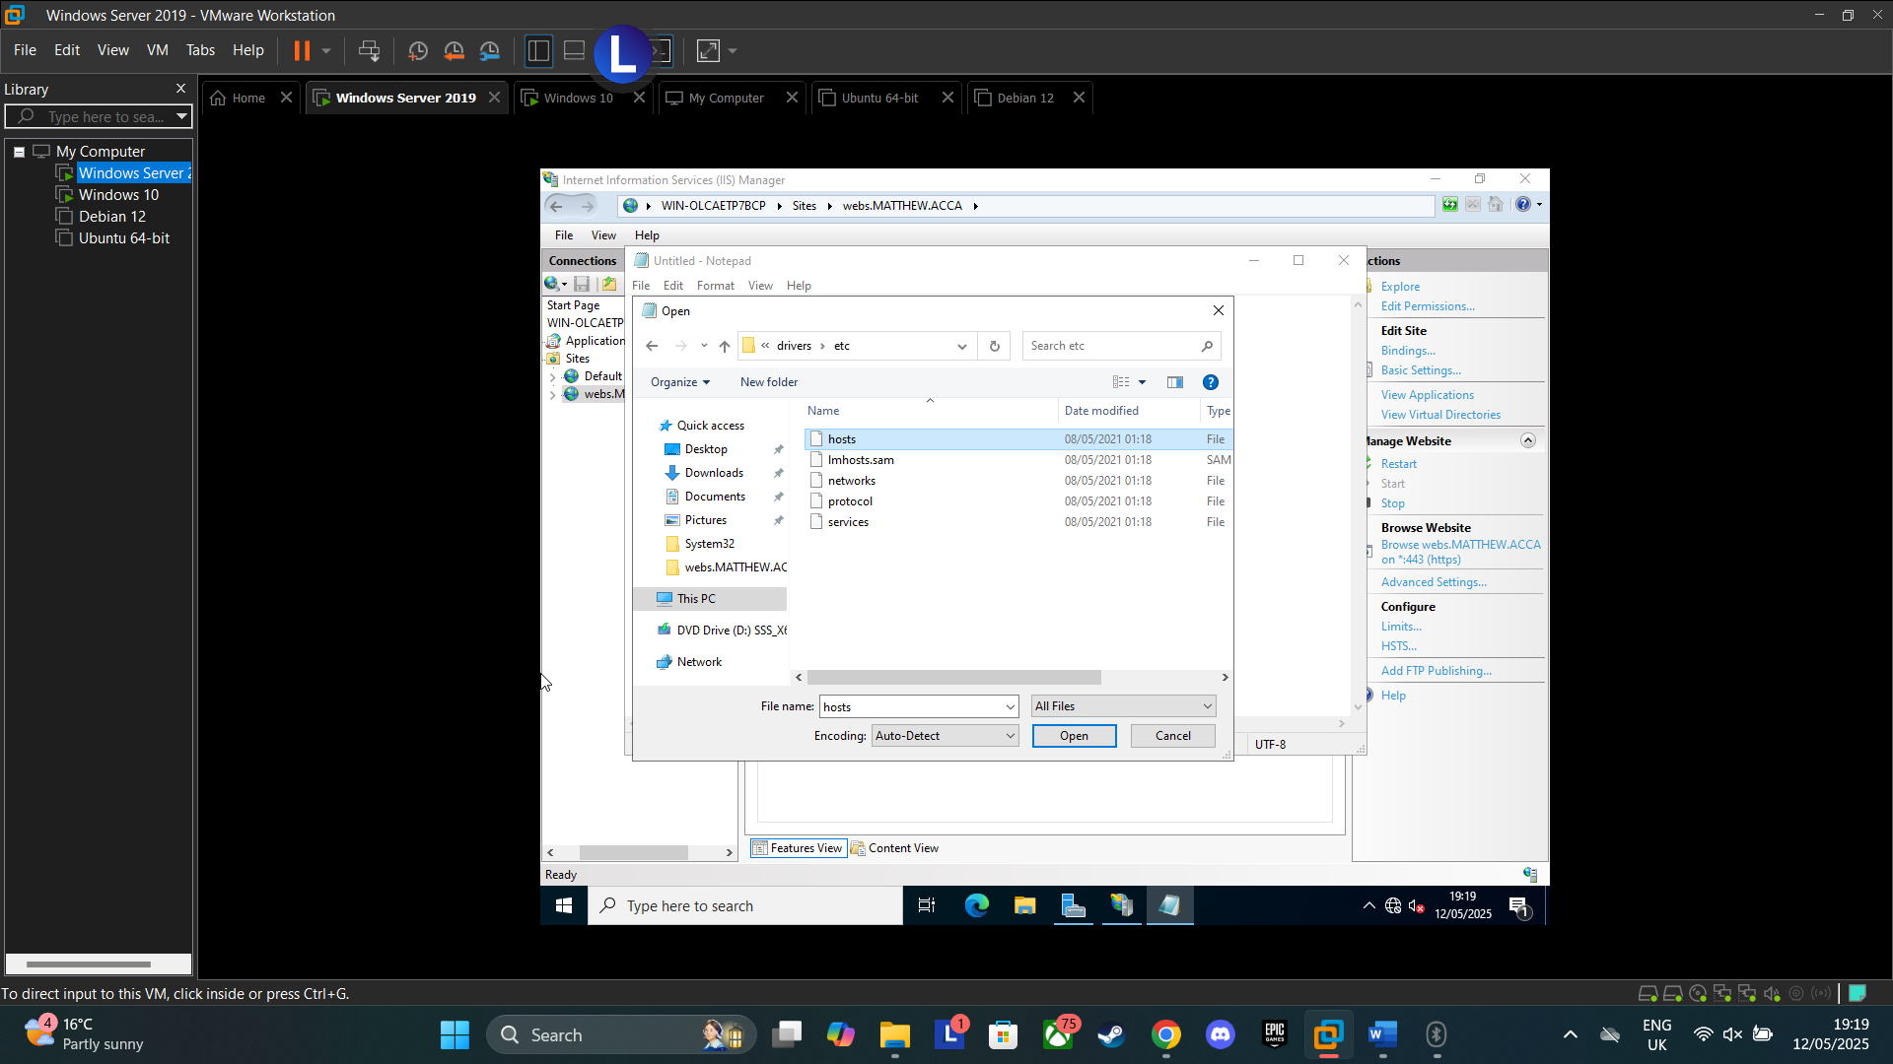
Figure 49: Opening Hosts file on Windows Server
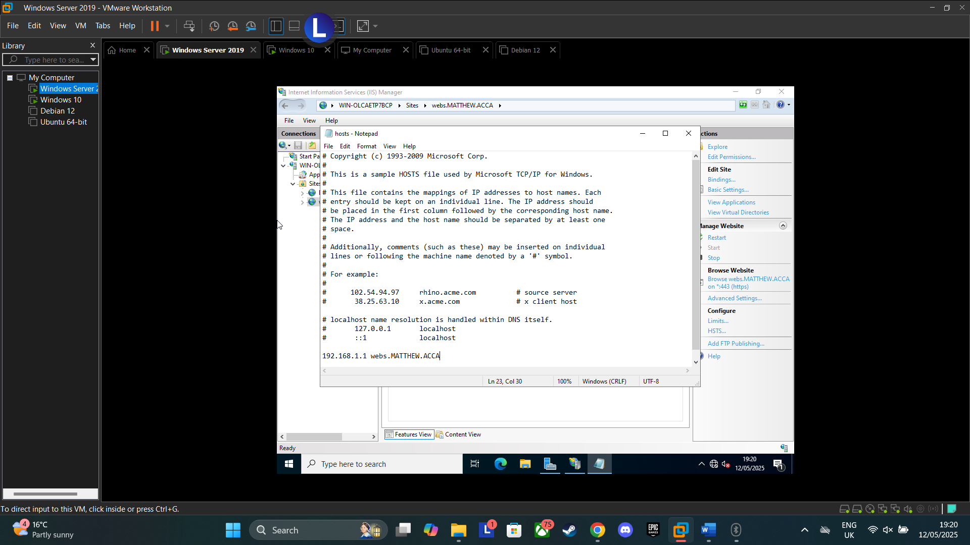
Figure 50: Added domain IP and website name to hosts file and saved

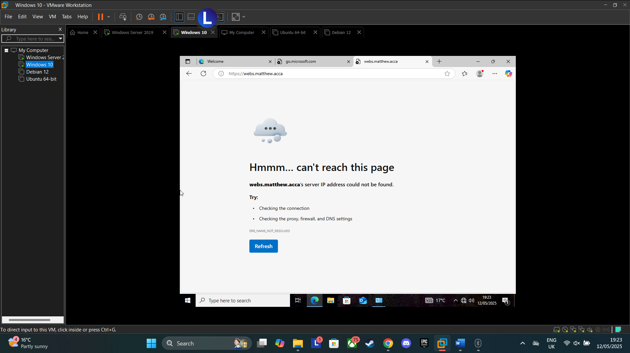
Figure 51: Unable to reach website on client, possibly in part to previous issues faced between server and client
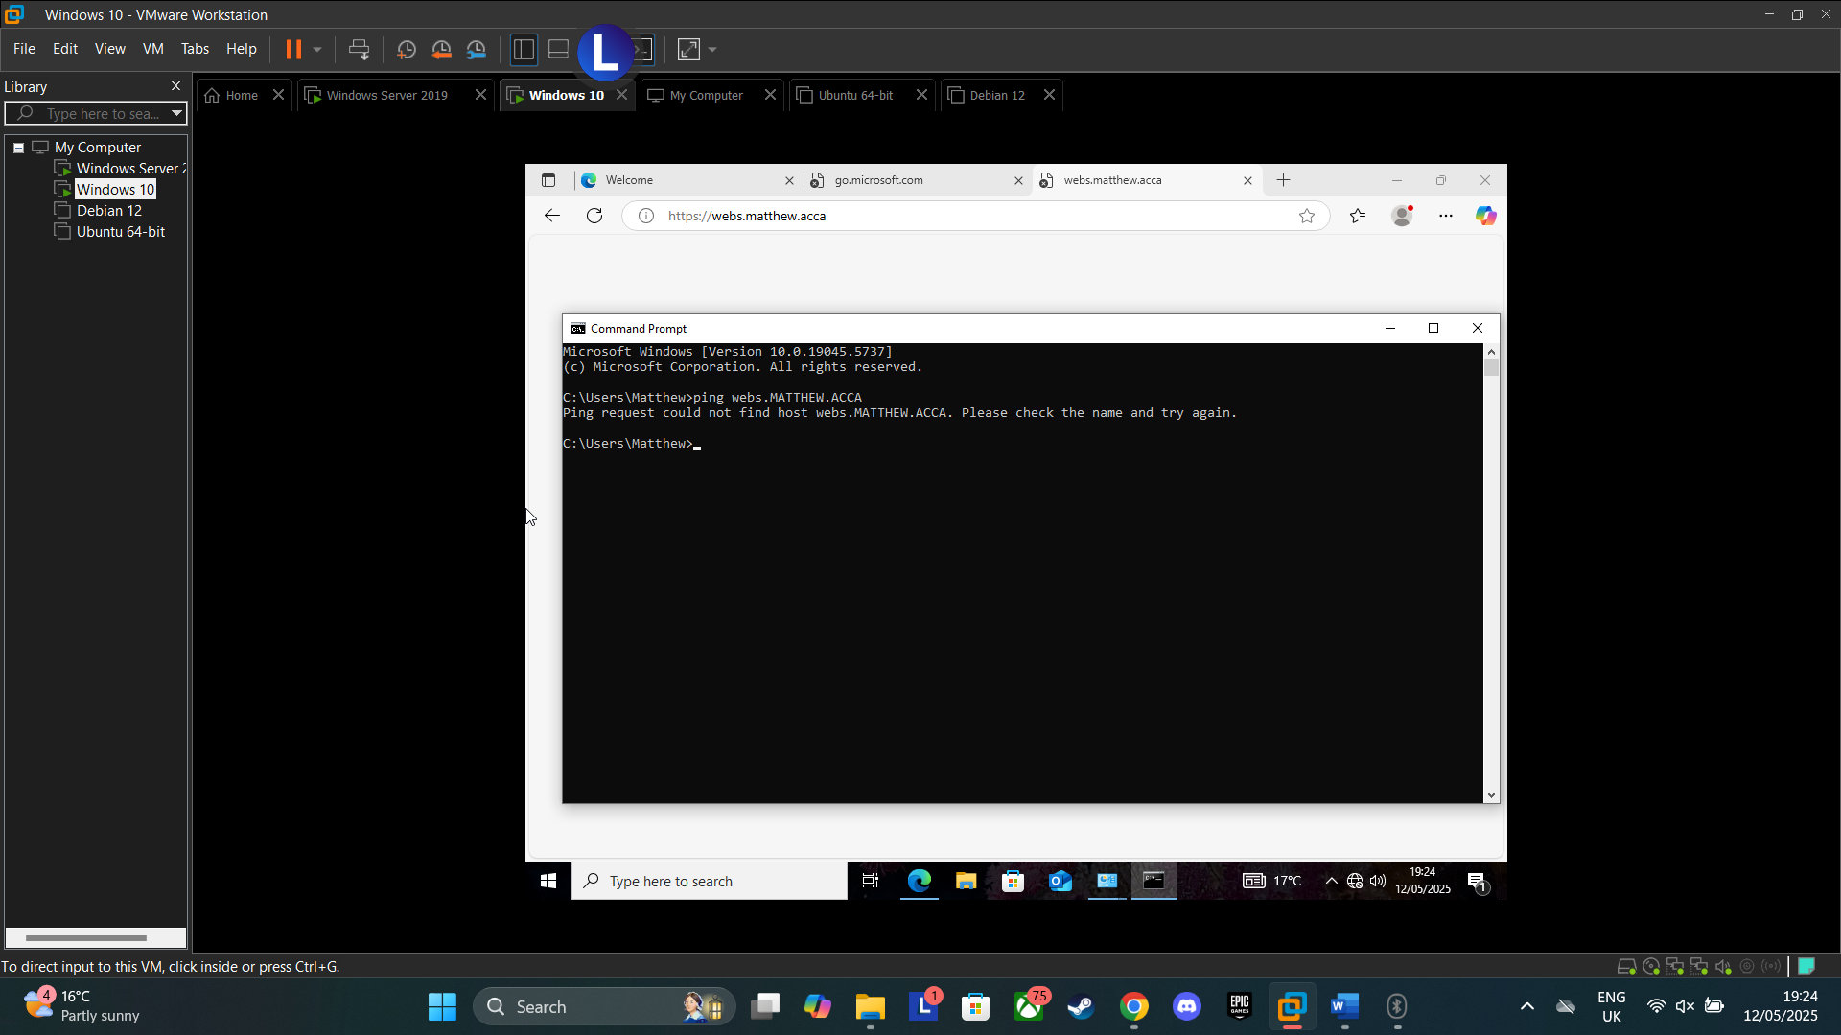
Figure 52: Attempt to ping website unsuccessful
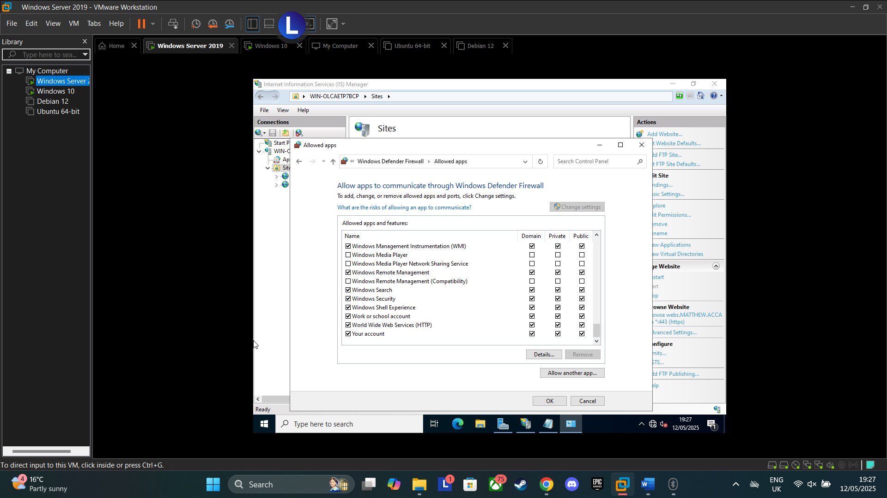
Figure 53: World Wide Web services allowed to run in firewall settings on server
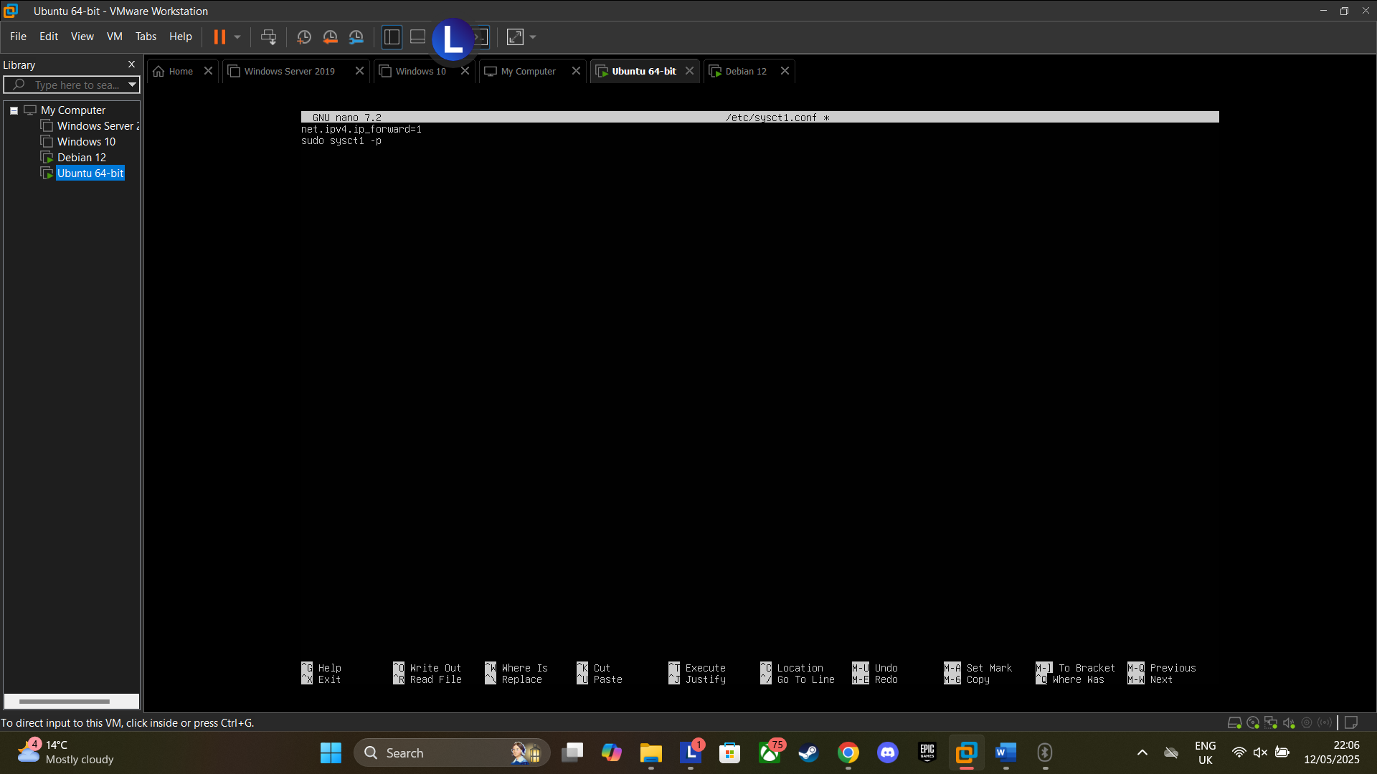
Figure 54: Enable IP forwarding
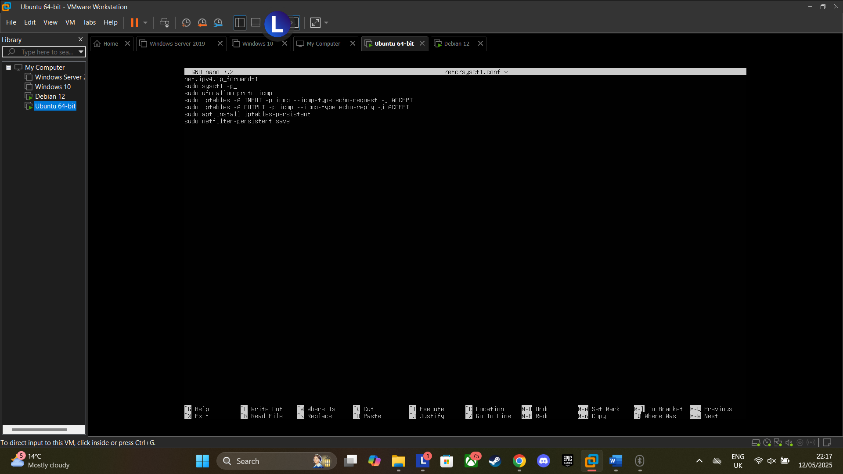
Figure 55: Modify Firewall Rules

