School of Hospitality & Tourism Management
BA International Hotel Management
Module Handbook Summer Term 2024
BMIH5007
Financial Management for the Hotel Industry
LEVEL 5
Module Lead:
Tristan Hawkins
T.Hawkins@uwtsd.ac.uk

Executive Summary
This report aims to compare and contrast between Shangri-La hotels and Travelodge hotels especially on the aspects of its revenue, positioning, prospect, and CSR activities. The study focuses on three questions and reveals that Shangri-La performs best in Luxury segment and participated meaningfully in Purposeful Expansion segment, while Travelodge is best-suited for Economy segment and has properties in every region. Ideas surround increasing ‘e-commerce’ of services offered for Shangri-La and streamlining the business processes for Travelodge, with the objectives of improving their standing in the market and increasing their sustainability in the long run.

Table of Contents
1.0. Introduction 4
1.1. Purpose 4
1.2. Overview 4
1.3. Key Areas 4
1.4. Scope and Limitations 4
2.0. Total Revenue 5
2.1. Analysis 5
2.2. Sources 5
2.3. Trends 5
2.4. Comparison 6
3.0. Market Position 6
3.1. Market Share 6
3.2. Customer Demographics 7
3.3. Brand Perceptions 7
3.4. Model Application-Bowman’s Strategic Clock 7
4.0. Growth Potential 9
4.1. Expansion Strategies 9
4.2. Market Opportunities 9
4.3. Potential Barriers to Growth 10
5.0. Financial Commitment to CSR 10
6.0. Recommendation 10
7.0. Conclusion 10
References 12

Introduction

Purpose
The purpose of this report is to compare and analyse the financial control techniques implemented in Shangri-La Hotels and Travelodge Hotels with a view of identifying the differences and similarities in their financial approaches and policies towards profitability and sustainability.

Overview
Shangri- La Hotels was founded in 1971 as an upscale hotels and lodging company with a range of locations in United States, Europe and Asia, providing luxury accommodations and services (Shangri- La Groups , 2024). On the other hand, Travelodge hotel belonging to the chain of Hospitality was established in 1985, offers economical accommodation for customers, who are on a budget, and caters for all classes of travellers for various reasons with the main focus being to deliver service that meets the needs of its clients without being expensive to set up or maintain (Travelodge Corporate, 2024).

Key Areas
Four key areas will be compared in the report:
- Total Revenue: To evaluate the relative performance of two organizations, there is the need to compare and analyse the revenue generated by the two organizations.
- Market Position: Topical analysis of the market and brand position, consumer base characteristics, and brand image.
- Growth Potential: Examining and evaluating different expansion approaches, markets, and constraints.
- Corporate Social Responsibility (CSR): Evaluating financial obligations and corporate social responsibility programs.

Scope and Limitations
This analysis will give a detailed comparison based on the latest information available and from latest reports. It is important to grasp here that the evaluation has been made under conditions of lack of the most recent financial data and, also, specific strategic information from both companies. The focus will be mainly on the public information and as such they help the public in planning their financial affairs, may not focus on all aspects.

2.0. Total Revenue

2.1. Analysis
The business models of Shangri-La Hotels and Travelodge Hotels depended on each other in that how each of them managed to perform in the market was quite different from the other. That is why in 2023, Shangri-La received significantly more revenues than in 2022 and managed to increase revenues by 46%, from 150 million pounds to 219 million (Shangri-La Group., 2023).. Meanwhile the growth that was noted in Travelodge was a notch lower with growth of 14%; its Revenues increased from £910 million to £1. 035 billion in the same period (Travelodge., 2023).
Company | 2022 Revenue (£ million) | 2023 Revenue (£ million) | Percentage Change
Shangri-La Hotels | 150 | 219 | 46%
Travelodge Hotels | 910 | 1,035 | 14%

2.2. Sources
Shangri-La Hotels
Room Revenue: Luxury positioning makes total room revenues very high with the backup of high room rates as the prime product (Park, and Min, 2020).
Food and Beverages: The catering and dining services are contributing a vast amount.
Other Services: Health care activities such as wellness services, events, and conferences are also encompassed.
Travelodge Hotels
Room Revenue: The businesses include high occupancy rates and budget prices to produce most of their earnings.
Food and Beverages: This is a hostel-type of offering aimed at offering simple bare needs, and the contribution is small.
Ancillary Services: Facilities such as internet connection, parking fees, and item sales from rooms yield income (Majeed et al., 2022).

2.3. Trends
Revenue trends over the past few years reveal several key factors influencing them:
Shangri-La Hotels
Strategic Expansion: The Superiority of Shangri-La in the Global Hospitality Industry Shangri-La’s revenues mostly originate from the company’s focused expansion in the Asia-Pacific region to address the escalating demand for luxury accommodations. With this strategy, it has been extending its operation to profitable markets, which has contributed to the company’s noted boost in its revenues (Shangri-La Group., 2023).
High-End Market Focus: Targeted customers who have maintained willingness to pay a premium price in the current environment have contributed positively to Shangri-La’s market by charging high prices which in turn boost total revenue per room (Shangri-La Group,2023).
Robust Loyalty Program: Membership reward programs have enhanced customer loyalty, increased frequency and charged high and stable revenues (Shangri-La Group,2023).
Travelodge Hotels
Affordability and Volume: According to the business needs, extending cheap hotel services for a broad Client base is Travelodge company’s strategy. This approach has resulted in consistently high occupancy levels, which has had a strong positive impact on the growth of its revenue base (Travelodge., 2023).
Market Penetration: Having a substantial market presence in strategic areas is also critical in that one is assured of constant business (Travelodge., 2023).
Digital and Technical Innovation: Online bookings in Travelodge are popular now increasing their clientele by expanding on the internet marketing platforms to target clients (Travelodge., 2023).

2.4. Comparison
Shangri-La gets more revenues that make more profits from their sophisticated facilities and services hence earning more revenue as compared to the room prices most of the time. On the other hand, Travelodge relies on occupancy of their rooms by offering cheap prices which will be successful in attracting most customers. This difference showcases the varied approaches to generating revenue: The strategies of Shangri-La and Travelodge represent two extreme approaches to the given problem: the former targets high-end market segment and sets high price levels while the latter seeks to attract as many customers as possible and actively utilizes online tools in order to increase Occupancy Rate.

3.0. Market Position

3.1. Market Share
Consumer needs can be segmented in many ways but, when it comes to the hotel business, Shangri-La Hotels targets one particular segment while Travelodge Hotels targets another (Alvarez et al., 2021). The company targets the high-end market and, therefore, has the least market share. In contrast, the Travelodge accommodates the low-end market segment and gains considerably larger coverage through this approach.

3.2. Customer Demographics
Shangri-La Hotels
Prime Location: Places in popular cities are important for the luxury travellers who have a concern about the site and privacy (Shangri-La Group., 2023).
Demographic Focus: The company focuses more on the wealthy persons mostly in the above 35years age bracket, who are conscious and wealthy and will prefer to pay more for quality services and accommodation.
Travelodge Hotels
Affordability: Serves meals at reasonable prices that are affordable by many clients and provides accommodation facilities that are within its client’s financial reach.
Demographic Focus: This hotel targets families, youths and any business persons who are between twenty five and fifty years of age who look for convenient and cheap places to sleep.

3.3. Brand Perceptions
Shangri-La Hotels
Brand Reputation: Shangri-La is one of the premium brands and their hotels are very popular for fine services. This perception is kept alive by Accor’s prime location and its offer of exclusive hospitality services in a luxurious setting.
Customer Feedbacks: The surveys show that the return guests appreciate the exclusivity of the venue and enhanced service offering (Shangri-La Group., 2023)
Travelodge Hotels
Brand Reputation: As a budget hotel brand, it is considered a popular option for those who need an inexpensive place to stay because its hotel is easily available.
Customer Feedback: The services provided are said to be averagely affordable as well as, the locations of the hotel being conveniently booked, but the overall services as well as the facilities provided are said to be rudimentary compared to the luxury hotel (Travelodge., 2023).

3.4. Model Application-Bowman’s Strategic Clock
Using Bowman's Strategy Clock, one can illustrate Shangri-La's and Travelodge's distinct market positioning:
Shangri-La Hotels: Shangri-La stands out in the “Differentiation” quadrant of the clock by providing exclusive, top-quality services at a premium cost. Their business approach emphasizes uniqueness, utmost care, and lavish offerings to appeal to affluent customers who value excellence over budget concerns (Shangri-La Group., 2023).
Travelodge Hotels: The last strategic space is the “Low Price” where Travelodge provides basic essential services of accommodation at rather low charges. Thus, as the key principle of this strategy traces its roots in a focus on efficiency and availability over opulence, the resulting approach is fundamentally aligned with a customer base that aims to get more value for the money they pay.
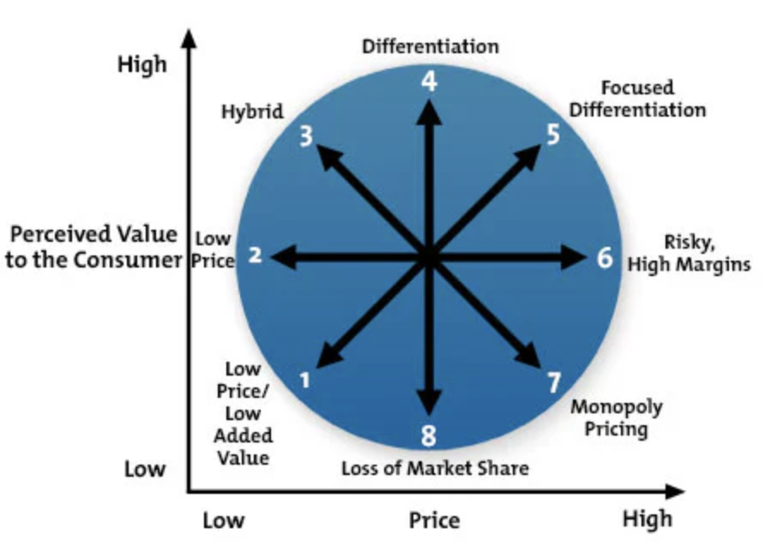
Figure 1: Bowman’s Strategic Clock Diagram
(Source: MindTools, 2024)
The Bowman's Strategy Clock looks like this:
Low Price: Travelodge: Based on cost leadership strategy as its main competitive advantage emphasises on lower price point.
Differentiation: Shangri-La- Provides sophisticated service with regard to price, focusing on high added value.
Shangri-La has distinguished itself in that it provides more upscale services and formulates unique experience excellence which can enable it to charge its service at a relatively higher price as it targets the more affluent clients. In this case, Travelodge has cut costs and offered more performances which can be embraced by a larger market that is looking for pocket friendly places.

4.0. Growth Potential

4.1. Expansion Strategies
Shangri-La Hotels:
Emerging Markets: Shangri-La has plans to expand in places that have more people gaining money to spend such as China and India where people are seeking to have better or luxurious places to live (Shangri-La Group, 2023). To downside risks, Shangri-La wants to enter these affluent markets early to establish a strong image and make new high end customers desire for their hotel services.
Partnerships: To help overcome barriers affecting entry into the market and minimize risks related to new market unfamiliarity, Shangri-La partners with local investors. These partnerships have become the solution to addressing issues arising from differing regulatory systems and cultural disparities.
Service Diversification: Currently it involves in other related services such as wellness programs and potentially restricted events like event catering. By offering wellness tourism services and becoming an official event venue and catering services supplier, Shangri-La is likely to address new target market segments and improve its revenues (MindTools., 2024).
Travelodge Hotels:
Franchising and Management Contracts: To achieve its objectives of very fast expansion and at the lowest expense possible, Travelodge relies on franchising as well as operational management agreements (Travelodge, 2023). In this model, rather than seeking ownership, Travelodge acquires franchise fees, which helps them expand without the huge investment needed for company-owned properties.
Key Locations: Concentration on the most populated and tourism-fluent regions enables Travelodge to address the unbroken stream of capacious lay, including business-tourist and tourist guests.
Technology Investments: The use of technology leads to effective functioning as well as augmentation of customers’ satisfaction. By the use of online booking systems and digital marketing, Travelodge increases the number of facilities and at the same time, decreases the time taken to coordinate all the business processes (Travelodge., 2023).

4.2. Market Opportunities
Shangri-La Hotels: Creating wellness tourism and upscale events, investing in the powerful, and encouraging the usage of finance in developing countries like China and India, and highlighting sustainability as a way of drawing new and budget-conscious tourists.
Travelodge Hotels: Investment in more locations, especially in urban and suburbs, focus on and expansion of the green policies, and improvement of digital presence for improved customer satisfaction and drive to book directly.

4.3. Potential Barriers to Growth
Shangri-La Hotels: Leading factors include fluctuations in the macroeconomic environment, high volatility of regulations, and high competitive pressures within the luxury goods segment (Park, and Min, 2020).
Travelodge Hotels: The need to maintain uniformity of service quality across franchises, excessive competition, and the issue of franchise sensitivity for the business.

5.0. Financial Commitment to CSR
Shangri-La Hotels: Promotes food safety, environmentally friendly practice in buildings, and membership in the community by issuing ISO 22000 certifications (Shangri-La Group., 2023).
Travelodge Hotels: Adopts the “Better Future” strategic plan with key areas of priorities focusing on diversity and inclusion, environmental action, and social impact (Travelodge., 2023).
Comparison: To appeal to the high-end travellers, sustainability is promoted as an essential element of the Shangri-La brand. Travelodge has a sensible and sensitive approach to CSR activity corresponding to its economic plan. In line with that, the CSR activities of both their firms differ in their efficiency in financial commitment.

6.0. Recommendation
For Shangri-La Hotels: Offer tailored services and enhance the quality of consumer contacts in the digital space.
Travelodge Hotels: Optimizing the operation with regards to the use of technology in order to increase and improve on customer satisfaction.
Justification: The digital implementations bear the luxuries that Shangri-La embraces while operational optimization fits Travelodge’s low-cost framework and customer appeal. Market growth and potential and consumer needs and wants are Utilized in both illustrated distinctive value strategies.

7.0. Conclusion
Shangri-La, therefore, leverages on luxury products and appropriate growth strategies to maintain its position at the apex while Travelodge seeks to dominate the low-budget market mainly through accessible locations. They each undergo their own challenges and opportunities for development. By doing so and committing to the key areas while also capitalizing on their respective strengths, they are able to grow and, in turn, expand their reach and influence the market more. This goes in a way to show the balanced formula needed in the hotel industry for achieving financial viability.

References
Alvarez, T., Sensini, L., Bello, C. and Vazquez, M., 2021. Management accounting practices and performance of SMEs in the Hotel industry: Evidence from an emerging economy. International Journal of Business and Social Science, 12(2), pp.24-35.
Majeed, M., Asare, C., Fatawu, A. and Abubakari, A., 2022. An analysis of the effects of customer satisfaction and engagement on social media on repurchase intention in the hospitality industry. Cogent Business & Management, 9(1), p.2028331.
MindTools, F. (2024) Home, MindTools. Available at: https://www.mindtools.com/a2rq300/bowmans-strategy-clock (Accessed: 14 September 2024).
Park, J. and Min, H.K., 2020. Turnover intention in the hospitality industry: A meta-analysis. International Journal of Hospitality Management, 90, p.102599.
Shangri- La Groups , A. (2024) Shangri- La Groups , Luxury escape at best rate. Available at: https://www.shangri-la.com/group/ (Accessed: 14 September 2024).
Shangri-La Group (2023). Annual Report 2023. Available at: https://sitecore-cd.shangri-la.com/-/media/Project/Shangri-La-Group/Investor/Files/Public-Disclosures/Latest-Top-Publications/2023_Annual_Report_E.pdf (Accessed: 12 September 2024).
Shangri-La Group (2023). Sustainability Report 2023. Available at: https://sitecore-cd.shangri-la.com/-/media/Project/Shangri-La-Group/Sustainability/Images/Sustainability-Report/2023_SustainabilityReport.pdf (Accessed: 12 September 2024).
Travelodge (2023). Annual Report 2023. Available at: https://www.travelodge.co.uk/nw/sites/default/files/Thame_and_London_Limited_signed_FY23.pdf (Accessed: 12 September 2024).
Travelodge (2023). Sustainability Strategy: Better Future. Available at: https://travelodge.co.uk/our-business/blog/2023/06/15/travelodge-reveals-2023-plans-for-its-sustainability-programme-better-future/#:~:text=Aim%3A%20To%20achieve%2090%25%20compliance,%E2%80%9CCPR%E2%80%9D)%20during%202022. (Accessed: 12 September 2024).
Travelodge Corporate, A. (2024) Company overview, Travelodge Corporate Website. Available at: https://travelodge.co.uk/our-business/about-us/company-overview/ (Accessed: 11 September 2024).

