

Developing relationships and workplace achievement

Executive Summary
Akbor Ali 1709535
April 17, 2019

BMSK5002

The purpose of this report is to analyse and identify development vehicles that enable developmental needs of an individual and of an organisation. The importance of development vehicles such as training, employee engagement and performance management will be analysed and debated. The use of organisational theories and their importance in the workplace and how beneficial it can be to determine its structure. Observations relating to the assumption that individuals in the workplace, hold the intention to do their necessary jobs and do them well. Identification of clear and systematic learning and development needs is analysed, to ensure effective learning across each level of an organisation is achieved. A personal development plan will be included to assess the observers needs and to identify further development necessary to achieve personal goals.

Table of Contents

Executive Summary 0
Introduction 3
1.0 Development Vehicles in a Workplace 4
1.1 Training 5
1.2 Employee Engagement 6
1.3 Performance Management 7
2.0 Benefits of Development Vehicles to an Organisation & Individuals in the Workplace 8
2.1 Benefits to an Organisation 9
2.2 Benefits to an Individual 10
3.0 Personal Development Plan (PDP) 11
Conclusion 14
References/Bibliography 15
Appendix 18

Introduction

The Aim of this report is to identify and understand development vehicles, that allow individuals to develop knowledge and enhance skills necessary to perform and meet their objectives. Jones, (2018) argues that identifying employee learning and development needs is a crucial element to organisations. Development vehicles work when there is an organisational structure that allows this process to happen. Development vehicles such as training, employee engagement and performance management are approaches taken by organisations to identify the necessary skills required to fill talent gaps.
Underlying this report is the assumption that organisations and individuals in the workplace, hold the intention to do their necessary jobs and do them well. Organisational structure is effective when management theories are implemented. Markgraf, (2019), states that, most organisational theories deal with similar principles and systems. Theories enable organisations to find a structure that would be suitable and beneficial in line with their circumstance in its workplace. Management theories can be an effective approach. Foster, (2019) explains that, theory is the foundation upon where an idea is based and reflects human behaviour and development. Developing and coaching relationships within an organisation should be the first step as employees are one of the most valuable assets to an organisation.
This report analyses the potential for an increase in productivity using development vehicles. With the assumption that management recognises this and provides the correct training to its employees. It will be suggested that, training might be incorporated in to development plans. Half, (2018) explains that, an employer needs to plan a training programme to ensure value is gained not just financially but in terms of developing employee skills. The workplace will be analysed and an evaluation of potential development areas will be presented.

Development Vehicles in a Workplace

Development vehicles according to Cornerstone, (2019) are, a set of processes where employees with support from the employer, undertakes numerous training programs to develop or enhance skills and acquire new knowledge. Development of individuals within an organisation’s workplace is essential for success, it’s a way to ensure that employees have the skills and knowledge necessary to perform and meet their objectives. According to Wood, (2018), employee retention in today’s work environment has stabilised especially among millennials due to high performance development vehicles, such as training, performance management and importantly employee engagement programs. To understand these approaches of development and to implement these an organisations needs a structure.
Organisational theories and models are appropriate elements to an organisation and its structure. They help to understand how organisations come to be structured in certain ways as well as how some are more successful than others. It in many ways determines the approach an organisation might take and how it goes about its business. Markgraf, (2019), states that “organisational theories can help address issues within an organisation successfully”, as most organisational theories deal with similar principles and systems. Foster, (2019) describes organisation theories as applications that are focused on how organisations function. Foster, (2019) further adds that “theory is the foundation upon where an idea is based and reflects human behaviour and development”.
This approach according to Educba, (2019) is that, the human relation theory known as the classical management theory, focuses on the relationship between manager and worker. Mullins, (2007, p.367) suggests, the human relations approach to management emphasises the importance of people in the workplace and the psychological and social factors shaping organisational behaviour. Educba, (2019) also explains, the understanding of management theories, is a way organisations can find out which theory would be suitable and beneficial in line with their circumstance in its workplace.
Development vehicles are important to an individual as Lipman, (2013) understands that young employees want training, mentoring, coaching and the desire to gain skills. They are ambitious and want to become more versatile and valuable to an organisation. Jones, (2018) argues that identifying employee learning and development needs is a crucial element to organisations. It links directly to their desired business outcome which is a very important part of an organisation's overall strategy and its business policies. Woods, (2018) suggests that “employee development vehicles mean nothing if they do not align with organisations goals”. In short, identify the skills required to fill talent gaps. Change in skill and knowledge can be developed using several employee development vehicles such as training, employee engagement and performance management which needs to be reviewed frequently.

1.1 Training

A clear training strategy helps workers align their work to organisational goals. Employees are one of the most valuable assets to an organisation, they should be given adequate training in order to improve and develop their functioning in the workplace. McNamara, (2019) states that, training can be initiated for a variety of reasons, whether it be for development needs or for performance enhancements. It is vital that the management recognises this and provides the correct training to its employees. Half, (2018) explains that, an employer needs to plan a training programme to ensure value is gained not just financially but in terms of developing employee skills. As an example-
Employees at Virgin Atlantic form an integral part of its business policy and is committed to serve its employees better. A case study by Rodrigo, (2017) explains that, good work at Virgin Atlantic is recognised through its acknowledgment program and provides world class training to all its employees. Training is given great emphasis as it is a core value to the company. Clear, precise training and development programs when implemented thoughtfully can make the difference to an organisation’s success. A training programme should include a skills gap analysis to assess the needs of an organisation. Pavlou, (2018) explains that, “identify the needs of an organisation to set objectives for employees and produce training programs that aim to develop the skills that are most important to the organisation”. For example, it could include-
- Professional training- IT courses to update software literacy
- On the Job learning- Gain experience practically, coaching
- Quality training- To conform to standards
- 360-degree feedback- Regular appraisals
- Motivation theories- Stephen Covey-
- Leadership development- Consider Adair’s theory, Tuckman model
Measure its results, to gauge the effectiveness of these training programs by tracking improvements in employee performance.

1.2 Employee Engagement

Employee engagement is an important development vehicle. According to Engagement Multiplier, (2018), the importance of employee engagement should not be overlooked and that employee engagement strategies have been proven to improve efficiency, productivity as well as retain customers at very high rates and most of all reduce employee turnover. This approach has been taken by Virgin Atlantic. According to Virgin.com, (2019), Richard Branson says “it was the people I surrounded myself with who made the difference, if you treat your employees right, they will treat your customers right and sustained profits will follow.” Employee engagement allows employees to make the best out of their skills and abilities for their benefit and of the employer.
It’s easy to mistake employee engagement with employee satisfaction. According to Rogel, (2018) they are completely different. Rogel, (2018) uses Frederick Herzberg’s Motivation & Hygiene Theory to represent this point by saying “people are influenced by two factors, those that include challenging work, responsibility and recognition, which are motivation factors. Secondly hygiene factors include, working conditions, benefits, pay and job security. These are basic factors”. Custominsight, (2019) states, employee engagement is a different vehicle to employee satisfaction. Employee satisfaction only indicates how content or happy an employee might be and does not address levels of motivation, involvement or the measurement of commitment emotionally or otherwise. Satisfied employees intend to do as little work as possible for a salary. This point falls in line with Maslow’s theory. Mullins, (2007, p. 368) explains that of, Maslow’s hierarchy of needs, where the central proposition of individuals is to satisfy a specific set of needs. These include basic physiological needs as well as progressing systematically up the hierarchy to self-actualisation. Realisation to this theory puts satisfied employees as just a stagnation to basic levels, rather than progression up the hierarchy.
The understanding according to Custominsight, (2019) is, although employee satisfaction is important to development, it may not necessarily lead to increased performance. Employee engagement on the other hand focuses on an engaged workforce. According to CIPD, (2018), employee engagement builds on an older concept of motivational theories by Herzberg and Maslow, with more behavioural elements closely relating to Katz organisational citizenship behaviour. This is supported by CMI, (2015) who references David MacLeod’s report of 2009 on employee engagement. MacLeod defines employee engagement as a workplace process developed to ensure an organisations workforce is committed to the values and goals of an organisation. Where employees are motivated to contribute to its success, along with a sense of personal well-being. Referring to Custominsight, (2019) there are two primary factors that drive employee engagement-
- Engagement with the Organisation-This measures how engaged an employee is with the organisation.
- Engagement with Managers-A more specific measure of how an employee can relate with their line managers.

1.3 Performance Management

Performance management according to Gilfford, (2018), is a set of processes that help improve employee performance and aims to maintain performance in line with organisational goals and to ensure employees contribute positively to business objectives. Gilfford, (2018) also states that, there is no clear definition of performance management but that of a range of tools and activities. Which help establish objectives, improve individual performance and to hold individuals to account. Gilfford, (2018) states, there is no clear definition of performance management, but further research enables Hearn, (2017) to give a more distinct definition referencing a quote from Michael Armstrong (the creator of the Armstrong performance management cycle), as saying “performance management is the continuous process of improving performance by setting individual and team goals which are aligned to the strategic goals of the organisation, planning performance to achieve the goals, reviewing and assessing progress, and developing the knowledge, skills and abilities of people.”
Performance management and performance appraisal are similar development vehicles, but both vehicles take a different approach. As Pawar, (2017) explains, performance management and performance appraisal can be, and is used interchangeably sharing certain similarities. Pawar’s, (2017) explanation to this is that, performance management is a more comprehensive approach that entails greater dialogue between all within the organisation. Whereas performance appraisal is primarily a top down assessment in terms of rating or grading employees’ performance periodically. A fare point to raise, is that this vehicle in conjunction with performance management can be combined to create a more comprehensive process. As stated by Pawar, (2017) who says, “many successful organisations have implemented performance appraisal as a part of their performance management process, and it has helped take corrective action and assign further targets by combining the two”. According to Virgin Atlantic, (2019), a clear and precise path of development will enable employees to have the support of their manager to facilitate success. Everyone has the chance to learn and develop, ensuring that progress is continuous. These claims show that a performance management vehicle is in place.

2.0 Benefits of Development Vehicles to an Organisation & Individuals in the Workplace

Organisations that continually engage in organisational and employee development, will not only prepare themselves for the present but also the future. Haydon, (2018) states that, clear and systematic identification of learning and development needs is a key aspect to an organisations process of ensuring effective learning across each level of an organisation. Haydon, (2018) also expresses that, if used correctly, it can provide new insight and data for identifying the learning needs of individuals and organisations.
For organisations to utilise these vehicles, the leadership and management need to be effective. According to Education portal, (2013), modern management theory has given a new direction on how managers view their job. With advancements made due to refinement and practice in management theory, it has enabled managers to use multiple theories to advance in their leadership roles. Education portal, (2013) states that, there are three popular management theories a leader could approach to implement employee direction that will help them create good leadership and management on all levels.
- The Quantitative approach- A measurement by statistics & data.
- The Systems approach- A process that builds with inputs, processes & outputs a combination of elements to create a complex whole.
- The Contingency approach- A situational approach of integrating organisations dependant on environmental conditions.
In other words, the relationships between the individuals working together and their overall effect are dependent on the leadership and management.

2.1 Benefits to an Organisation

Training and development of employees is a prime opportunity to expand the knowledge of employees and for the organisation. Frost, (2019) states, employers find the development opportunities expensive and prioritises in other activities rather than training and development. Entrepreneur, (2005) states in their opinion, the primary reason training is overlooked by so many organisations is due to it being considered more as an expense than an investment. Contrast that opinion to that of one where training is viewed as an investment rather than an expense. A case study on Admiral Insurance by InspireMe, (2019) highlights the advances that Admiral Insurance has made by investing in development vehicles. According to InspireMe, (2019) Admiral used inspirational in-house development vehicles for improvements in key areas such as attendance, motivation and goal setting by launching a new team building initiative. The success had an impact on confidence, motivation and performance of their employees. According to Business.com, (2017), the willingness to invest in the development of employees through vehicles such as employee engagement, performance management and training will likewise inspire them to invest their hard work, effort and are more likely to be loyal to the organisation. Key benefits for an organisation can be:
- More profits & revenue
- More efficient
- Enhanced reputation
- More competitive
- Increased innovation
- Increased employee retention
- Promote from within
- Augmented Abilities
Ignoring workplace training organisations can risk:
- Unsatisfied employees
- Reduced productivity
- Increased staff turnover
- Unsafe work environments

2.2 Benefits to an Individual

An organisation that invests in its employees providing training and development tends to have a satisfied workforce. Martinelli, (2018) suggests that, to retain good employees adequate training is crucial. According to Staff training solutions, (2017), ambitious employees’ look for quality training programs that can aid in their career development, to help them progress further. Key benefits for an individual can be:
- Motivation
- Job satisfaction
- Higher morale
- Self esteem
- More productivity
- Promotion
- Competitiveness
- Job Awareness
Development although crucial, some organisations may over-train their workforce. Robertson, (2019) says that “some organisations may cross the line into over-training their employees, which can have several problems”. Examples of this can be:
- Increased stress 4. Becomes a hindrance
- Loss of interest 5. Repetitive
- Time & money

3.0 Personal Development Plan (PDP)

Personal development for an individual is crucial both in and out of the workplace. Bangor University, (2019) explains, personal development plans can be useful to highlight an individual’s strengths, weaknesses and to develop skills to ensure the necessary vehicle is adopted to address both short and long-term development goals. Heatley, (2019) describes personal development plans as a forward-thinking plan, that allows individuals to reflect on how they can excel in their personal and professional life by simply asking the question of “what, where, how and when” of personal growth. Similarly, Matthews, (2014) says “by having a personal development plan, an individual can review, plan and take responsibility for their own learning”.
Personal development plans according to Bangor University, (2019) should define what is important to an individual by accurately outlining personal goals, strengths & weaknesses effectively using a SWOT analysis. The author has completed a personal development plan to reflect on his development needs and expectations.
Personal Analysis
Ali, A. (2018)
INTERNAL
Confidence
Problem Solving Organised
Communication
Social Skills Leadership

Writing Skills
Qualifications
Presentation skills
Team work skills

THREATS
University courses are more widely available.
Practice through Regular presentations in University.
Support classes are available to enhance writing skills.

EXTERNAL

People with qualifications are readily available.
New job seekers with less commitments.
Recruiters are more specific in the selection process, writing skills is a priority.

Personal

Development Plan
Name: Mr Akbor Ali Date: 17th April 2019
Short Term Goals: Complete 2-year University course.
Long Term Goals: A career in leadership and management

Objectives
Implementation
Actions
Success Criteria
To achieve the BA Qualification | Complete 2-year BA course with a distinction. | Complete course modules and apply feedback from tutors. | Further training and apply qualification to enhance potential for a career in leadership and management.
Improve on presentation skills | Memorisation and body language to dictate presentation, engaged audience. | Take on more presentations in class, apply feedback from tutors and audience acceptance. According to skillsyouneed, (2019) the ability to clearly and effectively get a message or opinion across, is a required skill. | With further development, will be able to present confidently in current workplace with a more focused and determined approach.
Improve on writing Skills | Feedback from tutors will demonstrate personal advancements through grades. As Bailey, S. (2015, p. 14) suggests, accurate and effective Writing and language use is an essential skill. | Read books, take more notes and apply feedback from tutors on completion of written work. | Training will allow the use of formal writing and be able to correspond to governmental institutions with ease.
Improve team working skills | Team feedback with positive results and progressive involvement as a team member. | Work with groups more often in the undertaken course, take on more responsibility. | Will have a more proactive team with the ability to remain focused and motivated with greater leadership qualities. According to Cottrell, S. (2015, p. 40) high levels of motivation is associated with success.
Improve knowledge on IT skills | Be able to create websites, use of different applications and create effective programs. | Practice a more varied set of applications during the university course and take an independent IT course | Apply the knowledge to create applications and websites for future business ideas.
Improve management skills | Feedback from workers in current workplace. Positive, motivated staff members. | Complete BA leadership and management course to gain more knowledge and to understand organisational theories. | Further development and training will enhance the ability to manage and lead successfully using the knowledge form the BA course.

Conclusion

The authors findings conclude, development vehicles support organisations and individuals prepare themselves for the present, also the future and bolsters workplace skills. Cornerstone, (2019) suggests, development of individuals within an organisation’s workplace is essential for its success. According to Wood, (2018), employee retention has stabilised due to high performance development vehicles. Using a variety of developmental vehicles such as, training, employee engagement and performance management, also helps to ensure employees have the skills and knowledge necessary to perform and meet their objectives.
The approach should match the development vehicle to the situation. Haydon, (2018) states, clear and systematic identification of learning and development needs, is a key aspect to an organisations process of ensuring effective learning across each level of an organisation. Employers should assess employees and get feedback from trainees to see if they learned anything. Employers should then use results from popular and most effective vehicles to design a specific training program. Frost, (2019) states, employers find the development opportunities expensive. According to Business.com, (2017), the willingness to invest in the development of employees can inspire them to invest their hard work, effort and are more likely to be loyal to the organisation. Training and development should be looked at, not as a hindrance but as an investment to an organisation’s success.
Theories help organisations address environmental changes and influence how organisations structure themselves. Foster, (2019) describes organisation theories as, applications that are focused on how organisations function. The use of theories within an organisational structure can help encourage employee learning. Educba, (2019) suggests, employers need to have a working knowledge on emerging insights into how people learn. Management theories, such as the human relation theory, can assist the leadership to focus more on its workers. In return this can lead to an increase of organisational productivity and maintain the bond with the employees associated with the organisation.

References/Bibliography

Bailey, S. (2015), Academic Writing – A Handbook for International Students, (Third Edition) Oxon: Routledge
Bangor University, (2019)’Staff Development’ [Online] Available: https://www.bangor.ac.uk/humanresources/staffdevelopment/pdr/pdp-guide.php.en, Accessed: [14th, April, 2019]
Business.com, (2017) ‘Why Business Should invest in Employee Training’ [Online] Available: https://www.business.com/articles/why-businesses-should-invest-in-employee-training/, Accessed: [ 4th, April, 2019]
CIPD, (2018)’Employee engagement and motivation’ [Online] Available: https://www.cipd.co.uk/knowledge/fundamentals/relations/engagement/factsheet, Accessed: [10th, April, 2019]
CMI, (2015)’Employee Engagement’ [Online] Available: https://www.managers.org.uk/knowledge-bank/employee-engagement, Accessed: [9th, April, 2019]
Cornerstone, (2019) ‘Employee Development’ [Online] Available: https://www.cornerstoneondemand.com/glossary/employee-development, Accessed: [ 4TH, April, 2019]
Cottrell, S. (2015), Skills for Success – Personal Development and Employability, (Third Edition) Hampshire: Palgrave Macmillan
Custominsight, (2019)’What is Employee Engagement’ [Online] Available: https://www.custominsight.com/employee-engagement-survey/what-is-employee-engagement.asp, Accessed: [9th, April, 2019]
Education portal, (2013)’Modern Theory of Management’ [Online] Available: http://oer2go.org/mods/en-oya/business-101/webpages/Chapter4/1-modern-theory-of-management.html, Accessed: [10th, April, 2019]
EDUCBA, (2019)’How to Apply Management Theories At Workplace’ [Online] Available: https://www.educba.com/how-to-apply-management-theories-at-workplace/, Accessed: [15th, April, 2019]
Engagement Multiplier, (2018)’Why is Employee Engagement So Important’ [Online] Available: https://www.engagementmultiplier.com/blog/why-is-employee-engagement-so-important/, Accessed: [8th, April, 2019]
Entrepreneur, (2005) ‘The Importance of employee Development’ [Online] Available: https://www.entrepreneur.com/article/77678, Accessed: [ 4th, April, 2019]
Foster, K, W. (2019)’Organizational theory’ [Online] Available: https://www.britannica.com/topic/organization-theory, Accessed: [11th, April, 2019]
Frost, S. (2019)’The Importance of Training & Development in the Workplace’ [Online] Available: https://smallbusiness.chron.com/importance-training-development-workplace-10321.html, Accessed: [11th, April, 2019]
Gilfford, J. (2018)’Performance management: an introduction’ [Online] Available: https://www.cipd.co.uk/knowledge/fundamentals/people/performance/factsheet, Accessed: [8th, April, 2019]
Half, R. (2018)’The Benefits of employee training’ [Online] Available: https://www.roberthalf.ae/advice/people-management/benefits-employee-training, Accessed: [9th, April, 2019]
Haydon, D. (2018) ‘Identifying learning and development needs’ [Online] Available: https://www.cipd.co.uk/knowledge/fundamentals/people/development/learning-needs-factsheet, Accessed: [ 4th, April, 2019]
Hearn, S. (2017)’ What is an Effective Performance Management System?’ [Online]. Available: https://www.clearreview.com/resources/guides/what-is-effective-performance-management/, Accessed: [8th, April, 2019]
Heatley, S. (2019)’The ultimate personal development plan guide + free templates’ [Online] Available: https://www.perkbox.com/uk/resources/blog/the-ultimate-personal-development-plan-guide-free-templates, Accessed: [14th, April, 2019]
InspireMe, (2019)’Case study: Admiral Insurance’ [Online] Available: https://www.andinspireme.com/happy-clients/admiral/, Accessed: [11th, April, 2019]
Jones, M. (2018)’How To identify training and development needs’ [Online] Available: https://www.breathehr.com/blog/how-to-identify-employee-training-and-development-needs, Accessed: [ 4th, April, 2019]
Lipman, V. (2013) ‘Why Employee Development is Important, Neglected and can Cost You Money’ [Online] Available: https://www.forbes.com/sites/victorlipman/2013/01/29/why-development-planning-is-important-neglected-and-can-cost-you-young-talent/, Accessed: [ 4th, April, 2019]
Markgraf, B. (2019)’What are Organizational Theories?’ [Online] Available: https://smallbusiness.chron.com/organizational-theories-61457.html, Accessed: [10th, April, 2019]
Martinelli, K. (2018)’The Consequences of a Lack of Training in the Workplace’ [Online] Available: https://www.highspeedtraining.co.uk/hub/lack-of-training-in-the-workplace/, Accessed: [10th, April, 2019]
Matthews, R. (2014)’What is a personal development plan and how to create one’ [Online] Available: https://brayleinolearning.co.uk/blog/2014/october/31/what-is-a-personal-development-plan-and-how-to-create-one/, Accessed: [14th, April, 2019]
McNamara, C. (2019)’Development Reasons and Benefits’ [Online] Available: https://managementhelp.org/training/basics/reasons-for-training.htm, Accessed: [9th, April, 2019]
Mullins, L.J. (2007), Management and Organisational Behaviour, (Ninth Edition) Harlow: Pearson
Pavlou, C. (2019)’How to build your first employee training program’ [Online] Available: https://resources.workable.com/tutorial/employee-training-program, Accessed: [10th, April, 2019]
Pawar, Y. (2017)’ How to differentiate performance appraisal from performance management?’ [Online] Available: https://upraise.io/blog/performance-appraisal-management/, Accessed: [8th, April, 2019]
Robertson, T. (2019)’The Disadvantages of Over-training in the Workplace’ [Online] Available: https://smallbusiness.chron.com/disadvantages-overtraining-workplace-20625.html, Accessed: [10th, April, 2019]
Rodrigo, (2017)’Virgin Atlantic Airlines’ [Online] Available: https://writepass.com/journal/2017/01/virgin-atlantic-airlines/, Accessed: [9th, April, 2019]
Rogel, C. (2018))’Employee Satisfaction vs Employee Engagement in 2018’ [Online] Available: https://www.decision-wise.com/job-satisfaction-vs-employee-engagement/, Accessed: [10th, April, 2019]
Skillsyouneed, (2019)’Presentation Skills’ [Online] Available: https://www.skillsyouneed.com/presentation-skills.html, Accessed: [15th, April, 2019]
Staff Training Solutions, (2017)’benefits of Training to Employees and Employers’ [Online] Available: https://www.stafftrainingsolutions.co.uk/sts-blog/benefits-of-training-to-employees, Accessed: [9th, April, 2019]
Virgin Atlantic, (2019)’Learning and Development’ [Online] Available: https://careersuk.virgin-atlantic.com/life-at-virgin-atlantic/learning-and-development, Accessed: [9th, April, 2019]
Virgin.com, (2019)’ Richard Branson secrets for success’ [Online] Available: https://www.virgin.com/entrepreneur/richard-bransons-secrets-success, Accessed: [9th, April, 2019]
Wood, S. (2018)’ 5 Steps to Help Improve Your Employee Development Methods’ [Online] Available: https://www.greatmanagers.com.au/improve-employee-development-methods/, Accessed: [8th, April, 2019]

Appendix

. 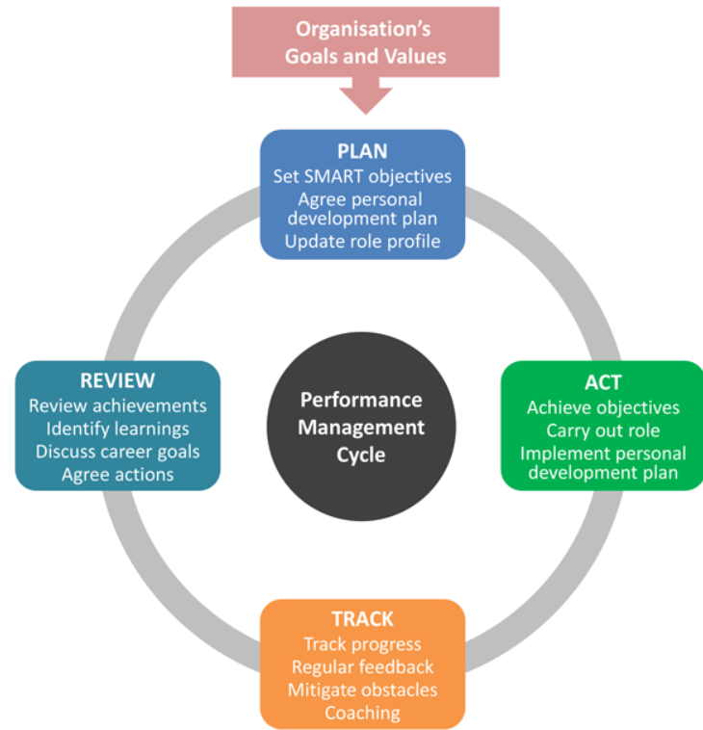Armstrong Performance management Cycle Hearn, (2017)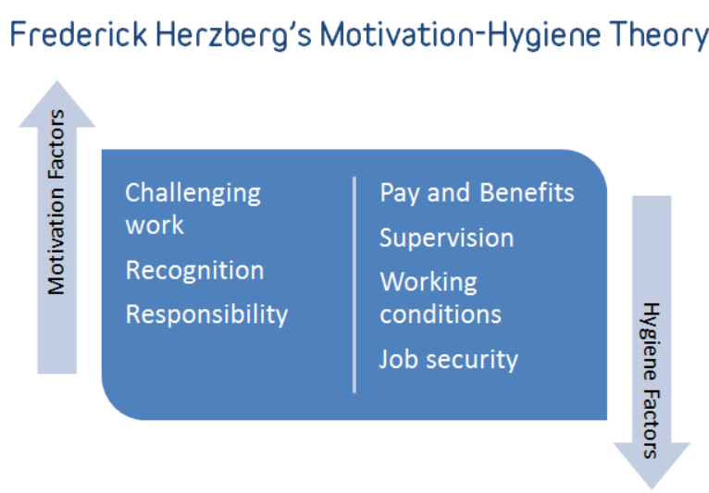Rogel, (2018)
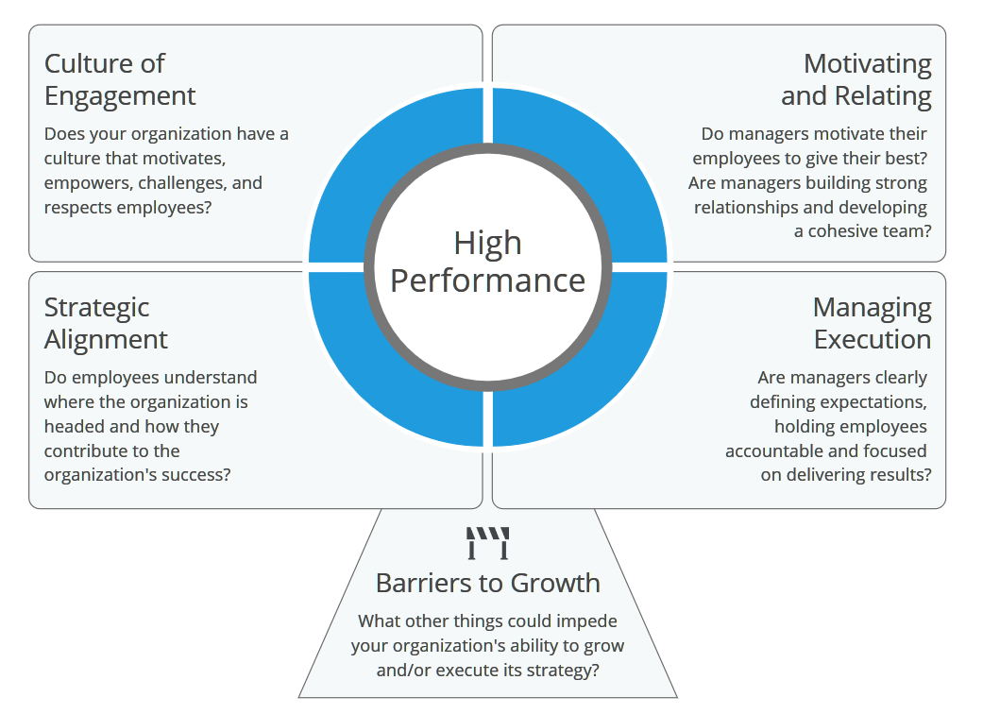Custominsight, (2019)

