
Module Name: Digital Skills for Personal Development and Business Growth
Module Code: BMSW4008
Assignment Title: Portfolio
Student Name: Gareth McDonagh
Student Number: 2520761
Lecturer: Scott James
Deadline: 16th March 23.59 2026

AI Acknowledgement Statement:
Examples of statements If you have not used AI
I confirm that I have not presented any AI generated materials as my own work.
I confirm that I have copies of my drafts, notes, and other resources I used, which I may be asked to provide in evidence.
Examples of AI statements if you have used AI
I acknowledge that o used AI tools such as Chat GPT to check grammar and improve the clarity of my writing, the AI tool was used to help refine my work.
ex(https://www.chatgpt.co.uk) on Date 16/03.2026
I confirm that I have not presented any AI generated text as my own work. I confirm that I have copies of my drafts, notes, and other resources I used before, and after the use of AI tools which I may be asked to provide in evidence.

Contents
Task 1: Assessment of Digital Skills (700 Words) 4
Introduction: Importance of Digital Skills 4
Overview of the JISC Digital Capability Tool 4
Summary of JISC Results 4
Strengths in Digital Skills 4
Areas for Improvement 4
Action Plan Using SMART Goals 4
Reflection and Conclusion 4
Task 1 References (Minimum 5) 4
Task 2: LinkedIn Learning Certificates – Office 365 5
Outlook Essential Training (Microsoft 365) 5
Word Essential Training (Microsoft 365) 5
Excel Essential Training (Microsoft 365) 5
PowerPoint Essential Training (Microsoft 365) 5
Task 3: Relevance and Importance of Microsoft Excel (1,000 Words) 5
Introduction 5
Uses of Microsoft Excel 5
Data Analysis 5
Budgeting and Financial Management 5
Reporting and Decision-Making 5
Practical Spreadsheet Task 5
Reflection and Conclusion 6
Task 3 References (Minimum 5) 6
Task 4: Reflective Presentation Summary (5 Minutes) 6
Overview of Presentation Content 6
Learning and Skill Development 6
Links to Task 1 6
Links to Task 2 6
Links to Task 3 6
Application to Studies and Career 6
Task 3 References (Minimum 5) 7

Task 1: Assessment of Digital Skills
Digital skills are the skills we use to work with technology and the internet to complete tasks, communicate and research information online.
Digital skills are important in higher education because students like myself use Microsoft word to write assignments, Microsoft Excel to organise data and Microsoft PowerPoint to present presentations. I also use the internet to gather and research any information that will be useful to any assignments I have, and I use email to communicate with my tutors and fellow classmates.
All these are digital skills I have developed being in higher education so the use of them are very important as I need them to complete tasks.
Digital skills are important in higher education because students use tools such as Microsoft Word, Excel and PowerPoint to complete academic work (European Commission,2020)
Digital skills are also used in most modern workplaces these days most business expect employees to be confident using digital tools like Microsoft word, excel, PowerPoint to create documents, analyse information and present information clearly. Once you develop any sort of digital skill you can increase your abilities by taking practice or looking for more information online, digital skills tend to stay with you for a lifetime and they can increase your chances of getting higher grades or higher salary jobs so learning any type of digital skill will benefit you now and in your future career.
The Jisc digital capability tool is an online self-assessment tool it was designed as a survey that asked several different questions regarding my knowledge of the digital skills I have already and how I use digital technology, the survey displayed a question or statement and tick box answers. I could choose more than one answer if I needed to, the tool then generated an online report and chart to help me identity my strengths and the areas I could do with improvement.
completing the JISC Digital Capability tool helped me understand the skills I already have and what I could improve in order to help me with my future assignments and my future career.
The JISC Digital Capability Tool is an online self- assessment tool that helps individuals identify their digital strengths and areas for improvement (JISC,2022).

Summary of JISC Results
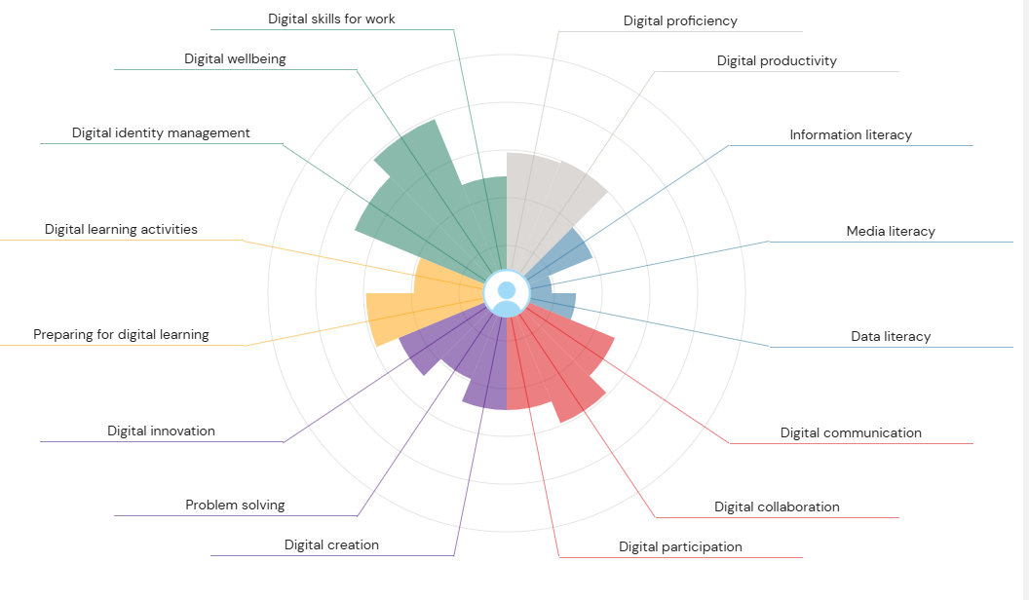
I have inserted a screenshot of my JISC Digital Capability Tool and to my surprise I had a few high scoring results of my digital skills. The JISC Digital Capability Tool showed that my strongest areas were digital wellbeing, digital identity management and digital communication. Digital skills are the skills we use to work with technology and the internet to complete tasks, communicate and research information online (JISC,2022)
These results made sense to me; the first one being digital wellbeing because I do manage my screen time while completing assignments and I do tend to avoid distractions.
My result for digital management indicates that I have a clear understanding on how to keep my personal information online private, I can also use strong passwords and I’m careful what I post on social media apps I only like to leave a positive impression not a negative one.
The last strength I can identify from my results is digital communication – I can clearly use digital tools to communicate one being email as I use email to communicate every day with my job as a hairdresser and my tutor for any help with assignments.
Although my results showed what my digital strengths, it also helped me identify where my weakness were.
One of these areas was media literacy. Media literacy is related to recognising if websites, videos and social media posts are legit. There is overflowing information online such as new outlets, advertisements and sources having so much access to this information I personally find it overwhelming and find it hard to identify whether the information I’m reading is misleading or false. Improving my media literacy skills will help me feel more confident when I’m researching information for assignments because it will help me identify sources that are reliable that will help me succeed in my future assignments.
another area that was identified for improvement was data literacy this refers to my ability to understand and organise interpret data using tools like graphs and tables. I recognise that this is an area I need to improve because I sometimes lack confidence when working with spreadsheets and reading numbers. Developing stronger data literacy skills will help me become more confidence using tools like Microsoft Excel which are commonly used in both higher education and the modern workplace.
I have come up with an action plan to improve my weaker digital skills. One goal is to improve my media literacy skills by learning how to assess online information more efficiently. Over the next coming months, I plan to research things online that I know are true and find sources that I know are not true and compare the two by doing that it will help me identify what misinformation I have been given and what search engines lead me that information. I also plan to watch videos and tutorials online to help me further my digital skills and improve the quality of the sources I use in my assignments.
Another digital skill I need to improve is my data literacy skills especially when using Microsoft Excel. Within the next three – six months I plan to practise filling out spreadsheets and go over the videos used on LinkedIn learning. I have a presentation on Moodle from week 7 I can look through. Doing these exercises will help me become more confident when working with digital data and improve my digital skills.
Overall, the JISC Capability Tool was pretty much straight forward too complete, it really helped me better understand my current digital skills and identify areas that I need to improve. The results did show that I already have strong abilities in areas like digital wellbeing and digital communication which are important skills for university and it will also help me with my future career as a hairdressing tutor.
The JISC Capability tool also highlighted a few areas that I would need further development on such as media literacy and data literacy. By creating an action plan, I can help myself work towards improving these skills over time. By developing these skills, it will help me with my future studies and assignments because I will be able to recognise useful and misleading information.
References:
European Commission (2020) Digital Skills and Jobs Coalition. Available at: https://digital-strategy.ec.europa.eu

JISC (2022) Building Digital Capability Framework. Available at: https://www.jisc.ac.uk

Task 2: LinkedIn Learning Certificates – Office 365

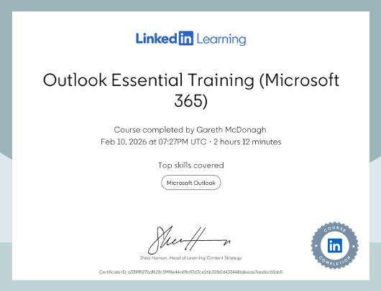
Outlook Essential Training (Microsoft 365)

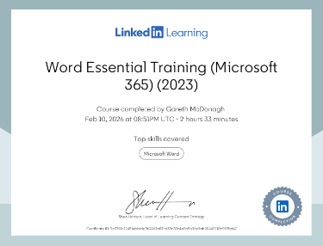
Word Essential Training (Microsoft 365)

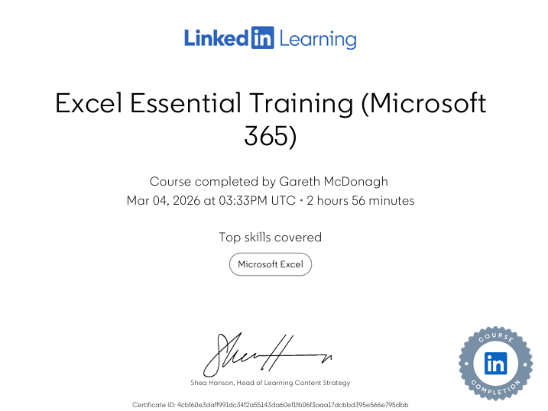
Excel Essential Training (Microsoft 365)

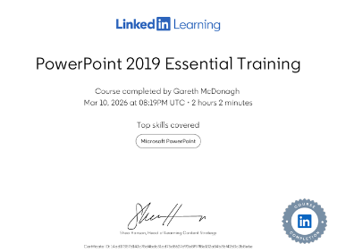
PowerPoint Essential Training (Microsoft 365)

Task 3: Relevance and Importance of Microsoft Excel
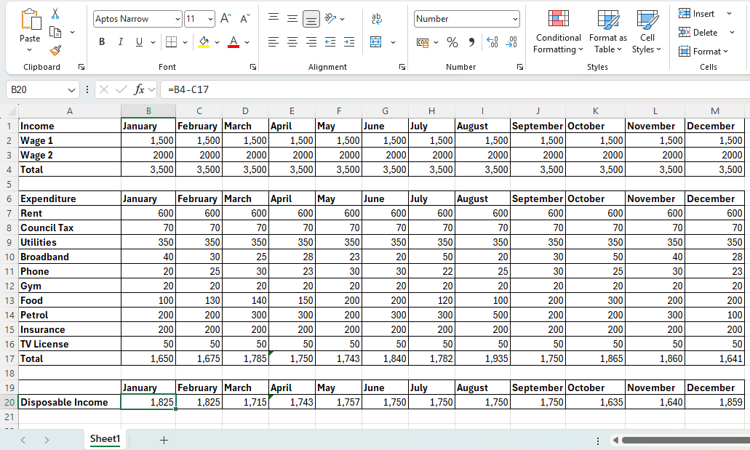
Microsoft Excel is a spreadsheet software that is mainly used to organise, analyse and present information. (Microsoft,2023) Microsoft excel allows students to work with numerical information through spreadsheets and charts. It also includes formulas to help with adding and subtracting, so you don’t have to work out huge mathematical sums. Teachers and students use excel to organise and understand information; business use excel to manage money, stock, information and reports. (GCFGlobal,2022) Everyday people use excel for personal organisation and managing and budgeting money.
one of the main advantages of Microsoft Excel is its ability to analyse and organise data using tools such as formulas, functions, sorting, filtering and pivot tables. Formulas are calculations used in Excel to work out numbers automatically. (Microsoft,2023)
for example:
SUM - adds numbers together
AVERAGE – finds the average value
COUNT – counts how many items are in a list.
Formulas help students apply calculations quickly without doing the maths manually. In addition to formulas Microsoft excel provides tools such as sorting and filtering which helps students organise and analyse data more efficiently, sorting allows information to be arranged in alphabetic order, filtering helps students display only the specific information they need from a large database.
Excell also allows users to create tables and charts which make data easier to understand.
Charts that can be made in excel are bar charts, pie charrs and line graphs which visually presents information so that patterns can be identified easily.
Tables help organise information into clear rows and columns making it easier to compare data and track changes. These tools are useful because they help students and business analyse information quickly and clearly.
Excel is also used for budgeting and tracking income in an organised way (Microsoft,2023) for example a ‘household budget’ spreadsheet can include categories like rent, bills, food and other expenses. The Microsoft Excel tools can help automatically calculate totals, helping anyone using it understand how much money they are spending and how much they have remaining, this helps people manage their finances effectively and avoid overspending.
As part of this module, I created a household income and expenditure spreadsheet using Microsoft excel. The purpose of this spreadsheet was to organise finical information and demonstrate how Excel can be used to analyse data. The Spreadsheet included income, expenses and totals which were calculated using the formulas tools. A chart was created to visually represent data, making it easier to understand spending patterns, below I have added a screenshot of the spreadsheet that was made.
Learning how to use Microsoft Excel has been valuable for my studies and future career. Excel helps organise information, analyse data and manage financial records efficiently. In the future I would like to open my own hair academy, and Excel could help me manage budgets, track income and expenses and organise business information.
References
GCFGlobal (2022) Excel Basics. Available at:
https://edu.gcfglobal.org/en/excel/

Microsoft (2023) Microsoft Excel Help and Learning. Available at:
https://support.microsoft.com/en-us/excel

Task 4: Reflective Presentation Summary


