Web Development: ASP.NET
  - Lecture 3 Lab Tutorial Exercise

Improving the Film Views

Objectives
In today’s exercise, you will update your film views.

Exercise 1: Adding Search to a View
In this exercise, you will add search/filter functionality to mail film list view. The original case study had the following requirement.
When a potential customer visits their websites, the home page should display a list of current films. Ideally, there should be some sort of way users can filter for films e.g.
- Top Films, New Releases, Coming Soon, Highest Rated
- The type of viewing experience: 2D, 3D, iMax
- Genres,
- Etc.

The Controller
- Open up your project in visual studio.
- Open up your Films Controller
- Locate the Index GET action method and modify it to accept a string input parameter representing the search string the user has specified.
- First, you need to define the model to Query and store this in a variable. For example to query the Customer model, you would add one of the following (use your preferred approach):
// Define the model to query
  - Method 1: Using IQueryable
  - Method 2: Using LINQ Select
- Next, if the search string parameter is not empty
  - Use a Lambda expression to find the films whose title matches the search string parameter value. For example, the following shows a match on the Genre field (you need to search the title).
// Use search string to find films WHERE title contains the search string entered. f is the lambda input parameter
- End If
- Finally, return the films as a list to the view.
// Return the films as a list to the view

The View
- Now go to the Index view for Films.
- Add a search form above the list of your films. For example:
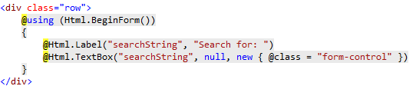
- Save your changes and test. Does it work?
- If you want your form to display on one line, you will need to specify the class HTML attribute. The syntax is:
Html.BeginForm(ActionName, ControllerName, FormMetthod, htmlAttributes)
  - As the HTML attribute is the fourth parameter available, you have to specify all the other parameters first.
  - For example, see below. Note: I have written on several lines, so I can add comments to show you what each parameter represents.
  - This example is adding two HTML attributes:
    - Class – to set the CSS classes (I am using Bootstrap classes)
    - Role – for accessibility
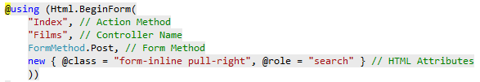

Bootstrap Classes
- You can find bootstrap classes at the following links:
  - W3Schols Complete List of Bootstrap Classes
  - Bootstrap 3 Classes List With Description Cheat Sheet
  - List of Bootstrap 3 CSS classes with description

Challenge Exercises

Challenge Exercise 1: Making the filter search the Genre and Cast Properties too
- A lot of search forms will give you the option to filter on more than one property. For example, the following is the search form on IMDB.
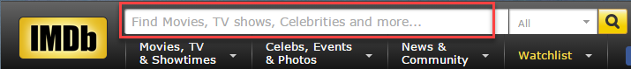
- Modify the view so that your textbox displays placeholder text to show what fields the filter is going to apply to as shown below.
- Go to back to your controller and see if you can modify the Lambda expression to search the additional fields (Hint: you need to use your logic operators).

Challenge Exercise 2: Filtering Top Films, New Releases, Coming Soon and Highest Rated
- One of the requirements in the case study was for users to be able to filter:
  - Top Films
  - New Releases
  - Coming Soon
  - Highest Rated

The View
- First modify your view to display a couple of action links with these four options as a navigation menu.
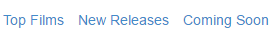
  - The Bootstrap Menu using list-inline CSS class example on W3Schools should help you.
  - You create an action link using the Html.ActionLink(linkText, ActionName, routeValues).
    - There should already be an example on the view page.
    - The routeValue is your search string parameter. You need to set it specifically. For example:

The Controller
- Now go to your controller and either using a switch statement (preferred) or if – else if … statement block, define different filters to apply for the different possible search strings.
- Note: You need to think carefully what field property you are going to search for each option and what the matching condition will be.
  - Top Films
  - New Releases
  - Coming Soon
  - Highest Rated
- Test your view and confirm it all works.
- Now see if you can modify the controller by adding a separate parameter for the film category - a user may want to filter by a category as well as a search term. You will need to adjust your existing code to allow users to filter the films based the two separate filters.

Exercise 2: Customising the Details View
In this exercise, you will use Bootstrap components to improve the display of the selected Film details. You should aim for something similar to the following (remove the Edit link):
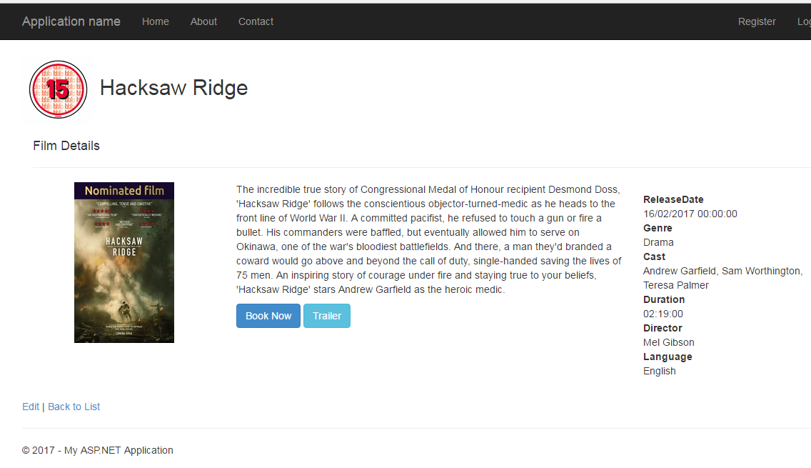
Bootstrap
- https://www.w3schools.com/bootstrap/default.asp
- http://getbootstrap.com/
Razor Syntax Reference
- Microsoft Docs Razor syntax: https://docs.microsoft.com/en-us/aspnet/core/mvc/views/razor
- C# Razor Syntax Quick Reference: http://haacked.com/archive/2011/01/06/razor-syntax-quick-reference.aspx/
- W3School’s ASP.NET Razor: https://www.w3schools.com/asp/razor_syntax.asp
- ASP.NET Razor Syntax Reference: https://gist.github.com/jonlabelle/8738373#aspnet-razor-syntax-reference

Displaying the Film Age Rating
- You will need to send the selected Film’s Age Rating details back to the view using the ViewBag in the Details action method. For example, the following shows a similar approach to select the Screen for a particular film showing.
- Use the Age Rating’s name property for the image – images are in the age ratings folder.
- Use the Age Rating’s description as the alternative text for the image.

Displaying Trailers
- Note, clicking on a Trailer link/button should display the film’s trailer in a Bootstrap modal component. For example:
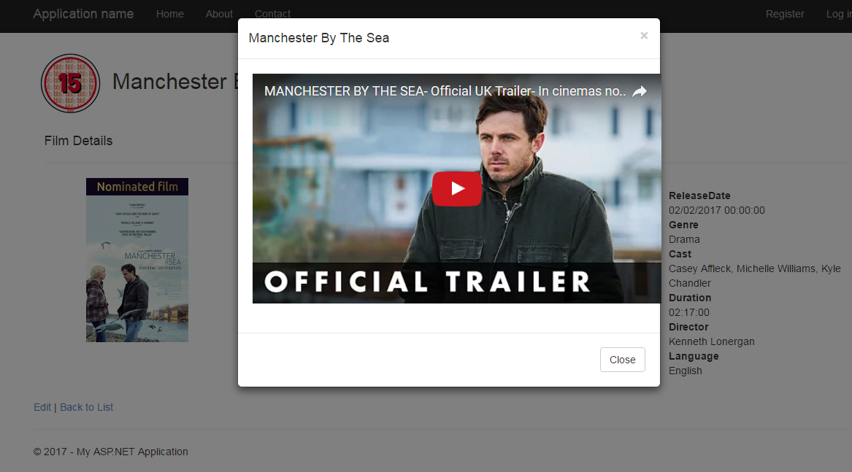
- The trailers have all been taken from YouTube and you will have to display them in an iframe.
  - First you will need to update the Trailers link in the database as I copied the wrong URL when I was creating the data. Download the “Update Trailers.sql” file from Moodle and run it against your database.
  - The format for displaying a YouTube video is shown below. You have to specify the source.

Displaying Film Show Times
- First download the script to update the film show times in your database and run the script.
- Go back to your controller and locate the Details action method.
- Limit the film show times listed in the view to only those showing for today.
- Next, you will create a partial view to display the film show times.
- Right-click on the Film’s View folder and select Add New Item … MVC 5 Partial Page (Razor)
  - Name the view _PartialFilmShowTime
- Specify its model type: FilmShowTime
- As a starting point, add the following – you can customise this as you prefer.
- Save your changes and return to the details view.
- Decide where you want to display the times. You will need a for { … } loop to go through them all and use the following HTML helper method to add the partial view component. The model will be the current film show time loop item.
@Html.Partial(“NameOfPartialFile”, model)

Challenge Exercise
- You might notice that the film show times is showing times that have already been shown earlier today.
- Modify the data returned to exclude these.
- Later, we will see how to include films for the next few days.
- That’s all for today

