Name: Nia Davies

Student Number: 2518521
__________________________________________________________

WORKSHEET 3 – TESTING (Chickens)

- Original code:
daysLaying =int(input("How many days has your chicken been laying?"))
while daysLaying <= 0:
print("not enough eggs")
print=int(input("how many days has your chicken been laying?"))
daysLaying=int(input())
while daysLaying >= 50:
print("too many eggs")
print=int(input("how many days has your chicken been laying?"))
daysLaying=int(input())
else:
reqEggs=2
dailyEgg = 1
[EXTENDED]
foodType=input("Enter 1 if the chicken eats superfood or 2 if chicken eats normal food")
while foodType == 1:
dailySuperegg= (3 / 2) % 2
print(daysLaying, "days of laying means", dailySuperegg, "super eggs and", totalCakes, "cake(s)")
[EXTENDED]
else:
totalEggs =int(daysLaying * dailyEgg)
totalCakes =int(totalEggs / reqEggs)
print(daysLaying, "days of laying means", totalEggs, "total eggs and", totalCakes, "cake(s)")

Code Testing

For each test below, run your code and enter the values provided. Provide a screenshot of what happened when the programme ran. Did the programme behave correctly or did it do something unexpected? Fill in a box for each test below. You should present 8 separate boxes, 1 for each test. (Note: the first box is provided as a template)

Normal food
i. 4 days (should be 4 eggs = 2 cakes)
ii. 9 days (should be 9 eggs = 4 cakes)
iii. -3 days (no cakes or error handled)
iv. 10000 days (program should catch the error – many of these eggs would be bad!)

Superfood
v. 4 days (should be 6 eggs = 3 cakes)
vi. 5 days (should be 7 eggs = 3 cakes)
vii. 1 days (should be 1 egg = 0 cakes)

Test your menu
viii. What happens if you enter “3”?

Test:
Normal food i) 4 days

Screenshot(s) of output:
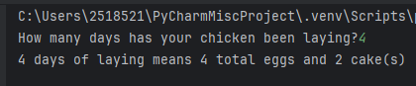
Result: Did the program behave as expected ie syntactically and logically correct?
YES
Code successfully run and calculations have returned correctly.

Test:
9 days (should be 9 eggs = 4 cakes)
Screenshot(s) of output:
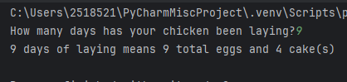
Result: Did the program behave as expected ie syntactically and logically correct?
YES
Code successfully run and calculations have returned correctly.

Test:
iv. 10000 days (program should catch the error – many of these eggs would be bad!)

Screenshot(s) of output:
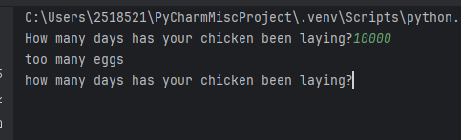
Result: Did the program behave as expected ie syntactically and logically correct?
YES
Code successfully run and calculations have returned correctly.

Test:
-3 days (no cakes or error handled)
Screenshot(s) of output:
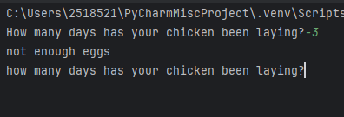
Result: Did the program behave as expected ie syntactically and logically correct?
YES
Code successfully run and calculations have returned correctly.

If NO, what problems were encountered and why? Suggest how things could be improved.

Test:
Superfood - v. 4 days (should be 6 eggs = 3 cakes)

Screenshot(s) of output:
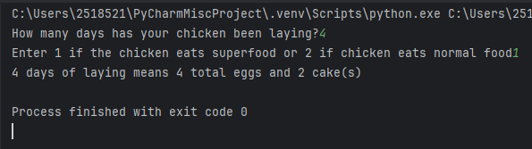
Result: Did the program behave as expected ie syntactically and logically correct?
NO
If NO, what problems were encountered and why? Suggest how things could be improved.

The same logic has applied to the superfood selection as the normal food selection,
Issues encountered with modulus feature and with the arithmetic logic involved. Could be improved with formatting – selection option messy. Also, could be reworked and rewritten to provide the correct output. Suspect the issue lies within the dailySuperegg calculation, unsure if code written to correctly run.

Test:
Superfood - 5 days (should be 7 eggs = 3 cakes)

Screenshot(s) of output:
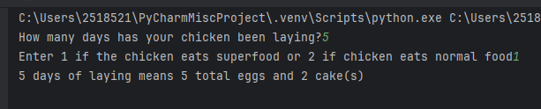
Result: Did the program behave as expected ie syntactically and logically correct?
NO
If NO, what problems were encountered and why? Suggest how things could be improved.

Like test v. (above) arithmetic/mathematical logic input to code not functional somewhere. Likely that error lies in modulus tag in dailySuperegg calculation.

Test:
Superfood - vii. 1 days (should be 1 egg = 0 cakes)

Screenshot(s) of output:
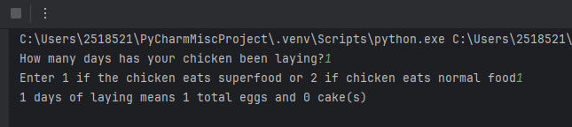
Result: Did the program behave as expected ie syntactically and logically correct?
YES – this superfood query has worked as explained within worksheet. Likely that this is due to the low value input to “daysLaying” section

Test:
Superfood - viii. What happens if you enter “3”?

Screenshot(s) of output:
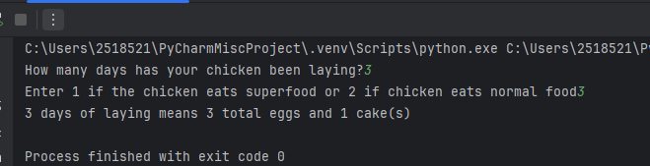
Result: Did the program behave as expected ie syntactically and logically correct?
NO
If NO, what problems were encountered and why? Suggest how things could be improved.

Calculation has run as code not written to stop any values being entered to “foodType” query. Could be improved with further statement to only allow input of “1” or “2”

(Copy and paste box above for each of the rest of the tests)

- Consider the results of the above tests and revisit your original code in order to address the tests that failed. (Note: you may not be able to solve all of the problems that were originally encountered, but solve as many as you can.)

Paste your full revised code here :

[Copy and paste your full revised code here – note, do not use a screenshot]

Unable to troubleshoot – original code remains

daysLaying =int(input("How many days has your chicken been laying?"))
while daysLaying <= 0:
print("not enough eggs")
print=int(input("how many days has your chicken been laying?"))
daysLaying=int(input())
while daysLaying >= 50:
print("too many eggs")
print=int(input("how many days has your chicken been laying?"))
daysLaying=int(input())
else:
reqEggs=2
dailyEgg = 1
[EXTENDED]
foodType=input("Enter 1 if the chicken eats superfood or 2 if chicken eats normal food")
while foodType == 1:
dailySuperegg= (3 / 2) % 2
print(daysLaying, "days of laying means", dailySuperegg, "super eggs and", totalCakes, "cake(s)")
[EXTENDED]
else:
totalEggs =int(daysLaying * dailyEgg)
totalCakes =int(totalEggs / reqEggs)
print(daysLaying, "days of laying means", totalEggs, "total eggs and", totalCakes, "cake(s)")

