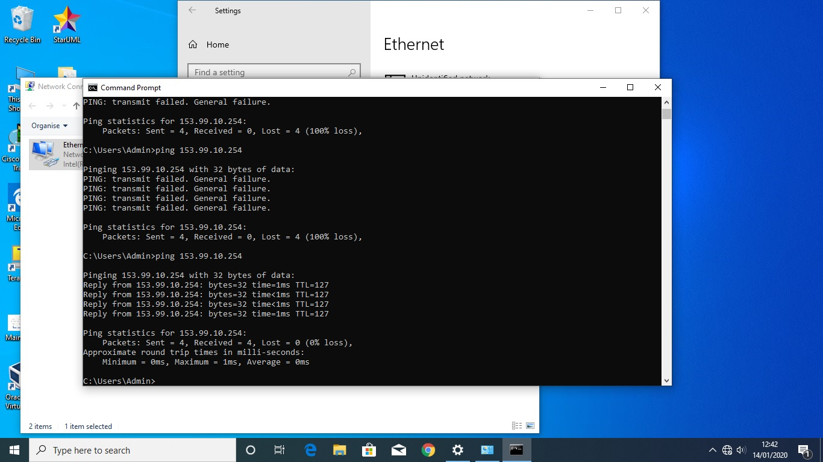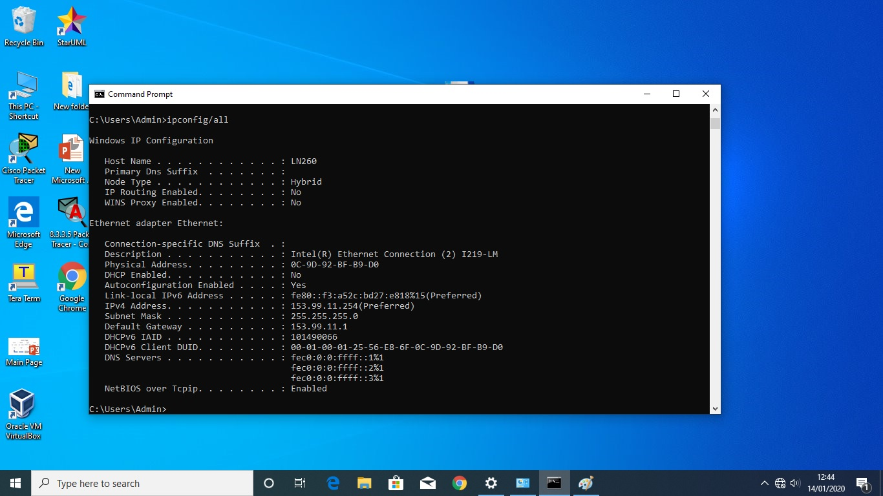

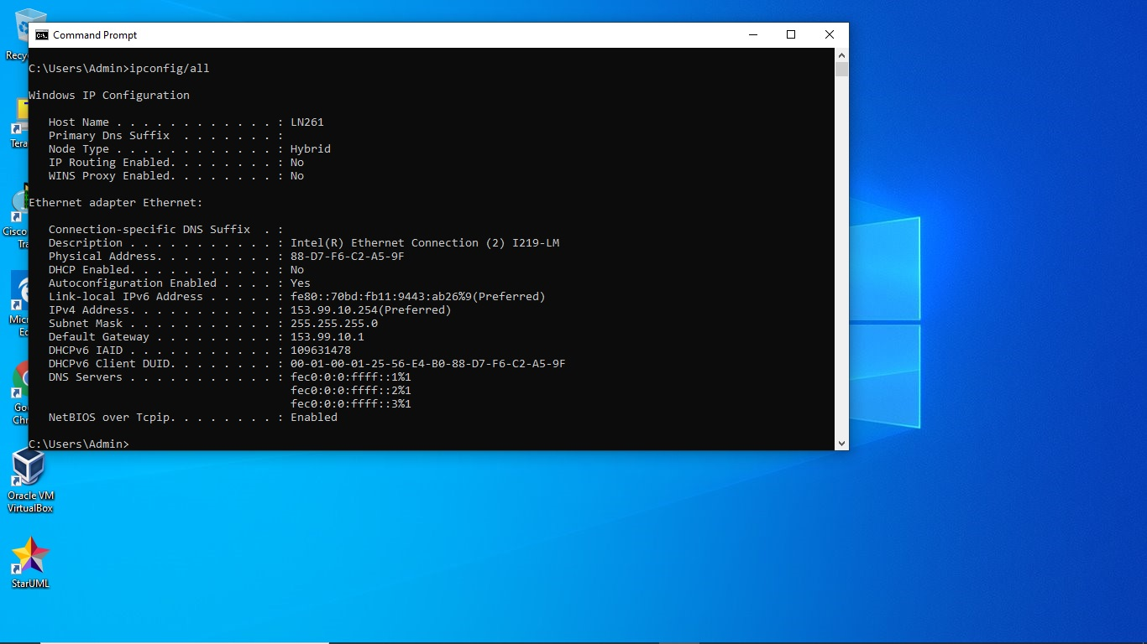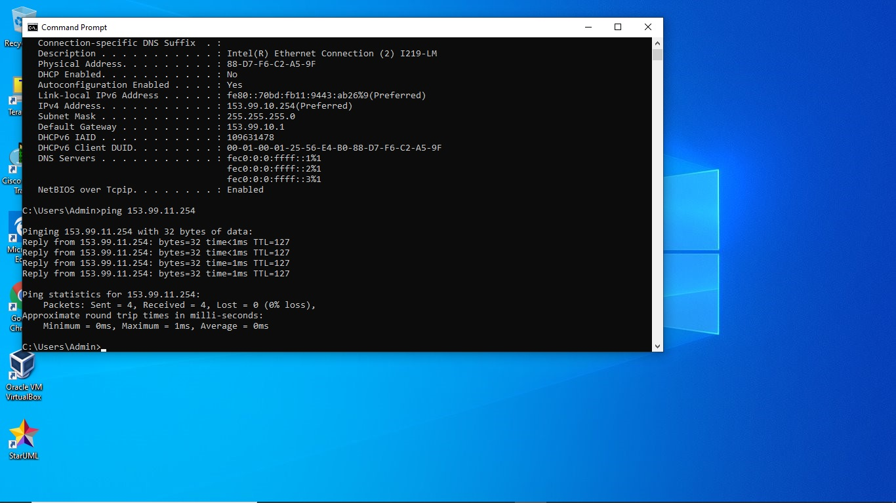

Switch
User Access Verification

Password:
S1>enable
Password:
S1#show run
Building configuration...

Current configuration : 1605 bytes
!
! Last configuration change at 00:14:48 UTC Sun Mar 7 1993
!
version 15.2
no service pad
service timestamps debug datetime msec
service timestamps log datetime msec
no service password-encryption
!
hostname S1
!
boot-start-marker
boot-end-marker
!
enable secret 5 $1$73r/$OiEIexAAIyDPvVZ5HtUIz0
!
no aaa new-model
system mtu routing 1500
!
!
!
!
!
!
!
no ip domain-lookup
!
!
!
spanning-tree mode pvst
spanning-tree extend system-id
!
vlan internal allocation policy ascending
!
!
!
!
!
!
interface FastEthernet0/1
!
interface FastEthernet0/2
!
interface FastEthernet0/3
!
interface FastEthernet0/4
!
interface FastEthernet0/5
!
interface FastEthernet0/6
!
interface FastEthernet0/7
!
interface FastEthernet0/8
!
interface FastEthernet0/9
!
interface FastEthernet0/10
!
interface FastEthernet0/11
!
interface FastEthernet0/12
!
interface FastEthernet0/13
!
interface FastEthernet0/14
!
interface FastEthernet0/15
!
interface FastEthernet0/16
!
interface FastEthernet0/17
!
interface FastEthernet0/18
!
interface FastEthernet0/19
!
interface FastEthernet0/20
!
interface FastEthernet0/21
!
interface FastEthernet0/22
!
interface FastEthernet0/23
!
interface FastEthernet0/24
!
interface GigabitEthernet0/1
!
interface GigabitEthernet0/2
!
interface Vlan1
ip address 101.12.10.254 255.255.255.0
!
ip http server
ip http secure-server
!
no vstack
banner motd ^CThis is authorised access only!

#This is authorised access only!

#This is authorised access only!#

exit

banner motd ^C
!
line con 0
password class
login
line vty 0 3
login
line vty 4
password cisco
login
line vty 5 15
login
!
End
Router
No unauthorized access

User Access Verification

Password:
R1>enable
Password:
R1#show
R1#show run
Building configuration...

Current configuration : 3624 bytes
!
! Last configuration change at 12:52:03 UTC Tue Jan 14 2020
!
version 16.9
service timestamps debug datetime msec
service timestamps log datetime msec
service password-encryption
platform qfp utilization monitor load 80
no platform punt-keepalive disable-kernel-core
!
hostname R1
!
boot-start-marker
boot-end-marker
!
!
enable secret 5 $1$vtD9$dn6OeCvPKlcYAh4GADEBB/
enable password 7 05080F1C2243
!
no aaa new-model
!
ip admission watch-list expiry-time 0
!
!
!
!
!
!
!
!
!
!
subscriber templating
multilink bundle-name authenticated
!
!
!
crypto pki trustpoint TP-self-signed-1562137005
enrollment selfsigned
subject-name cn=IOS-Self-Signed-Certificate-1562137005
revocation-check none
rsakeypair TP-self-signed-1562137005
!
!
crypto pki certificate chain TP-self-signed-1562137005
certificate self-signed 01
30820330 30820218 A0030201 02020101 300D0609 2A864886 F70D0101 05050030
31312F30 2D060355 04031326 494F532D 53656C66 2D536967 6E65642D 43657274
69666963 6174652D 31353632 31333730 3035301E 170D3230 30313134 31313535
30385A17 0D333030 31303130 30303030 305A3031 312F302D 06035504 03132649
4F532D53 656C662D 5369676E 65642D43 65727469 66696361 74652D31 35363231
33373030 35308201 22300D06 092A8648 86F70D01 01010500 0382010F 00308201
0A028201 0100C74A 5BFD994C 68A6AA62 AE9C693C 78AC688B CDF066A0 7768B5C5
35E1F97B B5743A7E 3D970443 22C9FFB8 4E52C410 F0979DCE A2FD3EF5 85DDDFFE
68FA253A 8402863C 02B4FA55 83115054 EF2B403A 949569D2 2440B2D4 EFBA3786
DD7A72CA 33028B09 ECA55060 9DB55CB2 73B97AAF AD4569A4 E448EE7D 1F18A685
C9EC82CF 7BDAF21B F9249C29 50A26FEF D7D70F01 BDA248C1 F09FFD91 60C141A3
0D92EF17 4CAF6AD9 3550593F FF474572 B6161AE1 86970A77 5D18F7F0 153D33D5
521E087A D4874CBB 88BD28FC 7688FF2D 2333C43F 233B5BF8 A88C536A D8265939
F3257206 F9804790 75400964 20E57FB5 95689F60 36798649 FDA10A4A F037DA8C
A40357D6 37C70203 010001A3 53305130 0F060355 1D130101 FF040530 030101FF
301F0603 551D2304 18301680 14AC13D2 C4AD34DD EFF8F1C5 02BF59C9 D157F959
B0301D06 03551D0E 04160414 AC13D2C4 AD34DDEF F8F1C502 BF59C9D1 57F959B0
300D0609 2A864886 F70D0101 05050003 82010100 511FE3FF FDF7D736 9B3A04C6
79FADD2D 24F336C3 D5AF52FD 889B7D91 A03549FA 681A6E41 D8359670 AADD3564
AB0600FF 173E1663 67B81721 203D5208 D625F89E 9E638B56 06D0CC66 AE111D96
191781B3 1D6FAB57 0BB30529 3EF59AB9 69FA1D80 A63B1FCC 8AF82994 99A86736
84EC2957 2C4C9E74 7A1022F3 9DF500C9 8EAF8105 A04AAEA3 4D336FA0 FDE27378
6129B3C4 E52D82FD E002B355 DDBAC5B0 0F5796F4 518C9E4E 933B2A71 62EEA0EC
4D27F4A3 7D5AFAA8 2841213B 9FC555D4 453AD234 AD4181FB B01C553E BA5981E7
DFB0BC79 0B594128 D414A3CF 93DAFC17 CF83C182 270C59DE 22B66D95 60ED2935
2B2FE5E5 E546AE7C AA2FC427 46E9E3DF BE8E1E0E
quit
!
license udi pid ISR4221/K9 sn FGL224190DN
no license smart enable
diagnostic bootup level minimal
!
spanning-tree extend system-id
!
!
!
username cisco privilege 15 password 7 030752180500
!
redundancy
mode none
!
!
!
!
!
!
!
!
interface GigabitEthernet0/0/0
ip address 153.99.10.1 255.255.255.0
negotiation auto
!
interface GigabitEthernet0/0/1
ip address 153.99.11.1 255.255.255.0
negotiation auto
!
interface Serial0/1/0
no ip address
shutdown
!
interface Serial0/1/1
no ip address
shutdown
!
ip forward-protocol nd
ip http server
ip http authentication local
ip http secure-server
!
!
!
!
snmp-server community o RO
!
!
control-plane
!
banner motd ^CNo unauthorized access^C
!
line con 0
password 7 070C285F4D06
login
transport input none
stopbits 1
line vty 0 4
password 7 1511021F0725
login
line vty 5 15
password 7 02050D480809
login
!
!
!
!
!
!
end

R1#

